**HUMANITIES IN MEDICINE: CHALLENGES AND OUTCOMES– EXPERIENCE AT PONDICHERRY INSTITUTE OF MEDICAL SCIENCES, PONDICHERRY, INDIA**

# Dr. Manjiri Phansalkar, Dr. Thomas Alexander,* Dr. Susan Solomon, Dr. Renu G'boy Varghese

Pondicherry Institute of Medical Sciences, Pondicherry, India

*Consultant Gastroenterologist, Zulekha Hospital, Sharjah, United Arab Emirates.

Mailing Address: Department of Psychiatry

Pondicherry Institute of Medical Sciences

Kalapet

Pondicherry- 605014

Telephone Number: 0413- 2656271 Extn 1136

E mail: susanjsolomon@gmail.com

Competing interest and funding support: None

Abstract

In India, a few institutes have started the program of Humanities in Medicine ( HiM ) on a smaller scale. In 2014, a decision was made at Pondicherry Institute of Medical Sciences (PIMS) to begin HiM program for undergraduate students and it has been conducted successfully for the last 3 years. The major strengths of the program were the formal integration of the program within the curriculum and the contribution by a huge number of enthusiastic, talented and motivated faculty. The immediate major challenges we had to deal with were – what objectives? what topics? for whom? by whom? when? how to conduct? and how to evaluate? We wish to discuss these points in detail.

Main Text

The challenge began with trying to understand the term “Humanities in Medicine”(HiM). In a three year period (2015-2017) during introductory sessions for the undergraduate students,it was observed that 'Humanities' was often confused with 'Humanity'. The Oxford English dictionary defines the word humanities as 'learning concerned with human culture, especially literature, history, art, music and philosophy'. According to the same dictionary, humanity however means different things - (a) human beings collectively (b) the state of being human and (c) the quality of being humane. Deborah Kirklin, who is considered as an international authority on the subject, defines humanities in medicine as “An interdisciplinary endeavor that draws on the creative and intellectual strengths of diverse disciplines like literature, art, creative writing, drama, film, music, philosophy, anthropology and history in pursuit of medical educational goals. (1)

In 2014, a decision was made at Pondicherry Institute of Medical Sciences (PIMS) to begin HiM program for undergraduate students. The initiative came after a meeting of the Medical Education Unit (MEU), with support from the administrative authorities. Forty hours of dedicated time was allotted for this endeavor. A co-coordinator was also appointed and a small team formed for the conduct and evaluation of the program.

The immediate major challenges we had to deal with were – what objectives? what topics? forwhom?by whom? when? how to conduct? and how to evaluate?

With lots of enthusiastic discussions, most of the details were sorted out and the program formally commenced in January 2015. It has been conducted successfully for the last 3 years and we eagerly look forward to its continuation in the forthcoming years.

**A) WHAT OBJECTIVES?**

The team unanimously decided on the following objectives.

To inculcate in all our graduates a love for

1. Art of healing
2. Ethical medicine
3. Humanitarian medicine

**B) FOR WHOM AND WHEN?**

In many institutes in the West, the program is conducted only for volunteers and that too during additional working hours.(2)In India, a few institutes have recently started this program but they have generally been on a smaller scale. We were of the firm opinion that every medical student needs to experience this program. It was therefore decided to include the entire class of the students with attendance being marked and also to conduct the sessions during the regular teaching hours. Hence, HiM was integrated into the curriculum for the 1st, 2nd and pre final year students during semester II, Semester IV and Semester VI, from January to May of every year. Every week, one/two hour sessions were started for all three semesters, simultaneously. Thus, three different topics were conducted each week. Currently we admit 150 students every year. This number was a big challenge. However, when the final year students came to know about these interesting and useful sessions from their juniors, some of them approached the authorities requesting a few sessions for themselves, in the year 2015 itself!This, we felt, was a certificate of success in the beginning and significantly improved faculty morale! In addition, many of the regular students started appreciating these sessions and said that they eagerlyawaited the next session.

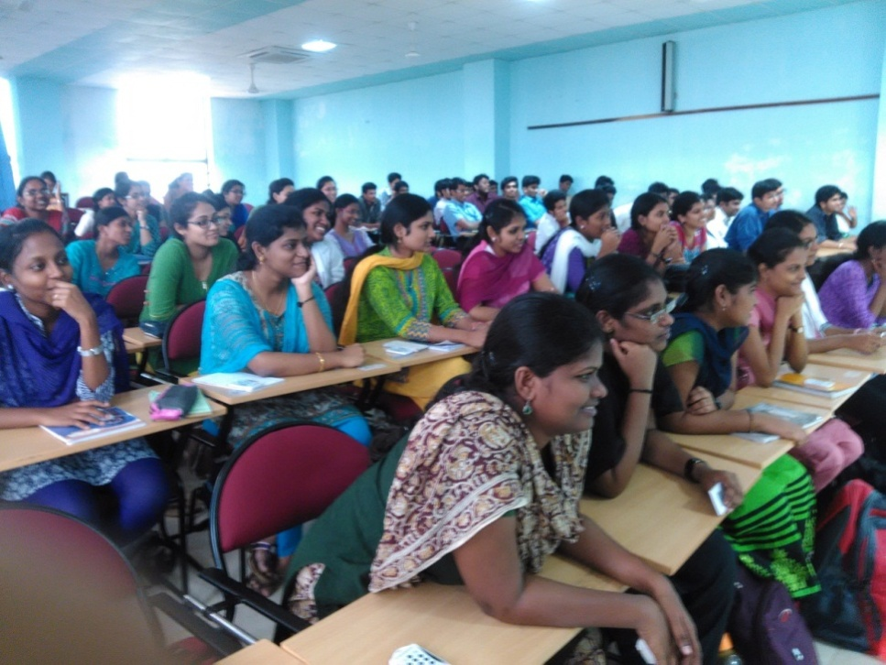

Figure 1: Whole class cherishing the HiM session

**C) WHO WILL CONDUCT AND HOW TO CONDUCT?**

There were a few more challenges faced initially. Certain guidelines were decided, such as – each session would be conducted by multiple faculty members so that various viewpoints would be expressed for sensitive issues, philosophical and ethical matters, attitude, communication skills, etc. We decided that the sessions would be conducted altogether differently from the routine didactic classes. Each session was planned in advance. The coordinator chose a team of facilitators for each topic, keeping in mind their interest, experience and ability to deal with the given topic. Of note is the fact that facilitators were chosen across departments. Then came the planning of various methodologies, scheduling of time and ways to obtain every student’s reflection and feedback, apart from getting attendance. The co-coordinator also decided to attend every session. Commonly used methodologies were role plays, debates, performing arts, interviews, appreciation of paintings, panel discussions, video clips, films, narrations, games, group activities, creative writing and reflective writing .

To give an example, a session on 'Perspectives on happiness' was conducted for semester II students. In the beginning of the session, three questions were posed to the students for reflection...

1. What will make me happy now?
2. What will make me happy after 5 years?
3. What will make me happy after 50 years?

Written answer slips were collected for analysis (this also served as a means to document attendance). Following this, a balloon game was played by the students, with the help of which, various perspectives on happiness were explored by student– facilitator interaction. In the last 15 minutes, a TED-talk video on the same topic was shown and the session was concluded within one hour!

Around 40 faculty members of various departments have contributed so far in these sessions. We were quite frankly amazed to see the talent among them. Their innovative ideas, cooperation, sincere efforts, hard work and strong desire to inculcate ethical and humanitarian attitudes and a love for the art of medicine among the budding doctors of our institution, were phenomenal. This, we feel is a major contributory factor for the success of the program. For a few sessions, we also invited guest faculty including those with a non-medical background.

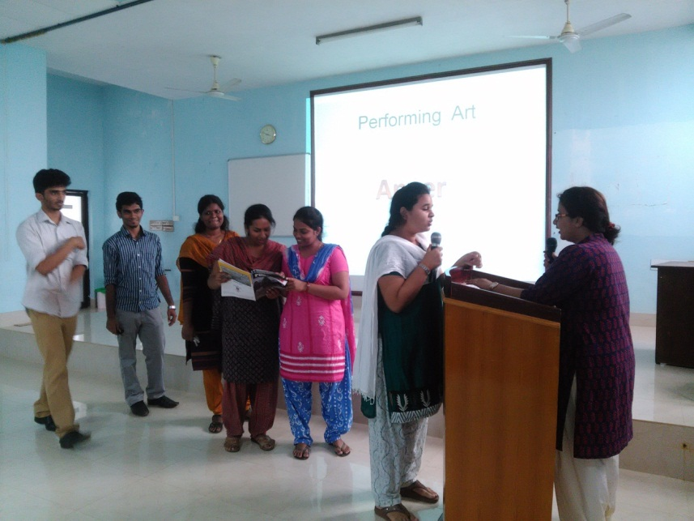

Figure2: Role play by the students

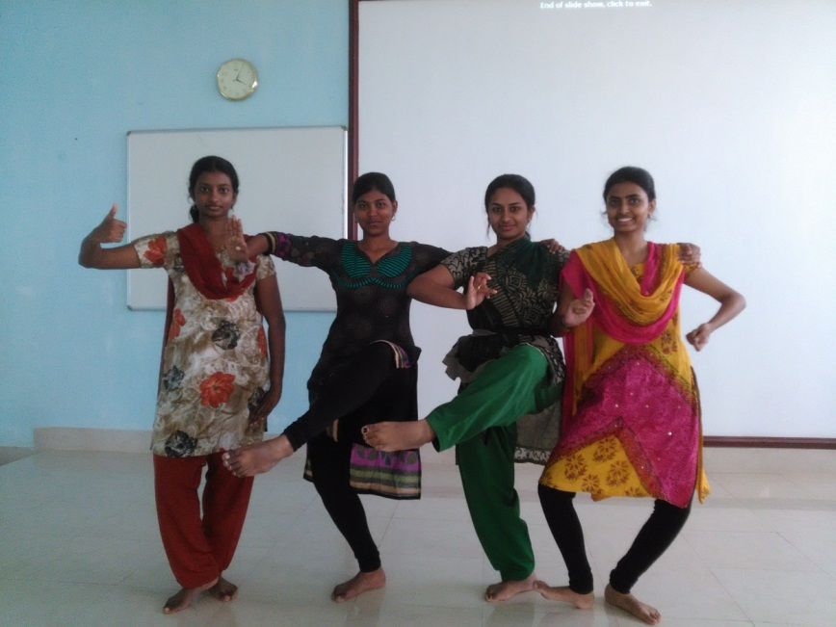

Figure3: Dance by the students expressing emotions

**D) WHICH TOPICS?**

We are evolving in this respect. In addition to the suggestions from faculty and students, the introduction of ATCOM (Attitudes & Communication) module by the Medical Council of India gave us quite a few extra ideas. Each batch of students, currently experience around 50-60 hours (increased from the initially allotted 40 hours) of HiM, spread across the different curricular stages. Topics are decided semester wise. We have now reached a stage with more topics than the available hours! Overall these topics can be categorized as (a) human values (b) medical ethics (c) communication skills (d) philosophy and (e) history of medicine. Topics for these sessions included 'Right or wrong','Art and science of death disclosure', 'Who am I', 'We are being watched', 'Curiosity for the human body' etc. Clinicians shared their experiences on themes like 'A rewarding day in my life' and 'My privileges and commitments as a doctor'.

**E) HOW TO EVALUATE?**

Evaluation of individual students remains the biggest challenge. Some experts have done only course–evaluation, based on the feedback given by the students.(3) We too collect anonymous feedback in some of the individual sessions and at the end of each semester. However, assessment of individual behavioral change has not been possible. Difficulties in this regard have been emphasized by others also.(4,5,6,7) Wershof SA, et al specifically mention that efforts have been taken to quantify the impact of MH course, however, subjective outcomes like increased empathy, professionalism and self-care are difficult to measure.(5)Shankar PR, writing on the medical humanities (MH) courses in India, wrote that measuring the long-term impact of MH is challenging and may be difficult. He has suggested some pattern be applied to small group to find out short term impact in another article, but that too would be difficult and time consuming.(6) Bleakley A, in his book with a chapter titled‘ Evaluating the impact of Medical Humanities provision’ has discussed various issues in the evaluation.(7) In one article, he mentions that it may be akin to measuring the immeasurable.(8)We too realized that the evaluation is difficult, but hope to evolve to some degree in this aspect as well, in the future.

Following are some of the findings from the term ending feedback analysis on the course.

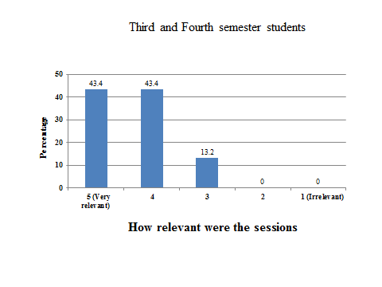

Figure 4: Student feedback on relevance of the topics

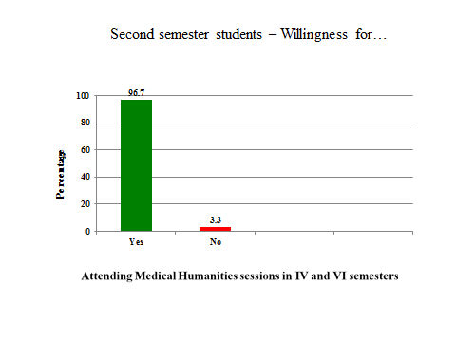

Figure 5: Student feedback on willingness to attend further sessions

**F) UNEXPECTED BENEFITS:**

An unintentional yet important benefit, that accrued during the course of this program, was the development of an increased spirit of camaraderie and cooperation among faculty across disciplines. We also believe that this program has sparked in many members of the faculty, a deeper realization of life, patient expectations and issues beyond 'traditional' curricular topics. This we think, will further enrich the fabric of our institute and society in the long term!

To conclude, from the experience of conducting the HiM program at PIMS, over the last three years,we would say that the overall response and outcomes have been well beyond our expectations. The major strengths of the program were the formal integration within the curriculum and the contribution by a huge number of enthusiastic, talented and motivated faculty. Though evaluation of behavioral and attitudinal change of individual students remains a challenge, we believe that this is a program with benefits for all involved!

**REFERENCES:**

1. Kirklin D. The centre for Medical Humanities, Royal Free and University College Medical School,London,England. Acad Med. 2003; 78: 1048- 53
2. Shankar P R . A voluntary Medical Humanities module in a Medical College in Western Nepal; Participant feedback. Teaching and learning in Medicine. 2009; 21: 248- 53
3. Rabie E Abdel Halim, Khaled M Alkattan. Introducing medical humanities in the medical curriculum in Saudi Arabia ; a pedagogical experiment. Urol Ann. 2012; 4 (2) : 73- 79
4. Downie R. Medical humanities: some uses and problems. JR Coll physicians Edinb. 2016; 46(4) :288- 94
5. Wershof SA, Abramson JS, Woinowich I, et al. Evaluating the impact of humanities, in Medical education. Mt Sinai J Med. 2009; 76 (4) :372 –80
6. Shankar PR. Medical humanities in medical schools in India. Arch Med Health Sci . 2016;4:166- 68
7. Bleakley A. Medical Humanities and Medical Education – How the medical humanities can shape better doctors. Routledge, London and New york. 2015
8. Bleakley A. Seven types of ambiguity in evaluating the impact of humanities provision in undergraduate medicine curricula. J Med Humanit 2015;36:337-57.