**HUMANITIES IN MEDICINE: EXPERIENCE AT PONDICHERRY INSTITUTE OF MEDICAL SCIENCES, PONDICHERRY, INDIA**

# Dr. Manjiri Phansalkar, Dr. Thomas Alexander,* Dr. Susan Solomon, Dr. Renu G'boy Varghese

Pondicherry Institute of Medical Sciences, Pondicherry, India

*Consultant Gastroenterologist, Zulekha Hospital, Sharjah, United Arab Emirates.

Mailing Address: Department of Psychiatry

Pondicherry Institute of Medical Sciences

Kalapet

Pondicherry- 605014

Telephone Number: 0413- 2656271 Extn 1136

E mail: susanjsolomon@gmail.com

Competing interest and funding support: None

Abstract

In India, a few institutes have started the program of Humanities in Medicine ( HiM ) on a small scale. In 2014, a decision was made at Pondicherry Institute of Medical Sciences (PIMS) to begin HiM program for undergraduate students and it has been conducted successfully for the last 3 years. The major strengths of the program were the formal integration of the program within the curriculum and the contribution by a huge number of enthusiastic, talented and motivated faculty. In this article we wish to discuss the evolution of the HiM program in our institution and its implementation.

Main Text

Introduction: The Medical Education Unit of Pondicherry Institute of Medical Sciences and the administrative authorities felt that there was a need to inculcate in medical students a love for the art of healing, ethical medicine and humanitarian medicine. Hence it was decided that a program of ‘Humanities in Medicine’ will be introduced.The challenge began with trying to understand the term ‘Humanities in Medicine’(HiM) as 'Humanities' was often confused with 'Humanity'. The Oxford English dictionary defines the word humanities as 'learning concerned with human culture, especially literature, history, art, music and philosophy'. According to the same dictionary, humanity however means different things (a) human beings collectively (b) the state of being human and (c) the quality of being humane. Deborah Kirklin, who is considered an international authority on the subject, defines humanities in medicine as “An interdisciplinary endeavour that draws on the creative and intellectual strengths of diverse disciplines like literature, art, creative writing, drama, film, music, philosophy, anthropology and history in pursuit of medical educational goals. (1)

Methods: A small team comprising the Dean (TA), Vice Dean (SS) of the Medical Education Unit and a coordinator (MP) for the overall conduct of the program was formed. The objective of the program was to inculcate in students love for the art of healing, ethical medicine and humanitarian medicine. The team was of the firm opinion that every medical student needs to experience this program. It was therefore decided to include the entire class of the students with attendance being marked and also to conduct the sessions during the regular teaching hours. Hence, it was decided to integrate HiM into the curriculum for the 1st, 2nd and pre final year students during semester II, Semester IV and Semester VI, from January to May of every year. Forty hours which were additional tutorial hours were dedicated to this endeavour. Regarding selection of topics, in addition to the suggestions from faculty and students, the introduction of ATCOM (Attitudes & Communication) module by the Medical Council of India gave us quite a few extra ideas.

We decided that the sessions would be conducted altogether differently from the routine didactic classes. Certain guidelines were decided, such as – each session would be conducted by multiple faculty members so that various viewpoints would be expressed for sensitive issues, philosophical and ethical matters, attitude, communication skills, etc. The coordinator chose a team of facilitators across specialties for each topic, keeping in mind their interest, experience and ability to deal with the given topic. The coordinator decided to attend every session in order to identify the interests and participation of students and faculty and to make modifications in further sessions, if needed.

**A)** .

Results: The HiM program was formally commenced in January 2015. Every week, one/two-hour sessions were started for all three semesters, simultaneously. Thus, three different topics were conducted each week Commonly used methodologies were role plays, debates, performing arts, interviews, appreciation of paintings, panel discussions, video clips, films, narrations, games, group activities, creative writing and reflective writing. For few sessions, we also invited guest faculty including those from a non-medical background.

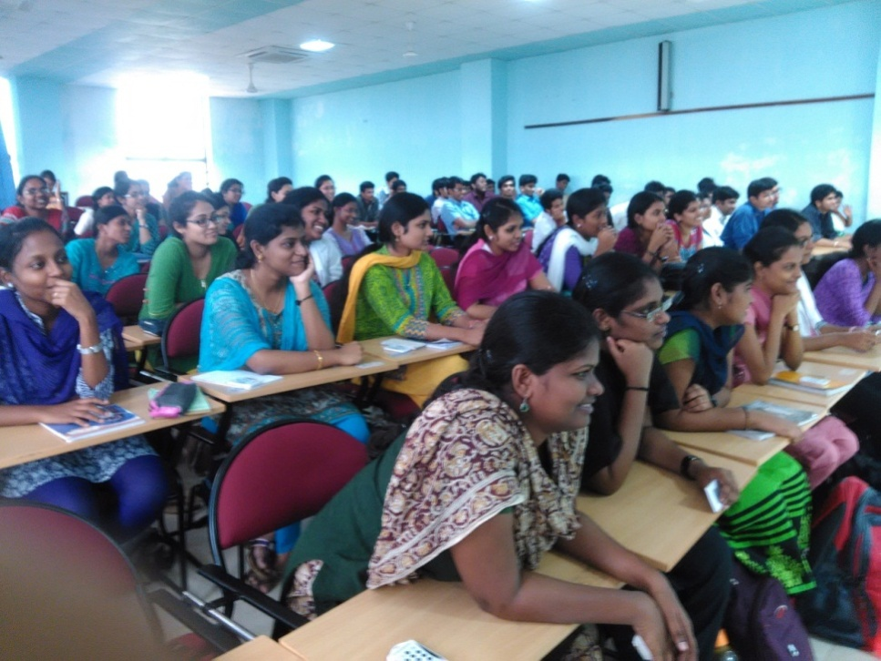

Figure 1: Whole class cherishing the HiM session

To give an example, a session on 'Perspectives on happiness' was conducted for semester II students. In the beginning of the session, three questions were posed to the students for reflection...

1. What will make me happy now?
2. What will make me happy after 5 years?
3. What will make me happy after 50 years?

Written answer slips were collected to elicit students’ perspectives on the topic (this also served as a means to document attendance). Following this, a balloon game was played by the students, with the help of which, various perspectives on happiness were explored by student– facilitator interaction. In the last 15 minutes, a TED-talk video on the same topic was shown and the session was concluded within one hour!

Topics for the sessions are decided semester wise. We have now reached a stage with more topics than the available hours! Overall these topics can be categorized as (a) human values (b) medical ethics (c) communication skills (d) philosophy and (e) history of medicine. Topics for these sessions included 'Right or wrong','Art and science of death disclosure', 'Who am I', 'We are being watched', 'Curiosity for the human body' etc. Clinicians shared their experiences on themes like 'A rewarding day in my life' and 'My privileges and commitments as a doctor'.

Discussion: The HiM program was started in 2015 with the objective of inculcating ethical and humanitarian values in our students.

Around 40 faculty members of various departments have contributed so far in these sessions. Their innovative ideas, cooperation, sincere efforts, hard work and strong desire to inculcate ethical and humanitarian attitudes and a love for the art of medicine among the budding doctors of our institution, were phenomenal.

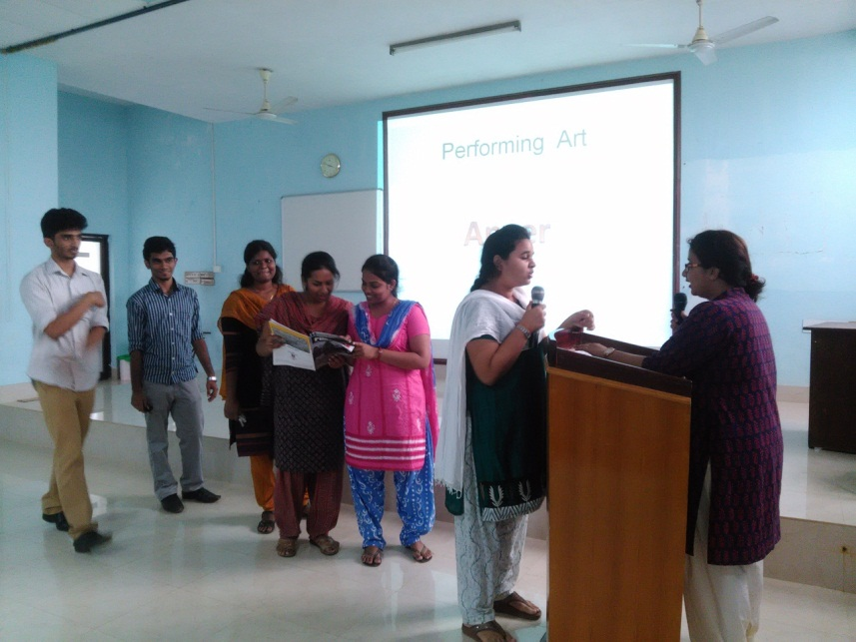

Figure2: Role play by the students

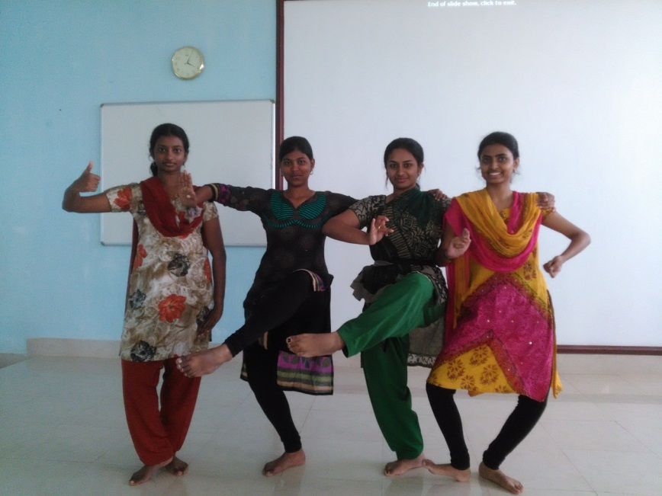

Figure3: Dance by the students expressing emotions

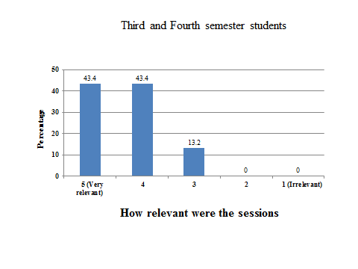

Figure 4: Student feedback on relevance of the topics

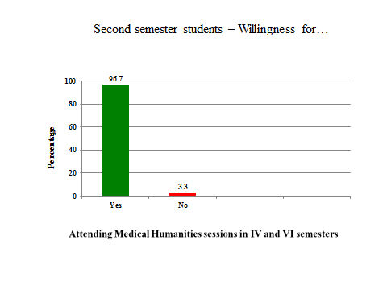

Figure 5: Student feedback on willingness to attend further sessions

Evaluation of individual students remains the biggest challenge. Some experts have done only course–evaluation, based on the feedback given by the students.(3) We too collected anonymous feedback in some of the individual sessions and at the end of each semester. However, assessment of individual behavioral change has not been possible. Difficulties in this regard have been emphasized by others also.(4,5,6,7) Wershof SA, et al specifically mention that efforts have been taken to quantify the impact of MH course, however, subjective outcomes like increased empathy, professionalism and self-care are difficult to measure.(5) Shankar PR, writing on the medical humanities (MH) courses in India, wrote that measuring the long-term impact of MH is challenging and may be difficult. He has suggested some pattern be applied to small group to find out short term impact but that it too would be difficult and time consuming.(6) Bleakley A, in his book with a chapter titled‘ Evaluating the impact of Medical Humanities provision’ has discussed various issues in the evaluation.(7) In one article, he mentions that it may be akin to measuring the immeasurable.(8)We too realized that the evaluation is difficult, but hope to evolve to some degree in this aspect as well, in the future.

Figure 4: Student feedback on relevance of the topics

Figure 5: Student feedback on willingness to attend further sessions

An unintentional yet important benefit, that accrued during the course of this program, was the development of an increased spirit of camaraderie and cooperation among faculty across disciplines. We also believe that this program has sparked in many members of the faculty, a deeper realization of life, patient expectations and issues beyond 'traditional' curricular topics. This we think, will further enrich the fabric of our institute and society in the long term!

To conclude we have been able to successfully implement HiM program for the past three years.The major strengths of the program were the formal integration within the curriculum and the contribution by a huge number of enthusiastic, talented and motivated faculty. Though evaluation of behavioral and attitudinal change of individual students remains a challenge, we believe that this is a program with benefits for all involved!

**REFERENCES:**

1. Kirklin D. The centre for Medical Humanities, Royal Free and University College Medical School,London,England. Acad Med. 2003; 78: 1048- 53
2. Rabie E Abdel Halim, Khaled M Alkattan. Introducing medical humanities in the medical curriculum in Saudi Arabia ; a pedagogical experiment. Urol Ann. 2012; 4 (2) : 73- 79
3. Downie R. Medical humanities: some uses and problems. JR Coll physicians Edinb. 2016; 46(4) :288- 94
4. Wershof SA, Abramson JS, Woinowich I, et al. Evaluating the impact of humanities, in Medical education. Mt Sinai J Med. 2009; 76 (4) :372 –80
5. Shankar PR. Medical humanities in medical schools in India. Arch Med Health Sci . 2016;4:166- 68
6. Bleakley A. Medical Humanities and Medical Education – How the medical humanities can shape better doctors. Routledge, London and New york. 2015
7. Bleakley A. Seven types of ambiguity in evaluating the impact of humanities provision in undergraduate medicine curricula. J Med Humanit 2015;36:337-57.