Blowing the whistle: Perceptions of surgical staff and medical students in a public South African hospital

**Authors and Affiliations:**

1. Mr. Ter-Er Kusu-Orkara; MBChB, [Hltkusuo@liv.ac.uk](mailto:Hltkusuo@liv.ac.uk)
2. Mr. Alexander L Symonds, a MScR,[hlasymon@liv.ac.uk](mailto:hlasymon@liv.ac.uk)
3. Mr. Harry C Bickerstaffea, MBChB student, hlhbicke@liv.ac.uk
4. Mrs. Nikki Allortob; MBChB, Mmed, FCS,Nikkiallorto@gmail.com
5. Dr Stuart Oultramc; [Stuart.Oultram@liverpool.ac.uk](mailto:Stuart.Oultram@liverpool.ac.uk)

aSchool of Medicine, University of Liverpool, Liverpool, UK

b MBChB, Mmed, FCS, Pietermaritzburg Metropolitan department of surgery

cInstitute of Psychology, Health and Society, Liverpool, UK

**Contribution statement:** TKO designed this research study, collected, analyzed the data and was involved in writing and revising the final manuscript. AS and HB were involved in the data analysis and writing of the final manuscript. NA helped collect data and was involved in the final changes and revision of the manuscript. SO assisted in writing the revisions to the manuscript and approved the final manuscript.

**Corresponding Author:**

Mr. Ter-Er Kusu-Orkar

University of Liverpool Medical School

Cedar House, Liverpool

L69 3GE

Hltkusuo@liv.ac.uk

**Funding:** This study received funding from the Institute of Medical Ethics (UK)

**Conflict of Interest:** There were no relationships that could have led to a conflict of interest in this study.

**Ethical Approval:** Approval for this study was given by Edendale hospital (South Africa), the Biomedical Research Ethics Committee (BREC) and the University of Liverpool Faculty of Health & Life Sciences Committee on Research Ethics (United Kingdom).

*Word Count* = 2,402 (Excluding abstract, references, tables and figures)

*Abstract Word count* = 148

**Abstract**

Understanding perspectives on whistleblowing is important in tackling resistance to speaking out. This study aimed to elicit the views of medical students and doctors in Edendale Hospital, South Africa using a mixed methods questionnaire study incorporating free text and tick box answers. Thematic analysis and descriptive statistics were used to interpret the results. Fifty-eight doctors and medical student’s responded (87% response-rate) and the majority were surgeons at Edendale hospital. Seventeen percent did not understand the concept of whistleblowing while 42% felt unable to report an adverse event. Motivation for reporting adverse events was overwhelmingly in the interests of patient safety (91%) but reluctance was mainly due to the potential consequences on workplace relationships (24%). The most common innovation suggested was a reporting structure (54%). These observations indicate workplace relationships are an important barrier to whistleblowing; further research should expand on these concerns and explore staff knowledge about whistleblowing.

**Key words:** *Whistleblowing, Questionnaire, Professional Ethics, Developing country, Work place relationships*

**Research Registration Number – KZ 201708 001**

**Introduction**

Whistleblowing is defined as raising a concern about a wrong doing and it has gained prominence in the UK National Health Service (NHS) following the publication of the Francis report into Mid-StaffordshireNHS trust in 2013 (1, 2, 3). The report noted that a lack of diligence and a reluctance to speak out about poor practice amongst staff had contributed to increased patient morbidity and mortality (1, 2). In the wake of the Mid-Staffordshire report, a new framework was introduced by the NHS to help workers raise concerns regarding other staff and poor working practices in general (3). Nevertheless, it has been suggested that this new framework has not helped to increase whistleblowing, nor has it prevented staff who do raise concerns from being penalized.(4, 5, 6). Furthermore, it has been claimed that such implementations will encourage defensive medicine and reduce the willingness of staff to report concerns; despite the important role of whistleblowing in helping to prevent catastrophic events and improve care (2, 8). Subsequently, further research is required to understand why healthcare professionals are reticent regarding whistleblowing (4). Moreover, while some research in the nursing and allied health community exists, this study is important as it adds to the limited evidence amongst medical students and staff in general (5, 9, 10, 11).

It is also our contention, in addition to the above, that any programme of research into whistleblowing ought to consider perspectives from other geographical and cultural settings. This is because international perspectives can help to illuminate new issues, questions, and solutions relating to whistleblowing that can positively impact other healthcare systems (12). Yet, in conducting research into international perspectives on whistleblowing, we noted that in the last decade there appeared to be limited research into the perceptions of medical personnel in developing countries.

In light of this, we the authors used the opportunity afforded by a placement in the Department of Surgery Edendale Hospital, South Africa to carry out research into the perceptions of whistleblowing amongst medical personnel.

The aims of the research were broadly threefold, i) to elicit the view of medical personnel regarding whistleblowing, ii) to add to the current discussion and evidence base on whistleblowing in the South African health system, and more generally iii) contribute to the current research base on whistleblowing in developing countries.

*A brief contextual note on healthcare & whistleblowing in South Africa*

The South African healthcare system consists primarily of a public/state healthcare system where a Uniform Patient Free Schedule is used to bill patients for healthcare services (13). Alongside this, there is a smaller private sector in which care is generally regarded as being better than that in the public system; although access is restricted by ability to pay. As such, private health providers are invariably concentrated in wealthier areas of the country. Additionally, within state health care, doctors work as a team within a department that reports to unit heads and ultimately the medical manager who has a, largely, non-clinical role. This is opposed to the private sector, were specialists or general practitioners practice independently from their peers.

South Africa currently has a number of frameworks relating to disclosure and whistleblowing that are in turn underpinned by a set number of legal instruments such as the Protected Disclosures Act and the Labour Relations Act (12). Despite these regulatory frameworks, Martins has argued that South Africans remain reluctant to engage in whistleblowing for, as she notes, reasons such as culture and perceived weaknesses in the law (12). Consequently, as noted previously, the study will add to the discussion on whistleblowing in South Africa, albeit from the healthcare perspective.

**Methods**

**Research approach**

For the purposes of this study, we used the following working definition of whistleblowing by Martins, “Raising a concern about wrongdoing within organisations or through an independent structure associated with it” (12); which in turn was drawn from a definition used by the UK Committee on Standards in Public Life (12). Additionally, an ‘adverse event’ was defined as an incident that caused (or had the potential to cause) harm to a patient. This was then expanded to encompass events that were illegal and/or were contrary to hospital guidelines.

A literature search was conducted to identify validated and standardized “Whistle Blowing” Questionnaires that could be used in our study was undertaken using PUBMED, SCOPUS, and DISCOVER (**Figure 1**). No appropriate questionnaires were found. A questionnaire was therefore developed using a variety of papers to be applicable internationally in gaining perspectives on whistleblowing (See **Table 1**) (1, 2). Ethical approvals for the study were granted by Edendale hospital, the BREC ethics committee and the University of Liverpool Faculty Of Health & Life Sciences Committee on Research Ethics. The study was conducted in line with the principles of the declaration of Helsinki.

|  |  |
| --- | --- |
| **Avoided in Questionnaire** | **Reason** |
| **“What would you do” questions** | This allows participants to describe their self-expectations rather than what they would actually do. |
| **Reporting suspected wrongdoing** | We wanted to gain responses from those who had observed wrongdoing |
| **Multiple questions at the same time** | To increase coherence and speed of questionnaire |

**Table 1:** Evidence based questionnaire development (10, 11)

Initial search (N=47)

Terms (All with 10 year filter:

Whistleblowing AND Healthcare

Whistleblowing AND Questionnaire

Whistle blow AND Developing country

After Abstracts Screened (N= 5)

Excluded due to:

Did not include medical professionals

Final number of papers (N=2)

Full text screen :

Exluded 3 papers - No Questionnaire data

**Figure 1** *–* Process to find papers/questionnaires that would inform our questionnaire: PubMed example

**The Questionnaire**

A pilot questionnaire was used to develop the final questionnaire, consisting of 15 questions with check box and free text answers. A pilot study highlighted the short and quick nature of our questionnaire. The questionnaire was distributed to clinicians and medical students amongst Edendale Hospital. Non-medical staff and those who could not understand English were not included in the study.

Non-probability sampling was used and a stratified population was drawn; this was disproportionate because a convenience sample method was utilised. The number of participants was sufficient once the number of responses given was saturated (14). The majority of participants were from the surgical department due to issues with access and resistance to implementation in different areas of the hospital. Surveys were distributed as hard copies mainly at staff meetings. Forms that were not returned or incorrectly completed were counted as non-respondents. Fifty-eight responses were collected between 24/08/2017 and 31/08/17.

**Data analysis**

Results were analysed through Graph Pad Prism using descriptive statistics; free text answers were evaluated using a thematic analysis (TK-O, AS). Thematic analysis was performed by giving the different free text answers codes that corresponded to certain themes and then adding up how often those themes were represented in the data. A second author, blinded to the first analysis, repeated this process in order to validate the thematic analysis. Both authors reached similar conclusions in their analysis and the outcomes were finalized after any disagreements were resolved by a more senior statistician.

**Results**

The response rate was 87% (58/67), from the approached Surgeons, physicians and medical students on their surgical rotation at Edendale hospital. **Table 2** illustrates the demographic profile of these respondents.

|  |  |  |  |  |
| --- | --- | --- | --- | --- |
|  | **Total number in specialty** | **Number approached in specialty** | **Number of participants that responded** | **Average Age (years)** |
| Male: Female | - | - | 27*:30 | - |
| Surgeons | 42 | 42 | 40 | 29 |
| Medical Students | 24 | 19 | 14 | 25 |
| Anaesthetics | 20 | 5 | 3 | 26 |
| Internal Medicine | -** | 1 | 1 | 26 |
| *Mean* | - | - | - | **27.7** |

**Table 2**: Participant demographics including gender, age, and specialty in Edendale hospital. Total number of respondents *(n =58*). *one respondent did not mark a gender) **data on surgical department only

**Whistleblowing knowledge**

Of responses collected (*n=58*), the majority believed whistleblowing would benefit their institution (77%). In addition, 12% thought it was not in their institutions best interests and 11% were unsure. Although the majority of respondents understood the term whistleblowing (83%) a significant minority did not; 10% were unsure and 7% did not know.

**About your unit**

Participants where asked if there were clear systems for reporting adverse events and/or problems, 43% said yes, 38% unsure and 18% said no. 79% of respondents reported no training in how to use these systems, whether they did or did not exist. 91% responded yes to there being a clear hierarchy in their unit, 74% agreed their unit delivers a high standard of care, only 3% of participants said they did not (**Figure 2A-D**).

**Reporting adverse events**

Clinicians were asked how able they felt to report an event in their unit, 55% felt they were able to report an adverse event, 20% said they could not and 22% were unsure; 3% of participants did not respond. Of 58 participants 91% said patient safety motivated them to whistleblow; this was followed by morality (34%) and hospital policy (26%). Although not explicitly mentioned in the questionnaire, participants were able to select more than one motivation for reporting and the most frequent number selected was a single response (39%). Therefore, of the 100 responses, the most common indications to report were patient safety (51%) followed by morality (25%) (**Figure 3**). Participants were also asked if they had ever been reluctant to report an event, 64% said they had never been reluctant and 33% responded admitted some hesitancy to whistleblowing. Of the 33% that had been reluctant in the past, 15 responded (79%) as to why this was the case. Hierarchy was cited by 33%, racism or negative targeting by colleagues and employers in 27% and other responses concerned work conditions, relationships, and process.

Participants were asked if it “is hard to acknowledge personal mistakes because of the consequences”, 33% agreed or strongly agreed. What situations, if any, they had been reluctant to report “an adverse event and/or concern about a colleague” were explored in free text answers (**Table 3,** *n=50*). Further to this, participants were asked, what they believed the most effective way to increase the reporting of adverse events and/or concerns was (**Table 3**, *n=50*).

|  |  |  |  |
| --- | --- | --- | --- |
| Reason to not take action | Frequency (%) | Way to improve reporting | Frequency (%) |
| Interpersonal relationship | 12 (24%) | **Reporting structure** | 27 (54%) |
| No System | 10 (20%) | **Confidentiality** | 9 (17%) |
| Hierarchy | 8 (16%) | **Consequences** | 6 (12%) |
| Prejudice/victimisation | 4 (8%) | **Openness/Transparency** | 5 (9%) |
| Don’t know | 4 (8%) | **Patient focused** | 2 (4%) |
| Nothing | 7 (14%) | **Informal procedures** | 2 (4%) |
| Fear of harm | 3 (6%) |  |  |
| Effort involved | 1 (2%) |
| No negative outcome | 1 (2%) |

**Table 3**: Free text responses on adverse events and/or concerns about a colleague (*n=50*)

**Comparison of surgeon and medical student views**

The potential differences in perspective amongst surgeons and medical students drove us to summarise these results separately. All in all both views did not contradict one another but medical students were more unsure about which answers to choose. Around 20% of both cohorts said there were no adequate systems for reporting and 80% of surgeons said they had not received training in any system (**Figure 2A**). This was compared with 59% of medical students who also had not received adequate training but large proportions (31%) were unsure (**Figure 2B**). Interestingly, 95% of surgeons said there was a hierarchy within their unit while only 70% of medical students agreed with this. Only 1% of surgeons believed no hierarchal working environment existed in contrast to 10% of medical students (**Figure 2C**).

**Discussion**

There is currently limited data on whistleblowing amongst doctors and medical students in the UK and developing countries. This study conducted in the Department of Surgery, Edendale Hospital, Pietermaritzburg, South Africa sought to add to a limited evidence base within this area of professional ethics. Although there was one physician, the main cohort in this study was surgical staff, nevertheless, advances in whistleblowing can be extrapolated to other healthcare professionals and other medical specialties because of similarities in clinical environment and consequences of blowing the whistle (16).Current literature on whistleblowing in healthcare settings highlights the potential short comings of reporting systems that hinder the progress of reporting wrongdoing. Consequences of whistle blowing such as character abuse, legal and financial penalties, and job security highlight how crucial it is to protect whistle blowers (16). Our research supports this evidence, in free-text responses 54% of participants said interpersonal factors (e.g relationships, hierarchy) hindered them from reporting, 14% said this was due to dangers involved. One participant said “My interpersonal relationships that are threatened” would stop her taking action and another was worried about “The consequences it may have if the incorrect person was blamed”. Furthermore, 33% of people agree or strongly agreed that they failed to “acknowledge their personal mistakes because of the consequences”. This highlights a significant proportion of medical personnel that are potentially jeopardizing patient safety because of legitimate concerns10.In comparison to US and European studies, Finland has shown extremely high rates of appropriate whistle blowing due to the positive response (73%) that reports are met with (17).This is in clear contrast to India, for example, where there is limited formal support for whistleblowers (18). A significant minority (43%) of respondents said there was a clear reporting structure in their unit but 53% highlighted a need for a reporting structure at Edendale. The discrepancy between responses emphasized the ambiguity and lack of adequate reporting system in Edendale. It would have been useful to further question the 43% who said there was a system and the 21% who said they had received training in this system, as there was no official system in existence at Edendale. There may have been some misunderstanding in answering the question or some genuine belief of a system, but this cannot be concluded.

Interestingly, our study highlights the leading factors contributing in failure to report events are personal and professional relationships. Patient safety being the leading factor for 91% of respondents to report a concern was challenged by interpersonal relationships in 24% of participants and seniority or hierarchy in 16% of participants. Participants said that “Anonymous written reports”, “Open fair communication that respects younger individuals” and “Actions being taken to correct what went wrong” would help encourage healthcare professionals to whistle blow in light of these interpersonal and structural barriers. Furthermore, of those that were reluctant to report an event in the past, 33% revealed that this was also due to hierarchy in their department. This, however, is within the context of a relatively young population sample (Mean 27.7 years) and may therefore disproportionately represent those who perceive hierarchy to be a barrier in reporting. Our research supports previous evidence that suggests medical professionals fear their superiors; which has been shown to be detrimental to both patient care and making positive change (19, 20). There are two main interventions that could address this issue. Firstly, staff should be educated on whistleblowing policies within their unit/hospital and further primed on how they can formally raise a concern. Secondly, the removal of barriers to reporting by improving IT reporting systems and appointing dedicated hospital guardians offer possible methods by which the whistleblowing processes can be simplified. Furthermore, the introduction of Schwartz rounds might help to minimize hierarchical attitudes as well as foster better team working and sharing of experiences. Briefly, Schwartz Rounds were founded in the USA during the early 1990’s by the Schwartz Round Centre for Compassionate Care (21). Named in remembrance of the Boston healthcare lawyer Ben Schwartz, Schwartz rounds are a multi-disciplinary forum in which a panel of clinical, and sometimes non-clinical, staff are invited to discuss the emotional and social aspects of healthcare - normally structured around the recounting of an experience relating to a particular title, for example ‘A patient I’ll never forget’ (21, 22). It is important to note that Schwartz rounds differ from traditional clinical ‘grand rounds’ or ‘debriefs’ as their focus is not on clinical aspects of care/practice or problem-solving (21, 22).

Not previously highlighted in recent questionnaire-based studies, was the term whistle blowing itself and its meaning. This study highlighted a significant number of students and staff (7%) who did not know what whistle blowing meant. This was in conjunction with a further 10% of people who were unsure of its meaning. If improving patient care via whistle blowing is to be attained, a target rate of 100% should be achieved amongst hospital employees in understanding exactly what whistleblowing means. This also means that some staff may actually blow the whistle, without knowing they are (11).Attempts to use other words with potentially less negative connotations have failed due to their ambiguity (11).As noted previously, in this study, whistleblowing was defined as “raising a concern about wrongdoing within organizations or through an independent structure associated with it” (12)”, this must be borne in mind before generalizing results to other definitions of whistleblowing.

**Limitations and strengths**

The closed questions in the survey were yes/no/unsure answers which limited the number of individual viewpoints that could be collected, however, this allowed for rapid responses. A consistent ‘agree’ to ‘disagree’ scale would have allowed for more descriptive feedback. Furthermore, it was not explicitly stated that multiple options could be selected for some questions; this may explain why most respondents only selected one. Changes in the phrasing of whistleblowing between questions i.e “adverse events and/or concerns” and “personal mistakes” may have caused variation in replies, however, each phrase is consistent with aspects of whistleblowing described in the information sheet.

The high response rate and percentage of the surgical department (95%) captured in this study allows our results to adequately represent this department in Edendale. The high number of participants in Edendale, a large government hospital, also allows our research to be more translatable to surgical departments in similar rural hospitals in South Africa. Nevertheless, the sample is unrepresentative of all hospital staff and the generalizability of the results should be cautiously interpreted. Additionally, the mean age of respondents was 27.7, thus most participants were relatively young; and although this sample adequately represented staff in the surgical department, it would have been useful to record their seniority.

The complexity of obtaining ethical approval and time constraints placed on the researchers meant that only one hospital could be surveyed. While the large size of the hospital, high response rate and response saturation (14) allow for generalization of results to the wider South African context, we acknowledge that caution is required when doing so. Research to include additional hospitals in South Africa would help to reinforce the results and strengthen generalizability. We are currently considering possible avenues to carry out an expanded version of our research in the future.

**Future implications**

This study can be a stepping stone to further investigation of whistleblowing internationally. Further investigation into whether education, reporting structures and protection of staff is needed to improve whistleblowing in recently developed and developing countries is needed. Making whistle blowing an unambiguous and clearly stated duty might help alleviate barriers to reporting. In addition to this, the impact that relationships between medical personnel within the work place have on patient safety should be further analyzed and addressed. With a particular focus on developing nations hospitals in the context of previous studies. Our research-based questionnaire may also be used to inform future questionnaires and develop a standard whistleblowing questionnaire, of which there is currently none.

**Conclusion**

Our research highlights relationships within the healthcare setting, consequences of whistleblowing, and understanding of the term whistleblowing as barriers to medical professionals and medical students raising concerns about deleterious practices in hospital. The potentially detrimental effects of working relationships on whistleblowing and thus patient safety need to be actively considered by clinicians. Better education as to what whistleblowing is, and how to approach reporting, appears to be a crucial, if overlooked, factor as is the need to actively address fears, either perceived or actual, regarding whistleblowing. As clinicians, patient safety is our utmost priority, however, a lack of reporting systems and training contribute to reluctant whistleblowing. Further work should be done to elicit the views of a wider range of staff in developing and developed countries to advance the current evidence on barriers to whistleblowing and provide routes for intervention and improvement of reporting.

**Acknowledgments:**

We would like to thank all the participants of this study for taking part. We would also like to extend our gratitude to the Institute of Medical Ethics (23) for helping sponsor the travel that made this research possible. Finally, we would like to thank our anonymous reviewers for their helpful feedback and advice on improving this paper.

**References**

1. Francis, R. Report of the Mid Staffordshire NHS Foundation Trust Public Inquiry, Her Majesty’s Stationary Office 2013 UK <https://www.gov.uk/government/publications/report-of-the-mid-staffordshire-nhs-foundation-trust-public-inquiry> (Accessed May 2018)
2. Bolsin S, Pal R, Wilmshurst P, Pena M. Whistleblowing and patient safety: the patient’s or the profession’s interests at stake? *Journal of the Royal Society of Medicine*. 2011;104(7):278-282.
3. Francis, R. Mid Staffordshire NHS foundation trust public inquiry, *Nursing Standard*, 2010;25(7):1––30.
4. Kaptein, M. From inaction to external Whistleblowing: The influence of the ethical culture of organizations on employee responses to observed wrongdoing, *Journal of Business Ethics*, 2010;98(3):513–530.
5. Francis, R. Freedom to Speak up: a review of whistle blowing in the NHS, *National Archives*, 2015;1—226. <http://webarchive.nationalarchives.gov.uk/20150218150953/https://freedomtospeakup.org.uk/wp-content/uploads/2014/07/F2SU_web.pdf> (Accessed July 2017)
6. The recent UK case of Dr Bawa-Garba has been cited as being illustrative of this problem (7)
7. Cohen, D. Back to blame: the Bawa-Garba case and the patient safety agenda, *BMJ* 2017;359:j5534
8. Evans, L. ‘Why there are businesses benefiting from whistleblowers’, Wales online. 2014; <http://www.walesonline.co.uk/business/business-opinion/business-benefits-encouraging-whistleblowers-6925451> (Accessed July 2017)
9. Mansbach A, Ziedenberg H, Bachner YG. Nursing students' willingness to blow the whistle. *Nurse Education Today*. 2013;33(1):69-72.
10. Mansbach A, Melzer I, Bachner YG. Blowing the whistle to protect a patient: a comparison between physiotherapy students and physiotherapists, *Physiotherapy*. 2012 Dec;98(4):307-12.
11. Hodges LE, Tak HJ, Curlin FA, Yoon JD. Whistle-blowing in Medical School: A National Survey on Peer Accountability and Professional Misconduct in Medical Students. *Academic Psychiatry*. 2016;40(3):530-3.
12. Martin, P. The Status of Whistleblowing in South Africa: Taking stock. *Open Democracy Advice Centre* 2010; pp. 34–80.
13. Makombo, T. Fast Facts: Public health sector in need of an antidote. Fast Facts. 2016; 6(298):6
14. For the qualitative research (as with other ‘emerging studies’) we felt that the ‘saturation’ method for sample size and power of the study was appropriate. Briefly, this method holds that a sample size is enough once there are no ‘surprise’ outputs from a survey/questionnaire. By having a range of ages, stages of careers, & a high number of participants, we were able to achieve this (15)
15. For example see Benjamin S,. Sim, J., Kingston, et al. Saturation in qualitative research: exploring its conceptualization and operationalization. Qual Quant (2017). https://doi.org/10.1007/s11135-017-0574-8 (last accessed 30-05-18)
16. The Schwartz Centre for Compassionate HealthCare <http://www.theschwartzcenter.org/>
17. Anon, About Schwartz Rounds, The Point of Care Foundation UK <https://www.pointofcarefoundation.org.uk/>https://www.pointofcarefoundation.org.uk/
18. The Institute of Medical Ethics (IME) Home page: <http://www.instituteofmedicalethics.org/website/> (last accessed 30-05-18)
19. **Error! Hyperlink reference not valid.Error! Hyperlink reference not valid.**

**Figures**

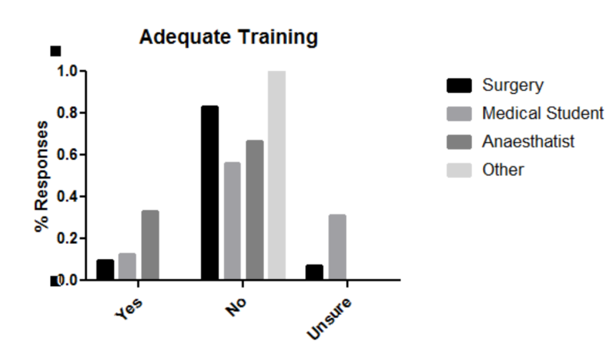

**a)**

Figure 2: a) b) c) d)

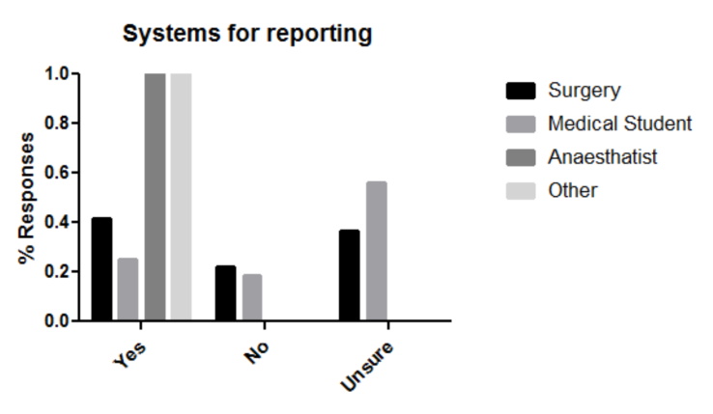

**b)**

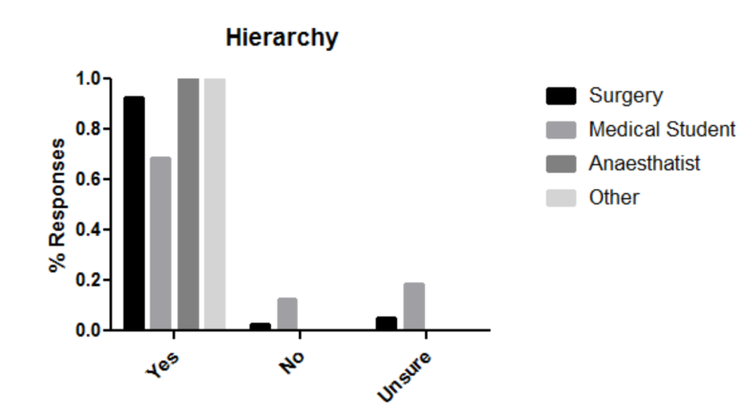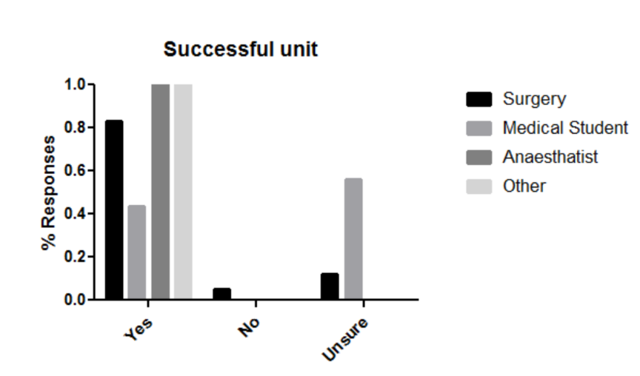

**c)**

**d)**

Figure 2 (A-D) : Staff responses to questions regarding reporting in their hospitals (*n=61, Surgeons: 41, Medical Students: 16, Anaesthetists: 3, Other:1*) The relative underrepresentation of groups other than surgeons must be considered when comparing response groups a) Is there an appropriate system for reporting. Both surgeons and medical students reported low agreement with the statement there were adequate systems for reporting (41% and 21% respectively). b) Is there adequate training within the hospital. The vast majority of surgeons (and small majority of medical students) disagree with the statement adequate training is provided in their hospitals (82% and 57% respectively) c) Is there a hierarchy in your hospital. The overwhelming response to this question suggests the majority of clinicains believe there is a hierarchy present in their hospital d) Does your unit deliver a high quality of patient care? The majority of clinicains believe there is high quality care being delivered, however a larger proportion of medical students were unsure (56%).

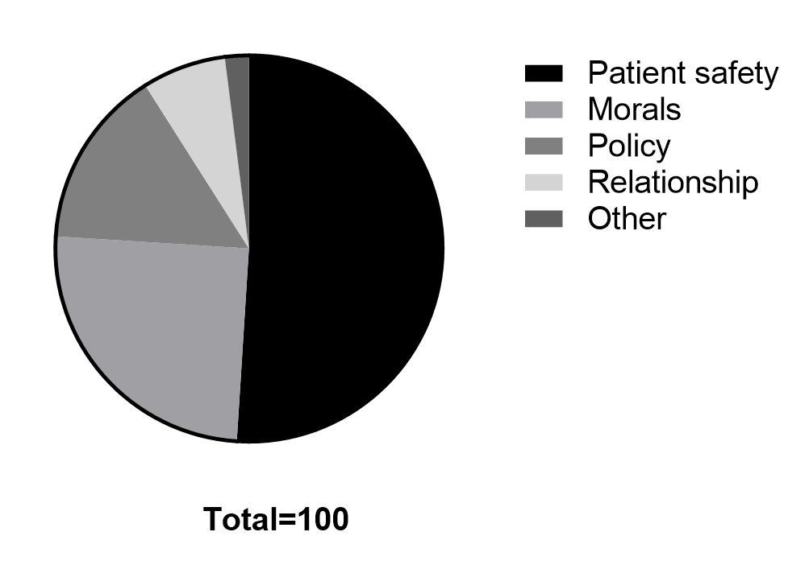

Figure 3: Motivation to report within Edendale hospital, total number of responses (*n=100*), total respondents *n=61*. The majority of responses indicated patient safety as the most important factor in determining whistleblowing, followed by personal morals and policy. Colleague relationships and other factors were less frequently cited as a motivation for reporting.