Blowing the whistle: Perceptions of surgical staff and medical students in a public South African hospital

**Authors and Affiliations:**

1. Mr. Ter-Er Kusu-Orkara; MBCHB, [Hltkusuo@liv.ac.uk](mailto:Hltkusuo@liv.ac.uk)
2. Mr Alexander L Symonds, a MScR,[hlasymon@liv.ac.uk](mailto:hlasymon@liv.ac.uk)
3. Mr Harry C Bickerstaffea, MBChB student, hlhbicke@liv.ac.uk
4. Mrs Nikki Allortob; MBCHB, Mmed, FCS,Nikkiallorto@gmail.com
5. Dr Stuart Oultramc; [Stuart.Oultram@liverpool.ac.uk](mailto:Stuart.Oultram@liverpool.ac.uk)

aSchool of Medicine, University of Liverpool, Liverpool, UK

b MBCHB, Mmed, FCS, Pietermaritzburg Metropolitan department of surgery

cInstitute of Psychology, Health and Society, Liverpool, UK

**Contribution statement:** TKO designed this research study, collected, analyzed the data and was involved in writing the final manuscript. AS and HB where involved in the data analysis and writing of the final manuscript. NA helped collect data and was involved in the final changes. SO approved the final manuscript.

**Corresponding Author:**

Mr Ter-Er Kusu-Orkar

University of Liverpool Medical School

Cedar House, Liverpool

L69 3GE

Hltkusuo@liv.ac.uk

**Funding:** This study received funding from the Institute of Medical Ethics

**Conflict of Interest:** There were no relationships that could have led to a conflict of interest in this study.

**Ethical Approval:** Approval for this study was given by Edendale hospital (South Africa), the Biomedical Research Ethics Committee (BREC) and the University of Liverpool Ethics Committee.

*Word Count* = 2,402 (Excluding abstract, references, tables and figures)

*Abstract Word count* = 148

**Abstract**

Understanding perspectives on whistleblowing is important in tackling resistance to speaking out. This study aimed to elicit the views of medical students and doctors in Edendale Hospital, South Africa using a mixed methods questionnaire study incorporating free text and tick box answers. Thematic analysis and descriptive statistics were used to interpret the results. Fifty-eight doctors and medical student’s responded (87% response-rate) and the majority were surgeons at Edendale hospital. Seventeen percent did not understand the concept of whistleblowing while 42% felt unable to report an adverse event. Motivation for reporting adverse events was overwhelmingly in the interests of patient safety (91%) but reluctance was mainly due to the potential consequences on workplace relationships (24%). The most common innovation suggested was a reporting structure (54%). These observations indicate workplace relationships are an important barrier to whistleblowing; further research should expand on these concerns and explore staff knowledge about whistleblowing.

**Key words:** *Whistleblowing, Questionnaire, Professional Ethics, Developing country, Work place relationships*

**Research Registration Number – KZ 201708 001**

**Introduction**

Whistleblowing is defined as raising a concern about a wrong doing and has gained renewed prominence in the NHS following the publication of the report into Mid-Staffordshire(1, 2). The report exposed instances where silence and lack of due diligence by NHS staff contributed to poor patient care; manifesting as increased morbidity and mortality in hospitals (2).Internationally, whistleblowing can cause more problems than in the NHS as many systems are yet to be implemented by other developing healthcare infrastructures, whether public or private (3). South Africa consists mainly of a public healthcare domain where a Uniform Patient Fee Schedule is used to bill patients (4). The smaller private sector tends to be concentrated in wealthier areas, and although the care here is generally better, it is only accessible to those who can afford it (4). In the NHS, a key focus has been to increase transparency in hospitals and put in place a framework that allows people to feed in concerns they may have regarding other staff(2). This method however, may not help to increase whistle blowing and may be negatively impacting patient care (5)*.* Efforts to prevent whistle blowers from persecution and refine the process have still resulted in poor compliance amongst NHS staff(6). Indeed, the recent publicity of the Dr Bawa-Garba case in the UK has highlighted a constant threat of criminal prosecution for clinical error in a collectivist organization which blames the individual rather than the system. The local implications have been huge, encouraging defensive medicine and reducing the willingness to report. The importance of whistleblowing in a health care system should not be overlooked as it does not only work to stop catastrophic events but also helps to improve working standards and the state of the system as a whole (1,6).

To understand why current policy, protection strategies and frameworks for whistleblowing are still being met with some resistance despite their ability to improve patient care, views of staff within the NHS and developing health care systems should be analysed (5). There is currently research in the nursing and allied health care communitybut little amongst medical students and medical staff (6, 8, and 9). Furthermore, it is helpful to investigate beliefs within another cultural setting, as new issues and/or resolutions may come to light that may positively impact the UK and other health care systems. There is limited research within the last decade that highlights the perceptions of medical personnel in developing countries; this study aims elicit these in a South African hospital and add to the current evidence base.

**Methods**

**Research approach**

A literature search was conducted to identify validated and standardized “Whistle Blowing” Questionnaires that could be used in our study was undertaken using PUBMED, SCOPUS and DISCOVER (**Figure 1**). No appropriate questionnaires were found. A questionnaire was therefore developed using a variety of papers to be applicable internationally in gaining perspectives on whistleblowing (See **Table 1**) (1, 2). Ethical approvals for the study were granted by Edendale hospital, the BREC ethics committee and the University of Liverpool Ethics Committee. The study was conducted in line with the principles of the declaration of

Helsinki.

|  |  |
| --- | --- |
| **Avoided in Questionnaire** | **Reason** |
| **“What would you do” questions** | This allows participants to describe their self-expectations rather than what they would actually do. |
| **Reporting suspected wrong doing** | We wanted to gain responses from those who had observed wrong doing |
| **Multiple questions at the same time** | To increase coherence and speed of questionnaire |

**Table 1:** Evidence based questionnaire development (9, 10)

Initial search (N=47)

Terms (All with 10 year filter:

Whistleblowing AND Healthcare

Whistleblowing AND Questionnaire

Whistle blow AND Developing country

After Abstracts Screened (N= 5)

Excluded due to:

Did not include medical professionals

Final number of papers (N=2)

Full text screen :

Exluded 3 papers - No Questionnaire data

**Figure 1** *–* Process to find papers/questionnaires that would inform our questionnaire: PubMed example

**The Questionnaire**

A pilot questionnaire was used to develop the final questionnaire, consisting of 15 questions with check box and free text answers. A pilot study highlighted the short and quick nature of our questionnaire. The questionnaire was distributed to clinicians and medical students amongst Edendale Hospital. Non-medical staff and those who could not understand English were not included in the study.

Non-probability sampling was used and a stratified population was drawn; this was disproportionate because a convenience sample method was drawn. Our aim was to reach as many clinicians as possible within the Edendale Hospital. The majority of participants were from the surgical department. Issues with access and resistance to implementation in different areas of the hospital limited distribution. Surveys were distributed mainly at staff meetings. Forms that were not returned or incorrectly completed were counted as non-respondents. Fifty eight responses were collected between 24/08/2017 and 31/08/17.

**Data analysis**

Results were analysed using Graph Pad Prism using descriptive statistics; free text answers were evaluated using a thematic analysis (TK-O, AS). The thematic analysis was performed by giving the different free text answers codes that corresponded to certain themes and then adding up how often those themes were represented in the data. A second author, blinded to the first analysis, repeated this process in order to validate the thematic analysis. Both authors reached similar conclusions in their analysis and the outcomes were finalized after any disagreements were resolved by a more senior statistician.

**Results**

The Response rate was 87% (58/67), from the approached Surgeons and medical students on their surgical rotation at Edendale hospital. **Table 2** illustrates the demographic profile of these respondents.

|  |  |  |  |
| --- | --- | --- | --- |
|  | Number | Proportion of study demographic (%) | Proportion of participants sampled in their respective specialties (%) |
| Male: Female | 27*:30 47:53 | |  |
| Mean Age | 26 — | |  |
| **Role/Unit** |  | |  |
| Surgeon | 40 69 | | 95 |
| Anaesthetist | 3 5 | | 15** |
| Student on Surgical Rotation | 14 24 | | 58 |
| Internal Medicine | 1 2 | | - ** |

**Table 2**: Participant demographics including gender, age, and specialty in Edendale hospital. Total number of respondents *(n =58*). *one respondent did not mark a gender) **data on surgical department only

**Whistleblowing knowledge**

Of responses collected (*n=58*) the majority believed whistleblowing would benefit their institution (77%). In addition, 12% thought it was not in their institutions best interests and 11% were unsure. Although the majority of respondents understood the term whistleblowing (83%) a significant minority did not; 10% were unsure and 7% did not know.

**About your unit**

Participants where asked if there were clear systems for reporting adverse events and/or problems, 43% said yes, 38% unsure and 18% said no. 79% of respondents reported no training in how to use these systems, whether they did or did not exist. 91% responded yes to there being a clear hierarchy in their unit, 74% agreed their unit delivers a high standard of care, only 3% of participants said they did not (**Figure 2A-D**).

**Reporting adverse events**

Clinicians where asked how able they felt to report an event in their unit, 55% felt they were able to report an adverse event, 20% said they could not and 22% were unsure; 3% of participants did not respond. Of 58 participants 91% said patient safety motivated them to whistleblow; this was followed by morality (34%) and hospital policy (26%). Although not explicitly mentioned in the questionnaire, participants were able to select more than one motivation for reporting and the most frequent number selected was a single response (39%). Therefore, of the 100 responses, the most common indications to report were patient safety (51%) followed by morality (25%) (**Figure 3**). Participants were also asked if they had ever been reluctant to report an event, 64% said they had never been reluctant and 33% responded admitted some hesitancy to whistleblowing. Of the 33% that had been reluctant in the past, 15 responded (79%) as to why this was the case. Hierarchy was cited by 33%, racism or negative targeting by colleagues and employers in 27% and other responses concerned work conditions, relationships and process.

Participants were asked if it “is hard to acknowledge personal mistakes because of the consequences”, 33% agreed or strongly agreed. What situations, if any, they had been reluctant to report “an adverse event and/or concern about a colleague” were explored in free text answers (**Table 3,** *n=50*). Further to this, participants were asked, what they believed the most effective way to increase the reporting of adverse events and/or concerns was (**Table 3**, *n=50*).

|  |  |  |  |
| --- | --- | --- | --- |
| Reason to not take action | Frequency /50  (%) | Way to improve reporting | Frequency /50 (%) |
| Interpersonal relationship | 12 (24%) | **Reporting structure** | 27 (54%) |
| No System | 10 (20%) | **Confidentiality** | 9 (17%) |
| Hierarchy | 8 (16%) | **Consequences** | 6 (12%) |
| Prejudice/victimisation | 4 (8%) | **Openness/Transparency** | 5 (9%) |
| Don’t know | 4 (8%) | **Patient focused** | 2 (4%) |
| Nothing | 7 (14%) | **Informal procedures** | 2 (4%) |
| Fear of harm | 3 (6%) |  |  |
| Effort involved | 1 (2%) |
| No negative outcome | 1 (2%) |

**Table 3**: Free text responses on adverse events and/or concerns about a colleague (*n=50*)

**Discussion**

There is currently limited data on whistleblowing amongst doctors and medical students in the UK and developing countries. This study conducted in Edendale Hospital, Pietermaritzburg, South Africa sought to add to a lacking evidence base within this field of professional ethics. The main cohort in this study were surgical staff, nevertheless, advances in whistleblowing can be extrapolated to other healthcare professionals and other medical specialties because of similarities in clinical environment and consequences of blowing the whistle (11).Current literature on whistleblowing in healthcare settings highlights the potential short comings of reporting systems that hinder the progress of reporting wrong doing. Consequences of whistle blowing such as character abuse, legal and financial penalties, and job security highlight how crucial it is to protect whistle blowers(11). Our research supports this evidence, in free-text responses 54% (relationships, hierarchy, fear of harm and prejudice) of participants said interpersonal factors hinder them from reporting, 14% of participants specifically said this was due to dangers involved. Furthermore, 33% of people agree or strongly agreed that they failed to “acknowledge their personal mistakes because of the consequences”. This highlights a significant proportion of medical personnel that are potentially jeopardizing patient safety because of legitimate concerns10.In comparison to US and European studies, Finland has shown extremely high rates of appropriate whistle blowing due to the positive response (73%) that reports are met with (12).

This is in clear contrast to India, for example, where there is limited formal support for whistleblowers (13). A significant minority (43%) of respondents said there was a clear reporting structure in their unit but 53% highlighted a need for a reporting structure at Edendale. The discrepancy between responses emphasized the ambiguity and lack of adequate reporting system in Edendale. It would have been useful to further question the 43% who said there was a system and the 21% who said they had received training in this system, as there was no official system in existence at Edendale. There may have been some misunderstanding in answering the question or some genuine belief of a system, but this cannot be concluded.

Interestingly, our study highlights the leading factors contributing in failure to report events are personal and professional relationships. Patient safety being the leading factor for 91% of respondents to report a concern was challenged by interpersonal relationships in 24% of participants and seniority or hierarchy in 16% of participants; furthermore, of those that were reluctant to report an event in the past, 33% revealed that this was also due to hierarchy in their department. However, this is within the context of a relatively young population sample (median 26). This may disproportionately represent those who perceive hierarchy to be a barrier in reporting. Our research supports previous evidence describing medical professionals fearing their superiors; which has been shown to be detrimental to patient care and making change (14, 15). There are two main interventions that could address this issue. Firstly, staff should be educated on whistleblowing policies within their unit/hospital and further primed on how they can formally raise a concern. The removal of barriers to reporting is also key; introducing Schwartz rounds to minimize hierarchal attitudes, improvement of IT systems and appointment of a dedicated hospital guardian are methods that can simplify whistle blowing.

Not previously highlighted in recent questionnaire-based studies, was the term whistle blowing itself and its meaning. This study highlighted a significant number of participants (7%) who did not know what whistle blowing meant. This was in conjunction with a further 10% of people who were unsure of its meaning. If improving patient care via whistle blowing is to be attained, a target rate of 100% should be achieved amongst hospital employees in understanding exactly what whistleblowing means. This also means that some staff may actually blow the whistle, without knowing they are (10).Attempts to use another word with less negative connotations have failed due to their ambiguity (10).In this study questionnaire, whistleblowing was defined as “raising a concern in the workplace with regards to something you believe is wrong or inaccurate practice”, which must be borne in mind before generalizing results to other definitions of whistleblowing.

**Limitations and strengths**

The closed questions in the survey were yes/no/unsure answers which limited the amount of individual viewpoints that could be collected, however, this allowed for rapid responses. A consistent agree to disagree scale would have allowed for more descriptive feedback. Furthermore, it was not explicitly stated that multiple options could be selected for some questions; this may explain why most respondents only selected one. Change in the phrasing of whistleblowing between questions i.e “adverse events and/or concerns” and “personal mistakes” may have caused variation in replies, however each phrase is consistent with aspects of whistleblowing described in the information sheet.

The high response rate and percentage of the surgical department (95%) captured in this study allows our results to adequately represent this department in Edendale. The high number of participants in Edendale, a large government hospital, also allows our research to be more translatable to surgical departments in similar rural hospitals in South Africa. Nevertheless, the sample is unrepresentative of all hospital staff and the generalizability of the results should be cautiously interpreted. In addition, the median age of respondents was 26, thus most participants were relatively junior; and although this sample adequately represented staff in the surgical department, it would have been useful to record their seniority.

**Future implications**

This study can be a stepping stone to further investigation of whistleblowing internationally. Further investigation into whether education, reporting structures and protection of staff is needed to improve whistleblowing in recently developed and developing countries is needed. Making whistle blowing an unambiguous and clearly stated duty might help alleviate barriers to reporting. In addition to this, the impact that relationships between medical personnel within the work place have on patient safety should be further analyzed and addressed. With a particular focus on developing nations hospitals in the context of previous studies. Our research based questionnaire may also be used to inform future questionnaires and develop a standard whistleblowing questionnaire, of which there is currently none.

**Conclusion**

Our research highlights consequences of whistleblowing, relationships within the health care setting and understanding of the term whistleblowing as barriers to medical professionals and medical students raising concerns about their colleagues in hospital. As clinicians, patient safety is our utmost priority, however a lack of reporting systems and training contribute to reluctant whistleblowing. Further work should be done to elicit the views of a wider range of staff in developing and developed countries to advance the current evidence on barriers to whistleblowing and provide routes for intervention and improvement of reporting.

**Acknowledgements:**

We would like to thank all the participants of this study for taking part. Furthermore, we would like to extend our gratitude to the Institute of Medical Ethics for helping sponsor the travel that made this research possible.

**References**

1. Bolsin S, Pal R, Wilmshurst P, Pena M. Whistleblowing and patient safety: the patient’s or the profession’s interests at stake? *Journal of the Royal Society of Medicine*. 2011;104(7):278-282.
2. Francis, R. Mid Staffordshire NHS foundation trust public inquiry, *Nursing Standard*, 2010;25(7):1––30.
3. Martin, P. The Status of Whistleblowing in South Africa: Taking stock. *Open Democracy Advice Centre* 2010; pp. 34–80.
4. Makombo, T. Fast Facts: Public health sector in need of an antidote. Fast Facts. 2016; 6(298):6
5. Kaptein, M. From inaction to external Whistleblowing: The influence of the ethical culture of organizations on employee responses to observed wrongdoing, *Journal of Business Ethics*, 2010;98(3):513–530.
6. Francis, R. Freedom to Speak up: a review of whistle blowing in the NHS, *National Archives*, 2015;1—226. <http://webarchive.nationalarchives.gov.uk/20150218150953/https://freedomtospeakup.org.uk/wp-content/uploads/2014/07/F2SU_web.pdf> (Accessed July 2017)
7. Evans, L. ‘Why there are businesses benefiting from whistleblowers’, Wales online. 2014; <http://www.walesonline.co.uk/business/business-opinion/business-benefits-encouraging-whistleblowers-6925451> (Accessed July 2017)
8. Mansbach A, Ziedenberg H, Bachner YG. Nursing students' willingness to blow the whistle. *Nurse Education Today*. 2013;33(1):69-72.
9. Mansbach A, Melzer I, Bachner YG. Blowing the whistle to protect a patient: a comparison between physiotherapy students and physiotherapists, *Physiotherapy*. 2012 Dec;98(4):307-12.
10. Hodges LE, Tak HJ, Curlin FA, Yoon JD. Whistle-blowing in Medical School: A National Survey on Peer Accountability and Professional Misconduct in Medical Students. *Academic Psychiatry*. 2016;40(3):530-3.
11. Lim CR, Zhang M, Hussain SF, Ho, Roger C.M. The Consequences of Whistle-blowing: An Integrative Review. *Journal of Patient Safety*. 2017;1-6
12. [Pohjanoksa J](https://www.ncbi.nlm.nih.gov/pubmed/?term=Pohjanoksa%20J%5BAuthor%5D&cauthor=true&cauthor_uid=28494645), [Stolt M](https://www.ncbi.nlm.nih.gov/pubmed/?term=Stolt%20M%5BAuthor%5D&cauthor=true&cauthor_uid=28494645), [Leino-Kilpi H](https://www.ncbi.nlm.nih.gov/pubmed/?term=Leino-Kilpi%20H%5BAuthor%5D&cauthor=true&cauthor_uid=28494645), [Suhonen R](https://www.ncbi.nlm.nih.gov/pubmed/?term=Suhonen%20R%5BAuthor%5D&cauthor=true&cauthor_uid=28494645), [Löyttyniemi E](https://www.ncbi.nlm.nih.gov/pubmed/?term=L%C3%B6yttyniemi%20E%5BAuthor%5D&cauthor=true&cauthor_uid=28494645). Whistle-blowing process in healthcare: From suspicion to action. *Nursing Ethics*. 2017; 1-15
13. Chatterjee P. Whistleblowing in India: what protections can doctors who raise concerns expect? *British Medical Journal Publishing Group*; 2015;350:h763.
14. Mansbach A, Kushnir T, Ziedenberg H, Bachner YG. Reporting Misconduct of a Coworker to Protect a Patient: A Comparison between Experienced Nurses and Nursing Students. *The Scientific World Journal*. 2014;413926.
15. Brown, A J, David Lewis, Richard E. Moberly, and Wim Vandekerckhove. Blowing the whistle and Power *International Handbook on Whistleblowing Research*. 2014; pp 154-176

**Figures**

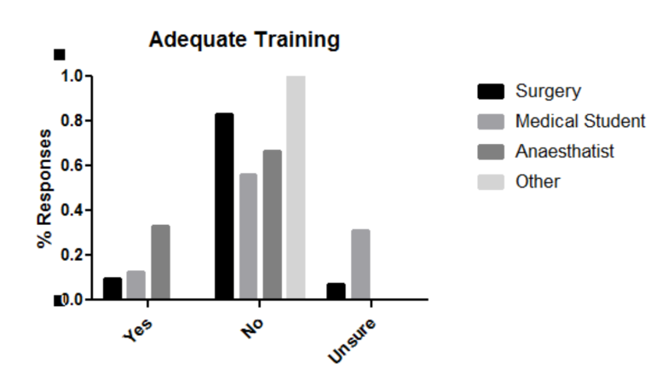

**a)**

Figure 2: a) b) c) d)

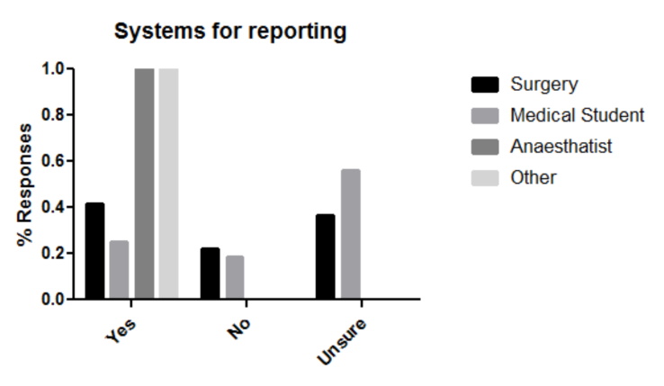

**b)**

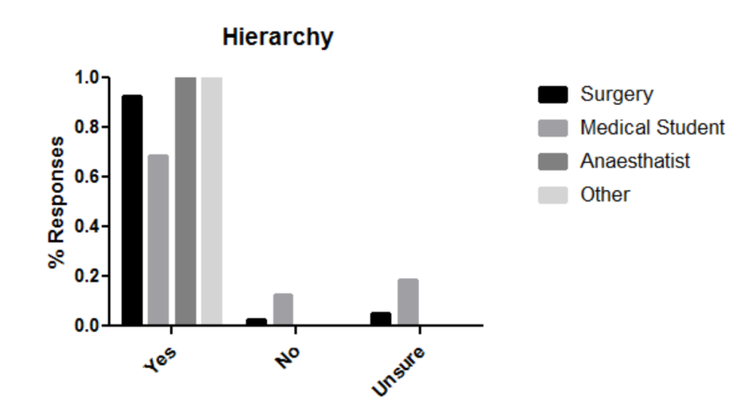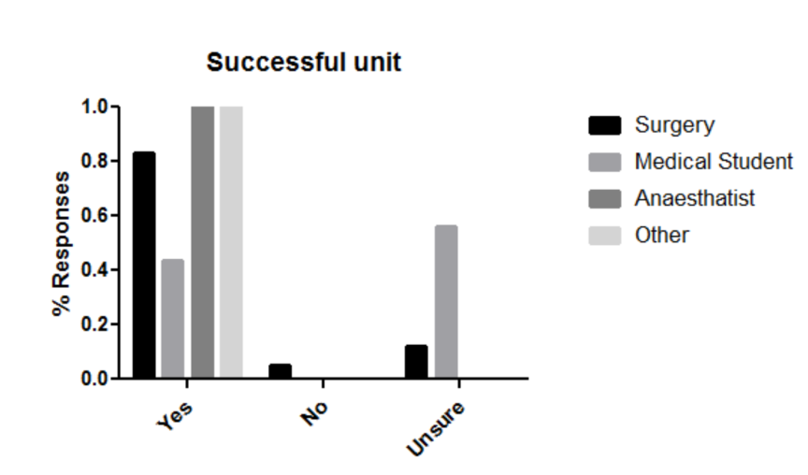

**c)**

**d)**

Figure 2 (A-D) : Staff responses to questions regarding reporting in their hospitals (*n=61, Surgeons: 41, Medical Students: 16, Anaesthetists: 3, Other:1*) The relative underrepresentation of groups other than surgeons must be considered when comparing response groups a) Is there an appropriate system for reporting. Both surgeons and medical students reported low agreement with the statement there were adequate systems for reporting (41% and 21% respectively). b) Is there adequate training within the hospital. The vast majority of surgeons (and small majority of medical students) disagree with the statement adequate training is provided in their hospitals (82% and 57% respectively) c) Is there a hierarchy in your hospital. The overwhelming response to this question suggests the majority of clinicains believe there is a hierarchy present in their hospital d) Does your unit deliver a high quality of patient care? The majority of clinicains believe there is high quality care being delivered, however a larger proportion of medical students were unsure (56%).

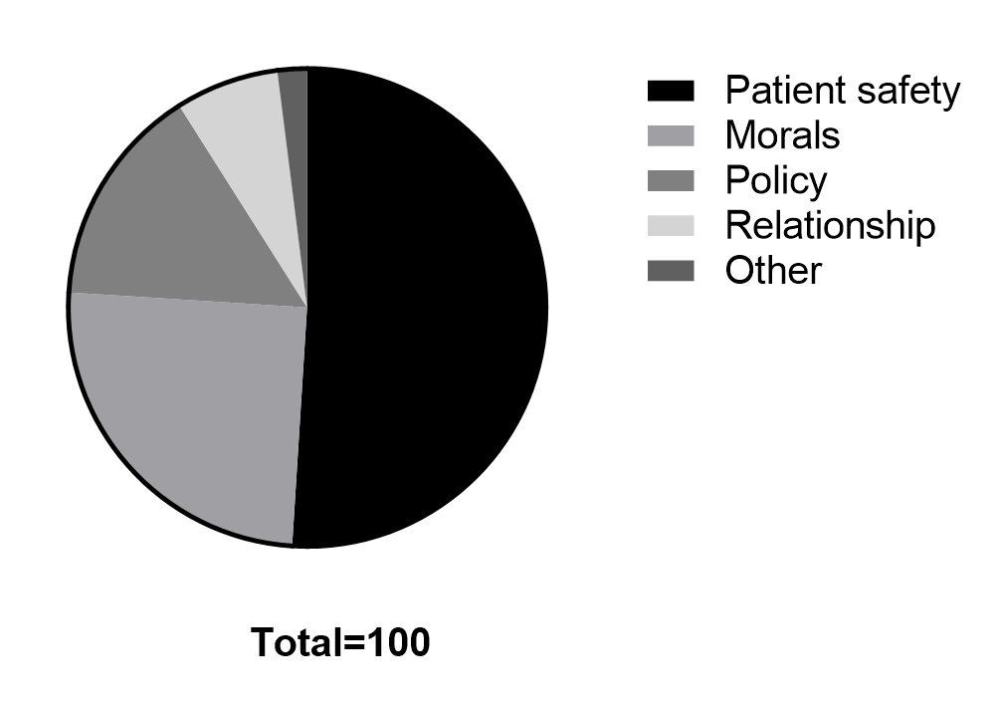

Figure 3: Motivation to report within Edendale hospital, total number of responses (*n=100*), total respondents *n=61*. The majority of responses indicated patient safety as the most important factor in determining whistleblowing, followed by personal morals and policy. Colleague relationships and other factors were less frequently cited as a motivation for reporting.