**MARIE CURIE and MAHATMA GANDHI**

(The life and legacy of the inspirational icons)

***Abstract***

*Marie Curie (1867-1934) as a nuclear scientist and Mohandas Karamchand Gandhi (1869-1947) as a political saint, gave the richest legacy for the well-being of global humanity. A comprehensive and comparative study of the Nobel laureate and noble personality of 19th-20thcentury is presented for the creative minds of youth and for teaching faculty of science and humanities.*

*“Radioactivity” means emission of ionizing radiation or particles caused by the spontaneous disintegration (decaying) of atomic nuclei, of unstable elements was invented by Curie in 1898 “Satyagraha” a complex structure of ideas and activities, a matchless or priceless weapon was coined by Mahatma Gandhi in 1908. It means spontaneous release of truth force from a stable individual while experimenting on himself for self-actualization by self-suffering and self-sacrifice with integrity of thought, word and deed*

*Though the science of Radioactivity and the art of Satyagraha are distinct, they are mutually compatible, globally valuable in serving the humanity scientifically and spiritually. Both Curie and Gandhi had a creative genius mind. Both faced discrimination and humiliation. Both did not lose courage in the darkest hours of life. Both belong to the future of humanity and hence their bio profile need to be reinterpreted and rephrased for an easy understanding by students of science and humanities to serve the humanity globally*

Marie Curie (1867-1934) as a nuclear scientist and Mohandas Karamchand Gandhi (1869-1947) as a political saint, gave the richest legacy for the well-being of global humanity (Figs 1 and 2).

Marie Curie initially known as Maria Sklodowska was born in Warsaw, of Poland, on 7th November 1867. Mohandas Karamchand Gandhi was born on 2nd October 1869, in a princely state of Porbandar Gujarat, India. Both are multidimensional personalities with a wide spectrum of activities. Marie’s experiments with truth were evidence based and Gandhi’s experiments with truth were faith based. A comprehensive and comparative study of the Nobel laureate and noble personality of 19th-20thcentury is presented for the creative minds of youth and for teaching faculty of science and humanities.

“Radioactivity” means emission of ionizing radiation or particles caused by the spontaneous disintegration (decaying) of atomic nuclei, of unstable elements was invented by Curie in 1898 while studying the Becquerel’s discovery of mysterious radiation from uranium. Radiation is emitted in the form of alpha, beta particles and gamma ray with variable penetration effects (Figs 3 and 5). Curie labeled this property of nuclear phenomenon as Radioactivity. Curie along with her husband Pierre discovered and extracted two new elements polonium and radium and announced the results in 1898. This led to the foundation of Nuclear Medicine, a diagnostic and therapeutic medical specialty for cancer patients over and above the award of Nobel Prize for

physics in 1903 and chemistry in 1911.

“Satyagraha” a complex structure of ideas and activities, a matchless or priceless weapon was coined by Mahatma Gandhi in 1908. It means spontaneous release of truth force from a stable individual while experimenting on himself for self-actualization by self-suffering and self-sacrifice with integrity of thought, word and deed. Gandhi analyzed his experiences in the nonviolence effects of Satyagraha while protesting against injustice and socioeconomic evils in the society. He worked hard till his last breath to bring sanctity and perfection to his doctrine of Satyagraha. The practice of this moral law led to the strong nonviolence mass moment at home and internationally to fight against barbarian force of unjust state and evils of the society. Satyagraha is a natural law of self-purification a great movement for peace and progress of all (Figs 4 and 6).

There are fundamental similarities and differences in their goals and methods. As a nuclear scientist Curie focused her observation on the nucleus of matter. Her most important work took place not in the laboratory, but on the front lines of battlefield during World War 1 (1914-1918). Her sterling qualities of leadership, as a non-medical radiologist in the war field, taking mobile X-rays to millions of wounded soldiers. Her radium during this period was hiding in a safe deposit box at a local bank. She directed her scientific skills towards the war effort not to make weapons, but to save lives.

Mahatma Gandhi focused his observations on the inner nature of human being. The truth (a divine particle) as a goal and Nonviolence as a means to postulate the doctrine of Satyagraha. The greatness of Gandhi is more in his holy life style than in his heroic struggle. He had supreme understanding of people’s psychology in leading the mass moments nonviolently against colonial exploitation and social evils. He contributed to the wide spectrum of human activities in social, political, economic, philosophical, rural and religious reforms, redefining moral and spiritual values as byproducts of internalized radioactivity, Satyagraha (Fig 7).

Though the science of Radioactivity and the art of Satyagraha are distinct, they are mutually compatible, globally valuable in serving the humanity scientifically and spiritually.

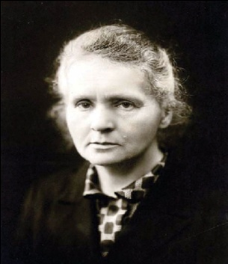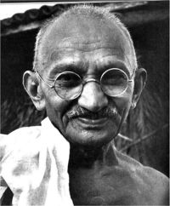Curie is agnostic and Gandhi is strong believer in truth, yet they share some common values for higher learning 1. curiosity and creativity, 2. Imagination and keen observation, 3. Courage and optimistic risk taking, 4. Patience and perseverance, 5. Self-suffering and Sacrifice, 6. Leadership, 7. Moral integrity and patriotism, 8. Diligence and versatility and 9. Publications.

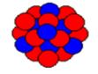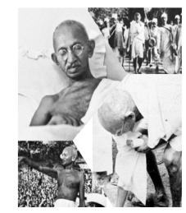Fig 1: Nobel laureate-Marie curie Fig 2: Mahatma Gandhi

Fig 3: Uranium Fig 4: Gandhi as satyagrahi

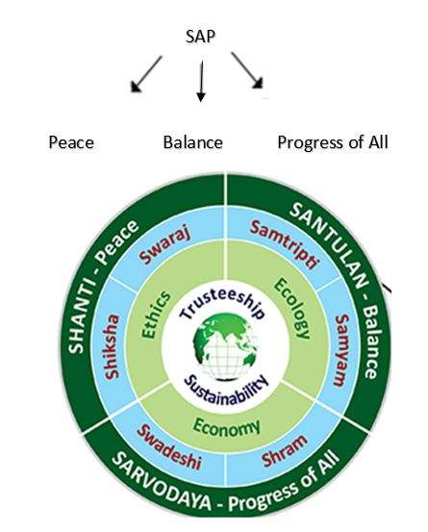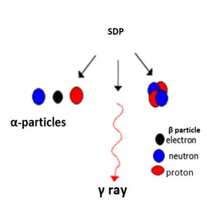

Fig 5: Spontaneous decay process (SDP) Fig 6: Self-actualization process (SAP)

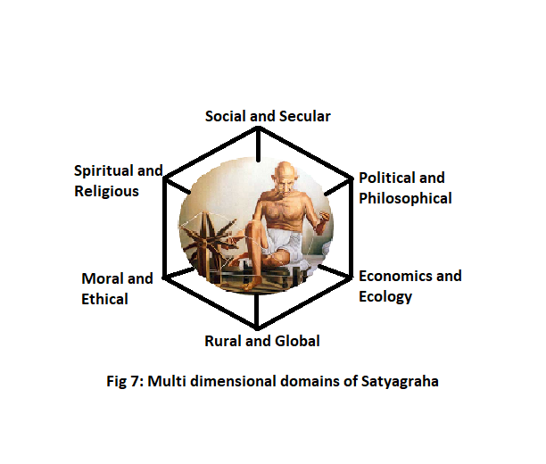

*Curie and Gandhi have a similar environment in early life (Table1), in career experiences (Table2),* leadership (Table3), awards and achievements (Table4), tributes and legacy (Table5), patriotism and humiliations (Table6). A comprehensive and comparative study of their bio profiles will be useful to refresh our memories of these ideal icons.

**Table 1: Comparison of Early life**

|  |  |  |
| --- | --- | --- |
|  | **Marie Curie**  **07 NOV 1867 - 04 JULY 1934(67years)** | **M K Gandhi**  **02 OCT 1869 - 30 JAN 1948 (79years)** |
| As a child | Youngest of 5 daughters. | Youngest of 4 children (3 sons and 1 daughter). |
|  | Teacher’s family. | Hindu Baniya family (merchant class). |
|  | Poor family. | Middle class family. |
|  | Inspired by father to study science and mathematics. | Influenced by mother towards truthful and holy living. |
| As a student | i) Brilliant and active student.  ii) Interested in games and gymnastics (gold medal). | i) Mediocre, shy, tongue tied not involved in games or gymnastics.  ii) Considered books as his companions. |
| Marriage | At the age of 28 years with Pierre Curie. | At the age 13years with Kasturba. |
| Parent hood | Twodaughters when she was 31years. | Four sons when he was 31years. |
| Celibacy | Not applicable. | Takes the vow of celibacy (brahmacharya) for life at the age of 37years. |
| Loss of spouse | When she was 39 years. | When he was 69 years. |
| Belief /prayer | Religious as a child but later became agnostic. | Deeply religious from child hood to his last breath, for him prayer was the only real activity in life. |
| Self-starvation/fasting | Self-starvation due to precariously shortage of money. | Fasting for moral strength and purification as a final tool of Satyagraha. |
| Quest | For scientific knowledge. | For absolute truth and Non-violence. |

**Table 2: Comparison of Career Experiences**

|  |  |  |
| --- | --- | --- |
| Category | Marie Curie | M K Gandhi |
| Education | As a student of Physics in Paris at an age of 24 years. | As a student of law at an age of 19 years. |
| Supported by | Elder sister Bronislawa. | Elder brother Laxmidas. |
| Institute | School of physics and chemistry University of Paris. | Inner temple London. |
| Degree | Earned her degree in physics (June 1893), degree in mathematics (July 1894).  DSc from university of Paris. | Barrister degree at 22 years of age (June 1891). |
| Influences | Passion for science and research. | Books and contacts with elite people in Vegetarian club and Theosophical society. |
| Early job/practice | Unable to get a job in Poland, her native land, moves to Paris and got  Married to Pierre Curie; to have an extraordinary partnership in scientific work. | Unable to practice law in India leaves for south Africa on one year contract as a legal consultant to Dada Abdullah’s shipping business. |
| Experiments on salt | In science with salts of uranium, thorium and application of radioactivity in diagnosis and treatment of cancer. | Gandhi’s salt satyagraha, the 24-days march from 12 March 1930 to 6 April 1930. Started this march with 78 of his trusted volunteers.  The march was over 240 miles. They walked for 24 days 10 miles a day. |
| Discovery | Radioactivity.  Polonium and Radium. | Satyagraha –as a force of Truth and Nonviolence. |
| Creative tools | Mobile X-ray units (little Curie’s) in World War I and radium needles for cancer treatment. | Spinning wheel (charkha) to promote national unity (Swaraj and swadeshi). |

**Table 3:Comparison of Leadership, Conferences and Public speeches:**

|  |  |  |
| --- | --- | --- |
| Quality | Marie Curie | M K Gandhi |
| Leadership | (i) In the research of scientific and human experiences of Radioactivity in Nuclear Medicine.  (ii) World War I (1914-1919), as a non-medical radiologist in the war with 200 mobile X-ray units. | (i) In South Africa (1906 – 1914), starts Natal Indian Congress to fight against the unjuststate laws on racial prejudices, Indian Franchise act, on Indian Trade rights, Anti Asiatic legislation of Transvaal.  (ii) Champaran satyagraha (1917), Kheda satyagraha (1918), Khilafat and noncooperation movement post World War I, civil disobedience movement, salt satyagraha (Dandi March (1930)), Quit India (1942) post World War II, freedom and partition of India, Hindu Muslim unity and social evils. |
| Conferences | Fifth Solvay International Conference on (1927), 17 of the 29 attendees were Nobel Prize winners. | (i) 2nd Round table conference in London(1931).  (ii) Had personal conference with every viceroy during his years of public life in India. |
| Public speeches | (i) Rarely uttered public comment except at a conference in 1933, in the future of culture, science dehumanization of modern life.  (ii) She defended science and scientist and said scientist is a child placed before a natural phenomenon which impresses him like a fairy tale. | (i) Many public speeches by a person who was tongue tied in student period.  (ii) Wished his thoughts to be audible publicly, words and actions are open in public life transparently though nothing personal. |
| Institutions/Ashrams | She founded the Curie Institutes in Paris and in Warsaw, which remain major centers of medical research in cancer, around the world. | in South Africa-Phoenix settlement in 100 acres.2.Tolstoy firm in 1100 acres. In India—1.Sabarmathi ashram in 36 acres 2.Sevagram in 300 acres at Wardh .They were laboratories for his experiments in Truth and Non-violence |

**Table 4: Comparison of Awards and Achievements**

|  |  |  |
| --- | --- | --- |
| Quality | Marie Curie | M K Gandhi |
| Known as | The most inspirational woman in science. | The Father of the Nation (India).  Oct 2nd is declared as a National holiday. |
| United Nation Organization declares | International year of chemistry 2011. | Oct 2nd International day of Non-violence. |
| Nobel prizes | Physics 1903,  Chemistry 1911. | Nobel prize for peace was given to Martin Luther King in USA, Nelson Mandela in South Africa inspired by Gandhian Nonviolent movements. |
| Status of recognition | In periodic table, Curium, element with atomic number 96. | In the hearts of global citizens and their imaginations. |
| Achievements | The First woman to win Nobel prize;first person and the only woman to win Nobel prize twice; the only person to win Nobel prize in two different sciences. | (i) Civil rights activist in South Africa (1893-1914)  (ii) Struggle for Indian Independence (1915- 1947). |
| Funds raising tour | Twice to USA to procure funds for cancer research institute with radium. | All over India for the support of satyagraha movement. |

**Table 5:Comparison of Tributes, Legacy andBiography**

|  |  |  |
| --- | --- | --- |
| Category | Marie Curie | M K Gandhi |
| Museums | In Warsaw, her birth town in Poland and Laboratory in France. | Gujarat, Mumbai, Patna, Madurai, Pune and many Indian cities; International: Durban (South Africa). |
| Temples | Curie was buried twice. On 6th July 1934 she was interred in cemetery at Sceaux.  Over 60 years later, her remains were re-interred in France’s national Mausoleum, the Pantheon in Paris. | Many temples in India, with religious rituals. |
| Auto Biography  Biography | ----  Many  Curie’s younger daughter, Irene gives a copy of her mother’s biography written by her to Gandhi personally during her visit to India. | My experiments with Truth by M.K.Gandhi.  Many |
| Films | The courage of Knowledge (2016). | The film Gandhi (1982)won eight Oscar awards in 11 categories. |
| As arefugee/prisoner | Curie and her daughters had to take refuge in the home of a friend in Paris, due to the Langevin Affair a major scandal of Genocide, after receiving 2nd Noble prize. | Many times.  Jails were his laboratories. |

**Table 6: Comparison of Patriotism and Humiliations**

|  |  |  |
| --- | --- | --- |
| Category | Marie Curie | M K Gandhi |
| Patriotism | Never lost her love for Poland, taught her daughters Polish; Named the new element(Z=84) Polonium;  Founded cancer institute in Warsaw, equally loved and served the adopted Nation France. | Gandhisays, “My patriotism embraces all life broadest and widest good to the largest humanity to promote universal brotherhood”. |
| Humiliations | Gender biased:  (i) Membership of academy in sciences was denied in spite of 2 Nobel prizes.  (ii) Not allowed to give speech in Royal institute London on Radioactivity. | Many:  (i) Based on racial, political, caste and communal,intellectual and political differences.  (ii) Out caste for going to London.  (iii) Thrown out of a train in Pietermaritzburg.  (iv) Called as Naked Fakir by Churchill British Prime Minister. |
| Demise by professional hazard | Aplastic anemia due to radiation exposure. | Assassinated by a Hindu activist (Nathuram Godse). |
| Albert Einstein’s statement | Madam Curie is, of all celebrated beings the only one whom fame has not corrupted (Curie did not patent her discovery and benefited little from this profitable business). | Generations to come will scarce believe that such a one as this ever in flesh and blood walked upon this earth. |

**Conclusion:**

Both Curie and Gandhi had a creative genius mind. They acquired knowledge through observation, experiments and activity with dedication and strong will power. Both had no greed for materialistic gains beyond basic needs. Both faced discrimination and humiliation. Both did not lose courage in the darkest hours of life. Both belong to the future of humanity and hence their bio profile need to be reinterpreted and rephrased for an easy understanding by students of science and humanities to serve the humanity globally