Introduction of Problem Based Learning In Physiotherapy Students

Meshram Virendra K

**Abstract**

**Title:** Introduction of Problem Based Learning In Physiotherapy Students

**Background:** In Indian scenario, dependency of students on the private tuition classes till higher secondary education is more prevalent, which in turns, transform them into passive learner. As an academician, rather than passive, the stimulation of active learning is warranted. This should be complemented by alternative forms of teaching and learning, such as e-learning, self-directed learning, problem-based learning (PBL) and collaborative projects. Owing to the physiotherapy curriculum design which is mostly based on the didactic & laboratory lectures, there is limited scope for active participation and interaction with students for the teachers. Hence, this study was aimed to introduce PBL approach to upgrade them to active learners.

**Methods:** 20 physiotherapy undergraduate students enrolled in third year were included in this study. These students were randomly divided into two groups A and B, with 10 in each group, based on their college roll numbers. Group A was allotted with 1 PBL scenario for clinical test and time was given for gathering information from the resources available for them via library books, internet, seniors, or peer group and they were instructed not to discuss the scenario with group A. After a set time students along with the facilitator had a discussion on scenario. The Group B students were having the didactic lecture on the same topic with other teacher in another classroom. Once the groups undergone through PBL and didactic lecture sessions a surprise theory test was carried out after 2 days to assess student’s understanding level of the clinical test in the form of structured SAQs, and their pre-post test scores was compared.

**Results:** Paired t-test exhibited significant improvement in pre-post SAQ scores for both PBL (4+0.81, 7.7+1.25) and Didactic group (4.4+0.84, 5.6+1.07) at p< 0.05. However, PBL Group (3.7+ 1.16) performed better with SAQ Scores than Didactic Group (1.2+1.13) at p<0.05, on unpaired t-test.

**Conclusion:** Problem-based learning approach transforms the students into active learners, and plays a vital role in preparing graduates to cope with future demands of the profession.

**Keywords:** Problem Based Learning, Structured Answer Questions, Teaching and Learning

Address for correspondence

Dr. Virendra K. Meshram

Asso. Professor

Dept. of Cardiovascular and Respiratory Physiotherapy

LSFPEF College of Physiotherapy

Nigdi, Pune 44 (Maharashtra, India)

Email: drvirubpth@gmail.com

**Introduction :**

The practice of Physiotherapy is evolving in a rapidly changing healthcare environment. An ever-expanding body of knowledge, an increasing well informed population, changing roles of many healthcare professionals and a demand for accountability all present challenges in relation to delivering any healthcare program. Physiotherapy education programs can no longer attempt to teach students everything they need to know1. Consequently, programs need to reflect this in their approach to teaching and adopt a more student-centered learning, which focus on students knowing how to learn rather than knowing everything there is to learn2. Physiotherapy graduates need to be effectively prepared to cope with future demands1. Current graduates are expected to work independently within a short time of commencing employment. Physiotherapy graduates are expected to make decisions about complex clinical cases and to be able to justify their decisions based on scientific evidence3. The need for this level of performance of new graduates raises the question of whether traditional methods of instruction can effectively prepare students for current practice environment.

The PBL tutorial process is central to problem-based learning, in which firstly thestudents are presented with a problem, and secondly they discuss the problem in a small group PBL tutorial. The facts of the case are clarified, and the exact nature of the problem is defined by them. The students are supposed to brainstorm ideas based on their prior knowledge, while they identify what they need to learn to work out the problem, and what they do not know (learning issues). They reason through the problem, and specify an action plan for working on the problem. Students are allowed to engage in independent study on their learning issues outside the tutorial, which might include library, databases, the web and resource people. Subsequently, they come back to the PBL tutorial sharing information, peer teaching and working together on the problem, and present their solution to the problem. Ultimately, they review what they have learned from working on the problem.

In this type of tutorial the role of the tutor is to facilitate a challenging learning process, not to give content knowledge. The students all contribute to the discussion of the problem and the work of the tutorial and some students take on additional role such as chairperson, reader, or scribe.

The tutorial group comprises approx. eight/nine students and a tutor (staff) who work as a team to discuss each problem or scenario. The term problem is not necessarily a ‘problem’ but can be a phenomenon or scenario. The tutor has to play various roles during PBL process. They are supposed to facilitate the PBL process, not give a mini-lecture. They are likely to listen very attentively and actively to what students are saying and observe the learning, difficulties and fun that are taking place. They should intervene where appropriate based on this listening and observation. Tutors are required to ask questions that encourage critical and creative thinking. They should attempt to challenge students to link theory and practice, and stimulate debate about major issues. The students should be facilitated to get responsible to complete high-quality independent learning, while encouraging them to reflect on their learning. The students should be guided away from going off on tangents if the students have not done these themselves after a while. The tutor should not supply any learning objectives, but should ask relevant questions to help guide the process, i.e. what are the priorities? What is the relevance of this to teaching and learning? The crucial part of PBL process that should be undertaken by the tutors is that all students should do all the learning objectives; they should not be divided out.

Similarly, the students are equally warranted to exhibit multiple roles in PBL Process. For each problem there is a student chair, scribe, time-keeper and reader. These are selected by the group and rotated after the completion of a full problem (i.e. brainstorm and Academic Debate).

The role of the chairperson is to encourage the participation of all team member, and to facilitate the team to make and work within agree ground rules. They should stop one person dominating the team and encourage quiet team members to contribute, and encourage discussion of different viewpoints. They are required to check that everyone is clear what learning issues the team has decided to work on, and get ensure that the team has a clear action plan. They should also ensure that someone summaries at the end of a tutorial

The scribe / recorder are needed to record the ideas of the team on the whiteboard / flipchart so that this information can be used as a shared learning environment, and write down clearly the learning issues that the team decide to work on. They should summaries and synthesis the learning from the problem on the whiteboard / flipchart as all team members contribute to this synthesis. They are inclined to invite other team members to write on the board if they want to illustrate a point, while co-ordinate electronic team communication.

The reader are supposed to read the problem aloud at the start of the tutorial, and re-read the problem again when the team and/or reader decides that this would be useful. They should continue to read the problem by drawing the team’s attention to key elements of the problem.

The timekeeper are requested to help the team to manage the time in tutorials, and remind the team at key stages about how much time is left in the tutorial

**Context of the study**:

In Indian scenario, dependency of students on the private tuition classes till higher secondary education is more prevalent, which in turns, transform them into passive learner. As an academician, rather than passive, the stimulation of active learning is warranted. This should be complemented by alternative forms of teaching and learning, such as e-learning, self-directed learning, problem-based learning (PBL) and collaborative projects. Owing to the physiotherapy curriculum design which is mostly based on the didactic & laboratory lectures, there is limited scope for active participation and interaction with students for the teachers. Hence, the overall goal of the study was to promote active learning method & student’s better learner lifelong. The specific objective was to assess the level of understanding of the third year students regarding the clinical test.

**Methods :**

Study was conducted in P.E.S. Modern College of Physiotherapy, Shivajinagar, Pune from July 2014 to December 2014. The ethical consent was obtained from the institutional ethics committee of P.E.S. Modern College of Physiotherapy, Shivajinagar, Pune. Total 20 students belonging to third year Bachelor of Physiotherapy (B.P.Th) degree program were recruited for the study. These students were divided into 2 groups (10 students in each group) Group A and Group B based on their college roll numbers.

**Procedure:**

Group A was allotted with 1 PBL scenario for clinical test and time was given for gathering the information from the resources available for them viz. library books, internet, resource person (seniors) or peer group and they were instructed not to discuss the scenario with group A students. After a set time students along with the facilitator had a discussion on scenario.

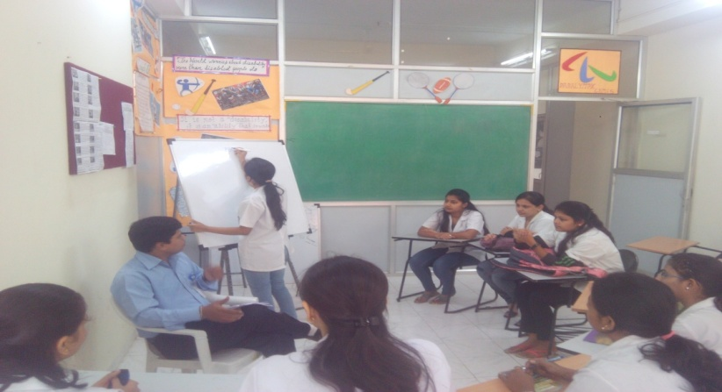

**PBL Session**

Group B students were having the didactic lecture on the same topic with other teacher in another classroom. Once the groups undergone through problem based learning and didactic lecture sessions a surprise theory test was be carried out after 2 days to assess the students understanding level of the clinical test in the form of structured SAQs.

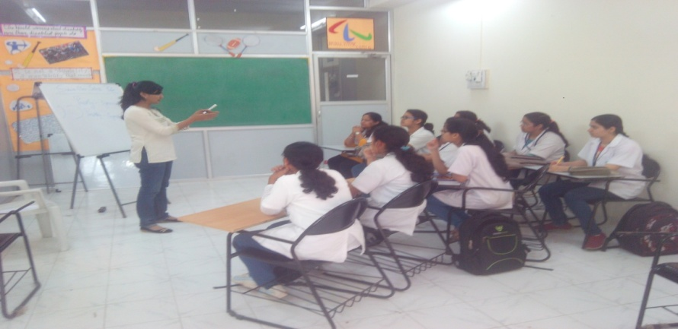

**Didactic Lecture**

**Results:**

The scores obtained after the evaluation of SAQs were compared for the groups and the result was concluded as further. The results of pre (4+0.81) and post (7.7+1.25) PBL scores had significant difference using paired t test (p<0.05) suggesting there was improvement in the students undergoing PBL studies. Also results of pre (4.4+0.84) and post (5.6+1.07) didactic scores had significant difference using paired t test (p<0.05) suggesting there was improvement in the students undergoing didactic studies.(Table 1, Graph 1)

**Table 1: With group comparison of Mean and SD Pre-Post SAQ Scores**

|  |  |  |  |  |  |
| --- | --- | --- | --- | --- | --- |
| Group | Within Group SAQ Scores | | P-value  (<0.005) | Between Group SAQ Scores | P-value  (<0.005) |
| Pre-test  Mean + SD | Post-Test  Mean + SD | Post-Test  Mean + SD |
| PBL | 4+0.81 | 7.7+1.25 | 0.0001 | 3.7+ 1.16 | 0.0001 |
| Didactic Lecture | 4.4+0.84 | 5.6+1.07 | 1.2+1.13 |

While comparing difference of individual improvement in PBL(3.7+ 1.16) and didactic(1.2+1.13) group studies it was noticed PBL group had significant (p<0.005) improvement compared to didactic group using unpaired t test.( Graph 2)

**Discussion:**

The present study was designed to investigate the effect of Introduction of Problem Based Learning in Physiotherapy to promote active learning & make students better learner lifelong. One of the principles of PBL is the stimulation of self-directed learning. Being able to efficiently seek out and evaluate information resources is vital to PBL4. Students would need to be equipped with the necessary tools and skills of effective information gathering before embarking in a PBL tutorial. This would empower the students with the skills required and allow them to become competent problem solvers4.

There is a link between development of self-directing and the enhancement of the student’s information literacy5. Forging stronger links with the librarians would be of importance to implementing PBL further. Before the start of this project students and the faculty were little heisted to change the teaching learning method in the field of physiotherapy. After sensitizing to them regarding the Problem Based Learning they were ready to participate actively in the study.

Total 20 students and 2 staff were participated willingly in the study. Their informed consent were taken and divided into two groups. Group A was the Experimental group with PBL teaching including 10 students. Group B was control group with traditional didactic lecture. Each group had 1-1 facilitator. Group A was given PBL scenario for the clinical test and asked them to gather the information within the stipulated time. On the day of PBL discussion group A students had PBL discussion in one room with the allotted facilitator and at same time group B students with the other facilitator in another room. Both the groups were given the structured SAQs before and after the sessions.

It was observed that all students of group A were having active participation in the discussion and everyone was giving their idea in the discussion. While in group B only few students participated in the interaction with the facilitator. In a PBL curriculum the content is integrated across courses and modules, therefore the School must communicate clearly within itself and with other departments and Collaborate fully with one another6. Individual teachers cannot simply design and teach a course in isolation. The need for working in teams and meeting frequently to review course content and objectives and to ensure the integration of content across all modules within the School would need to be addressed. Both staff and students felt that some modules were not conducive to PBL. Further discussions as to the particular modules would need to be considered.

The students of group A enjoyed the PBL learning a lot as they were allowed to put forward their ideas and got the chance to defend it also. Also they enjoyed the gathering information on given scenario. They felt to be responsible for concluding the scenario. While group B students are not enjoying the didactic lecture that much as it’s a one way communication with the students. Also it was observed that group A students had more knowledge of the scenario when they were discussing compared to the group B students.

**Conclusion:**

Problem-based learning has a role to play in preparing graduates to cope with future demands and should gradually be implemented. Developing and harnessing the skills needed in confronting real-world challenges, and the ability to deal with complexity is vital to graduates today.

**References:**

1. Webb, G., Skinner, M., Jones, S., Vicenzine, B., Nall, C. and Baxter, D. (2009). Physiotherapy in the 21st century. In Higgs, J., Smith, M., Webb, G., Skinner, M. and Croker, A. (Eds.) *Contexts of Physiotherapy Practice,* Chatswood, NSW: Elsevier.
2. WHO (2006). *The world health report 2006 – working together for health.* World Health Organisation. Retrieved http:// www.who.int / whr / 2006/ en / 26Dec2007
3. Foord-May, L. (2006). A faculty’s experience in changing instructional methods in a professional physical therapist education program. *Physical Therapy*, 86, 223-235.
4. Kumar, M. and Natarajan, U. (2007). A problem-based learning model: showcasing educational paradigm shift. *Curriculum Journal,* 18(1), 89-102.
5. Barrett, T. and Moore, S. (Eds.) (2011.) *New Approaches to Problem-based Learning, Revitalising Your Practice in Higher Education*. Oxon: Routledge.
6. Salvatori, P. (2000). Implementing a problem-based curriculum in occupational therapy: a conceptual model. *Australian Occupational Therapy Journal,* 47(3), 119-133.