**Title:** **Indiscriminate disposal of Museum specimen - A case report**

**Authors**

1. Dr. Mandar Ramchandra Sane

(Corresponding author)

Assistant Professor

Department of Forensic Medicine,

Government Medical College

Aurangabad

Maharashtra State, India.

Email: [drmrsane@gmail.com](mailto:drmrsane@gmail.com), Mob: 08793973615

1. Dr. Naveen Kumar T

Associate Professor

Department of Forensic Medicine

Kempegowda Institute of Medical Sciences

Bangalore, Karnataka

Email: [drnaveenfm@gmail.com](mailto:drnaveenfm@gmail.com), Mob: 09902744445

1. Dr. Ananda K

Professor and Head of Department

Department of Forensic Medicine

Kempegowda Institute of Medical Sciences

Bangalore, Karnataka

Email: [anand.dr@hotmail.com](mailto:anand.dr@hotmail.com), Mob: 09844238205

Statement of Funding: No funding or sponsorship was provided for this work.

Statement of Competing Interests: The authors state that there is no actual or potential competing interest including any financial, personal or other relationships with other people or organizations that could inappropriately influence, or be perceived to influence, their work.

Statement of Submission in any other journal: This work or similar work is not submitted by authors to any other journal for publication.

**Abstract**

Human body, body parts and organs are invariably used in medical teaching institutions for academic purpose. Legal provisions for preservation of such specimens are made in Anatomy Acts across the country. However, after use the specimens are improperly disposed off, causing public menace and unnecessary investigations by concerned authorities. We report a case, where bodies of two infants were brought for medico legal autopsy, which later turned out to be formalin preserved ‘museum specimens’, used for anatomical study purpose. We place emphasis for need for framework of guidelines for proper disposal of anatomical museum specimens.

**Key Words**: museum specimen, biomedical waste, disposal guidelines

**Introduction**

Understanding the human body and related pathology is best done by anatomical dissections and study of museum specimens depicting the typical findings. Hence, integrating museum specimens with regular training is being practiced by most of the medical schools and alternative health systems teaching institutions. For these purposes body parts or organ specimens are retrieved or procured by medical institutions as per legal provisions. However, when such specimens are damaged or no longer needed, they should be disposed off properly and not just dumped in garbage. We report a case report where bodies of two newborns were brought for medico legal autopsy, which later turned out to be formalin preserved ‘museum specimens’ of fetuses, used for academic purpose in anatomy.

**Case report**

The police received the information that dead bodies of two newborns were lying in a heap of garbage in an open field. Suspecting some foul play, police seized the newborn dead bodies and submitted for medico legal autopsy. Following were the External findings:

**CASE-1** Body of a male fetus measuring 25 cms in length and weighing 295 gms with intact umbilical cord and placenta. Length of umbilical cord was 40 cms, placenta weighed 110 gms. No congenital abnormality was noted in body, cord or placenta.(Fig 1)

**CASE-2** Body of female fetus measuring 25 cms in length and weighing 190 gms with intact umbilical cord. Length of umbilical cord was 10 cms. Congenital abnormality in form of anencephaly, spina bifida, cleft lip and cleft palate was noted.

Both the bodies imparted smell of formalin all over. Skin was grayish, hard and fixed. Internally no congenital abnormalities were noted in viscera, however all organs and tissues were grayish in colour, hard and fixed (fig 2). Stomach was empty in both cases and mucosa was hard and fixed. No external injuries were present. It was opined that fetus bodies were preserved in formalin for considerable amount of time. This directed investigating agency to nearby ‘nursing college’. On further probing it was confessed by college authority that infants were preserved in Department of Anatomy for teaching purpose and were disposed off in the nearby open field garbage.

**Discussion**

In the present case, the fetus bodies had been used by college authorities as a teaching material for better understanding of anatomy. Initially, both cases were registered under-

1. 315 IPC- Act done with intent to prevent child being born alive or to cause it to die after birth.
2. 318 IPC- Concealment of birth by secret disposal of dead body.

However, after detailed medicolegal opinion, offence was reinvoked under section 297 IPC1 which states that- whoever acts as a depository for the remains of the dead or offers any indignity to any human corpse, shall be punished with imprisonment of either description for a term which may extend to one year or with fine or both. Such cases give rise to legal implications and can be booked under various sections of Indian Penal Code, 1833.

Retrieval and procurement of human body parts, organs or skeleton can be done for medical study purposes. These can be termed as anonymous museum specimens, with material coming from postmortem examinations, surgical operations and, in anatomy museums, from bodies bequeathed to anatomy departments. Of these three sources, the only one covered by regulations will be the bequeathed bodies.2 Legal provision for this is covered under Karnataka Anatomy Act (Section 4 A)3 and other Anatomy Acts across the India. However, disposal of anatomical study material remains unaddressed.

‘Bio-medical waste’ which means ‘any waste, which is generated during the diagnosis, treatment or immunization of human beings or animals or in research activities’. By virtue of research purpose, Pathology ‘organ’ museum specimens and slides comes under the ambit of Bio-medical waste rules. Rules suggested for disposal of human anatomical waste is by deep burial, which shall be an option available only for rural areas or in towns having population less than five lakhs.4 Stubblefeild PR5 reported a case where anthropological investigations were required to be done on skeletal remains which was interred in an informal dumping site instead of formal burial. Hence, inceration must be a preferred method of treatment and disposal of anatomical waste in larger towns and particularly in medical institutions. Inceration of anatomical waste is being increasingly practiced in most of the medical institutions across India, however it should be also extended to museum specimen archieves.

Sporadic incidences are being reported by press mentioning illegal and improper disposals of other human waste generated from hospital like of human body parts particularly surgically amputed parts6 and aborted fetuses7. An unnecessary police investigation due to improper disposal of skeleton used for anatomical study has been reported by Bharadwaj.8 Such cases can be prevented by adhering to rules of hospital waste management. It not only creates public nuisance but may also initiate unnecessary investigations by law enforcing agencies. Neither the lack of informed consent for the acquisition of material, nor regarding the material as property, is sufficient reason for allowing museum collections to remain unregulated. Regulations are urgently required to control the storage of all such human material.

This case brings to fore the importance of proper disposal of anatomical specimens, hence authors felt need to highlight this case. Along these lines we suggest following measures:

1. Registration and licensing of collections for museums.
2. All collections would be brought under the same regulatory framework, thereby eliminating any distinction between pathology and anatomy collections; in this way, a one tier oversight of all body parts could be provided, covering human material obtained at postmortem examination and operation.
3. All collections to have detailed records of all human specimens and body parts in their collections.
4. All collections would have their own ethics committees to oversee approval of research projects and teaching usage.

**References**

1. Manohar VR. Ratanlal and Dhirajlal’s The Indian Penal Code. 33rd Ed. Gurgaon: LexisNexis Butterworths Wadhwa Nagpur; 2011.
2. Jones D.G, Gear R, Galvin K.A. Stored human tissue: an ethical perspective on the fate of anonymous, archival material. J Med Ethics 2003; 29: 343–347
3. Karnataka Anatomy Act, 1957 [Internet] Government of Karnataka [Cited on 25/11/2012] Available on: http://dpal.kar.nic.in/.%5C23%20of%201957%20(E).pdf.
4. Bio-Medical Waste (Management And Handling) Rules 1998 [Internet] Government of Madhya Pradesh [Cited on 26/11/2012] Available on: http://www.mppcb.nic.in/bio-medical_waste.htm.
5. Stubblefield PR. The anatomical diaspora: Evidence of early American anatomical traditions in North Dakota. J.Forensic Sciences 2011;56 (5): 1326.
6. Bushra Baseerat. Hygiene goes for a toss as hospitals dump bio-waste. Times of India 2011 Mar 4:4
7. TNN. Two foetuses found on garbage heap. Times of India 2008 Jul 3:3
8. Bharadwaj D.N, Millo T and Lalwani S. Skeleton used for anatomical study brought for medicolegal autopsy: a case report. Med. Sci. Law. 2007;47(1):86-87.

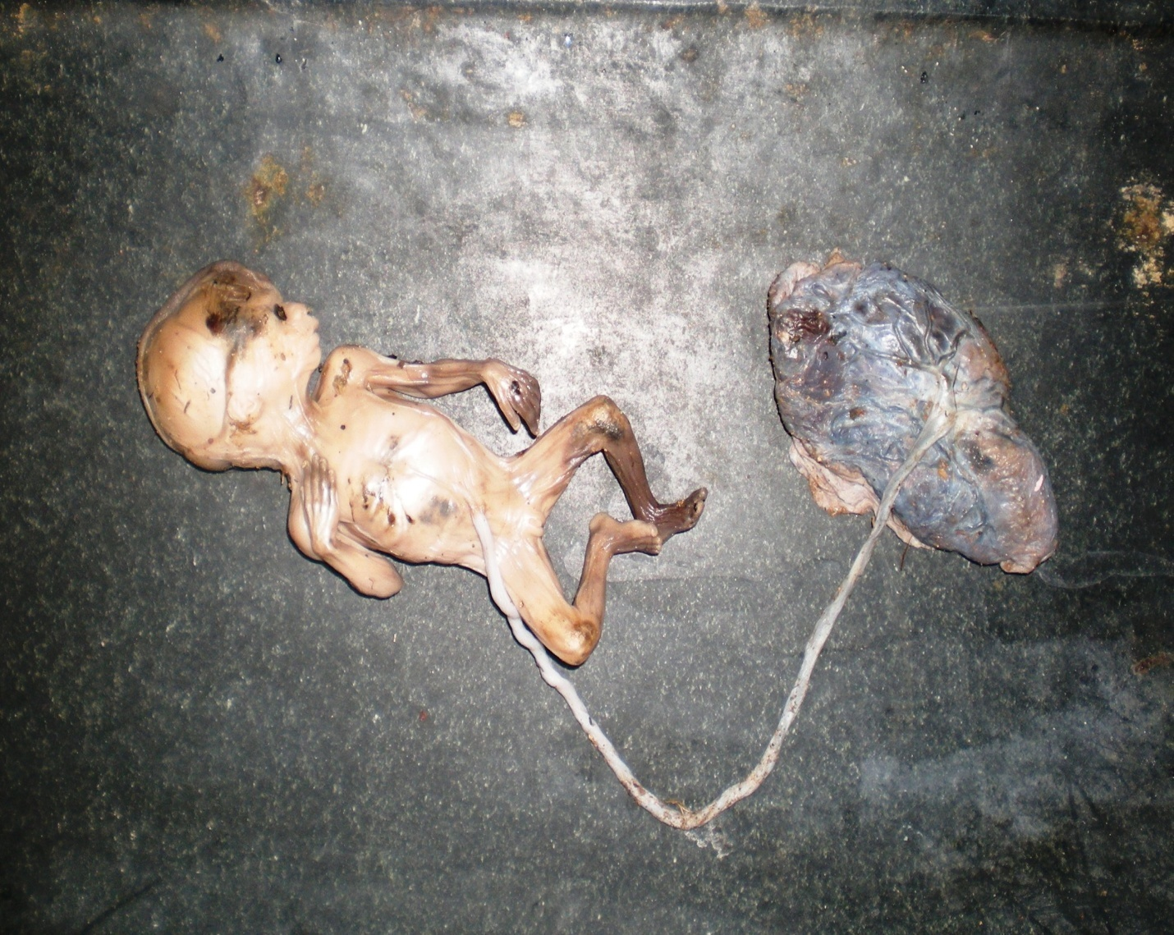

Figure 1: Fetus attached with placenta

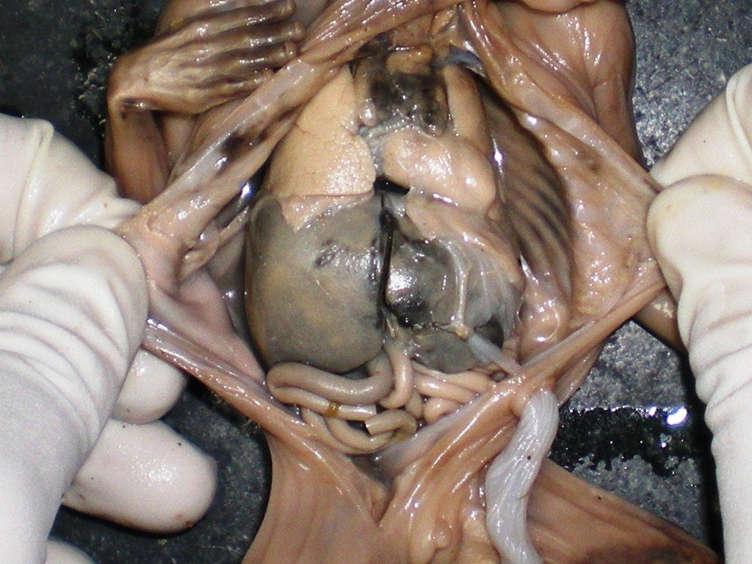

Figure 2: Appearance of viscera of museum specimen