CM-RS232-485 Quick Guide
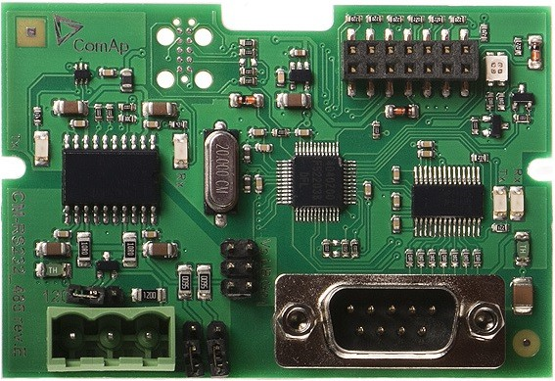
CM-RS232-485 is optional plug-in card to enable InteliLite the RS232 and RS485 communication. This is required for computer or Modbus connection. The CM-RS232-485 is a dual port module with RS232 and RS485 interfaces at independent COM channels. The RS232 is connected to COM1 and RS485 to COM2.
Image 1.1 CM-RS232-485 interface
IMPORTANT: Any manipulation with plug-in module shall be done with disconnected power supply to controller.
Firmware upgrade
Download the newest FW of module from ComAp website (in form of PSI file or installation package) Install package to computer or open PSI to install it into InteliConfig
Plug the module into the controller and power the controller on. Open a connection with controller via InteliConfig
Go the menu Tools -> Firmware upgrade, select the Plug-in modules tab and select the appropriate firmware you want to program into the module (in InteliConfig).
Press the OK button to start upgrade of firmware.
The firmware update process may be performed via any kind of connection including connection via the same module in which the firmware is to be updated. The connection is re-established again automatically when the update process is finished.
Note: For more information see InteliLite Global Guide on www.comap-control.com.

Plug-in module installation
IMPORTANT: Any manipulation with plug-in module shall be done with disconnected power supply to controller.
Remove the back cover. To do this, press four holders which are located in corners.
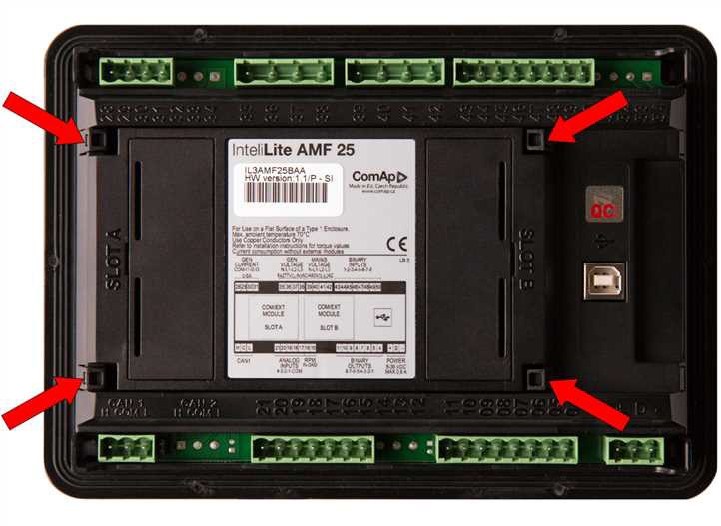
After removing back cover insert the plug-in module. Plug-in module has to be inserted under holders. Start with holders marked by symbol 1. On the controller are also arrows for better navigation. After inserting plug- in module under holders (1) press it down to holders marked by symbol 2 which lock the module.
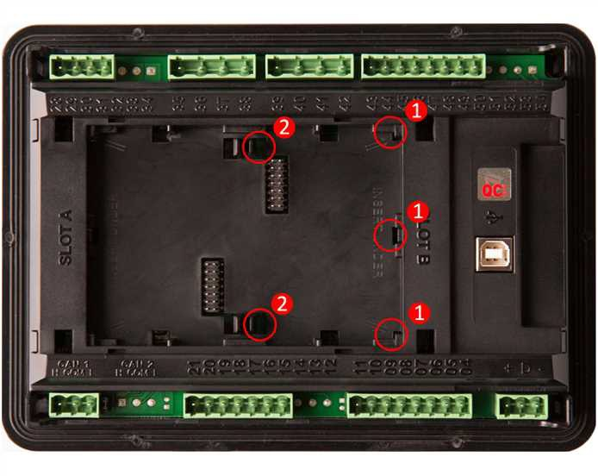
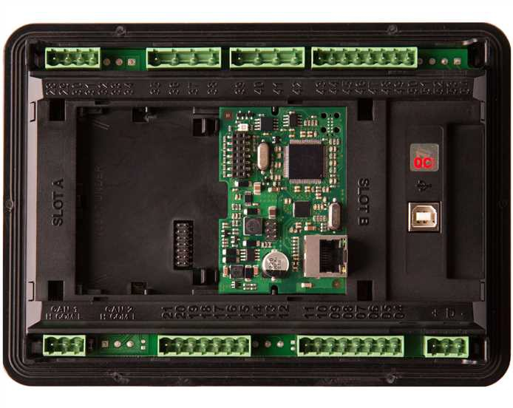
Insert the plug-in module under holders marked by symbol 1. Then insert the plug-in module under holders marked by symbol 2.
After locking the plug-in module into holders, place back the back cover (small cover for connectors has to be removed from back cover). Finally insert the small cover for connectors. Small covers are unique for each plug-in module.

