The Development Environment
A development environment is a vague designation intended to describe all of the domain used by a developer to create applications. It includes tools like compilers and editors, the operating system and associated environment variables, manuals and on-line help, and specialized libraries.
Your DNA development environment includes all of these and the DNA API as well.
This section covers installation of the API and discusses a little about optimizing your DNA development environment.
The following table summarizes API support for the compilers in the various operating systems.
Operating System | Language | Compiler | Memory Model
Win32 (32-bit) | C/C++  Visual Basic | Microsoft® Visual C++™ Version 2.0, Version 4.0 and Version 5.0  Microsoft® Visual Basic™ Version 5.0 | Dynamic Link and Static Link

Installing the DNA API

Hardware and Software Requirements
To use the DNA API, you need:
- An IBM®-compatible personal computer with an 80386 or higher processor;
- A hard disk with 1 megabyte of free space;
- A VGA or higher display;
- One megabyte of random-access memory (8 megabytes or more is recommended);
- Microsoft® Windows NT™ or Windows 95™;
- A mouse or other pointing device is optional but is strongly recommended; and
- The computer must be connected to a network communicating Novell® NetWare®, Banyan® Vines®, or TCP/IP, and the appropriate network drivers for Windows NT® or Windows 95® must be properly installed.
Because Distributed Network Architecture (DNA) supports a variety of network protocols, there are multiple versions of the API. It is important that you use the correct version of the API for your network protocol.
If you wish to use the DNA API with Windows 3.1™ in the Novell® environment you should use the NetWare™ drivers (IPX/SPX drivers) provided by Novell® (you sould also refer to the 16-bit version of the DNA API docuemntation). If you wish to use the DNA API in the Novell® environment on Windows NT™ or Windows 95™ you must use the NetWare™ drivers (IPX/SPX drivers) provided by Microsoft®. For more information, contact your DNA system administrator or your Industrial Peer-To-Peer representative.
Though, not required for development, it is convenient to have a DNA environment on your network for testing.

Installation
The DNA API is delivered on one disk. Before proceeding with the installation, check the disk labels to be sure this version of the API supports your networking protocol.
You install the DNA API by running the Setup program.
To start Setup
- Insert Disk 1 in drive A.
- From the File (or Start) menu, choose Run.
- Type a:setup
- Follow the Setup instructions on the screen.
The diagram below shows the directory structure installed by Setup.
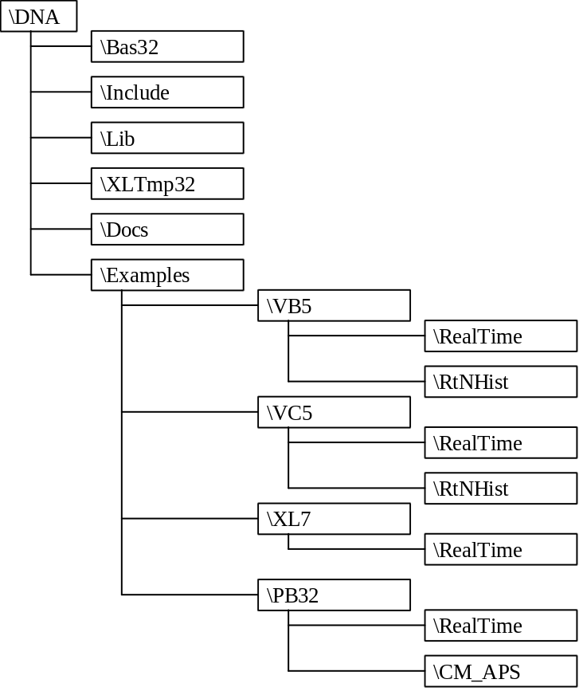
The directories contain the following:
Bas32 Visual Basic™ declaration files that identify DNA library functions allowing you to call them from your applications. The declaration files are formatted for Visual Basic™ version 5.0.
Include C header files that provide definitions and declarations used to access functions in the DNA libraries.
Lib Static-link and import DNA client libraries.
XLTmp32 Template file for developing DNA solutions using Excel™. The Excel ™ template files are formatted for version 7.0.
Docs Electronic copy of this document.
Examples Sample programs that explain programming in DNA. Samples have been included for Visual Basic™, Visual C++™, Excel™, and Power Builder™. The directory names indicate the development environment and version used to build the examples.

Optimizing the Development Environment
Optimizing your development environment means configuring and locating the tools you use in the development process to maximize productivity and minimize bother. Every developer seems to have his or her own style.
The DNA API installation, described above, installs files in directories in a form that we use at Industrial Peer-To-Peer.
The diagram below shows the directory structure I use when developing DNA applications.
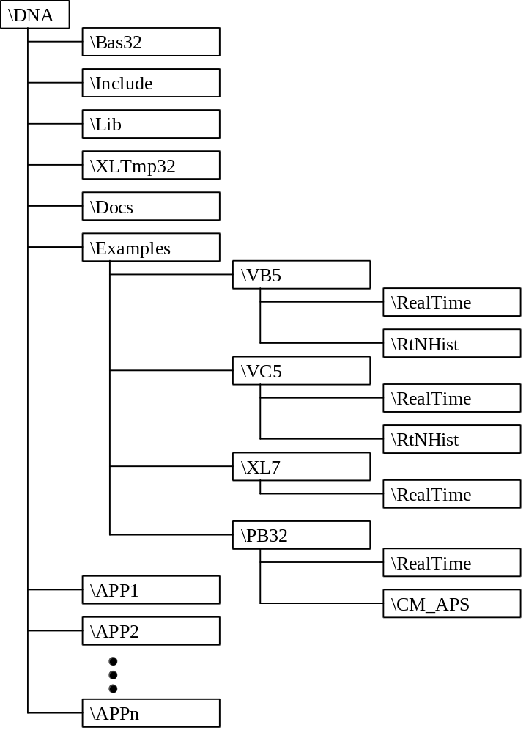

Working With C / C++
When developing DNA applications in C/C++, using the DNA API, you must include API header files and API libraries compatible with the operating system and compiler you are using. The header files tell the compiler about the form of structures, constants, and functions. The libraries contain compiled functions that are bound to your application and perform DNA operations. You will also have to select compiler and linker options compatible with the library files.
Location of the API files is an important piece of the development environment.
Header files are common to all operating systems and compilers. They typically reside in a single directory.
The DNA API header files are designed to be located in one of the directories that the compiler automatically searches. Once you have selected a directory for the headers, be sure to include that directory in the search list for the compiler.
The list of directories to search is specified differently in each compiler, and it can be specified in a number of ways. The following table enumerates the popular methods used for each of the supported compilers in the supported operating systems. Multiple directories are typically separated by semi-colons.
Win32 (32-bit) Visual C++™ 2.0
Project File Specification: To add the DNA API header file path to a project, begin with the project open. From the Project menu, select Settings. In the Project Settings dialog, choose the C/C++ tab. Select the Preprocessor Category. Add the API header file path to the Additional Include Directories field.
Win32 (32-bit) Visual C++™ 4.0
Project File Specification: To add the DNA API header file path to a project, begin with the project open. From the Build menu, select Settings. In the Project Settings dialog, choose the C/C++ tab. Select the Preprocessor Category. Add the API header file path to the Additional Include Directories field.
Win32 (32-bit) Visual C++™ 5.0
Project File Specification: To add the DNA API header file path to a project, begin with the project open. From the Project menu, select Settings. In the Project Settings dialog, choose the C/C++ tab. Select the Preprocessor Category. Add the API header file path to the Additional Include Directories field.
The form of DNA client API functions is uniform between operating systems. Though there is only one format for the functions, there are multiple DNA API libraries. Each different DNA API library copes with different specific situations (i.e. 16-bit verses 32-bit operating systems and different network communication protocols).
The table below details the specific network communication libraries that support the various operating systems and networks.
 | TCP/IP | Novell® NetWare™ | Banyan® Vines™
Win32 Dynamic-Link | DNAAPI32.DLL  WSOCK32.DLL | DNAAPI32.DLL  WSOCK32.DLL | Not presently supported
Win32 Static-Link | DNAAPIS.DLL  WSOCK32.LIB | DNAAPIS.DLL  WSOCK32.LIB | Not presently supported

It is important that the compiler be set for single byte structure alignment. DNA messages and corresponding structures have been designed for single byte alignment, and the DNA API libraries have been built using single byte alignment.
In Win32 you link to import libraries (implib) that provide link reference to dynamic-link-libraries (DLLs). The dynamic-link-libraries are DNAAPI32.DLL and WSOCK32.DLL.
When I develop DNA applications, I use the following directory structure.
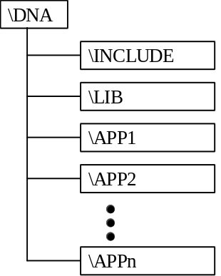
All the modules I used to build a specific application reside in their own directory, below \DNA. The headers all reside in the \DNA\INCLUDE directory and the static-link and import libraries reside in the \DNA\LIB directory. The dynamic link libraries reside in the \DNA directory.

Working With Visual Basic™
Visual Basic™ applications communicate with DNA using a dynamic-link library. Visual Basic™ version 5.0, which operates in 32-bit, links to DNAAPI32.DLL through an intermediate dynamic-link-library, DNAVB5.DLL. DNAVB5.DLL is required to compensate for the automatic byte-alignment provided by Visual Basic™ version 5.0. Visual Basic™ version 5.0 aligns their structures to the nearest 4-bytes.
The DNA API includes Visual Basic™ files containing constant and type definitions and function references that you will use when communicating using the DNA Client Library. Including the declaration files in your Visual Basic™ project enables you to use the DNA Client Library to communicate with DNA services.
The DNA API Visual Basic™ reference files are:
DNAAPI.BAS | The base library definition file included in every project;
ALC.BAS | Contains definitions used when communicating with the Alarm Logic Combiner portion of the Alarm Service;
ALSERV.BAS | Contains definitions used when communicating with the Alarm Service;
BOSS.BAS | Contains definitions used when communicating with the Boot, Operate, and Supervisory Service;
DBSERV.BAS | Contains definitions used when communicating with the Database Service, DBServ;
HSERV.BAS | Contains definitions used when communicating with History Services;
RTSERVER.BAS | Contains definitions used when communicating with real-time services;
SECCS.BAS | Contains definitions used when communicating with the Security Service;
SRVREFS.BAS | Contains definitions used when communicating with a Generic Service;
SVCDIR.BAS | Contains definitions used when communicating with the Services Directory;

When developing DNA client applications using Visual Basic™, I use nearly the same directory structure that I use when developing for C/C++.
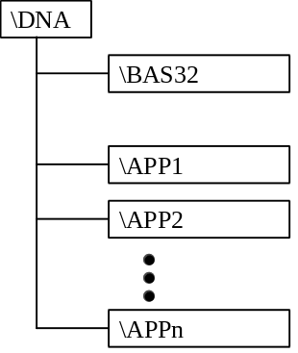
All of the Visual Basic™ reference files are in the \DNA\BAS32 directory. I find it convenient to keep only one copy of the files, because if one of them changes, I only have to replace it in one spot.

Visual Basic™ Function Naming Format
The functions in the DNAVB5.DLL mimic the functions in DNAAPI32.DLL with a VB prescript. Thus, if you wished to call DnaClientInit() from Visual Basic, you would call VBDnaClientInit().

