Examples
This section describes the examples included with the DNA API installation.
When you install the DNA API, samples programs are included for Visual Basic™, Visual C++™, Excel™, and Power Builder™. All of the samples are installed under the \Examples directory, categorized by language and application. The diagram below shows the directories installed with the DNA API.
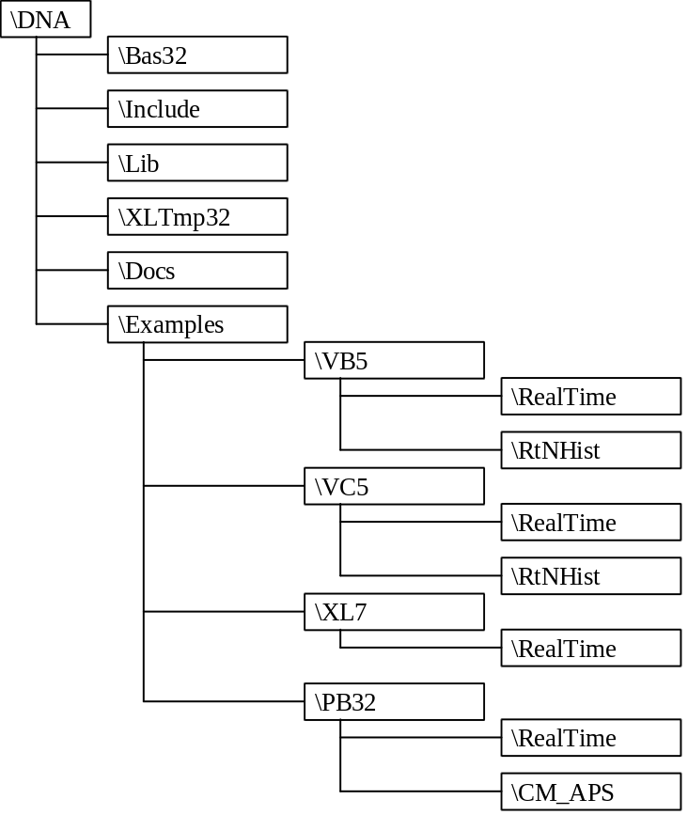
In this section, only Visual Basic™ and Visual C++™ examples are discussed. The examples are nearly identical between the two languages.
The real-time examples, in the \RealTime directories, requests and displays values for two points. The real-time and history examples, in the \RtNHist directories, interface with a real-time service and a History Service, acquiring both current and historical values.

Real-Time Data Example
REALTIME demonstrates the process of acquiring values from a DNA real-time service. REALTIME illustrates the basic concepts of:
- Initializing and terminating DNA network communication,
- Connecting to a DNA service,
- Request and response structures,
- Communication with a DNA service, and
- The basic real-time record structure.
This application allows you to enter the names of two point. When you click on the Refresh button, it displays current information about those points. The points must be from the same real-time service.
The samples provided are intended to be viewed in the Visual C++™ Version 5.0 and Visual Basic™ Version 5.0 development environments.
When working with Visual C++™ or Visual Basic™, open the REALTIME.MAK project.
The Visual C++™ version of the REALTIME project includes the files, realtime.cpp, pointdlg.cpp, stdafx.cpp, realtime.rc, realtime.def, dnaapi32.lib, and associated header files.
realtime.cpp main module for the REALTIME application.
pointdlg.cpp implementation file. This module manages the dialog and performs DNA communication.
stdafx.cpp source file that includes just the standard includes.
realtime.rc resource file.
realtime.def definition file.
Dnaapi32.lib DNA API library import library used as a reference to the DNAAPI32.DLL.
This discussion will focus on the PointDlg::OnRefreshButton() and PointDlg::OnCancel() functions in the pointdlg.cpp module.
The Visual Basic™ version of the REALTIME project includes the files, REALTIME.FRM, DNAAPI.BAS, and RTSERVER.BAS.
REALTIME.FRM implements the application. This module manages the dialog and performs DNA communication.
DNAAPI.BAS primary DNA API declaration file.
RTSERVER.BAS real-time service communication declaration file.
The declaration files are found in the \DNA\BAS directory.
This discussion will focus on the Refresh_Click() and Exit_Click() subroutines in the REALTIME.FRM module.

Discussion of Code
Only the code segments relative to DNA are discussed in this document. For a full view of the code, refer to the example directory in the DNA API.
The following code segments follow the standard flow of a DNA client application.

Initializing DNA Networking
Before communicating with DNA services, you must initialize networking by calling the DnaClientInit() function.
The following code segment shows the use of a global variable to track that DNA networking has been initialized.
C/C++ | //Initialize DNA network  if(m_NetworkInited == 0)  {  ret = DnaClientInit(400);  if(ret)  m_RTMessage = "Unable to init network.";  else  m_NetworkInited = 1;  }
Visual Basic™ | 'Initialize DNA networking  If NetworkInited = 0 Then  ret = VBDnaClientInit(400)  If ret Then  Messages.Text = "Unable to init network, "  + Str$(ret)  Else  NetworkInited = 1  End If  End If

Connecting to a Service
To communicate with a DNA service, certain information about the service must be entered into a table internal to the DNA API. This is accomplished using the DnaClientSvcDirConnect() function. As the name of the function implies, the Services Directory is involved with this function.
The following code segment shows how to connect to a service.
C/C++ | //Connect to the real-time service  if(ret == 0)  {  ret = DnaClientSvcDirConnect(  RTService.GetBuffer(0));  if(ret)  m_RTMessage = "Unable to connect to service";  }
Visual Basic™ | 'Connect to the real-time service  If ret = 0 Then  ret = VBDnaClientSvcDirConnect(RTService)  If ret Then  Messages.Text = "Unable to connect to service "  + RTService + ", " + Str$(ret)  End If  End If

Making a Network Request
A request to a DNA service involves filling out the request structure and calling the DNA API request function.
The following code segment shows a DclRtRecGetNamed() request.
C/C++ | RT_GET_NAMED_REC_REQ RTReq;  RT_GET_NAMED_REC_RESP RTResp;  //Make the RTRequest  if(ret == 0)  {  RTReq.header.count = 2;  strncpy( RTReq.names[0],  Id1.GetBuffer(0),  sizeof(RTReq.names[0])  );  strncpy( RTReq.names[1],  Id2.GetBuffer(0),  sizeof(RTReq.names[0])  );  ret = DclRtRecGetNamed( RTService.GetBuffer(0),  &RTReq,  &RTResp  );  if (  ret == 0  &&  RTResp.header.err  )  ret = RTResp.header.err;  if(ret)  m_RTMessage = "RTRequest failed";  }
Visual Basic™ | Dim RTReq As RT_GET_NAMED_REC_REQ  Dim RTResp As RT_GET_NAMED_REC_RESP  'Make the RTRequest  If ret = 0 Then  RTReq.header.Type = RT_GET_NAMED_REC  RTReq.header.count = 2  RTReq.header.err = 0  RTReq.header.P4 = 0  RTReq.names(0) = Id1  RTReq.names(1) = Id2  ret = VBDclRtRecGetNamed(RTService,  RTReq, RTResp)  If ret = 0 And RTResp.header.err Then  ret = RTResp.header.err  End If  If ret Then  Messages.Text = "RTRequest failed, "  + Str$(ret)  End If  End If

Disconnecting from a Service
Once you are through communicating with a service, you should disconnect from that service. Disconnecting from a service removes information about that service from internal DNA API connection tables.
C/C++ | // disconnect from service  ret = DnaClientDisconnect(RTService.GetBuffer(0));
Visual Basic™ | 'Disconnect from service  ret = VBDnaClientDisconnect(RTService)

Stopping DNA Networking
Before terminating your application, you should stop DNA networking, by calling DnaClientStop(). This performs cleanup of DNA network communications, including closing any open network sockets, and closing the DNA network libraries.
C/C++ | void PointDlg::OnCancel()  {  DnaClientStop();  CDialog::OnCancel();  }
Visual Basic™ | Sub Exit_Click ()  If NetworkInited Then  ret = VBDnaClientStop  End If  End  End Sub

History Example
RTNHIST demonstrates
- Acquiring current values from a real-time service,
- Asking the real-time service for the name of its History Service , and
- The process of acquiring data from a History Service.
When you run RTNHIST you can specify a point name and press the Refresh button to acquire the point’s current value and values for the last 24-hours.
The samples provided are intended to be viewed in the Visual C++™ Version 5.0 and Visual Basic™ Version 5.0 development environments.
When working with Visual C++™ or Visual Basic™, open the RTNHIST.MAK project.
The Visual C++™ version of the RTNHIST project includes the files, rtnhist.cpp, pointdlg.cpp, stdafx.cpp, realtime.rc, realtime.def, dnaapi32.lib, and associated header files.
rtnhist.cpp main module for the RTNHIST application.
pointdlg.cpp implementation file. This module manages the dialog and performs DNA communication.
stdafx.cpp source file that includes just the standard includes.
rtnhist.rc resource file.
rtnhist.def definition file.
dnaapi32.lib DNA API library import library used as a reference to the DNAAPI32.DLL.
This discussion will focus on the PointDlg:: OnUpdate() function in the pointdlg.cpp module.
The Visual Basic™ version of the RTNHIST project includes the files, RTNHIST.FRM, DNAAPI.BAS, and RTSERVER.BAS.
RTNHIST.FRM implements the application. This module manages the dialog and performs DNA communication.
DNAAPI.BAS primary DNA API declaration file.
RTSERVER.BAS real-time service communication declaration file.
The declaration files are found in the \DNA\BAS directory.
This discussion will focus on the ButtonUpdate_Click() subroutine in the REALTIME.FRM module.

Discussion of Code
Only the code segments relative to DNA are discussed in this document. For a full view of the code, refer to the example directory in the DNA API.
The following code segments follow the standard flow of a DNA client application.

Requesting the Current Value
RTNHIST begins by collecting and displaying the current value for the specified point. This procedure is nearly identical to that discussed in REALTIME.
C/C++ | int ret = 0;  CString RTService, Id;  RT_GET_NAMED_REC_REQ RTReq;  RT_GET_NAMED_REC_RESP RTResp;  //Connnect to Real Time service  if(ret == 0)  {  ret = DnaClientSvcDirConnect(  RTService.GetBuffer(0));  if(ret)  {  m_RTValue = "Unable to connect to service";  ret = -1;  }  }  //Make Real Time Request  if(ret == 0)  {  RTReq.header.count = 1;  strncpy( RTReq.names[0],  Id.GetBuffer(0),  sizeof(RTReq.names[0])  );  ret = DclRtRecGetNamed( RTService.GetBuffer(0),  &RTReq,  &RTResp  );  if (  ret == 0 // something wrong with req.  &&  RTResp.header.err  )  ret = RTResp.header.err;  if(ret)  {  m_RTValue = "RTRequest failed";  ret = -1;  }  else  {  NullFill( RTResp.recs[0].id,  sizeof(RTResp.recs[0].id)  );  if (  strnicmp( RTResp.recs[0].id,  Id,sizeof(RTResp.recs[0].id))  )  {  m_RTValue = "RTRequest failed,”  + “ point not found";  ret = -1;  }  }  }  if(ret == 0)  {  m_RTValue = ctime(&RTResp.recs[0].time);  m_RTValue.SetAt(m_RTValue.Find('\n'), ' ');  TempStr = NullResult( RTResp.recs[0].desc,  sizeof(RTResp.recs[0].desc)  );  m_RTValue += " " + TempStr;  TempStr = NullResult( RTResp.recs[0].val,  sizeof(RTResp.recs[0].val)  );  m_RTValue += " " + TempStr;  }
Visual Basic™ | Dim ret As Integer  Dim RTReq As RT_GET_NAMED_REC_REQ  Dim RTResp As RT_GET_NAMED_REC_RESP  Dim Id As String * 8  Dim t As Variant  ret = 0  'Connect to the real-time service  If ret = 0 Then  ret = VBDnaClientSvcDirConnect(RTService)  If ret Then  RTText.Text = "Unable to connect to service "  + RTService + ", " + Str$(ret)  End If  End If  'Make the RTRequest  If ret = 0 Then  RTReq.header.Type = RT_GET_NAMED_REC  RTReq.header.count = 1  RTReq.header.err = 0  RTReq.header.P4 = 0  RTReq.names(0) = Id  ret=VBDclRtRecGetNamed(RTService, RTReq, RTResp)  If ret = 0 And RTResp.header.err Then  ret = RTResp.header.err  End If  If ret Then  RTText.Text = "RTRequest failed, " + Str$(ret)  End If  End If  'Fill in RT values  If ret = 0 Then  t = ConvertDNATimeToVBTime(RTResp.recs(0).time)  temp$ = Format$(Hour(t), "00") + ":"  + Format$(Minute(t), "00") + ":"  + Format$(Second(t), "00")  temp$ = temp$ + " " + RTResp.recs(0).val  temp$ = temp$ + " " + RTResp.recs(0).desc  RTText.Text = temp$  End If

Acquiring the name of a History Service
After collecting the current value from the real-time service, RTNHIST requests the name of the real-time service’s History Service. Associates services are determined using the get references request.
C/C++ | int ret = 0;  CString RTService, Hservice;  RT_GET_REFS_REQ RfReq;  RT_GET_REFS_RESP RfResp;  // Acquire the name of the History Service  if (ret == 0)  {  RfReq.header.count = 1;  ret = DclRtRefs(RTService, &RfReq, &RfResp);  if(ret == 0 && RfResp.header.err)  ret = RfResp.header.err;  if(ret)  {  m_lRTHistValues.AddString( "Unable to acquire”  “History Service name");  ret = -1;  }  else if (m_RTPointId.Find('.') == -1)  {  m_lRTHistValues.AddString("Unable to acquire “  “History Service name");  ret = -1;  }  else  {  HService = NullResult( fResp.ref.history.name,  sizeof(RfResp.ref.history.name)  );  }  }
Visual Basic™ | Dim ret As Integer  Dim RfReq As RT_GET_REFS_REQ  Dim RfResp As RT_GET_REFS_RESP  Dim HService As String  'Acquire the name of the History Service  If ret = 0 Then  RfReq.header.Type = RT_GET_REFS  RfReq.header.count = 1  RfReq.header.err = 0  RfReq.header.P4 = 0  ret = VBDclRtRefs(RTService, RfReq, RfResp)  If ret = 0 And RfResp.header.err Then  ret = RfResp.header.err  End If  If ret Then  HistResults.AddItem "Unable to acquire “  + “History Service name"  ElseIf InStr(1, RfResp.ref.history.name, ".")  = 0 Then  HistResults.AddItem "No History Service”  + “ specified"  Else  HService = RfResp.ref.history.name  End If  End If

Acquiring History
History values are collected in blocks of 90 values. If you want more than 90 values, you must make multiple requests to the History Service.
Begin history collection with a Start History Read Request. Continue collecting values, with Continue History Read Requests, until there are no more values.
C/C++ | int ret = 0;  CString Hservice;  START_HISTORY_READ_REQ HSReq;  CONTINUE_HISTORY_READ_REQ HCReq;  HISTORY_READ_RESP HResp;  //Connect to history service  if (ret == 0)  {  ret = DnaClientSvcDirConnect(  HService.GetBuffer(0));  if(ret)  {  m_lRTHistValues.AddString( "Unable to connect”  “ to History Service");  ret = -1;  }  }  //Read the first block of history  if (ret == 0)  {  HSReq.req_count = 90;  strncpy( HSReq.name.site,  m_RTPointId.Left(EndSite),  sizeof(HSReq.name.site)  );  strncpy( HSReq.name.service,  m_RTPointId.Mid( EndSite + 1,  EndServ - EndSite  ),  sizeof(HSReq.name.service)  );  strncpy( HSReq.name.point,  Id,  sizeof(HSReq.name.point)  );  HSReq.latest_time = time(NULL);  HSReq.earliest_time = HSReq.latest_time  - (60l*60l*60l);  ret = DclHistReadStart( HService.GetBuffer(0),  &HSReq,  &Hresp  );  if (  ret == 0  &&  Hresp.resp_error != 0  &&  HResp.resp_error != END_OF_HISTORY  )  {  m_lRTHistValues.AddString("Unable to acquire”  “ History");  ret = -1;  }  }  if ret == 0)  {  do  {  // output results  for(int i = 0; i < (int)HResp.req_count; i++)  {  TempStr = ctime(&HResp.data[i].t);  TempStr.SetAt(TempStr.Find('\n'), ' ');  TempStr += " ";  TempStr += NullResult( HResp.data[i].value,  sizeof(HResp.data[i].value));  m_lRTHistValues.AddString(TempStr);  }  HCReq.req_count = 90;  memcpy( HCReq.restart,  HResp.restart,  sizeof(HCReq.restart)  );  if (HResp.resp_error == 0)  {  //collect more data  ret = DclHistReadContinue( HService,  &HCReq,  &Hresp  );  if (  ret == 0  &&  HResp.resp_error != 0  &&  HResp.resp_error != END_OF_HISTORY  )  {  m_lRTHistValues.ResetContent();  m_lRTHistValues.AddString("Unable to”  “ acquire History");  ret = -1;  }  }  }while (HResp.resp_error == 0);  ret = DnaClientDisconnect(RTService);  ret = DnaClientDisconnect(HService);  }
Visual Basic™ | Dim ret As Integer  Dim HSReq As START_HISTORY_READ_REQ  Dim HCReq As CONTINUE_HISTORY_READ_REQ  Dim HResp As HISTORY_READ_RESP  Dim HService As String  Dim t As Variant  'Connect to the history service  If ret = 0 Then  ret = VBDnaClientSvcDirConnect(HService)  If ret Then  HistResults.AddItem "Unable to connect to”  + “ history service, " + HService  End If  End If  'Read first block of history, start read request  If ret = 0 Then  HSReq.req_type = START_HISTORY_READ  HSReq.req_count = 90  HSReq.resp_error = 0  HSReq.resp_ver = 0  HSReq.name.site = Left$(PointName$, EndSite% - 1)  HSReq.name.service = Mid$( PointName$,  EndSite% + 1,  EndServ% - EndSite%  )  HSReq.name.point_ = Id  HSReq.latest_time = ConvertVBTimeToDNATime(Now)  HSReq.earliest_time = HSReq.latest_time  - (60& * 60& * 24&)'now - one day  ret = DclHistReadStart(HService, HSReq, HResp)  If ret = 0 And HResp.resp_error <> 0 And  HResp.resp_error <> END_OF_HISTORY Then  ret = HResp.resp_error  End If  If ret Then  HistResults.AddItem "Unable to acquire”  “ History, " + Str$(ret)  End If  End If  'Loop printing results and collecting more data  ' until out of history  If ret = 0 Then  Do  'output results  For i% = 0 To HResp.req_count - 1  t = ConvertDNATimeToVBTime(HResp.data_(i%).t)  temp$ = Format$(i%, "00 ")  temp$ = temp$ + Format$(Hour(t), "00") + ":"  + Format$(Minute(t), "00") + ":"  + Format$(Second(t), "00") + " "  temp$ = temp$ + HResp.data_(i%).value  HistResults.AddItem temp$  Next i%  'collect next block of data  HCReq.req_type = CONTINUE_HISTORY_READ  HCReq.req_count = 90  HCReq.resp_error = 0  HCReq.resp_ver = 0  HCReq.restart = HResp.restart  If HResp.resp_error = 0 Then  'collect more data  ret = VBDclHistReadContinue( HService,  HCReq, HResp)  If ret = 0 And HResp.resp_error <> 0 And  HResp.resp_error <> END_OF_HISTORY Then  ret = HResp.resp_error  End If  If ret Then  HistResults.Clear  HistResults.AddItem "Unable to acquire”  + “ History, " + Str$(ret)  End If  Else  'Flag end of collection  ret = HResp.resp_error  End If  Loop Until ret  End If

