Using iNaturalist to learn more about echinoderms

François Michonneau  
Gustav Paulay

# Context

Echinoderms are among the most conspicuous and abundant marine invertebrates. Several species undergo large demographic fluctuations, with important ecological consequences, for reasons that are not always well understood (e.g., crown-of-thorns outbreaks, *Diadema antillarum* die-off, starfish-wasting-syndrome, reviewed in Uthicke et al. (2009)). In addition, many species are targeted by unregulated fisheries (e.g. Purcell et al. 2014)). Despite these factors, echinoderms have received limited taxonomic attention, and many large species remain undescribed or are poorly known.

With recent technological advances, it has become increasingly easier to document species encountered in nature. For instance, smartphones can take a picture and record the exact geographical location and time of the observation. Digital cameras have made underwater photography much more accessible, and many divers now document the species they encounter by sharing their pictures on social media websites. These pictures regularly illustrate species that are undescribed or little-known. Taxonomic studies are increasingly utilizing live appearance of echinoderms, as many taxonomic species are most easily discerned by color pattern or field appearance. Our knowledge of echinoderms could therefore be improved by aggregating user observations of these organisms, while, at the same time, educating the public about the diversity and natural history of these fascinating organisms.

# What is iNaturalist?

iNaturalist (<http://inaturalist.org>) is an established website (started in 2008), recently acquired by the California Academy of Sciences in 2014. iNaturalist allows users to submit observations about any species (on land or underwater), along with images, GPS coordinates and ancillary information about the habitat or natural history (Figure [fig:example-observation]). Once submitted, the observations can be further identified by the community and vetted by “curators” (users with recognized knowledge of a given taxonomic group whose opinion can be trusted). This mechanism allows users to hone their identification skills, learn about the organisms, and communicate with each other. Observations, in turn, provide a wealth of information about distribution, variation, abundance, and other aspects of natural history. Mobile applications for Android and iOS are available to access and submit observations to iNaturalist.

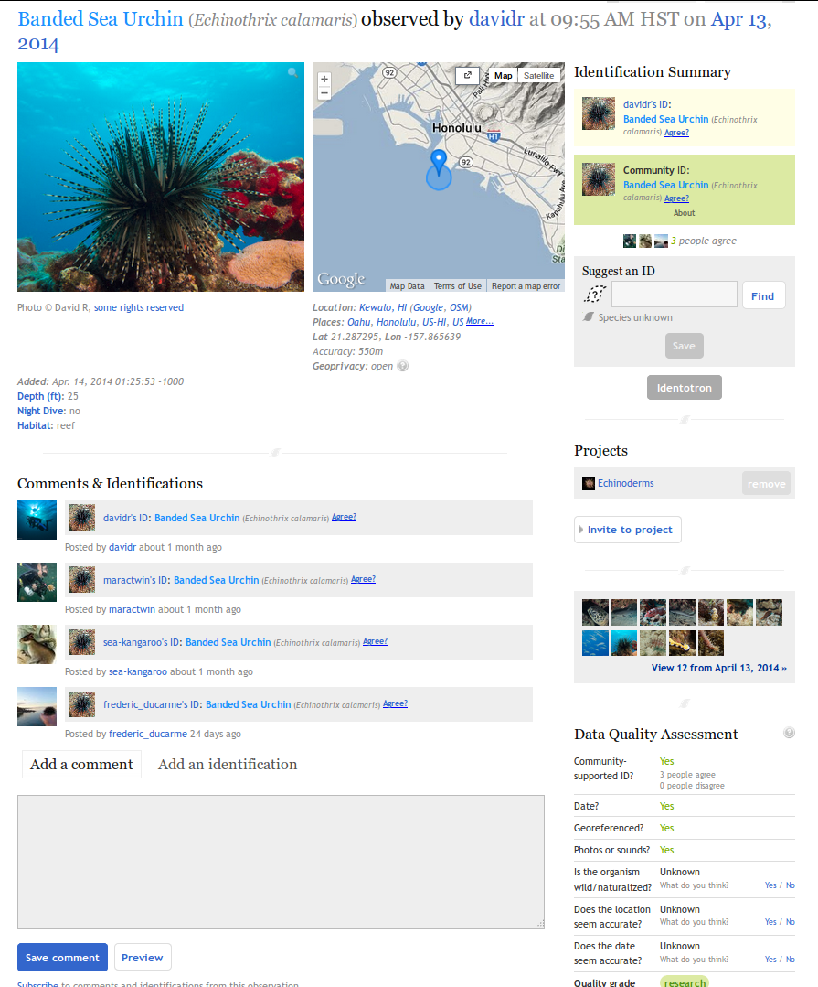 [fig:example-observation]

# The Echinoderm project on iNaturalist

We have started a project on Echinoderms using iNaturalist (<http://inaturalist.org/projects/echinoderms>) to gather observations worldwide, and across taxa. Our goal is to improve our knowledge of species distributions, variation, and biology, and to educate the public about the diversity of echinoderms. This platform provides a great outreach tool facilitating communication between scientists and naturalists. Because iNaturalist is easy to use and has applications for mobile devices, it can also be used during citizen science initiatives (e.g., Bioblitzes), or class field trips.

Beyond outreach, iNaturalist can be a useful tool for scientists. Echinoderms are among the few mobile invertebrates regularly recorded during coral reef ecosystem monitoring. By submitting species observations on iNaturalist, data will be archived, accessible, and shareable with the community. Additionally, it also provides users with accurate identifications for the species encountered with the help of the community.

The aggregated data is made openly available and can be used by scientists to study demographic and spatial patterns, or infer distributions using ecological niche modeling. For instance, recent taxonomic research on sea cucumbers has shown that species can be told apart based on their color patterns (Kerr 2013; e.g. Kim et al. 2013). However, taxonomic confusion through the years has hindered our knowledge of species distributions, as incorrect identifications in many species complexes are pervasive in the literature. Having photographic evidence associated with geospatial data will allow accurate delineation of the geographical distributions of once confused species, after taxonomic research has clarified species limits. iNaturalist can also help track changes in species abundance (e.g., crown-of-thorns outbreaks) and condition (e.g., starfish-wasting-syndrome).

# Present and future observations

Since the beginning of the project in March 2014, over 150 users have contributed 1,300+ observations of 170 species worldwide. Currently, large and abundant species from the intertidal of the Western United States dominate, reflecting the development of iNaturalist in California (Figure [fig:all-observations]). However, underwater sightings from the Caribbean and the Indo-West Pacific also represent a large proportion of the observations and indicate the potential of iNaturalist to document marine invertebrate biodiversity associated with coral reefs.

We aim at expanding both taxonomic and geographic coverage. Many of the species associated with coral reefs don’t have well characterized geographical distributions. Reef scientists can improve our knowledge of their distribution by reporting the species they see in the field. Additionally, we are in the process of advertising the project to the SCUBA diving community and through citizen science initiatives in order to increase participation.

We welcome anyone submitting their echinoderm observations, or indeed becoming involved in curating the records submitted to the project. Don’t hesitate to join us!

image

[fig:all-observations]

# Methods

This article is open-source ([Creative Commons Attribution License](http://creativecommons.org/licenses/by/4.0/)), fully reproducible, available on [GitHub](https://github.com/fmichonneau/inat-paper/) and figshare (doi:[10.6084/m9.figshare.1309937](http://dx.doi.org/10.6084/m9.figshare.1309937)). It was made possible using R (R Development Core Team 2014) complemented with the packages ggplot2 (Wickham 2009) to draw the maps, knitr (Xie 2014) to generate the manuscript, taxizesoap (Chamberlain and Szöcs 2013; Chamberlain et al. 2014) to obtain the higher taxonomy of the species observed through [WoRMS](http://marinespecies.org/), and wesanderson (Ram 2014) for the color palette.

Chamberlain S, Szöcs E, Boettiger C, Ram K, Bartomeus I, Baumgartner J (2014) taxize: Taxonomic information from around the web <https://github.com/ropensci/taxize>.

Chamberlain SA, Szöcs E (2013) taxize: taxonomic search and retrieval in R. F1000Research 2:191

Kerr AM (2013) Holothuria (Semperothuria) roseomaculata n. sp. (Aspidochirotida: Holothuriidae), a coral-reef inhabiting sea cucumber from the western Pacific Ocean. Zootaxa 3641:384

Kim SW, Kerr AM, Paulay G (2013) Colour, confusion, and crossing: resolution of species problems in Bohadschia (Echinodermata: Holothuroidea). Zoological Journal of the Linnean Society 168:81–97

Purcell SW, Polidoro BA, Hamel J-F, Gamboa RU, Mercier A (2014) The cost of being valuable: predictors of extinction risk in marine invertebrates exploited as luxury seafood. Proceedings of the Royal Society B 281:20133296

R Development Core Team (2014) R: A language and environment for statistical computing <http://www.r-project.org>.

Ram K (2014) wesanderson: A Wes Anderson Palette Generator <http://cran.r-project.org/package=wesanderson>. http://cran.r-project.org/package=wesanderson,

Uthicke S, Schaffelke B, Byrne M (2009) A boom–bust phylum? Ecological and evolutionary consequences of density variations in echinoderms. Ecological Monographs 79:3–24

Wickham H (2009) ggplot2: elegant graphics for data analysis. Springer New York,

Xie Y (2014) knitr: A general-purpose package for dynamic report generation in R <http://cran.r-project.org/package=knitr>.