High level data model
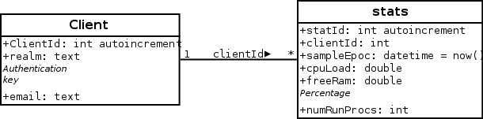

Architecture diagrams

Classes Diagram
See internal documentation to know the responsibilities of each class.

Client
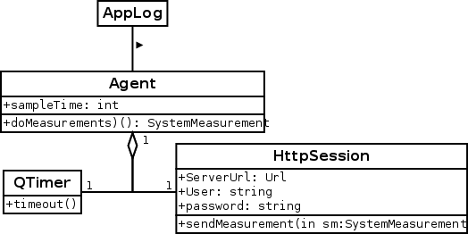

Server
