Antialiasing Methods to Improve Image Quality

Copyright © 2000 Sony Computer Entertainment Inc.
All Rights Reserved.
SCEI Confidential
Contents
1 What Is Aliasing? 3
2 AA1 Antialiasing Feature of GS 5
3 Antialiasing Feature Using AA1 6
4 Antialiasing Methods by Two-Dimensional Image Processing 8
Super sampling 8
Two-dimensional filter 10
Time-base filter 11
Depth queue 12
5 Antialiasing at Object Level 13
6 Details of Sample Programs 14
refmap-noAA 14
refmap-448 15
refmap-4times 18
refmap-onepass-AAline 23
aa1-feather 27

What Is Aliasing?
Aliasing is a generic name for noise which produces glare or flicker on the screen. Since aliasing is a leading cause to degrade image quality, many methods of removing aliasing have been proposed to date. A technique for removing aliasing is generally called "antialiasing". This document describes the antialiasing feature of the GS, and some sample programming methods which compensate for this feature.

The GS generates polygons in the shapes requested by the drawing command strings from the EE. They are finally sampled at a specified frame resolution (e.g. 640 x 480) and unwanted signals are generated by the sampling. Aliasing is image degradation resulted from these signals. These signals are generated by migration of the high frequency elements, that exceed the half of the frame resolution, to lower frequency band.

Aliasing is visually recognized as a screen glare/flicker or a jagged edge because of the unexpected frequency elements added to the original signal.

As compared with white (flat-band) noise, aliasing elements are physiologically annoying, so it could be a big problem in image quality.

In addition, aliasing is sensitive to the phase of signals. When a shape on the screen changes over time, the aliasing signal makes much bigger changes than the shape does. The annoyance increases when viewing an image with aliasing as movie data, since the human eye is sensitive to image signals which change over time.

Aliasing chiefly results from:

1. Texture pattern
2. Polygon edge

Aliasing resulting from the texture pattern can be reduced by bilinear texture mapping. Bilinear mapping, which takes the weighted average of four adjacent texels, works as a low-pass filter (high cut filter), and can remove the high frequency signals, which cause aliasing.

Bilinear mapping is, however, effective only when the texture pattern is expanded. When vertices are degenerated and then the texture is mapped in a smaller size, such as texture mapping of a distant object, aliasing of the texture pattern becomes a problem even though bilinear mapping is applied. This can be solved by using the MIPMAP texture.

Aliasing at the polygon edge originates in discontinuities of the luminance values of the adjacent pixels sharing the edge. The aliasing becomes greater as the difference of the level of pixels increases. Therefore, aliasing of the polygon edge shared by different objects is more serious than aliasing of the polygon edge shared by different polygons of one object. The reason is that there is a big difference in luminance values when the polygon edge is also the object edge.

AA1 Antialiasing Feature of GS
The GS has the "AA1" feature named after Anti-Aliasing. This feature removes aliasing on polygon edges, by adding (extrapolating) translucent pixels in the direction of their normals. As a result, this feature externally smoothes the difference in luminance values.

- Writes 1 to the AA1 bit of the PRIM register.
- Sets blending function of alpha-blending.
- Blends and displays edge pixels based on the alpha values calculated from the coverage.

Antialiasing by the AA1 mostly brings about excellent results, but has the following restrictions exist.

- Cannot be used with alpha-blending.
- To be strict, the drawing order must be considered.
- Since AA1 allways extends polygons by one pixel, when the polygon is highly inclined to the line of sight, the polygon becomes too thick.

The reasons for (1) and (2) are that the AA1 uses the alpha-blending function so the function can not be used concurrently, and inherits the limitations of alpha-blending.
(3) is a problem unique to the AA1.

Therefore, the AA1 needs some techniques to avoid above limitations.

Antialiasing Feature Using AA1

Method of controlling AA1 by the inclination of a polygon

This method complements an "AA1" disadvantage. It obtains the inner product of the normal of the polygon and the line of sight, determines from the obtained value the inclination of the polygon toward the line of sight, and selectively turns the AA1 off for polygons with a large angle of inclination. As a result, it compensates for an AA1 disadvantage of displaying a wider edge than is necessary.

Sample programs:
ee/sample/graphics/anti
aa1-feather (R1 button)

Method of drawing the polygon edge again with a AA1 line

This method draws AA1 lines on already-drawn polygon edges. Although an AA1 line uses the center Z values for two pixels, the artifact is small.

It is effective to draw AA1 lines on the textures to be kept displayed in the distance (e.g. a center line on the ground). It is also possible to use the AA1 polygon to prevent a texture from vanishing.

Drawing AA1 lines on polygon edges also can be applied to reduce aliasing from textures in distant view and filling gaps in subdivided polygons.

Sample programs:
refmap-onepass-AAline
texmap-onepass-AAline
mountain
Limitation:
Redrawing a line increases amount of drawing.

Antialiasing Methods by Two-Dimensional Image Processing
Anatialiasing can also be performed by two-dimensional image processing to an already-drawn image in the frame buffer.
This is easy to implement, but has limited effect.

The following are descriptions of antialiasing methods by two-dimensional image processing.

Super sampling
Super sampling is a technique to draw an image to a high-resolution buffer before down-sampling the image through the low-pass filter to display it. Aliasing can be reduced with the increase of the nominal sampling frequency by super-sampling.

Method of drawing an image in field mode (h=448), re-sampling it with h=224, and re-drawing it

Draws an image to the frame buffer with doubled vertical resolution [H=448], and down-samples it by half by using bilinear texture mapping.

Sample program:
refmap-448 (refmap-noAA: no antialiasing)
Limitation:
The Z-buffer must be twice as big as that in frame mode.

Method of drawing only an object to the work buffer, re-sampling the object, and redrawing it

Draws an object to avoid aliasing in high resolution (by expansion), then reduces/re-maps it by using bilinear texture mapping. Out-of-focus effect can be added.

Limitations:
Work area is necessary.
It is difficult to overlap objects.

Method of drawing polygon data more than once with the full screen shifted by sub-pixel, and drawing them by alpha-blending

Draws polygon data more than once while shifting the full screen by sub-pixels (e.g. values below).
(0.0,0.0), (0.5,0.0), (0.0,0.5), (0.5,0.5)
In this example, each of them is multiplied by 0.25, then is accumulated to obtain an output image.

This method can also provide out-of-focus effect and motion blur.

Sample program:
refmap-4times (refmap-noAA: no antialiasing)
Limitations:
A buffer for accumlation is necessary.
It is necessary to draw all the objects more than once.

Method of reading odd and even scanning lines by different PCRTC's and alpha-blending their output images using double buffers of 640 x 448

Reads odd and even scanning lines via two PCRTC's and alpha-blends the two output images by providing double buffers of 640x448. This method realizes interlaced scanning by shifting the scanning lines according to the odd and even fields of the display.

This method reduces interlace flickers. This method also has an advantage that frame drops are less unrecognizable even when drawing time exceeds 1 field.

Sample program:
pcrtc-blend
Limitation:
A big display buffer is necessary.

Two-dimensional filter
This method applies a low-pass filter to drawing images adaptively.

Method of moving the already-drawn buffer by half a pixel, re-samples the image, and draws it.

Moves the drawing buffer for half a pixel as a texture source, and draws the image again. At this time, the average of four adjoining points is taken as a bilinear effect of texture mapping. This works as a low-pass filter.

- Can increase or decrease the effect of the low-pass filter by varying pixel travel within the range from 0 to 0.5. (0.5: max effect, 0.0: no effect)

- Can provide out-of-focus effect by re-mapping recurrently.

- Can set the filter on/off selectively according to the Z value, by testing the Z value along with re-mapping.

- Can select on/off of the filter for each object, by re-mapping the image when the background is drawn, and then drawing another object.

Limitations:
Mapping an already-drawn image again as a texture in the same area might wobble the image. It is necessary to draw images via a small intermediate buffer.

From the point of view of image quality, the image might be unnaturally obscure.
Especially in frame mode of interlaced display, obscurity of the edges in vertical direction becomes large. This is because the next pixel value in the y direction of the drawing buffer is actually the pixel value of one pixel ahead.

Time-base filter
This method removes aliasing by applying the low-pass filter to the time average between the image in the drawing buffer and the image in the field immediately before (image in the display buffer).

Method of moving the image in the display buffer for half a pixel, sampling the image again, and adding the image in the drawing buffer to it, and mixing them

The pixel value of the display buffer corresponding to the pixel of the drawing buffer does not show the same position in interlace mode. Therefore, this method moves the display buffer for half a pixel, performs bilinear mapping when re-sampling the image, adds the display buffer value to the results, and mixes them. The direction in which display buffer is moved for half a pixel (+0.5 or -0.5) differs between the even number field and the odd number field.

It is expected that this method will remove interlace flickers. In addition, it can control the filter effect by changing the pixel addition ratio between the display buffer and drawing buffer. (0.5: max effect, 0.0: no effect)

Pixel correction in the display buffer is unnecessary in modes other than interlace mode.

Sample program:
aa1-feather (L1, L2 button)
Limitation:
This method is based on the assumption that pixel values of an image vary continuously along time. Therefore, images with rapid movement leave afterimages.

Depth queue
This method reduces difference in luminance values of a distant object, and removes aliasing.

Method of setting fog color of an object by its average luminance value

This method assumes an average luminance value of an object to be the fog color, and changes the fog convergence value for each object. Since the luminance values of the pixels which compose an object converge to the same color in proportion to the distance, aliasing within the object can be reduced.

It is possible aliasing on edges common to two or more objects might remain. Even so, however, application of this method produces better results. In other words, even when objects A and B are adjacent to each other, the difference between the averages of the luminance values of A and B never exceeds the maximum value of the difference between the luminance values of A and B.

Antialiasing at Object Level
Aliasing occurs frequently to distant degenerated (reduced) objects, because textures are mapped in reduced sizes by the degeneration of the vertex of objects, and the number of edges to the unit drawing area increases and generates edge aliasing frequently. An essential solution to this is to examine the texture pattern and modeling considering antialiasing and mechanisms of MIPMAP and MIP modeling.

Modeling-based solutions are also necessary for problems with display modes. For instance, directivity of aliasing occurs in interlace mode, since the values of adjacent pixels in vertical (Y) direction of the drawing buffer are displayed on every other line on TV. This generates flicker to the floor texture twice as much as the wall texture. Therefore, when designing a texture pattern, it is necessary to consider in which direction the texture will be mapped.

Such consideration is required at the authoring level, and might need examination based on the display system design of video games.

Details of Sample Programs
This section provides more detailed descriptions of the following antialiasing sample programs.

refmap-noAA, refmap-448, refmap-4times,
refmap-onepass-AAline, texmap-onepass-AAline, aa1-feather

refmap-noAA
This is a sample program of a normal interlaced scanning display with 640 x 448 pixel resolution without antialiasing. This sample draws polygon data according to the following flow.

sceGsResetGraph: Sets up GS.

sceGsSetDefDBuff: Sets up parameters for double buffers.

sceGsSetDefTexEnv: Sets up parameters for texture mapping.
(Sets up parameters in the self-specified structure TexEnv).

sceGsPutDrawEnv(&texenv.giftag):
Transfers the parameters for texture mapping to GS by DMA.

DMA transfer of My_dma_setup via VU1:
Transfers packets including data such as texture, which have been specified in packet.dsm, by DMA via VU1.

open pad processing

while: Repeats this and the following steps every field. (1/60 second)

sceGsSetHalfOffset:
Shifts xy-offset by 1/2 pixel in V direction according to the odd and even fields.

sceGsSwapDBuff:
Swaps the display and drawing buffers in the double buffers (DBP=0, DBP=70).

get pad status: Gets pad information.

DMA transfer of My_dma_setup via VU1:
Transfers packets including texture, which have been specified in packet.dsm, by DMA via VU1. (Actually, the only information required to be transferred is setting. In this step, however, all the information is simply transferred via DMA.)

SetVu1PacketMatrix:
Writes data such as locations of viewpoint and light source calculated from pad information in my_environment (this is data in packet.dsm, and is written to VU1 MEM by the next DMA transfer).

<Shading Display>
DMA transfer of My_dma_start via VU1:
Transfers matrix information in my_environment and polygon data to VU1 via DMA, and starts light source calculation and transparent perspective conversion programs in VU1.

<Line Display>
DMA transfer of My_dma_line_start via VU1:
Transfers matrix information in my_environment and straight line data to VU1 via DMA, and starts light source calculation and transparent perspective conversion programs in VU1. (The line display data differs from the shading display data only in GIFTAG.)

The above is the original refmap program. It conforms to the previous reflection mapping sample program.

refmap-448
In this program, polygon data is drawn in 640 x 448 pixel resolution in PSMCT16 (R5, G5, B5, A1) format, and is displayed in 640 x 224 pixel resolution in PSMCT32 format by compression.

Since the buffer for 640 x 448 PSMCT16 is the same size as that for 640 x 224 PSMCT32, normal double buffers can be applied to them. Z buffer whose vertical resolution is twice as high as normal buffers uses twice the area.

NTSC format draws polygon data in 640 x 224 resolution by dividing the 640 x 448 resolution screen into 2 screens of odd and even lines. Therefore, the resolution in Y direction is substantially halved. This program, however, allows vertical and horizontal resolutions to be almost the same by drawing polygon data to the 640 x 448 pixel buffer.

When converting data from 640 x 448 into 640 x 224 to produce an output, it is possible to retrieve only odd or even lines by point sampling without performing filter processing. In the case the image changes, however, it is accompanied by flicker peculiar to interlaced scanning. Therefore, an output buffer of 640 x 224 is created by filtering 640 x 448.

When the select button is down (filter_flg ==0), odd and even lines are blended at a ratio of 1:1 by functions squeeze_frame and squeeze_frame1.

A texture address is shifted by 1 pixel when drawing polygon data in interlace mode, so that the Y coordinate is shifted by 1/2 pixel.

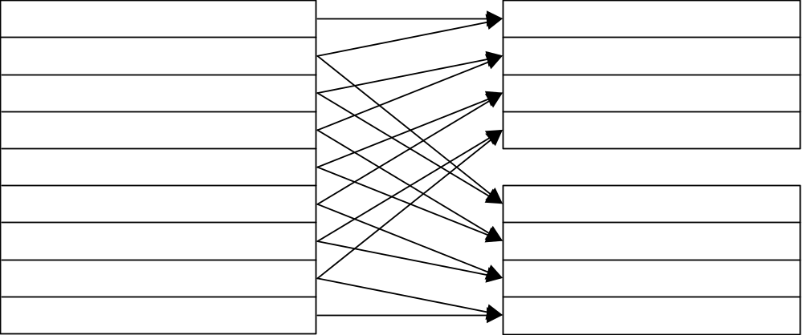
Synthesis of Interlaced Screens at a Blending Ratio of 1:1

When the start button is down (filter_flg ==1), three lines are blended at a ratio of 1:2:1 by functions such as squeeze_frame_50p and squeeze_frame1_50p
Compared with the blending ratio of 1:1, the image is blurred, but produces a more natural feeling.

sceGsResetGraph: Sets up GS.

sceGsSetDefDBuff: Sets up parameters for double buffers.

use one buffer as 640x448x16
Sets xyoffset, scissor, and dither to use the drawing buffer in 640 x 448 pixel resolution in PSMCT16 format.

sceGsSetDefTexEnv: Sets up parameters for texture mapping.
(Sets up parameters in the structure TexEnv.)

sceGsPutDrawEnv(&texenv.giftag):
Transfers the parameters for texture mapping to GS by DMA.

DMA transfer of My_dma_setup via VU1:
Transfers packets including data such as texture, which have been specified in packet.dsm, by DMA via VU1.

open pad processing

while: Repeats this and the following steps every field. (1/60 second)

sceGsSetHalfOffset: (Not performed)
This step is not performed since V direction is shifted when copying frames. It cannot be used practically due to the parameters differently specified for scissor.

squeeze_frame and other processing:
Copies data from the drawing buffer to the display buffer with a filter according to the odd and even fields.

sceGsSwapDBuff:
Swaps the display and drawing buffers in the double buffers (DBP=0, DBP=70).

get pad status: Gets pad information.

DMA transfer of My_dma_setup via VU1:
Transfers packets including texture, which have been specified in packet.dsm, by DMA via VU1. (Actually, the only information required to be transferred is setting. In this step, however, all the information is simply transferred via DMA.)

SetVu1PacketMatrix:
Writes data such as locations of viewpoint and light source calculated from pad information in my_environment (this is data in packet.dsm, and is written to VU1 MEM by the next DMA transfer). Parameters for doubling the size of the image in Y direction are set. (The arguments of sceSamp0ViewScreenMatrix have been changed.)

<Shading Display>
DMA transfer of My_dma_start via VU1:
Transfers matrix information in my_environment and polygon data to VU1 via DMA, and starts light source calculation and transparent perspective conversion programs in VU1.

<Line Display>
DMA transfer of My_dma_line_start via VU1:
Transfers matrix information in my_environment and straight line data to VU1 via DMA, and starts light source calculation and transparent perspective conversion programs in VU1. (The line display data differs from the shading display data only in GIFTAG.)

The above has been created by altering the original refmap program.

refmap-4times
This program, realizes a high resolution and removes aliasing by repeating the following steps and creating four shifted images of one object.
- Shifts an object in sub-pixel units.
- Draws it in the drawing buffer of 640 x 224 PSMCT32.
- Stores the image in the display buffer in 1/4 size.

The principle of a set of four-layered shifted images is described as follows:

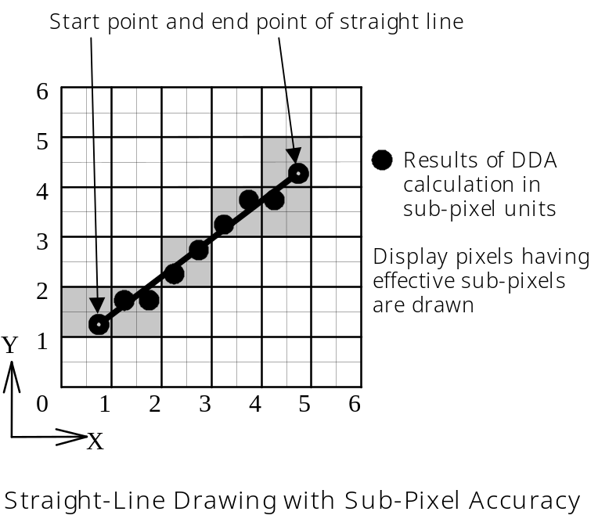

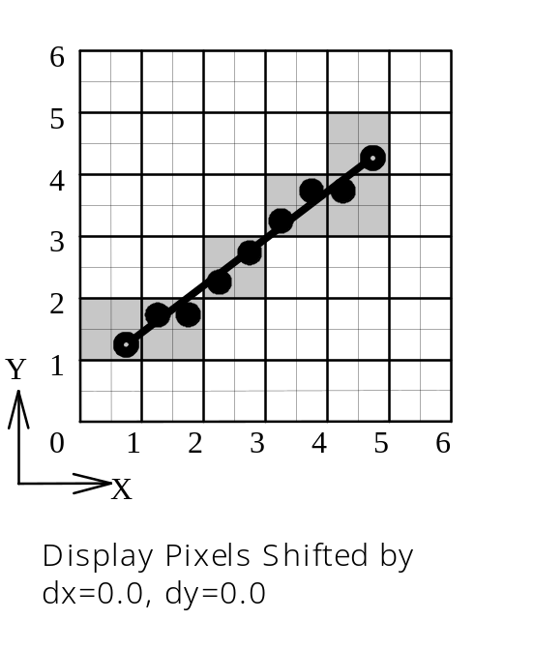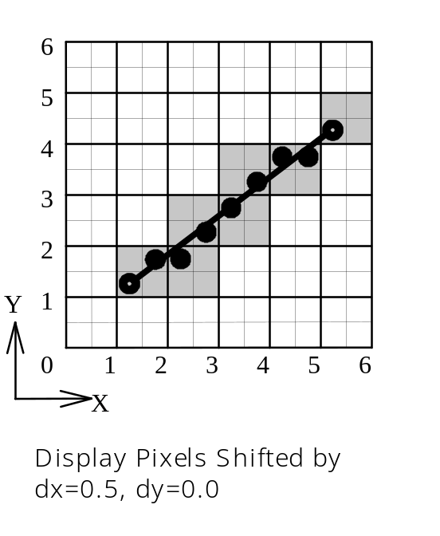

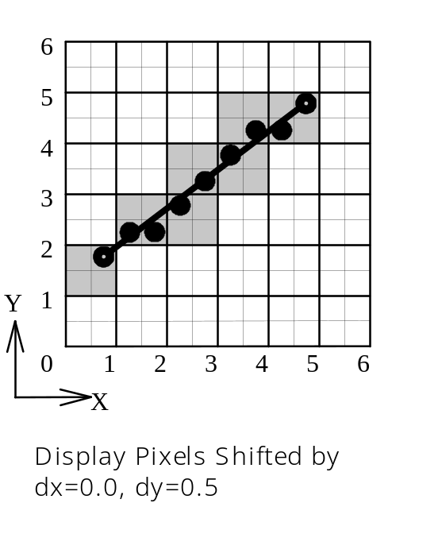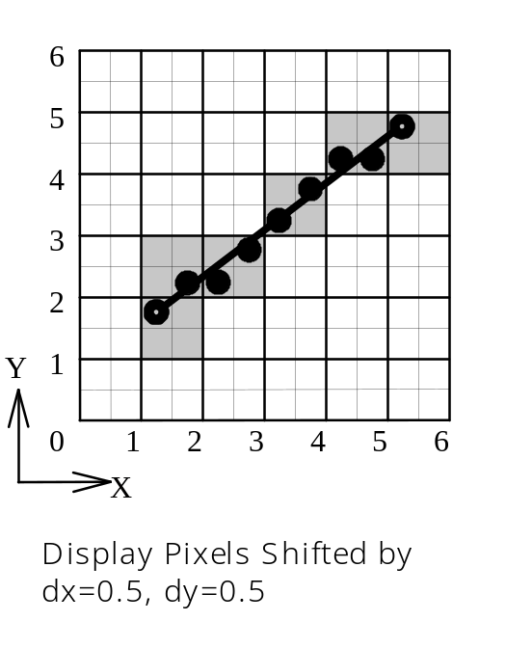

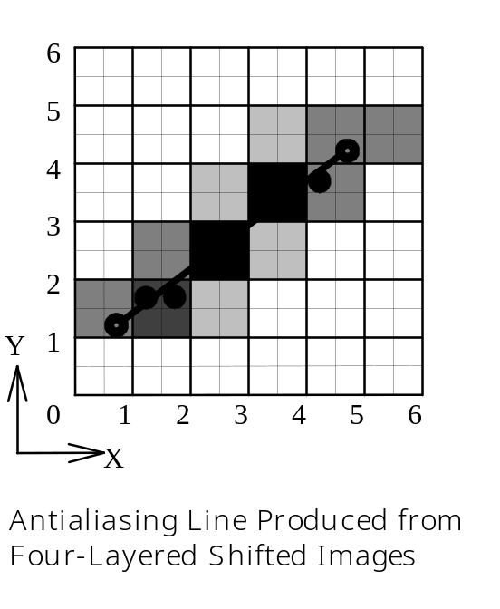

Pixel shifting has effect on the Z buffer as well, and increases the substantial resolution of the entire screen.

Pressing L1/L2 button can switch the object display mode (between shading and line). This clarifies the difference of effect between refmap-448 and refmap-4times.

This program uses a drawing buffer in addition to the normal double buffers. Parameters for this buffer are stored in the structure sb.

sceGsResetGraph: Sets up GS.

sceGsSetDefDBuff: Sets up parameters for double buffers.

set drawing buffer environment
Sets a drawing buffer for drawing polygon data four times. Specifies drawing parameters for the drawing buffer using context 2 to avoid specifying them more than once.

sceGsSetDefTexEnv: Sets up parameters for texture mapping.
(Sets up parameters in the structue TexEnv.)
Uses context 1 for drawing polygon data (i.e. copying four alpha-blended images) to the double buffers.

sceGsPutDrawEnv(&texenv.giftag):
Transfers the parameters for texture mapping to GS by DMA

DMA transfer of My_dma_setup via VU1:
Transfers packets including data such as texture, which have been specified in packet.dsm, by DMA via VU1.

open pad processing

while: Repeats this and the following steps every field. (1/60 second)

sceGsSetHalfOffset2:
Adds odd and even offsets in Y direction to the odd and even fields of the drawing buffer (context 2).

sceGsSwapDBuff:
Swaps the display and drawing buffers in the double buffers (DBP=0, DBP=70).

get pad status: Gets pad information.

DMA transfer of My_dma_setup viaVU1:
Transfers packets including texture, which have been specified in packet.dsm, by DMA via VU1. (Actually, the only information required to be transferred is setting. In this step, however, all the information is simply transferred via DMA.)

SetVu1PacketMatrix:
Writes data such as locations of viewpoint and light source calculated from pad information in my_environment (this is data in packet.dsm, and is written to VU1 MEM by the next DMA transfer). Parameters for doubling the size of the image in Y direction are set. (The arguments of sceSamp0ViewScreenMatrix have been changed.)

sceGsPutDrawEnv(&sb.giftag):
Clears the drawing buffer.

set offset:
sceGsPutDrawEnv(&lb1.giftag):
Draws the first polygon data without shifting pixels.

<Shading Display>
DMA transfer of My_dma_start via VU1:
Transfers matrix information in my_environment and polygon data to VU1 via DMA, and starts light source calculation and transparent perspective conversion programs in VU1.

<Line Display>
DMA transfer of My_dma_line_start via VU1:
Transfers matrix information in my_environment and straight line data to VU1 via DMA, and starts light source calculation and transparent perspective conversion programs in VU1. (The line display data differs from the shading display data only in GIFTAG.)

add_frame:
Adds the contents of the drawing buffer to the display buffer in 1/4 sizing.

sceGsPutDrawEnv(&sb.giftag):
Clears the drawing buffer.

set offset:
sceGsPutDrawEnv(&lb1.giftag):
Draws the object by shifting it by 1/4 pixel in Y direction. (In interlace mode, pixels are shifted in Y direction by 1/4 pixel, not 1/2 pixel.)

<The above steps are repeated until a set of four-layered shifted images is obtained. >

The above has been created by altering the original refmap program.

refmap-onepass-AAline
refmap-onepass-AAline, texmap-onepass-AAline, and mountain remove aliasing by drawing an antialiasing line (AAline) on a line which appears to generate aliasing.

The principle of drawing an AAline on a line is described as follows:

Line Antialiasing (AA1) Feature of the Graphics Synthesizer

The Graphics Synthesizer has a coordinate calculation feature with sub-pixel accuracy, and can draw antialiasing-applied straight lines.

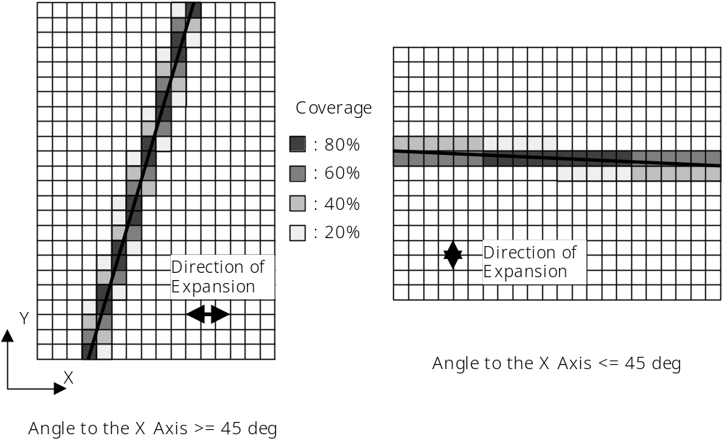

When applying antialiasing to Line, the effect can be obtained by
- deciding the direction in which the Line is widened according to the angle to the X axis (horizontal direction)
- assuming the coverage of the widened Line to a pixel to be the alpha value of the pixel
- drawing polygon data according to the following blending formula.
It is decided that the total coverage of adjoining 2 pixels in the line expansion direction is always 100%. (The above figure uses 20%, 40%, 60%, and 80% as coverage models. Actually, however, it is calculated continuously with the accuracy of sub-pixels.)

(Pixel Value) = (Source Color) x (Alpha) + (Destination Color) x (1 - Alpha)

Antialiasing Method for Triangle and Triangle Strip

STEP1
Retrieves outer lines and potential outer lines of a shape, which will consist of Triangles and TriangleStrips, as Line or LineStrip data, in advance.
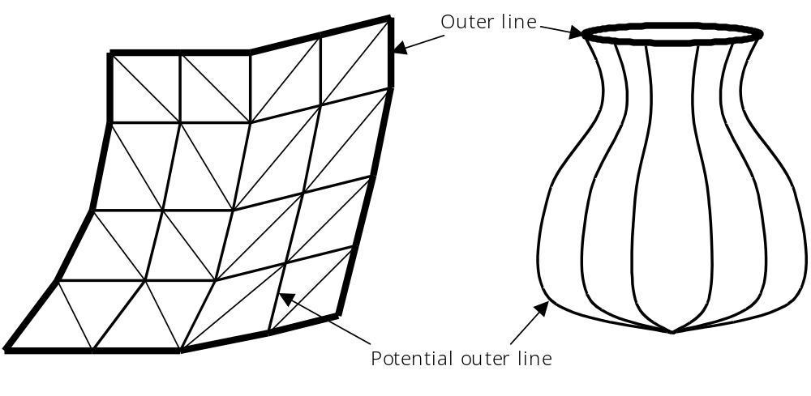

The above figures show examples of outer lines and potential outer lines. The vase-like shape on the right is subdivided by small Triangles. A line forming the outer shape of an object from any three-dimensional direction is called an outer line, and a line forming the outer shape depending on the direction is called a potential outer line. Drawing a line (e.g. a diagonal line) with low probability of becoming an outer line should be avoided, to lower the probability of side effects on antialiasing-applied drawing and to speed up drawing.

STEP2
Draws Triangle or TriangleStrip with the Z buffer on.
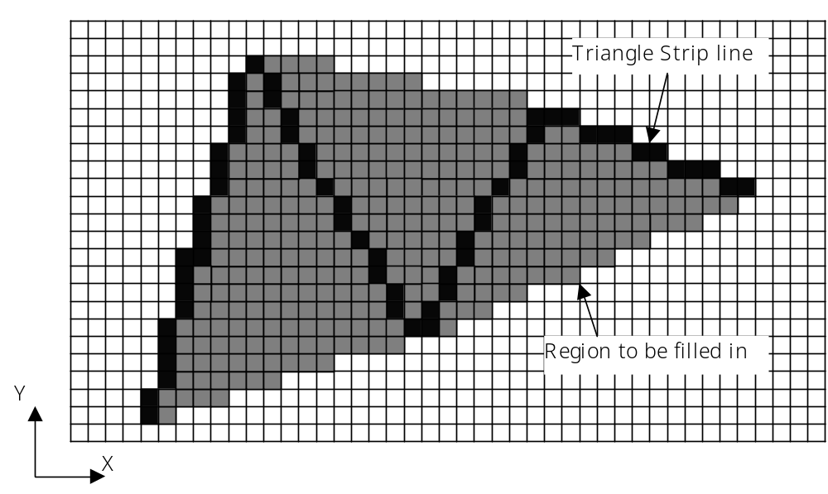

The polygon is filled in with aliasing attached.

STEP3
Draws the outer line and the potential outer line as necessary with the AA1 feature and the Z buffer test on. The Graphics Synthesizer only runs a test for and disables write operations to the Z buffer when the AA1 feature is on. The following figures show the pixels drawn with the AA1 feature on.
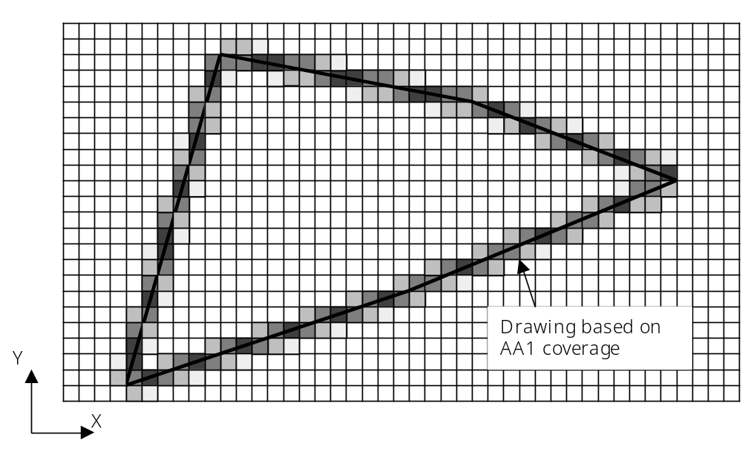
The figure below shows a polygon with antialiasing-applied edges.

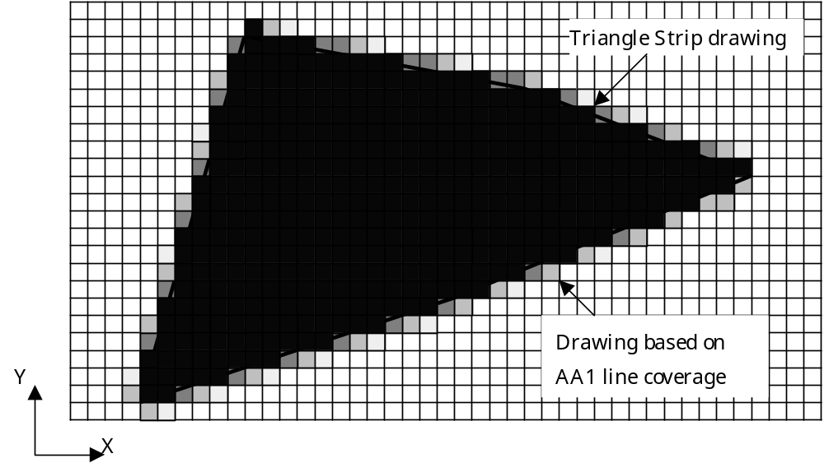

In refmap-onepass-AAline and texmap-onepass-AAline, antialiasing effect can be confirmed by toggling the AA1 line on and off with the L1 button.

In mountain, the AA1 line is set on and off by pressing the L2 and R2 buttons respectively while holding down the select button.

In spite of using 640 x 224 pixel buffers, these programs can generate almost flicker-free high-quality images.

aa1-feather
aa1-feather is equipped with the following anitaliasing methods.

- Removes aliasing by alpha-blending the (display) frame in the immediately preceding field and adding it to the current drawing frame, after finishing drawing in the current drawing frame.
L1 button: Alpha-blended drawing with the original luminance
L2 button: Alpha-blended drawing by increasing luminance
(Pressing the L1 and L2 buttons at the same time brightens and whitens the screen, and makes the image invisible.)
Functions such as copy_frame and copy_frame1 in this program carry out the above antialiasing method, by alpha-blending the display frame as a texture to the drawing frame. When it is necessary to speed up the drawing process, the Sprite should be drawn 10 times in 64 x 224, not once in 640 x 224. (It reduces the number of page breaks in the GS D-RAM). Then, the drawing speed doubles.
- Removes AA1 side effects.
aa1-feather is programmed to carry out side-effect-free processing whenever AA1 is applied. When activated, this program displays neither Triangle nor Line. By holding the circle button down, however, the number of Triangles and Lines increases.
- When drawing Triangles with AA1
Pressing the R2 button switches the primitive for the drawing object between Triangle and Line, and pressing R1 button sets AA1 on and off.
In applying AA1 to a Triangle, the AA1 is set off when the Triangle seems collapsed on the screen (due to the plane of the Triangle located perpendicular to the line of sight).
The above is calculated by attaching normal direction data to all the Triangles, transferring them to VU1, calculating the inner product of the sight-line vector and the normal vector in VU1, and setting the AA1 off when the inner product becomes smaller than or equal to the threshold value. The AA1 is switched on and off by sending the PRMODE command to each vertex.
The calculation is outlined as follows.
1. Calculates vertex coordinates in the view coordinate system and stores the coordinate values in VF05.
2. Calculates the normal vector of the polygon in the view coordinate system and stores it in VF06.
3. Calculates the inner product VF05*VF06 and stores the results in VF29x.
4. Substitutes VF05z for the distance from the line of sight to the vertex, and stores it in VF08x.
5. Calculates VF29x*8.0f-VF08x.
6. Stores the PRMODE command which has switched on/off the AA1 in VF07, according to the sign of the calculation results in 5.
7. Switches the AA1 on and off with PRMODE every time a vertex is drawn.
The AA1 is set off when the cos of the sight-line vector and the normal vector of the plane is 1/8 or less.
- When drawing Lines with AA1
When drawing AA1 lines, values cannot be written to the Z buffer.
As an action to prevent this, a method of drawing Lines in two steps is adopted. In the first step, lines are drawn only to the Z buffer by masking RGBA values with the AA1 off. In the second step, AA1 lines are drawn after comparing Z values with the AA1 on. These steps allow AA1 lines processed in the Z buffer to be drawn.

