**INSTITUTO POLITECNICO NACIONAL**

**Unidad Profesional Interdisciplinaria   
de Biotecnología**

**Métodos Numéricos**

**TAREA No. 2-SEGUNDO PARCIAL**

**REGRESION LINEAL**

Grupo: 4MV3

Integrante del equipo 7:

* Galván Rojas Dulce Sofia

**PROFESORES**

* González Pascual Victor.
* Zamora Justo José Alberto.

Fecha de entrega: 07 de octubre de2021

EJERCICIO

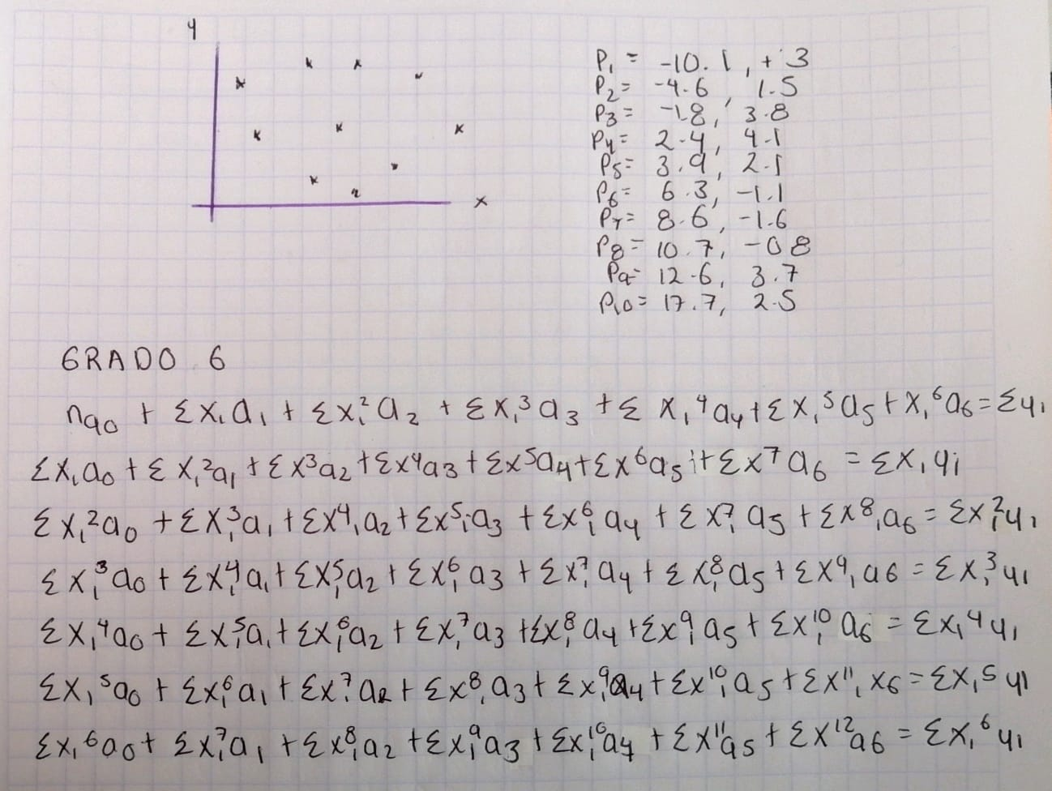

CODIGO

x=[-10.1 -4.6 -1.8 2.4 3.9 6.3 8.6 10.7 12.6 17.7]

y=[3 1.5 3.8 4.1 2.1 -1.1 -1.6 -0.8 3.7 2.5]

plot(x,y, '*')

N=length(x)

%sumatoria de grado 6

Sx=sum(x)

Sx2=sum(x.^2)

Sx3=sum(x.^3)

Sx4=sum(x.^4)

Sx5=sum(x.^5)

Sx6=sum(x.^6)

Sx7=sum(x.^7)

Sx8=sum(x.^8)

Sx9=sum(x.^9)

Sx10=sum(x.^10)

Sx11=sum(x.^11)

Sx12=sum(x.^12)

Sy=sum(y)

Sxy=sum(x.*y)

Sx2y=sum(x.^2.*y)

Sx3y=sum(x.^3.*y)

Sx4y=sum(x.^4.*y)

Sx5y=sum(x.^5.*y)

Sx6y=sum(x.^6.*y)

A=[N Sx Sx2 Sx3 Sx4 Sx5 Sx6 Sy;

Sx Sx2 Sx3 Sx4 Sx5 Sx6 Sx7 Sxy;

Sx2 Sx3 Sx4 Sx5 Sx6 Sx7 Sx8 Sx2y;

Sx3 Sx4 Sx5 Sx6 Sx7 Sx8 Sx9 Sx3y;

Sx4 Sx5 Sx6 Sx7 Sx8 Sx9 Sx10 Sx4y;

Sx5 Sx6 Sx7 Sx8 Sx9 Sx10 Sx11 Sx5y;

Sx6 Sx7 Sx8 Sx9 Sx10 Sx11 Sx12 Sx6y]

% 0.0000 0.0006 0.0106 0.1795 3.1520 0.0001

%Pasar la fila 7 a la 1

aux=A(1,:);

A(1,:)=A(7,:);

A(7,:)=aux

%CONVERTIR 1,1 em uno y los valores debajo de esta en 0

A(1,:)=A(1,:)/A(1,1)

A(2,:)=A(2,:)-A(1,:)*A(2,1);

A(3,:)=A(3,:)-A(1,:)*A(3,1);

A(4,:)=A(4,:)-A(1,:)*A(4,1);

A(5,:)=A(5,:)-A(1,:)*A(5,1);

A(6,:)=A(6,:)-A(1,:)*A(6,1);

A(7,:)=A(7,:)-A(1,:)*A(7,1)

%fila 5 se va a la 2

aux=A(2,:);

A(2,:)=A(5,:);

A(5,:)=aux

%convertir el primer valor en uno y por abajo y arriba en cero

A(2,:)=A(2,:)/A(2,2);

A(3,:)=A(3,:)-A(2,:)*A(3,2);

A(4,:)=A(4,:)-A(2,:)*A(4,2);

A(5,:)=A(5,:)-A(2,:)*A(5,2);

A(6,:)=A(6,:)-A(2,:)*A(6,2);

A(7,:)=A(7,:)-A(2,:)*A(7,2);

A(1,:)=A(1,:)-A(2,:)*A(1,2)

%fila 6 se va a la 3

aux=A(3,:);

A(3,:)=A(6,:);

A(6,:)=aux

%convertir el primer valor en uno y por abajo y arriba en cero

A(3,:)=A(3,:)/A(3,3);

A(4,:)=A(4,:)-A(3,:)*A(4,3);

A(5,:)=A(5,:)-A(3,:)*A(5,3);

A(6,:)=A(6,:)-A(3,:)*A(6,3);

A(7,:)=A(7,:)-A(3,:)*A(7,3);

A(2,:)=A(2,:)-A(3,:)*A(2,3);

A(1,:)=A(1,:)-A(3,:)*A(1,3)

%fila 6 se va a la 4

aux=A(4,:);

A(4,:)=A(6,:);

A(6,:)=aux

%convertir el primer valor en uno y por abajo y arriba en cero

A(4,:)=A(4,:)/A(4,4);

A(5,:)=A(5,:)-A(4,:)*A(5,4);

A(6,:)=A(6,:)-A(4,:)*A(6,4);

A(7,:)=A(7,:)-A(4,:)*A(7,4);

A(3,:)=A(3,:)-A(4,:)*A(3,4);

A(2,:)=A(2,:)-A(4,:)*A(2,4);

A(1,:)=A(1,:)-A(4,:)*A(1,4)

%fila 6 se va a la 5

aux=A(5,:);

A(5,:)=A(6,:);

A(6,:)=aux

%convertir el primer valor en uno y por abajo y arriba en cero

A(5,:)=A(5,:)/A(5,5);

A(6,:)=A(6,:)-A(5,:)*A(6,5);

A(7,:)=A(7,:)-A(5,:)*A(7,5);

A(4,:)=A(4,:)-A(5,:)*A(4,5);

A(3,:)=A(3,:)-A(5,:)*A(3,5);

A(2,:)=A(2,:)-A(5,:)*A(2,5);

A(1,:)=A(1,:)-A(5,:)*A(1,5)

%convertir el primer valor en uno y por abajo y arriba en cero

A(6,:)=A(6,:)/A(6,6);

A(7,:)=A(7,:)-A(6,:)*A(7,6);

A(5,:)=A(5,:)-A(6,:)*A(5,6);

A(4,:)=A(4,:)-A(6,:)*A(4,6);

A(3,:)=A(3,:)-A(6,:)*A(3,6);

A(2,:)=A(2,:)-A(6,:)*A(2,6);

A(1,:)=A(1,:)-A(6,:)*A(1,6)

%convertir el primer valor en uno y por abajo y arriba en cero

A(7,:)=A(7,:)/A(7,7);

A(1,:)=A(1,:)-A(7,:)*A(1,7);

A(2,:)=A(2,:)-A(7,:)*A(2,7);

A(3,:)=A(3,:)-A(7,:)*A(3,7);

A(4,:)=A(4,:)-A(7,:)*A(4,7);

A(5,:)=A(5,:)-A(7,:)*A(5,7);

A(6,:)=A(6,:)-A(7,:)*A(6,7)

a0=A(1,8)

a1=A(2,8)

a2=A(3,8)

a3=A(4,8)

a4=A(5,8)

a5=A(6,8)

a6=A(7,8)

f=@(X) a0+a1*X+a2*X.^2+a3*X.^3+a4*X.^4+a5*X.^5+a6*X.^6

X=min(x)-1:max(x)+1

Y=f(X)

hold on

plot(X,Y)

N=length(x)

ymedido=y

ymodelo=f(x)

mediaymedidoss=mean(ymedido)

Sr=sum((ymodelo-ymedido).^2)/N

St=sum((ymedido-mediaymedidoss).^2)/N

r=sqrt((St-Sr)/St)

RESULTADOS

x = 1×10

-10.1000 -4.6000 -1.8000 2.4000 3.9000 6.3000 8.6000 10.7000 12.6000 17.7000

y = 1×10

3.0000 1.5000 3.8000 4.1000 2.1000 -1.1000 -1.6000 -0.8000 3.7000 2.5000

N = 10

Sx = 45.7000

Sx2 = 847.5700

Sx3 = 8.5964e+03

Sx4 = 1.5464e+05

Sx5 = 2.1459e+06

Sx6 = 3.7794e+07

Sx7 = 6.0387e+08

Sx8 = 1.0582e+10

Sx9 = 1.7954e+11

Sx10 = 3.1520e+12

Sx11 = 5.4810e+13

Sx12 = 9.6510e+14

Sy = 17.2000

Sxy = 35.6100

Sx2y = 1.5227e+03

Sx3y = 1.5914e+04

Sx4y = 3.5021e+05

Sx5y = 5.0036e+06

Sx6y = 9.2970e+07

A = 7×8

1014 ×

0.0000 0.0000 0.0000 0.0000 0.0000 0.0000 0.0000 0.0000

0.0000 0.0000 0.0000 0.0000 0.0000 0.0000 0.0000 0.0000

0.0000 0.0000 0.0000 0.0000 0.0000 0.0000 0.0001 0.0000

0.0000 0.0000 0.0000 0.0000 0.0000 0.0001 0.0018 0.0000

0.0000 0.0000 0.0000 0.0000 0.0001 0.0018 0.0315 0.0000

0.0000 0.0000 0.0000 0.0001 0.0018 0.0315 0.5481 0.0000

0.0000 0.0000 0.0001 0.0018 0.0315 0.5481 9.6510 0.0000

A = 7×8

1014 ×

0.0000 0.0000 0.0001 0.0018 0.0315 0.5481 9.6510 0.0000

0.0000 0.0000 0.0000 0.0000 0.0000 0.0000 0.0000 0.0000

0.0000 0.0000 0.0000 0.0000 0.0000 0.0000 0.0001 0.0000

0.0000 0.0000 0.0000 0.0000 0.0000 0.0001 0.0018 0.0000

0.0000 0.0000 0.0000 0.0000 0.0001 0.0018 0.0315 0.0000

0.0000 0.0000 0.0000 0.0001 0.0018 0.0315 0.5481 0.0000

0.0000 0.0000 0.0000 0.0000 0.0000 0.0000 0.0000 0.0000

A = 7×8

1013 ×

0.0000 0.0000 0.0000 0.0000 0.0000 0.0000 0.0000 0.0000

0.0000 0.0000 0.0000 0.0000 0.0000 0.0000 0.0001 0.0000

0.0000 0.0000 0.0000 0.0000 0.0000 0.0001 0.0011 0.0000

0.0000 0.0000 0.0000 0.0000 0.0001 0.0011 0.0180 0.0000

0.0000 0.0000 0.0000 0.0001 0.0011 0.0180 0.3152 0.0000

0.0000 0.0000 0.0001 0.0011 0.0180 0.3152 5.4810 0.0000

0.0000 0.0000 0.0000 0.0000 0.0000 0.0000 0.0000 0.0000

A = 7×8

1011 ×

0.0000 0.0000 0.0000 0.0000 0.0000 0.0000 0.0003 0.0000

0 0.0000 -0.0000 -0.0000 -0.0000 -0.0003 -0.0056 -0.0000

0 -0.0000 -0.0000 -0.0000 -0.0003 -0.0063 -0.1106 -0.0000

0 0.0000 -0.0000 -0.0000 -0.0011 -0.0189 -0.3998 -0.0000

0 -0.0000 -0.0001 -0.0013 -0.0232 -0.4473 -7.9683 -0.0000

0 0.0000 0.0000 0.0039 0.0057 0.3997 0.1277 -0.0000

0 -0.0000 -0.0000 -0.0000 -0.0000 -0.0001 -0.0022 -0.0000

A = 7×8

1011 ×

0.0000 0.0000 0.0000 0.0000 0.0000 0.0000 0.0003 0.0000

0 -0.0000 -0.0001 -0.0013 -0.0232 -0.4473 -7.9683 -0.0000

0 -0.0000 -0.0000 -0.0000 -0.0003 -0.0063 -0.1106 -0.0000

0 0.0000 -0.0000 -0.0000 -0.0011 -0.0189 -0.3998 -0.0000

0 0.0000 -0.0000 -0.0000 -0.0000 -0.0003 -0.0056 -0.0000

0 0.0000 0.0000 0.0039 0.0057 0.3997 0.1277 -0.0000

0 -0.0000 -0.0000 -0.0000 -0.0000 -0.0001 -0.0022 -0.0000

A = 7×8

1012 ×

0.0000 0 0.0000 -0.0000 -0.0000 -0.0000 -0.0000 0.0000

0 0.0000 0.0000 0.0000 0.0000 0.0000 0.0000 0.0000

0 0 0.0000 0.0000 0.0000 0.0001 0.0011 -0.0000

0 0 -0.0000 -0.0000 -0.0002 -0.0043 -0.0824 -0.0000

0 0 -0.0000 -0.0000 -0.0000 -0.0000 -0.0009 -0.0000

0 0 -0.0001 -0.0010 -0.0244 -0.4427 -8.5875 -0.0000

0 0 -0.0000 0.0000 0.0000 0.0000 0.0001 0.0000

A = 7×8

1012 ×

0.0000 0 0.0000 -0.0000 -0.0000 -0.0000 -0.0000 0.0000

0 0.0000 0.0000 0.0000 0.0000 0.0000 0.0000 0.0000

0 0 -0.0001 -0.0010 -0.0244 -0.4427 -8.5875 -0.0000

0 0 -0.0000 -0.0000 -0.0002 -0.0043 -0.0824 -0.0000

0 0 -0.0000 -0.0000 -0.0000 -0.0000 -0.0009 -0.0000

0 0 0.0000 0.0000 0.0000 0.0001 0.0011 -0.0000

0 0 -0.0000 0.0000 0.0000 0.0000 0.0001 0.0000

A = 7×8

109 ×

0.0000 0 0 -0.0000 -0.0000 -0.0008 -0.0151 0.0000

0 0.0000 0 0.0000 -0.0000 0.0000 -0.0001 -0.0000

0 0 0.0000 0.0000 0.0000 0.0000 0.0002 0.0000

0 0 0 0.0001 0.0038 0.0878 2.0435 -0.0000

0 0 0 0.0000 0.0002 0.0040 0.0922 -0.0000

0 0 0 0.0001 0.0019 0.0470 0.9017 -0.0000

0 0 0 0.0000 0.0001 0.0035 0.0653 0.0000

A = 7×8

109 ×

0.0000 0 0 -0.0000 -0.0000 -0.0008 -0.0151 0.0000

0 0.0000 0 0.0000 -0.0000 0.0000 -0.0001 -0.0000

0 0 0.0000 0.0000 0.0000 0.0000 0.0002 0.0000

0 0 0 0.0001 0.0019 0.0470 0.9017 -0.0000

0 0 0 0.0000 0.0002 0.0040 0.0922 -0.0000

0 0 0 0.0001 0.0038 0.0878 2.0435 -0.0000

0 0 0 0.0000 0.0001 0.0035 0.0653 0.0000

A = 7×8

109 ×

0.0000 0 0 0 0.0000 0.0001 0.0035 -0.0000

0 0.0000 0 0 -0.0000 -0.0000 -0.0011 0.0000

0 0 0.0000 0 0.0000 -0.0000 -0.0000 0.0000

0 0 0 0.0000 0.0000 0.0000 0.0000 -0.0000

0 0 0 0 0.0001 0.0026 0.0652 -0.0000

0 0 0 0 0.0025 0.0563 1.4395 -0.0000

0 0 0 0 -0.0000 -0.0003 -0.0087 0.0000

A = 7×8

109 ×

0.0000 0 0 0 0.0000 0.0001 0.0035 -0.0000

0 0.0000 0 0 -0.0000 -0.0000 -0.0011 0.0000

0 0 0.0000 0 0.0000 -0.0000 -0.0000 0.0000

0 0 0 0.0000 0.0000 0.0000 0.0000 -0.0000

0 0 0 0 0.0025 0.0563 1.4395 -0.0000

0 0 0 0 0.0001 0.0026 0.0652 -0.0000

0 0 0 0 -0.0000 -0.0003 -0.0087 0.0000

A = 7×8

106 ×

0.0000 0 0 0 0 0.0525 1.1462 -0.0000

0 0.0000 0 0 0 0.0038 0.1661 -0.0000

0 0 0.0000 0 0 -0.0028 -0.0605 0.0000

0 0 0 0.0000 0 0.0001 -0.0018 0.0000

0 0 0 0 0.0000 0.0000 0.0006 -0.0000

0 0 0 0 0 -0.1665 -5.0880 0.0000

0 0 0 0 0 -0.0874 -2.0696 0.0000

A = 7×8

105 ×

0.0000 0 0 0 0 0 -4.5892 0.0001

0 0.0000 0 0 0 0 0.5127 -0.0000

0 0 0.0000 0 0 0 0.2616 -0.0000

0 0 0 0.0000 0 0 -0.0362 0.0000

0 0 0 0 0.0000 0 -0.0011 0.0000

0 0 0 0 0 0.0000 0.0003 -0.0000

0 0 0 0 0 0 6.0103 -0.0000

A = 7×8

1.0000 0 0 0 0 0 0 4.6976

0 1.0000 0 0 0 0 0 0.1137

0 0 1.0000 0 0 0 0 -0.1985

0 0 0 1.0000 0 0 0 -0.0066

0 0 0 0 1.0000 0 0 0.0022

0 0 0 0 0 1.0000 0 0.0000

0 0 0 0 0 0 1.0000 -0.0000

a0 = 4.6976

a1 = 0.1137

a2 = -0.1985

a3 = -0.0066

a4 = 0.0022

a5 = 3.3488e-05

a6 = -5.7056e-06

f = function_handle with value:

@(X)a0+a1*X+a2*X.^2+a3*X.^3+a4*X.^4+a5*X.^5+a6*X.^6

X = 1×30

-11.1000 -10.1000 -9.1000 -8.1000 -7.1000 -6.1000 -5.1000 -4.1000 -3.1000 -2.1000 -1.1000 -0.1000 0.9000 1.9000 2.9000 3.9000 4.9000 5.9000 6.9000 7.9000 8.9000 9.9000 10.9000 11.9000 12.9000 13.9000 14.9000 15.9000 16.9000 17.9000

Y = 1×30

4.4787 3.0017 1.6831 0.7820 0.4025 0.5320 1.0773 1.8952 2.8197 3.6851 4.3443 4.6842 4.6357 4.1805 3.3532 2.2399 0.9722 -0.2827 -1.3363 -1.9965 -2.0904 -1.4903 -0.1443 1.8891 4.4023 6.9958 9.0310 9.5798 7.3688 0.7206

N = 10

ymedido = 1×10

3.0000 1.5000 3.8000 4.1000 2.1000 -1.1000 -1.6000 -0.8000 3.7000 2.5000

ymodelo = 1×10

3.0017 1.4623 3.9104 3.8091 2.2399 -0.7392 -2.1305 -0.4723 3.6176 2.5009

mediaymedidoss = 1.7200

Sr = 0.0644

St = 4.1676

r = 0.9922