# Environment

Eclipse Oxygen.3a Release (4.7.3a)

Java 1.8

Maven 3.5.4

Maven Integration for Eclipse

Windows 10

Postman 6.4.4

Spring Boot

All my code is put at this file: demo_src.zip, you can check it with Eclipse.

The release jar pack is here: demo-0.0.1-SNAPSHOT.jar , the details to create package, please refer to “How to package”.

And you can run this package by command “java -jar demo-0.0.1-SNAPSHOT.jar” to start the web service and then skip to “How to verify the RESTful API” to test it.

When using Postman, you can import the file “DEMO_BMW.postman_collection.json” to speed up your inputs.

# How to package

Here are the steps:

1. Go to the project path, in my case it’s “c:\bmw\demo”
2. Run command “mvn clean”

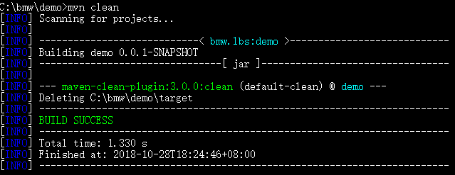

1. Run command “mvn install”

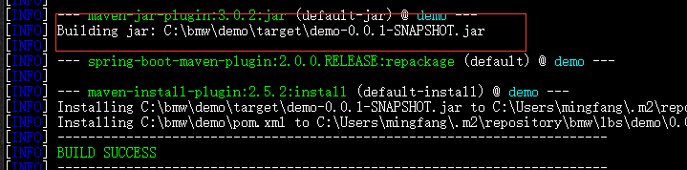

1. As you can see the package it under the foder, “c:\bwm\demo\target” and If you want to run it, to go the folder, and run it with “java -jar xxx.jar”, like below:

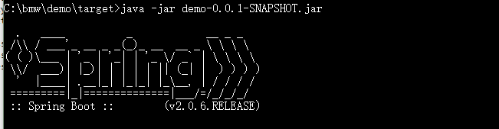

# How to verify the RESTful API

The general process is to access the login resource to create a token, and user will use that token to access other APIs, below are concrete steps:

1. How to create the token?

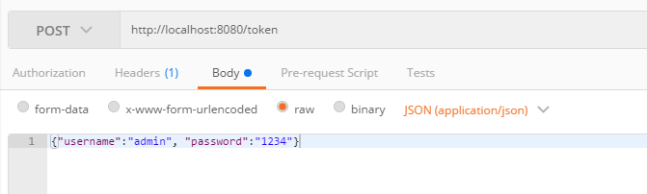

Then you will get a token like this:

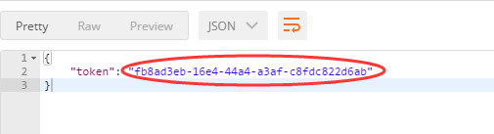

Remember this token, you need this to access other APIs!

1. How to “Get all sessions of a vehicle in correct ordering”?

The URL is: localhost:8080/sessions/WLQBNAL7EM14E3N/

“WLQBNAL7EM14E3N” is the vehicle ID and we need to put the token at the header, please refer below, please note that the before the token, there is some word “bearer “

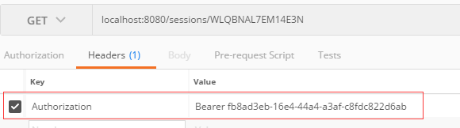

1. Get a single session as an ordered list of the received positions by timestamp?

localhost:8080/sessions/WLQBNAL7EM14E3N/date?timestamp=1519990625885

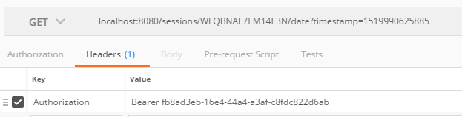

1. Get the last position of a certain vehicle?

The URL is like this “localhost:8080/sessions/WLQBNAL7EM14E3N/last/”

