Tourism Points - Architecture Documentation

Table of Contents
- System Overview
- Technology Stack
- Solution Structure
- System Architecture
- Sequence Diagrams
- Data Models
- API Endpoints
- Configuration
- Project Dependencies

System Overview
The Tourism Points (Portuguese: Pontos Turísticos) application is a full-stack web application for managing Brazilian tourist destinations. It provides a complete CRUD (Create, Read, Update, Delete) interface for tourist point records with the following features:
- List tourist points with pagination and search functionality
- View individual tourist point details
- Create new tourist point entries
- Update existing tourist point information
- Delete tourist point records
- Auto-seeding of 20 sample Brazilian tourist points on first run

Architecture Pattern
The application follows a Layered Architecture with clear separation of concerns:
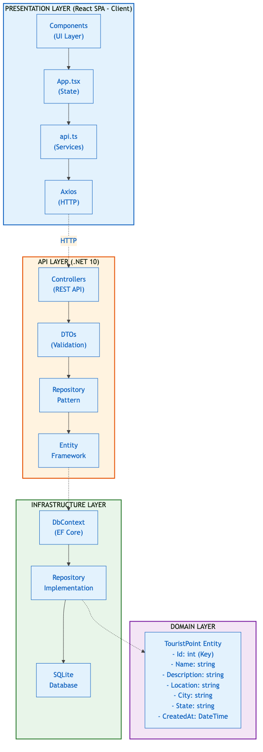
Layered Architecture

Technology Stack
Layer | Technology | Version
Frontend Framework | React + Vite + TypeScript | React 18.x, Vite 6.x
HTTP Client | Axios | Latest
Backend Framework | ASP.NET Core | .NET 10 (net10.0)
ORM | Entity Framework Core | EF Core 10
Database | SQLite | Bundled with EF Core
Logging | Serilog | Latest
API Documentation | Swagger/OpenAPI | Swashbuckle 7.2

Solution Structure
tourism-points/
├── TourismPoints.slnx # Solution file (XML format)
├── README.md # Project documentation
├── ARCHITECTURE.md # This file
├── .gitignore
│
├── src/
│ ├── TourismPoints.API/ # ASP.NET Core Web API (Entry Point)
│ │ ├── Controllers/
│ │ │ └── TouristPointsController.cs # REST API endpoints
│ │ ├── DTOs/
│ │ │ ├── CreateTouristPointDto.cs # Input validation DTO
│ │ │ └── TouristPointDto.cs # Output DTO
│ │ ├── ExceptionHandling/
│ │ │ └── GlobalExceptionHandler.cs # Global exception handling
│ │ ├── Program.cs # Application configuration & DI
│ │ ├── TourismPoints.API.csproj
│ │ └── Properties/
│ │ └── launchSettings.json # Port configuration (5151)
│ │
│ ├── TourismPoints.Domain/ # Domain Layer
│ │ ├── Entities/
│ │ │ └── TouristPoint.cs # Core entity definition
│ │ └── TourismPoints.Domain.csproj
│ │
│ ├── TourismPoints.Infrastructure/ # Data Access Layer
│ │ ├── Context/
│ │ │ └── TourismDbContext.cs # EF Core DbContext
│ │ ├── Repositories/
│ │ │ ├── ITouristPointRepository.cs # Repository interface
│ │ │ └── TouristPointRepository.cs # Repository implementation
│ │ ├── Data/
│ │ │ └── TourismDbSeeder.cs # Seeds 20 sample tourist points
│ │ └── TourismPoints.Infrastructure.csproj
│ │
│ └── TourismPoints.Client/ # React Frontend
│ ├── src/
│ │ ├── components/
│ │ │ ├── TouristPointForm.tsx # Create/Edit form
│ │ │ ├── TouristPointList.tsx # List with pagination
│ │ │ ├── TouristPointHome.tsx # Home page
│ │ │ ├── BrandLogo.tsx # Logo component
│ │ │ └── BrowserWindow.tsx # Layout wrapper
│ │ ├── services/
│ │ │ └── api.ts # API client (Axios)
│ │ ├── App.tsx # Main app component
│ │ ├── App.css # Styles
│ │ ├── index.css # Global styles
│ │ └── main.tsx # Entry point
│ ├── vite.config.ts # Vite config (port 5175)
│ └── package.json
│
└── tests/
└── TourismPoints.Tests/ # Unit Tests
├── Controllers/
│ └── TouristPointsControllerTests.cs
├── Repositories/
│ └── TouristPointRepositoryTests.cs
└── TourismPoints.Tests.csproj

System Architecture

Request/Response Flow
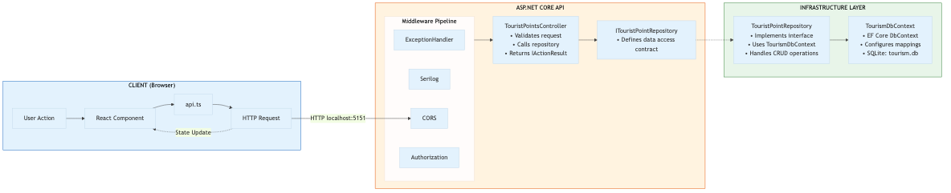
Request/Response Flow

Dependency Injection Configuration
The following services are registered in Program.cs:
// Database
builder.Services.AddDbContext<TourismDbContext>(options =>
options.UseSqlite("Data Source=tourism.db"));
// Repository Pattern
builder.Services.AddScoped<ITouristPointRepository, TouristPointRepository>();
// CORS Policy
builder.Services.AddCors(options =>
{
options.AddPolicy("AllowReact", policy =>
{
policy.WithOrigins("http://localhost:5175")
.AllowAnyMethod()
.AllowAnyHeader();
});
});

Sequence Diagrams

1. Get All Tourist Points (with Pagination & Search)
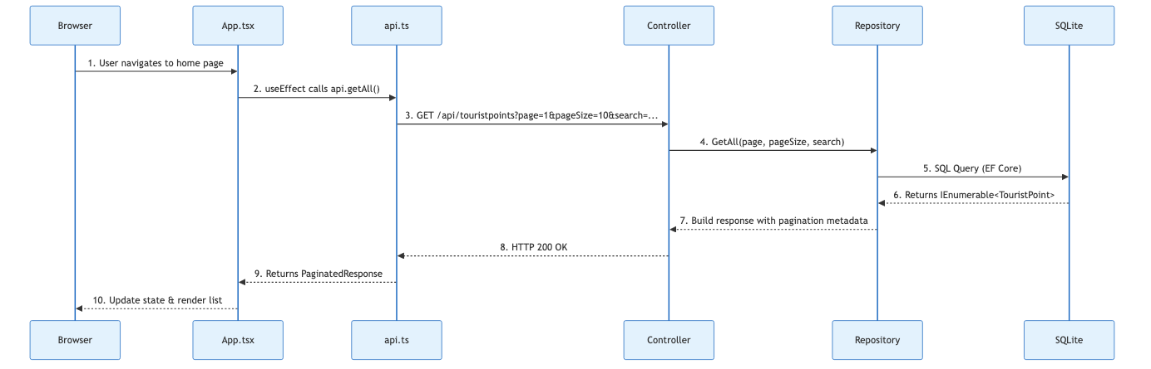
Get All Tourist Points

2. Get Single Tourist Point
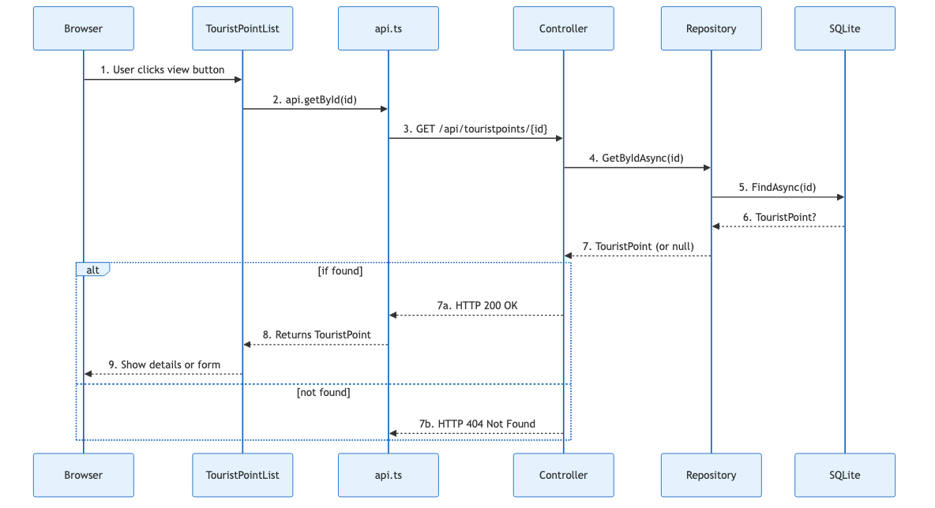
Get Single Tourist Point

3. Create Tourist Point
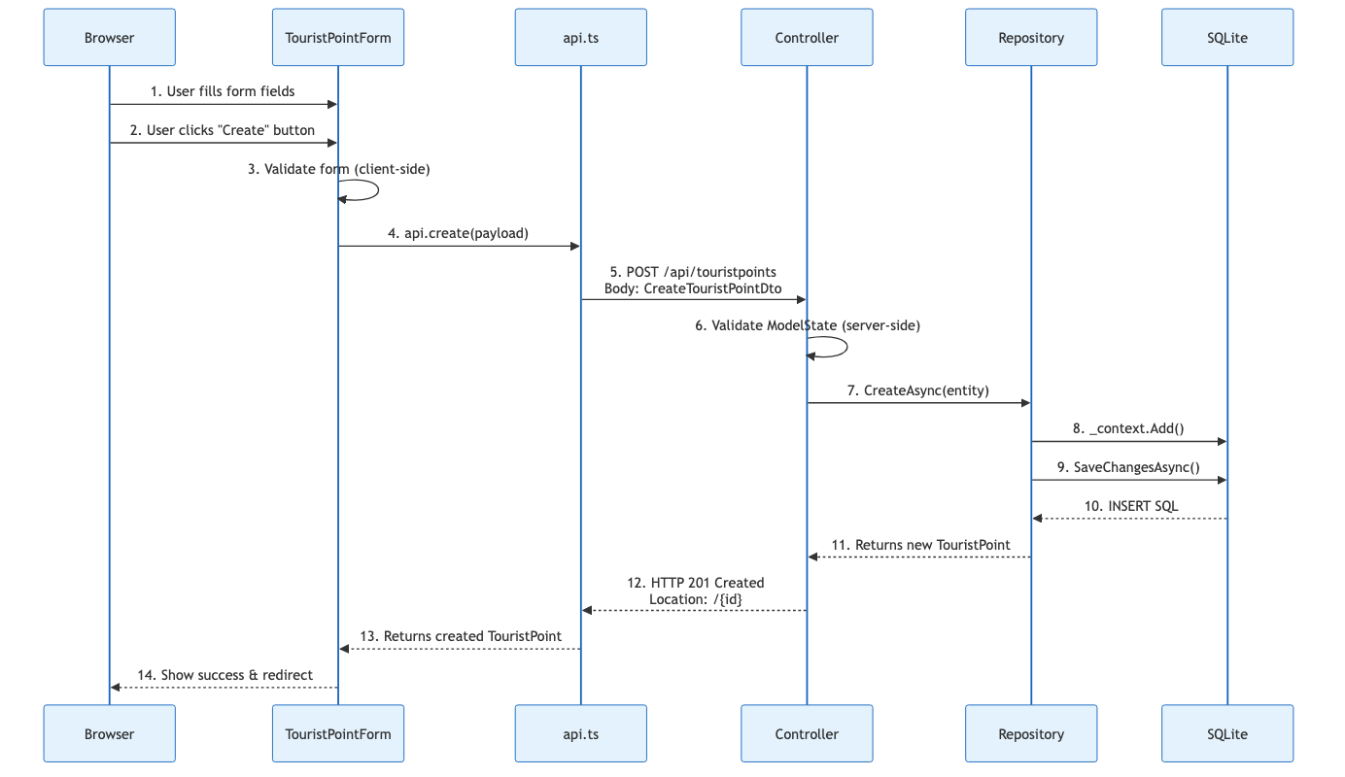
Create Tourist Point

4. Update Tourist Point
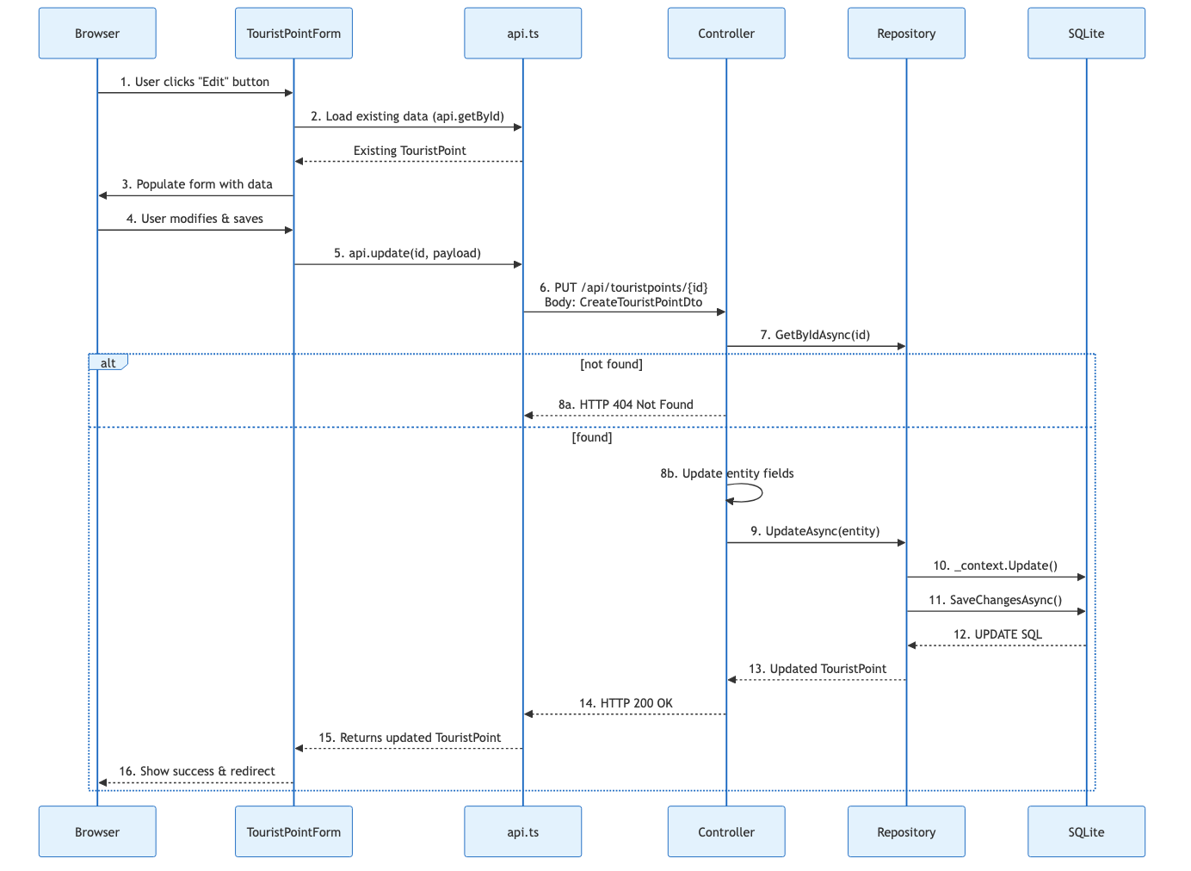
Update Tourist Point

5. Delete Tourist Point
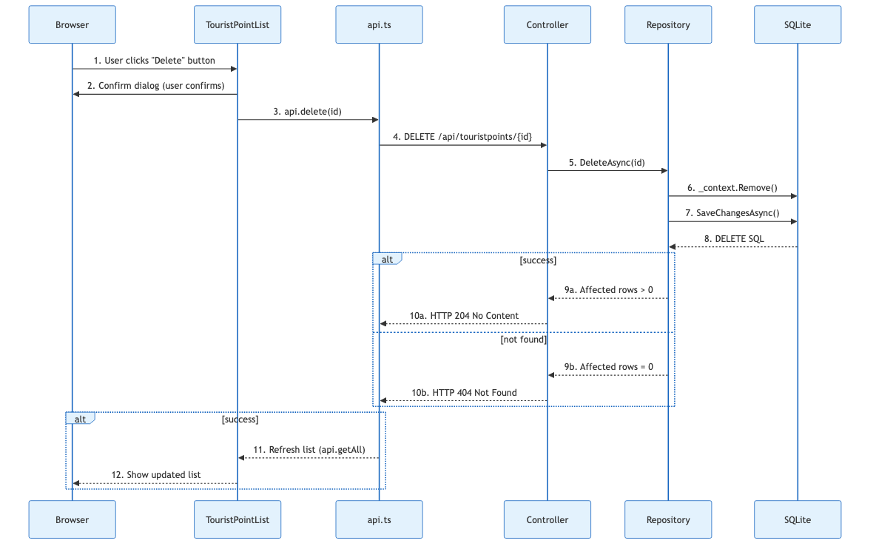
Delete Tourist Point

Data Models

TouristPoint Entity
Located in TouristPoint.cs:
public class TouristPoint
{
[Key]
public int Id { get; set; }
[Required]
[MaxLength(100)]
public string Name { get; set; } = string.Empty;
[Required]
[MaxLength(100)]
public string Description { get; set; } = string.Empty;
[Required]
public string Location { get; set; } = string.Empty;
[Required]
public string City { get; set; } = string.Empty;
[Required]
[StringLength(2)]
public string State { get; set; } = string.Empty;
public DateTime CreatedAt { get; set; } = DateTime.UtcNow;
}

DTOs
CreateTouristPointDto (Input):
public class CreateTouristPointDto
{
[Required]
[MaxLength(100)]
public string Name { get; set; } = string.Empty;
[Required]
[MaxLength(100)]
public string Description { get; set; } = string.Empty;
[Required]
public string Location { get; set; } = string.Empty;
[Required]
public string City { get; set; } = string.Empty;
[Required]
[StringLength(2)]
public string State { get; set; } = string.Empty;
}
TouristPointDto (Output):
public class TouristPointDto
{
public int Id { get; set; }
public string Name { get; set; } = string.Empty;
public string Description { get; set; } = string.Empty;
public string Location { get; set; } = string.Empty;
public string City { get; set; } = string.Empty;
public string State { get; set; } = string.Empty;
public DateTime CreatedAt { get; set; }
}

API Endpoints
Base URL: http://localhost:5151/api
Method | Endpoint | Description | Request Body | Response
GET | /api/touristpoints | List all with pagination | Query: page, pageSize, search | PaginatedResponse
GET | /api/touristpoints/{id} | Get single by ID | - | TouristPointDto or 404
POST | /api/touristpoints | Create new | CreateTouristPointDto | 201 Created
PUT | /api/touristpoints/{id} | Update existing | CreateTouristPointDto | TouristPointDto or 404
DELETE | /api/touristpoints/{id} | Delete by ID | - | 204 No Content or 404

Paginated Response Format
{
"items": [TouristPoint],
"totalCount": 20,
"page": 1,
"pageSize": 10,
"totalPages": 2
}

Configuration

Default Ports
Service | Port | Configuration File
API HTTP | 5151 | src/TourismPoints.API/Properties/launchSettings.json
Frontend Dev | 5175 | src/TourismPoints.Client/vite.config.ts
Frontend HTTPS | 7161 | src/TourismPoints.API/Properties/launchSettings.json

CORS Configuration
The API is configured to accept requests from http://localhost:5175 (frontend dev server). This is configured in Program.cs:
builder.Services.AddCors(options =>
{
options.AddPolicy("AllowReact", policy =>
{
policy.WithOrigins("http://localhost:5175")
.AllowAnyMethod()
.AllowAnyHeader();
});
});

Database
- Engine: SQLite
- File Location: src/TourismPoints.API/tourism.db (auto-created on first run)
- Ignored by Git: .gitignore contains *.db pattern

Project Dependencies

TourismPoints.API
Microsoft.EntityFrameworkCore.Sqlite 10.0.0
Serilog.AspNetCore 9.0.0
Serilog.Settings.Configuration 9.0.0
Serilog.Sinks.Console 6.0.0
Swashbuckle.AspNetCore 7.2.0
→ TourismPoints.Domain
→ TourismPoints.Infrastructure

TourismPoints.Infrastructure
Microsoft.EntityFrameworkCore 10.0.0
Microsoft.EntityFrameworkCore.Sqlite 10.0.0
→ TourismPoints.Domain

TourismPoints.Domain
No external dependencies (pure domain layer)

TourismPoints.Client
react, react-dom (React 18.x)
axios (HTTP client)
typescript
vite (build tool)

Document generated: 2026 Target Framework: .NET 10 (net10.0) Architecture: Layered Architecture (API / Domain / Infrastructure)

