info@electrobittech.com

This document provides comprehensive technical documentation for the SNMP-BACnet integration implemented in the T3 ESP32 programmable controller.
SNMP-BACnet Integration Documentation
T3 ESP32 Controller

Contents
Summary 2
Key Achievements 2
System Architecture 2
Overview 2
Component Architecture 2
T3 Specification Compliance 3
Enterprise OID Structure 3
Object Groups and Fields 3
Field Definitions 3
SNMP-BACnet Object Mappings 3
Configuration Type Mapping (cfgType) 3
Data Type Conversion Matrix 4
Engineering Units Mapping 4
Implementation Details 5
File Structure 5
The agent exposes 6
Key Features 6
SNMP Agent Task 7
Testing Procedures 8
Manual Testing 8
Testing Using Scripts 10

Summary
This document provides comprehensive technical documentation for the SNMP-BACnet integration implemented in the T3 ESP32 programmable controller. The integration enables seamless communication between SNMP network management systems and BACnet building automation protocols, providing complete T3 specification compliance.

Key Achievements
- Full T3 specification compliance with enterprise OID `1.3.6.1.4.1.64991.1`
- Complete mapping of 14 configuration types to BACnet objects
- Real-time bidirectional data exchange between SNMP and BACnet
- Production-ready implementation with comprehensive error handling
- Support for 1,152 SNMP MIB entries (3 groups × 6 fields × 64 instances)

System Architecture

Overview
The T3 SNMP-BACnet integration acts as a bridge between two critical building automation protocols:

Component Architecture

SNMP Manager
T3 Controller
Input
BACNet Task
SNMP Agent Task
Output
Variable

T3 Specification Compliance

Enterprise OID Structure
1.3.6.1.4.1. 64991.<group>.<field>.<instance>
├─ 1.3.6.1.4.1 = Enterprise OID (TEMCO)
├─ 64991.1 = T3 Product Family
├─ .Group = [1] Inputs Group / [2] Outputs Group / [3] Variables Group
├─ .Field = Specific Field [0-4]
└─ .instance = Instance [0-63]

Object Groups and Fields
Group | OID Base | Purpose | Instances
t3Inputs | 1.3.6.1.4.1. 64991.1.1 | Input Objects | 0 - 63
t3Outputs | 1.3.6.1.4.1. 64991.1.2 | Output Objects | 0 – 63
t3Variables | 1.3.6.1.4.1. 64991.1.3 | Variable Objects | 0 - 63

Field Definitions
Field | OID Suffix | SNMP Type | Access | Description
index | .0 | INTEGER | RD_ONLY | Instance number
cfgType | .1 | INTEGER | RD_ONLY | Configuration type
analogVal | .2 | GAUGE | RD/WR* | Analog value
binaryVal | .3 | INTEGER | RD/WR* | Binary value
desc | .4 | OCTET_STRING | RD/WR* | Description
units | .5 | INTEGER | RD_ONLY | Engineering units
*Write access depends on object group (inputs are read-only)

SNMP-BACnet Object Mappings

Configuration Type Mapping (cfgType)
cfgType | Value | BACnet Object | Description | Range
T3_CFGTYPE_BI | 1 | BINARY_INPUT | Binary Input | 0/1
T3_CFGTYPE_AI_0_100 | 2 | ANALOG_INPUT | Analog Input 0-100% | 0-100
T3_CFGTYPE_AI_0_10V | 3 | ANALOG_INPUT | Analog Input 0-10V | 0-10V
T3_CFGTYPE_AI_4_20MA | 4 | ANALOG_INPUT | Analog Input 4-20mA | 4-20mA
T3_CFGTYPE_AI_NEG10_10V | 5 | ANALOG_INPUT | Analog Input -10 to +10V | -10V to +10V
T3_CFGTYPE_AI_0_5V | 6 | ANALOG_INPUT | Analog Input 0-5V | 0-5V
T3_CFGTYPE_BO | 7 | BINARY_OUTPUT | Binary Output | 0/1
T3_CFGTYPE_AO_0_10V | 8 | ANALOG_OUTPUT | Analog Output 0-10V | 0-10V
T3_CFGTYPE_AO_4_20MA | 9 | ANALOG_OUTPUT | Analog Output 4-20mA | 4-20mA
T3_CFGTYPE_AO_0_100 | 10 | ANALOG_OUTPUT | Analog Output 0-100% | 0-100%
T3_CFGTYPE_VAR_INT | 11 | CHARACTERSTRING_VALUE | Integer Variable | -2³¹ to 2³¹-1
T3_CFGTYPE_VAR_FLOAT | 12 | CHARACTERSTRING_VALUE | Float Variable | ±3.4×10³
T3_CFGTYPE_VAR_STRING | 13 | CHARACTERSTRING_VALUE | String Variable | 64 chars
T3_CFGTYPE_RESERVED | 14 | N/A | Reserved | N/A

Data Type Conversion Matrix
SNMP Type | BACnet Type | Conversion | Precision
GAUGE | REAL | Float × 1000 → Integer | 3 decimal places
INTEGER | INTEGER | Direct mapping | N/A
OCTET_STRING | CHARACTER_STRING | Direct mapping | N/A

Engineering Units Mapping
T3 Units | BACnet Units | Description
T3_UNITS_NONE | UNITS_NO_UNITS | No units
T3_UNITS_CELSIUS | UNITS_DEGREES_CELSIUS | Degrees Celsius
T3_UNITS_FAHRENHEIT | UNITS_DEGREES_FAHRENHEIT | Degrees Fahrenheit
T3_UNITS_PERCENT | UNITS_PERCENT | Percentage
T3_UNITS_PASCAL | UNITS_PASCALS | Pascals
T3_UNITS_PSI | UNITS_PASCALS | PSI (converted to Pa)
T3_UNITS_MILLIAMPS | UNITS_MILLIAMPERES | Milliamperes
T3_UNITS_VOLTS | UNITS_VOLTS | Volts
T3_UNITS_HERTZ | UNITS_HERTZ | Hertz
T3_UNITS_SECONDS | UNITS_SECONDS | Seconds

Implementation Details

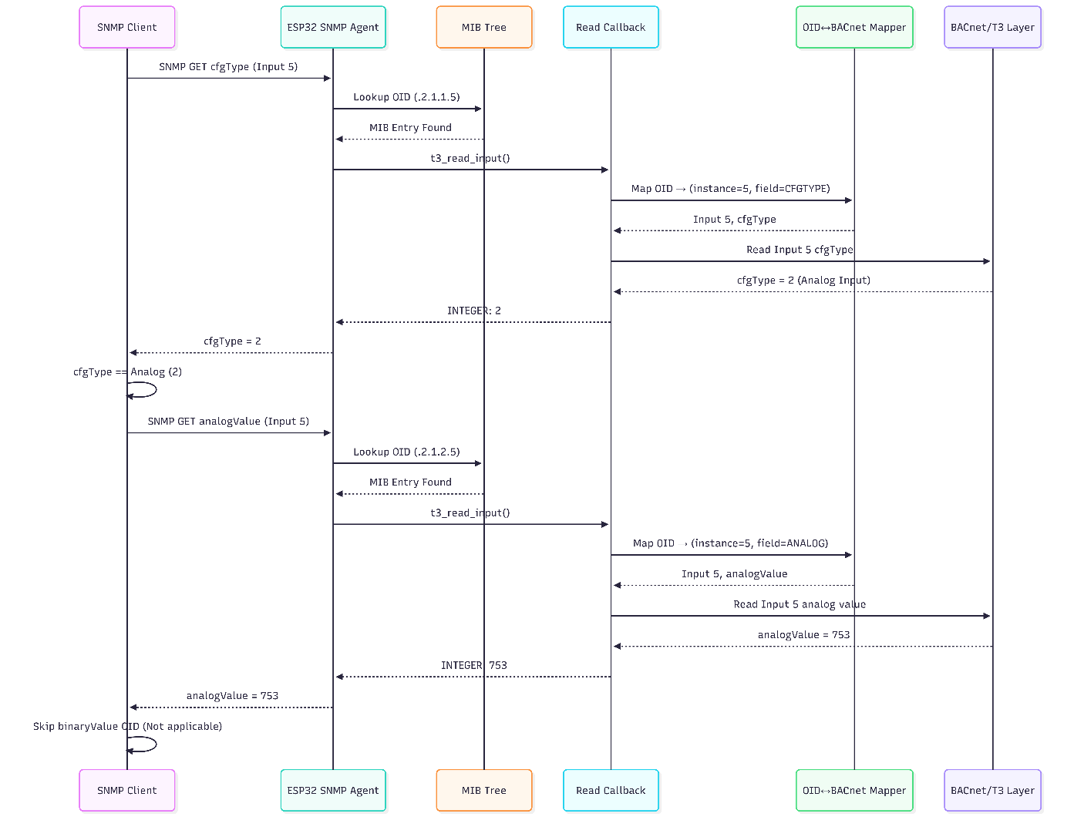

File Structure

main/
├── snmp_interface.c # Main SNMP interface (T3-compliant)
├── t3_snmp_bacnet_mapping.h # Core mapping definitions
├── t3_snmp_bacnet_mapping.c # Mapping implementation
Components
├─ snmp_agent ├─ include (snmp agent core header files)
├─ src (snmp agent core source files)
├─ CMakefile.txt

snmp_agent.h --> uSNMP core agent APIs
snmp_interface.h --> Public SNMP interface
t3_snmp_bacnet_mapping.h --> SNMP ↔ BACnet OID mapping

Once application gets IP address, FreeRTOS application needs to only call snmp_app_init().It will create a separate thread.

The agent exposes
- Standard MIB-II system objects
- Private enterprise MIBs mapped to T3 controller BACnet objects
- Support for SNMP GET / WALK / SET
- Cold-start and enterprise-specific traps
- Dynamic value handling via read/write callbacks
- The SNMP agent runs as a FreeRTOS task and integrates with the existing BACnet/T3 data layer.

Key Features
- SNMP v2c compatible (RO & RW communities)
- Dynamic MIB tree creation
- BACnet ↔ SNMP OID mapping
- Read-only and read-write objects
- Custom enterprise traps
- Modular callback-based design.
Object | OID | Description
sysDescr | 1.3.6.1.2.1.1.1.0 | Device description
sysObjectID | 1.3.6.1.2.1.1.2.0 | Enterprise OID
sysUpTime | 1.3.6.1.2.1.1.3.0 | System uptime
sysContact | 1.3.6.1.2.1.1.4.0 | Admin contact
sysName | 1.3.6.1.2.1.1.5.0 | Device name
sysLocation | 1.3.6.1.2.1.1.6.0 | Physical location

SNMP Agent Task

static void snmp_agent_task(void *pvParameters)
- Wait for network readiness.
- Initialize SNMP core.
- Build MIB tree.
- Send start up traps (ColdStart).
- Process SNMP requests continuously.
initSnmpAgent(SNMP_PORT, ENTERPRISE_OID, RO_COMMUNITY, RW_COMMUNITY);
- Binds SNMP agent to UDP port (161)
- Registers enterprise OID
- Configures community strings
static void init_standard_mibs(void);
- Uses prefix B → 1.3.6.1.2.1
- Implements standard SNMP system objects
- Uses callbacks for dynamic values (uptime, IP)
SNMP ↔ BACnet Mapping
- Instance number
- Field type
- BACnet object type
- Data representation.
int t3_read_input(MIB *thismib)
Supported Data Types:
- Convert OID to string
- Lookup BACnet mapping
- Read value from BACnet
- Populate SNMP response
- Return SNMP status
int t3_write_output(MIB *thismib, void *ptr, int len)
- Validate input
- Map OID → BACnet object
- Convert SNMP data to BACnet format
- Write value to controller
- Return SNMP status

Sending Trap command to manager
- Cold Start Trap
send_snmp_trap_cold_start(my_ip, manager_ip);
- Enterprise Trap
snmp_trap_enterprise(my_ip, manager_ip, "this is custom trap!!!");

Testing Procedures

All testing has been done using Net-SNMP CLI tool. This is available in both windows and linux OS.
https://github.com/net-snmp/net-snmp
https://www.net-snmp.org/tutorial/tutorial-5/commands/index.html
https://sourceforge.net/projects/net-snmp/files/net-snmp%20binaries/

Manual Testing
- Reading input object 0 (index, cfgType, analogVal, binaryVal, desc, units)
$ snmpget -v2c -L n -c public 192.168.1.15 1.3.6.1.4.1.2026.1.1.0.0 1.3.6.1.4.1.2026.1.1.1.0 1.3.6.1.4.1.2026.1.1.2.0 1.3.6.1.4.1.2026.1.1.3.0 1.3.6.1.4.1.2026.1.1.4.0 1.3.6.1.4.1.2026.1.1.5.0
iso.3.6.1.4.1.64991.1.1.0.0 = INTEGER: 0
iso.3.6.1.4.1.64991.1.1.1.0 = INTEGER: 1
iso.3.6.1.4.1.64991.1.1.2.0 = INTEGER: 0
iso.3.6.1.4.1.64991.1.1.3.0 = INTEGER: 0
iso.3.6.1.4.1.64991.1.1.4.0 = STRING: "INPUT_0"
iso.3.6.1.4.1.64991.1.1.5.0 = INTEGER: 1
- Read the Conﬁguration First:

# Ask the device: "How is Input 5 configured?"
snmpget -v2c -c public 192.168.1.100 .1.3.6.1.4.1.2026.2.1.1.5
Result: iso.3.6.1.4.1.2026.2.1.1.5 = INTEGER: 2 (Meaning: It's an Analog Input)

- Read the Correct Value Based on Conﬁguration:
# Ask the device: "What is the analog value of Input 5?"
snmpget -v2c -c public 192.168.1.100 .1.3.6.1.4.1.2026.2.1.2.5

Result: iso.3.6.1.4.1.2026.2.1.2.5 = INTEGER: 753

The client would ignore the inputBinaryValue OID for this input.

- Read/Write Value for OIDS

snmpset -v2c -L n -c private 192.168.1.15 1.3.6.1.4.1.2026.1.2.3.0 i 30
iso.3.6.1.4.1.2026.1.2.3.0 = INTEGER: 30

snmpget -v2c -L n -c public 192.168.1.15 1.3.6.1.4.1.2026.1.2.3.0
iso.3.6.1.4.1.2026.1.2.3.0 = INTEGER: 30

snmpset -v2c -L n -c private 192.168.1.15 1.3.6.1.4.1.2026.1.3.3.1 i 50
iso.3.6.1.4.1.2026.1.3.3.1 = INTEGER: 50

nmpget -v2c -L n -c public 192.168.1.15 1.3.6.1.4.1.2026.1.3.3.1
iso.3.6.1.4.1.2026.1.3.3.1 = INTEGER: 50

snmpset -v2c -L n -c private 192.168.1.15 1.3.6.1.4.1.2026.1.2.4.0 s OP_T1
iso.3.6.1.4.1.2026.1.2.4.0 = STRING: "OP_T1"

snmpget -v2c -L n -c private 192.168.1.15 1.3.6.1.4.1.2026.1.2.4.0
iso.3.6.1.4.1.2026.1.2.4.0 = STRING: "OP_T1"

nmpget -v2c -L n -c private 192.168.1.15 1.3.6.1.4.1.2026.1.3.4.0
iso.3.6.1.4.1.2026.1.3.4.0 = STRING: "VAR_0"

snmpset -v2c -L n -c private 192.168.1.15 1.3.6.1.4.1.2026.1.3.4.0 s "VAR_XL"
iso.3.6.1.4.1.2026.1.3.4.0 = STRING: "VAR_XL"

snmpget -v2c -L n -c private 192.168.1.15 1.3.6.1.4.1.2026.1.3.4.0
iso.3.6.1.4.1.2026.1.3.4.0 = STRING: "VAR_XL"

snmpget -v2c -L n -c private 192.168.1.15 1.3.6.1.4.1.2026.1.3.2.0
iso.3.6.1.4.1.2026.1.3.2.0 = INTEGER: 0

snmpset -v2c -L n -c private 192.168.1.15 1.3.6.1.4.1.2026.1.3.2.0 i 77
iso.3.6.1.4.1.2026.1.3.2.0 = INTEGER: 77

snmpget -v2c -L n -c private 192.168.1.15 1.3.6.1.4.1.2026.1.3.2.0
iso.3.6.1.4.1.2026.1.3.2.0 = INTEGER: 77

- Testing Trap
TRAP message will be sent to remote machine snmp manager. Remote machine needs to start snmptrapd and then restart esp device.

There will also an INFORM command send to remote machine and also ACK will be received.
In snmp_interface.h, we can configure TRAP_DST_ADDR and ENTERPRISE_OID macros.
ESP Debug Logs

I (4408) esp_netif_handlers: sta ip: 192.168.1.12, mask: 255.255.255.0, gw: 192.168.1.1
I (4408) wifi station: got ip:192.168.1.12
I (4408) wifi station: Starting SNMP agent
I (4408) snmp_agent: T3 SNMP agent initialized
I (4418) wifi station: connected to ap SSID:FM360 password:novakdjokovic
I (7418) snmp_agent: Initializing T3 SNMP MIB tree (instances=64)
I (9338) snmp_agent: initMibTree complete
I (9338) SNMP_TRAP: SNMP TRAP sent to 192.168.1.10
I (9338) SNMP_TRAP: SNMP INFORM sent to 192.168.1.10
I (9528) wifi:<ba-add>idx:1 (ifx:0, 0a:aa:89:9a:33:aa), tid:6, ssn:2, winSize:64
I (9838) SNMP_TRAP: INFORM ACK received

SNMP NET CLI Logs

$ snmptrapd -f -Lo -n
NET-SNMP version 5.5.1
2026-01-27 20:57:59 UDP: [192.168.1.12]:57255->[0.0.0.0] [UDP: [192.168.1.12]:57255->[0.0.0.0]]:
iso.3.6.1.2.1.1.3.0 = Timeticks: (882) 0:00:08.82 iso.3.6.1.6.3.1.1.4.1.0 = OID: iso.3.6.1.6.3.1.1.5.1
2026-01-27 20:57:59 UDP: [192.168.1.12]:57255->[0.0.0.0] [UDP: [192.168.1.12]:57255->[0.0.0.0]]:
iso.3.6.1.2.1.1.3.0 = Timeticks: (882) 0:00:08.82 iso.3.6.1.6.3.1.1.4.1.0 = OID: iso.3.6.1.6.3.1.1.5.1
2026-01-27 20:57:59 UDP: [192.168.1.12]:57256->[0.0.0.0] [UDP: [192.168.1.12]:57256->[0.0.0.0]]:
iso.3.6.1.2.1.1.3.0 = Timeticks: (882) 0:00:08.82 iso.3.6.1.6.3.1.1.4.1.0 = OID: iso.3.6.1.4.1.999.1 iso.3.6.1.4.1.999.1.1 = STRING: "this is custom trap!!!"

Testing Using Scripts
In script directory, there are three bat scripts which we can used to read all objects in bulk or individually. There scripts internally use SNMP Net CLI tools.
Below command reads all objects (0-63) of particular types.
- read_T3_input.bat 192.168.1.12
- read_T3_ouput.bat 192.168.1.12
- read_T3_variable.bat 192.168.1.12

Reading particular object by providing object index in argument.
read_T3_input.bat 192.168.1.12 1
===============================
Testing Object 1
===============================
iso.3.6.1.4.1.64991.1.1.0.1 = INTEGER: 1
iso.3.6.1.4.1.64991.1.1.1.1 = INTEGER: 1
iso.3.6.1.4.1.64991.1.1.2.1 = INTEGER: 100
iso.3.6.1.4.1.64991.1.1.3.1 = INTEGER: 100
iso.3.6.1.4.1.64991.1.1.4.1 = STRING: "INPUT_1"
iso.3.6.1.4.1.64991.1.1.5.1 = INTEGER: 1

Done.

