Create File10 master branch

Add image of a rabbit to File10 – rabbits branch

[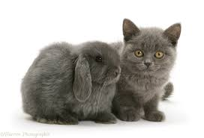](https://www.google.co.uk/imgres?imgurl=https%3A%2F%2Fwww.warrenphotographic.co.uk%2Fphotography%2Fbigs%2F17893-Grey-kitten-and-grey-rabbit-white-background.jpg&imgrefurl=https%3A%2F%2Fwww.warrenphotographic.co.uk%2F17893-grey-kitten-and-grey-rabbit&docid=k0vjyhd0qD3OyM&tbnid=SA0wTbyCvr57fM%3A&vet=10ahUKEwjF3KO5uv_hAhU8UBUIHeSbBs8QMwhmKBkwGQ..i&w=1618&h=1104&bih=861&biw=1920&q=grey%20rabbit%20images&ved=0ahUKEwjF3KO5uv_hAhU8UBUIHeSbBs8QMwhmKBkwGQ&iact=mrc&uact=8)