Adaptive DSR Route Cache Parameter Sweep Report
Fernando Molina Rodriguez, Rajat Chaudhary.

Introduction
This project studies Dynamic Source Routing (DSR) behavior in ns-3 MANET simulations. DSR relies on cached route and link information to avoid repeated route discovery, but that cache can become harmful when nodes move quickly. A route that was valid a few seconds ago may now point through a broken link, causing packets to be lost before DSR discovers a better route.
The new adaptive DSR experiment keeps the standard ns-3 manet-routing-compare topology and metrics, but changes the cache lifetime assumptions. The central idea is simple: when mobility is high, DSR should trust cached state for less time. The experiment applies this by scaling RouteCacheTimeout, InitStability, and UseExtends from node speed.

Experiment Design
The sweep tested four parameter scales relative to the original DSR cache values:
- 10% of original parameters
- 50% of original parameters
- 110% of original parameters
- 150% of original parameters
Original parameter bases:
Parameter | Original Value
RouteCacheTimeout | 300 s
InitStability | 25 s
UseExtends | 120 s

The adaptive formula used by the simulation is:
adaptive_value = clamp(base_value * cache_reference_speed / node_speed,
min_value,
max_value)
The formula variables are:
Variable | Meaning | Value Used In This Sweep
adaptive_value | Final timer value passed into ns-3 DSR for the current run. This is the value DSR actually uses. | Depends on the run and parameter
base_value | The starting cache timer before mobility scaling. In the sweep, this is the original DSR value multiplied by 10%, 50%, 110%, or 150%. | Varies by run
cache_reference_speed | The mobility speed where the base value should be preserved. If node_speed equals this value, the multiplier is 1.0. | 5 m/s
node_speed | Scenario mobility speed used to scale cache trust. Higher speed means cached routes are assumed to become stale faster. | 20 m/s
min_value | Lower safety bound. This prevents the adaptive value from becoming too aggressive or unrealistically small. | Parameter-specific
max_value | Upper safety bound. This prevents the adaptive value from becoming too long-lived. | Parameter-specific
clamp(...) | Bounds the scaled value so it stays between min_value and max_value. | n/a

For these runs, cache_reference_speed=5 m/s and node_speed=20 m/s, so:
mobility_scale = cache_reference_speed / node_speed
= 5 / 20
= 0.25
That means the adaptive experiment initially tries to use 25% of each run's base value. The final value may still be raised or lowered by clamp if it falls outside the configured bounds.
The bounds used by this experiment are:
Parameter | min_value | max_value | Why It Matters
RouteCacheTimeout | 30 s | 300 s | Controls how long cached routes can remain usable before expiring.
InitStability | 2 s | 25 s | Controls the initial expected stability assigned to a newly learned link in LinkCache.
UseExtends | 10 s | 120 s | Controls how much successful link use extends confidence in that link.

Example for the 50% run:
base RouteCacheTimeout = 300 s * 0.50 = 150 s
adaptive RouteCacheTimeout = clamp(150 * 0.25, 30, 300)
= clamp(37.5, 30, 300)
= 37.5 s
base InitStability = 25 s * 0.50 = 12.5 s
adaptive InitStability = clamp(12.5 * 0.25, 2, 25)
= 3.125 s
base UseExtends = 120 s * 0.50 = 60 s
adaptive UseExtends = clamp(60 * 0.25, 10, 120)
= 15 s
This is why the 50% adaptive run does not use the fixed 50% values directly. It first scales the original DSR values to 50%, then applies the mobility-aware 0.25 multiplier.

Implementation Summary
The adaptive experiment was implemented in ns-3.46.1/examples/routing/manet-routing-compare-adaptive-cache.cc. It started as a copy of ns-3's manet-routing-compare example, then was modified to expose DSR cache controls, compute mobility-scaled values, apply those values before DSR is installed, and store run outputs in project-local folders.

Command-Line Controls
The experiment adds command-line arguments so cache behavior can be changed without recompiling:
cmd.AddValue("adaptiveRouteCache",
"Enable adaptive DSR route cache timeout",
m_adaptiveRouteCache);
cmd.AddValue("adaptiveLinkStability",
"Enable adaptive DSR LinkCache InitStability and UseExtends",
m_adaptiveLinkStability);
cmd.AddValue("cacheType", "DSR route cache type (PathCache or LinkCache)", m_cacheType);
cmd.AddValue("baseRouteCacheTimeout",
"Base DSR route cache timeout in seconds",
m_baseRouteCacheTimeout);
cmd.AddValue("baseInitStability",
"Base DSR LinkCache InitStability in seconds",
m_baseInitStability);
cmd.AddValue("baseUseExtends", "Base DSR LinkCache UseExtends in seconds", m_baseUseExtends);
cmd.AddValue("cacheReferenceSpeed",
"Mobility speed in m/s where the base cache timeout is used",
m_cacheReferenceSpeed);
The key point is that the same executable can run either adaptive-cache DSR or fixed-cache DSR. The fixed-cache comparison runs used:
adaptiveRouteCache=false
adaptiveLinkStability=false

Adaptive Timer Calculation
The adaptive logic is applied only for DSR. The simulation computes a mobility scale from the reference speed and scenario node speed:
const double speed = std::max(1.0, static_cast<double>(nodeSpeed));
const double mobilityScale = m_cacheReferenceSpeed / speed;
Then RouteCacheTimeout is shortened or lengthened from the chosen base value:
m_effectiveRouteCacheTimeout = m_baseRouteCacheTimeout;
if (m_adaptiveRouteCache)
{
const double scaledTimeout = m_baseRouteCacheTimeout * mobilityScale;
m_effectiveRouteCacheTimeout =
std::clamp(scaledTimeout, m_minRouteCacheTimeout, m_maxRouteCacheTimeout);
}
The LinkCache stability values are adapted the same way:
m_effectiveInitStability = m_baseInitStability;
m_effectiveUseExtends = m_baseUseExtends;
if (m_adaptiveLinkStability)
{
m_effectiveInitStability =
std::clamp(m_baseInitStability * mobilityScale,
m_minInitStability,
m_maxInitStability);
m_effectiveUseExtends =
std::clamp(m_baseUseExtends * mobilityScale, m_minUseExtends, m_maxUseExtends);
}
The clamp bounds matter. They prevent aggressive sweep values from becoming unrealistically small and prevent large sweep values from growing without limit.

Applying The Values To DSR
The computed values are applied with Config::SetDefault before the DSR helper installs routing on the nodes:
Config::SetDefault("ns3::dsr::DsrRouting::CacheType", StringValue(m_cacheType));
Config::SetDefault("ns3::dsr::DsrRouting::RouteCacheTimeout",
TimeValue(Seconds(m_effectiveRouteCacheTimeout)));
Config::SetDefault("ns3::dsr::DsrRouting::InitStability",
TimeValue(Seconds(m_effectiveInitStability)));
Config::SetDefault("ns3::dsr::DsrRouting::UseExtends",
TimeValue(Seconds(m_effectiveUseExtends)));
This placement is important. If the values are set after dsrMain.Install(dsr, adhocNodes), the DSR objects may already have been created with their old defaults. Setting them first ensures the experiment actually changes the DSR route-cache behavior.

Metrics Collection
Packet reception is counted in ReceivePacket():
bytesTotal += packet->GetSize();
packetsReceived += 1;
Then CheckThroughput() writes one CSV row per simulated second:
double kbs = (bytesTotal * 8.0) / 1000;
out << (Simulator::Now()).GetSeconds() << "," << kbs << "," << packetsReceived << ","
<< m_nSinks << "," << m_protocolName << "," << m_txp << "" << std::endl;
This preserves the original manet-routing-compare style metrics while letting the cache policy change.

Output Folder Modification
The experiment was also modified to store metrics under the project directory instead of /tmp:
std::string m_outputDirectory{
"/Users/fmolinar/Documents/school/csci256-wireless-spring26/ns3-dsr/simulation-results/"
"adaptive-cache"};
std::string m_runLabel{"linkcache-tuned"};
When no exact CSVfileName is provided, it creates a timestamped folder:
m_runDirectory = (fs::path(m_outputDirectory) / (m_runLabel + "-" + MakeTimestamp())).string();
fs::create_directories(m_runDirectory);
m_CSVfileName = (fs::path(m_runDirectory) / "metrics.csv").string();
This made the parameter sweep manageable because each run can keep its own metrics.csv, run.log, and README without overwriting previous results.

Simulation Scenario
The scenario remains aligned with ns-3's default MANET routing comparison example:
Setting | Value
Nodes | 50
Area | 300 m x 1500 m
Mobility | RandomWaypointMobilityModel
Speed | 0-20 m/s
Pause | 0 s
Simulation time | 200 s
Traffic start | Random between 100 and 101 s
Traffic pairs | 10 one-to-one UDP source/sink pairs
Packet size | 64 bytes
Application rate | 2048 bps
WiFi mode | 802.11b, DsssRate11Mbps
Propagation | FriisPropagationLossModel
Tx power | 7.5 dBm

Results
Run | Base Timeout | Effective Timeout | Effective InitStability | Effective UseExtends | Total Packets | Avg kbps | Peak kbps
10% | 30 s | 30 s | 2 s | 10 s | 1165 | 2.982 | 37.888
50% | 150 s | 37.5 s | 3.125 s | 15 s | 1261 | 3.228 | 32.256
110% | 330 s | 82.5 s | 6.875 s | 33 s | 1207 | 3.09 | 14.848
150% | 450 s | 112.5 s | 9.375 s | 45 s | 1097 | 2.808 | 33.28

The best run in this sweep was 50%, with 1261 packets received and an average receive rate of 3.228 kbps over the full 200-second simulation.
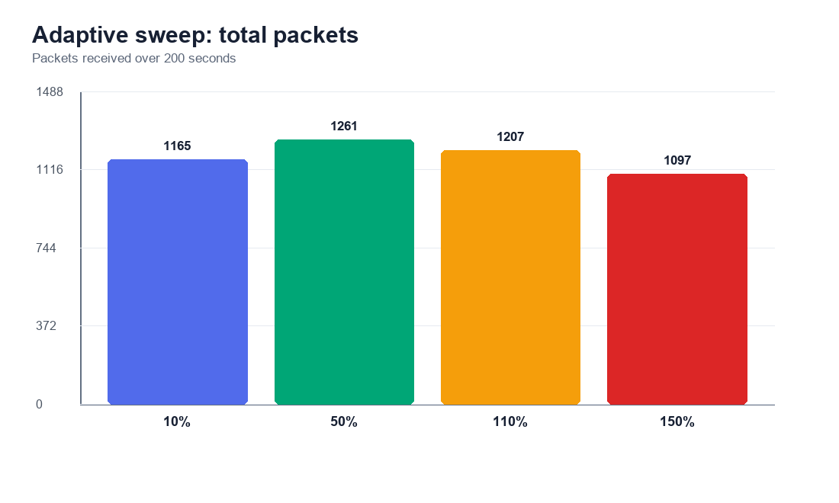
Total packets
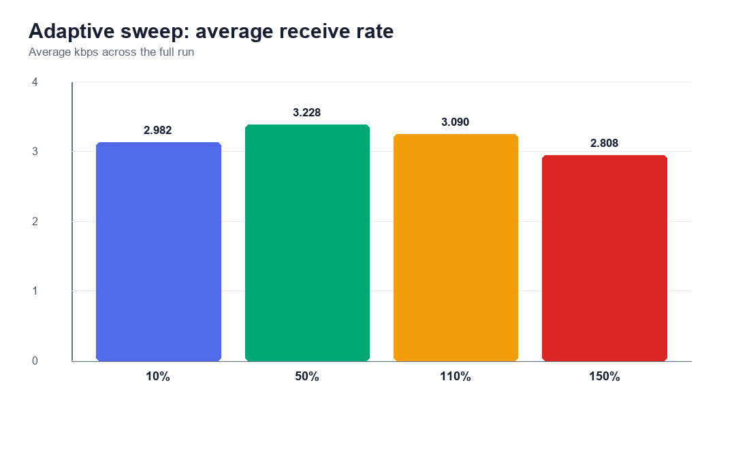
Average receive rate
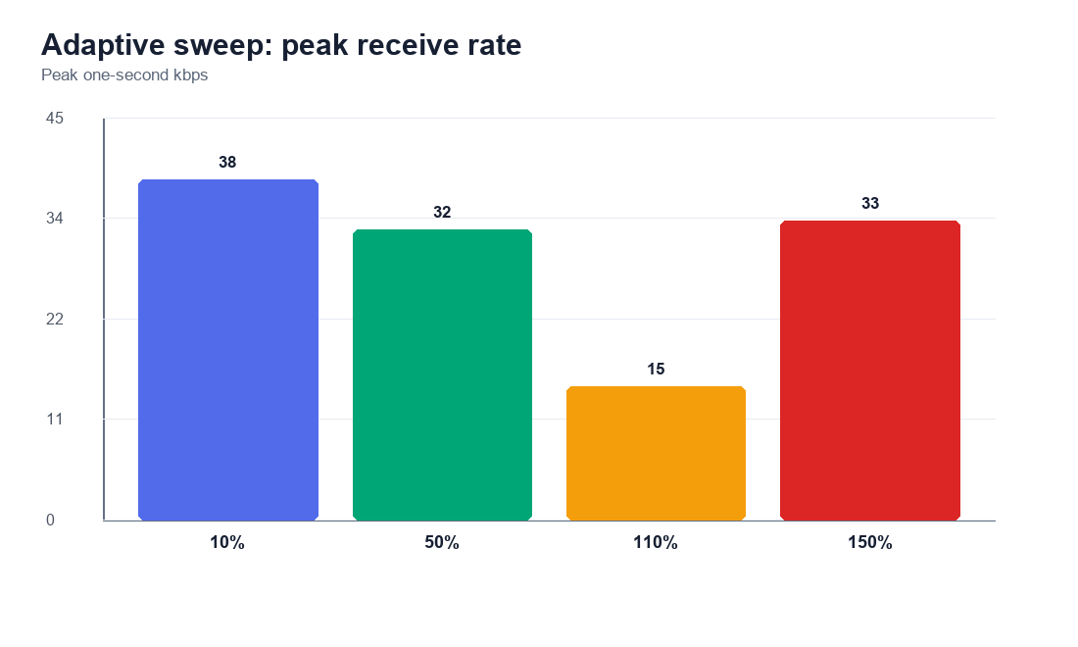
Peak receive rate
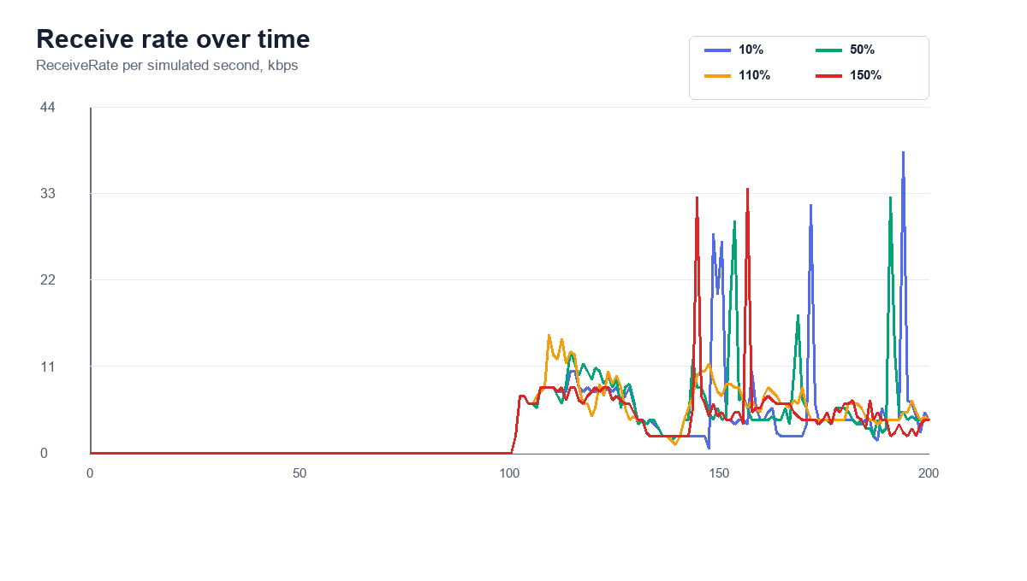
Receive rate over time

Interpretation
The 50% setting produced the strongest packet delivery in this sweep. That suggests that the original cache assumptions may still be too optimistic for this high-mobility scenario, but cutting them too aggressively can also leave performance on the table.
The 10% run still performed well, but its effective values were clamped to minimums for all three tuned parameters. This means it represents the lower bound behavior more than a pure 10% scaling result.
The 110% and 150% runs were weaker than 50%. This supports the route-staleness hypothesis: longer cache/link stability assumptions allow DSR to reuse stale state more often under mobility, which can reduce delivery.

Fixed-Cache Comparison
After the initial adaptive-only sweep, a second set of runs was added to compare against fixed-cache DSR behavior using the same parameter percentages. These comparator runs use the same topology, traffic, and metrics, but set:
adaptiveRouteCache=false
adaptiveLinkStability=false
So, for example, the 50% fixed run uses RouteCacheTimeout=150s, InitStability=12.5s, and UseExtends=60s directly. The matching 50% adaptive run scales those values by mobility and uses RouteCacheTimeout=37.5s, InitStability=3.125s, and UseExtends=15s.
Run | Adaptive Effective Timeout | Fixed Timeout | Adaptive Packets | Fixed Packets | Adaptive Delta | Adaptive Avg kbps | Fixed Avg kbps
10% | 30 s | 30 s | 1165 | 1260 | -95 (-7.54%) | 2.982 | 3.226
50% | 37.5 s | 150 s | 1261 | 1088 | +173 (15.901%) | 3.228 | 2.785
110% | 82.5 s | 330 s | 1207 | 880 | +327 (37.159%) | 3.09 | 2.253
150% | 112.5 s | 450 s | 1097 | 833 | +264 (31.693%) | 2.808 | 2.132

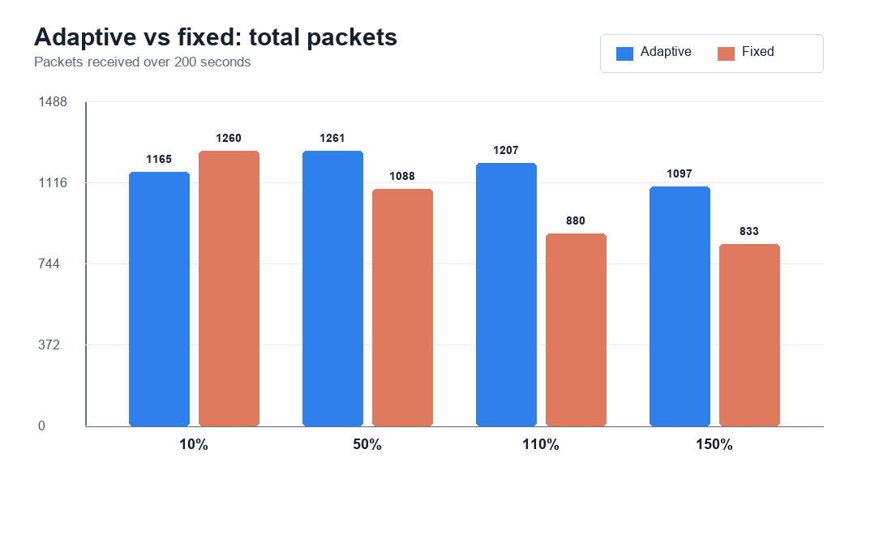
Adaptive vs fixed total packets
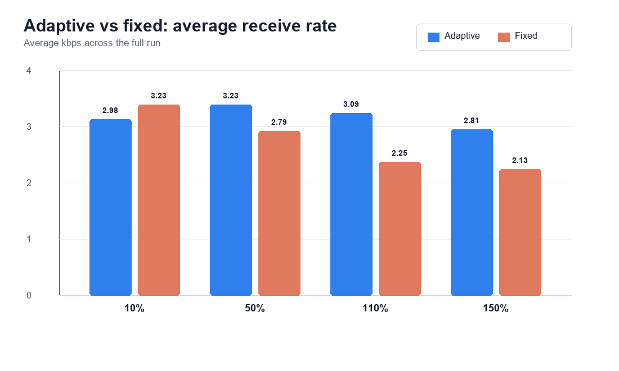
Adaptive vs fixed average receive rate
The fixed comparison shows that adaptive tuning helped at 50%, 110%, and 150%, but not at 10%. The 10% adaptive run hits the configured minimums, while the fixed 10% run uses an even smaller InitStability base than the adaptive minimum would allow. That makes the 10% point useful, but also a reminder that clamps shape the low end of the experiment.

Notes
- Each CSV has 200 data rows, one per simulated second, plus a header row.
- ReceiveRate is measured in kilobits received during that one-second interval.
- PacketsReceived is the packet count received during that interval.
- These runs used LinkCache, matching the default adaptive experiment configuration.
- The simulation is deterministic for this setup because the example assigns streams for mobility; still, future work should repeat runs across seeds before making strong claims.

Future Work
- Add repeated trials with different random seeds to measure variance.
- Sweep cacheReferenceSpeed separately from the cache parameter bases.
- Compare LinkCache against PathCache across the same percentage settings.
- Add node speed as a command-line option and sweep low, medium, and high mobility scenarios.
- Add node density sweeps, such as 25, 50, 75, and 100 nodes.
- Track routing overhead if we want to measure the tradeoff between better delivery and extra route discovery.
- Consider writing a helper script that runs all sweeps automatically and emits this report after each batch.

