Calculadora con immge button

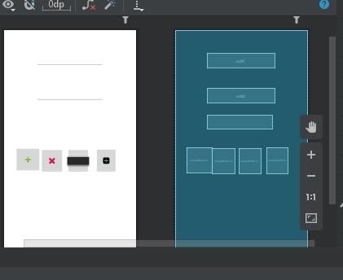

package com.example.myapplication;  
  
import androidx.appcompat.app.AppCompatActivity;  
  
import android.os.Bundle;  
import android.view.View;  
import android.widget.EditText;  
import android.widget.TextView;  
  
public class MainActivity extends AppCompatActivity {  
 private EditText e1,e2;  
 private TextView t1;  
  
 @Override  
 protected void onCreate(Bundle savedInstanceState) {  
 super.onCreate(savedInstanceState);  
 setContentView(R.layout.*activity_main*);  
  
 e1=findViewById(R.id.*edit1*);  
 e2=findViewById(R.id.*edit2*);  
 t1=findViewById(R.id.*Text*);  
 }  
  
 public void sumar(View v){  
 Double valor1=Double.*parseDouble*(e1.getText().toString());  
 Double valor2=Double.*parseDouble*(e2.getText().toString());  
 Double suma=valor1+valor2;  
 t1.setText("resultado:"+suma);  
 }  
 public void restar(View v){  
 int valor1=Integer.*parseInt*(e1.getText().toString());  
 int valor2=Integer.*parseInt*(e2.getText().toString());  
 int resta=valor1-valor2;  
 t1.setText("resultado:"+resta);  
 }  
 public void multi(View v){  
 int valor1=Integer.*parseInt*(e1.getText().toString());  
 int valor2=Integer.*parseInt*(e2.getText().toString());  
 int mult=valor1*valor2;  
 t1.setText("resultado:"+mult);  
 }  
 public void dividir(View v){  
 Double valor1=Double.*parseDouble*(e1.getText().toString());  
 Double valor2=Double.*parseDouble*(e2.getText().toString());  
 Double divide=valor1/valor2;  
 t1.setText("resultado:"+divide);  
 }  
}

calculadora con radio buttons

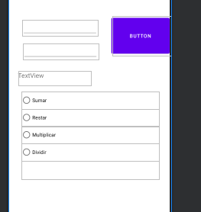

package com.example.myapplication3;  
  
import androidx.appcompat.app.AppCompatActivity;  
  
import android.os.Bundle;  
import android.view.View;  
import android.widget.EditText;  
import android.widget.RadioButton;  
import android.widget.TextView;  
import android.widget.Toast;  
  
public class MainActivity extends AppCompatActivity {  
 private EditText e1,e2;  
 private TextView t1;  
 private RadioButton r1,r2,r3,r4;  
 @Override  
 protected void onCreate(Bundle savedInstanceState) {  
 super.onCreate(savedInstanceState);  
 setContentView(R.layout.*activity_main*);  
  
 e1=findViewById(R.id.*edit1*);  
 e2=findViewById(R.id.*edit2*);  
 t1=findViewById(R.id.*Text*);  
 r1=findViewById(R.id.*R1*);  
 r2=findViewById(R.id.*R2*);  
 r3=findViewById(R.id.*R3*);  
 r4=findViewById(R.id.*R4*);  
  
 }  
 public void operaciones(View v){  
 Double valor1=Double.*parseDouble*(e1.getText().toString());  
 Double valor2=Double.*parseDouble*(e2.getText().toString());  
 if (r1.isChecked()) {  
 Double suma = valor1 + valor2;  
 t1.setText("resultado:" + suma);  
 }else if(r2.isChecked()){  
 Double resta = valor1 - valor2;  
 t1.setText("resultado:" + resta);  
 }else if(r3.isChecked()){  
 Double mult = valor1 * valor2;  
 t1.setText("resultado:" + mult);  
 }else if(r4.isChecked()){  
 if (valor2>0) {  
 Double divide = valor1 / valor2;  
 t1.setText("resultado:" + divide);  
 }else{  
 Toast.*makeText*(this,"Error... division por cero",Toast.*LENGTH_LONG*).show();  
 }  
 }  
 }  
}