Calculadora con checkbutton

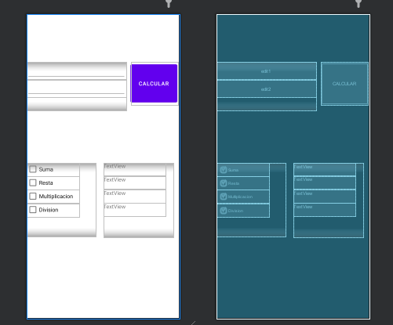

package com.example.myapplication;  
  
import androidx.appcompat.app.AppCompatActivity;  
  
import android.os.Bundle;  
import android.view.View;  
import android.widget.CheckBox;  
import android.widget.EditText;  
import android.widget.RadioButton;  
import android.widget.TextView;  
import android.widget.Toast;  
  
public class MainActivity extends AppCompatActivity {  
 private EditText e1,e2;  
 private TextView t1,t2,t3,t4;  
 private CheckBox c1,c2,c3,c4;  
 @Override  
 protected void onCreate(Bundle savedInstanceState) {  
 super.onCreate(savedInstanceState);  
 setContentView(R.layout.*activity_main*);  
  
 e1=findViewById(R.id.*edit1*);  
 e2=findViewById(R.id.*edit2*);  
 t1=findViewById(R.id.*Text1*);  
 t2=findViewById(R.id.*Text2*);  
 t3=findViewById(R.id.*Text3*);  
 t4=findViewById(R.id.*Text4*);  
 c1=findViewById(R.id.*checkBox*);  
 c2=findViewById(R.id.*checkBox2*);  
 c3=findViewById(R.id.*checkBox3*);  
 c4=findViewById(R.id.*checkBox4*);  
  
 }  
 public void limpiar(View v){  
 t1.setText("");  
 t2.setText("");  
 t3.setText("");  
 t4.setText("");  
 }  
  
 public void operaciones(View v){  
 limpiar(v);  
 Double valor1=Double.*parseDouble*(e1.getText().toString());  
 Double valor2=Double.*parseDouble*(e2.getText().toString());  
 if (c1.isChecked()) {  
 Double suma = valor1 + valor2;  
 t1.setText("resultado:" + suma);  
 }  
 if(c2.isChecked()){  
 Double resta = valor1 - valor2;  
 t2.setText("resultado:" + resta);  
 }  
 if(c3.isChecked()){  
 Double mult = valor1 * valor2;  
 t3.setText("resultado:" + mult);  
 }  
 if(c4.isChecked()){  
 if (valor2>0) {  
 Double divide = valor1 / valor2;  
 t4.setText("resultado:" + divide);  
 }else{  
 t4.setText("error division por cero");  
 Toast.*makeText*(this,"Error... division por cero",Toast.*LENGTH_LONG*).show();  
 }  
 }  
 }  
}