Usando switch

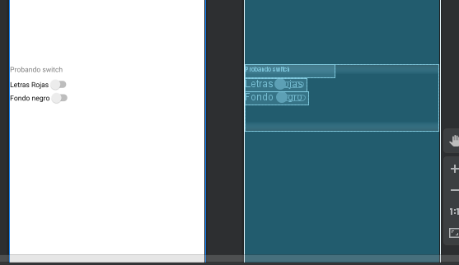

package com.example.myapplication;  
  
import androidx.appcompat.app.AppCompatActivity;  
  
import android.graphics.Color;  
import android.os.Bundle;  
import android.view.View;  
import android.widget.CheckBox;  
import android.widget.EditText;  
import android.widget.Switch;  
import android.widget.TextView;  
import android.widget.Toast;  
  
public class MainActivity extends AppCompatActivity {  
 private Switch s1,s2;  
 private TextView t1;  
  
 @Override  
 protected void onCreate(Bundle savedInstanceState) {  
 super.onCreate(savedInstanceState);  
 setContentView(R.layout.*activity_main*);  
  
  
 s1=findViewById(R.id.*switch1*);  
 s2=findViewById(R.id.*switch2*);  
 t1=findViewById(R.id.*textView*);  
 }  
  
 public void fondo(View v){  
 if(s2.isChecked()) {  
 findViewById(R.id.*idFondo*).setBackgroundColor(Color.*rgb*(100, 100, 100));  
 s1.setTextColor(Color.*rgb*(250, 250, 250));  
 s2.setTextColor(Color.*rgb*(250, 250, 250));  
 t1.setTextColor(Color.*rgb*(250, 250, 250));  
 }else{  
 findViewById(R.id.*idFondo*).setBackgroundColor(Color.*rgb*(250, 250, 250));  
 s1.setTextColor(Color.*rgb*(0, 0, 0));  
 s2.setTextColor(Color.*rgb*(0, 0, 0));  
 t1.setTextColor(Color.*rgb*(0, 0, 0));  
 }  
 Toast.*makeText*(this,"cambia color de fondo",Toast.*LENGTH_LONG*);  
 }  
 public void Letras_rojas (View v){  
 if(s1.isChecked()) {  
 t1.setTextColor(Color.*rgb*(250, 0, 0));  
 s1.setTextColor(Color.*rgb*(250, 0, 0));  
 s2.setTextColor(Color.*rgb*(250, 0, 0));  
 }else{  
 t1.setTextColor(Color.*rgb*(0, 0, 0));  
 s1.setTextColor(Color.*rgb*(0, 0, 0));  
 s2.setTextColor(Color.*rgb*(0, 0, 0));  
 }  
 Toast.*makeText*(this,"cambia color de letras",Toast.*LENGTH_LONG*);  
 }  
}

calculadora con spinner

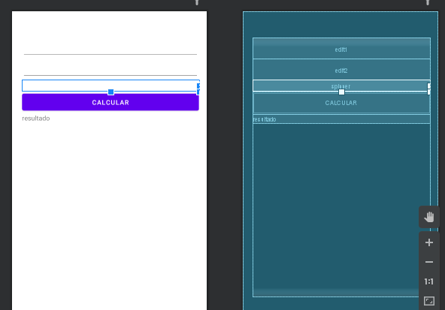

package com.example.myapplication;  
  
import androidx.appcompat.app.AppCompatActivity;  
  
import android.os.Bundle;  
import android.view.View;  
import android.widget.ArrayAdapter;  
import android.widget.EditText;  
import android.widget.Spinner;  
import android.widget.TextView;  
  
public class MainActivity extends AppCompatActivity {  
 private Spinner sp1;  
 private EditText e1,e2;  
 private TextView t1;  
 private String[] operaciones={"sumar","restar","multiplicar","dividir"};  
  
  
 @Override  
 protected void onCreate(Bundle savedInstanceState) {  
 super.onCreate(savedInstanceState);  
 setContentView(R.layout.*activity_main*);  
  
 e1=findViewById(R.id.*edit1*);  
 e2=findViewById(R.id.*edit2*);  
 t1=findViewById(R.id.*Text*);  
 sp1=findViewById(R.id.*spinner*);  
  
 ArrayAdapter<String> adaptador= new ArrayAdapter<>(this, android.R.layout.*simple_spinner_item*,operaciones);  
 sp1.setAdapter(adaptador);  
  
 }  
  
 public void operar(View v){  
 Double valor1=Double.*parseDouble*(e1.getText().toString());  
 Double valor2=Double.*parseDouble*(e2.getText().toString());  
 Double ope;  
 switch (sp1.getSelectedItem().toString()){  
 case "sumar":  
 ope=valor1+valor2;  
 t1.setText("la suma es:"+ope);  
 break;  
 case "restar":  
 ope=valor1-valor2;  
 t1.setText("la resta es:"+ope);  
 break;  
 case "multiplicar":  
 ope=valor1*valor2;  
 t1.setText("la multiplicacion es:"+ope);  
 break;  
 case "dividir":  
 if (valor2>0) {  
 ope = valor1 / valor2;  
 t1.setText("la division es:" + ope);  
 }else{  
 t1.setText("No se puede dividir por 0");  
 }  
 break;  
 }  
 }  
}