Trabajos cn varios activity

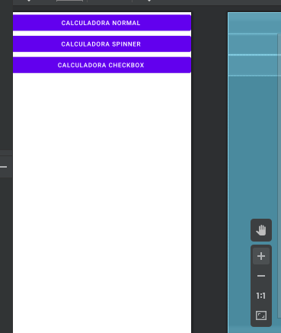

package com.example.myapplication;  
  
import androidx.appcompat.app.AppCompatActivity;  
  
import android.content.Intent;  
import android.os.Bundle;  
import android.view.View;  
  
public class MainActivity extends AppCompatActivity {  
  
 @Override  
 protected void onCreate(Bundle savedInstanceState) {  
 super.onCreate(savedInstanceState);  
 setContentView(R.layout.*activity_main*);  
 }  
 public void salir(View v){  
 finish();  
 }  
  
 public void Cnormal(View v){  
 Intent normal = new Intent(this, CalcN.class );  
 startActivity(normal);  
 }  
 public void Ccheck(View v){  
 Intent check = new Intent(this, CalcC.class );  
 startActivity(check);  
 }  
 public void Cspinner(View v){  
 Intent spinner = new Intent(this, CalcS.class );  
 startActivity(spinner);  
 }  
}

Activity Spinner

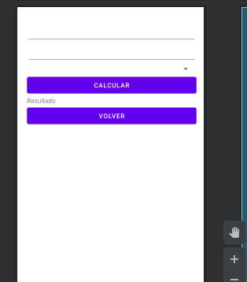

package com.example.myapplication;  
  
import androidx.appcompat.app.AppCompatActivity;  
  
import android.content.Intent;  
import android.os.Bundle;  
import android.view.View;  
import android.widget.ArrayAdapter;  
import android.widget.EditText;  
import android.widget.Spinner;  
import android.widget.TextView;  
  
public class CalcS extends AppCompatActivity {  
 private Spinner sp1;  
 private EditText e1,e2;  
 private TextView t1;  
 private String[] operaciones={"sumar","restar","multiplicar","dividir"};  
  
 @Override  
 protected void onCreate(Bundle savedInstanceState) {  
 super.onCreate(savedInstanceState);  
 setContentView(R.layout.*activity_calc_s*);  
 e1=findViewById(R.id.*edit1*);  
 e2=findViewById(R.id.*edit2*);  
 t1=findViewById(R.id.*Text*);  
 sp1=findViewById(R.id.*spinner*);  
  
 ArrayAdapter<String> adaptador= new ArrayAdapter<>(this, android.R.layout.*simple_spinner_item*,operaciones);  
 sp1.setAdapter(adaptador);  
  
 }  
  
 public void operar(View v){  
 Double valor1=Double.*parseDouble*(e1.getText().toString());  
 Double valor2=Double.*parseDouble*(e2.getText().toString());  
 Double ope;  
 switch (sp1.getSelectedItem().toString()){  
 case "sumar":  
 ope=valor1+valor2;  
 t1.setText("la suma es:"+ope);  
 break;  
 case "restar":  
 ope=valor1-valor2;  
 t1.setText("la resta es:"+ope);  
 break;  
 case "multiplicar":  
 ope=valor1*valor2;  
 t1.setText("la multiplicacion es:"+ope);  
 break;  
 case "dividir":  
 if (valor2>0) {  
 ope = valor1 / valor2;  
 t1.setText("la division es:" + ope);  
 }else{  
 t1.setText("No se puede dividir por 0");  
 }  
 break;  
 }  
 }  
 public void volver(View v){  
 Intent inicio = new Intent(this, MainActivity.class );  
 startActivity(inicio);  
 }  
}

Activity Check box

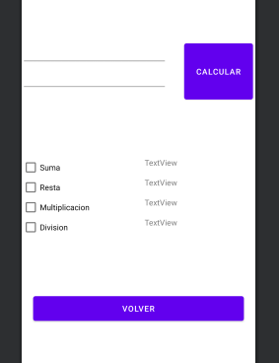

package com.example.myapplication;  
  
import androidx.appcompat.app.AppCompatActivity;  
  
import android.content.Intent;  
import android.os.Bundle;  
import android.view.View;  
import android.widget.CheckBox;  
import android.widget.EditText;  
import android.widget.TextView;  
import android.widget.Toast;  
  
public class CalcC extends AppCompatActivity {  
 private EditText e1,e2;  
 private TextView t1,t2,t3,t4;  
 private CheckBox c1,c2,c3,c4;  
 @Override  
 protected void onCreate(Bundle savedInstanceState) {  
 super.onCreate(savedInstanceState);  
 setContentView(R.layout.*activity_calc_c*);  
 e1=findViewById(R.id.*edit1*);  
 e2=findViewById(R.id.*edit2*);  
 t1=findViewById(R.id.*Text1*);  
 t2=findViewById(R.id.*Text2*);  
 t3=findViewById(R.id.*Text3*);  
 t4=findViewById(R.id.*Text4*);  
 c1=findViewById(R.id.*checkBox*);  
 c2=findViewById(R.id.*checkBox2*);  
 c3=findViewById(R.id.*checkBox3*);  
 c4=findViewById(R.id.*checkBox4*);  
 }  
  
 public void limpiar(View v){  
 t1.setText("");  
 t2.setText("");  
 t3.setText("");  
 t4.setText("");  
 }  
  
 public void operaciones(View v){  
 limpiar(v);  
 Double valor1=Double.*parseDouble*(e1.getText().toString());  
 Double valor2=Double.*parseDouble*(e2.getText().toString());  
 if (c1.isChecked()) {  
 Double suma = valor1 + valor2;  
 t1.setText("resultado:" + suma);  
 }  
 if(c2.isChecked()){  
 Double resta = valor1 - valor2;  
 t2.setText("resultado:" + resta);  
 }  
 if(c3.isChecked()){  
 Double mult = valor1 * valor2;  
 t3.setText("resultado:" + mult);  
 }  
 if(c4.isChecked()){  
 if (valor2>0) {  
 Double divide = valor1 / valor2;  
 t4.setText("resultado:" + divide);  
 }else{  
 t4.setText("error division por cero");  
 Toast.*makeText*(this,"Error... division por cero",Toast.*LENGTH_LONG*).show();  
 }  
 }  
 }  
  
  
  
 public void volver(View v){  
 Intent inicio = new Intent(this, MainActivity.class );  
 startActivity(inicio);  
 }  
}

activity imagebutton

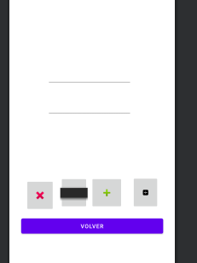

package com.example.myapplication;  
  
import androidx.appcompat.app.AppCompatActivity;  
  
import android.content.Intent;  
import android.os.Bundle;  
import android.view.View;  
import android.widget.EditText;  
import android.widget.TextView;  
  
public class CalcN extends AppCompatActivity {  
 private EditText e1,e2;  
 private TextView t1;  
 @Override  
 protected void onCreate(Bundle savedInstanceState) {  
 super.onCreate(savedInstanceState);  
 setContentView(R.layout.*activity_calc_n*);  
  
 e1=findViewById(R.id.*edit4*);  
 e2=findViewById(R.id.*edit5*);  
 t1=findViewById(R.id.*text4*);  
 }  
  
  
 public void sumar(View v){  
 Double valor1=Double.*parseDouble*(e1.getText().toString());  
 Double valor2=Double.*parseDouble*(e2.getText().toString());  
 Double suma=valor1+valor2;  
 t1.setText("resultado:"+suma);  
 }  
 public void restar(View v){  
 int valor1=Integer.*parseInt*(e1.getText().toString());  
 int valor2=Integer.*parseInt*(e2.getText().toString());  
 int resta=valor1-valor2;  
 t1.setText("resultado:"+resta);  
 }  
 public void multi(View v){  
 int valor1=Integer.*parseInt*(e1.getText().toString());  
 int valor2=Integer.*parseInt*(e2.getText().toString());  
 int mult=valor1*valor2;  
 t1.setText("resultado:"+mult);  
 }  
 public void dividir(View v){  
 Double valor1=Double.*parseDouble*(e1.getText().toString());  
 Double valor2=Double.*parseDouble*(e2.getText().toString());  
 Double divide=valor1/valor2;  
 t1.setText("resultado:"+divide);  
 }  
 public void volver(View v){  
 Intent inicio = new Intent(this, MainActivity.class );  
 startActivity(inicio);  
 }  
}