Putextra

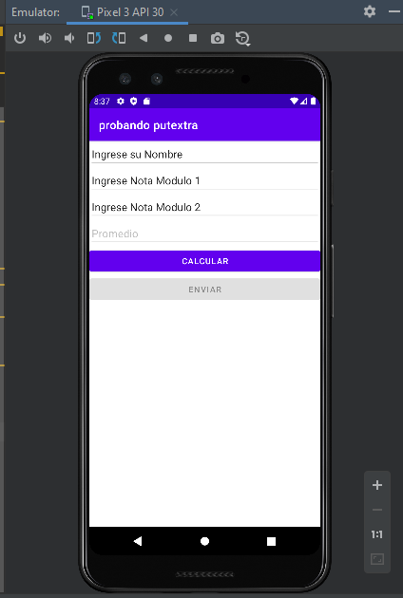

package com.example.myapplication;  
  
import androidx.appcompat.app.AppCompatActivity;  
  
import android.content.Intent;  
import android.os.Bundle;  
import android.view.View;  
import android.widget.Button;  
import android.widget.EditText;  
import android.widget.TextView;  
  
public class MainActivity extends AppCompatActivity {  
 private EditText edn,ed1,ed2,ed3;  
 private TextView tv;  
 private Button b;  
 @Override  
 protected void onCreate(Bundle savedInstanceState) {  
 super.onCreate(savedInstanceState);  
 setContentView(R.layout.*activity_main*);  
 edn=findViewById(R.id.*editNombre*);  
 ed1=findViewById(R.id.*edit1*);  
 ed2=findViewById(R.id.*edit2*);  
 ed3=findViewById(R.id.*edit3*);  
 b=findViewById(R.id.*button*);  
 b.setEnabled(false);  
 ed3.setEnabled(false);  
 }  
  
 public void enviar(View v){  
 Intent i =new Intent(this, MainActivity2.class);  
 i.putExtra("nombre",edn.getText().toString());  
 i.putExtra("prom",ed3.getText().toString());  
 startActivity(i);  
  
 }  
 public void calcular(View v){  
 double valor1=Double.*parseDouble*(ed1.getText().toString());  
 double valor2=Double.*parseDouble*(ed2.getText().toString());  
 double promedio=(valor1+valor2)/2;  
 ed3.setText("Promedio es:"+promedio);  
 b.setEnabled(true);  
 }  
}

activity resultado

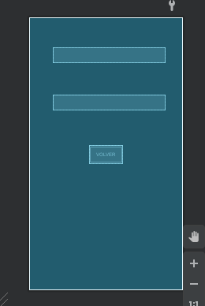

package com.example.myapplication;  
  
import androidx.appcompat.app.AppCompatActivity;  
  
import android.content.Intent;  
import android.graphics.Color;  
import android.os.Bundle;  
import android.view.View;  
import android.widget.TextView;  
import android.widget.Toast;  
  
public class MainActivity2 extends AppCompatActivity {  
 private TextView tv1,tv2;  
 @Override  
 protected void onCreate(Bundle savedInstanceState) {  
 super.onCreate(savedInstanceState);  
 setContentView(R.layout.*activity_main2*);  
 tv1=findViewById(R.id.*textView*);  
 tv2=findViewById(R.id.*textView2*);  
 String valor=getIntent().getStringExtra("nombre");  
 String valorp=getIntent().getStringExtra("prom");  
 String arrprom[]=valorp.split(":");  
 tv1.setText("hola "+valor);  
 if (Double.*parseDouble*(arrprom[1])>40){  
 tv2.setText("ha aprobado");  
 tv2.setTextColor(Color.*rgb*(0,240,0));  
 }else{  
 tv2.setText("ha reprobado");  
 tv2.setTextColor(Color.*rgb*(240,0,0));  
 }  
 }  
 public void volver(View v){  
 Intent i =new Intent(this, MainActivity.class);  
 startActivity(i);  
 }  
}