Manejo base de datos

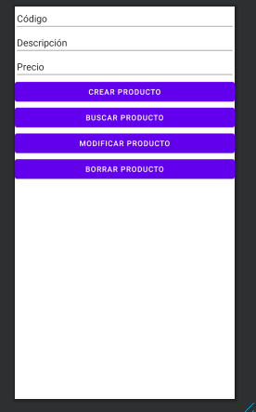

mainactivity

package com.example.userbd;  
  
import androidx.appcompat.app.AppCompatActivity;  
  
import android.content.ContentValues;  
import android.database.Cursor;  
import android.database.sqlite.SQLiteDatabase;  
import android.os.Bundle;  
import android.view.View;  
import android.widget.EditText;  
import android.widget.Toast;  
  
public class MainActivity extends AppCompatActivity {  
 private EditText edcodigo,ednombre,edprecio;  
 @Override  
 protected void onCreate(Bundle savedInstanceState) {  
 super.onCreate(savedInstanceState);  
 setContentView(R.layout.*activity_main*);  
 edcodigo=findViewById(R.id.*editCod*);  
 ednombre=findViewById(R.id.*editNom*);  
 edprecio=findViewById(R.id.*editPre*);  
 }  
  
  
 public void crearProducto(View v){  
 //AdminBD admin= new AdminBD(this,"Productos",null,1);  
 //SQLiteDatabase base=admin.getWritableDatabase();  
 SQLiteDatabase base=abreBase();  
 String codigo=edcodigo.getText().toString();  
 String desc=ednombre.getText().toString();  
 String precio=edprecio.getText().toString();  
 if (!codigo.isEmpty() && !desc.isEmpty() && !precio.isEmpty()){  
 ContentValues crear=new ContentValues();  
 crear.put("codigo",codigo);  
 crear.put("desc",desc);  
 crear.put("precio",precio);  
 base.insert("productos",null,crear);  
 base.close();  
 edcodigo.setText("");  
 ednombre.setText("");  
 edprecio.setText("");  
 Toast.*makeText*(this,"Producto creado!!", Toast.*LENGTH_LONG*).show();  
  
 }else{  
 Toast.*makeText*(this, "Debe ingresar todos los campos", Toast.*LENGTH_SHORT*).show();  
 }  
 }  
public SQLiteDatabase abreBase(){  
 AdminBD admin= new AdminBD(this,"Productos",null,1);  
 SQLiteDatabase base=admin.getWritableDatabase();  
 return base;  
}  
 public void buscarProducto(View v){  
 //AdminBD admin= new AdminBD(this,"Productos",null,1);  
 //SQLiteDatabase base=admin.getWritableDatabase();  
 SQLiteDatabase base;  
 base=abreBase();  
 String codigo=edcodigo.getText().toString();  
 if (!codigo.isEmpty() ){  
 Cursor fila=base.rawQuery("Select desc, precio from productos where codigo="+codigo,null);  
 if(fila.moveToFirst()){  
 ednombre.setText(fila.getString(0));  
 edprecio.setText(fila.getString(1));  
 base.close();  
 }else{  
 Toast.*makeText*(this,"registro no existe", Toast.*LENGTH_LONG*).show();  
 }  
 }  
 }  
}

adminbd

package com.example.userbd;  
  
import android.content.Context;  
import android.database.sqlite.SQLiteDatabase;  
import android.database.sqlite.SQLiteOpenHelper;  
  
import androidx.annotation.Nullable;  
  
public class AdminBD extends SQLiteOpenHelper {  
 public AdminBD(@Nullable Context context, @Nullable String name, @Nullable SQLiteDatabase.CursorFactory factory, int version){  
 super(context,name,factory,version);  
 }  
  
 @Override  
 public void onCreate(SQLiteDatabase db) {  
 db.execSQL("create table productos (codigo int primary key, desc varchar,precio int)");  
 }  
  
 @Override  
 public void onUpgrade(SQLiteDatabase db, int oldVersion, int newVersion) {  
  
 }  
}