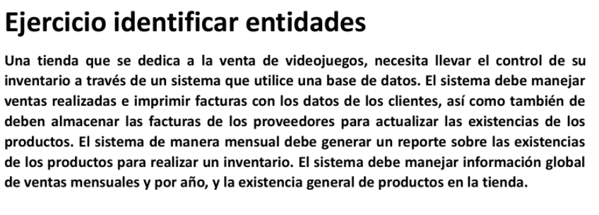

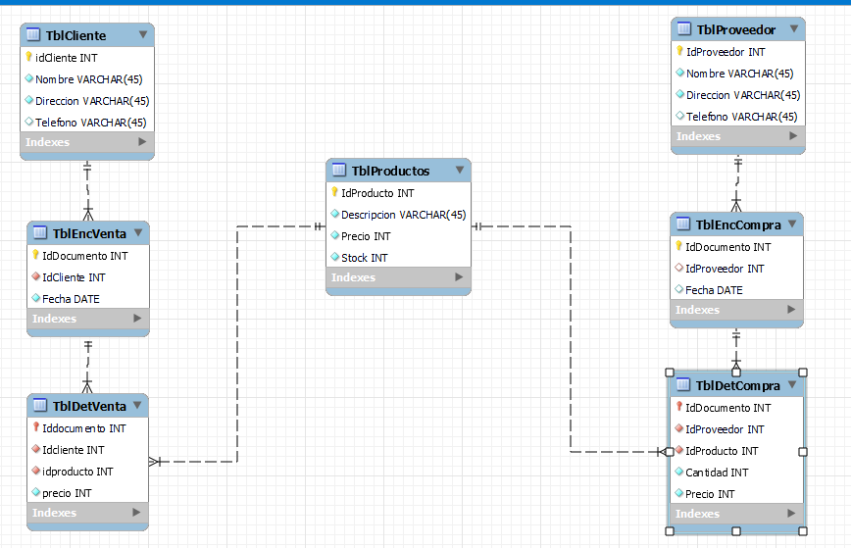

-- MySQL Workbench Forward Engineering

SET @OLD_UNIQUE_CHECKS=@@UNIQUE_CHECKS, UNIQUE_CHECKS=0;

SET @OLD_FOREIGN_KEY_CHECKS=@@FOREIGN_KEY_CHECKS, FOREIGN_KEY_CHECKS=0;

SET @OLD_SQL_MODE=@@SQL_MODE, SQL_MODE='ONLY_FULL_GROUP_BY,STRICT_TRANS_TABLES,NO_ZERO_IN_DATE,NO_ZERO_DATE,ERROR_FOR_DIVISION_BY_ZERO,NO_ENGINE_SUBSTITUTION';

-- -----------------------------------------------------

-- Schema mydb

-- -----------------------------------------------------

-- -----------------------------------------------------

-- Schema ej1tienda

-- -----------------------------------------------------

-- -----------------------------------------------------

-- Schema ej1tienda

-- -----------------------------------------------------

CREATE SCHEMA IF NOT EXISTS `ej1tienda` DEFAULT CHARACTER SET latin1 ;

USE `ej1tienda` ;

-- -----------------------------------------------------

-- Table `ej1tienda`.`TblCliente`

-- -----------------------------------------------------

CREATE TABLE IF NOT EXISTS `ej1tienda`.`TblCliente` (

`idCliente` INT NOT NULL AUTO_INCREMENT,

`Nombre` VARCHAR(45) NOT NULL,

`Direccion` VARCHAR(45) NOT NULL,

`Telefono` VARCHAR(45) NULL,

PRIMARY KEY (`idCliente`))

ENGINE = InnoDB;

-- -----------------------------------------------------

-- Table `ej1tienda`.`TblProductos`

-- -----------------------------------------------------

CREATE TABLE IF NOT EXISTS `ej1tienda`.`TblProductos` (

`IdProducto` INT NOT NULL AUTO_INCREMENT,

`Descripcion` VARCHAR(45) NOT NULL,

`Precio` INT NOT NULL,

`Stock` INT NOT NULL,

PRIMARY KEY (`IdProducto`))

ENGINE = InnoDB;

-- -----------------------------------------------------

-- Table `ej1tienda`.`TblProveedor`

-- -----------------------------------------------------

CREATE TABLE IF NOT EXISTS `ej1tienda`.`TblProveedor` (

`IdProveedor` INT NOT NULL AUTO_INCREMENT,

`Nombre` VARCHAR(45) NOT NULL,

`Direccion` VARCHAR(45) NOT NULL,

`Telefono` VARCHAR(45) NULL,

PRIMARY KEY (`IdProveedor`))

ENGINE = InnoDB;

-- -----------------------------------------------------

-- Table `ej1tienda`.`TblEncCompra`

-- -----------------------------------------------------

CREATE TABLE IF NOT EXISTS `ej1tienda`.`TblEncCompra` (

`IdDocumento` INT NOT NULL,

`IdProveedor` INT NOT NULL,

`Fecha` DATE NULL,

PRIMARY KEY (`IdDocumento`),

INDEX `proveesor_idx` (`IdProveedor` ASC),

CONSTRAINT `proveedor`

FOREIGN KEY (`IdProveedor`)

REFERENCES `ej1tienda`.`TblProveedor` (`IdProveedor`)

ON DELETE NO ACTION

ON UPDATE NO ACTION)

ENGINE = InnoDB;

-- -----------------------------------------------------

-- Table `ej1tienda`.`TblDetCompra`

-- -----------------------------------------------------

CREATE TABLE IF NOT EXISTS `ej1tienda`.`TblDetCompra` (

`IdDocumento` INT NOT NULL,

`IdProveedor` INT NOT NULL,

`IdProducto` INT NOT NULL,

`Cantidad` INT NOT NULL,

`Precio` INT NOT NULL,

PRIMARY KEY (`IdDocumento`),

INDEX `producto_idx` (`IdProducto` ASC),

CONSTRAINT `detallecompra`

FOREIGN KEY (`IdDocumento`)

REFERENCES `ej1tienda`.`TblEncCompra` (`IdDocumento`)

ON DELETE NO ACTION

ON UPDATE NO ACTION,

CONSTRAINT `producto`

FOREIGN KEY (`IdProducto`)

REFERENCES `ej1tienda`.`TblProductos` (`IdProducto`)

ON DELETE NO ACTION

ON UPDATE NO ACTION)

ENGINE = InnoDB;

-- -----------------------------------------------------

-- Table `ej1tienda`.`TblEncVenta`

-- -----------------------------------------------------

CREATE TABLE IF NOT EXISTS `ej1tienda`.`TblEncVenta` (

`IdDocumento` INT NOT NULL,

`IdCliente` INT NOT NULL,

`Fecha` DATE NOT NULL,

PRIMARY KEY (`IdDocumento`),

INDEX `idcliente_idx` (`IdCliente` ASC),

CONSTRAINT `idcliente`

FOREIGN KEY (`IdCliente`)

REFERENCES `ej1tienda`.`TblCliente` (`idCliente`)

ON DELETE NO ACTION

ON UPDATE NO ACTION)

ENGINE = InnoDB;

-- -----------------------------------------------------

-- Table `ej1tienda`.`TblDetVenta`

-- -----------------------------------------------------

CREATE TABLE IF NOT EXISTS `ej1tienda`.`TblDetVenta` (

`Iddocumento` INT NOT NULL,

`Idcliente` INT NOT NULL,

`idproducto` INT NOT NULL,

`precio` INT NOT NULL,

`cantidad` INT NOT NULL,

PRIMARY KEY (`Iddocumento`),

INDEX `idproducto_idx` (`idproducto` ASC),

CONSTRAINT `iddocumento`

FOREIGN KEY (`Iddocumento`)

REFERENCES `ej1tienda`.`TblEncVenta` (`IdDocumento`)

ON DELETE NO ACTION

ON UPDATE NO ACTION,

CONSTRAINT `idproducto`

FOREIGN KEY (`idproducto`)

REFERENCES `ej1tienda`.`TblProductos` (`IdProducto`)

ON DELETE NO ACTION

ON UPDATE NO ACTION)

ENGINE = InnoDB;

SET SQL_MODE=@OLD_SQL_MODE;

SET FOREIGN_KEY_CHECKS=@OLD_FOREIGN_KEY_CHECKS;

SET UNIQUE_CHECKS=@OLD_UNIQUE_CHECKS;



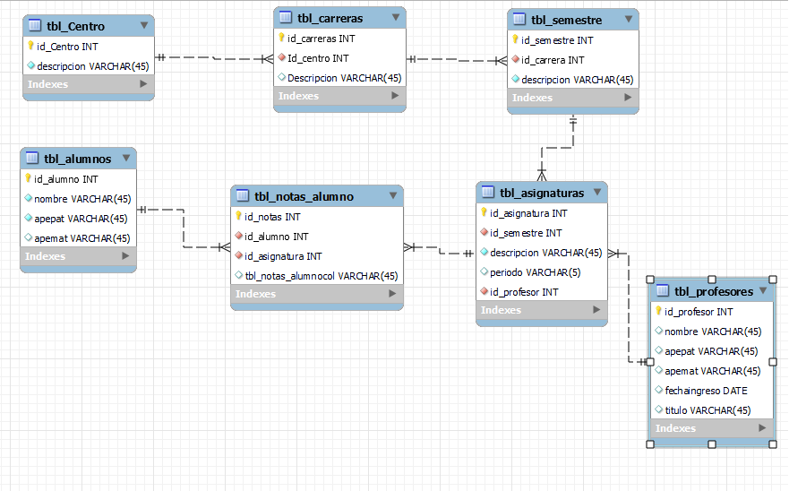

-- MySQL Workbench Forward Engineering

SET @OLD_UNIQUE_CHECKS=@@UNIQUE_CHECKS, UNIQUE_CHECKS=0;

SET @OLD_FOREIGN_KEY_CHECKS=@@FOREIGN_KEY_CHECKS, FOREIGN_KEY_CHECKS=0;

SET @OLD_SQL_MODE=@@SQL_MODE, SQL_MODE='ONLY_FULL_GROUP_BY,STRICT_TRANS_TABLES,NO_ZERO_IN_DATE,NO_ZERO_DATE,ERROR_FOR_DIVISION_BY_ZERO,NO_ENGINE_SUBSTITUTION';

-- -----------------------------------------------------

-- Schema mydb

-- -----------------------------------------------------

-- -----------------------------------------------------

-- Schema mydb

-- -----------------------------------------------------

CREATE SCHEMA IF NOT EXISTS `mydb` DEFAULT CHARACTER SET utf8 ;

USE `mydb` ;

-- -----------------------------------------------------

-- Table `mydb`.`tbl_Centro`

-- -----------------------------------------------------

CREATE TABLE IF NOT EXISTS `mydb`.`tbl_Centro` (

`id_Centro` INT NOT NULL AUTO_INCREMENT,

`descripcion` VARCHAR(45) NOT NULL,

PRIMARY KEY (`id_Centro`))

ENGINE = InnoDB;

-- -----------------------------------------------------

-- Table `mydb`.`tbl_carreras`

-- -----------------------------------------------------

CREATE TABLE IF NOT EXISTS `mydb`.`tbl_carreras` (

`id_carreras` INT NOT NULL AUTO_INCREMENT,

`Id_centro` INT NOT NULL,

`Descripcion` VARCHAR(45) NULL,

PRIMARY KEY (`id_carreras`),

INDEX `centro_idx` (`Id_centro` ASC),

CONSTRAINT `centro`

FOREIGN KEY (`Id_centro`)

REFERENCES `mydb`.`tbl_Centro` (`id_Centro`)

ON DELETE NO ACTION

ON UPDATE NO ACTION)

ENGINE = InnoDB;

-- -----------------------------------------------------

-- Table `mydb`.`tbl_semestre`

-- -----------------------------------------------------

CREATE TABLE IF NOT EXISTS `mydb`.`tbl_semestre` (

`id_semestre` INT NOT NULL AUTO_INCREMENT,

`id_carrera` INT NOT NULL,

`descripcion` VARCHAR(45) NOT NULL,

PRIMARY KEY (`id_semestre`),

INDEX `carrera_idx` (`id_carrera` ASC),

CONSTRAINT `carrera`

FOREIGN KEY (`id_carrera`)

REFERENCES `mydb`.`tbl_carreras` (`id_carreras`)

ON DELETE NO ACTION

ON UPDATE NO ACTION)

ENGINE = InnoDB;

-- -----------------------------------------------------

-- Table `mydb`.`tbl_profesores`

-- -----------------------------------------------------

CREATE TABLE IF NOT EXISTS `mydb`.`tbl_profesores` (

`id_profesor` INT NOT NULL AUTO_INCREMENT,

`nombre` VARCHAR(45) NULL,

`apepat` VARCHAR(45) NULL,

`apemat` VARCHAR(45) NULL,

`fechaingreso` DATE NULL,

`titulo` VARCHAR(45) NULL,

PRIMARY KEY (`id_profesor`))

ENGINE = InnoDB;

-- -----------------------------------------------------

-- Table `mydb`.`tbl_asignaturas`

-- -----------------------------------------------------

CREATE TABLE IF NOT EXISTS `mydb`.`tbl_asignaturas` (

`id_asignatura` INT NOT NULL,

`id_semestre` INT NOT NULL,

`descripcion` VARCHAR(45) NOT NULL,

`periodo` VARCHAR(5) NULL,

`id_profesor` INT NOT NULL,

PRIMARY KEY (`id_asignatura`),

INDEX `semestre_idx` (`id_semestre` ASC),

INDEX `profesor_idx` (`id_profesor` ASC),

CONSTRAINT `semestre`

FOREIGN KEY (`id_semestre`)

REFERENCES `mydb`.`tbl_semestre` (`id_semestre`)

ON DELETE NO ACTION

ON UPDATE NO ACTION,

CONSTRAINT `profesor`

FOREIGN KEY (`id_profesor`)

REFERENCES `mydb`.`tbl_profesores` (`id_profesor`)

ON DELETE NO ACTION

ON UPDATE NO ACTION)

ENGINE = InnoDB;

-- -----------------------------------------------------

-- Table `mydb`.`tbl_alumnos`

-- -----------------------------------------------------

CREATE TABLE IF NOT EXISTS `mydb`.`tbl_alumnos` (

`id_alumno` INT NOT NULL,

`nombre` VARCHAR(45) NOT NULL,

`apepat` VARCHAR(45) NOT NULL,

`apemat` VARCHAR(45) NULL,

PRIMARY KEY (`id_alumno`))

ENGINE = InnoDB;

-- -----------------------------------------------------

-- Table `mydb`.`tbl_notas_alumno`

-- -----------------------------------------------------

CREATE TABLE IF NOT EXISTS `mydb`.`tbl_notas_alumno` (

`id_notas` INT NOT NULL,

`id_alumno` INT NOT NULL,

`id_asignatura` INT NOT NULL,

`tbl_notas_alumnocol` VARCHAR(45) NULL,

PRIMARY KEY (`id_notas`),

INDEX `alumno_idx` (`id_alumno` ASC),

INDEX `asignaturas_idx` (`id_asignatura` ASC),

CONSTRAINT `alumno`

FOREIGN KEY (`id_alumno`)

REFERENCES `mydb`.`tbl_alumnos` (`id_alumno`)

ON DELETE NO ACTION

ON UPDATE NO ACTION,

CONSTRAINT `asignaturas`

FOREIGN KEY (`id_asignatura`)

REFERENCES `mydb`.`tbl_asignaturas` (`id_asignatura`)

ON DELETE NO ACTION

ON UPDATE NO ACTION)

ENGINE = InnoDB;

SET SQL_MODE=@OLD_SQL_MODE;

SET FOREIGN_KEY_CHECKS=@OLD_FOREIGN_KEY_CHECKS;

SET UNIQUE_CHECKS=@OLD_UNIQUE_CHECKS;