Contents

Purpose 2

Prerequisites 2

Lab 3A: Static web hosting 2

Lab 3A using Web Management Console 2

Create the bucket and apply public default policies 2

Upload files 5

Apply web hosting feature 8

Lab 3A using Command Line (Windows) 12

Create Bucket, apply resource-based policies, sync files and able web hosting feature 12

Evidences to send 13

# Purpose

General Idea of this lab is to have a control of information of your S3 bucket. The first lab shows Web Hosting feature of S3 and involve resource-based policy.

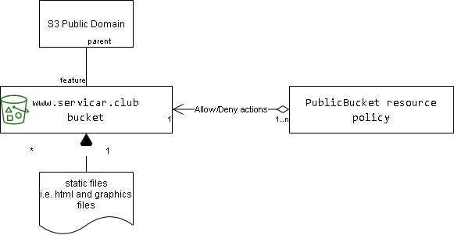

Lab 3A: Static Web Hosting using S3.

# Prerequisites

Labs1c1 have to be done and the context for Administrative user have to activated on Command Line Session.

# Lab 3A: Static web hosting

## Lab 3A using Web Management Console

### Create the bucket and apply public default policies

Create the bucket on S3

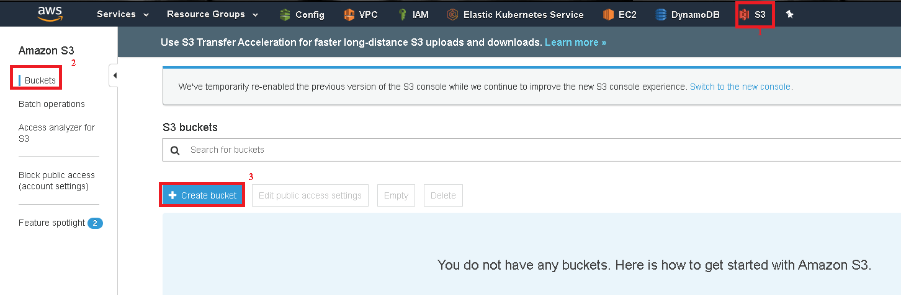

Allow default values

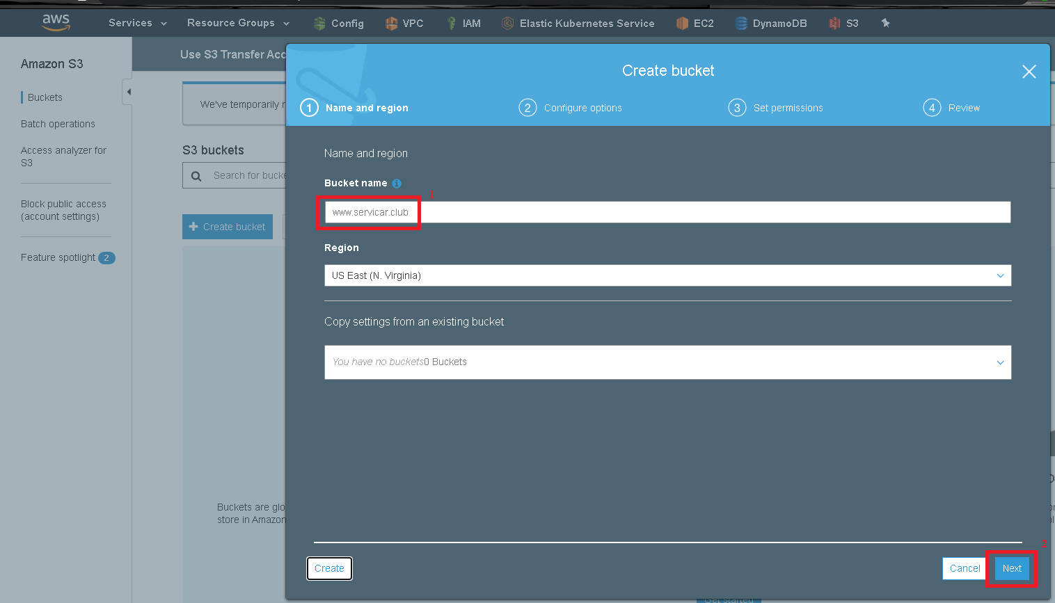

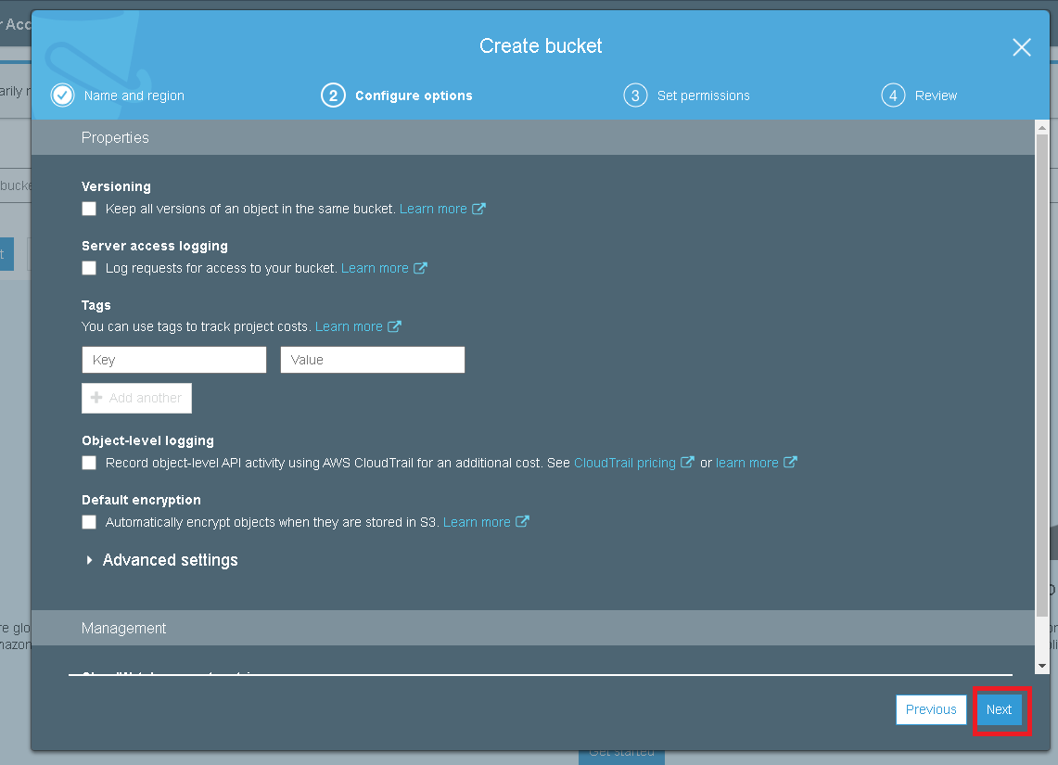

Assign public access to the bucket and acknowledge the risks.

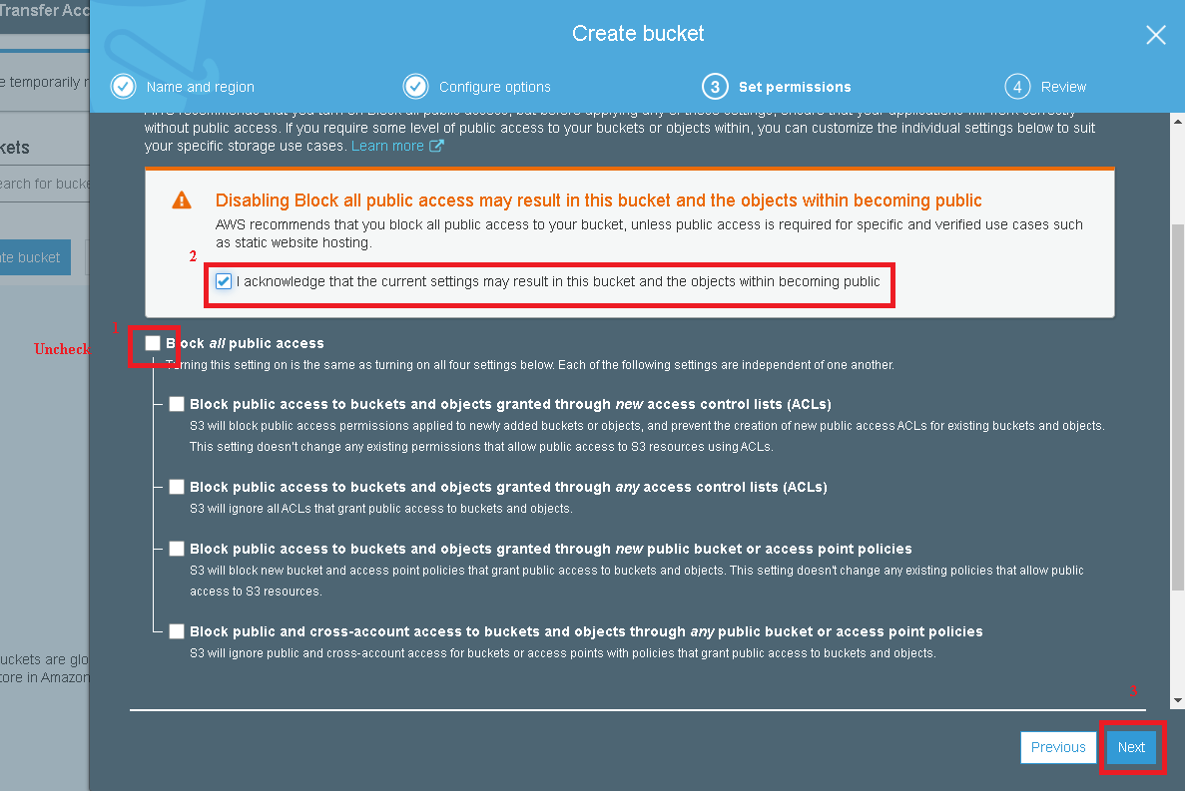

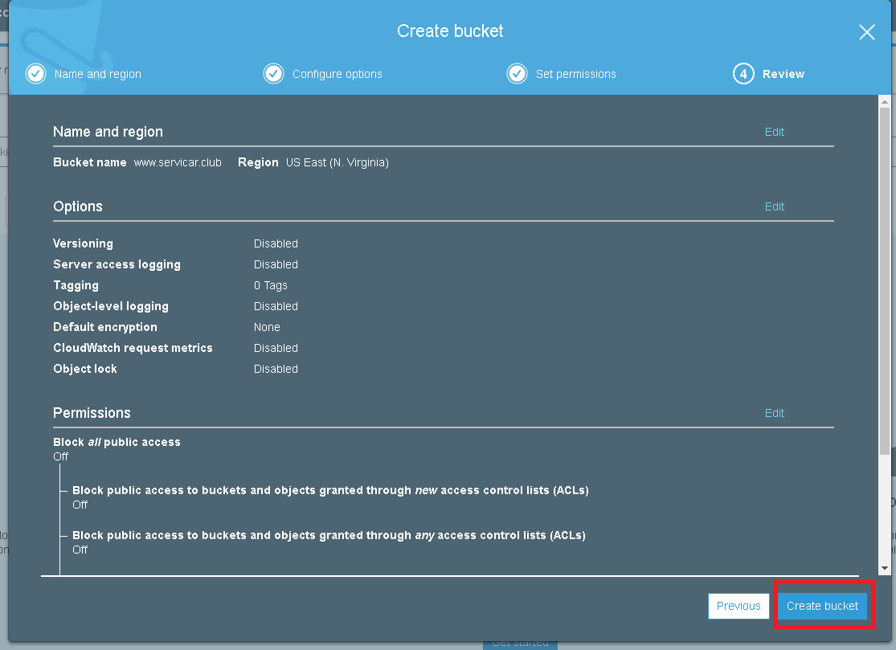

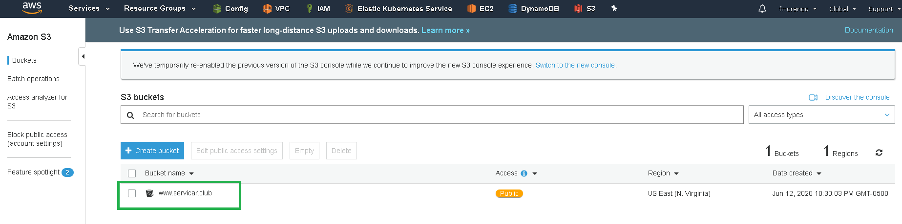

### Upload files

For this lab, I create simple files: index.html and error.html, however you can create a fancy HTML files.

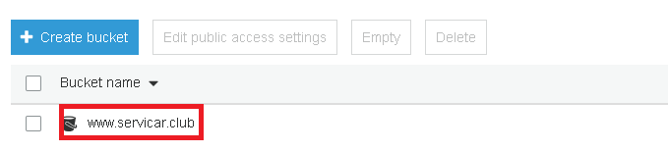

Drag the files to the bucket.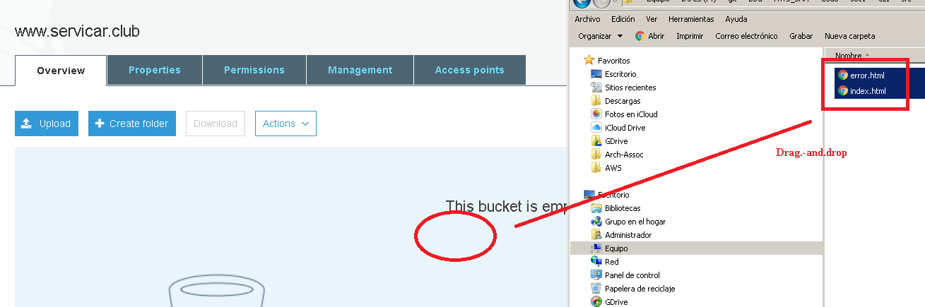

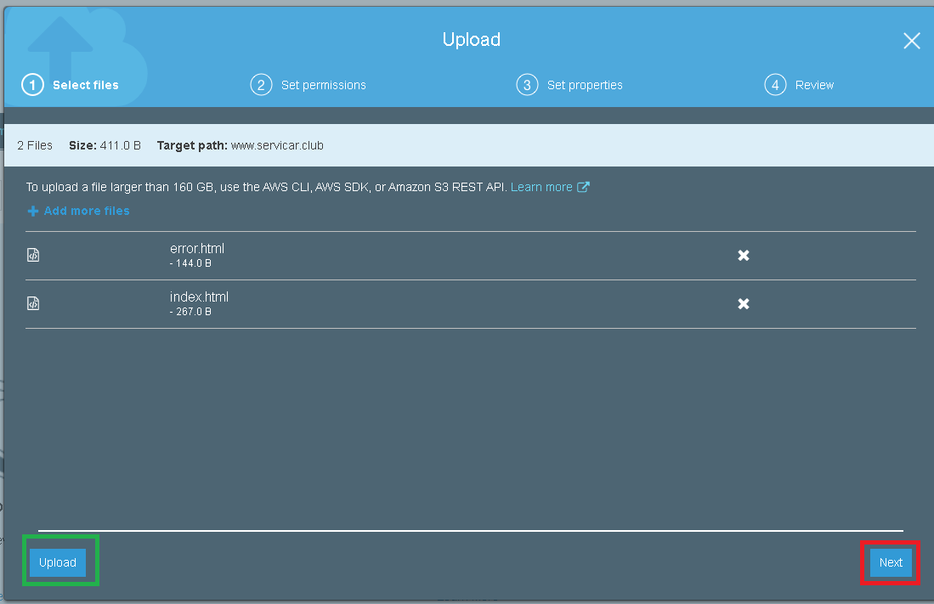

Allow the public access permissions to the files.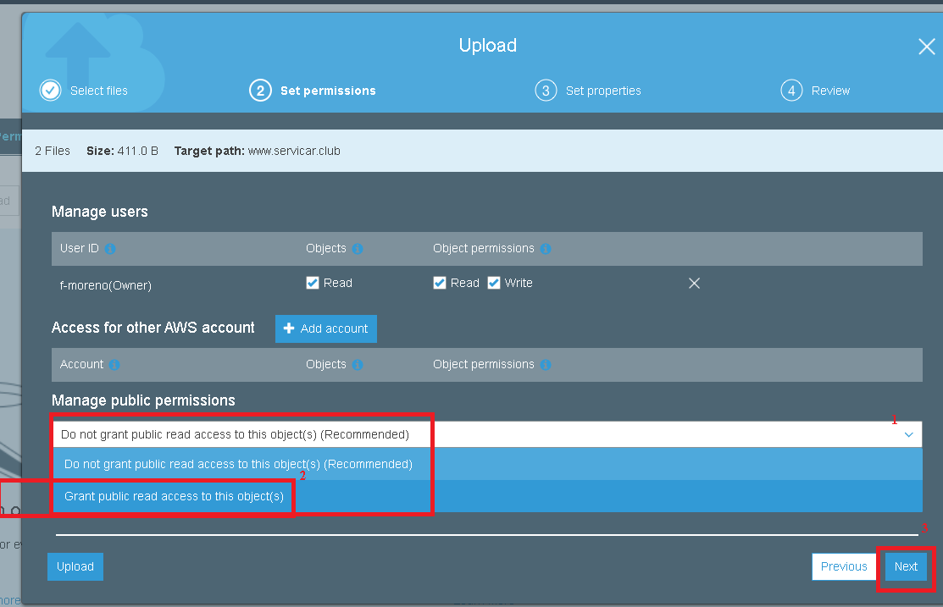

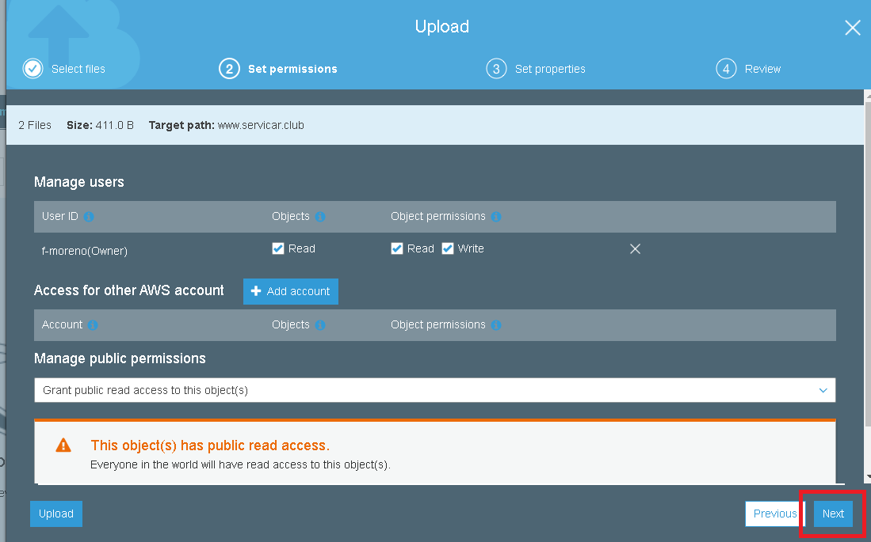

Select S3 Standard storage.

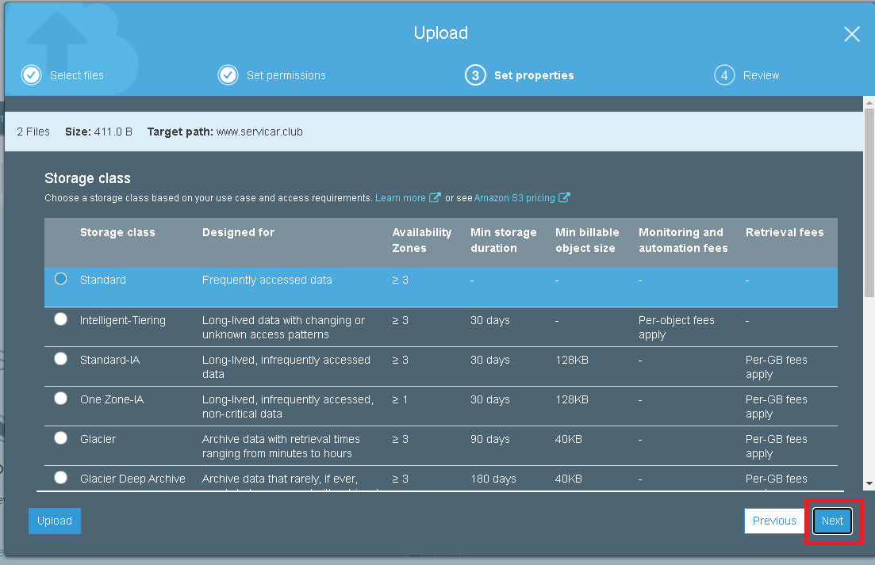

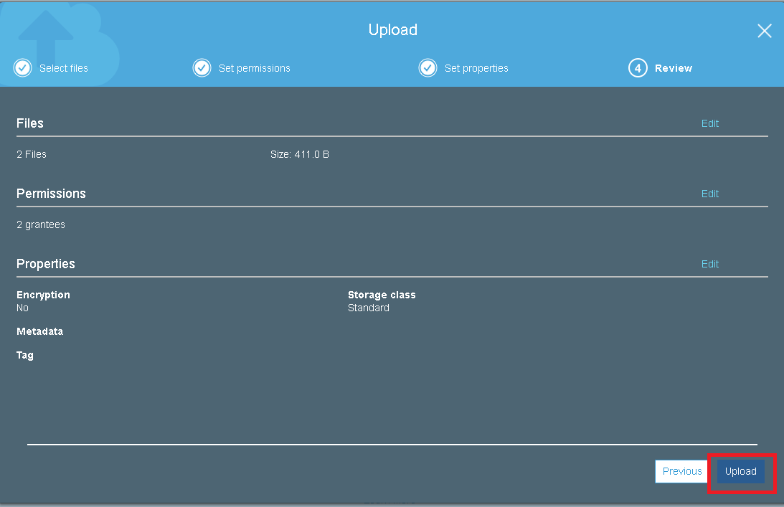

### Apply web hosting feature

When you files are on the bucket, you have to able the web hosting feature.

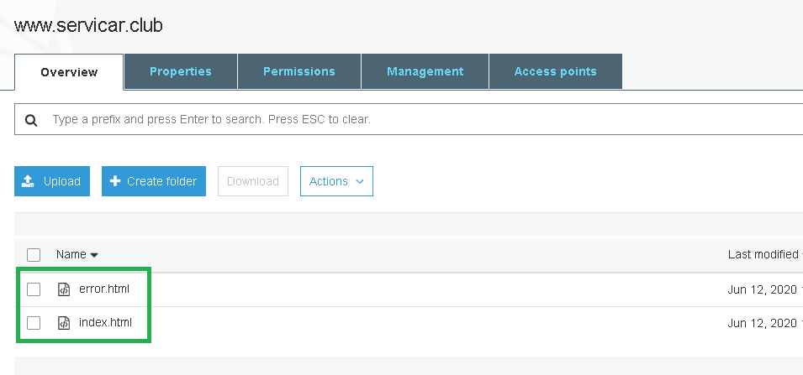

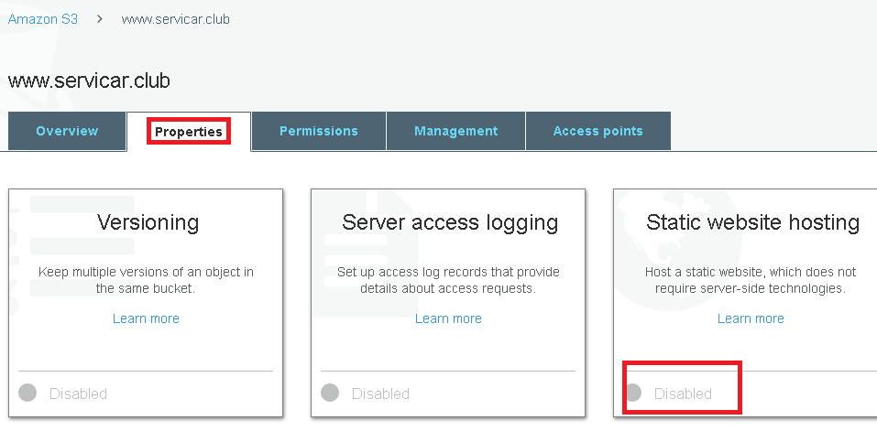

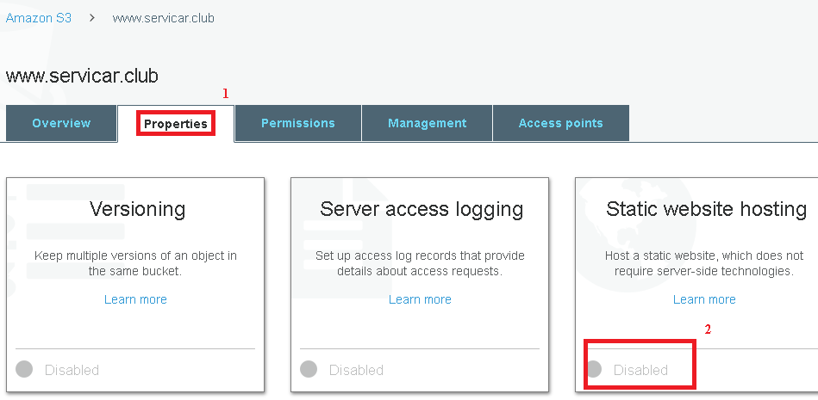

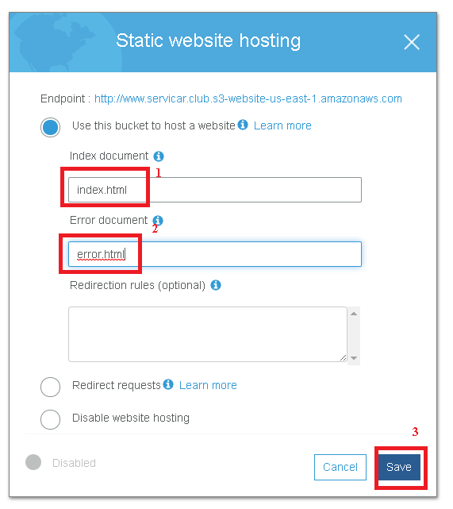

Then, you can go to the feature again to recover the endpoint (URL) of the website.

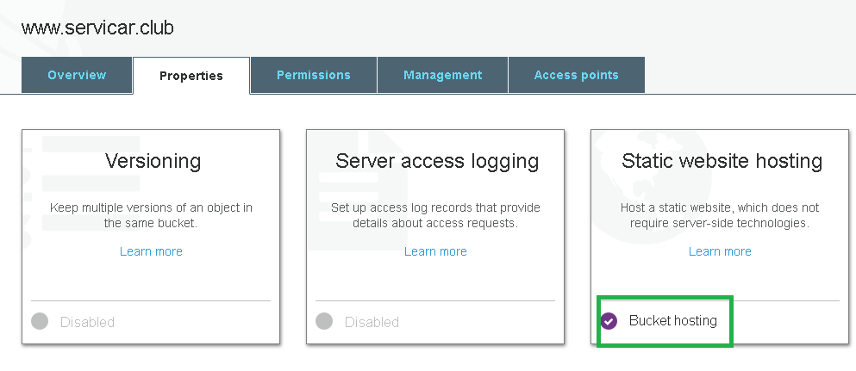

To see the URL of provided on the web hosting.

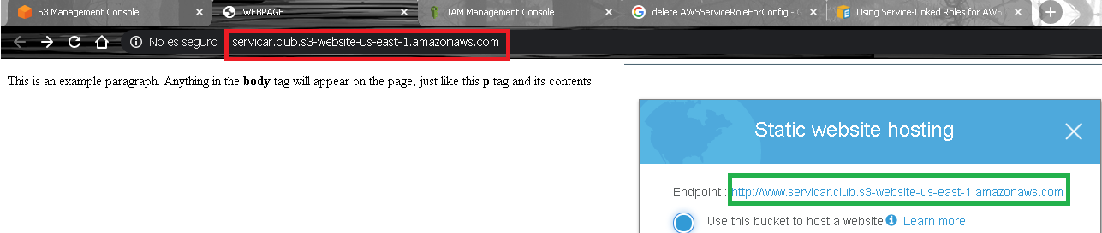

Write a non-existent file on the URL, and see the error.html file.

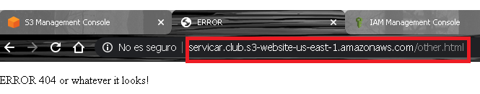

## Lab 3A using Command Line (Windows)

### Create Bucket, apply resource-based policies, sync files and able web hosting feature

rem Se realiza la creacion del bucket. Revisar cuando tienen location diferente a us-east-1 https://github.com/aws/aws-cli/issues/2603

set  BucketName=www.servicar.club

aws s3api create-bucket --bucket %BucketName% --region us-east-1

aws s3api put-bucket-policy --bucket %BucketName% --policy file://bucket_policy.json

aws s3 sync ./src s3://%BucketName%/

aws s3 website s3://%BucketName%/ --index-document index.html --error-document error.html

rem Ir a www.servicar.club.s3-website.us-east-1.amazonaws.com

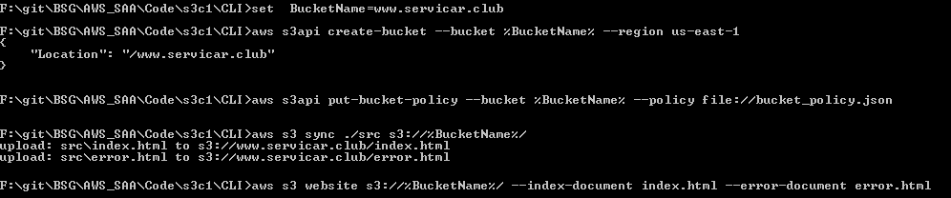

Come to see the 2 screenshots of Apply web hosting feature.

# Evidences to send

To have a review, the student has to send some screenshots to instructor email:

1. Screenshots from Static Web Page (URL) using any browser, with right index or error. Those static webpages can have your name or any contact detail to differentiate. Those 2 screenshots are the last images of Apply web hosting feature.