Contents

Purpose 2

Prerequisites 2

Lab 3B: Cross-replication and versioning 2

Lab 3B using Web Management Console 2

Create the buckets 2

Activate the replication feature on source bucket 4

Create/choose the replication role 8

Lab 3B using Command-Line (Windows) 9

Create the buckets and able requirements (Versioning) 9

Apply replication configuration and review 10

Review for both methods: Web and CLI 11

Review for Replication 11

Review for Versioning 15

# Purpose

General Idea of this lab is to have a control of information of your S3 bucket. The second lab show additional feature such as: Replication, Versioning and Role.

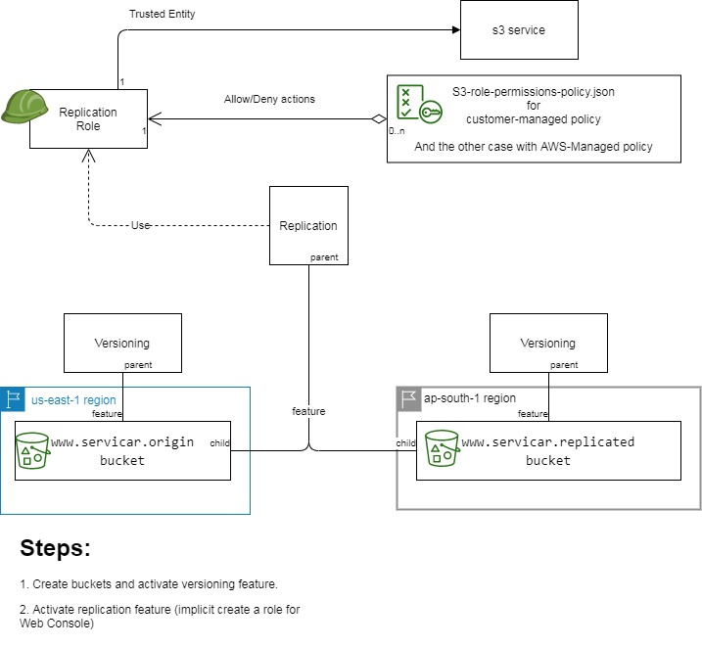

Lab 3B: Replication Bucket for S3.

# Prerequisites

Labs1c1 have to be done and the context for Administrative user have to activated on Command Line Session.

# Lab 3B: Cross-replication and versioning

## Lab 3B using Web Management Console

## Create the buckets

We recommend to create with versioning options done, however you can test how AWS forbidden the replication and asks to allow it.

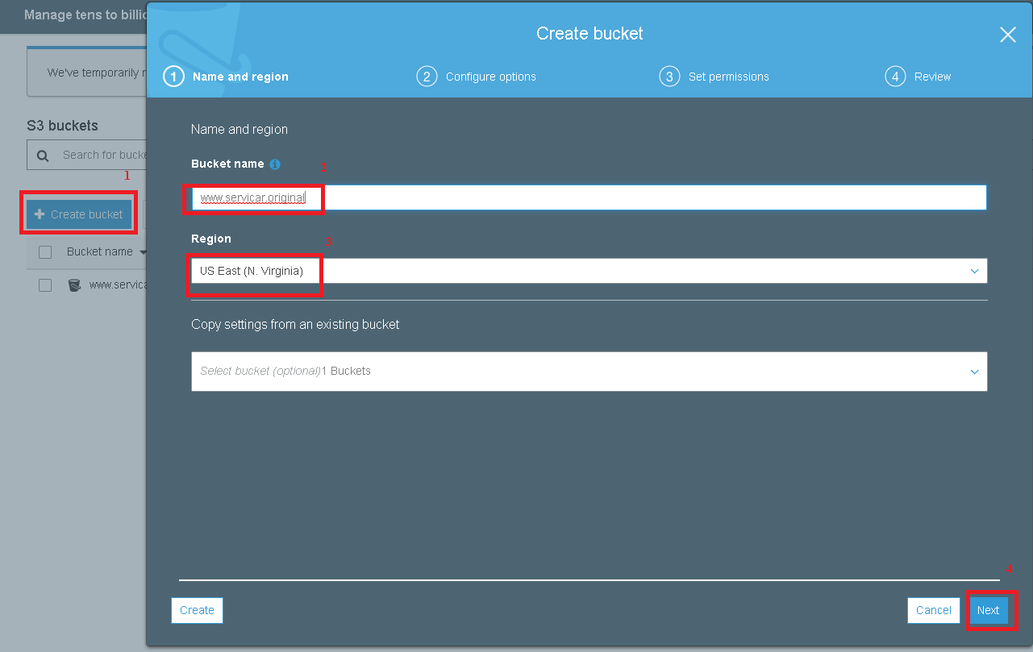

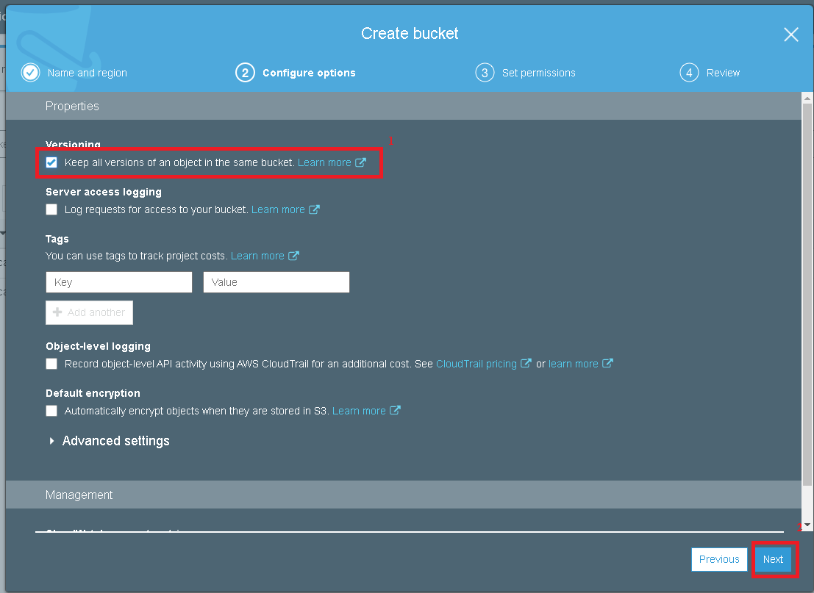

The permissions can be public or private, it works on the same way.

We will create the destination bucket.

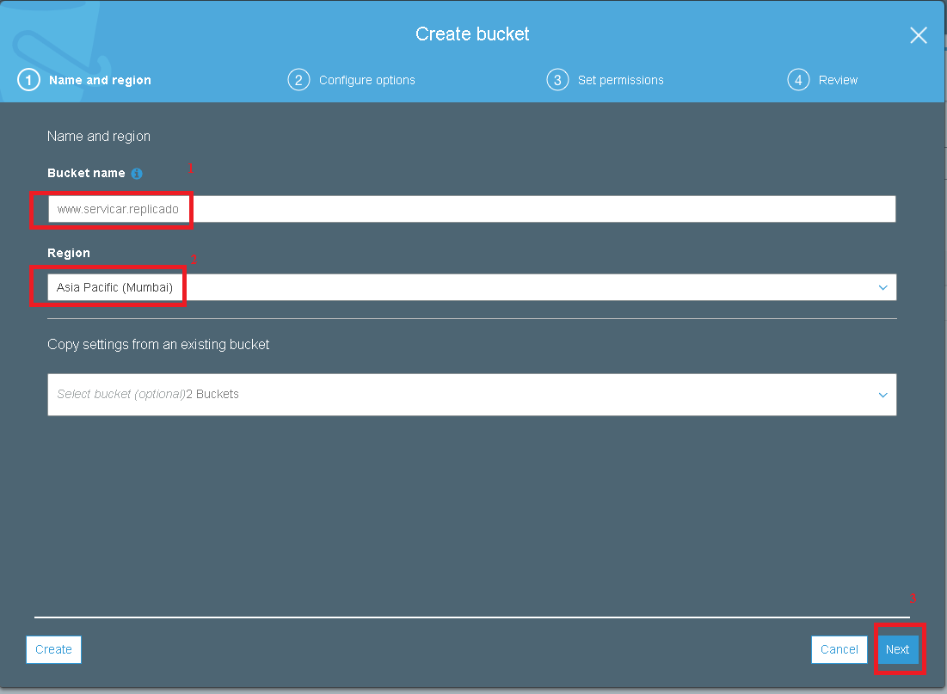

### Activate the replication feature on source bucket

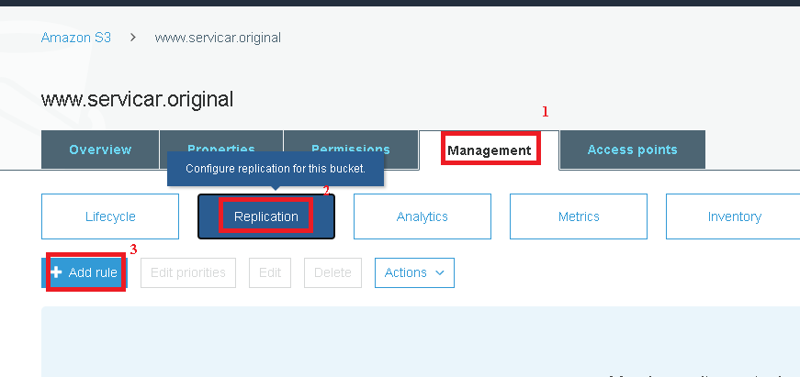

If you don’t activate versioning on creation bucket for source bucket, AWS asks

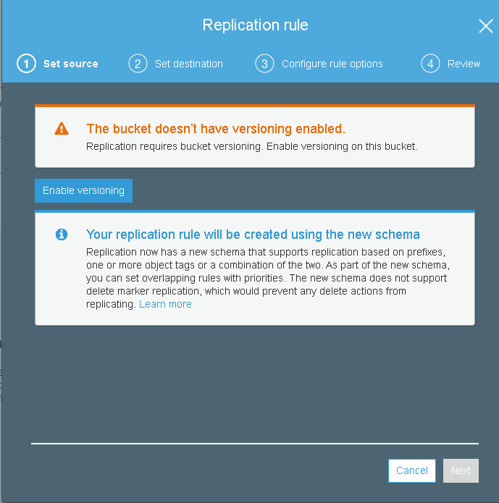

Otherwise,

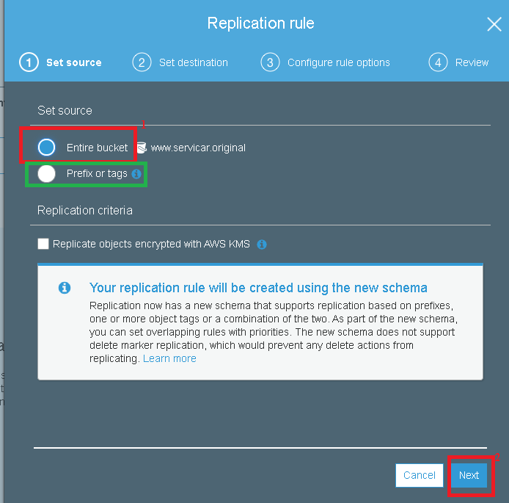

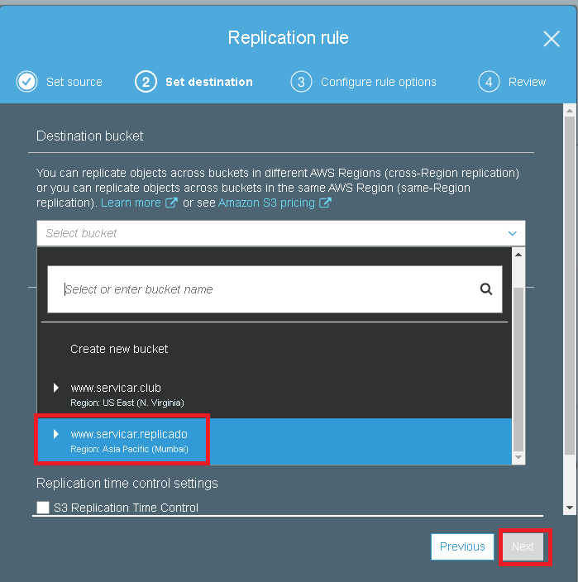

### Create/choose the replication role

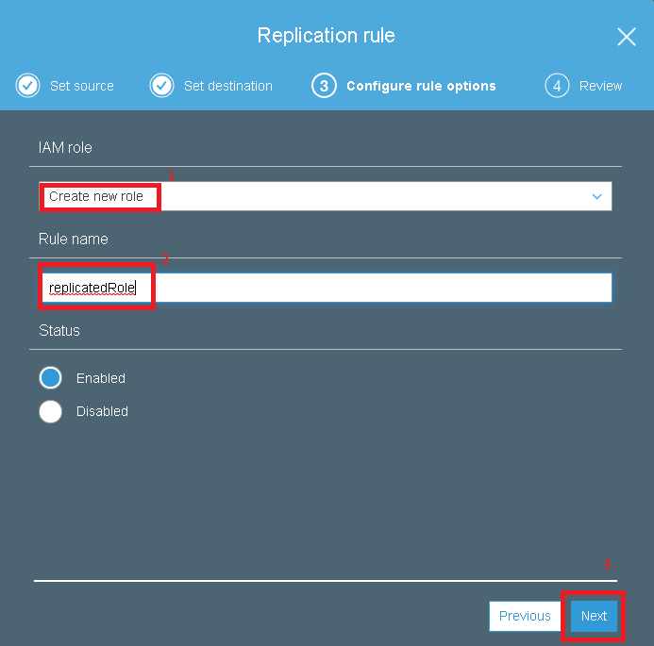

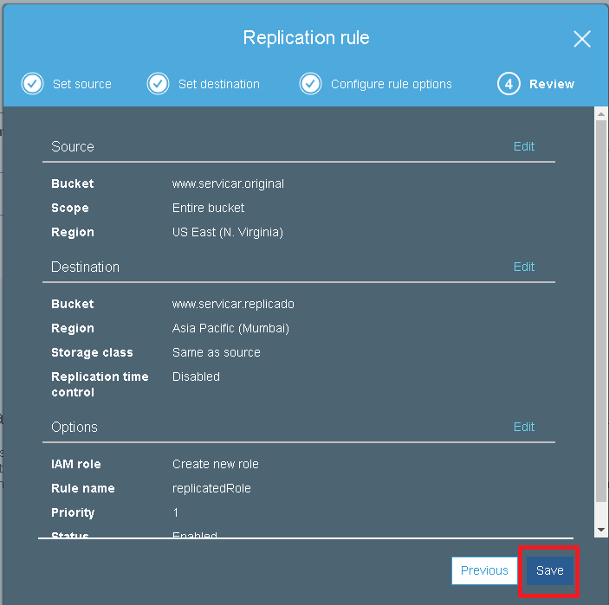

## Lab 3B using Command-Line (Windows)

### Create the buckets and able requirements (Versioning)

rem Definicion de nombres que sea DNS-Compliant Name

set SourceBucket=www.servicar.original

set DestinationBucket=www.servicar.replicado

rem Creacion de buckets y que tenga el versionamiento habilitados en ambos

aws s3api create-bucket --bucket %SourceBucket% --region us-east-1

aws s3api put-bucket-versioning --bucket %SourceBucket% --versioning-configuration Status=Enabled

aws s3api create-bucket --bucket %DestinationBucket% --region ap-south-1 --create-bucket-configuration LocationConstraint=ap-south-1

aws s3api put-bucket-versioning --bucket %DestinationBucket% --versioning-configuration Status=Enabled

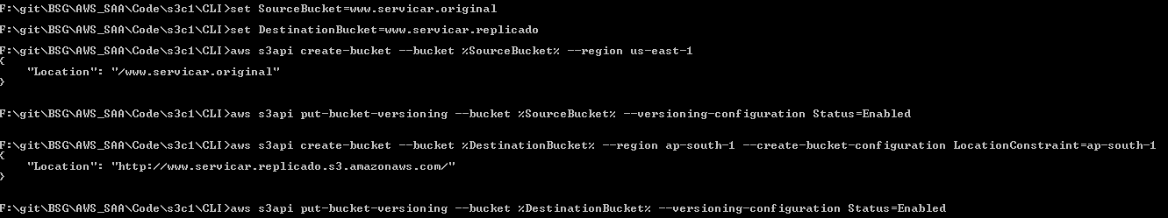

rem Crear un rol que tenga un alcance/Trusted Entity al servicio s3; y aplicar un rol que permite leer, escribir y duplicar en los buckets

aws iam create-role --role-name replicationRole --assume-role-policy-document file://s3-role-trust-policy.json

rem Copiar el ARN del Rol que se genero

rem Modificar el documento de permisos por rol para añadir el nombre de los 2 buckets

aws iam put-role-policy --role-name replicationRole --policy-document file://s3-role-permissions-policy.json --policy-name replicationRolePolicy

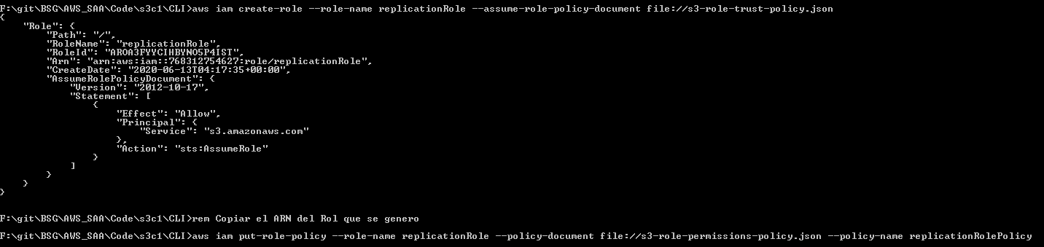

### Apply replication configuration and review

rem Modificar el archivo de replication.json que permite la replicacion por medio de la configuracion del bucket

rem Aplicar el Role ARN; y el nombre del bucket destino

aws s3api put-bucket-replication --replication-configuration file://replication.json --bucket %SourceBucket%

rem Revisar configuracion

aws s3api get-bucket-replication --bucket %SourceBucket%

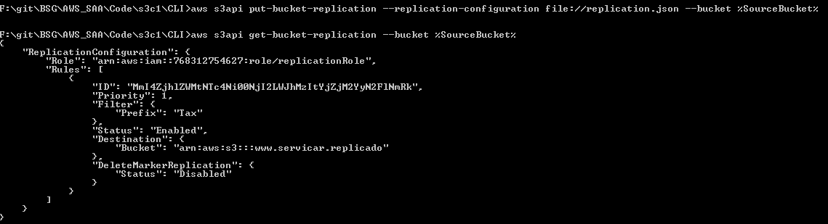

## Review for both methods: Web and CLI

### Review for Replication

rem Realizar la prueba en AWS Web Management Console creando una carpeta llamada Tax en el Bucket Origen y enviando archivos alli. Tambien aplica si se quita el filtrado en el archivo replication.json

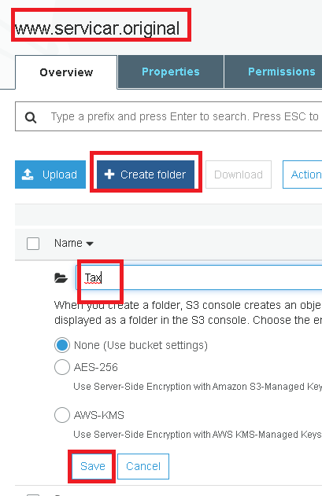

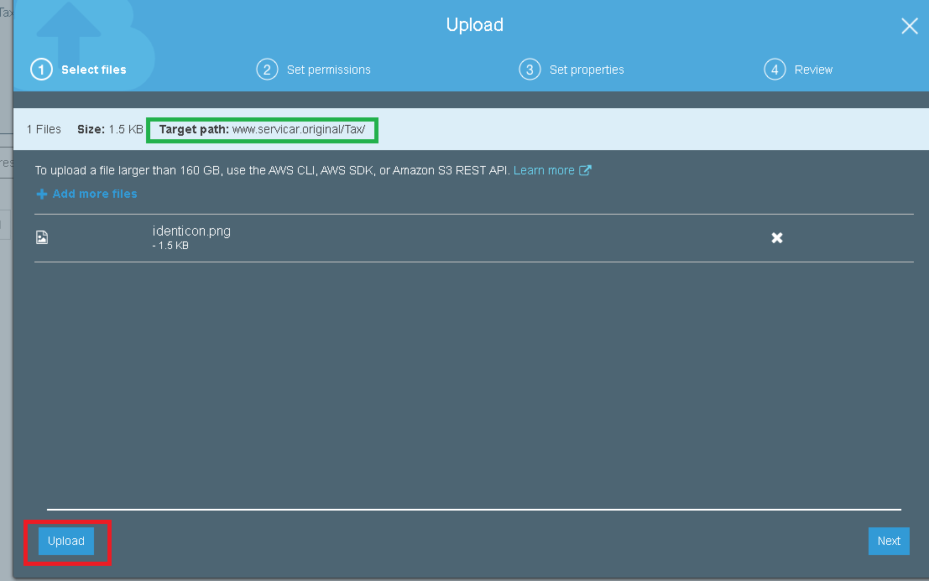

rem Seleccionar el bucket replicado y revisando las propiedades del archivo creado

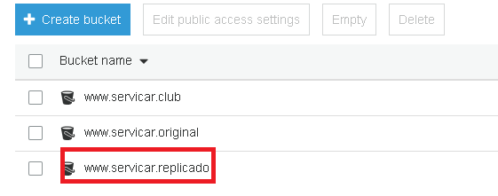

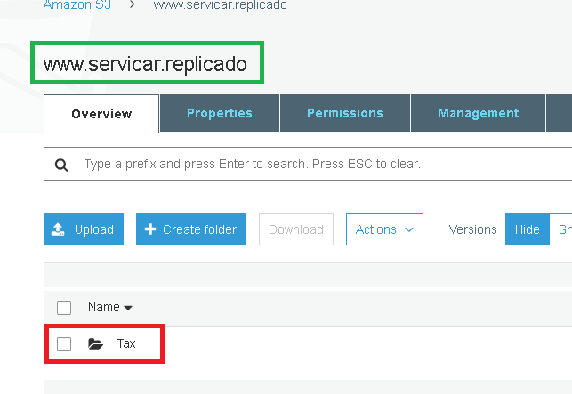

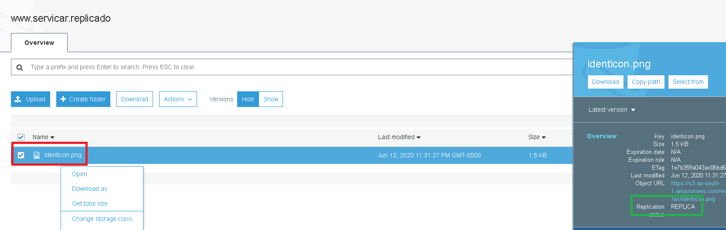

rem Puede revisar y saber que tipo de politica se esta aplicando al role de replica cuando fue creado por línea de comando

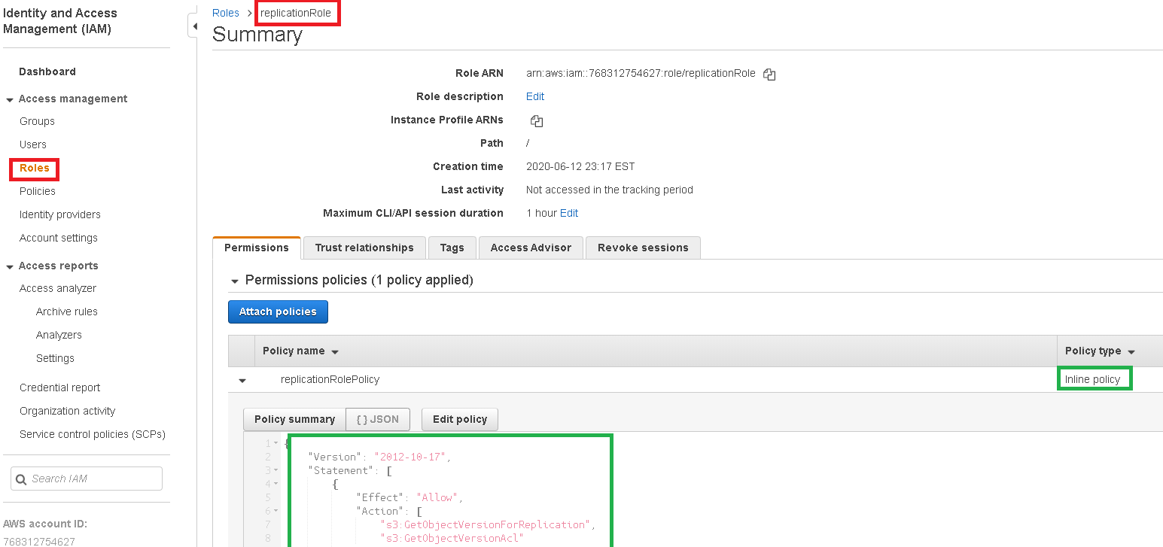

rem Puede revisar y saber que tipo de politica se esta aplicando al role de replica ya sea por linea de comando o por Web Management Console

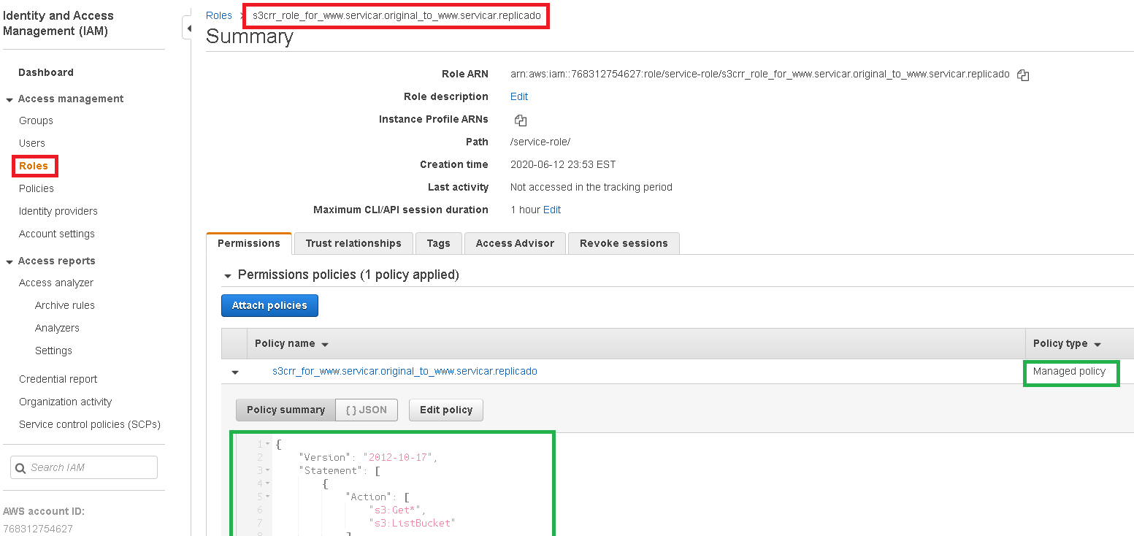

### Review for Versioning

You have to rewrite the files several times on source bucket, using drag-and-drop and then,

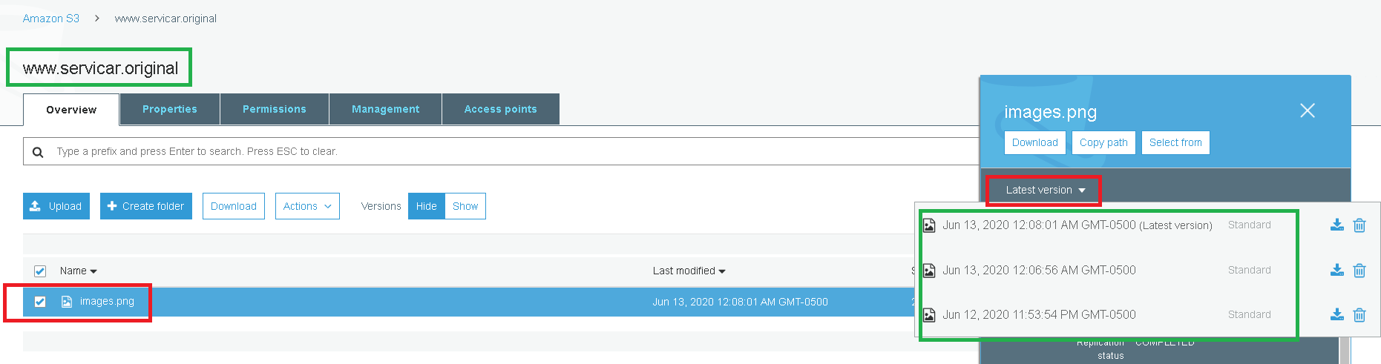

What happened if you delete some of them?

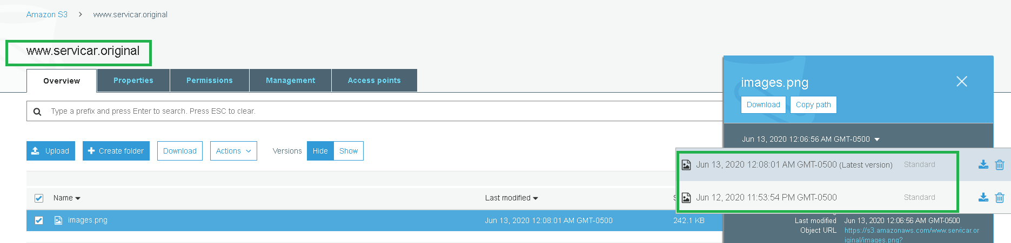

What happened on the replication?

