Contents

Prerequisites 2

Lab 6B: Multi-tier Web App with Autoscaling 2

Create VPC, Subnet, IGW, NAT, Routing Table, Keys, Sec Groups (Labs4c1) VPC Peering (Labs4c2), Instances on App Layer (Labs5c1), ALB, NLB and their target groups (Labs6c1). 2

Lab 6B using Web Management Console 3

Create Launch Configuration, Autoscaling Group and internal configurations 3

Lab 6B using Command Line (Windows) 8

Create Launch Configuration, Autoscaling Group, Simple Scaling Policy with Cloudwatch as trigger 8

Forcing Policy Status 9

Clean Resources 13

# Prerequisites

Labs1c1 have to be done and the context for Administrative user have to activated on Command Line Session.

Labs6c1 have to be done, because you learn how to: Deploy Network Infrastructure, Securize instances, deploy applications using Docker, create a functional ALB and NLB. The only exception is that you have to delete the instances A and B of previous lab.

# Lab 6B: Multi-tier Web App with Autoscaling

### Create VPC, Subnet, IGW, NAT, Routing Table, Keys, Sec Groups (Labs4c1) VPC Peering (Labs4c2), Instances on App Layer (Labs5c1), ALB, NLB and their target groups (Labs6c1).

Review with the browser from Lab s6c1 as initial status. Delete Instances A and B to force that work Autoscaling Group

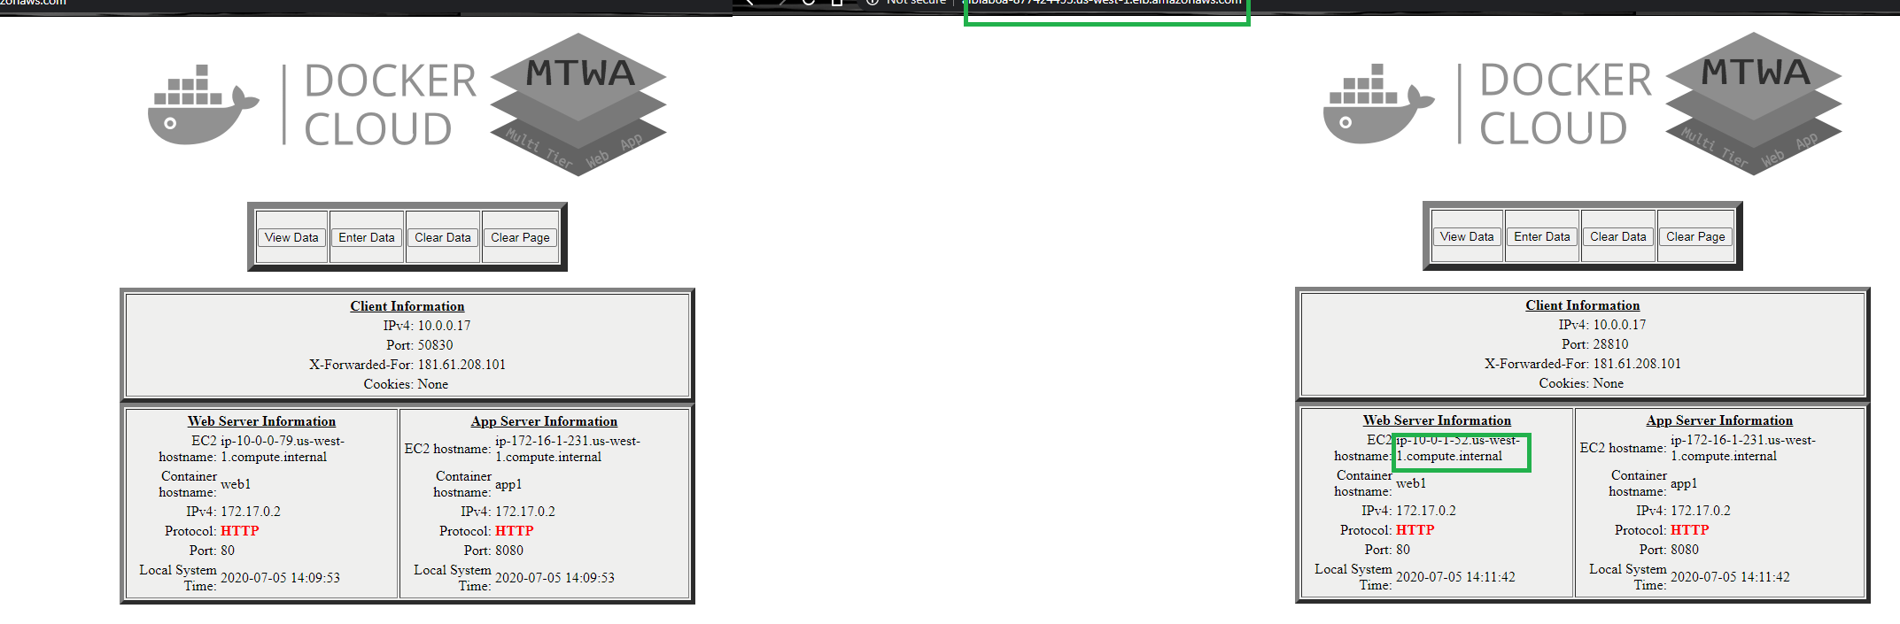

## Lab 6B using Web Management Console

### Create Launch Configuration, Autoscaling Group and internal configurations

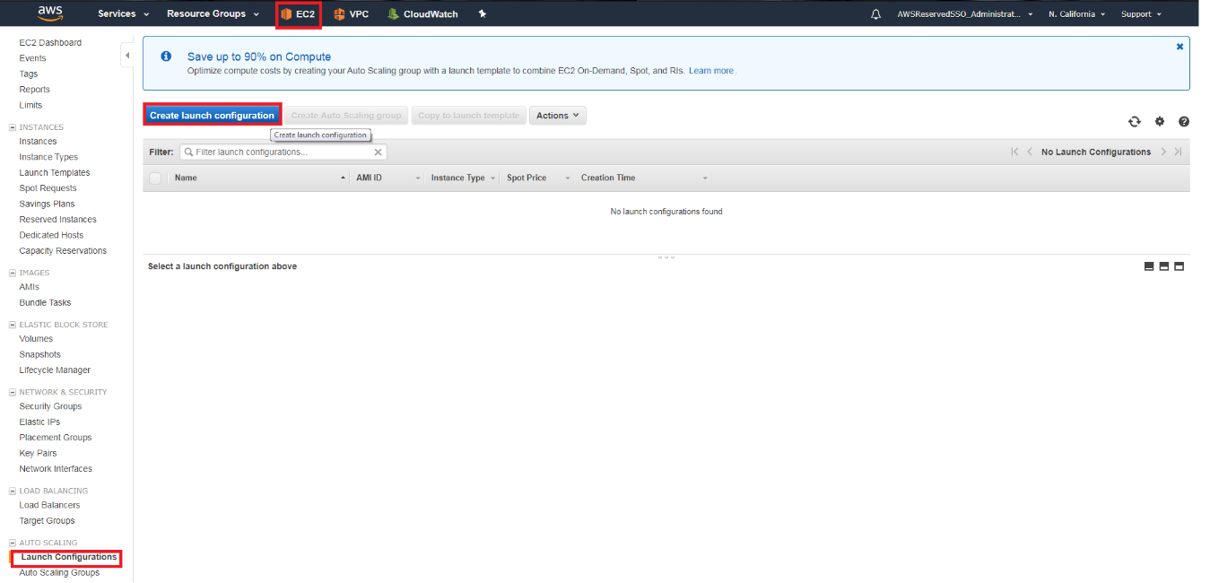

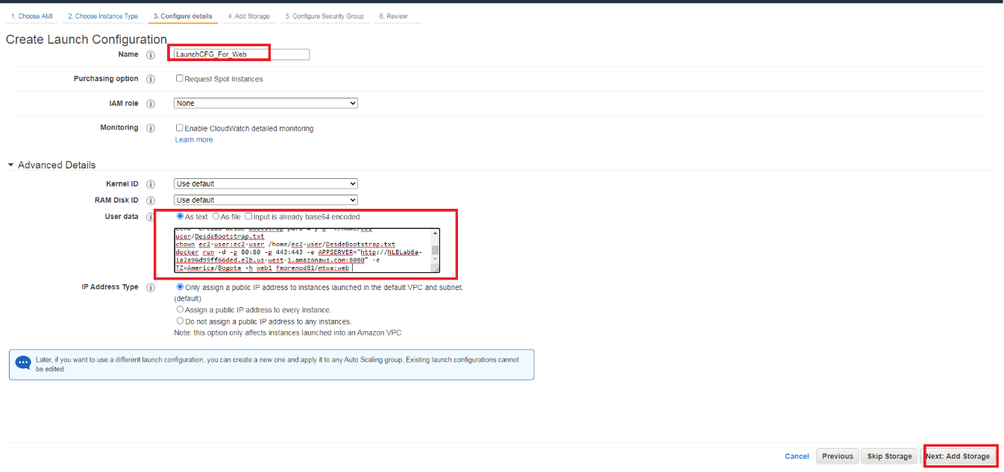

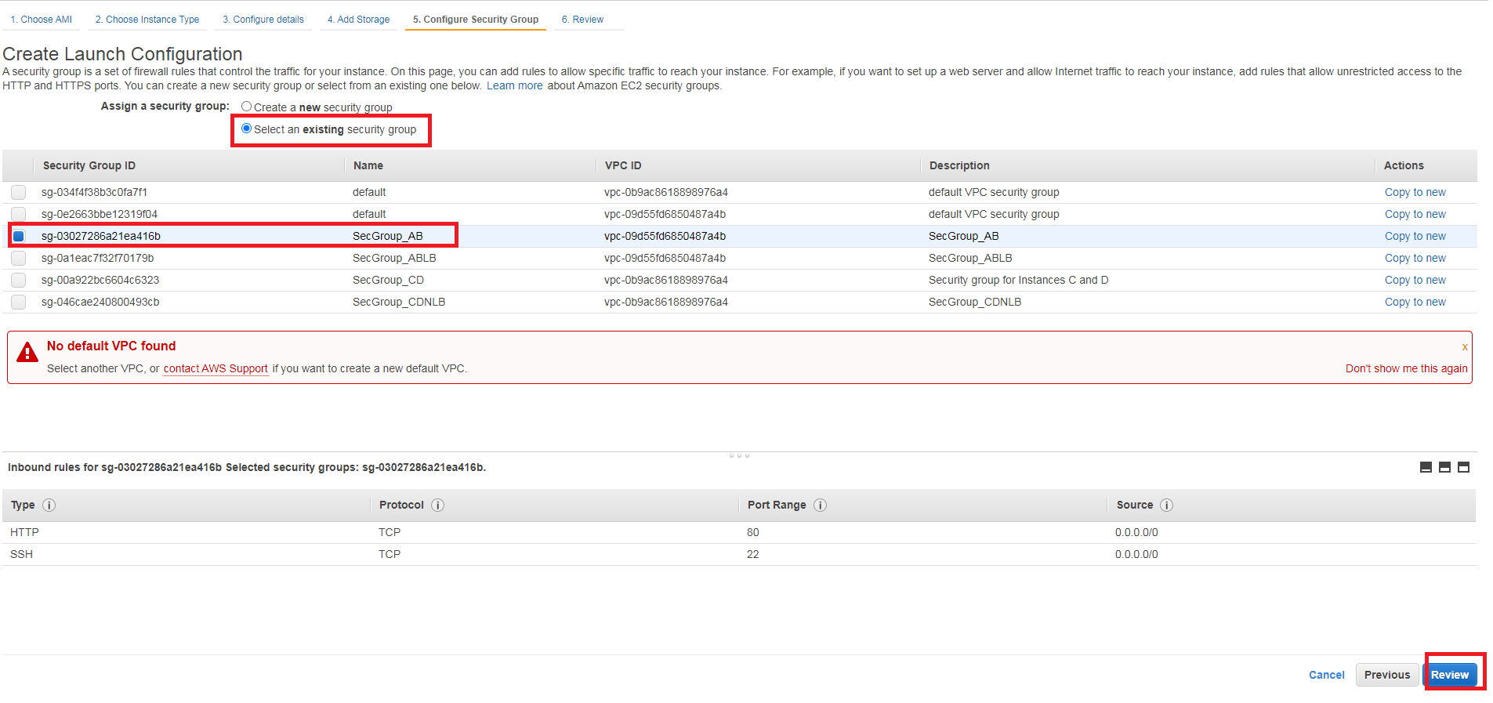

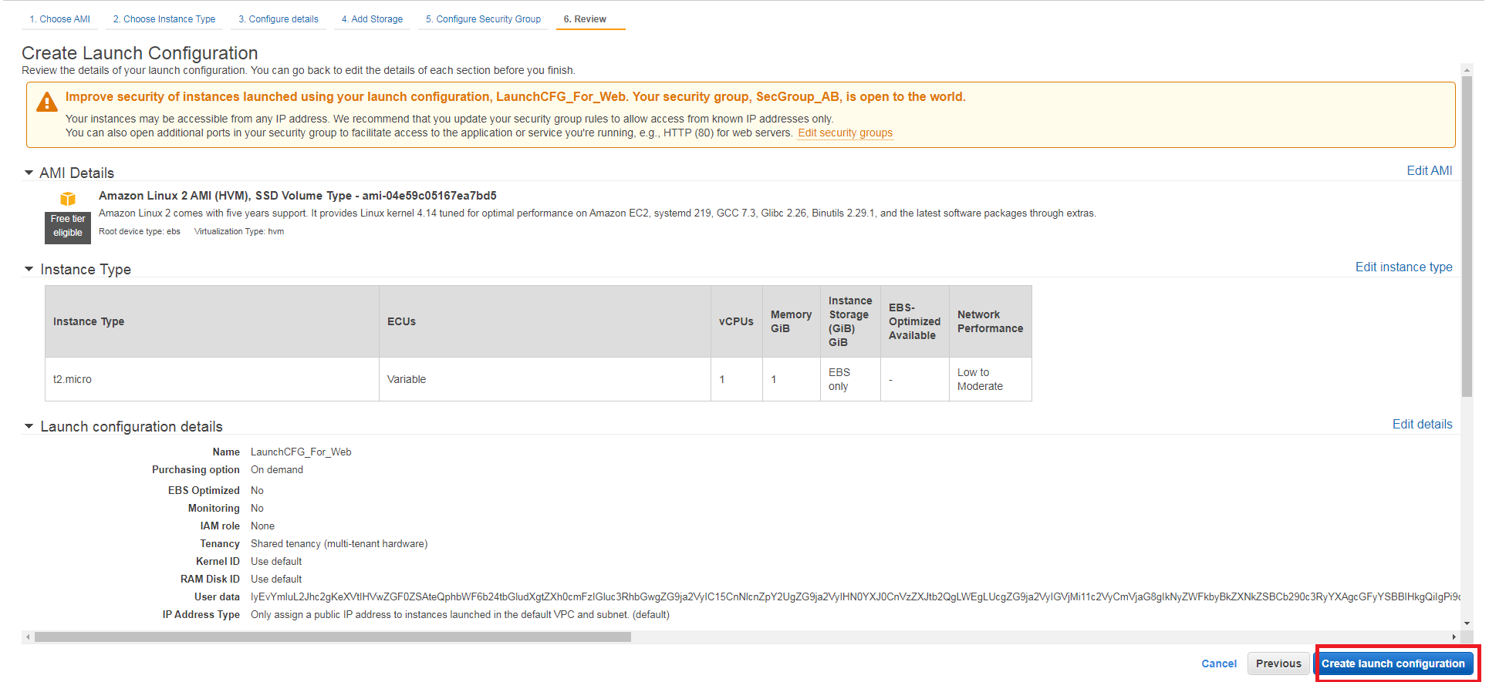

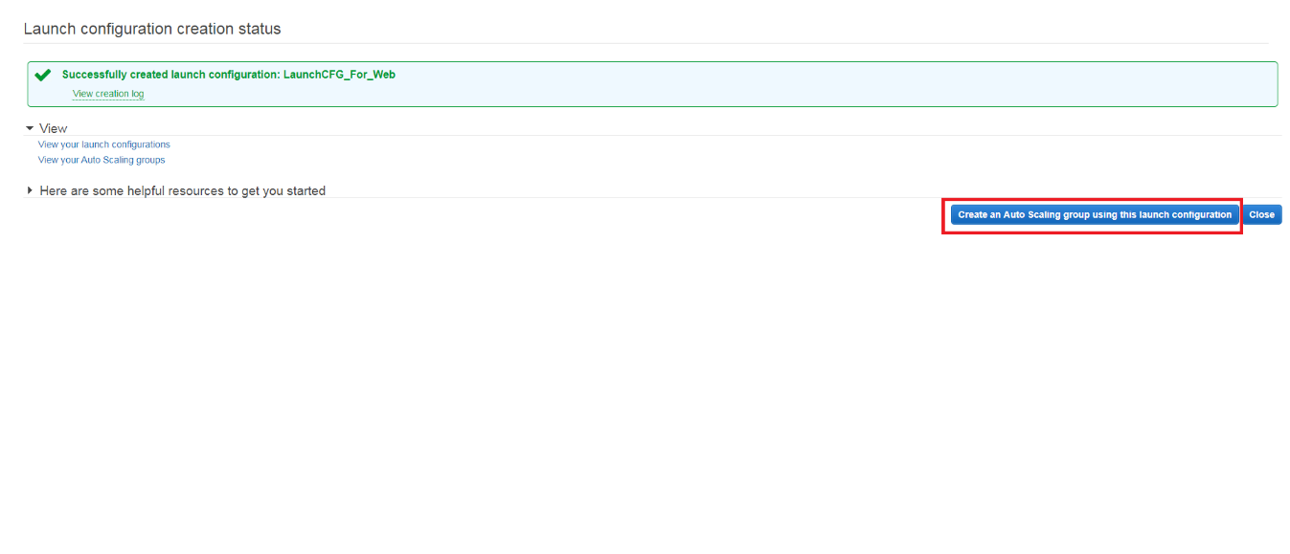

This is a shortcut to create a Auto Scaling Group from a Launch configuration:

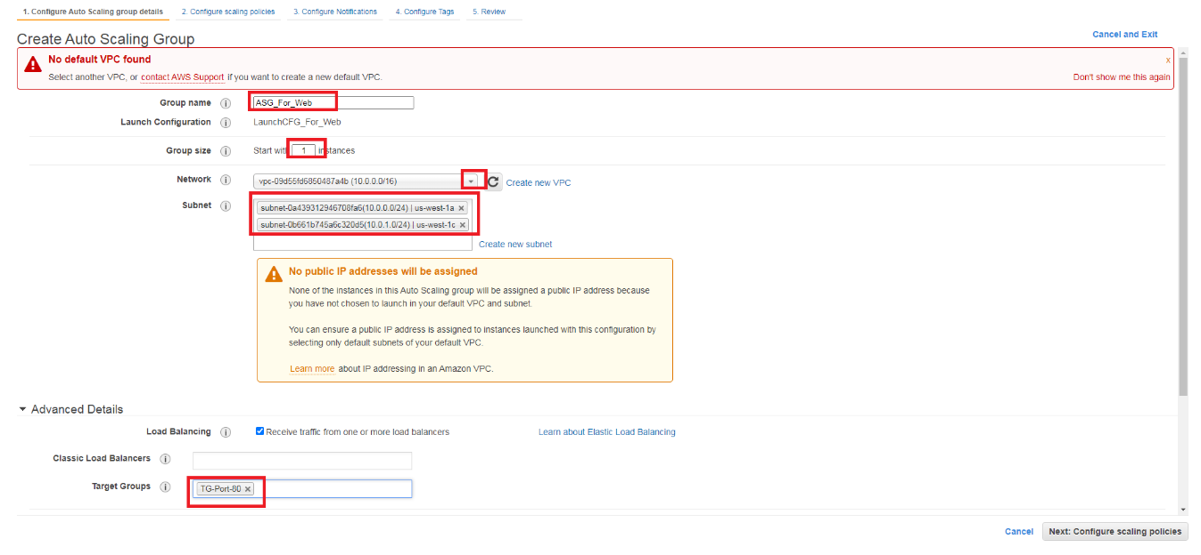

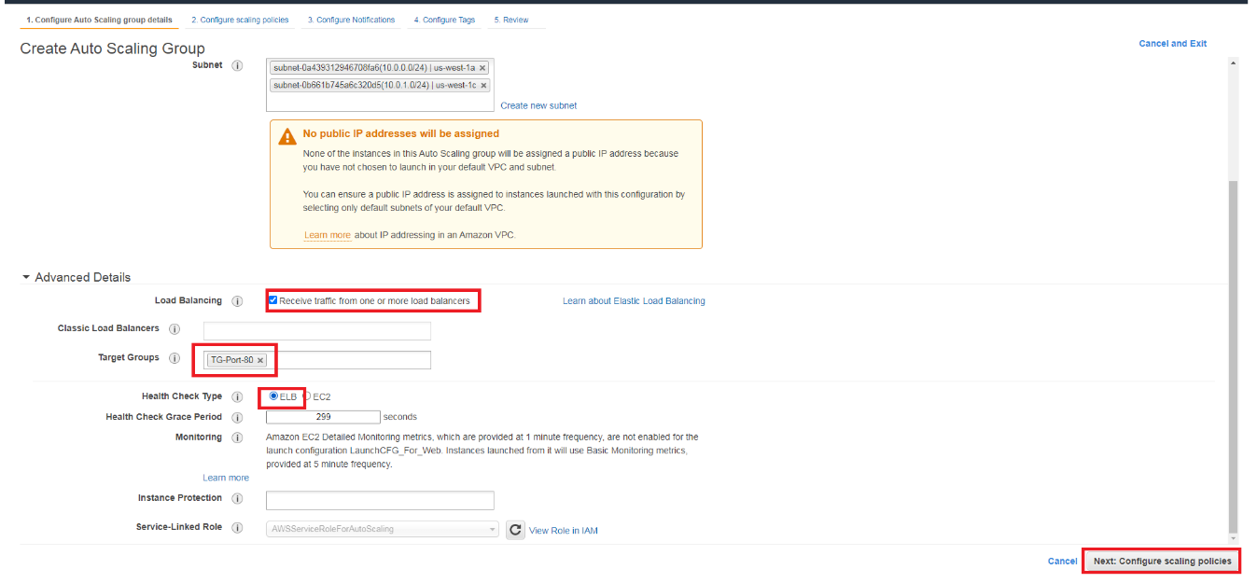

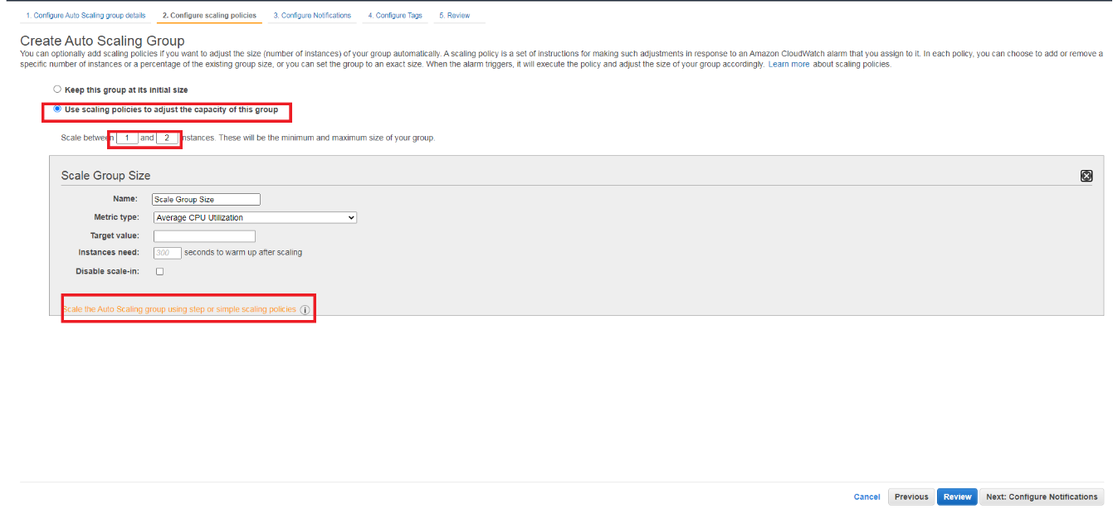

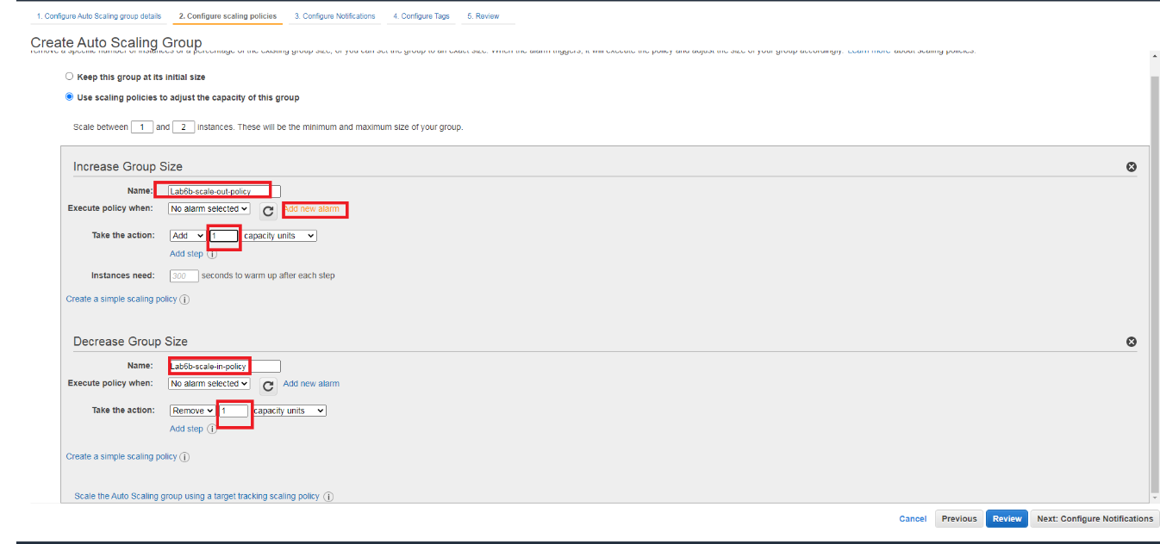

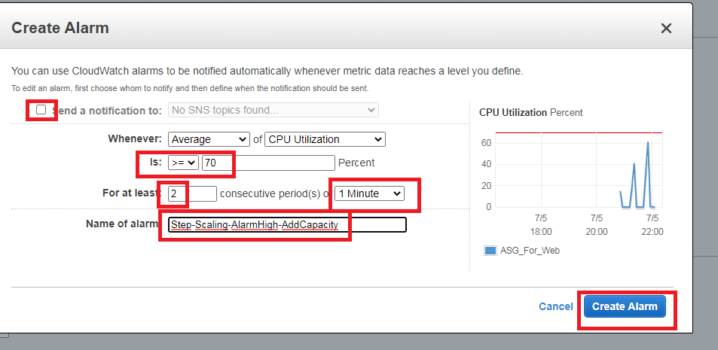

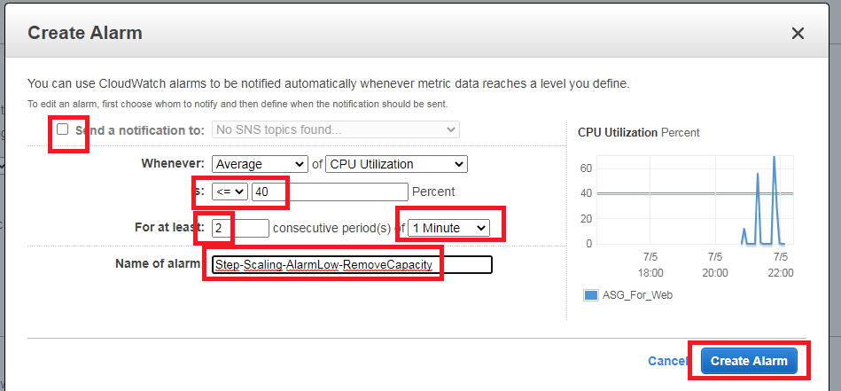

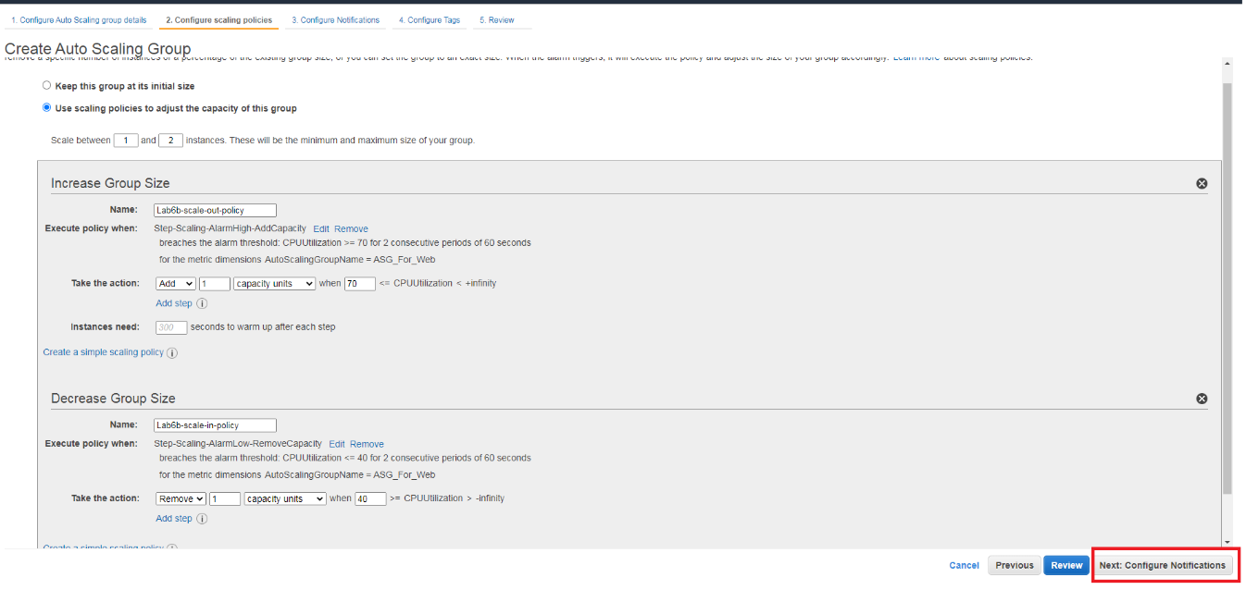

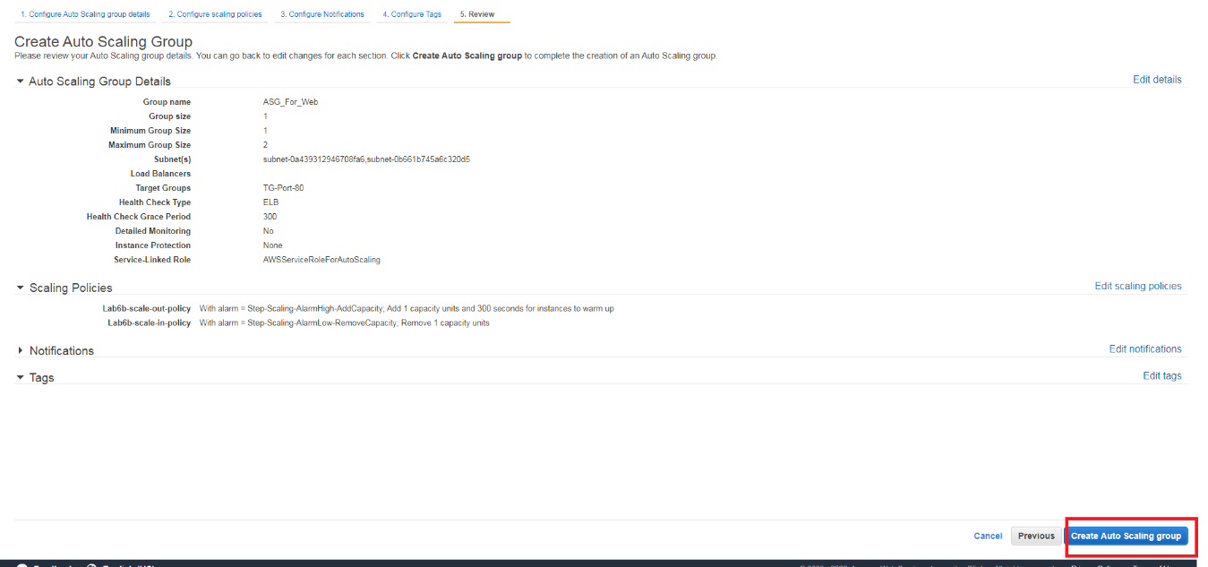

Finally, you can check that a new instance is created:

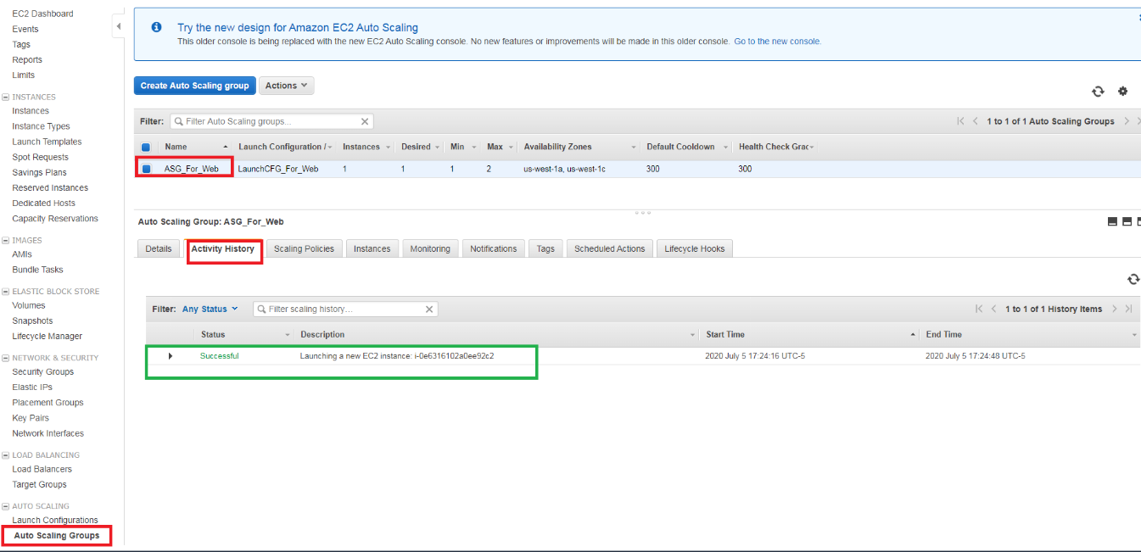

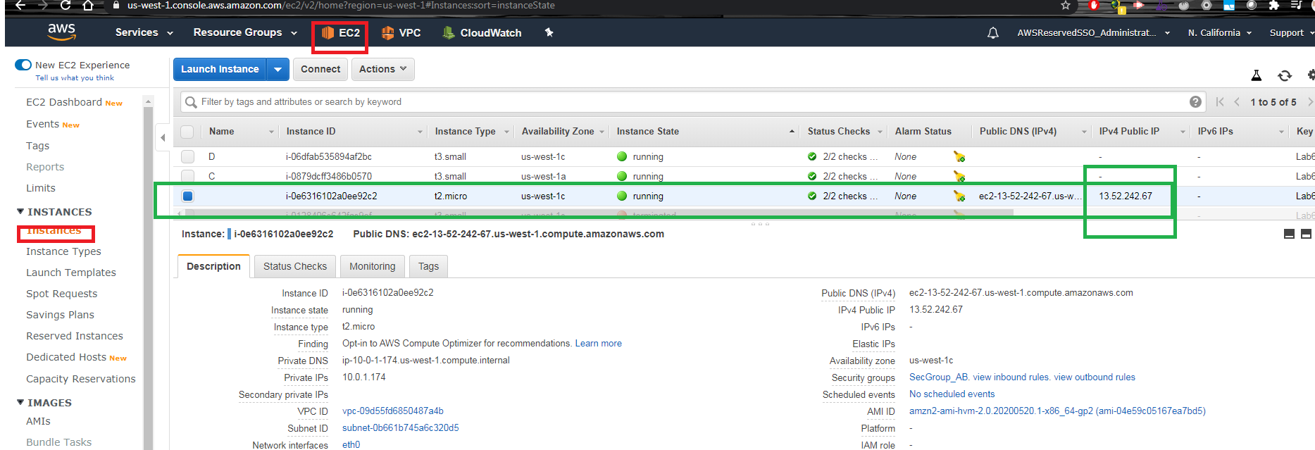

Go to “Forcing Policy Status” section

## Lab 6B using Command Line (Windows)

### Create Launch Configuration, Autoscaling Group, Simple Scaling Policy with Cloudwatch as trigger

rem Se tiene que crear un Launch Template

rem Se crea ua configuracion para la capa Web

aws autoscaling create-launch-configuration --launch-configuration-name LaunchCFG_For_Web --image-id %AMI% --instance-type %instance_type% --security-groups %SecGroup_AB_Id% --key-name Lab6a --user-data file://bootstrapAB.txt >tmpFile

rem Se tiene que crear un AutoScaling Group para un LB

aws autoscaling create-auto-scaling-group --auto-scaling-group-name ASG_For_Web --launch-configuration-name LaunchCFG_For_Web --vpc-zone-identifier %pbsn1_Id%,%pbsn2_Id% --target-group-arns %TG80_ARN% --max-size 5 --min-size 1 --desired-capacity 1

rem Se crea un escalamiento simple en crecimiento y decreciendo. https://docs.aws.amazon.com/autoscaling/ec2/userguide/as-scaling-simple-step.html#simple-scaling-policies-aws-cli

aws autoscaling put-scaling-policy --policy-name Lab6b-scale-out-policy --auto-scaling-group-name ASG_For_Web --scaling-adjustment 50 --adjustment-type PercentChangeInCapacity|jq ".PolicyARN" >tmpFile

set /p ASG_Scaleout_Policy= <tmpFile

aws autoscaling put-scaling-policy --policy-name Lab6b-scale-in-policy --auto-scaling-group-name ASG_For_Web --scaling-adjustment -1 --adjustment-type ChangeInCapacity --cooldown 180 |jq ".PolicyARN" >tmpFile

set /p ASG_Scalein_Policy= <tmpFile

aws cloudwatch put-metric-alarm --alarm-name Step-Scaling-AlarmHigh-AddCapacity  --metric-name CPUUtilization --namespace AWS/EC2 --statistic Average  --period 120 --evaluation-periods 1 --threshold 70 --comparison-operator GreaterThanOrEqualToThreshold --dimensions "Name=AutoScalingGroupName,Value=ASG_For_Web" --alarm-actions %ASG_Scaleout_Policy%

aws cloudwatch put-metric-alarm --alarm-name Step-Scaling-AlarmLow-RemoveCapacity --metric-name CPUUtilization --namespace AWS/EC2 --statistic Average --period 120 --evaluation-periods 1 --threshold 40 --comparison-operator LessThanOrEqualToThreshold --dimensions "Name=AutoScalingGroupName,Value=ASG_For_Web" --alarm-actions %ASG_Scalein_Policy%

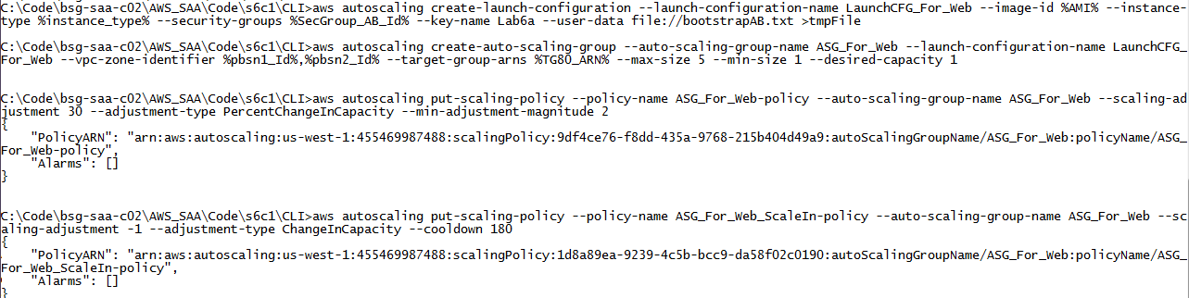

Go to “Forcing Policy Status” section

## Forcing Policy Status

Given the new IP, goes to Putty and run the following commands:

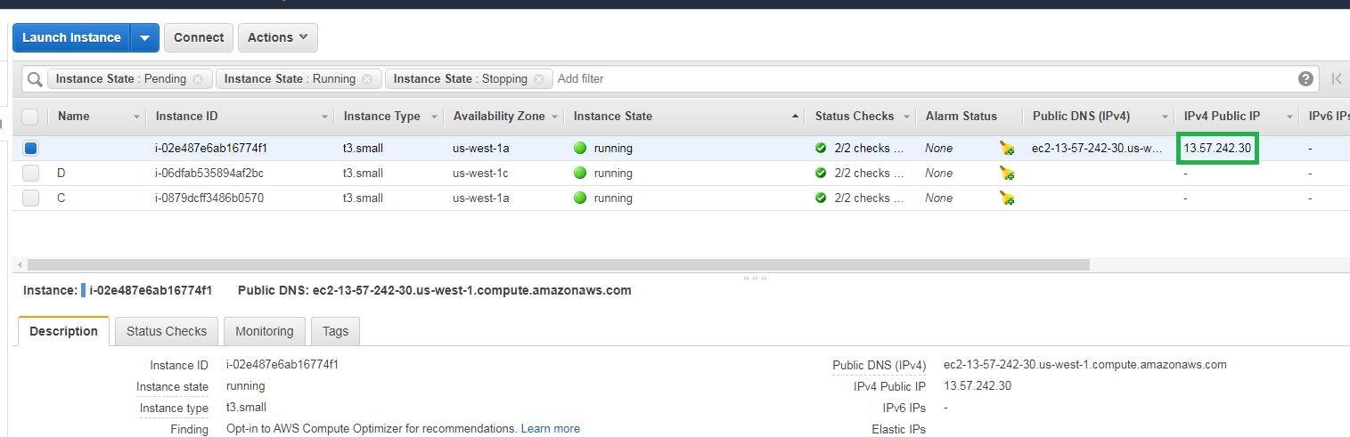

putty -i "Lab6a.ppk" ec2-user@13.57.242.30

putty -i "Lab6a.ppk" ec2-user@13.57.242.30

sudo amazon-linux-extras install epel -y

sudo yum install stress -y

rem Definir la cantidad de CPUs a cargar, esto depende del tipo de instancia a realizar la prueba. t3.small tiene 2 cpus

stress --cpu 2 --timeout 360

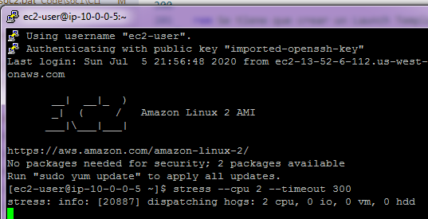

You can check its status on Monitoring on the same instance page.

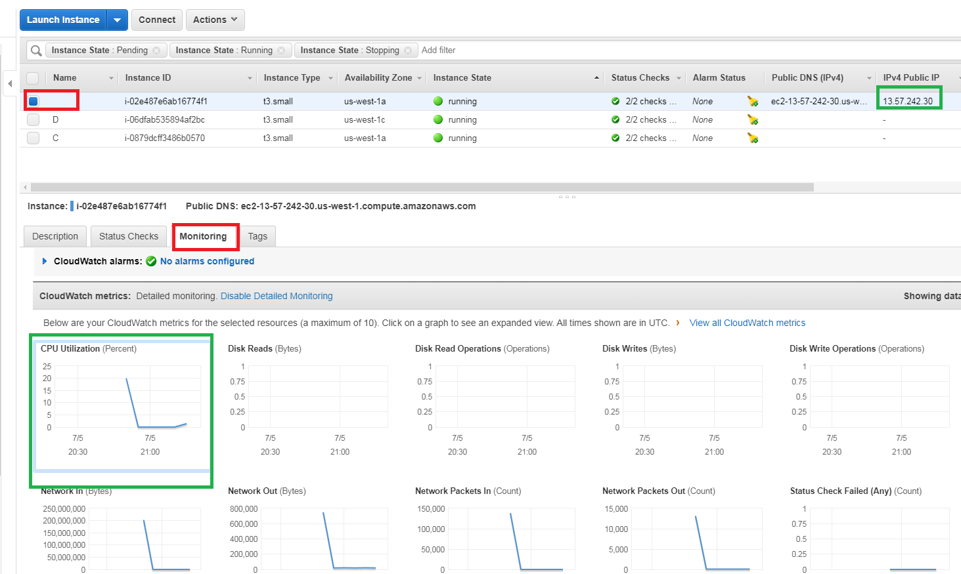

And you check the status of the alarmas on Cloudwatch. At starting, there are “insufficient data” status upto have a complete period.

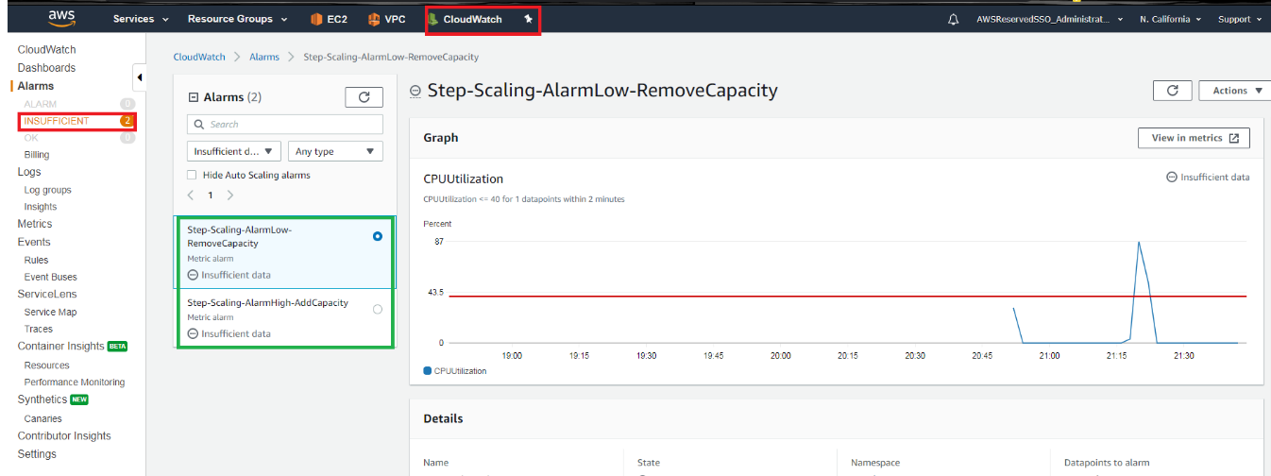

Later,

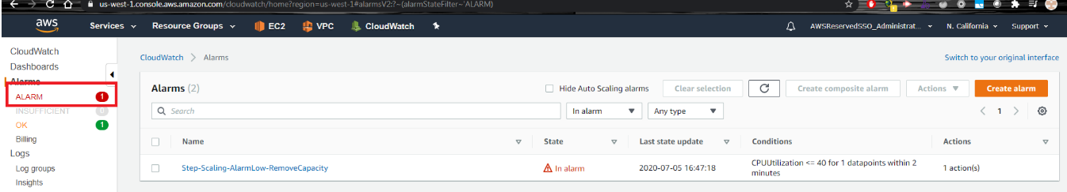

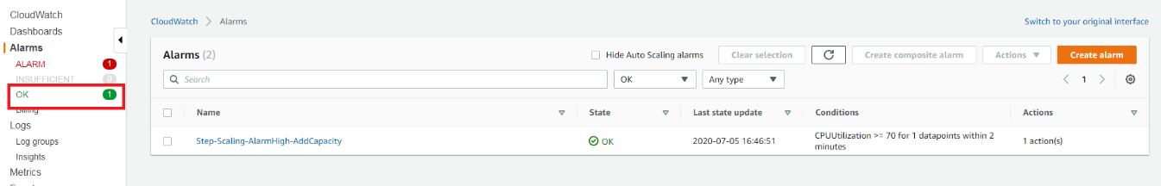

When it detects the CPU stress, the alarms change its statues.

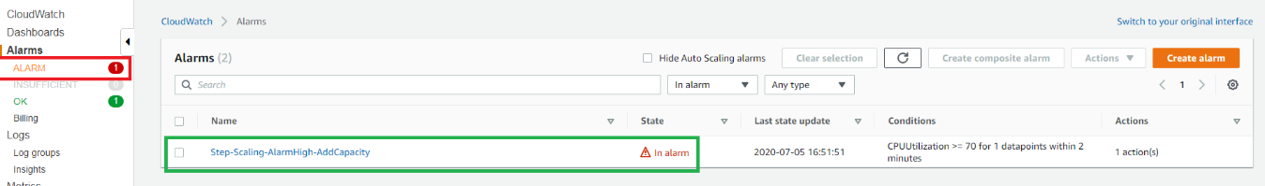

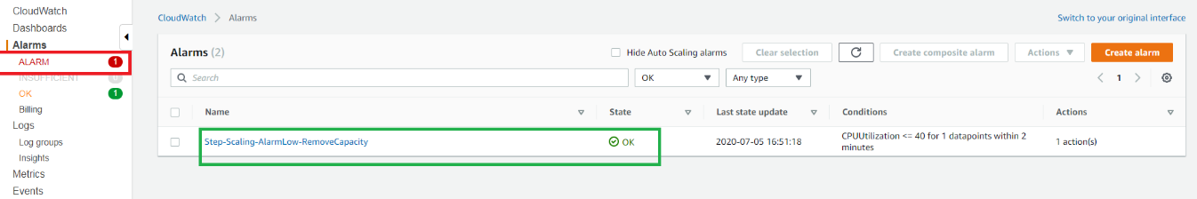

And you can see the activity of Autoscaling group history,

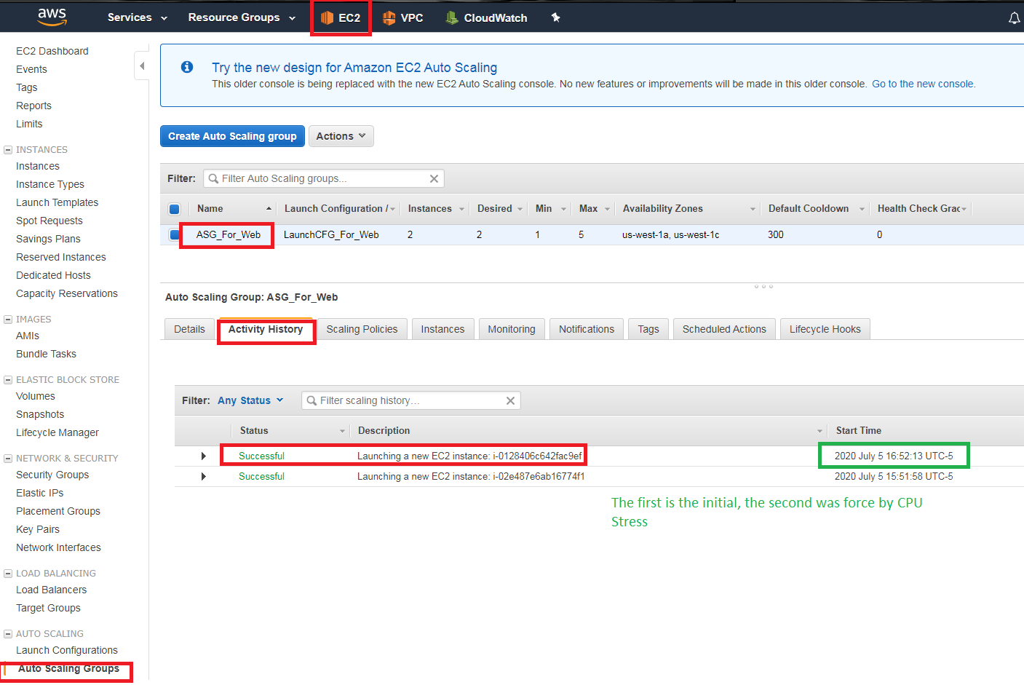

Even on the instance page, you see the new instance

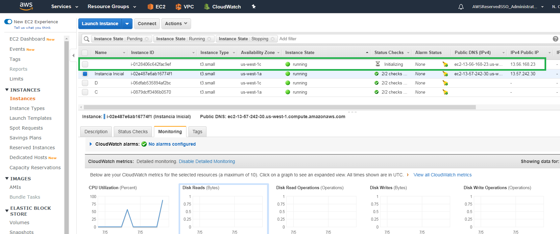

On the other way, to scale-in you have to wait until it happened, and the default policy is to delete the older.

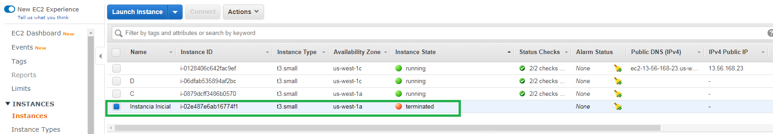

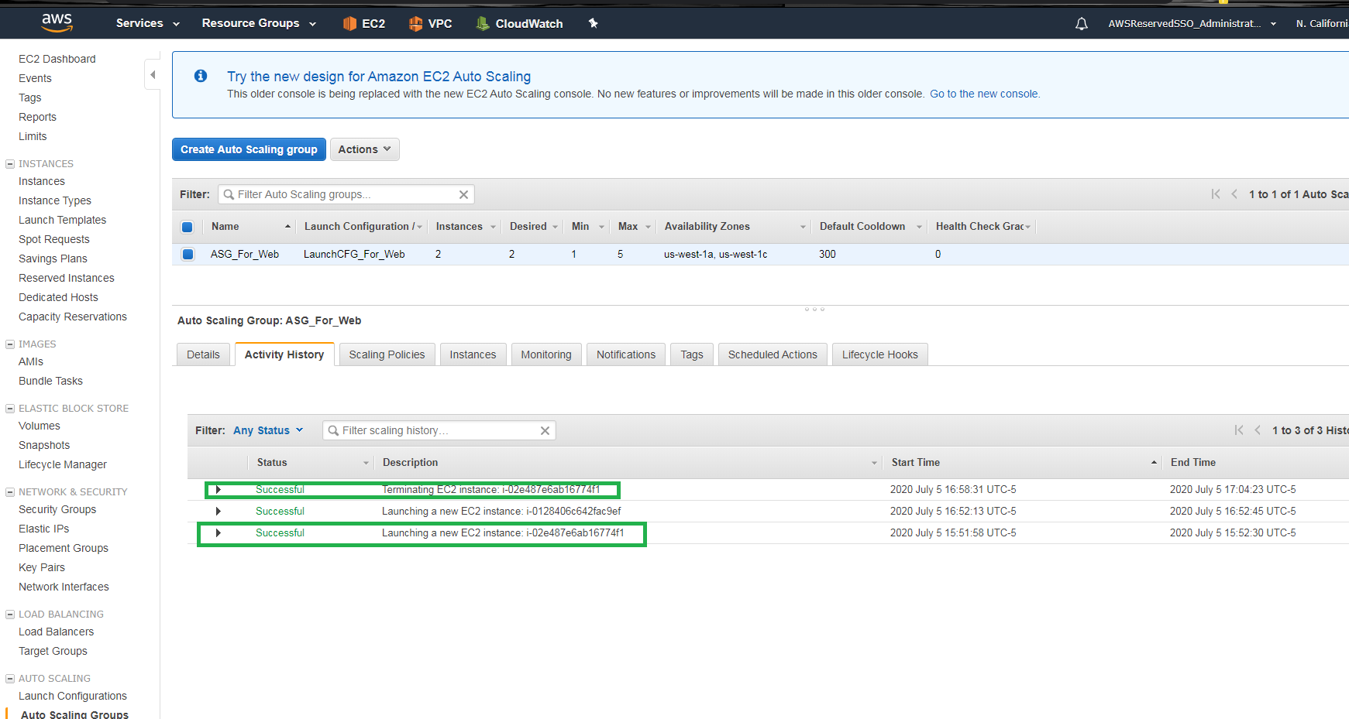

## Clean Resources

VPC: Peering Connections

EC2: Instances

EC2: Load LoadBalancers

EC2: TargetGroups

VPC: NAT gateway

VPC: EIP

EC2: Keypair

EC2: Security Group

VPC: VPC