Contents

General Diagram 2

Prerequisites 2

Labs9: Lab Prerequisites (Using Cloudformation) 3

Lab 9c1: Create multiattach EBS and mount on 2 Instances 7

Create Multiattach EBS and attach to the instances 7

Create Filesystem, mount it to instances and create a file 10

Create Standard EBS and modifying size without instances actions 12

Evidences to send 17

Clean Resources 17

Detaching and deleting EBS 17

Deleting Cloudformation Stack 18

Clean resources from command line 19

# General Diagram

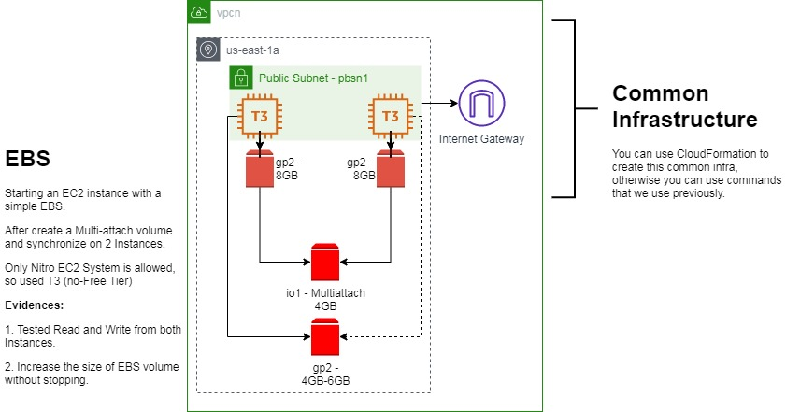

Create a well know infrastructure with 2 Public Instances to access them using SSH. Then create a multiattach EBS and see that its possible to access from both instances. In addition, we have to create another standard EBS and increase its size without detach from instances or unmount filesystem.

# Prerequisites

Labs1c1 have to be done and the context for administrative user have to activated on Command Line Session.

Labs4c1 has the context to create infrastructure: Network (VPC, Subnets), Sec Groups and Instances.

As the instances must be T3 as minimum, the lab cost can be U$1 or less, depends on the time that you spend.

You must create a Keypair before to launch Cloudformation, in this example, the key is ds4_kp, but it can be anything.

# Labs9: Lab Prerequisites (Using Cloudformation)

Use Clouformation service to upload the JSON file, if you like read the file using a notepad or view it using CloudFormation Designer.

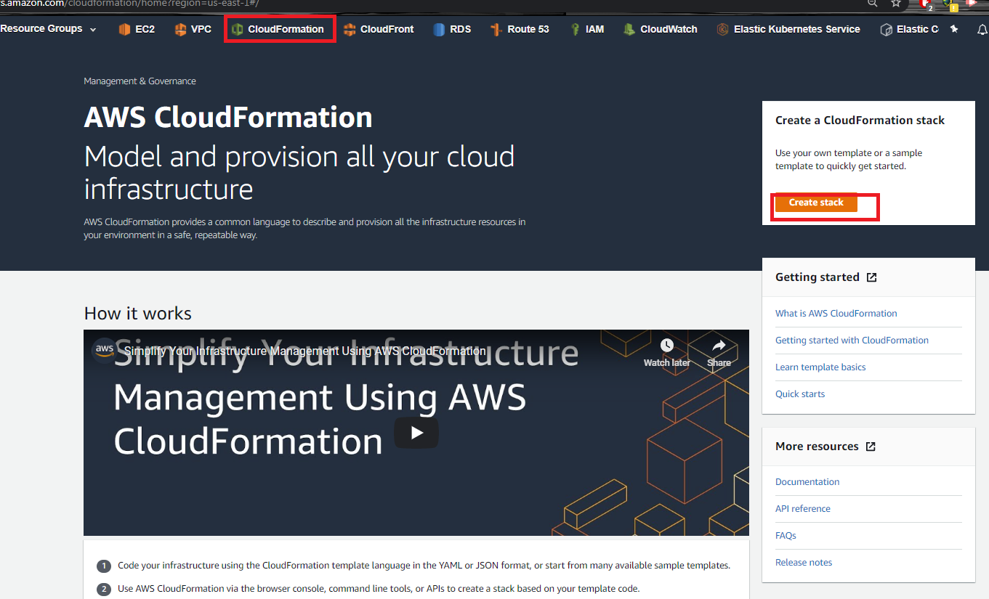

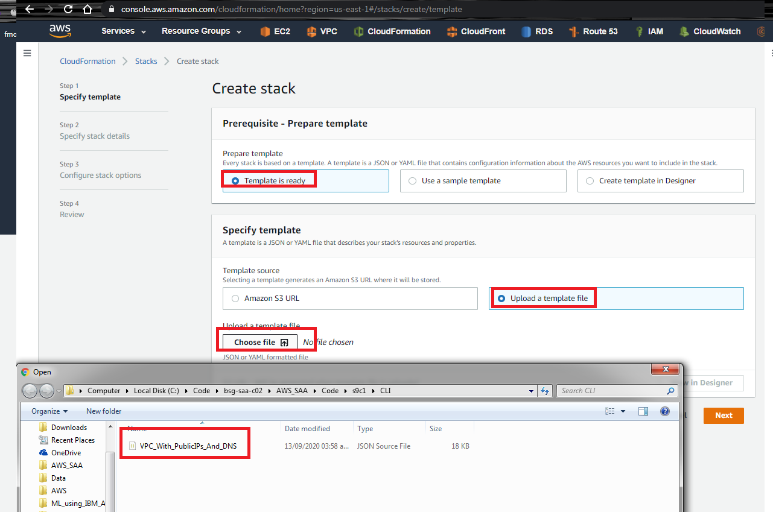

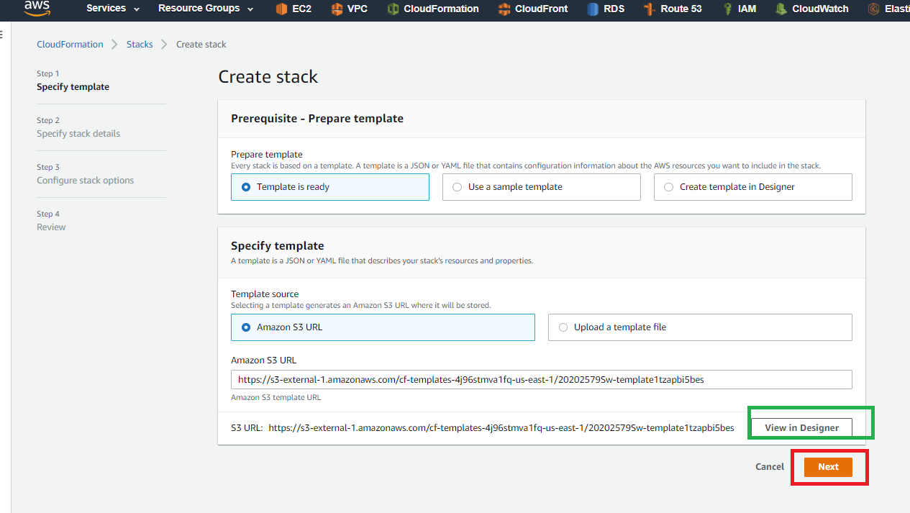

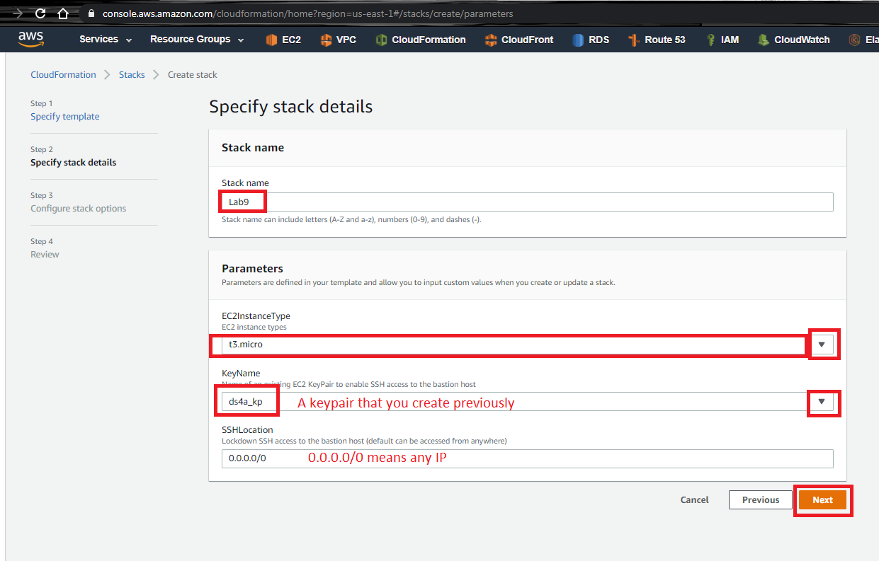

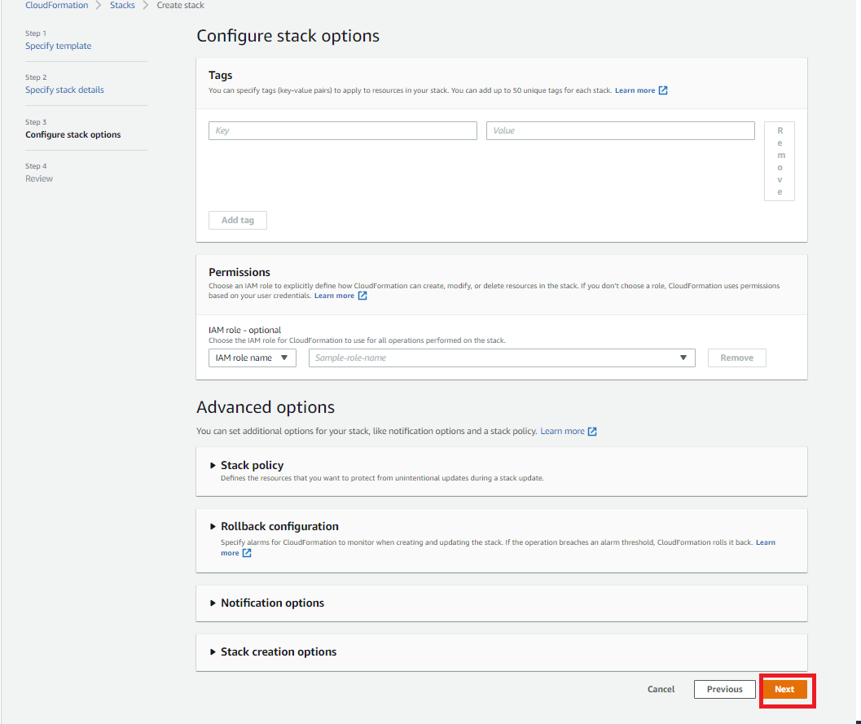

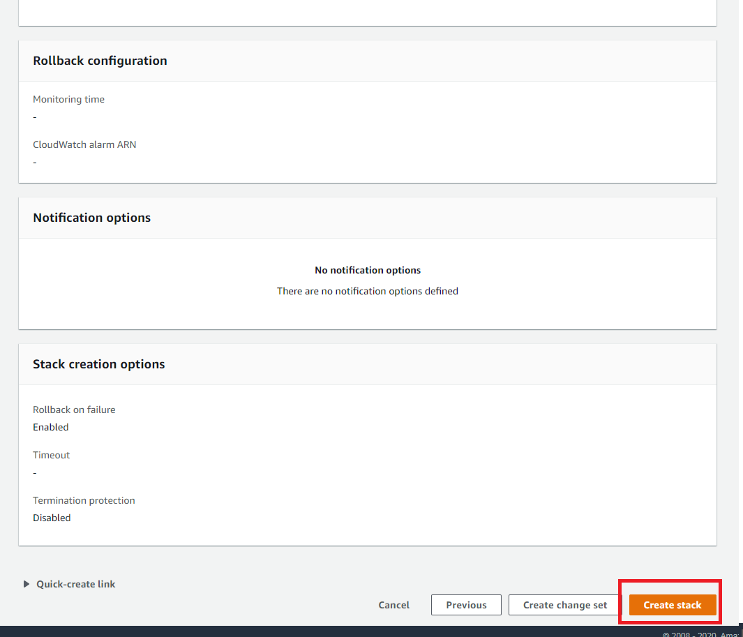

While Cloudformation is creating the stack, see on Events and Resources where the progress and the details appear.

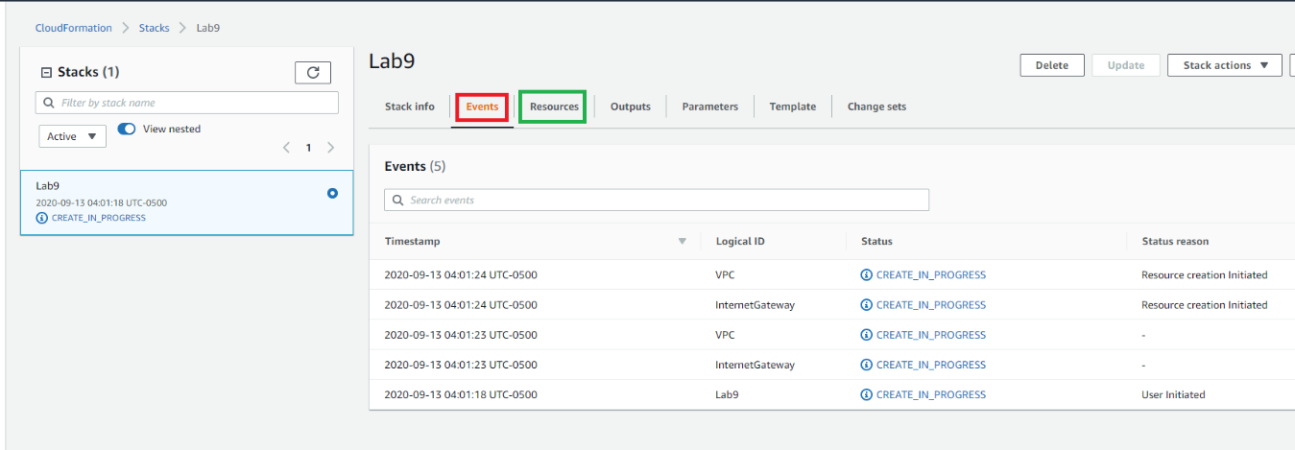

After few minutes, the deployment is complete and the outputs appear on the rigth tab.

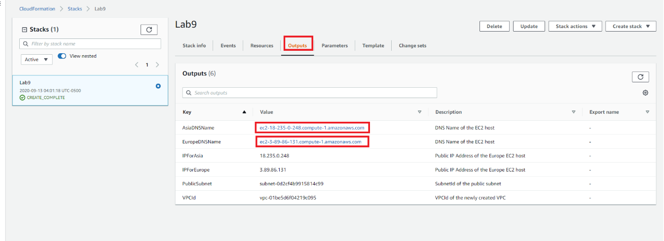

On click on the instance URLs, your browser show Docker on those instances.

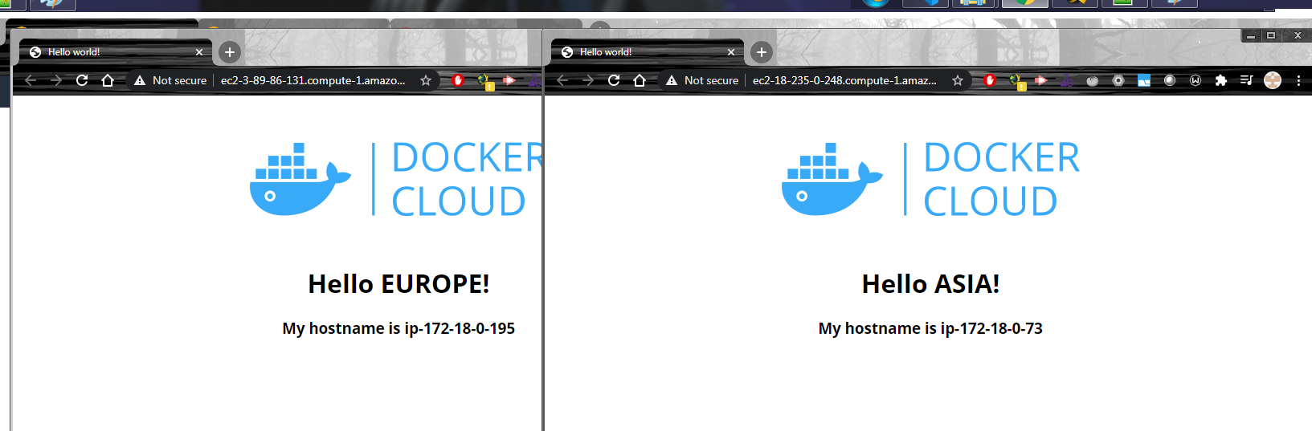

# Lab 9c1: Create multiattach EBS and mount on 2 Instances

## Create Multiattach EBS and attach to the instances

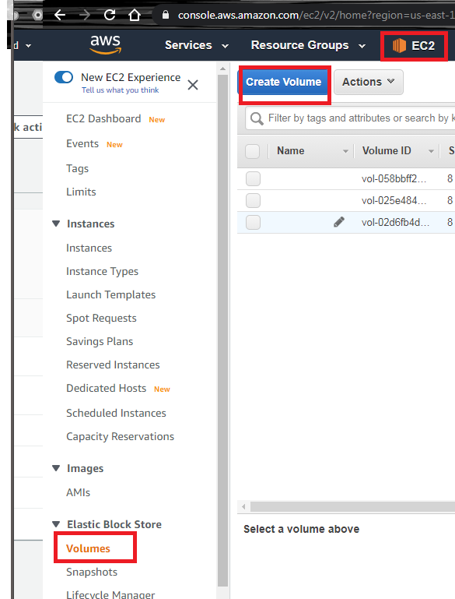

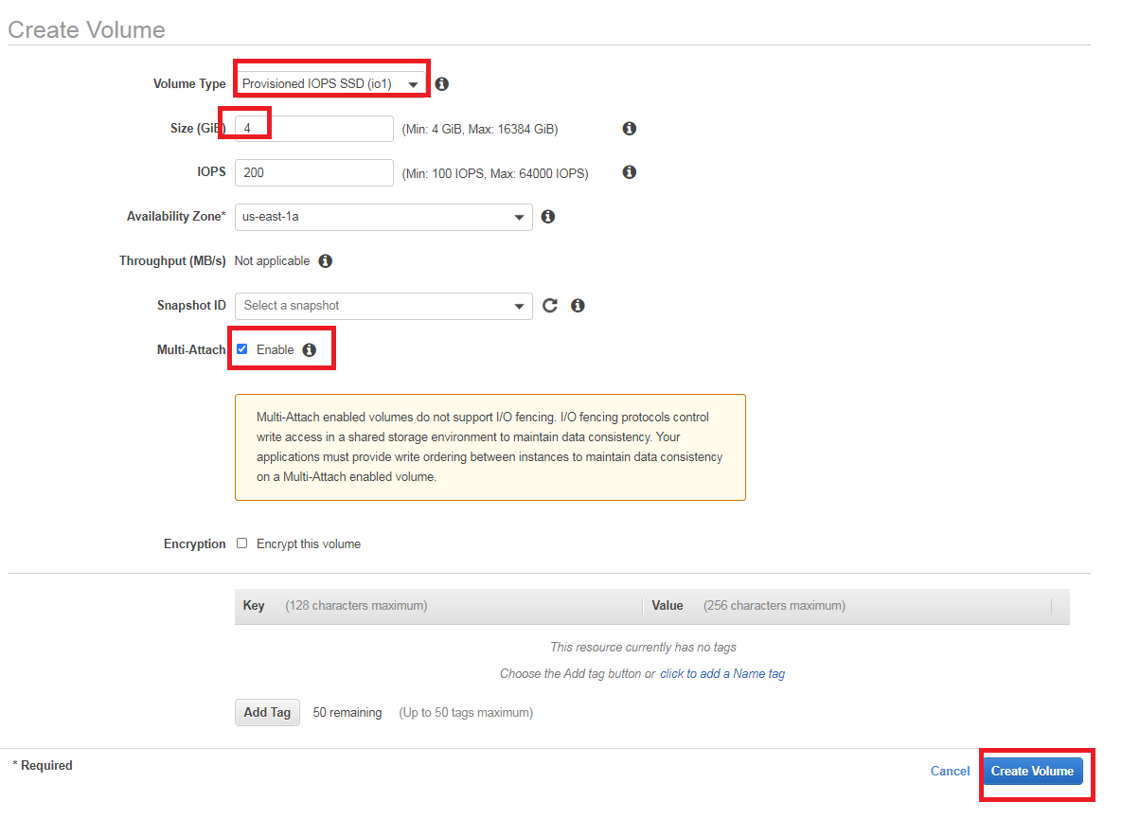

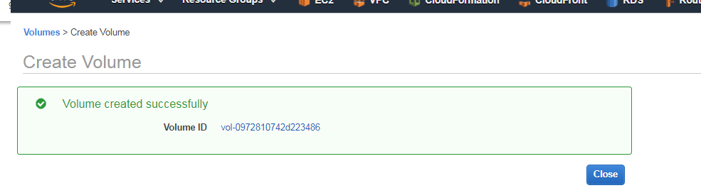

It’s time to attach that multiattach volume to both instances, repeat those steps to both instances.

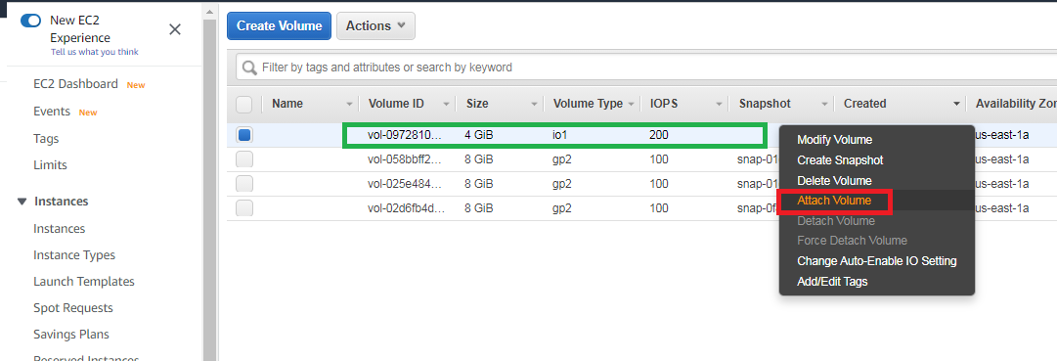

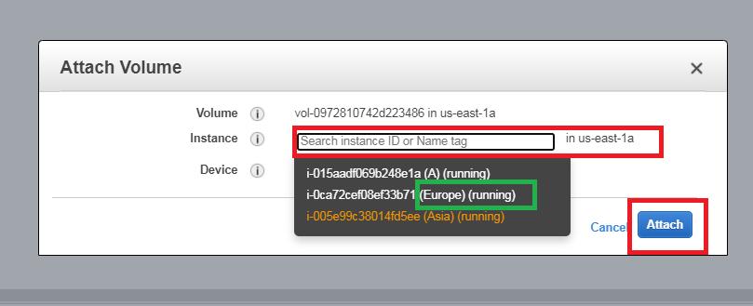

You can see the EBS status is change to in-use when you associate with one instance, at least.

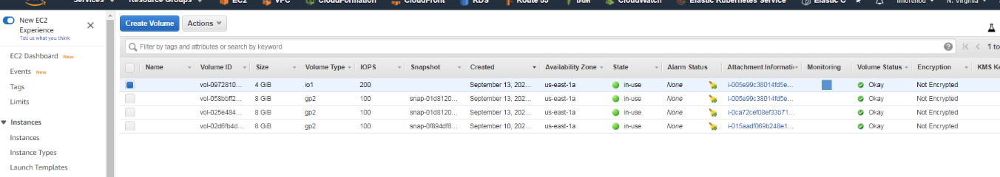

## Create Filesystem, mount it to instances and create a file

You can go to any instance using putty, to create the filesystem and mount it. Finally you can create a file to show on the another instance.

#Crear una carpeta para ser usado como punto de montaje

sudo mkdir /data

#Este comando comprueba que fue "attachado" a la instancia. Se verifica por tamaño la ruta del dispositivo.

lsblk

#Este comando crea el filesystem al dispositivo

sudo mkfs -t xfs /dev/nvme1n1

# Este comando monta el dispositivo fisico a una carpeta de su instancia

sudo mount -o rw /dev/nvme1n1 /data

sudo chown ec2-user:ec2-user /data

ls -la

#Aqui ya se pueden crear archivos

echo "This a shared file using Multiattach EBS " >/data/Lab9.txt

cat /data/Lab9.txt

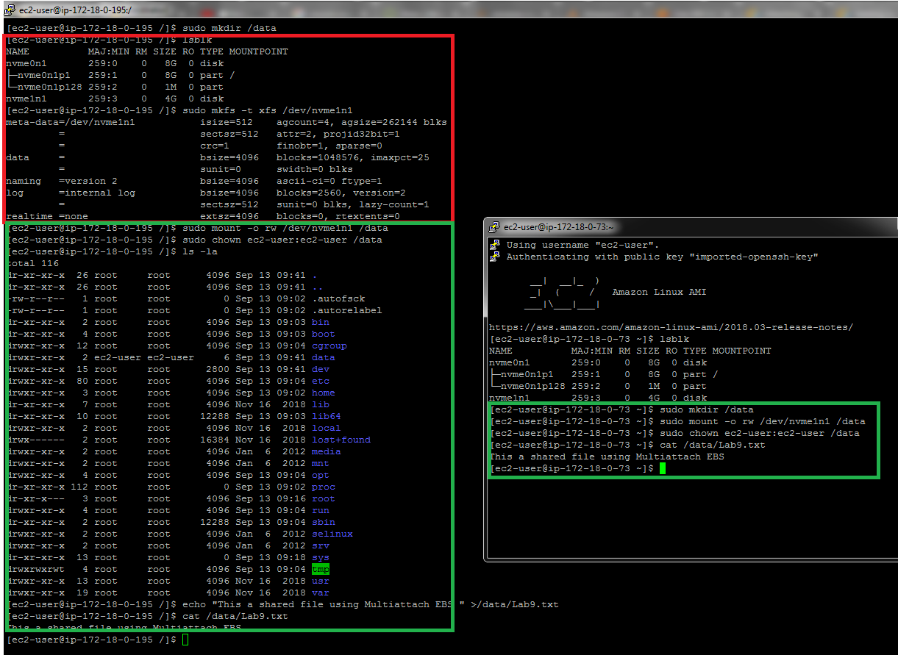

On the another instance you must mount the unit**, but not to create the filesystem.**

#Este comando comprueba que fue "attachado" a la instancia. Se verifica por tamaño la ruta del dispositivo.

lsblk

# Este comando monta el dispositivo fisico a una carpeta de su instancia

sudo mount -o rw /dev/nvme1n1 /data

sudo chown ec2-user:ec2-user /data

ls -la

## Create Standard EBS and modifying size without instances actions

Create a simple EBS volumen of 4GB and attach to any instance.

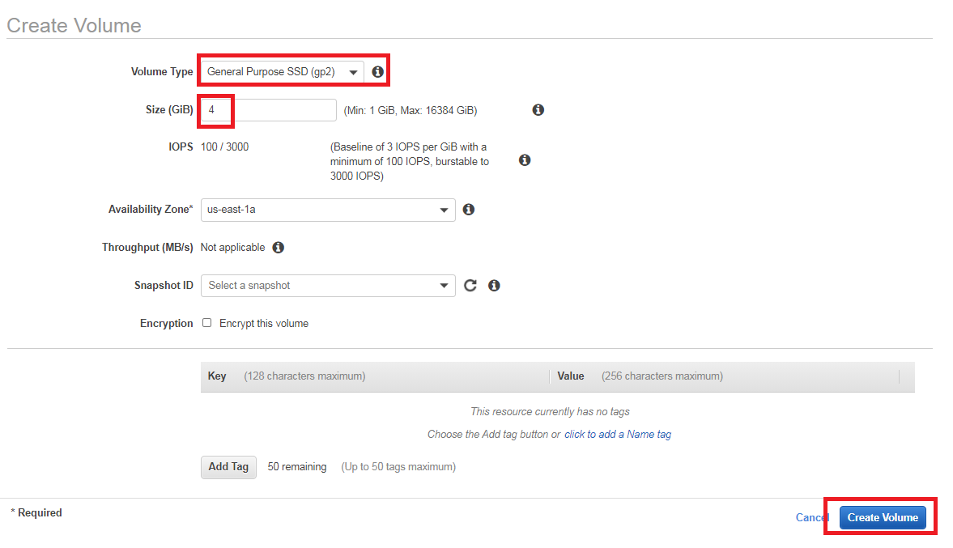

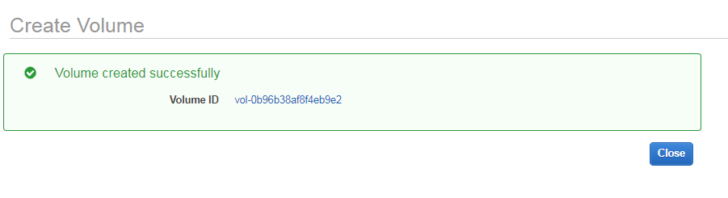

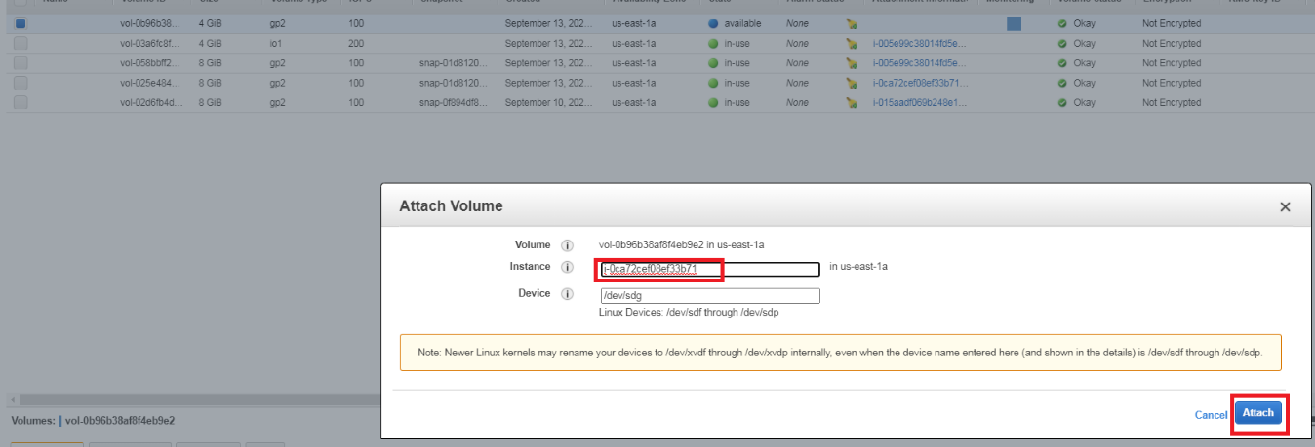

You go to any instance and mount that volumen in a new mount point.

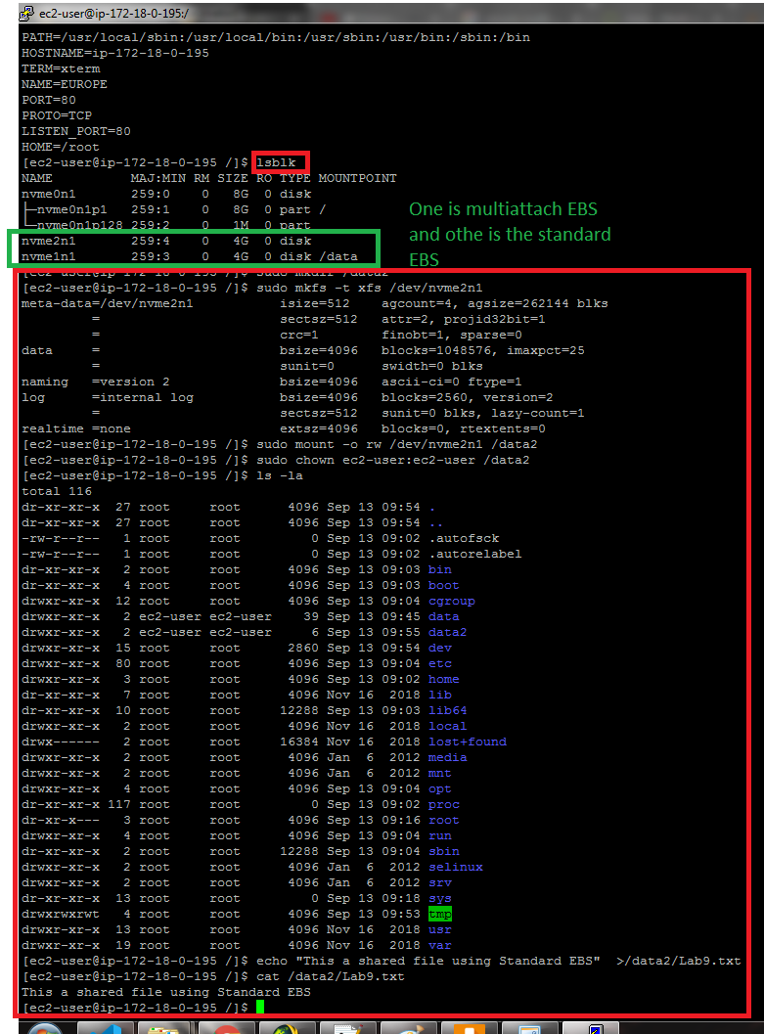

Choose the volume and modify the size.

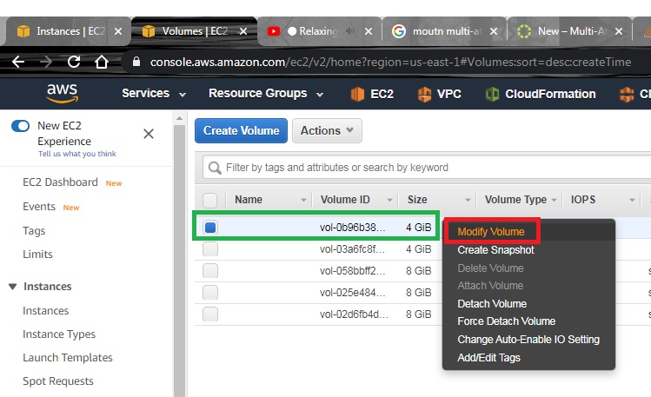

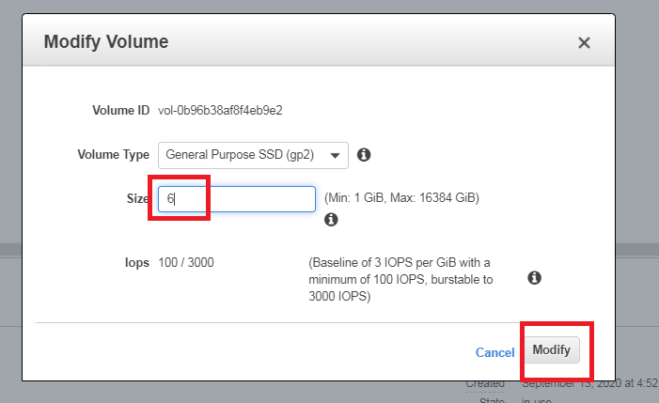

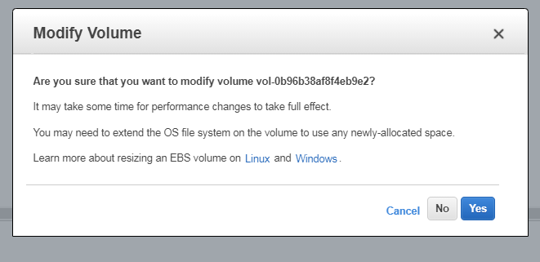

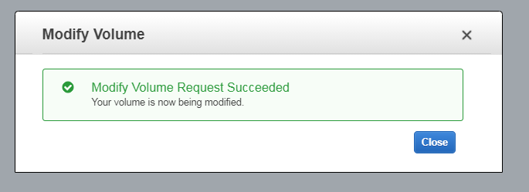

Show the change on the instance.

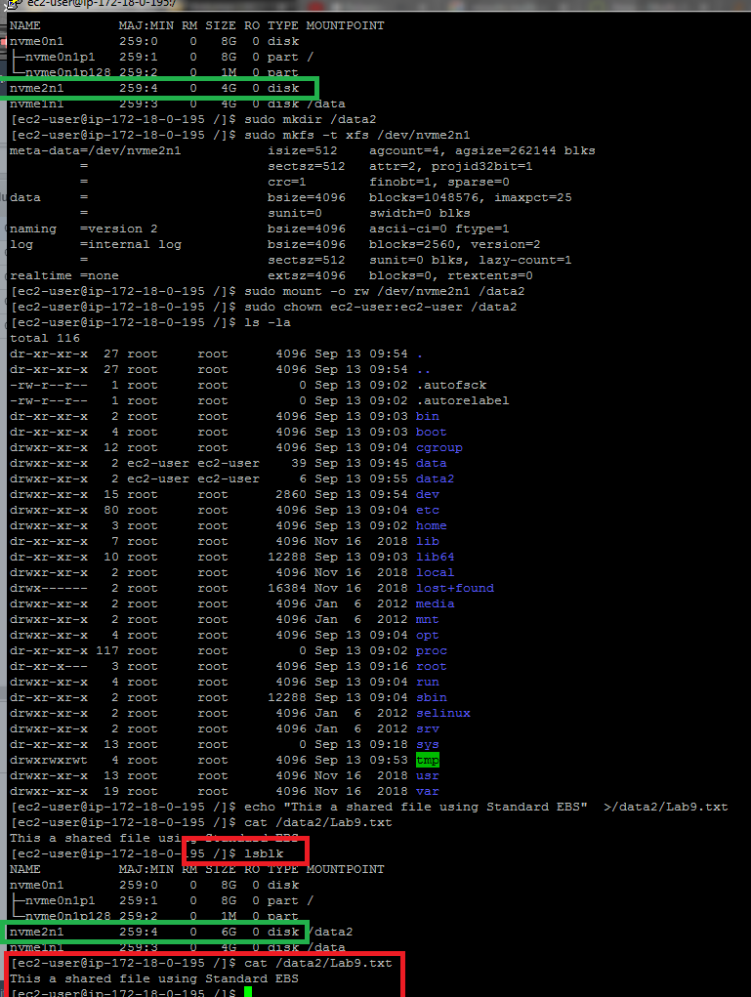

To check if the instance expand this hard disk, you have to use

df -hT

sudo xfs_growfs -d /data2

df -hT

You have more information on <https://docs.aws.amazon.com/ebs/latest/userguide/recognize-expanded-volume-linux.html?icmpid=docs_ec2_console>

# Evidences to send

To have a review, the student has to send some screenshots to instructor email:

1. Putty Screenshot of both instances with Multiattach EBS mounted and the shared file. It’s similar to the last picture of Create Filesystem, mount it to instances and create a file
2. Putty screenshot to visualize size change without instance stopping or remount it. It’s similar to the last picture of Create Standard EBS and modifying size without instances actions.

# Clean Resources

## Detaching and deleting EBS

Para borrar un volumen, primero se desmonta desde el sistema operativo usando

rem Quitando el punto de montaje desde Linux, umount /data

sudo umount <punto de montaje>

Luego, se va a la

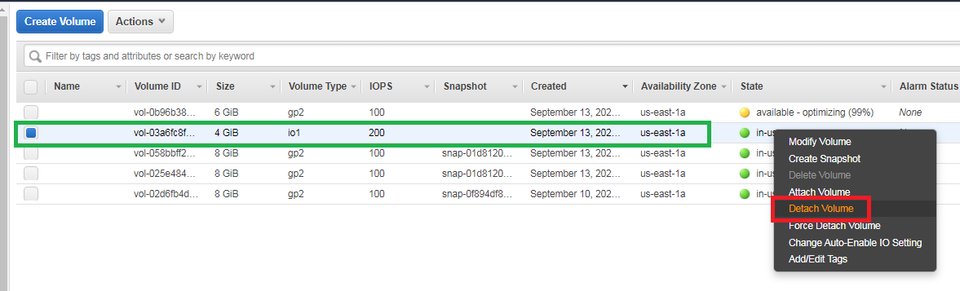

Cuando es multiattach se seleccióna la instancia, mientras que para el Standard EBS es por defecto.

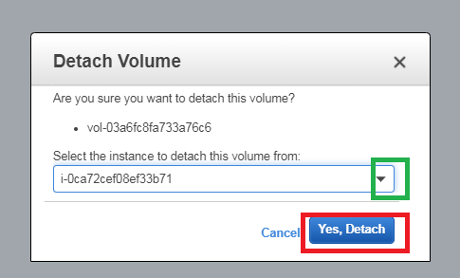

Cuando el volumen ya esta en estado Available se procede a eliminarlo.

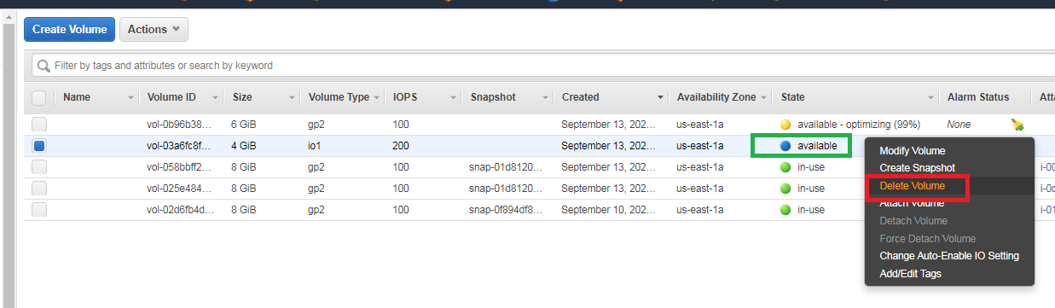

## Deleting Cloudformation Stack

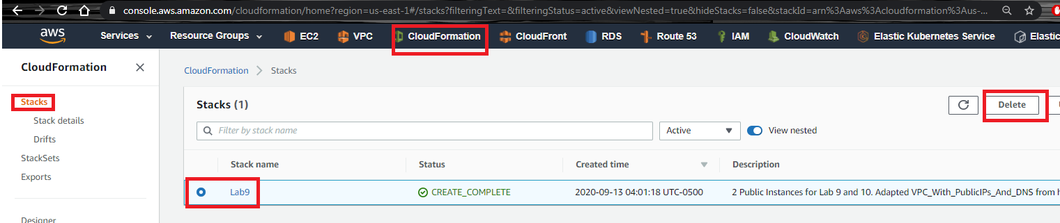

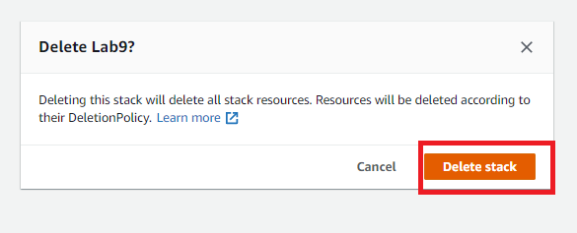

## Clean resources from command line

rem ----- ELIMINAR RECURSOS ----

aws ec2 terminate-instances --instance-ids <Codigo de las Instancias>

aws ec2 delete-security-group --group-id %SecGroup_A_Id%

aws ec2 detach-internet-gateway --internet-gateway-id %IGW_Id% --vpc-id %vpcn_Id%

aws ec2 delete-internet-gateway --internet-gateway-id %IGW_Id%

aws ec2 delete-subnet --subnet-id %pbsn1_Id%

aws ec2 delete-route-table --route-table-id %Public_RT_Id%

aws ec2 delete-vpc --vpc-id %vpcn_Id%

aws ec2 delete-key-pair --key-name Lab10a