**Consider the following table, Where Table name is “Customers”**

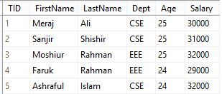

1. Find the total number of customers whose firstname includes the substring “sa”
2. Find the firstname from customers table and renaming the “firstName” table name as a “FULLNAME”

Output before renaming Output after renaming

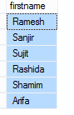 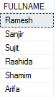

1. Find first name,lastname and add first name + lastname the of that customers table and rename the columns “FULLNAME” only show the length of lastname is 5 . e.g if first name: sujit, last name: kumar , you show FULLNAME : “sujit kumar” , which lastname is = “ kumar”, which length is 5
2. Find the 2nd highest salary of that customer’s name, address.
3. Find the 3rd highest salary of that customer’s name, address.
4. How can you efficiently select the first 100 odd TID values from the table? (Assume the table contains well over 100 records with odd TID values.)
5. List all students in group of their dept and those whose age is greater than 15
6. List the number of students those who taken credit according to their department
7. Find first top 3 row in Customers table.
8. Add extra column in following table.