|  |  |  |  |  |
| --- | --- | --- | --- | --- |
| Consider the 2 table, Where 1st Table name is **“Teacher” ,** 2nd table name is **“Student” .**TID is primary key of Teacher table ,SID is primary key of Student table and TeacherID is foriegen key of Student table.Both table are joined each other. | | |  | |
| C:\Users\Evoluction done\Desktop\1.JPG |  | C:\Users\Evoluction done\Desktop\2.JPG | |  |
| **Figure 1: Teacher** |  | **Figure 2: Student** | |  |

1. Write down the query to show the following result .

Output is:

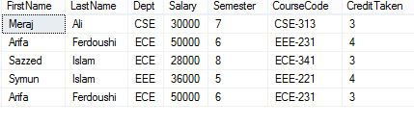

1. Swap the Dept name of all Teachers (i.e change all ‘CSE’ values to ‘EEE’, and all ‘EEE’ to ‘CSE’) with a single update query and no intermediate temp table.
2. Update all teachers ids whose id is 1.
3. Write an SQL Query to print the FirstName, LastName, Dept, Salary, CourseCode and CreditTaken of the Teacher who’s Salary between 30000 to 40000.
4. Write down the query to show the following result .

Output is:

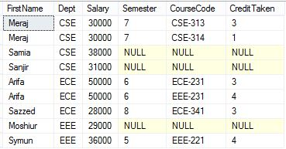

1. Write down the query to show the following result where semester is asending order.

Output is:

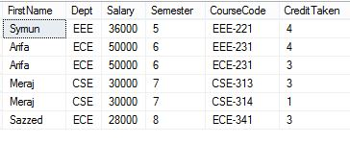

1. Write down the query to show the following result where creditTaken is decending order..

Output is:

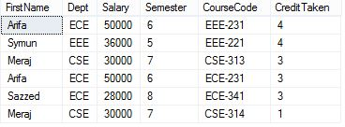

1. Delete all student whose name is ‘Arko and semester is 6.
2. Delete all teacher whose Firstname is ‘Faruk’.
3. Find max Salary, FirstName,CreditTaken from each department where max salary is rename to “TotalSalary” and Dept whose CourseCode name end with “31”.
4. List the number of students, assign teacher name with credit those who taken salary according to their department.