**A C# .NET Calculator - Design Stage**

You're now going to write your own very own C# .NET calculator programme. We'll keep it simple at first, and the only thing it will be able to do is add up. After you understand how it all works, we'll make it divide, subtract and multiply. Version 1 of your calculator will look like this:

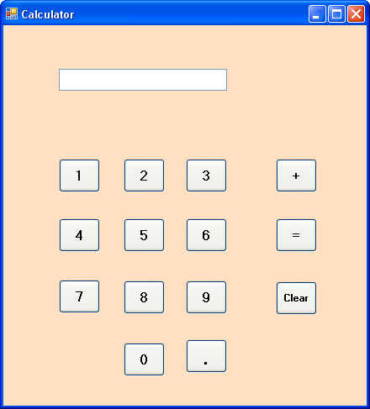

As you can see, it has a text box for the display of numbers, buttons for the numbers 0 to 9, a point symbol, plus and equals buttons, and a clear button.

So the first thing to do is to design your calculator. Start a new project by clicking File > New project. For your new form, set the following properties:

**Size**: 440, 487  
**Text**: Calculator

To add a bit of colour to your calculator, you can change the BackColour property of the form, as in the image below: