About simulations of equilibration, deformation and bond-breakage in ideal networks

This report presents a systematic investigation of equilibration, deformation, and bond-breakage processes in networks made of ideal chains using computational simulation methods. The emphasis of this study is on the underlying mechanical response, structural evolution, and failure criteria that emerge under controlled loading and equilibration, the latest one through Monte Carlo protocols following the Metropolis algorithm. The objective of this study is to utilize first-principle supported simulations to elucidate macroscopical failure.

The efficacy of the algorithm is contingent on the successful extraction of the positions and connections from .bfm files produced by bond-fluctuation model simulations, following the next structure:
- The positions encompass 3 columns with the x, y and z coordinates of the crosslinks, and a number of rows which corresponds to the number of simulated crosslinks (16130 in this particular instance)
- The connections variable is comprised of 5 columns. The first one corresponds to the ID of the crosslink, while subsequent ones correspond to the ID of each connection. In the event of a null value, which indicates a low connectivity crosslink arising from dangling chain ends, with the value -1 assigned to this null state. The quantity of rows is equivalent to the number of crosslinks (positions and connections are of equal length).

It should be noted that, given the random sorting of connections, and the subsequent re-shuffling during subsequent phases to ensure the elimination of order biases from the BFM simulation, a trivial transformation is applied. The connections are organized according to the first column value (the ID of the crosslink), and then offset by 1 to ensure that -1 signifies no connectivity. The array thus begins at 0 and extends to the number of crosslinks minus 1 (16129 in our case).

Our first objective is to attain equilibrium in the sample, given the possibility that the most recent configuration obtained through BFM simulation does not represent a minimum energy state. Monte Carlo methods have been demonstrated to be a reliable approach for the equilibration of data derived from molecular dynamics simulations. In accordance with the Metropolis algorithm, the new positions were computed as follows: the crosslinks were relocated to new positions calculated through the center of mass of the system formed by the connections.

The equilibration routine is predicated on a series of assumptions and models, the details of which will be expounded in the following. In the fast analysis presented here, 100 Monte Carlo steps (MCs) have been established as a fixed point. Convergence is defined as a difference in energy of 10⁻⁶or less between two consecutive MCs, which is achieved always within those 100 MCs. To circumvent potential ordering biases, a random permutation of the crosslinks IDs is executed at the commencement of each equilibration process. A random crosslink is selected and periodic boundary conditions (pbc) are applied to the position of said crosslink through the use of modulo operator (for loop):

positions[i] = positions[i] % box

Where positions[i] includes the Cartesian coordinates of the specified crosslink and box includes the dimensions (x,y,z) of the simulation box. Subsequently, for each connection of the designated crosslink, it is ascertained whether the connection is -1 to disregard the subsequent steps. In the event that it is not, pbc is computed on the position of the connection, and subsequently

delta = positions[conn] – positions[i]
Where conn is the ID of the connection. It should be noted that if conn = i, then delta = 0. Consequently, the force and energy will be also 0. Given our involvement with pbc, it is imperative to conduct an additional evaluation to ascertain the viability of displacements. In the event that the displacements (delta) exceed half of the box size in each dimension of space, the real displacement (delta) will be computed for the virtual position of the connection outside of the box satisfying delta < box/2. This goal is realized through the implementation of the minimum-image convention.

delta = (delta - 0.5 * box) % box – 0.5 * box

This guarantees that if delta = 0, i.e. self-connectivity, delta is overwritten to 0 again. While this approach may not represent the most efficient method for managing exceptions, it is a reliable approach under certain conditions. Specifically, this method is valid as long as the energy and forces are dependent on the distance between the positions of the particles and not on their absolute positions. In this section, the displacement (delta) for each connection is obtained. The displacement is then accumulated and averaged to determine the center of mass (COM) of the system. This is done under the assumptions that the crosslink is placed at the origin of coordinates and that the mass of all the crosslinks is equal to unity. It should be noted that crosslinks that undergo connected only to one crosslink are moved directly to the position of the connected crosslink because they are not elastically active and will relax faster than the equilibration timescale (?). Some crosslinks (at least one) enclosed self-connections only, those are neglected for the same reason.

COM = 1/count * (total_delta)

Where count denotes the number of effective connections of the crosslink, while total_delta is the sum of all computed displacements (delta) of the particular crosslink. The subsequent step involves computing the new position of the crosslink as follows:

new_pos = (positions[i] + COM) % box

In accordance with this step, it is ensured that the crosslink has been moved to the COM of the system, under the assumption that its previous coordinates are held. Furthermore, the pbc is applied to ensure that the crosslink is contained within the box. In conclusion, the position of the particle is overwritten with the new position for recursion. The energy is computed as

(total_delta_{x})²+(total_delta_{y})²+(total_delta_{z})² (?)

The harmonic potential, when considered in isolation from constants, is defined as follows: the quantity U α Δr² is defined as the energy, with U representing the energy itself and Δr denoting the displacement vector. The length of the displacement vector is denoted by Δr² . Therefore, it can be concluded that F α Δr, given the established relationship between F, the force (vector), and U, the energy (in this case, elastic energy) F =∇U. Please note that bold symbols denote vectors. Figure 1 shows the result of the equilibration.

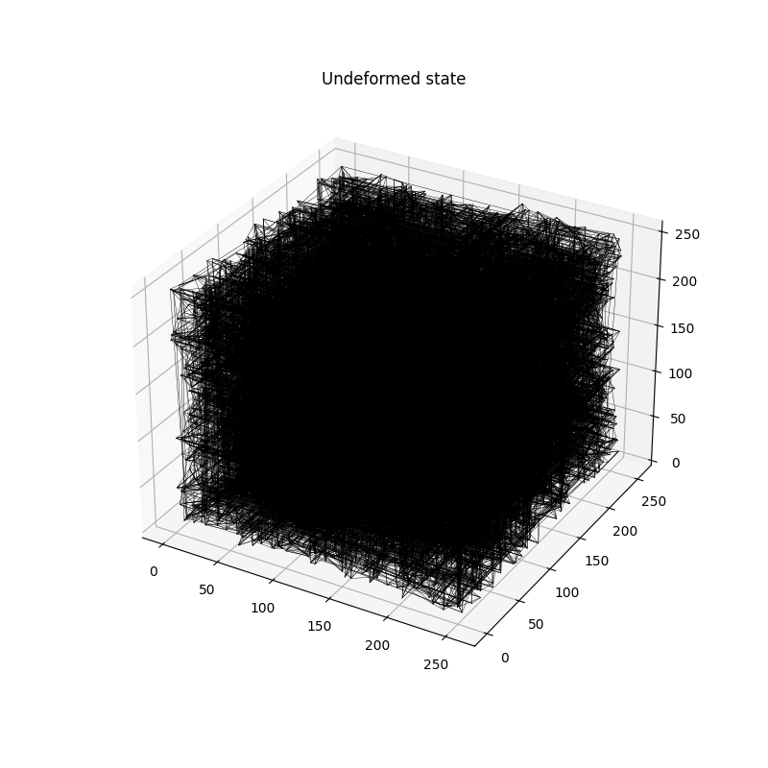Figure 1: Equilibrium configuration before deformation.

The second objective of the study is to compute the total force assuming elastic springs (F = k * Δr, k=1) among crosslinks. This objective is pursued subsequent to equilibration. The primary focus is once again on the distances, and thus the initialization is analogous to that of the equilibration: first, the IDs of the crosslinks are arranged in a random sequence to mitigate order-biases, and then we apply pbc to each crosslink and connection positions. Subsequently, delta is calculated using the minimum-image convention, and this value is aggregated for all the connections and then for all the crosslinks. Finally, stress is computed as a function of the components of the vector F and the box lengths:

sigma = F_{z}/(box_{x}*box_{y}) – 0.5 * (F_{x}/(box_{y}*box_{z}) + F_{y}/(box_{x}*box_{z}))

The subsequent procedure entails the implementation of affine deformation to the equilibrated positions, in conjunction with the consistent deformation of the box. This is followed by the application of pbc once more, with the objective of ensuring that all crosslinks are confined within the confines of the current box. The scaling factors are computed under the assumption of volume preservation and uniaxial deformation under z-axis:

λ_{x} = λ_{y} = 1/√λ, λ_{z} = λ

Therefore, the new box is re-defined after each step as

curr_box = initial_box * (λ_{x}, λ_{y}, λ_{z})

Where initial_box = (256, 256, 256). In the context of affine deformation, the current box size is incrementally augmented by a constant amount following each iteration. The same logic is applied to positions. Not anymore. All the information about equilibrations after breakage under deformation steps was lost, how it deforms now it is by multypling the current positions by the ratio between the new box and the previous one, so it deforms affinely preserving information about previous iterations.

The third objective is to ascertain the energy stored in each connection (i.e. bond) subsequent to each deformation step and determine whether its removal (i.e., breakage) is necessary once a threshold value in length (or energy) is attained. This threshold is defined as the maximum length of the ideal chains: r_{max} = N * b, where N is the number of monomers per chain (33 in this case) and b is the length of the Kuhn segment (√10 for BFM). Since U α r², then U_{max} ≈ (N* b)² ≈ 10⁴ in units of k_{B}T. This energy is at least 2 orders of magnitude higher than the bond energy of typical bonds in gels and rubbers. However, it should be noted that our model does not include finite extensibility and entanglements. Therefore, it is not realistic. In each deformation step, each crosslink is examined once in a random order. As previously delineated in the preceding objectives, delta is computed for each crosslink and connection in accordance with the minimum-image convention. The energy is computed as follows for each connection

energy = delta_{x}² + delta_{y}² + delta_{z}²

In the event that this energy surpasses U_{max}, then the connection (or bond) is removed by replacing the value of the connection in the connections with -1. Furthermore, the symmetric connection is also eliminated. Subsequently, the IDs of the crosslink and the removed connection are documented into a text file. Please note that more than one connection can be removed in each step of deformation if deformation is not applied carefully.

The process of overwriting connections and positions following each equilibration and breakage is essential for ensuring the successful execution and storage of a simulated uniaxial tensile test. The findings of this study are presented in the conclusion of this report. As illustrated in Figure 2, the stress-strain curve demonstrates a non-linear relationship between force and deformation, even in scenarios where a substantial number of bonds are removed (more than 5%). As illustrated in Figure 3, the figure displays the quantity of bonds that persist and the quantity of bonds that are extricated during the final deformation step of Figure 2.

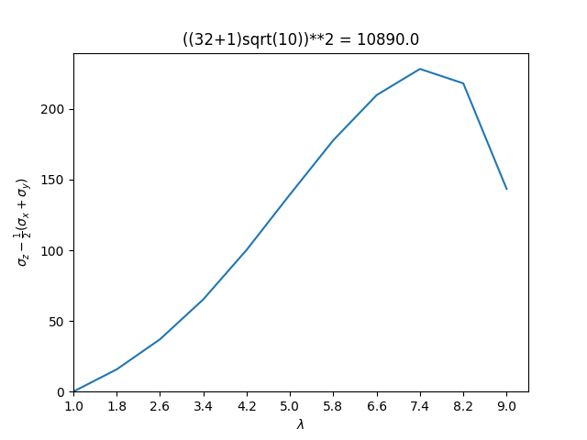
Figure 2: Stress-strain relationship for the described analysis.

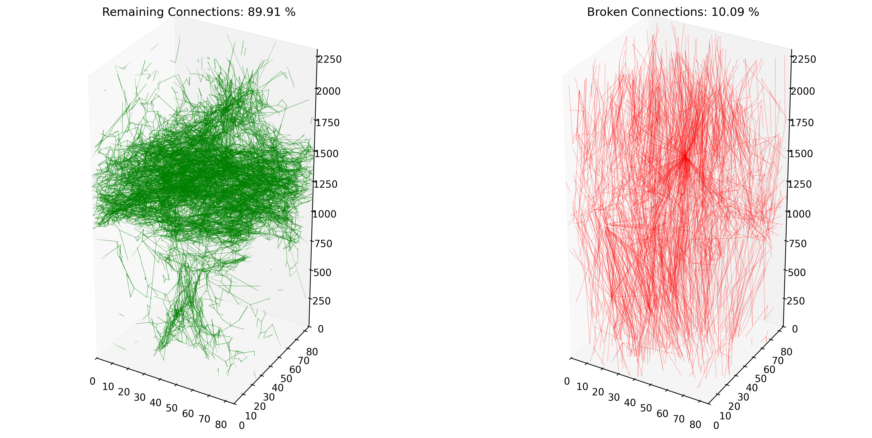Figure 3: Remaining (left) and broken (right) bonds after last step of deformation.

