UNDERGRADUATE RESEARCH REPORT · COMPUTATIONAL DATA ANALYTICS
Daily step count and energy expenditure do not predict next-night sleep quality: an n-of-1 wearable study across six sleep indicators
Faris Muratović — Supervised by Prof. Aida Branković
Computational Data Analytics, Faculty of Electrical Engineering, University of Sarajevo
ABSTRACT
Consumer wearables record daily physical activity and nightly sleep from the same device, raising the possibility of forecasting sleep quality from the preceding day's behaviour. We tested this in a single adult participant over 151 consecutive nights recorded by a consumer sleep-tracking device. Six sleep quality indicators were selected a priori from consensus literature, spanning the sleep continuity, duration and architecture domains: sleep efficiency, total sleep time, wake after sleep onset (WASO), sleep onset latency, and REM and deep sleep as proportions of total sleep time. Predictors comprised the preceding day's step count and energy expenditure, the previous night's efficiency and bedtime, seven-night bedtime variability, and a weekend indicator. Four model families were evaluated under blocked forward-chaining cross-validation and compared against uninformative baselines. No model outperformed its baseline on any outcome: cross-validated R² was negative for all six continuous outcomes, and all AUC confidence intervals for the two dichotomised outcomes included 0.50. None of 36 predictor–outcome correlations reached significance, against 1.8 expected by chance. A positive control using mathematically determined predictors recovered AUC 0.87 under the identical pipeline, excluding implementation error. Model performance degraded monotonically with predictor count and with reduced training window, indicating that additional model capacity captured only noise. Separately, WASO increased by 53% and sleep onset latency decreased by 32% across the observation period (both p < 0.005) while sleep efficiency remained unchanged (p = 0.72), demonstrating that a single summary metric can conceal substantial change in the underlying sleep. Findings are indicative for one individual and are consistent with the within-person literature, in which day-level associations between activity and sleep are conditional rather than robust.

Introduction
Sleep occupies approximately one third of the human lifespan and supports memory consolidation, emotional regulation, physical development and immune function¹. Sustained insufficient sleep is associated with increased risk of cardiovascular disease, hypertension, obesity and metabolic dysregulation¹. Sleep-related complaints are among the most frequent reasons for seeking medical attention, and the associated economic burden through lost workplace productivity has been estimated in the hundreds of billions of dollars annually in the United States alone¹. Objective, low-burden assessment of sleep therefore has substantial public health relevance.
Despite this importance, the term "sleep quality" lacks definitional consensus even as it is widely used by clinicians, researchers and the public¹. A systematic review of methods published between 2000 and 2018 organised objective sleep quality indicators into six groups — duration, intensity, continuity, stability, frequency and sleep episodes — and found that 69% of proposed methods rely on sleep macrostructure¹. The National Sleep Foundation subsequently convened an 18-member expert panel which applied a modified Delphi RAND/UCLA Appropriateness Method to 277 studies in order to establish which indicators signal good sleep quality². That panel endorsed the sleep continuity variables — sleep latency, awakenings, wake after sleep onset and sleep efficiency — as appropriate indicators across the lifespan, but reached less or no consensus on sleep architecture variables, attributing the disagreement to sparse epidemiological data in healthy individuals². Sleep efficiency of 85% or above was judged appropriate for good quality across all age groups, and WASO of 41 minutes or more was judged not indicative of good quality in adults².
A physiological rationale connects daytime behaviour to subsequent sleep. The two-process model of sleep regulation describes sleep as governed by the interaction of a homeostatic Process S, which accumulates during wakefulness and dissipates exponentially during sleep, with a circadian Process C controlled by the endogenous pacemaker³. The level of Process S at sleep onset is a function of prior waking time and waking activity^{3,4}, which provides the mechanistic basis for expecting that physical activity during the day should influence the sleep that follows. Empirically, a meta-analysis of 66 studies found that acute exercise produces small beneficial effects on total sleep time, sleep onset latency, sleep efficiency and slow wave sleep, and a moderate beneficial effect on wake after sleep onset⁵. The effects are consistent in direction but modest in magnitude.
A critical distinction separates these findings from the present question. The majority of evidence compares individuals: more active people sleep better than less active people on average. Whether an individual sleeps better on days when they were more active than usual is a within-person question, and the two need not agree⁶. An ecological momentary assessment study of 158 women examined exactly this within-person relationship and found that daily activity level and sleep were related only once perceived stress was taken into account as a moderator, rather than showing a direct day-level association on its own⁷. This suggests the within-person relationship, where it exists at all, is more conditional and less consistent than the average between-person effects reported above.
Consumer wearables make daily within-person monitoring practical, but their measurement properties constrain what can be studied. Validation work consistently reports high sensitivity for detecting sleep and poor specificity for detecting wake, because devices cannot distinguish lying still while awake from sleeping¹. Comparisons against polysomnography find good agreement for total sleep time and sleep onset latency but poor estimation of sleep efficiency and WASO, and devices have been reported to overestimate deep sleep while underestimating light sleep¹. Stability measures such as the cyclic alternating pattern rate, which may correlate more closely with subjective sleep quality, require electroencephalography and are unavailable from actigraphy¹.
The closest published precedent to the present work predicted dichotomised sleep efficiency from wearable activity recorded during awake periods, reporting AUC of 0.94 for a convolutional neural network against 0.65 for logistic regression⁸. That study used activity sequences at fine temporal resolution in a predominantly adolescent sample. Whether the relationship survives aggregation to daily totals, in a single adult, across the range of indicators the consensus literature endorses, has not been established. This study addresses that question. We treat the problem as a prognostic prediction task and report it according to the TRIPOD+AI statement⁹.
Results
Participant and data characteristics
The analysis dataset comprised 151 nights from a single adult participant recorded between 30 November 2025 and 3 May 2026. Of 160 nights spanned by the recording period, two contained no sleep episode, three lacked a previous night from which to derive lagged predictors, and four fell within the initial seven-night window required for the bedtime variability predictor, leaving 151 modellable nights (94.4% of the period). Descriptive statistics are given in Table 1.
Table 1. Sleep quality outcomes and predictors across 151 nights.
Variable | Mean | SD | Min | Max
Sleep efficiency (%) | 85.9 | 4.3 | 74.0 | 96.0
Total sleep time (min) | 495.4 | 101.0 | 210.0 | 775.0
WASO (min) | 44.1 | 26.2 | 3.0 | 133.0
Sleep onset latency (min) | 24.3 | 13.9 | 5.0 | 60.0
REM (% of TST) | 27.2 | 6.5 | 7.8 | 47.4
Deep sleep (% of TST) | 24.0 | 4.1 | 10.1 | 37.2
Steps | 5117 | 2163 | 274 | 11817
Energy expenditure (kcal) | 1679 | 158 | 1335 | 2266
Prev-night efficiency (%) | 85.9 | 4.3 | 74.0 | 96.0
Prev-night bedtime (h) | 0.0 | 1.8 | −6.8 | +6.5
Bedtime SD, 7 nights (h) | 1.2 | 0.6 | 0.2 | 3.2
WASO, wake after sleep onset; TST, total sleep time. Bedtime is on a continuous scale through midnight, so 23:00 is −1.0 and 01:30 is +1.5.
Measured against the consensus reference values, 63% of nights reached the 85% efficiency threshold, 48% showed WASO at or above the 41-minute adult threshold, and 32% achieved sleep onset within 15 minutes. Deep sleep averaged 24.0% of total sleep time against an adult reference band of 16–20%, consistent with the reported tendency of consumer devices to overestimate this stage.
Pre-modelling analysis
None of the 36 predictor–outcome correlations reached statistical significance. The smallest p-value across all 36 tests was 0.051, against 1.8 significant results expected by chance alone at the conventional threshold; the Bonferroni-corrected threshold would be 0.0014. Spearman correlations gave the same pattern, excluding monotonic non-linear relationships as an explanation. Absolute Pearson coefficients between the activity predictors and the six outcomes ranged from 0.010 to 0.159.
Dividing nights into quartiles of daily step count produced no dose–response relationship for any outcome (one-way ANOVA p = 0.21 to 0.99). Sleep efficiency by ascending activity quartile was 86.5, 85.0, 86.3 and 86.0%, and total sleep time was 492, 489, 497 and 503 minutes.
Lag-1 autocorrelation was near zero for every outcome (Fig. 1). All values fell within the 95% band for zero autocorrelation, as did all lags up to 10 nights. The previous night — the most closely related observation available — therefore carried essentially no information about the night to be predicted.
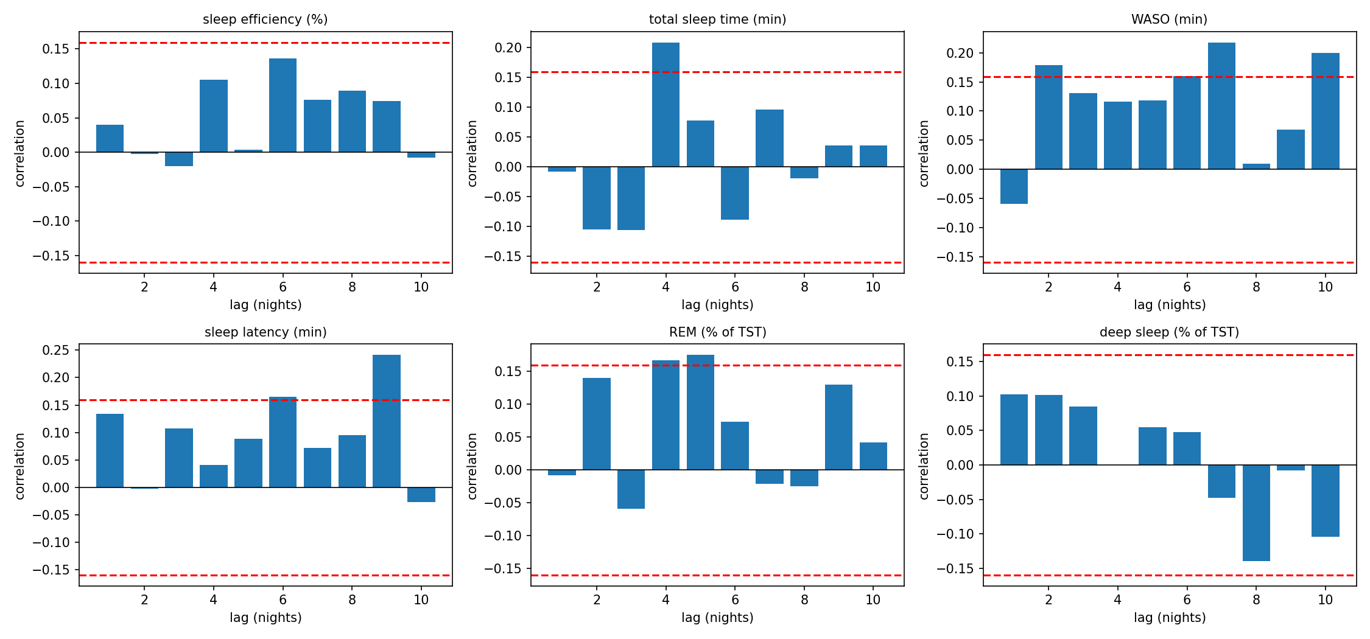
Figure 1. Autocorrelation of each sleep quality outcome at lags of 1–10 nights. Dashed lines mark the 95% band for zero autocorrelation. No outcome shows night-to-night persistence.
Model performance
No model outperformed its uninformative baseline on any outcome. Cross-validated R² was negative for all six continuous outcomes, meaning predictions were further from the observed values than the training-set mean would have been (Table 2). The mean baseline achieved the best R² of any approach on five of six outcomes.
Table 2. Best cross-validated regression performance per outcome, against baseline.
Outcome | Model | R² | RMSE | Base R²
Efficiency (%) | Linear (M1) | −0.060 | 4.27 | −0.029
TST (min) | Linear (M0) | −0.038 | 104.6 | −0.034
WASO (min) | Linear (M1) | −0.157 | 28.37 | −0.138
Latency (min) | Linear (M0) | −0.046 | 13.88 | −0.051
REM (%) | Linear (M0) | −0.058 | 6.57 | −0.054
Deep (%) | Linear (M0) | −0.048 | 4.30 | −0.024
Best of three predictor sets and three model families. M0, previous-night efficiency only; M1, activity only. Negative R² indicates performance worse than predicting the mean.
Because Table 2 reports whichever predictor set performed best per outcome, it does not show the activity predictors in isolation. Table 2b reports linear regression R² for each of the three nested predictor sets separately. Steps and energy expenditure alone (M1) never achieved a positive R² on any outcome, confirming that activity carries no predictive information even before other predictors are added, and performance worsened further once all six predictors were combined (M2).
Table 2b. Linear regression R² by nested predictor set, all six outcomes.
Outcome | M0 (1 pred.) | M1 (2 pred.) | M2 (6 pred.) | Baseline
Efficiency (%) | −0.082 | −0.060 | −0.255 | −0.029
TST (min) | −0.038 | −0.147 | −0.462 | −0.034
WASO (min) | −0.188 | −0.157 | −0.285 | −0.138
Latency (min) | −0.046 | −0.092 | −0.192 | −0.051
REM (%) | −0.058 | −0.094 | −0.119 | −0.054
Deep (%) | −0.048 | −0.099 | −0.228 | −0.024
M0, previous-night efficiency only; M1, steps and energy expenditure only; M2, all six predictors. R² is negative throughout: activity alone (M1) fails on every outcome, and adding the remaining predictors (M2) makes performance worse rather than better in five of six cases.
For the two dichotomised outcomes, no classifier exceeded the majority-class baseline on accuracy and every AUC confidence interval included 0.50 (Table 3). For poor efficiency, the majority baseline achieved 65.6% accuracy while the best classifier reached 59.2%. For high WASO, the decision tree achieved 54.4% accuracy and AUC 0.579, with a bootstrap interval of [0.476, 0.681] that crosses chance.
Table 3. Classification performance, full predictor set, forward-chaining CV.
Model | Acc. | Prec. | Rec. | Spec. | AUC
Poor eff. — Logistic | .592 | .278 | .116 | .841 | .410
Poor eff. — NB | .576 | .375 | .349 | .695 | .470
Poor eff. — Tree | .568 | .359 | .326 | .695 | .510
Poor eff. — RF | .568 | .323 | .233 | .744 | .437
Poor eff. — Baseline | .656 | .000 | .000 | 1.00 | .500
WASO — Logistic | .488 | .533 | .358 | .638 | .542
WASO — NB | .408 | .436 | .358 | .466 | .510
WASO — Tree | .544 | .614 | .403 | .707 | .579
WASO — RF | .480 | .528 | .284 | .707 | .489
Poor efficiency, 54/151 nights (35.8%); high WASO, 73/151 (48.3%). NB, Naive Bayes; RF, random forest.
Positive control
To exclude implementation error, the identical pipeline was applied to two predictors that determine the outcome by construction: total sleep time and time in bed, whose ratio defines sleep efficiency. Logistic regression achieved AUC 0.873 and accuracy 0.728 on this control, against AUC 0.410 on the real predictor set. The random forest reached AUC 0.720. The cross-validation scheme, model fitting and metric computation therefore detect association when association is present.
Model capacity and the absence of signal
Three analyses converged on the same conclusion: additional model capacity produced only noise-fitting. Performance degraded monotonically with predictor count — the six-predictor model was outperformed by the two-predictor model on all six outcomes, which was in turn outperformed by the zero-predictor baseline (Fig. 2); for sleep efficiency, R² fell from −0.029 to −0.060 to −0.255 as predictors increased from zero to two to six.
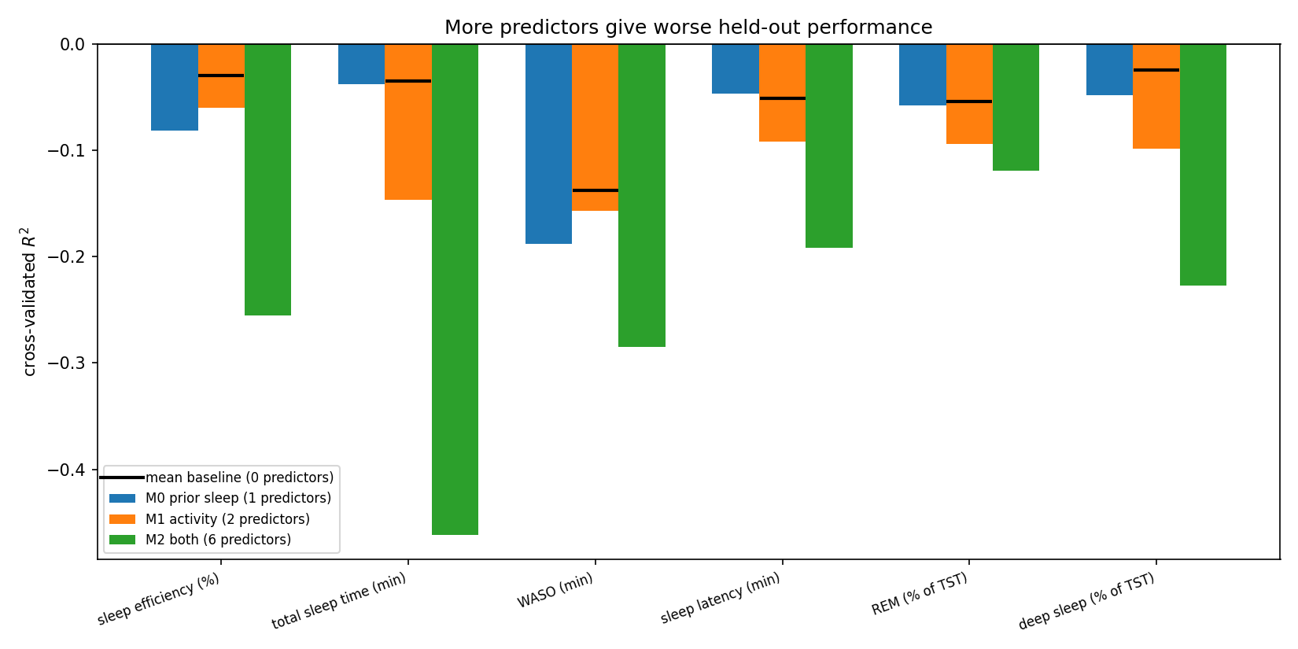
Figure 2. Cross-validated R² by predictor set for each outcome. Horizontal markers show the zero-predictor baseline; performance declines as predictors are added, across every outcome.
Restricting training to the most recent 30, 60 or 90 nights likewise degraded performance relative to using all earlier nights (efficiency R²: −0.618, −0.388, −0.296, −0.255), indicating the variance cost of a smaller sample outweighed any benefit from excluding older data. Increasing decision tree depth from 1 to 12 raised training accuracy from 0.684 to 0.994 while held-out accuracy fell from 0.616 to 0.512.
Change in sleep across the observation period
Although no predictor forecast the outcomes, several outcomes changed materially over the six months (Table 4). WASO rose from a mean of 33.5 minutes in the first third of the period to 51.3 minutes in the last, an increase of 53%. Sleep onset latency fell from 28.8 to 19.7 minutes, a decrease of 32%. REM proportion also changed significantly. Sleep efficiency, by contrast, was statistically indistinguishable across the three periods (86.3, 85.8, 85.7%; p = 0.72), because the two continuity changes act on it in opposite directions and offset one another.
Table 4. Outcome means by third of the observation period.
Outcome | First | Mid | Last | p
WASO (min) | 33.5 | 47.6 | 51.3 | .0013
Latency (min) | 28.8 | 24.3 | 19.7 | .0038
REM (%) | 26.4 | 25.7 | 29.4 | .0102
Deep (%) | 23.1 | 23.8 | 25.0 | .0623
TST (min) | 489.6 | 517.2 | 479.3 | .1518
Efficiency (%) | 86.3 | 85.8 | 85.7 | .7203
Each period comprises ~50 nights. Significant change in two consensus continuity indicators is not detectable in sleep efficiency.
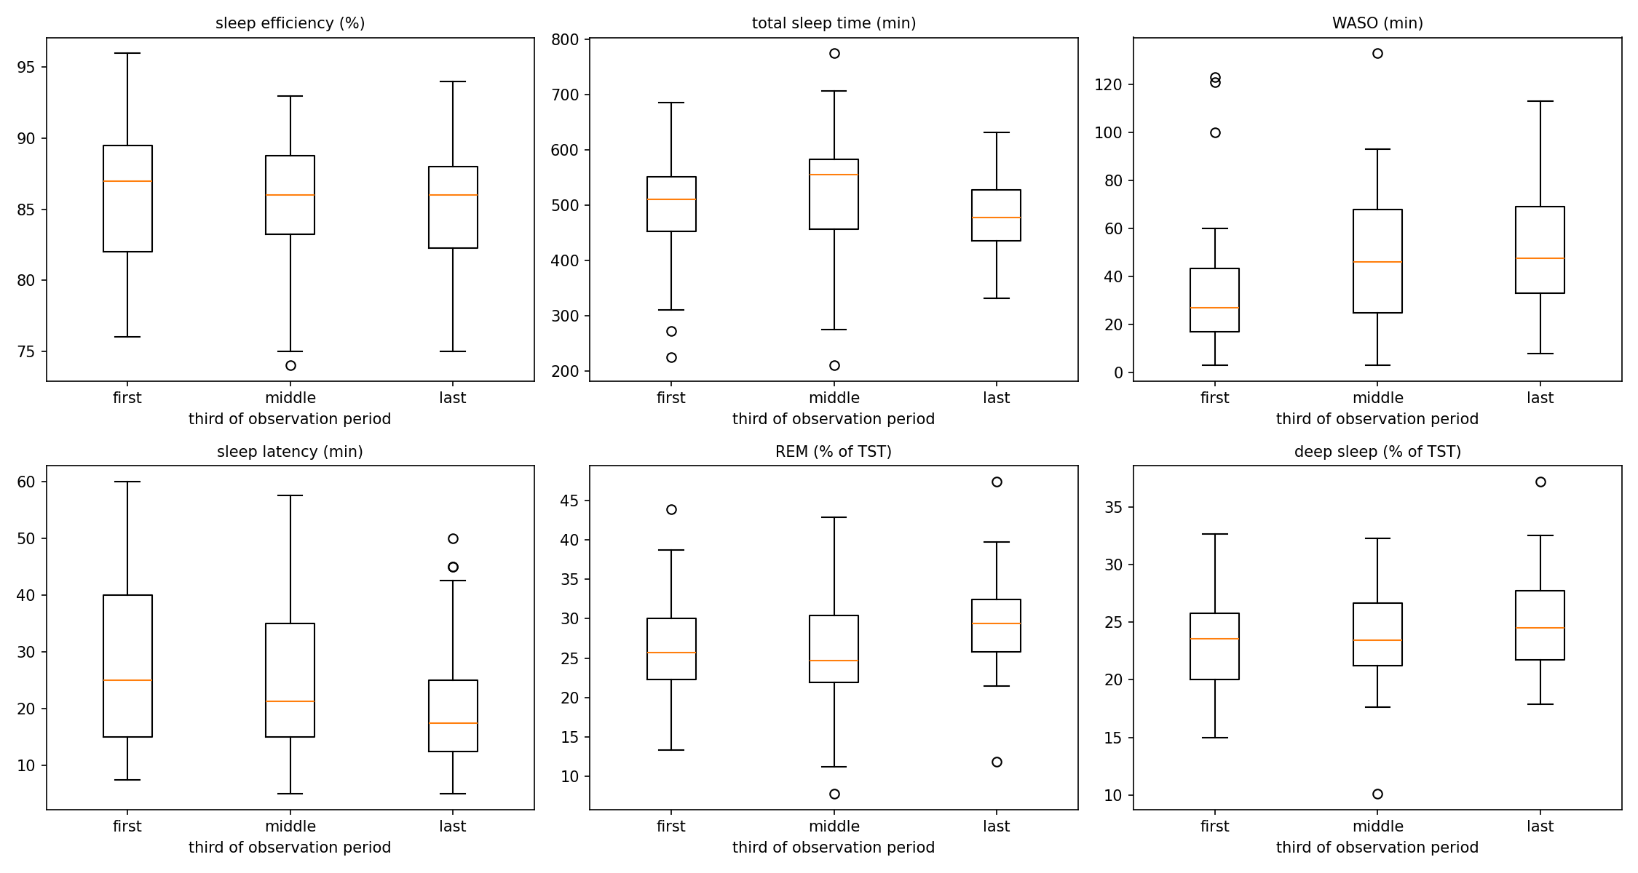
Figure 3. Distribution of each outcome across thirds of the observation period. WASO increases and sleep onset latency decreases, while sleep efficiency remains flat.
Discussion
Daily step count and energy expenditure did not predict any of six consensus-derived sleep quality indicators on the following night in this participant. The finding was consistent across four model families, three predictor sets and two outcome types, and was anticipated by the pre-modelling analysis, in which none of 36 predictor–outcome correlations reached significance and no dose–response relationship appeared across activity quartiles. A positive control recovering AUC 0.873 under the same pipeline excludes implementation error.
Three explanations are compatible with the data and cannot be fully separated. First, temporal aggregation. The published precedent that achieved AUC 0.94 used activity sequences within the awake period⁸, whereas the present predictors are daily totals. Summing to a single daily figure discards the timing of activity, its distribution through the day and its intensity profile — all of which are physiologically relevant under the two-process model, where the timing of behaviour relative to circadian phase matters as much as its quantity³. Step count also cannot distinguish vigorous from light activity, and the meta-analytic evidence indicates effects concentrated in exercise rather than incidental movement⁵.
Second, measurement. The device used here estimates the continuity outcomes with known imprecision, and validation studies report poor specificity for wake detection and poor agreement with polysomnography for efficiency and WASO specifically¹. The deep sleep proportion observed here, 24.0% against an adult reference band of 16–20%², is consistent with the documented overestimation of this stage by consumer devices. Measurement error in the outcome attenuates any true association and reduces the power of any model to detect it. Sleep onset latency in this dataset was recorded on an exact 2.5-minute grid with a floor at 5 minutes and a ceiling at 60, taking only 22 distinct values across 168 episodes, indicating substantial quantisation in the device output.
Third, the magnitude of the effect being sought, and the conditions under which it appears. The meta-analytic estimates for acute exercise are small for most outcomes⁵, and the within-person, day-level literature on activity and sleep is markedly less consistent than the between-person literature: at least one dedicated within-person study found that the relationship depended on perceived stress rather than appearing as a direct daily effect⁷. The present null is therefore not inconsistent with a literature in which within-person, day-level associations are conditional rather than robust. Sleep is additionally influenced by caffeine, alcohol, illness, evening light exposure and ambient conditions¹, none of which were available here; unmeasured day-to-day variation of this kind plausibly dominates the contribution of ambulatory activity.
The most informative positive finding concerns outcome selection. Two consensus continuity indicators changed significantly over six months in opposite directions — WASO increased by 53% while sleep onset latency decreased by 32% — yet sleep efficiency, the single most widely used summary measure and the outcome used by the closest precedent study⁸, showed no change whatever. Because efficiency is the ratio of sleep to time in bed, offsetting changes in the components are invisible in the ratio. Had this analysis followed the common practice of adopting efficiency as the sole outcome, it would have concluded that this participant's sleep was stable throughout. This provides direct empirical support, within a single dataset, for the argument that sleep quality is multifaceted and difficult to characterise by any single measure¹, and it is an argument for reporting the continuity indicators separately rather than only in composite form.
The analysis also illustrates a methodological point relevant to n-of-1 prediction. In the absence of a genuine association, model complexity is purely harmful: six predictors performed worse than two, which performed worse than none, and deeper trees fitted the training data almost perfectly while degrading on held-out nights. Reporting an uninformative baseline alongside every performance figure is therefore not a formality. A classifier achieving 59.2% accuracy on the poor-efficiency outcome would appear serviceable in isolation; against a 65.6% majority baseline it is clearly worthless. Several AUC values fell below 0.50, which reflects the non-stationarity documented above: forward-chaining validation trains on earlier nights and tests on later ones, so a model fitted to an outdated regime errs systematically rather than randomly.
Limitations
This is a single-participant observational study and the findings do not generalise to other individuals; no external validation is possible. The absence of an association in one person is compatible with an association existing in others or on average. The specific device used to record activity and sleep was not identified in the exported data, so device-specific validation findings from the literature can be discussed only as general context for consumer sleep-tracking technology, not as direct evidence about this participant's measurements. Sleep was measured by a consumer device rather than polysomnography, and its staging algorithm is proprietary and unvalidated in this participant. The intensity, timing and modality of physical activity were unavailable, as were behavioural and environmental covariates. Sleep stability measures such as the cyclic alternating pattern rate, which may relate more closely to subjective sleep quality¹, require electroencephalography and could not be assessed. With 151 nights and 54 events on the primary binary outcome, the analysis was restricted to six predictors and was underpowered to detect small effects; a true standardised effect below approximately 0.25 would likely have been missed.
Because a single-participant design cannot distinguish a true absence of effect from individual non-responsiveness, priority future directions are recording activity at finer within-day temporal resolution, capturing likely confounders (caffeine, alcohol, stress, evening light exposure), and repeating this design across multiple participants.
Methods
Data source and participants
Data were exported from a consumer sleep-tracking application used by one adult participant. The specific device and its form factor (for example wrist-worn, ring, under-mattress or smartphone-based) were not specified in the exported records and could not be determined. Two files were provided: a daily activity record containing date, step count and estimated energy expenditure (160 rows), and a sleep record containing one row per sleep episode with bedtime, final wake time, sleep onset time, wake-up time, reported sleep efficiency, total sleep time and minutes in each of four stages — awake, REM, light and deep (168 rows). The recording period ran from 25 November 2025 to 4 May 2026. No demographic information was available.
The dataset was provided by the course instructor as part of a university coursework assignment. The author did not collect this data, was not involved in recruiting the participant, and cannot independently confirm consent status; no analysis-specific intervention was performed on the participant, and consent and data-governance arrangements for coursework use are understood to be managed at the course level.
Setting: free-living, non-clinical, home-based monitoring with no researcher contact during collection. As a single-participant design, the eligibility unit is the individual night; night-level inclusion criteria are described under Attrition in the Results.
Data preparation
Preparation followed the CRISP-DM framework. Ten integrity checks were applied before any transformation and all passed: reported efficiency matched total sleep time divided by time in bed to within 0.7 percentage points; REM, light and deep minutes summed exactly to total sleep time on all 168 episodes; and the reported awake minutes matched wake time minus onset time minus total sleep time to within one minute, confirming that column as wake after sleep onset rather than total time awake in bed. No missing values, duplicate rows, duplicate keys, placeholder missing codes or overlapping episodes were found. Reported efficiency was stored as text owing to a percent character and was converted to numeric.
The unit of analysis is a night, defined so that night d comprises the daytime of day d and the sleep that follows. Sleep episodes were assigned to nights on a noon-to-noon basis, so that a 01:30 bedtime is attributed to the preceding evening. Of 158 nights containing at least one episode, 148 contained one and 10 contained two. Within each night the episode with the greatest total sleep time was designated the main sleep and supplied the outcomes; the remaining 10 episodes, ranging from 95 to 200 minutes, were treated as naps and summed into a separate variable.
Outliers were screened using the interquartile range method with 1.5 × IQR fences on all numeric variables. Flagged values were reviewed against physiological plausibility rather than removed automatically: short episodes reflected the presence of naps and were separated by the main-sleep rule, and extreme step counts reflected genuine inactive and active days. No episode met criteria for physiological implausibility (time in bed under 30 minutes or over 16 hours, efficiency under 20% or over 100%), and no records were removed.
Activity and sleep records were combined by left join from a complete calendar spine, so that nights without a sleep record remained visible as missing rather than being silently dropped. Key data types and duplicate keys were verified before joining. Two nights lacked any sleep episode. Because the probability of the device being worn is unrelated to the quality of sleep on that night, these were treated as missing completely at random. Mean imputation, median imputation, forward fill and row deletion were compared; deletion was selected because the missing values are the outcome itself, and imputing an outcome would inflate apparent performance. Forward fill was additionally inappropriate given the near-zero night-to-night autocorrelation.
Skewness was assessed for all numeric variables. Log transformation was considered and not applied, as the models employed do not assume normally distributed predictors and the untransformed scale preserves interpretability. A standardised copy of the dataset was produced for methods sensitive to variable scale.
Outcomes
Six outcomes were specified in advance, selected to span the domains identified in the systematic review¹ and prioritised according to the consensus panel². Three continuity indicators — sleep efficiency, wake after sleep onset and sleep onset latency — and one duration indicator, total sleep time, were designated primary, as these were endorsed by the panel and are the domains actigraphy can address. Two architecture indicators, REM and deep sleep as percentages of total sleep time, were designated exploratory, as the panel did not reach consensus on these and consumer devices stage sleep less reliably. Architecture outcomes were expressed as proportions of total sleep time rather than raw minutes, following the panel definition. Two outcomes were additionally dichotomised at the panel thresholds: efficiency below 85% and WASO at or above 41 minutes. Both thresholds were fixed before inspecting the distributions.
Predictors
Six predictors were specified: step count and energy expenditure for day d; the previous night's sleep efficiency and bedtime; the standard deviation of bedtime across the previous seven nights; and a weekend indicator for Friday and Saturday nights. Every predictor is measurable before the night to be predicted begins. The wake time, sleep onset time and stage minutes of the target night were excluded as these fall within the outcome window; the target night's bedtime was also excluded, as a prediction available only once the participant is in bed has no actionable use, and the previous night's bedtime carries closely related information.
Previous-night total sleep time and wake time were assessed and excluded on collinearity grounds. Time in bed is wake time minus bedtime and efficiency is total sleep time divided by time in bed, so these four lagged variables are linked by an arithmetic identity and any three determine the fourth. Fitted together they produced variance inflation factors of 5.0, 88.3, 74.2 and 90.4. Retaining previous-night efficiency and bedtime only broke the identity; all retained predictors had variance inflation factors below 2.1. Step count and energy expenditure correlated at r = 0.647 with variance inflation factors near 1.9 and were both retained.
Bedtime was placed on a continuous scale centred at midnight, so that 23:00 becomes −1.0 and 01:30 becomes +1.5, preventing the discontinuity that a 0–24 clock would introduce. Lagged predictors were carried forward only where the preceding row was genuinely the preceding calendar night.
Sample size
The binding constraint was the number of events on the rarer class of the primary binary outcome, 54 poor-efficiency nights. At the conventional ten events per predictor this supports five to six predictors, which is stricter than the row count would suggest and stricter still given that consecutive nights are not fully independent. Both regression and classification analyses were therefore capped at six predictors, applied identically so that comparisons remain fair. Predictors were selected on physiological grounds before any performance was examined.
The two binary outcomes were moderately but not severely imbalanced (poor efficiency, 35.8% positive; high WASO, 48.3% positive). No class-imbalance correction method (e.g., oversampling, undersampling, SMOTE, or class weighting) was applied. Given the imbalance ratios were both within a conventional 60:40 range and the primary finding was an absence of discrimination rather than a marginal one, correction was judged unlikely to materially change the conclusions and was omitted to keep the modelling pipeline identical to the one applied to the positive control.
Models
Three nested predictor sets were compared: M0 containing previous-night efficiency alone, as a persistence baseline; M1 containing the two activity predictors, which addresses the primary research question; and M2 containing all six. Four model families were fitted to each: linear or logistic regression as the primary approach, given that the reporting standard for clinical prediction models is framed around regression and that coefficients are directly interpretable without post-hoc explanation; and decision trees, random forests and Gaussian naive Bayes as comparators capable of capturing non-linear structure. An uninformative baseline was included in every comparison — the training-set mean for regression and the training-set majority class for classification — and was passed through the identical cross-validation procedure so that comparisons are made under matched conditions. Continuous predictors were standardised within a pipeline so that scaling parameters were estimated on training data only.
Validation
Because observations are ordered in time and drawn from a single participant, random partitioning would permit training on nights that follow those used for testing. Validation therefore used blocked forward-chaining cross-validation with five folds, in which the training window expands and the test block always follows it in time, mirroring the conditions under which such a model would be deployed. Out-of-fold predictions were pooled across folds so that each metric is computed once on 125 held-out predictions, rather than averaged across folds of unequal size and class balance. A rolling-window sensitivity analysis repeated the procedure with training restricted to the most recent 30, 60 and 90 nights.
Performance measures and analysis
Regression performance was summarised by R², root mean squared error and mean absolute error. Classification performance was summarised by accuracy, precision, recall, specificity and area under the ROC curve, with 95% confidence intervals for AUC obtained from 1000 bootstrap resamples of the pooled out-of-fold predictions. Pre-modelling analysis used Pearson and Spearman correlations, Welch's t-test for predictor differences between outcome groups, one-way ANOVA across activity quartiles and across thirds of the observation period, and autocorrelation to lag 10 with a 95% band of 1.96/√n. Analyses were conducted in Python 3 using pandas, NumPy, SciPy, scikit-learn and Matplotlib, with a fixed random seed throughout.
Reporting and availability
The study is reported according to the TRIPOD+AI statement for prognostic prediction models⁹. No explainability method was applied, as the primary model is intrinsically interpretable and post-hoc attribution for models performing at chance would describe noise; the CLIX-M checklist is therefore not applicable. Analysis code and the derived night-level dataset are available in the project repository.
The fitted logistic regression coefficients for each outcome are reported in the coefficients table in the project repository, together with the full data preparation, model-fitting and evaluation code, allowing the exact model to be refitted and applied to new nights of data from this or another individual. The tree-based models (decision tree, random forest) do not reduce to a closed-form equation; their trained model objects are not included in the repository, but can be regenerated exactly from the shared code and a fixed random seed.
Conclusion
This study tested whether the previous day's step count and energy expenditure predict six literature-derived indicators of next-night sleep quality in a single adult over 151 nights. The answer was no: no model exceeded an uninformative baseline on any outcome, none of 36 predictor-outcome correlations reached significance, and a positive control confirmed the pipeline correctly detects association when present. Model complexity was actively harmful in the absence of a genuine relationship: six predictors performed worse than two, which performed worse than none.
Independently of the prediction task, sleep efficiency — the outcome most commonly used as a single summary measure, including by the closest precedent study — was found to conceal a genuine, significant change in this participant's sleep continuity over six months, because two of its components moved in opposite directions and cancelled in the ratio. This is a concrete argument for reporting continuity indicators separately rather than relying on one composite outcome.
These findings are indicative for this individual only. They are consistent with a within-person literature in which day-level activity-sleep associations are conditional rather than robust, and with the possibility that daily totals discard timing and intensity information that finer-resolution data would retain. Repeating this design with richer predictors, additional covariates, and multiple participants is the natural next step.
Declarations
Funding. Not applicable; no external funding was received.
Conflict of interest. The authors declare no competing interests.
Ethics approval and consent to participate. The dataset was provided by the course instructor for coursework; the author did not collect it, was not involved in recruiting the participant, and cannot independently confirm consent status, which is understood to be managed at the course level. No intervention was performed by the author.
Consent for publication. Not applicable; no identifying information about the participant is reported.
Data availability. The derived, de-identified night-level dataset is available in the project repository; original raw exports were provided for coursework and are not published separately.
Materials availability. Not applicable.
Code availability. All data preparation, modelling and evaluation code is available in the project repository.
Author contribution. The author performed all data preparation, analysis and manuscript preparation under the supervision of Prof. Aida Branković.
References
1. Mendonça, F., Mostafa, S. S., Morgado-Dias, F., Ravelo-García, A. G. & Penzel, T. A review of approaches for sleep quality analysis. IEEE Access 7, 24527–24546 (2019).
2. Ohayon, M. et al. National Sleep Foundation's sleep quality recommendations: first report. Sleep Health 3, 6–19 (2017).
3. Borbély, A. A. A two process model of sleep regulation. Hum. Neurobiol. 1, 195–204 (1982).
4. Borbély, A. A., Daan, S., Wirz-Justice, A. & Deboer, T. The two-process model of sleep regulation: a reappraisal. J. Sleep Res. 25, 131–143 (2016).
5. Kredlow, M. A., Capozzoli, M. C., Hearon, B. A., Calkins, A. W. & Otto, M. W. The effects of physical activity on sleep: a meta-analytic review. J. Behav. Med. 38, 427–449 (2015).
6. Dunton, G. F. Ecological momentary assessment in physical activity research. Exerc. Sport Sci. Rev. 45, 48–54 (2017).
7. Liao, Y., Robertson, M. C., O'Connor, S. G., Naya, C. H., Balachandran, D. D. & Dunton, G. F. Exploring the effects of perceived stress on the within-person relationships between daily activity levels and sleep in women: an ecological momentary assessment study. Int. J. Behav. Med. 30, 578–583 (2023).
8. Sathyanarayana, A. et al. Sleep quality prediction from wearable data using deep learning. JMIR Mhealth Uhealth 4, e125 (2016).
9. Collins, G. S. et al. TRIPOD+AI statement: updated guidance for reporting clinical prediction models that use regression or machine learning methods. BMJ 385, e078378 (2024).

