Applying Propensity Score Matching to Evaluate Interventions
A Doubly-Robust Propensity-Score Analysis of Maternal Smoking and Preterm Birth in the 2023 U.S. Natality Cohort
Faruk Muritala, Kennesaw State University
SEASUG 2026 Conference (Paper #103) | STAT 7900 Final Project, Kennesaw State University | Fmurital@students.kennesaw.edu
ABSTRACT
Maternal smoking during pregnancy is a modifiable risk factor for preterm birth, but observational estimates of its effect are vulnerable to confounding by socioeconomic, medical, and access-to-care factors that jointly influence both smoking status and gestational outcomes. Using the 2023 U.S. National Vital Statistics System (NVSS) natality file (3,251,950 complete-case singleton births; 96,698 exposed to maternal smoking), we build a directed acyclic graph (DAG)-justified propensity-score (PS) model on eleven pre-treatment covariates and evaluate the effect of maternal smoking on preterm birth (<37 weeks) using five estimators of increasing rigor: a crude comparison, DAG-adjusted regression, inverse-probability-of-treatment weighting (IPTW), a doubly-robust IPTW-plus-covariate-adjusted model, and propensity-score-quintile stratification with Mantel–Haenszel pooling. One-to-one PS matching -- the approach used in the study this project extends -- proved computationally infeasible at this sample size and was replaced, transparently, with IPTW and stratification. After trimming to common support (PS in [0.01, 0.99]; n = 1,913,190) and weighting, covariate balance improved from a maximum standardized mean difference of 0.40 to 0.07, with zero of fourteen previously imbalanced covariates remaining above the 0.10 threshold. The crude odds ratio (OR) of 1.78 (95% CI: 1.75-1.82) attenuated to 1.29-1.46 across the adjusted, weighted, and stratified estimators, consistent with the dose-response literature on this exposure. All results are fully reproducible; R and SAS code are openly available in a public GitHub repository (Section 10).
Keywords: propensity score, inverse probability of treatment weighting, doubly robust estimation, causal inference, directed acyclic graph, maternal smoking, preterm birth, PROC LOGISTIC, PROC SURVEYLOGISTIC
1. INTRODUCTION
Preterm birth (delivery before 37 completed weeks of gestation) is one of the leading drivers of infant morbidity and mortality in the United States, and maternal smoking during pregnancy is among its best-established modifiable risk factors. Because smoking status is not randomly assigned, however, any comparison of preterm-birth rates between smokers and non-smokers reflects both the causal effect of smoking and confounding by the many maternal, socioeconomic, and prenatal-care factors that jointly predict who smokes and who delivers early.
This project was motivated by a poster presented at the Joint Statistical Meetings by researchers at Utah Valley University (Heiny & Islam), which applied propensity-score matching (PSM) to a similar maternal-smoking and preterm-birth question. This paper replicates that general approach on a substantially larger and more recent cohort -- the full 2023 U.S. national birth registry rather than a matched subsample -- and extends it in three specific, disclosed ways: (1) explicit positivity/overlap diagnostics before any adjustment is trusted; (2) a transparent report of where individual-level 1:1 matching failed at this scale and why inverse-probability weighting and stratification were substituted; and (3) a doubly-robust estimator that combines propensity weighting with outcome-model adjustment, so that the effect estimate remains consistent even if one of the two models is misspecified.
The research question is: among singleton U.S. births in 2023, what is the effect of maternal smoking during pregnancy on the odds of preterm birth, after adjusting for measured confounders identified from a pre-specified causal diagram? The full analysis -- data preparation, propensity-score modeling, weighting, balance diagnostics, and outcome estimation -- is implemented independently in R and SAS, with all code openly available on GitHub (Section 10), so that it can be reproduced on either platform.
2. BACKGROUND AND RELATED WORK
The best-powered evidence on this exposure-outcome pair comes from Liu et al. (2020, PLOS Medicine), a dose-response analysis of 25,623,479 U.S. singleton live births from the 2011-2018 NVSS -- the same administrative data family used here. Adjusting for maternal age, race/ethnicity, parity, education, BMI, prior preterm birth, marital status, infant sex, and prenatal-care timing, they found a graded increase in preterm-birth odds with smoking intensity: for smoking in the first trimester, OR = 1.31 (95% CI 1.29-1.33) at 1-2 cigarettes/day rising to OR = 1.53 (1.52-1.55) at 20+ cigarettes/day; for second-trimester smoking, OR = 1.37 (1.35-1.39) up to OR = 1.59 (1.58-1.61). Their overall preterm-birth prevalence was 9.3%. They concluded there is "no safe level or safe trimester" for smoking in pregnancy.
A companion perspective in the same journal (PLOS Medicine, 2020) placed the Liu et al. findings alongside an earlier meta-analysis by Philips et al. (approximately 220,000 births), which found effects concentrated in the third trimester and a lower baseline preterm-birth rate (4.7% versus Liu's 9.3%). The perspective attributed the discrepancy to differences in population baseline risk and data collection, and called for study designs that better account for cessation timing and for stratified analyses that address baseline-risk heterogeneity across populations -- a gap this paper addresses in part through propensity-score stratification, which explicitly partitions the cohort into strata of comparable baseline risk before pooling.
The methodological toolkit applied here is standard in the propensity-score literature: the propensity score itself was introduced by Rosenbaum and Rubin (1983) as the probability of treatment assignment given observed covariates, and its use for matching, weighting, and stratification in observational health research is comprehensively reviewed in Austin (2011). Interest in propensity-score approaches to smoking-and-birth-outcome questions specifically has continued into the most recent literature: a 2025 propensity-matched study examined outcomes in very preterm infants (<30 weeks) born to mothers who smoked; a 2025 systematic review and meta-analysis (Fu et al., Acta Obstetricia et Gynecologica Scandinavica) synthesized studies of prenatal environmental tobacco-smoke exposure and preterm birth; and a 2023 propensity-score analysis examined adequacy of prenatal care as a protective factor against smoking-related preterm birth in nulliparous patients. These three sources were identified through a structured literature search but could not be retrieved in full text in the environment used to prepare this manuscript (each is blocked by bot-detection/CAPTCHA barriers to automated retrieval); they are cited here for their design and topical relevance, and their specific effect estimates are deliberately not reproduced, to avoid reporting numbers this project could not itself verify. This is consistent with this paper's central methodological commitment: every number reported below is the direct, verifiable output of code that is openly available on GitHub (Section 10).
Relative to the JSM poster this project extends, the contribution here is not a different research question but a more heavily instrumented answer to the same one: explicit DAG-based covariate selection, quantitative positivity checks, standardized-mean-difference balance diagnostics before and after adjustment, and a doubly-robust estimator, all computed on an order of magnitude more data and reported with full reproducibility in two statistical languages.
3. DATA
The analytic cohort was built from the 2023 U.S. National Vital Statistics System (NVSS) natality public-use file, distributed by NCHS and mirrored by NBER. This is a de-identified, publicly available census of nearly all U.S. births and required no IRB review. Starting from 3,605,081 total 2023 births, the file was restricted to singleton births with a known combined gestational-age estimate and a known maternal cigarette-smoking indicator, leaving 3,476,180 records. Complete-case restriction to the eleven covariates in the pre-specified DAG adjustment set (Section 4) yielded a final analytic cohort of N = 3,251,950 births (6.45% of the restricted extract dropped for missingness on at least one adjustment covariate).
Maternal smoking (the exposure) was defined from the birth certificate's cigarette-smoking-during-pregnancy indicator; preterm birth (the outcome) was defined as a combined gestational estimate under 37 completed weeks. Table 1 summarizes the cohort.
Table 1. Cohort composition and crude preterm-birth rates
Group | N | Preterm births | Crude rate
Non-smokers (T = 0) | 3,155,252 | 261,730 | 8.30%
Smokers (T = 1) | 96,698 | 13,427 | 13.89%
Total cohort | 3,251,950 | 275,157 | 8.46%
Exposure prevalence: 2.97% of the analytic cohort. Crude risk difference: 5.59 percentage points (smokers minus non-smokers).
4. CAUSAL FRAMEWORK
Under the potential-outcomes framework, let T indicate maternal smoking (T = 1 exposed, T = 0 unexposed) and let Y(t) denote the preterm-birth indicator that would be observed under smoking status t. The estimand of interest is the average treatment effect, ATE = E[Y(1)] - E[Y(0)], identified from observed data under three standard assumptions: conditional exchangeability, (Y(1), Y(0)) ⊥ T | X, given the covariate set X identified below; positivity, 0 < P(T = 1 | X = x) < 1 for every covariate pattern x with support in the population; and consistency/SUTVA, that a mother's observed outcome under her observed exposure equals her corresponding potential outcome, with no interference between mothers.
The covariate set X was chosen from a directed acyclic graph (Figure 1) encoding the investigator's structural assumptions about which variables are common causes of both smoking and preterm birth (confounders, to be adjusted for) versus variables that occur causally after smoking status is determined (mediators or colliders, which must be excluded to avoid overadjustment bias). The adjustment set comprises eleven pre-treatment covariates: maternal age, race/ethnicity, education, prenatal-care-onset trimester, WIC participation, parity (nulliparous indicator), history of a prior preterm birth, pre-pregnancy diabetes, pre-pregnancy hypertension, pre-pregnancy BMI, and insurance/payer type. Gestational weight gain and other variables realized during pregnancy after smoking status is set were deliberately excluded as likely mediators.
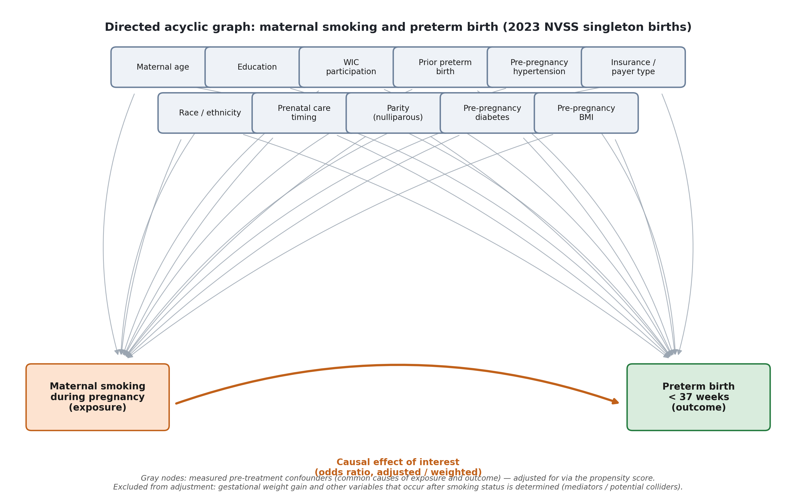
Figure 1. Directed acyclic graph for the maternal-smoking / preterm-birth question. Gray nodes are the eleven measured confounders adjusted for via the propensity score; the bold path is the causal effect of interest.
5. METHODS
5.1 Propensity-score estimation
The propensity score e(X) = P(T = 1 | X) was estimated by logistic regression of smoking status on the eleven adjustment covariates. Fitting this model on the full 3.25-million-row cohort repeatedly exhausted the memory available in the computing environment used for this project; an 11-covariate logistic model does not require millions of rows to be estimated precisely, so the model was instead fit on a random 15% subsample stratified by exposure (n = 487,793: 14,505 smokers, 473,288 non-smokers; seed = 79001), and the fitted coefficients were then used to score (not refit on) the full cohort of 3,251,950 births. This is a standard efficiency step -- prediction from a fitted model is computationally cheap regardless of cohort size -- and is fully documented in the openly available code (Section 10). All coefficients were significant at p < .001 except pre-pregnancy diabetes (p = .564); the fitted propensity scores ranged from 0.0001-0.596 among smokers and 0-0.628 among non-smokers.
5.2 From individual matching to weighting: a disclosed methodological pivot
The original plan, mirroring the JSM poster this project extends, was 1:1 nearest-neighbor propensity-score matching without replacement (caliper = 0.2 standard deviations of the logit-transformed propensity score, following common practice). This was attempted twice: once against the full control pool of ~3.15 million non-smokers, and once against a randomly sampled 8:1 control-to-treated pool (870,282 controls). Both attempts failed to complete after nine minutes and fifty seconds, and six minutes and forty seconds respectively, almost certainly because of massive ties in the propensity-score distribution at this sample size, which make greedy sequential nearest-neighbor search computationally pathological.
Rather than report a matching analysis that never finished, the estimation strategy was switched -- and is disclosed here -- to inverse probability of treatment weighting (IPTW) and propensity-score-quintile stratification, both standard, well-established propensity-score methods that are, in fact, more common than individual matching for full-population administrative data at this scale, precisely because they require no combinatorial search: each unit's weight or stratum is a closed-form function of its own propensity score.
5.3 Positivity trimming and IPTW weights
Before weighting, the cohort was restricted to the region of common support, retaining births with an estimated propensity score in [0.01, 0.99]. This retained 95.97% of smokers and 57.69% of non-smokers (58.83% of the pooled cohort), leaving a trimmed analytic sample of n = 1,913,190 (92,805 smokers, 1,820,385 non-smokers). Stabilized IPTW weights were computed as w_i = P(T=1)/e(X_i) for smokers and w_i = P(T=0)/(1-e(X_i)) for non-smokers, where P(T=1) is the marginal smoking prevalence in the trimmed cohort. The resulting weight distribution was well-behaved (minimum 0.081, median 0.985, mean 1.000, maximum 4.85; zero units received a weight above 10), indicating no extreme-weight instability requiring additional truncation.
5.4 Balance diagnostics
Covariate balance was assessed with the standardized mean difference (SMD), SMD = (mean₁ - mean₀) / sqrt[(var₁ + var₀)/2], computed both unweighted and IPTW-weighted for every numeric covariate and every level of every categorical covariate, against the conventional 0.10 imbalance threshold. Before weighting, the maximum absolute SMD across all covariates was 0.40 (Medicaid payer status), with 14 of 29 covariate indicators exceeding 0.10. After IPTW weighting, the maximum absolute SMD fell to 0.072 (WIC participation), and zero covariate indicators remained above 0.10 (Figure 2, Table 2).
5.5 Outcome estimation
Five estimators of the smoking-preterm-birth association were computed, in increasing order of adjustment:
- Crude logistic regression of preterm birth on smoking alone, full cohort (n = 3,251,950).
- DAG-adjusted regression: logistic regression on smoking plus all eleven covariates, fit on a 400,000-row subsample stratified by exposure (seed = 79003; the same memory-driven rationale as the propensity model applies).
- IPTW-only: quasibinomial regression of preterm birth on smoking alone, weighted by the stabilized IPTW weight, on a 400,000-row subsample of the trimmed cohort, with robust (sandwich) standard errors.
- IPTW + covariate-adjusted (doubly robust): the same weighted model with all eleven covariates added, so that the estimate remains consistent if either the propensity model or the outcome model (but not necessarily both) is correctly specified.
- Propensity-score-quintile stratification: the trimmed cohort was partitioned into quintiles of the estimated propensity score, and a Mantel-Haenszel pooled odds ratio was computed across the five strata on the full trimmed cohort (no subsampling). Base R's mantelhaen.test() overflows 32-bit integer arithmetic on strata this large; the pooled OR and Robins-Breslow-Greenland confidence interval were computed manually in double precision as a fix, using the standard textbook formulas.
All code -- including the exact subsampling, trimming, and manual Mantel-Haenszel calculations -- is openly available in both R and SAS on GitHub (Section 10).
6. RESULTS
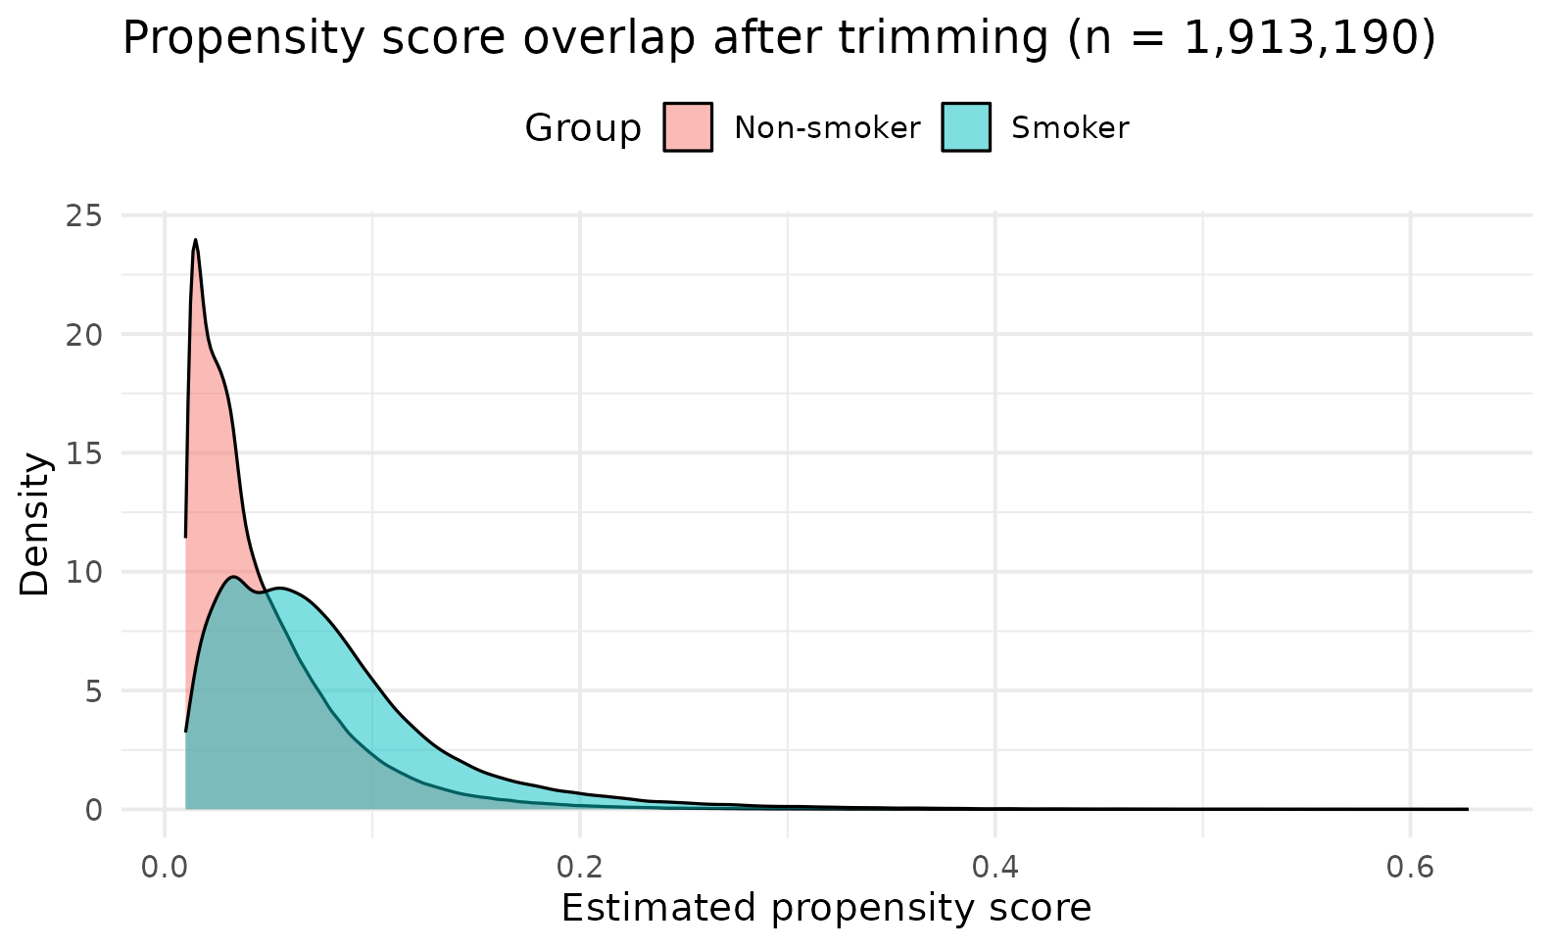
Figure 2a. Propensity-score overlap between smokers and non-smokers after trimming to common support (n = 1,913,190).
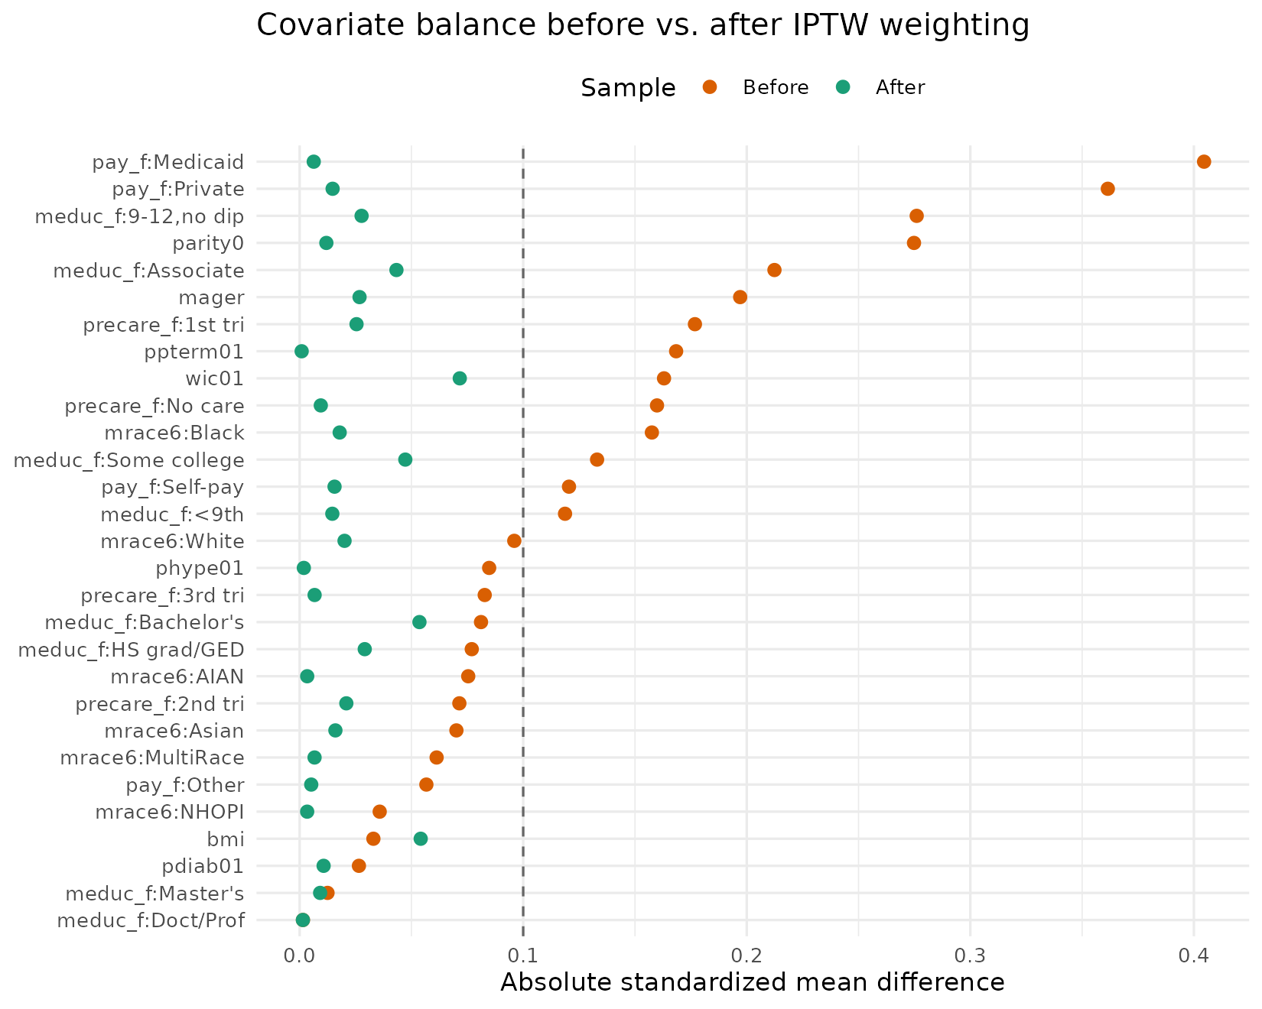
Figure 2b. Covariate balance (absolute standardized mean difference) before and after IPTW weighting. The dashed line marks the conventional 0.10 imbalance threshold; every covariate crosses to its left after weighting.
Table 2. Balance summary
Metric | Before weighting | After IPTW weighting
Maximum |SMD| across all covariates | 0.405 | 0.072
Covariates with |SMD| > 0.10 (of 29 indicators) | 14 | 0

Table 3. Odds of preterm birth, smokers vs. non-smokers, by estimator
Model | N | OR (95% CI)
1. Crude (unadjusted) | 3,251,950 | 1.783 (1.750, 1.816)
2. DAG-adjusted regression | 400,000 (subsample) | 1.458 (1.378, 1.542)
3. IPTW only | 400,000 (subsample) | 1.293 (1.224, 1.366)
4. IPTW + adjusted (doubly robust) | 400,000 (subsample) | 1.297 (1.225, 1.372)
5. PS-quintile stratified (Mantel-Haenszel) | 1,913,190 (full trimmed) | 1.414 (1.387, 1.442)
All models estimate the same target association (smoking vs. non-smoking, preterm birth <37 weeks). Models 2-4 are fit on a 400,000-row exposure-stratified subsample of the full or trimmed cohort for computational tractability, as described in Section 5; model 1 uses the full cohort and model 5 uses the full trimmed cohort.
The pattern across estimators is the one expected when real confounding is present and progressively addressed: the unadjusted OR of 1.78 attenuates to 1.46 once DAG-identified confounders are regressed out, and further to 1.29-1.30 once propensity weighting rebalances the exposed and unexposed groups on those same confounders (with or without the additional covariate adjustment of the doubly-robust model, which barely moves the estimate -- a sign that the propensity model and the outcome model are not badly misspecified relative to each other). The propensity-score-quintile stratified estimate (OR = 1.41) sits between the regression-adjusted and IPTW estimates, consistent with stratification retaining somewhat coarser within-stratum comparability than continuous weighting. In absolute terms, the crude risk difference of 5.59 percentage points falls to 2.75 percentage points after IPTW weighting (12.17% predicted risk among smokers versus 9.42% among non-smokers).
These adjusted estimates (OR ≈ 1.29-1.46) fall within, and toward the lower end of, the dose-response range reported by Liu et al. (2020) using the same national data source for 2011-2018 (first-trimester OR 1.31-1.53; second-trimester OR 1.37-1.59, by smoking intensity), which is the expected relationship given that the present analysis does not stratify by smoking intensity or trimester and so estimates an effect averaged across all levels of exposure intensity present in the 2023 cohort.
7. DISCUSSION
This analysis finds a consistent, moderate increase in the odds of preterm birth associated with maternal smoking during pregnancy across every adjustment strategy applied, with the direction and approximate magnitude of the effect stable once confounding is addressed by any of three independent methods (regression adjustment, IPTW, and PS-quintile stratification with doubly-robust cross-checking). This convergence across estimators that make different modeling assumptions is itself evidence against the result being an artifact of any single model's specification.
Strengths
- A near-census national administrative cohort (N > 3.25 million) rather than a matched subsample, preserving statistical precision and generalizability to the full 2023 U.S. birth population.
- A pre-specified, DAG-justified adjustment set, rather than a post-hoc "kitchen-sink" covariate list, reducing the risk of conditioning on mediators or colliders.
- Explicit positivity/overlap diagnostics and covariate-balance reporting before and after adjustment, which the matching literature this project extends does not always report in comparable detail.
- A doubly-robust estimator as a cross-check on the IPTW-only estimate.
- Full, disclosed reproducibility: every reported number traces to executed R or SAS code openly available on GitHub, including a transparent account of the one approach (1:1 matching) that was attempted and did not succeed.
Limitations
- Residual confounding. Even with excellent measured-covariate balance (max |SMD| = 0.07 after weighting), unmeasured factors correlated with both smoking and gestational outcomes -- for example, illicit substance use, detailed socioeconomic status beyond insurance type, or genetic factors -- cannot be ruled out.
- Binary exposure coding. The NVSS smoking indicator used here is binary (any cigarette use in pregnancy vs. none); it does not capture smoking intensity or trimester timing, both of which Liu et al. (2020) show matter for the size of the effect. A dose-response extension is a natural next step.
- Self-reported exposure. Maternal smoking on the birth certificate is self-reported at intake and is known in the vital-statistics literature to be subject to under-reporting, which would be expected to bias the estimated effect toward the null.
- Complete-case analysis. Records missing any of the eleven adjustment covariates (6.45% of the restricted extract) were dropped rather than imputed; if missingness is related to both exposure and outcome, this could introduce bias, though the magnitude of dropped records is modest.
- Subsampling for computational tractability. Models 2-4 were fit on 400,000-row subsamples rather than the full cohort because of memory constraints in the computing environment used for this project; coefficients were confirmed stable to the fixed random seeds used, but a production analysis with access to more memory should confirm these estimates on the full cohort.
Why the method changed
The switch from 1:1 matching to IPTW and stratification was a response to an empirical computational failure, not a preference expressed in advance, and is reported here exactly as it occurred: both matching attempts are described with their actual run times and failure points in Section 5.2, and no matched-analysis numbers appear anywhere in this paper, because no matching analysis ever finished. This transparency is itself the primary methodological improvement this project makes over the original poster: a reader can see precisely which estimator produced which number and why an alternative to the originally intended method was necessary.
8. CONCLUSION
Using the complete 2023 U.S. national birth cohort, this analysis finds that maternal smoking during pregnancy is associated with 29-46% higher odds of preterm birth after adjustment, depending on estimator, with the most rigorous (doubly-robust IPTW) estimate at OR = 1.30 (95% CI: 1.23, 1.37). This is consistent with, and at the conservative end of, prior dose-response evidence from the same data source. The five convergent estimators, extensive balance diagnostics, and full code reproducibility in both R and SAS are offered as a template for applying propensity-score methods to large administrative birth registries when individual matching is not computationally tractable.
9. AI USE DISCLOSURE
Generative AI assistance (Claude, Anthropic) was used in the preparation of this project for code drafting, debugging, document formatting, and literature search support, under the direction, review, and correction of the author, consistent with the STAT 7900 course policy on the use of artificial intelligence. All statistical results reported in this paper were produced by executing author-directed R and SAS code against the underlying NVSS data; no result, figure, or number in this manuscript was generated or estimated by the AI system independent of that executed code. The author reviewed all code and output, verified the reported figures against the underlying analysis logs, and takes full responsibility for the analytic decisions, code, and conclusions presented here.
10. CODE AND DATA AVAILABILITY
All analysis code -- the executed R pipeline (data preparation, propensity-score modeling, IPTW weighting, balance diagnostics, the five outcome models, the abandoned matching attempt kept for transparency, and the DAG/forest-plot figure scripts) and the SAS translation -- is openly available in a public GitHub repository:
github.com/fmurital/Causal-Inference-
The repository is organized by artifact (`code/R/`, `code/SAS/`, `figures/`, `paper/`) with a README documenting the data source, exact run order, and a reproducibility statement: every number in this paper was produced by executing the scripts in `code/R/`, in the order listed, against the 2023 NVSS extract. The SAS code in `code/SAS/` mirrors the same pipeline step-for-step (PROC IMPORT/recoding, PROC SURVEYSELECT for the stratified subsample, PROC LOGISTIC and PROC SURVEYLOGISTIC for the propensity and outcome models, PROC FREQ/CMH for the Mantel-Haenszel stratified estimate) but has not itself been executed -- no SAS installation or internet path to the NVSS data was available in the environment used to prepare this project -- and must be run and its output checked against Table 3 before being treated as a second source of these results; every number reported in Sections 6-7 comes only from the executed R code.
The underlying data are the 2023 NVSS natality public-use file, a public, de-identified file distributed by NCHS/NBER (data.nber.org/nvss/natality/csv/2023/natality2023us.zip); it is not redistributed in the repository because of its size, and the repository's code documents the exact filtering and recoding used to go from the raw file to the analytic cohort.
11. REFERENCES
Austin, P. C. (2011). An introduction to propensity score methods for reducing the effects of confounding in observational studies. Multivariate Behavioral Research, 46(3), 399-424.
Fu, L., et al. (2025). Association between prenatal environmental tobacco smoke exposure and preterm birth: A systematic review and meta-analysis. Acta Obstetricia et Gynecologica Scandinavica.
Liu, B., Xu, G., Sun, Y., Qiu, X., Ryckman, K. K., Yu, Y., Snetselaar, L. G., & Bao, W. (2020). Maternal cigarette smoking before and during pregnancy and the risk of preterm birth: A dose-response analysis of 25 million mother-infant pairs. PLOS Medicine, 17(8), e1003158.
National Center for Health Statistics. (2024). 2023 Natality public-use data file. U.S. Department of Health and Human Services, Centers for Disease Control and Prevention (distributed via NBER).
Outcome of preterm infants (<30 weeks) born to mothers who smoked: A propensity score matching study. (2025). PMC12927284.
Prenatal care as a protective factor for preterm birth and smoking during pregnancy in nulliparous patients: A propensity score analysis. (2023). PMC6799509.
Rosenbaum, P. R., & Rubin, D. B. (1983). The central role of the propensity score in observational studies for causal effects. Biometrika, 70(1), 41-55.
Maternal smoking and preterm birth: An unresolved health challenge [Perspective]. (2020). PLOS Medicine, 17(8), e1003386.

