SEASUG 2026 | Paper 103
Applying Propensity Score Matching to Evaluate Interventions
Maternal smoking in pregnancy and preterm birth: a doubly robust propensity score weighting analysis of 3.26 million U.S. births
Faruk Muritala1 and Dhrubajyoti Ghosh2
1 Ph.D. program in Data Science and Analytics, Kennesaw State University, Georgia, USA
2 Kennesaw State University, Georgia, USA
Abstract
Background: Smoking during pregnancy is a well-established risk factor for preterm birth, but large U.S. analyses mostly report adjusted odds ratios from regression, and the size of the effect on the absolute scale, after accounting for who smokes, is less often reported. Methods: We used the 2023 U.S. Natality Public Use File (3,259,496 singleton live births, 97,187 to mothers who smoked) to estimate the average causal effect of smoking during pregnancy on preterm birth (under 37 weeks). Ten confounders were chosen from a causal diagram in which the evidence for every arrow is documented, including where it is only indirect. The primary estimator was augmented inverse probability of treatment weighting (AIPTW), compared with outcome regression, stabilized IPTW and propensity score stratification, with influence-function standard errors, overlap and balance diagnostics, sensitivity analyses and an E-value. Results: The crude risk difference was 5.60 percentage points. The AIPTW risk difference was 3.26 (95% CI 2.47 to 4.04), with preterm risk of 11.6% if all mothers smoked and 8.4% if none did (risk ratio 1.39, odds ratio 1.44); among smokers the effect was 3.39 points. Estimates ranged from 3.02 to 3.65 points across propensity score handling and covariate specifications. Overlap was limited: 41% of non-smokers had an estimated probability of smoking below 0.01. The E-value was 2.12. Conclusion: Under explicit assumptions, smoking in pregnancy raises the risk of preterm birth by about three percentage points; the estimate is stable across analytic choices, but rests on limited overlap, self-reported smoking and unmeasured confounding that the E-value can size but not rule out. R code with a fixed seed (1234) and data instructions accompany the paper.
Keywords: causal inference, propensity score weighting, doubly robust estimation, AIPTW, preterm birth, maternal smoking, birth certificate data, E-value

1. Introduction
Preterm birth, delivery before 37 completed weeks of gestation, is a common and consequential perinatal outcome with many causes (Goldenberg et al., 2008). In 2023, 10.41 percent of all U.S. births and 8.71 percent of singleton births were preterm, and 3.0 percent of mothers reported smoking at any time during pregnancy (Osterman et al., 2025). Whether smoking during pregnancy raises the chance of preterm birth, and by how much on the absolute scale, matters for counselling, for cessation programs, and for the way we judge claims made from observational data.
The association itself is not in doubt. A meta-analysis of prospective studies found it two decades ago (Shah & Bracken, 2000), and the largest U.S. analysis to date, covering 25,623,479 singleton births from birth certificates, reported odds ratios for preterm birth that rose from 1.31 at one to two cigarettes per day to 1.53 at twenty or more in the first trimester (Liu et al., 2020). A pooled analysis of European and North American cohorts reported a smaller association and baseline preterm rates about half as high, and commentators attributed part of the difference to exposure definitions and confounding control (Philips et al., 2020; Stock & Bauld, 2020). The size of the effect, and how much of it is left after we account for who smokes, remains the open part of the question.
Smoking in pregnancy is far from random. In the 2023 birth certificate data analysed here, mothers who smoked were much more likely to have less than a high school diploma, to start prenatal care late or not at all, to have had a previous preterm birth, and to have chronic conditions, and every one of these also raises the risk of preterm birth on its own. The crude difference in preterm risk between smokers and non-smokers (5.60 percentage points in these data) therefore mixes the effect of smoking with the effect of who smokes. Designs that handle this more credibly, such as sibling comparisons, Mendelian randomization and cigarette-tax instruments, have mostly been applied to birth weight and fetal growth rather than to gestational age (Juárez & Merlo, 2013; Evans & Ringel, 1999).
This paper estimates the average causal effect of smoking during pregnancy on preterm birth in the 2023 U.S. Natality Public Use File, using a doubly robust estimator, augmented inverse probability of treatment weighting (AIPTW), with the confounder set chosen from a causal diagram that is justified edge by edge from the published literature. The propensity score is used here to weight, not to match, for reasons given in Section 5. The contributions are: (1) an effect estimate on the absolute scale (risk difference) with risk ratio and odds ratio alongside; (2) a causal diagram placed in the data context, with the evidence and the weakness of each arrow stated; (3) five estimators compared on the same data, with overlap and balance diagnostics reported in full, including where they are unsatisfactory; and (4) sensitivity analyses, subgroup estimates and an E-value for unmeasured confounding. All code, with the data link and run instructions, accompanies the paper and runs with a fixed seed (1234).

2. Related work and the gap
Evidence on smoking and preterm birth comes in three layers. The first is observational association at scale (Liu et al. (2020); Shah & Bracken (2000)). The second is quasi-experimental designs that address unmeasured familial or genetic confounding. A sibling analysis of 677,922 Swedish singletons found effects on birth weight that were 6 to 78 grams smaller than conventional estimates, which the authors attribute to residual familial confounding in standard adjustment (Juárez & Merlo, 2013), and a tax-based instrumental variable analysis of about 10.5 million U.S. birth records estimated a large effect on birth weight (Evans & Ringel, 1999). These designs address birth weight, not gestational age. The third layer is propensity score and weighting methods applied to prenatal smoking: matching for birth weight (Veiga & Wilder, 2008), a doubly robust estimator for early-childhood developmental vulnerability (Duko et al., 2023), and inverse probability weighting on 17,381,709 U.S. birth certificates for fetal growth restriction (Chen et al., 2026). A recent conference abstract used propensity score matching on about 2.6 million U.S. natality records for preterm birth and reported odds ratios (Heiny & Islam, 2026).
The large U.S. analyses of smoking and preterm birth report adjusted odds ratios from regression. This paper adds a doubly robust estimate of the effect on the absolute risk scale, with a full overlap assessment and an E-value for the same outcome, so that the size of the effect, the strength of the assumptions behind it, and the stability of the answer can be read together. That is the gap this paper addresses. We do not claim that the estimate here is more accurate than the large regression-based analyses. The point is to show how much of the association survives adjustment under explicit assumptions, and how fragile or stable that answer is to analytic choices.

3. Data

3.1 Source and analytic cohort
We used the 2023 Natality Public Use File of the National Center for Health Statistics (NCHS), which contains 3,605,081 records of U.S. births and no personal identifiers (NCHS, 2024). All states and the District of Columbia have used the 2003 revised Certificate of Live Birth since 2016, so the file has a single certificate version (NCHS, 2024). We kept singleton births with known gestational age and known smoking status (3,476,180 births), excluded births to mothers who were not U.S. residents (3,467,679 remaining), and kept births with complete data on the ten confounders, which left 3,259,496 births (93.77 percent of the extract). Of these, 97,187 (2.98 percent) were to mothers who reported smoking during pregnancy. The singleton preterm proportion in the analytic cohort (8.47 percent) and the smoking prevalence (2.98 percent) are close to the national figures of 8.71 and 3.0 percent (Osterman et al., 2025). Missingness on any single confounder was at most 2.2 percent (education 1.7, prenatal care 1.8, WIC 1.0, BMI 2.2, parity 0.2, previous preterm birth, diabetes and hypertension 0.1 each), and we used complete cases; Section 8 discusses this choice.

3.2 Exposure, outcome and confounders
The exposure T is any cigarette smoking during pregnancy as recorded in the NCHS cigarette recode (CIG_REC, yes or no). It is self-reported by the mother and recorded on the birth certificate worksheet, which matters for misclassification (Section 8). The outcome Y is preterm birth, a gestational age below 37 completed weeks by the obstetric estimate (OEGEST_COMB), which NCHS has used instead of the last menstrual period estimate since 2014 (Martin et al., 2015). The ten confounders, chosen in Section 4, are maternal age (under 20, 20 to 24, 25 to 29, 30 to 34, 35 to 39, 40 and over), race and Hispanic origin (six groups), education (eight levels), timing of prenatal care (first, second or third trimester, or none), participation in WIC, parity (number of previous live births, 0, 1, 2, 3 or more), previous preterm birth, pre-pregnancy diabetes, pre-pregnancy hypertension and pre-pregnancy body mass index (under 18.5, 18.5 to 24.9, 25 to 29.9, 30 to 34.9, 35 to 39.9, 40 and over). Table A1 in the appendix gives the cohort composition and the crude preterm risk for every level.

3.3 What the data show before any modelling
Smoking in pregnancy is concentrated in specific groups (Figure 1). 8.4 percent of mothers with 9 to 12 years of schooling and no diploma smoked, compared with 0.4 percent of mothers with a bachelor's degree and 0.1 percent with a doctorate. Prevalence was 7.3 percent among American Indian and Alaska Native mothers and 0.2 percent among Asian mothers. Smokers delivered earlier on average (mean gestation 37.97 against 38.45 weeks), and the whole gestational age distribution is shifted left (Figure 2). The crude preterm risk was 13.90 percent in smokers and 8.30 percent in non-smokers. Many of the same characteristics that predict smoking predict preterm birth on their own: among non-smokers, preterm risk was 26.1 percent with a previous preterm birth against 7.6 percent without, and 26.1 percent with pre-pregnancy diabetes against 8.1 percent without (Table A1). That is the confounding the analysis has to address.
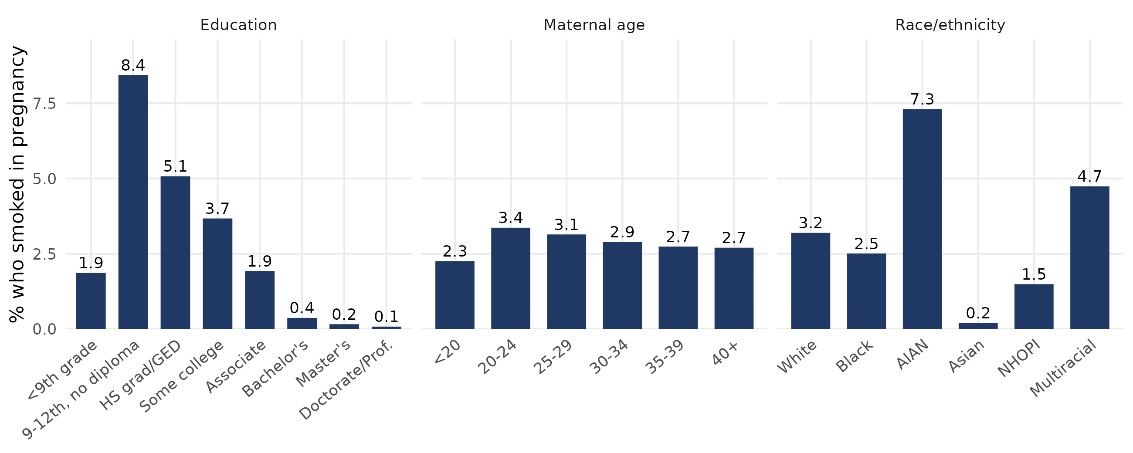
Figure 1. Percentage of mothers who smoked during pregnancy, by education, maternal age and race/ethnicity (2023 U.S. singleton births, n = 3,259,496).
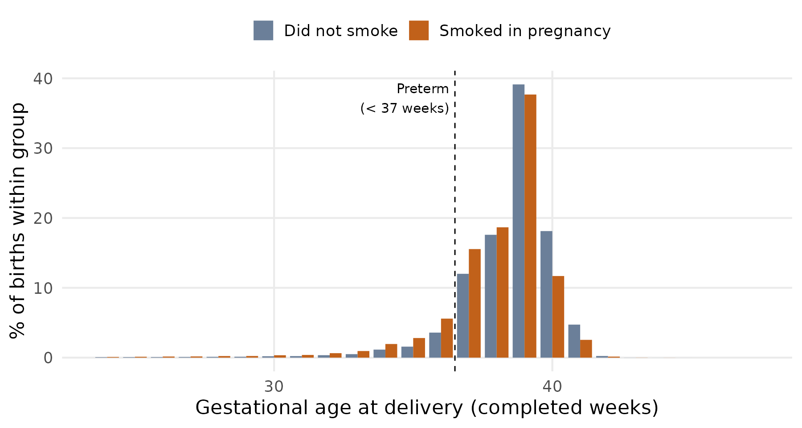
Figure 2. Distribution of gestational age at delivery by smoking status. The dashed line marks 37 weeks.

4. Causal framework

4.1 Estimand and assumptions
Let T be smoking during pregnancy, Y preterm birth, and Y(1) and Y(0) the potential outcomes if the mother had smoked or not (Rubin, 1974). The primary estimand is the average treatment effect on the risk difference scale, ATE = E[Y(1)] - E[Y(0)], the difference in preterm risk if every mother in the cohort smoked against if none did. We also report the ratio and odds ratio versions, and the average effect among mothers who actually smoked (ATT), which is better supported by the data because the non-smoking comparison group is large. Identification rests on four assumptions. Conditional exchangeability, Y(t) independent of T given X, is argued through the causal diagram below and cannot be tested. Positivity, 0 < P(T = 1 | X) < 1, is assessed with the propensity score distribution (Section 6.2). Consistency means that the observed outcome equals the potential outcome under the observed exposure; here "any smoking" combines different doses and timing, so it holds only for that coarse exposure, and we assume no interference between mothers. The fourth condition belongs to the estimator: AIPTW is consistent if either the propensity model or the outcome model is correctly specified (Bang & Robins, 2005; Funk et al., 2011).

4.2 The causal diagram
We built the diagram from published evidence for each arrow, following the recommendation to document every edge of an applied DAG (Tennant et al., 2021; Ferguson et al., 2020) and the standard graphical criterion for adjustment (Pearl, 1995; Greenland et al., 1999). The diagram (Figure 3) has smoking (T) and preterm birth (Y) and ten confounders, each a parent of both. That gives ten back-door paths, T <- X -> Y, and adjusting for all ten blocks every one of them. Table 2 gives the evidence for each arrow into T and into Y and states how strong that evidence is, because for several arrows into T it is indirect. Arrows among the confounders (dashed in Figure 3, Table 3) are plausible relationships; they do not change the minimal sufficient adjustment set, because every confounder is a direct parent of T and so each back-door path is blocked at its first node, whatever arrows connect the confounders to each other.
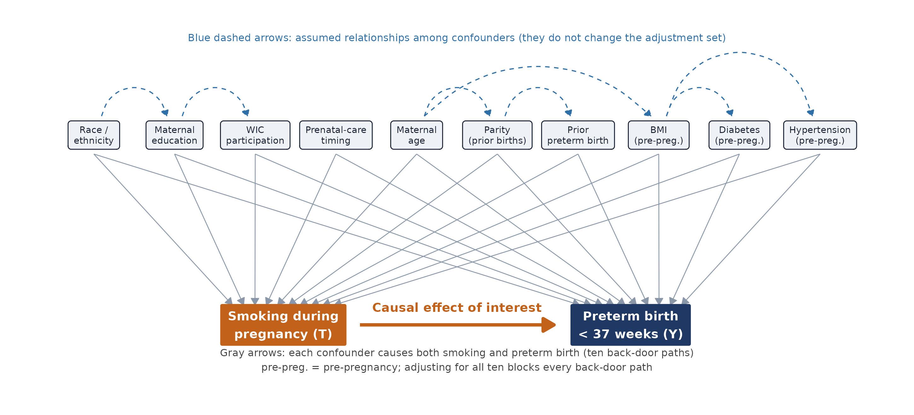
Figure 3. Causal diagram. Orange: exposure (T). Navy: outcome (Y). Gray arrows: each confounder affects both T and Y. Blue dashed arrows: assumed relationships among confounders. Pre-preg. = pre-pregnancy.
Three points deserve emphasis because they are where an applied diagram is most open to challenge. First, several arrows into smoking are documented as associations or are included as proxies for shared upstream causes rather than as direct causal effects (diabetes, hypertension, previous preterm birth, parity, and in part BMI). They stay in the set because each is also a strong cause of preterm birth and each is related to smoking through socioeconomic position, age and health status. This follows the rule of adjusting for covariates that cause the exposure, the outcome or both (VanderWeele & Shpitser, 2011), and adjusting for strong predictors of the outcome reduces variance in propensity score analyses (Brookhart et al., 2006). Second, prenatal-care timing and WIC are recorded during pregnancy, so they can be influenced by smoking history and by the length of the pregnancy itself, which is a gestational age bias (Shin & Song, 2019; Heaman et al., 2008; Joyce et al., 2008; Stoner et al., 2018). We keep them in the main model as markers of access and socioeconomic position and show the result without them (sensitivity analysis A), because adjusting for variables downstream of the exposure can bias the estimate (Schisterman et al., 2009; Cole et al., 2010; Hernán et al., 2004). Third, we left out health insurance type. Payer on the birth certificate is a strong marker of income and is associated with smoking, but it is largely captured by education, race and WIC, it is measured at delivery, and causal evidence that insurance itself changes smoking is small and mixed in sign. Insurance enters only in sensitivity analysis B. We also did not adjust for conditions that arise during the pregnancy (gestational diabetes and hypertension), which come after smoking in time, or for pre-pregnancy cigarettes per day, which is closely tied to the exposure and would remove most of the contrast between mothers who smoke and mothers who do not; this is a design choice that we list among the limitations.
Table 2. Evidence for each arrow from a confounder into smoking (T) and into preterm birth (Y). "Documented" means a statistic or study was found for the arrow; "proxy" means the variable is included as a marker of shared causes, with no direct causal study found.
Confounder | Arrow into smoking (T) | Arrow into preterm birth (Y)
Maternal age | Documented. Non-monotone: 10.7% at ages 20-24, 2.0% at 45 and over (2016 birth certificates) (Drake et al., 2018; Kondracki, 2019; Tong et al., 2013). | Documented. Lowest preterm rate at 25-29 (9.28%), highest at 40 and over (14.59%) in 2017 (Martin et al., 2018); higher risk in adolescent mothers in a WHO multicountry study (Ganchimeg et al., 2014).
Race and ethnicity | Documented. Prevalence differs several-fold (2016: American Indian and Alaska Native 16.7%, Asian 0.6%) (Drake et al., 2018); 2023: White 4.4%, Black 2.7%, Hispanic 0.8% (Osterman et al., 2025). Race stands for social and structural processes, not biology (Phelan & Link, 2015; VanderWeele & Robinson, 2014). | Documented. 2023 preterm rates: Black 14.65%, Hispanic 10.14%, White 9.44%, Asian 9.08% (Osterman et al., 2025); structural factors explain about half of the Black-White gap in one U.S. analysis (Gangopadhyaya et al., 2024).
Education | Documented. 12.2% (high school) and 11.7% (less than high school) against at most 1.0% (bachelor's or higher) among women 25 and over (Drake et al., 2018); Mendelian randomization supports a causal effect of education on smoking (Gage et al., 2018); reviewed in (Hiscock et al., 2012). | Documented in European data. Low maternal education: relative excess risk 1.48 (95% CI 1.29 to 1.69) in 12 cohorts (Ruiz et al., 2015). The U.S. gradient is shown from these data in Table A1.
Prenatal-care timing | Documented, but care leads to smoking: early care raised the relative risk of early cessation by 52% in over one million Ohio births (Moore et al., 2016). Post-baseline; see text. | Documented, with gestational age bias: later or inadequate care is associated with preterm birth, but shorter pregnancies have less time to accumulate care (Shin & Song, 2019; Heaman et al., 2008).
WIC participation | Plausible, weakest evidence. WIC enrollees smoked more at intake, while earlier enrollment was associated with quitting (Yunzal-Butler et al., 2009). Marker of low income. | Documented association with better outcomes after adjustment (Bitler & Currie, 2005), with a gestational age bias caution (Joyce et al., 2008).
Parity | Proxy. No U.S. causal study found; association through age, education and accumulated stressors. | Documented, U-shaped. Nulliparity: odds ratio 1.95 for spontaneous preterm birth in 802,119 Dutch pregnancies (Koullali et al., 2020); parity of three or more raised the odds in low- and middle-income cohorts (Kozuki et al., 2013). Modelled as categories.
Previous preterm birth | Proxy. The earlier pregnancy shares its causes (smoking habit, income, health) with the current one. | Documented, the strongest arrow. Recurrence of about 20% after a previous preterm singleton (Kazemier et al., 2014).
Pre-pregnancy diabetes | Proxy. No study found of diabetes as a cause of smoking in pregnancy; shared causes are income and obesity. | Documented. 42.5% of type 1 and 23.4% of type 2 pregnancies delivered before 37 weeks in a UK national cohort (Murphy et al., 2021). Excess-risk interaction with smoking reported (Borsari et al., 2018); see subgroups.
Pre-pregnancy hypertension | Proxy. Same reasoning as diabetes. | Documented. Pooled preterm delivery 28.1% (95% CI 22.6 to 34.4), 2.7-fold higher than the general population (Bramham et al., 2014).
Pre-pregnancy BMI | Plausible, contestable. Mendelian randomization in general adult populations: higher BMI raised the odds of smoking (odds ratio 1.18 per standard deviation) (Carreras-Torres et al., 2018). The reverse arrow, smoking to weight, is also real (Aubin et al., 2012), so part of the association reflects smoking history. | Documented, heterogeneous. Null overall (RR 1.06, 95% CI 0.87 to 1.30), with increased induced preterm birth in obesity (McDonald et al., 2010); lower spontaneous preterm risk in overweight and class@@we obesity, highest very-preterm risk in class III obesity (Torloni et al., 2009). Modelled as categories.

Table 3. Assumed arrows among confounders (dashed in Figure 3). None changes the adjustment set.
Arrow | Reason and evidence
Race to education | Attainment gaps by race are large (bachelor's attainment at ages 25 to 29 in 2022: Asian 72%, White 45%, Black 28%, Hispanic 25%) (NCES, 2023); racism as a fundamental cause of differences in socioeconomic position (Phelan & Link, 2015).
Education to WIC | WIC eligibility is income-based, and income rises with education (USDA, n.d.). The arrow is a reduced form of education to income to WIC.
Age to parity | Older mothers have had more time to accumulate births (Mathews & Hamilton, 2016); nearly definitional.
Age to BMI | Weaker and non-monotone: among pregnant women in 2019, obesity was 20.5% under age 20 and about 30% at ages 20 to 29 and 40 and over (Driscoll & Gregory, 2020).
Parity to previous preterm birth | Structural: a mother cannot have a previous preterm birth without a previous birth.
BMI to diabetes and to hypertension | Relative risk of incident type 2 diabetes 12.41 and of hypertension 2.42 in obese against normal-weight women in adult cohorts (Guh et al., 2009); not pregnancy-specific.

We considered and did not draw an arrow from WIC to prenatal-care timing: for most women prenatal care registration comes before WIC enrollment, so the evidence points the other way, and the direction does not change which variables must be adjusted for (Yunzal-Butler et al., 2009). Race is treated as a node that carries social processes, as recommended for causal interpretation of race in regression (VanderWeele & Robinson, 2014). The diagram is a statement of assumptions, not a finding of the data.

5. Methods

5.1 Estimators
Let e(X) = P(T = 1 | X) be the propensity score (Rosenbaum & Rubin, 1983) and mu_t(X) = P(Y = 1 | T = t, X) the outcome regressions. All three nuisance models are logistic regressions on the ten confounders (age, BMI, and the other variables as categories, so that the models do not assume a straight line in age or BMI). We report five estimators of the risk difference, risk ratio and odds ratio. (1) Crude: the unadjusted contrast. (2) Outcome regression (g-computation): the average of mu_1(X) and mu_0(X) over all births (Naimi et al., 2017). (3) Stabilized inverse probability of treatment weighting (IPTW) with normalized (Hajek) weights, w = P(T = t) / P(T = t | X) (Austin & Stuart, 2015). (4) Propensity score stratification into quintiles with a Mantel-Haenszel odds ratio (Rosenbaum & Rubin, 1984). (5) AIPTW, the primary estimator: psi_1 = mean[ mu_1(X) + T (Y - mu_1(X)) / e(X) ] and psi_0 = mean[ mu_0(X) + (1 - T)(Y - mu_0(X)) / (1 - e(X)) ], with ATE = psi_1 - psi_0 (Robins et al., 1994; Bang & Robins, 2005; Funk et al., 2011). AIPTW starts from the outcome-model prediction for every mother and corrects it with the inverse-probability-weighted residual of the mothers who actually had that exposure. If the outcome model is right, the correction averages to zero; if only the propensity model is right, the correction removes the bias of the outcome model.

5.2 Why weighting and not matching
We use the propensity score to weight, for four reasons. Weighting keeps all 3,259,496 births, whereas matching discards unmatched births and changes the population to which the estimate applies. Weighting targets the population average effect directly, which is the estimand stated above. Matching on the propensity score can increase imbalance, inefficiency, model dependence and bias (King & Nielsen, 2019), and finite-sample comparisons of reweighting and matching estimators are an active literature (Busso et al., 2014; Stuart, 2010). And with 3.26 million births and a 3 percent exposure, weighting is computationally direct, with variances available from the influence function rather than from a resampling scheme alone. The cost is that weighting is sensitive to very small propensity scores, which we address with clamping, diagnostics and sensitivity analyses.

5.3 Inference, extreme weights and overlap weights
Standard errors come from the estimated influence function of each estimator, with the delta method for the risk ratio and odds ratio, and 95 percent confidence intervals are Wald intervals. These ignore uncertainty in the propensity and outcome models, as is conventional for AIPTW with parametric nuisance models (Funk et al., 2011); a bootstrap on a subsample, described in Section 6.6, checks them. Because a large share of non-smokers have a very low estimated probability of smoking, a few smokers receive large weights. In the main analysis we clamp (rather than delete) the propensity score at its 1st and 99th percentiles, which bounds the largest weight; weight trimming can improve precision with a logistic propensity model but is no substitute for a well specified one (Lee et al., 2011), and doubly robust estimators remain sensitive to small estimated propensities (Kang & Schafer, 2007), so we report no truncation, truncation at the 0.1/99.9 and 5/95 percentiles, and deletion of births outside a propensity range of 0.01 to 0.99 (Section 6.4). As an additional check that does not depend on the tails, we estimate overlap-weighted effects, which target the population with the most overlap and give bounded weights (Li et al., 2018). We also report the ATT by AIPTW, which needs weights only for non-smokers and is more stable here.

5.4 Sensitivity analyses, subgroups and unmeasured confounding
We re-estimated the AIPTW risk difference under four alternative covariate specifications: (A) only pre-pregnancy confounders, dropping prenatal-care timing and WIC; (B) the main set plus insurance type; (C) age and BMI as continuous variables with quadratic terms; and (D) the main set plus two-way interactions (race by education, age by education, age by parity, education by WIC, education by prenatal care). Because the effect may differ between groups, we estimated AIPTW within subgroups of age, race and ethnicity, education, BMI, parity and previous preterm birth, and treat these as exploratory. For unmeasured confounding we report the E-value, the minimum risk ratio association that an unmeasured confounder would need with both smoking and preterm birth, beyond the measured confounders, to explain the observed risk ratio away (VanderWeele & Ding, 2017); for a risk ratio RR above one it is RR + sqrt(RR (RR - 1)).

5.5 Software and reproducibility
All analyses were run in R 4.3.3 with base R and the data.table package; figures use ggplot2. To keep the code runnable on a standard laptop and independent of package versions, the logistic regressions are fitted by iteratively reweighted least squares in base R, processed in chunks; a self-test in the code confirms they match glm() to within 5e-6. Every random operation uses set.seed(1234). The scripts are numbered in run order (00 optional data extraction, 01 data preparation, 02 exploratory analysis, 03 main analysis, 04 sensitivity analyses, 05 variance check, 06 causal diagram, 07 numbers quoted in the text), and each states its inputs, outputs and run time at the top. The data link and download instructions are at the top of scripts 00 and 01.

6. Results

6.1 Unadjusted comparison
In the analytic cohort the crude preterm risk was 13.90 percent among mothers who smoked and 8.30 percent among those who did not, a crude risk difference of 5.60 (5.38, 5.82) percentage points, a risk ratio of 1.68 (1.65, 1.70) and an odds ratio of 1.78 (1.75, 1.82) (Table 4).

6.2 Overlap and covariate balance
The propensity score separates the two groups only partly (Figure 4). The median estimated probability of smoking was 0.058 among smokers and 0.018 among non-smokers, and 40.8 percent of non-smokers had a score below 0.01, so a large share of non-smoking mothers resemble almost no smoking mother. Only 4.1 percent of smokers had a score below 0.01. The 1st and 99th percentiles used for clamping were 0.0002 and 0.163. Because the target is the whole cohort, smokers with low scores carry large weights: after clamping, the largest stabilized weight among smokers was 187, the top 1 percent of smokers carried 23.2 percent of the total smoker weight, and the effective sample size of the weighted smokers was 6,807 of 97,187. The weights among non-smokers were close to one (range 0.97 to 1.16). This is the main weakness of the ATE analysis, and it is why the ATT and overlap-weighted results are shown alongside it.
Weighting reduced imbalance substantially (Figure 5). The largest absolute standardized mean difference fell from 0.64 before weighting (bachelor's degree) to 0.13 after, and 3 of 38 covariate levels remained above the conventional 0.10 threshold: age 40+ (0.10), Asian (0.11), BMI 18.5-24.9 (0.13). These are small levels, and in AIPTW the outcome model adjusts for them as well, but we report them as residual imbalance (Austin & Stuart, 2015).
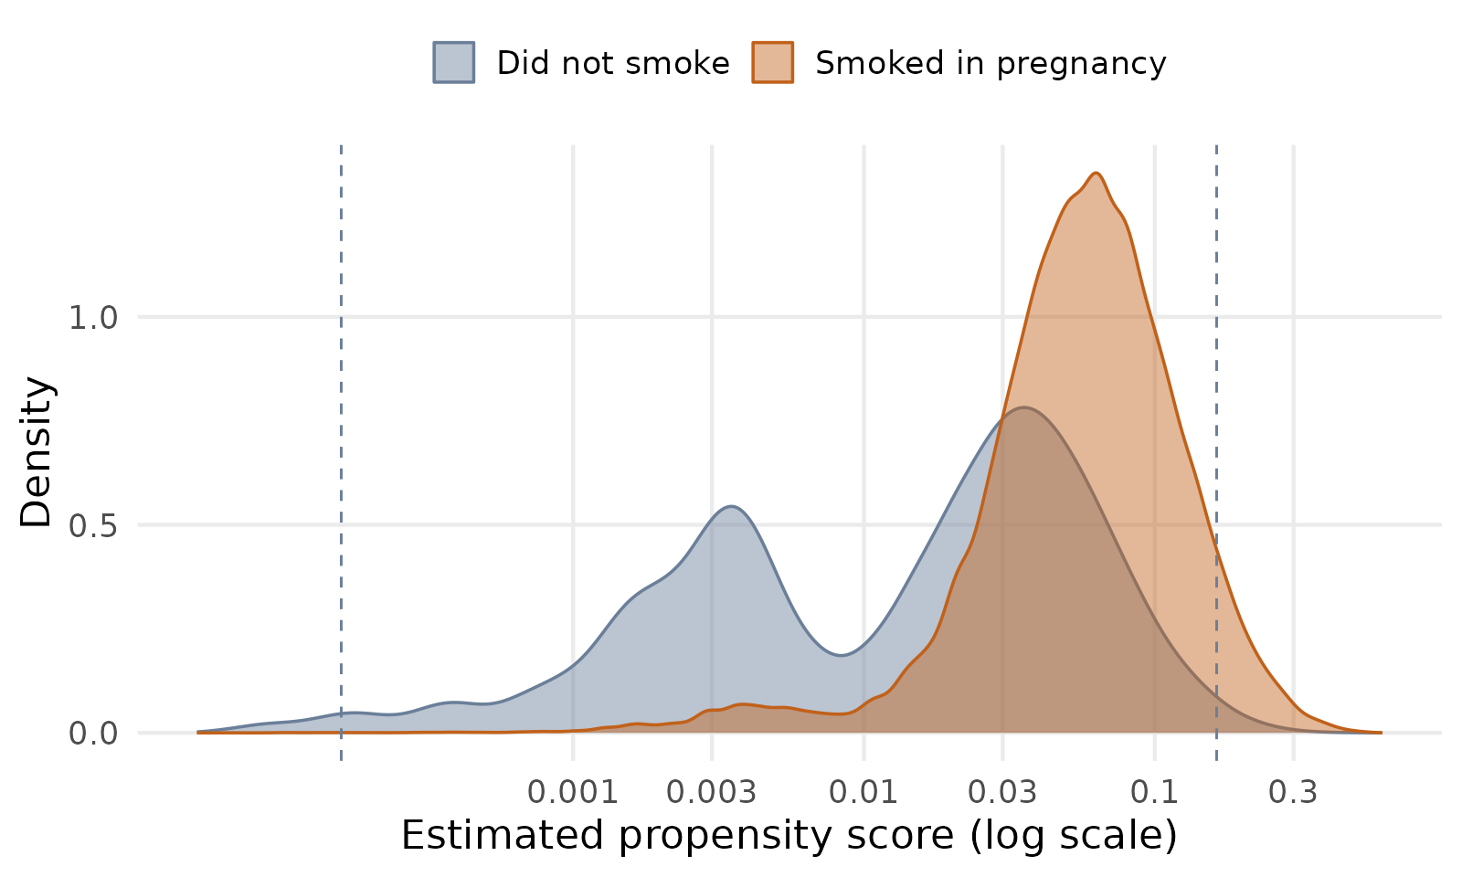
Figure 4. Estimated propensity score (probability of smoking given the ten confounders) by smoking status, log scale. Dashed lines mark the 1st and 99th percentiles at which the score is clamped.
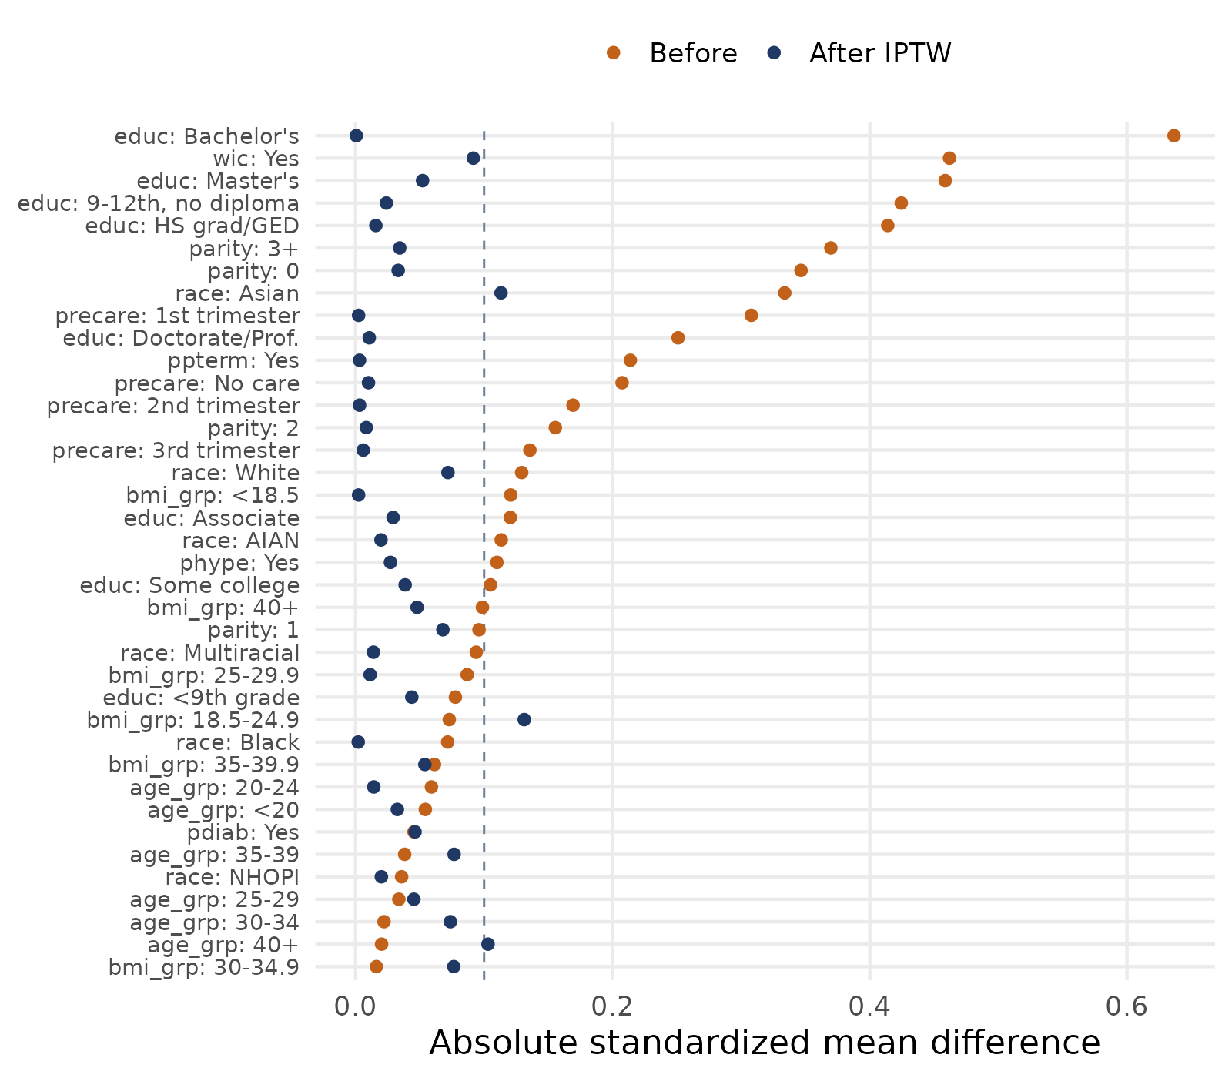
Figure 5. Absolute standardized mean differences for all covariate levels before and after stabilized inverse probability weighting. Dashed line: 0.10.

6.3 Effect estimates
The four adjusted estimators agree closely (Table 4, Figure 6). The AIPTW risk difference was 3.26 (2.47, 4.04) percentage points, with standardized preterm risks of 11.62 percent if every mother smoked and 8.37 percent if none did, a risk ratio of 1.39 (1.30, 1.49) and an odds ratio of 1.44 (1.33, 1.55). Outcome regression gave 3.48, stabilized IPTW 3.53 and propensity score stratification 3.74 percentage points. Adjustment therefore reduced the crude risk difference of 5.60 by 33 to 42 percent. The IPTW interval (2.77 to 4.30) is wider than the outcome regression interval (3.00 to 3.96), as expected given the weights discussed above. Conditional odds ratios from the usual adjusted logistic regression and from the Mantel-Haenszel combination over propensity score quintiles were 1.42 (1.39, 1.44) and 1.48 (1.45, 1.50). Among mothers who smoked, the AIPTW average effect (ATT) was 3.39 (3.17, 3.61) percentage points. In plain terms, about 34 additional preterm births per 1,000 smoking pregnancies are attributable to smoking under the assumptions of Section 4.
Table 4. Effect of smoking during pregnancy on preterm birth, 2023 U.S. singleton births (n = 3,259,496). Risk difference (RD) in percentage points. 95% confidence intervals in parentheses. AIPTW is the primary estimator.
Estimator | Risk if smoked (%) | Risk if not (%) | Risk difference | Risk ratio | Odds ratio
Crude (unadjusted) | 13.90 | 8.30 | 5.60 (5.38, 5.82) | 1.68 (1.65, 1.70) | 1.78 (1.75, 1.82)
Outcome regression (g-computation) | 11.84 | 8.36 | 3.48 (3.00, 3.96) | 1.42 (1.36, 1.47) | 1.47 (1.41, 1.54)
IPTW (stabilized) | 11.89 | 8.36 | 3.53 (2.77, 4.30) | 1.42 (1.33, 1.52) | 1.48 (1.38, 1.59)
PS-quintile stratification | 12.08 | 8.35 | 3.74 (3.25, 4.22) | 1.45 (1.39, 1.51) | 1.51 (1.44, 1.58)
AIPTW (doubly robust) | 11.62 | 8.37 | 3.26 (2.47, 4.04) | 1.39 (1.30, 1.49) | 1.44 (1.33, 1.55)

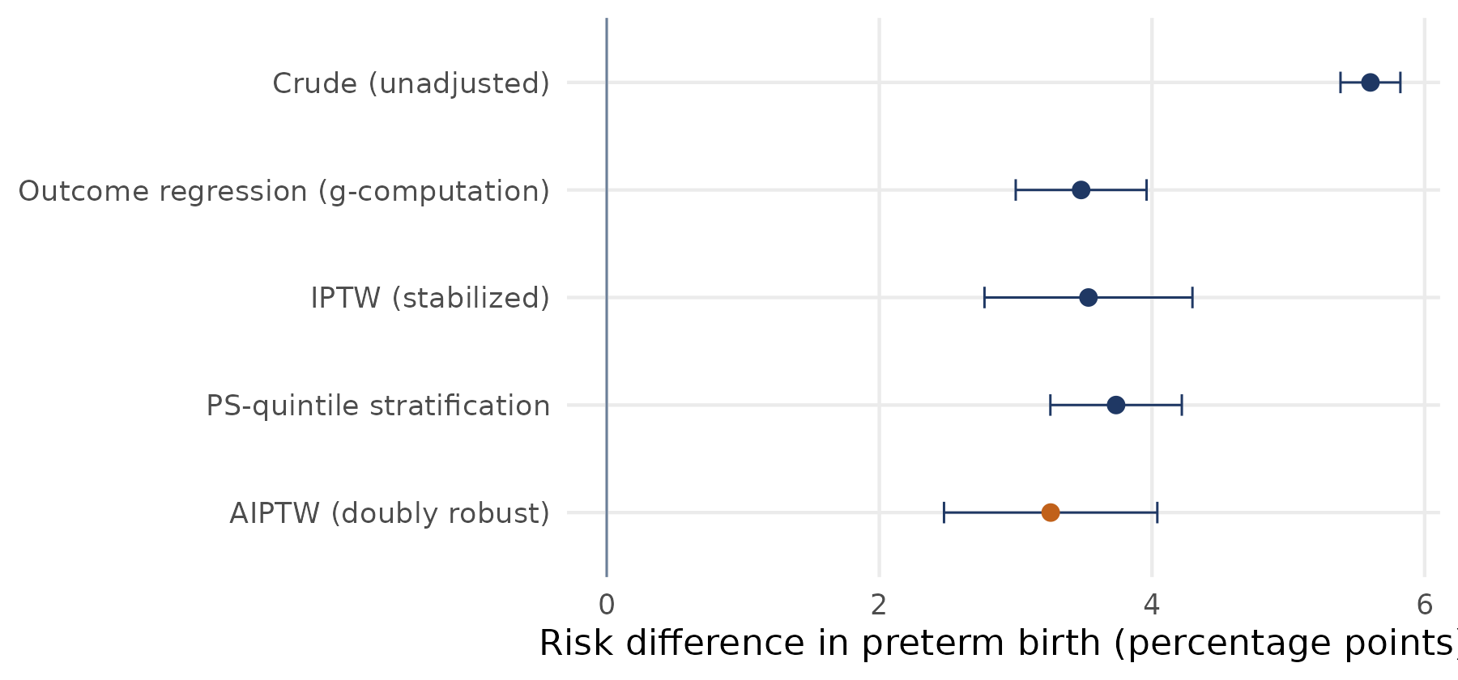
Figure 6. Risk difference in preterm birth (percentage points) by estimator, with 95% confidence intervals. The primary estimator (AIPTW) is in orange.
The E-value for the AIPTW risk ratio is 2.12, and 1.92 for the lower confidence limit. An unmeasured confounder would have to be associated with both smoking and preterm birth by a risk ratio of at least about 2.1 each, beyond the ten confounders already in the model, to explain the point estimate away entirely, and by about 1.9 each to move the confidence interval to include no effect (VanderWeele & Ding, 2017). The E-value says how strong such a confounder would need to be, not whether one exists. Alcohol, cannabis, e-cigarette use, stress and interpregnancy interval are unmeasured here and each is related to preterm birth (Patra et al., 2011; Regan et al., 2021; Dole et al., 2003; Ahrens et al., 2019).

6.4 Sensitivity to propensity score handling and to the covariate specification
The estimate is stable but not unaffected by how the extreme propensity scores are handled (Table 5). The AIPTW risk difference ranged from 3.03 to 3.39 percentage points across no truncation, clamping at the 0.1/99.9, 1/99 and 5/95 percentiles, deleting births with a score outside 0.01 to 0.99, and overlap weighting. Without any truncation the largest weight was 453 and the effective smoker sample 5,134. Deleting births outside the 0.01 to 0.99 range keeps only about 60 percent of the cohort, changes the population to which the estimate applies, and gives a narrower interval; we show it for completeness and do not use it as the main result. The overlap-weighted risk difference was 3.30 percentage points, in the same range, which supports the conclusion that the result does not depend on the tails.
Table 5. Sensitivity of the effect estimate to propensity score handling (AIPTW and overlap weighting). RD in percentage points. Max. weight and effective n (ESS) are for smokers.
Scenario | Estimator | Risk difference | Risk ratio | Max. weight | ESS
No truncation | AIPTW | 3.38 (2.39, 4.36) | 1.40 (1.29, 1.53) | 453 | 5,134
Clamp PS at 0.1 / 99.9 percentile | AIPTW | 3.39 (2.40, 4.37) | 1.40 (1.29, 1.53) | 388 | 5,278
Clamp PS at 1 / 99 percentile | AIPTW | 3.26 (2.47, 4.04) | 1.39 (1.30, 1.49) | 187 | 6,807
Clamp PS at 5 / 95 percentile | AIPTW | 3.22 (2.72, 3.72) | 1.38 (1.33, 1.45) | 42 | 15,128
Delete births with score outside 0.01 to 0.99 (keeps 60.3%) | AIPTW | 3.03 (2.77, 3.28) | 1.32 (1.30, 1.35) | n/a | n/a
Overlap weights (target = ATO) | Overlap-weighted (ATO) | 3.30 (3.08, 3.52) | 1.32 (1.30, 1.34) | n/a | n/a

Changing the covariate specification moved the AIPTW risk difference between 3.02 and 3.65 percentage points (Table 6, Figure 7). Dropping prenatal-care timing and WIC (specification A), the two variables measured during pregnancy, raised the estimate to 3.65; adding insurance type (B) gave 3.05; quadratic age and BMI (C) gave 3.30; and adding two-way interactions (D) gave 3.02. In every specification the interval excluded zero and the point estimate stayed between 3.0 and 3.7 percentage points; the specification that drops the two variables measured during pregnancy gives the largest estimate.
Table 6. AIPTW effect estimate under alternative covariate specifications. RD in percentage points; ATT = average effect among smokers.
Specification | Risk difference (AIPTW) | Odds ratio (AIPTW) | ATT (AIPTW)
Main: ten DAG confounders | 3.26 (2.47, 4.04) | 1.44 (1.33, 1.55) | 3.39
A: pre-pregnancy confounders only (no prenatal-care timing, no WIC) | 3.65 (2.88, 4.43) | 1.50 (1.39, 1.61) | 3.65
B: main set + insurance type | 3.05 (2.23, 3.87) | 1.41 (1.30, 1.53) | 3.20
C: age and BMI as continuous (quadratic) | 3.30 (2.50, 4.10) | 1.45 (1.34, 1.56) | 3.42
D: main set + two-way interactions | 3.02 (2.46, 3.59) | 1.41 (1.33, 1.49) | 3.31

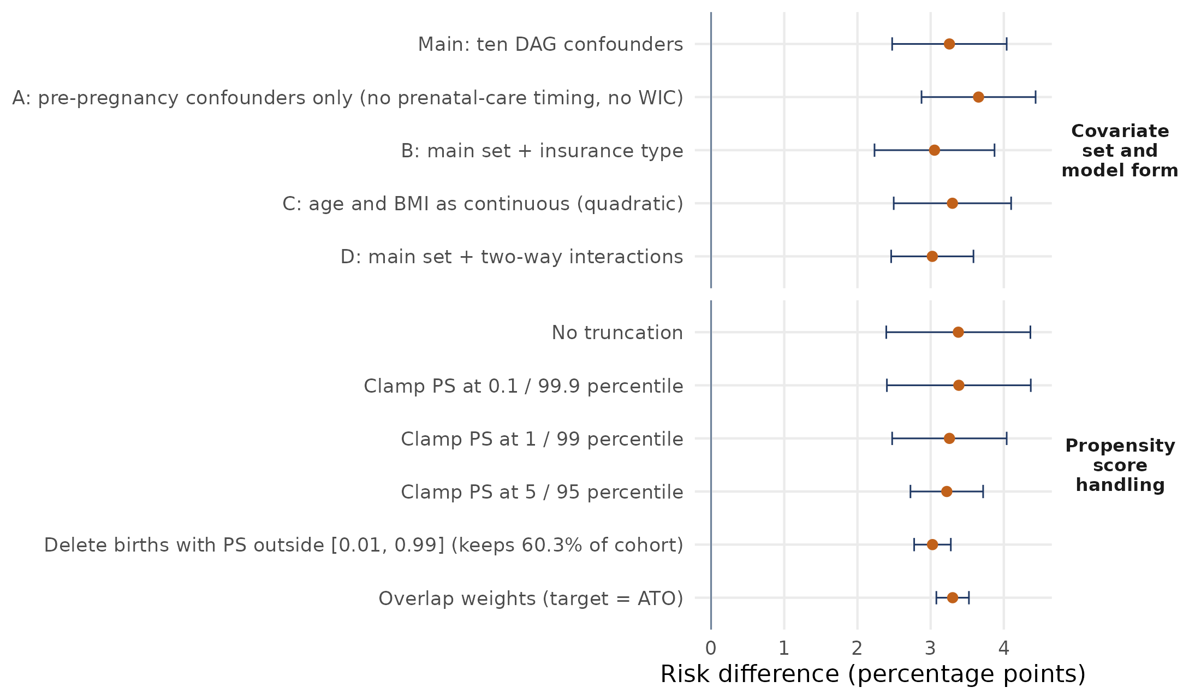
Figure 7. AIPTW (and overlap-weighted) risk difference under alternative handling of the propensity score and alternative covariate specifications.

6.5 Subgroups (exploratory)
Subgroup AIPTW risk differences ranged from 0.90 to 5.53 percentage points (Figure 8), and the interval excluded zero in 24 of 29 subgroups. The point estimates were largest among Black mothers (5.0), mothers aged 35 to 39 (5.5), mothers with three or more previous births (5.2) and mothers with a normal pre-pregnancy BMI (4.6), and smallest among American Indian and Alaska Native mothers (0.9, interval -2.5 to 4.3), mothers with a BMI of 40 or more (1.2, interval -1.0 to 3.4), and mothers with a previous preterm birth (2.2 against 3.3 without). The last contrast is worth noting because previous preterm birth carries by far the highest baseline risk (26.2 percent among non-smokers); we do not draw a conclusion from it. Because a subgroup estimate is the average of the same per-mother AIPTW values within the subgroup, intervals are wide for small groups, and with 29 subgroup estimates we treat the pattern as hypothesis-generating, not as evidence of effect modification. The full results are in the output file subgroup_aiptw.csv.
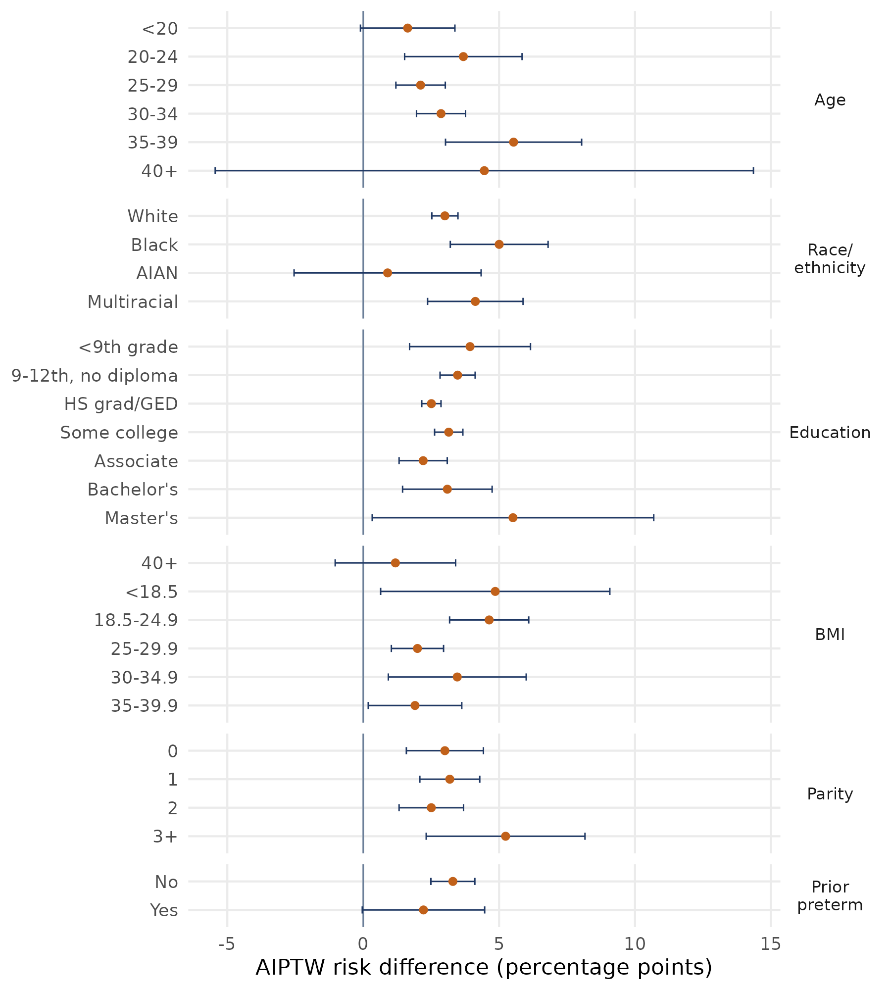
Figure 8. Exploratory AIPTW risk differences (percentage points, 95% CI) within subgroups. Groups with fewer than 500 smokers are omitted.

6.6 Check of the standard errors
To check the closed-form standard errors, we repeated the whole pipeline (propensity model, outcome models, estimator) on 200 bootstrap resamples of a random subsample of 200,000 births (seed 1234). The subsample holds only about 6,000 smokers, so its point estimates (risk differences of 2.0 for AIPTW, 2.6 for stabilized IPTW, 1.8 for outcome regression) differ from the full-cohort values through sampling error; the purpose of this check is the standard errors, not the estimates. The ratio of the influence-function standard error to the bootstrap standard error was 1.17 for AIPTW (1.08 against 0.92 percentage points), 1.05 for stabilized IPTW (1.09 against 1.04 percentage points), 1.05 for outcome regression (0.69 against 0.66 percentage points). A ratio near one means the fast formulas reproduce the bootstrap, and a ratio above one means the formulas are, if anything, conservative. The ratio is close to one for stabilized IPTW and outcome regression and somewhat above one for AIPTW, so the intervals reported for the full cohort are not too narrow by this check. With 200 replications the bootstrap standard error itself carries a few percent of Monte Carlo error.

7. Discussion
Under the assumptions in Section 4, smoking during pregnancy raised the risk of preterm birth in the 2023 U.S. cohort by about 3.3 percentage points (relative risk 1.39), from 8.4 to 11.6 percent. This is about 42 percent smaller than the crude difference of 5.6 points, which shows how much of the raw gap reflects who smokes. The adjusted odds ratio of 1.44 lies inside the range of 1.31 to 1.53 reported for first-trimester smoking by cigarettes per day in the largest U.S. regression analysis (Liu et al., 2020), so the analysis does not point to a different answer from that literature; what it adds is the absolute scale, four estimators that agree, and an explicit account of overlap and assumptions. On the absolute scale the result means roughly three to four additional preterm births per 100 smoking pregnancies, and the ATT of 3.4 points is the more precisely estimated quantity.
Three features of the analysis shape how the result should be read. First, overlap is weak for part of the cohort, so the ATE interval is wider than the outcome regression interval suggests and the estimate leans on model extrapolation for non-smokers with very low probabilities of smoking; the stability across truncation rules and the overlap-weighted estimate are reassuring, but they are not a substitute for positivity. Second, three covariate levels remain above the 0.10 balance threshold after weighting; AIPTW's outcome model offers some protection, and the specification checks did not move the result. Third, the identification argument is a set of assumptions: the diagram encodes what the literature supports, and for several arrows into smoking that support is indirect (Table 2). The E-value of 2.1 indicates how much unmeasured confounding would be required, and the unmeasured factors listed in Section 8 are plausible candidates, so we describe the estimate as a causal effect under assumptions, not as a proven causal effect.

8. Limitations
Smoking is self-reported on the birth certificate and is underreported. In eight states the revised certificate gave lower prenatal smoking than PRAMS (11.3 against 14.0 percent) (Tong et al., 2013b), in New York City and Vermont certificates recorded 10.4 percent against 14.1 percent in medical records (Howland et al., 2015), and pregnant smokers deny smoking more often than non-pregnant smokers when cotinine is measured (Dietz et al., 2011; Searles Nielsen et al., 2014). Non-differential misclassification of a binary exposure usually, but not always, biases toward the null (Jurek et al., 2005), and underreporting varies with education and parity, so it may be differential. Gestational age from the obstetric estimate is the best national measure but is not error free, and disagreement with last-menstrual-period estimates is largest at 28 to 36 weeks, which is where most preterm births fall (Qin et al., 2008; Martin et al., 2015).
The file contains live births only. If smoking raises fetal loss, conditioning on live birth can bias exposure-outcome estimates in either direction (Leung et al., 2021; Liew et al., 2015; Neophytou et al., 2021), and we cannot quantify that here. Birth certificates record clinical risk factors with low sensitivity (Reichman & Hade, 2001; Vinikoor et al., 2010), so adjustment for diabetes, hypertension and previous preterm birth is imperfect. Important confounders are unmeasured (alcohol, cannabis, e-cigarette use, stress, intimate partner violence, nutrition, interpregnancy interval, paternal factors) (Patra et al., 2011; Regan et al., 2021; Dole et al., 2003; Donovan et al., 2016; Ahrens et al., 2019). Prenatal-care timing and WIC are recorded during pregnancy and are subject to gestational age bias, and we did not adjust for pre-pregnancy cigarettes per day or for gestational conditions; the first of these choices could leave confounding by a persistent smoking habit (Schisterman et al., 2009; Hernán et al., 2004). "Any smoking" combines doses and timing, so the estimate is an average over them. We used complete cases (93.8 percent of the extract); missingness was low for each variable, but it is not guaranteed to be random. Overlap and the three unbalanced levels are discussed above. The results are for one national year, and the subgroup results are exploratory.

9. Conclusion and next steps
In 3.26 million singleton births, smoking during pregnancy raised the risk of preterm birth by about 3.3 percentage points (95% CI 2.5 to 4.0) under explicit causal assumptions, a risk ratio of 1.39, and by 3.4 points among mothers who smoked. The estimate is stable across four estimators and across alternative propensity score handling and covariate specifications, but it rests on limited overlap for some mothers, on self-reported exposure, and on assumptions that the E-value helps to size but cannot verify. Next steps are (1) flexible machine-learning nuisance models with cross-fitting inside the same AIPTW structure (Chernozhukov et al., 2018; Zivich & Breskin, 2021); (2) dose, timing and cessation of smoking, which the binary exposure here cannot separate; (3) pooling several birth years; and (4) a SAS implementation so that the analysis can be reproduced in the SAS environment of this conference.

Data and code availability
The data are the public-use 2023 Natality file of the National Center for Health Statistics (https://ftp.cdc.gov/pub/Health_Statistics/NCHS/Datasets/DVS/natality/Nat2023us.zip, 224 MB, fixed-width; user guide at https://ftp.cdc.gov/pub/Health_Statistics/NCHS/Dataset_Documentation/DVS/natality/UserGuide2023.pdf). The analysis uses a 24-variable extract of 3,476,180 births that script 00_extract_data.R rebuilds from the full file, and that is also supplied compressed (35.8 MB) with the code. All scripts run from a single folder in the order listed in Section 5.5, use set.seed(1234), and print their results; the run times are given at the top of each script.

Use of AI assistance
The authors used an AI assistant (Claude, Anthropic) to organize and check the literature, to help write and test the R code, and to draft and edit text. The first author specified the question, the design and the analytic choices and ran the code. The numbers in this paper come directly from the code output, and the references were checked against journal, publisher or CDC records during preparation. Both authors are responsible for the content.

References
Ahrens, K. A., Nelson, H., Stidd, R. L., Moskosky, S., & Hutcheon, J. A. (2019). Short interpregnancy intervals and adverse perinatal outcomes in high-resource settings: An updated systematic review. Paediatric and Perinatal Epidemiology, 33(1). https://doi.org/10.1111/ppe.12503
Aubin, H.-J., Farley, A., Lycett, D., Lahmek, P., & Aveyard, P. (2012). Weight gain in smokers after quitting cigarettes: Meta-analysis. BMJ, 345. https://doi.org/10.1136/bmj.e4439
Austin, P. C., & Stuart, E. A. (2015). Moving towards best practice when using inverse probability of treatment weighting (IPTW) using the propensity score to estimate causal treatment effects in observational studies. Statistics in Medicine, 34(28), 3661-3679. https://doi.org/10.1002/sim.6607
Bang, H., & Robins, J. M. (2005). Doubly robust estimation in missing data and causal inference models. Biometrics, 61(4), 962-973. https://doi.org/10.1111/j.1541-0420.2005.00377.x
Bitler, M. P., & Currie, J. (2005). Does WIC work? The effects of WIC on pregnancy and birth outcomes. Journal of Policy Analysis and Management, 24(1), 73-91. https://doi.org/10.1002/pam.20070
Borsari, L., Malagoli, C., Werler, M. M., Rothman, K. J., Malavolti, M., Rodolfi, R., De Girolamo, G., Nicolini, F., & Vinceti, M. (2018). Joint effect of maternal tobacco smoking and pregestational diabetes on preterm births and congenital anomalies: A population-based study in Northern Italy. Journal of Diabetes Research. https://doi.org/10.1155/2018/2782741
Bramham, K., Parnell, B., Nelson-Piercy, C., Seed, P. T., Poston, L., & Chappell, L. C. (2014). Chronic hypertension and pregnancy outcomes: Systematic review and meta-analysis. BMJ, 348, g2301. https://doi.org/10.1136/bmj.g2301
Brookhart, M. A., Schneeweiss, S., Rothman, K. J., Glynn, R. J., Avorn, J., & Stürmer, T. (2006). Variable selection for propensity score models. American Journal of Epidemiology, 163(12), 1149-1156. https://doi.org/10.1093/aje/kwj149
Busso, M., DiNardo, J., & McCrary, J. (2014). New evidence on the finite sample properties of propensity score reweighting and matching estimators. Review of Economics and Statistics, 96(5), 885-897. https://doi.org/10.1162/REST_a_00431
Carreras-Torres, R., Johansson, M., Haycock, P. C., Relton, C. L., Davey Smith, G., Brennan, P., & Martin, R. M. (2018). Role of obesity in smoking behaviour: Mendelian randomisation study in UK Biobank. BMJ, 361, k1767. https://doi.org/10.1136/bmj.k1767
Chen, J., Sun, Y., Zhou, J., Meng, M., Zhou, F., He, J., & Zou, G. (2026). Interaction between maternal smoking cessation timing and preexisting hypertension on fetal growth restriction: A nationwide population-based cohort study. Clinical Epidemiology. https://doi.org/10.2147/CLEP.S596174
Chernozhukov, V., Chetverikov, D., Demirer, M., Duflo, E., Hansen, C., Newey, W., & Robins, J. (2018). Double/debiased machine learning for treatment and structural parameters. The Econometrics Journal, 21(1), C1-C68. https://doi.org/10.1111/ectj.12097
Cole, S. R., Platt, R. W., Schisterman, E. F., Chu, H., Westreich, D., Richardson, D., & Poole, C. (2010). Illustrating bias due to conditioning on a collider. International Journal of Epidemiology, 39(2), 417-420. https://doi.org/10.1093/ije/dyp334
Dietz, P. M., Homa, D., England, L. J., Burley, K., Tong, V. T., Dube, S. R., & Bernert, J. T. (2011). Estimates of nondisclosure of cigarette smoking among pregnant and nonpregnant women of reproductive age in the United States. American Journal of Epidemiology, 173(3), 355-359. https://doi.org/10.1093/aje/kwq381
Dole, N., Savitz, D. A., Hertz-Picciotto, I., Siega-Riz, A. M., McMahon, M. J., & Buekens, P. (2003). Maternal stress and preterm birth. American Journal of Epidemiology, 157(1), 14-24.
Donovan, B. M., Spracklen, C. N., Schweizer, M. L., Ryckman, K. K., & Saftlas, A. F. (2016). Intimate partner violence during pregnancy and the risk for adverse infant outcomes: A systematic review and meta-analysis. BJOG, 123(8), 1289-1299. https://doi.org/10.1111/1471-0528.13928
Drake, P., Driscoll, A. K., & Mathews, T. J. (2018). Cigarette smoking during pregnancy: United States, 2016 (NCHS Data Brief No. 305). National Center for Health Statistics.
Driscoll, A. K., & Gregory, E. C. W. (2020). Increases in prepregnancy obesity: United States, 2016-2019 (NCHS Data Brief No. 392). National Center for Health Statistics.
Duko, B., Gebremedhin, A. T., Tessema, G. A., Alati, R., & Pereira, G. (2023). Average treatment effect of maternal prenatal tobacco smoking on offspring developmental vulnerability in early childhood. Annals of Epidemiology. https://doi.org/10.1016/j.annepidem.2022.12.007
Evans, W. N., & Ringel, J. S. (1999). Can higher cigarette taxes improve birth outcomes? Journal of Public Economics, 72(1), 135-154.
Ferguson, K. D., McCann, M., Katikireddi, S. V., Thomson, H., Green, M. J., Smith, D. J., & Lewsey, J. D. (2020). Evidence synthesis for constructing directed acyclic graphs (ESC-DAGs): A novel and systematic method for building directed acyclic graphs. International Journal of Epidemiology, 49, 322-329. https://doi.org/10.1093/ije/dyz150
Funk, M. J., Westreich, D., Wiesen, C., Stürmer, T., Brookhart, M. A., & Davidian, M. (2011). Doubly robust estimation of causal effects. American Journal of Epidemiology, 173(7), 761-767. https://doi.org/10.1093/aje/kwq439
Gage, S. H., Bowden, J., Davey Smith, G., & Munafo, M. R. (2018). Investigating causality in associations between education and smoking: A two-sample Mendelian randomization study. International Journal of Epidemiology. https://doi.org/10.1093/ije/dyy131
Ganchimeg, T., Ota, E., Morisaki, N., Laopaiboon, M., Lumbiganon, P., et al. (2014). Pregnancy and childbirth outcomes among adolescent mothers: A World Health Organization multicountry study. BJOG, 121(Suppl. 1), 40-48. https://doi.org/10.1111/1471-0528.12630
Gangopadhyaya, A., Dubay, L., Johnston, E., & Pancini, V. (2024). How structural racism, neighborhood deprivation, and maternal characteristics contribute to inequities in birth outcomes. Health Affairs Scholar, 2(8), qxae092. https://doi.org/10.1093/haschl/qxae092
Goldenberg, R. L., Culhane, J. F., Iams, J. D., & Romero, R. (2008). Epidemiology and causes of preterm birth. The Lancet, 371(9606), 75-84. https://doi.org/10.1016/S0140-6736(08)60074-4
Greenland, S., Pearl, J., & Robins, J. M. (1999). Causal diagrams for epidemiologic research. Epidemiology, 10(1), 37-48. https://doi.org/10.1097/00001648-199901000-00008
Guh, D. P., Zhang, W., Bansback, N., Amarsi, Z., Birmingham, C. L., & Anis, A. H. (2009). The incidence of co-morbidities related to obesity and overweight: A systematic review and meta-analysis. BMC Public Health, 9, 88. https://doi.org/10.1186/1471-2458-9-88
Heaman, M. I., Newburn-Cook, C. V., Green, C. G., Elliott, L. J., & Helewa, M. E. (2008). Inadequate prenatal care and its association with adverse pregnancy outcomes: A comparison of indices. BMC Pregnancy and Childbirth, 8, 15. https://doi.org/10.1186/1471-2393-8-15
Heiny, E., & Islam, M. (2026). Impact of maternal smoking during pregnancy on preterm birth risk in the United States [Invited e-poster abstract]. Joint Statistical Meetings 2026, Boston, MA.
Hernán, M. A., Hernández-Díaz, S., & Robins, J. M. (2004). A structural approach to selection bias. Epidemiology, 15(5), 615-625. https://doi.org/10.1097/01.ede.0000135174.63482.43
Hiscock, R., Bauld, L., Amos, A., Fidler, J. A., & Munafo, M. (2012). Socioeconomic status and smoking: A review. Annals of the New York Academy of Sciences, 1248(1), 107-123. https://doi.org/10.1111/j.1749-6632.2011.06202.x
Howland, R. E., Mulready-Ward, C., Madsen, A. M., Sackoff, J., Nyland-Funke, M., Bombard, J. M., & Tong, V. T. (2015). Reliability of reported maternal smoking: Comparing the birth certificate to maternal worksheets and prenatal and hospital medical records, New York City and Vermont, 2009. Maternal and Child Health Journal, 19(9), 1916-1924. https://doi.org/10.1007/s10995-015-1722-1
Joyce, T., Racine, A., & Yunzal-Butler, C. (2008). Reassessing the WIC effect: Evidence from the Pregnancy Nutrition Surveillance System. Journal of Policy Analysis and Management, 27(2), 277-303.
Juárez, S. P., & Merlo, J. (2013). Revisiting the effect of maternal smoking during pregnancy on offspring birthweight: A quasi-experimental sibling analysis in Sweden. PLOS ONE. https://doi.org/10.1371/journal.pone.0061734
Jurek, A. M., Greenland, S., Maldonado, G., & Church, T. R. (2005). Proper interpretation of non-differential misclassification effects: Expectations vs observations. International Journal of Epidemiology, 34(3), 680-687. https://doi.org/10.1093/ije/dyi060
Kang, J. D. Y., & Schafer, J. L. (2007). Demystifying double robustness: A comparison of alternative strategies for estimating a population mean from incomplete data. Statistical Science, 22(4). https://doi.org/10.1214/07-STS227
Kazemier, B. M., Buijs, P. E., Mignini, L., Limpens, J., de Groot, C. J. M., Mol, B. W. J., & Oude Rengerink, K. (2014). Impact of obstetric history on the risk of spontaneous preterm birth in singleton and multiple pregnancies: A systematic review. BJOG. https://doi.org/10.1111/1471-0528.12896
King, G., & Nielsen, R. (2019). Why propensity scores should not be used for matching. Political Analysis, 27(4), 435-454. https://doi.org/10.1017/pan.2019.11
Kondracki, A. J. (2019). Prevalence and patterns of cigarette smoking before and during early and late pregnancy according to maternal characteristics: The first national data based on the 2003 birth certificate revision, United States, 2016. Reproductive Health, 16. https://doi.org/10.1186/s12978-019-0807-5
Koullali, B., van Zijl, M. D., Kazemier, B. M., Oudijk, M. A., Mol, B. W. J., Pajkrt, E., & Ravelli, A. C. J. (2020). The association between parity and spontaneous preterm birth: A population based study. BMC Pregnancy and Childbirth. https://doi.org/10.1186/s12884-020-02940-w
Kozuki, N., Lee, A. C., Silveira, M. F., Victora, C. G., Adair, L., Humphrey, J., ... Katz, J. (2013). The associations of parity and maternal age with small-for-gestational-age, preterm, and neonatal and infant mortality: A meta-analysis. BMC Public Health, 13(Suppl 3), S2.
Lee, B. K., Lessler, J., & Stuart, E. A. (2011). Weight trimming and propensity score weighting. PLoS ONE, 6(3), e18174. https://doi.org/10.1371/journal.pone.0018174
Leung, M., Kioumourtzoglou, M.-A., Raz, R., & Weisskopf, M. G. (2021). Bias due to selection on live births in studies of environmental exposures during pregnancy: A simulation study. Environmental Health Perspectives, 129(4), 047001. https://doi.org/10.1289/EHP7961
Li, F., Morgan, K. L., & Zaslavsky, A. M. (2018). Balancing covariates via propensity score weighting. Journal of the American Statistical Association, 113(521), 390-400. https://doi.org/10.1080/01621459.2016.1260466
Liew, Z., Olsen, J., Cui, X., Ritz, B., & Arah, O. A. (2015). Bias from conditioning on live birth in pregnancy cohorts: An illustration based on neurodevelopment in children after prenatal exposure to organic pollutants. International Journal of Epidemiology, 44(1), 345-354. https://doi.org/10.1093/ije/dyu249
Liu, B., Xu, G., Sun, Y., Qiu, X., Ryckman, K. K., Yu, Y., Snetselaar, L. G., & Bao, W. (2020). Maternal cigarette smoking before and during pregnancy and the risk of preterm birth: A dose-response analysis of 25 million mother-infant pairs. PLOS Medicine, 17(8), e1003158. https://doi.org/10.1371/journal.pmed.1003158
Martin, J. A., Hamilton, B. E., & Osterman, M. J. K. (2018). Births in the United States, 2017 (NCHS Data Brief No. 318). National Center for Health Statistics.
Martin, J. A., Osterman, M. J. K., Kirmeyer, S. E., & Gregory, E. C. W. (2015). Measuring gestational age in vital statistics data: Transitioning to the obstetric estimate. National Vital Statistics Reports, 64(5).
Mathews, T. J., & Hamilton, B. E. (2016). Mean age of mothers is on the rise: United States, 2000-2014 (NCHS Data Brief No. 232). National Center for Health Statistics.
McDonald, S. D., Han, Z., Mulla, S., & Beyene, J. (2010). Overweight and obesity in mothers and risk of preterm birth and low birth weight infants: Systematic review and meta-analyses. BMJ, c3428.
Moore, E., Blatt, K., Chen, A., Van Hook, J., & DeFranco, E. A. (2016). Factors associated with smoking cessation in pregnancy. American Journal of Perinatology. https://doi.org/10.1055/s-0035-1570319
Murphy, H. R., Howgate, C., O'Keefe, J., et al. (2021). Characteristics and outcomes of pregnant women with type 1 or type 2 diabetes: A 5-year national population-based cohort study. The Lancet Diabetes & Endocrinology.
Naimi, A. I., Cole, S. R., & Kennedy, E. H. (2017). An introduction to g methods. International Journal of Epidemiology, 46(2), 756-762. https://doi.org/10.1093/ije/dyw323
National Center for Education Statistics. (2023). Educational attainment of young adults (Condition of Education). U.S. Department of Education. https://nces.ed.gov/programs/coe/indicator/caa
National Center for Health Statistics. (2024). User guide to the 2023 natality public use file. https://ftp.cdc.gov/pub/Health_Statistics/NCHS/Dataset_Documentation/DVS/natality/UserGuide2023.pdf
Neophytou, A. M., Kioumourtzoglou, M.-A., Goin, D. E., Darwin, K. C., & Casey, J. A. (2021). Educational note: Addressing special cases of bias that frequently occur in perinatal epidemiology. International Journal of Epidemiology, 50(1), 337-345. https://doi.org/10.1093/ije/dyaa252
Osterman, M. J. K., Hamilton, B. E., Martin, J. A., Driscoll, A. K., & Valenzuela, C. P. (2025). Births: Final data for 2023. National Vital Statistics Reports, 74(1). National Center for Health Statistics.
Patra, J., Bakker, R., Irving, H., Jaddoe, V. W. V., Malini, S., & Rehm, J. (2011). Dose-response relationship between alcohol consumption before and during pregnancy and the risks of low birthweight, preterm birth and small for gestational age (SGA): A systematic review and meta-analyses. BJOG, 118(12), 1411-1421. https://doi.org/10.1111/j.1471-0528.2011.03050.x
Pearl, J. (1995). Causal diagrams for empirical research. Biometrika, 82(4), 669-688. https://doi.org/10.1093/biomet/82.4.669
Phelan, J. C., & Link, B. G. (2015). Is racism a fundamental cause of inequalities in health? Annual Review of Sociology, 41, 311-330. https://doi.org/10.1146/annurev-soc-073014-112305
Philips, E. M., Santos, S., Trasande, L., Aurrekoetxea, J. J., Barros, H., von Berg, A., ... Jaddoe, V. W. V. (2020). Changes in parental smoking during pregnancy and risks of adverse birth outcomes and childhood overweight in Europe and North America: An individual participant data meta-analysis of 229,000 singleton births. PLOS Medicine. https://doi.org/10.1371/journal.pmed.1003182
Qin, C., Hsia, J., & Berg, C. J. (2008). Variation between last-menstrual-period and clinical estimates of gestational age in vital records. American Journal of Epidemiology, 167(6), 646-652.
Regan, A. K., Bombard, J. M., O'Hegarty, M. M., Smith, R. A., & Tong, V. T. (2021). Adverse birth outcomes associated with prepregnancy and prenatal electronic cigarette use. Obstetrics & Gynecology, 138(1), 85-94. https://doi.org/10.1097/AOG.0000000000004432
Reichman, N. E., & Hade, E. M. (2001). Validation of birth certificate data: A study of women in New Jersey's HealthStart program. Annals of Epidemiology, 11(3), 186-193.
Robins, J. M., Rotnitzky, A., & Zhao, L. P. (1994). Estimation of regression coefficients when some regressors are not always observed. Journal of the American Statistical Association, 89(427), 846-866. https://doi.org/10.1080/01621459.1994.10476818
Rosenbaum, P. R., & Rubin, D. B. (1983). The central role of the propensity score in observational studies for causal effects. Biometrika, 70(1), 41-55. https://doi.org/10.1093/biomet/70.1.41
Rosenbaum, P. R., & Rubin, D. B. (1984). Reducing bias in observational studies using subclassification on the propensity score. Journal of the American Statistical Association, 79(387), 516-524. https://doi.org/10.1080/01621459.1984.10478078
Rubin, D. B. (1974). Estimating causal effects of treatments in randomized and nonrandomized studies. Journal of Educational Psychology, 66(5), 688-701. https://doi.org/10.1037/h0037350
Ruiz, M., Goldblatt, P., Morrison, J., Kukla, L., Svancara, J., et al. (2015). Mother's education and the risk of preterm and small for gestational age birth: A DRIVERS meta-analysis of 12 European cohorts. Journal of Epidemiology and Community Health, 69(9), 826-833. https://doi.org/10.1136/jech-2014-205387
Schisterman, E. F., Cole, S. R., & Platt, R. W. (2009). Overadjustment bias and unnecessary adjustment in epidemiologic studies. Epidemiology, 20(4), 488-495. https://doi.org/10.1097/EDE.0b013e3181a819a1
Searles Nielsen, S., Dills, R. L., Glass, M., & Mueller, B. A. (2014). Accuracy of prenatal smoking data from Washington State birth certificates in a population-based sample with cotinine measurements. Annals of Epidemiology, 24(3). https://doi.org/10.1016/j.annepidem.2013.12.008
Shah, N. R., & Bracken, M. B. (2000). A systematic review and meta-analysis of prospective studies on the association between maternal cigarette smoking and preterm delivery. American Journal of Obstetrics and Gynecology, 182, 465-472. https://doi.org/10.1016/s0002-9378(00)70240-7
Shin, D., & Song, W. O. (2019). Influence of the adequacy of the Prenatal Care Utilization Index on small-for-gestational-age infants and preterm births in the United States. Journal of Clinical Medicine, 8(6), 838. https://doi.org/10.3390/jcm8060838
Stock, S. J., & Bauld, L. (2020). Maternal smoking and preterm birth: An unresolved health challenge. PLOS Medicine. https://doi.org/10.1371/journal.pmed.1003386
Stoner, M. C. D., Cole, S. R., Price, J. T., Winston, J. J., & Stringer, J. S. A. (2018). Timing of initiation of antiretroviral therapy and risk of preterm birth in studies of HIV-infected pregnant women: The role of selection bias. Epidemiology. https://doi.org/10.1097/ede.0000000000000772
Stuart, E. A. (2010). Matching methods for causal inference: A review and a look forward. Statistical Science, 25(1). https://doi.org/10.1214/09-STS313
Tennant, P. W. G., Murray, E. J., Arnold, K. F., Berrie, L., Fox, M. P., Gadd, S. C., ... Ellison, G. T. H. (2021). Use of directed acyclic graphs (DAGs) to identify confounders in applied health research: Review and recommendations. International Journal of Epidemiology, 50(2), 620-632. https://doi.org/10.1093/ije/dyaa213
Tong, V. T., Dietz, P. M., Farr, S. L., D'Angelo, D. V., & England, L. J. (2013). Estimates of smoking before and during pregnancy, and smoking cessation during pregnancy: Comparing two population-based data sources. Public Health Reports, 128(3), 179-188.
Tong, V. T., Dietz, P. M., Morrow, B., D'Angelo, D. V., Farr, S. L., Rockhill, K. M., & England, L. J. (2013). Trends in smoking before, during, and after pregnancy: Pregnancy Risk Assessment Monitoring System, United States, 40 sites, 2000-2010. MMWR Surveillance Summaries, 62(SS-6).
Torloni, M. R., Betran, A. P., Daher, S., Widmer, M., Dolan, S. M., Menon, R., Bergel, E., Allen, T., & Merialdi, M. (2009). Maternal BMI and preterm birth: A systematic review of the literature with meta-analysis. Journal of Maternal-Fetal and Neonatal Medicine. https://doi.org/10.3109/14767050903042561
U.S. Department of Agriculture, Food and Nutrition Service. (n.d.). WIC eligibility. https://www.fns.usda.gov/wic/eligibility
VanderWeele, T. J., & Ding, P. (2017). Sensitivity analysis in observational research: Introducing the E-value. Annals of Internal Medicine, 167(4), 268-274. https://doi.org/10.7326/M16-2607
VanderWeele, T. J., & Robinson, W. R. (2014). On the causal interpretation of race in regressions adjusting for confounding and mediating variables. Epidemiology, 25, 473-484. https://doi.org/10.1097/EDE.0000000000000105
VanderWeele, T. J., & Shpitser, I. (2011). A new criterion for confounder selection. Biometrics, 67(4), 1406-1413. https://doi.org/10.1111/j.1541-0420.2011.01619.x
Veiga, P. V., & Wilder, R. P. (2008). Maternal smoking during pregnancy and birthweight: A propensity score matching approach. Maternal and Child Health Journal, 12(2). https://doi.org/10.1007/s10995-007-0238-8
Vinikoor, L. C., Messer, L. C., Laraia, B. A., & Kaufman, J. S. (2010). Reliability of variables on the North Carolina birth certificate: A comparison with directly queried values from a cohort study. Paediatric and Perinatal Epidemiology, 24(1), 102-112.
Yunzal-Butler, C., Joyce, T. J., & Racine, A. D. (2009). Maternal smoking and the timing of WIC enrollment (NBER Working Paper No. 14728). National Bureau of Economic Research. https://doi.org/10.3386/w14728
Zivich, P. N., & Breskin, A. (2021). Machine learning for causal inference: On the use of cross-fit estimators. Epidemiology, 32(3), 393-401. https://doi.org/10.1097/EDE.0000000000001332

Appendix
Table A1. Characteristics of the analytic cohort by smoking status, and crude preterm birth risk (%) within each level. Column percentages are within smoking group.
Variable | Level | Non-smokers n (%) | Smokers n (%) | Preterm % non-smokers | Preterm % smokers
Maternal age (years) | <20 | 126,638 (4.0) | 2,922 (3.0) | 9.7 | 11.8
 | 20-24 | 544,546 (17.2) | 18,956 (19.5) | 8.1 | 10.9
 | 25-29 | 870,584 (27.5) | 28,230 (29.0) | 7.6 | 11.9
 | 30-34 | 966,655 (30.6) | 28,721 (29.6) | 7.8 | 14.4
 | 35-39 | 527,652 (16.7) | 14,855 (15.3) | 9.2 | 19.0
 | 40+ | 126,234 (4.0) | 3,503 (3.6) | 12.2 | 21.8
Race/ethnicity | White | 2,346,025 (74.2) | 77,382 (79.6) | 7.7 | 13.0
 | Black | 481,211 (15.2) | 12,376 (12.7) | 11.6 | 19.2
 | AIAN | 28,932 (0.9) | 2,282 (2.3) | 9.5 | 13.6
 | Asian | 202,949 (6.4) | 418 (0.4) | 7.6 | 14.4
 | NHOPI | 11,707 (0.4) | 177 (0.2) | 10.0 | 11.3
 | Multiracial | 91,485 (2.9) | 4,552 (4.7) | 8.5 | 15.4
Education | <9th grade | 102,634 (3.2) | 1,948 (2.0) | 8.5 | 16.2
 | 9-12th, no diploma | 232,495 (7.4) | 21,434 (22.1) | 10.3 | 15.2
 | HS grad/GED | 831,985 (26.3) | 44,482 (45.8) | 9.3 | 13.3
 | Some college | 543,999 (17.2) | 20,739 (21.3) | 9.1 | 14.0
 | Associate | 268,066 (8.5) | 5,268 (5.4) | 8.6 | 13.7
 | Bachelor's | 731,502 (23.1) | 2,688 (2.8) | 6.8 | 11.9
 | Master's | 347,646 (11.0) | 547 (0.6) | 6.8 | 13.7
 | Doctorate/Prof. | 103,982 (3.3) | 81 (0.1) | 6.7 | 12.3
Prenatal care began | 1st trimester | 2,439,888 (77.2) | 61,460 (63.2) | 8.2 | 12.2
 | 2nd trimester | 522,024 (16.5) | 22,580 (23.2) | 7.8 | 13.5
 | 3rd trimester | 142,354 (4.5) | 7,527 (7.7) | 6.6 | 12.2
 | No care | 58,043 (1.8) | 5,620 (5.8) | 20.3 | 36.7
WIC | No | 2,191,695 (69.3) | 45,782 (47.1) | 8.0 | 15.6
 | Yes | 970,614 (30.7) | 51,405 (52.9) | 9.0 | 12.4
Parity (previous live births) | 0 | 1,291,042 (40.8) | 24,099 (24.8) | 8.5 | 13.2
 | 1 | 985,650 (31.2) | 26,063 (26.8) | 7.1 | 12.3
 | 2 | 507,264 (16.0) | 21,507 (22.1) | 8.3 | 12.8
 | 3+ | 378,353 (12.0) | 25,518 (26.3) | 10.7 | 17.1
Previous preterm birth | No | 3,044,731 (96.3) | 88,555 (91.1) | 7.6 | 12.2
 | Yes | 117,578 (3.7) | 8,632 (8.9) | 26.1 | 31.1
Pre-pregnancy diabetes | No | 3,123,571 (98.8) | 95,459 (98.2) | 8.1 | 13.5
 | Yes | 38,738 (1.2) | 1,728 (1.8) | 26.1 | 33.8
Pre-pregnancy hypertension | No | 3,065,467 (96.9) | 92,081 (94.7) | 7.9 | 13.3
 | Yes | 96,842 (3.1) | 5,106 (5.3) | 19.9 | 25.0
Pre-pregnancy BMI | <18.5 | 82,622 (2.6) | 4,766 (4.9) | 9.7 | 17.7
 | 18.5-24.9 | 1,193,962 (37.8) | 33,295 (34.3) | 7.1 | 15.1
 | 25-29.9 | 880,286 (27.8) | 23,359 (24.0) | 7.8 | 13.1
 | 30-34.9 | 537,854 (17.0) | 17,126 (17.6) | 9.1 | 12.6
 | 35-39.9 | 271,392 (8.6) | 10,087 (10.4) | 10.4 | 12.7
 | 40+ | 196,193 (6.2) | 8,554 (8.8) | 12.5 | 13.5

