STAT 7900 – Causal Analysis
Assignment 1
Name: Faruk Murital | Kennesaw State University | Due: Sep 21, 2026, 11:59 AM
Problem 1: Tutoring and Exam Scores (20 points)
(a) [4 pts] No. The crude gap is an association, E[Y | T = 1] − E[Y | T = 0], not the causal effect E[Y(1)] − E[Y(0)]. Because students choose whether to attend, the two groups may differ before tutoring:
Observed difference = ATT + selection bias, where selection bias = E[Y(0) | T = 1] − E[Y(0) | T = 0].
The 8 points equals the causal effect only if attendees and non-attendees are exchangeable (e.g., randomized tutoring). Otherwise, part or all of it reflects pre-existing differences.
(b) [4 pts] Y_{i}(1) is the final exam score student i would obtain if they attended tutoring. Y_{i}(0) is the score student i would obtain if they did not attend. Only one is observed: Y_{i} = T_{i}·Y_{i}(1) + (1 − T_{i})·Y_{i}(0).
(c) [4 pts] ATE = E[Y(1) − Y(0)] = E[Y(1)] − E[Y(0)], the average exam-score difference if all students attended versus if none did.
(d) [4 pts] Motivation (M) is a common cause of attendance and scores: T ← M → Y. Motivated students are more likely to attend and would score higher even without tutoring, so E[Y(0) | T = 1] > E[Y(0) | T = 0] and the groups are not exchangeable. The 84 vs. 76 comparison mixes the tutoring effect with the motivation difference (positive selection bias) and likely overstates the effect. Remedies: randomize tutoring, or adjust for motivation (or proxies such as prior GPA) under conditional exchangeability. Unmeasured motivation would leave residual confounding.
(e) [4 pts] Assumptions in this study:
Assumption | Meaning here | Example of violation
Exchangeability | Given measured covariates X (e.g., prior GPA), attendees and non-attendees have the same potential exam scores: (Y(1), Y(0)) ⊥ T | X. | Unmeasured motivation drives both attendance and scores.
Positivity | Every type of student (each X = x) has some chance of both attending and not attending: 0 < P(T = 1 | X = x) < 1. | Tutoring is mandatory for students on academic probation, so no untreated comparison exists.
Consistency | If T_{i} = t then Y_{i} = Y_{i}(t): “attending tutoring” is one well-defined intervention. | “Attend” mixes one visit with twelve, or strong and weak tutors.
SUTVA / no interference | A student’s score depends only on their own tutoring status, not on other students’ (and there are no hidden versions of treatment). | Tutored students share notes with friends who did not attend.

Problem 2: Blood-Pressure Medication (20 points)
(a) [5 pts] Complete DAG (Figure 1). Edges: A → T, A → Y, D → T, D → Y, T → M, M → Y. There is no direct T → Y arrow; all of T’s effect on Y passes through M.
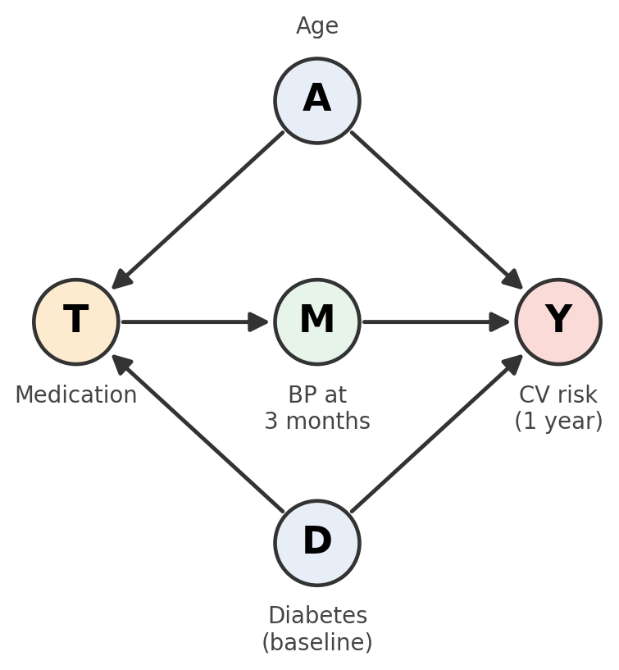
Figure 1. DAG for Problem 2 (A = age, D = baseline diabetes, T = medication, M = BP at 3 months, Y = cardiovascular outcome).
(b) [5 pts] A backdoor path starts with an arrow into T. There are exactly two:
- T ← A → Y
- T ← D → Y
The only other T–Y path, T → M → Y, is causal (it leaves T).
(c) [5 pts] Adjustment set: {A, D}. Each backdoor path is a fork, so conditioning on its middle node blocks it: A blocks path 1 and D blocks path 2. Neither is a descendant of T and neither is a collider, so no new path opens. The causal path T → M → Y stays open, so the remaining T–Y association is the total effect:
E[Y(t)] = Σ_{a,d} E[Y | T = t, A = a, D = d] · P(A = a, D = d).
The set is minimal: both A and D are needed, since each blocks a different path.
(d) [5 pts] M is a mediator, a post-treatment variable on the causal path T → M → Y. Conditioning on M blocks part of the effect we want, so Y ~ T + A + D + M no longer estimates the total effect (overadjustment; the estimand changes). The researcher is moving toward the (controlled) direct effect of T on Y not through M. In this DAG there is no T → Y arrow, so that direct effect is 0: the coefficient of T would be near zero even if the drug works by lowering blood pressure.
Problem 3: Colliders and Adjustment (20 points)
(a) [4 pts] C is a collider. On T ← A → C ← B → Y, the arrows from A and B both point into C (A → C ← B). A and B are forks (common causes).
(b) [4 pts] Closed (blocked). A collider blocks a path unless the collider or one of its descendants is conditioned on. A and B are independent, so no association flows from T to Y through C. With no other paths, T and Y are unassociated.
(c) [4 pts] Conditioning on C opens the path. Given C, A and B become associated, so T ← A → C ← B → Y transmits association and T and Y appear related even though neither causes the other (collider bias). Conditioning on a descendant of C has the same effect.
(d) [4 pts] Timing does not determine causal role; position in the graph does. C is measured before treatment but is a collider, so this is an M-bias structure. Without adjustment no backdoor path is open and the crude comparison is unbiased. Adjusting for C opens T ← A → C ← B → Y and creates bias. (Example: T = private high school, A = family wealth, B = parental education, C = elite enrichment program, Y = admission.) Pre-treatment does not mean “adjust for it.”
(e) [4 pts] Regression conditions on whatever is included and cannot tell a confounder from a collider or mediator. A “kitchen-sink” model may block real confounding paths, but it also conditions on colliders (or their descendants), which opens paths that were closed and creates a spurious link between the collider’s causes, and on mediators, which removes part of the effect. In Problem 3, the unadjusted estimate is unbiased; adding the collider C opens T ← A → C ← B → Y and introduces bias. Covariates should be chosen from the causal graph (block all backdoor paths, avoid colliders and mediators), not by count.
Problem 4: Simulation of Confounding (20 points)
set.seed(7901); n <- 5000
C <- rnorm(n); T <- rbinom(n, 1, plogis(C))
Y <- 2*T + 1.5*C + rnorm(n); dat <- data.frame(Y, T, C)
coef(lm(Y ~ T, data = dat))["T"] # (a) crude
coef(lm(Y ~ T + C, data = dat))["T"] # (b) adjusted

(a) [4 pts] Crude coefficient of T: 3.242 (SE 0.048).
(b) [4 pts] Adjusted coefficient of T: 1.985 (SE 0.031).
(c) [4 pts] The adjusted estimate is closer to the truth (2): error −0.015, versus +1.242 for the crude estimate.
(d) [4 pts] In the DAG C → T, C → Y, T → Y, the backdoor path T ← C → Y is open in the crude model. Higher C raises the chance of treatment and raises Y (1.5 per unit), so treated students have higher C on average (mean 0.45 vs. −0.39) and would have higher Y even without treatment. Crude estimate = causal effect + confounding bias ≈ 2 + 1.24 = 3.24. Adjusting for C blocks the backdoor path and leaves only T → Y, so the estimate is ≈ 2 (up to sampling error).
(e) [4 pts] Rerunning with the new outcome equation (same seed, so C and T are unchanged):
Y <- -1*T + 1.5*C + rnorm(n)

Outcome equation | True effect | Crude (Y ~ T) | Adjusted (Y ~ T + C)
Y = 2T + 1.5C + ε | 2 | 3.242 | 1.985
Y = −1T + 1.5C + ε | −1 | 0.242 | −1.015

No: confounding does not necessarily bias an estimate away from zero. The bias is the same (+1.24) in both runs because it depends only on how C relates to T and Y (both positive), not on the true effect. With a true effect of −1, that upward bias pulls the crude estimate toward zero and past it, to +0.24, so the sign is reversed. Confounding can inflate, shrink, mask, or reverse an effect, depending on the signs of the C–T and C–Y relationships. Adjusting for C recovers the truth in both cases.
Problem 5: UC Berkeley Admissions (1973) (20 points)
library(dplyr); library(ggplot2)
data(UCBAdmissions); ucb <- as.data.frame(UCBAdmissions)
# (a) overall rates by gender
ucb %>% group_by(Gender) %>% summarise(applicants = sum(Freq),
admitted = sum(Freq[Admit == 'Admitted']), admission_rate = admitted / applicants)
# (b) rates by department and gender
dept_rates <- ucb %>% group_by(Dept, Gender) %>% summarise(applicants = sum(Freq),
admitted = sum(Freq[Admit == 'Admitted']), admission_rate = admitted / applicants,
.groups = 'drop')
# (c) figure
ggplot(dept_rates, aes(x = Dept, y = admission_rate, fill = Gender)) +
geom_col(position = 'dodge') + labs(x = 'Department', y = 'Admission Rate',
title = 'UC Berkeley Admission Rates by Department and Gender')

(a) [4 pts] Overall, men were admitted at a much higher rate:
Gender | Applicants | Admitted | Admission rate
Male | 2,691 | 1,198 | 44.5%
Female | 1,835 | 557 | 30.4%

(b) [4 pts] Rates by department and gender:
Dept | Male applicants | Male rate | Female applicants | Female rate | Higher rate
A | 825 | 62.1% | 108 | 82.4% | Female
B | 560 | 63.0% | 25 | 68.0% | Female
C | 325 | 36.9% | 593 | 34.1% | Male
D | 417 | 33.1% | 375 | 34.9% | Female
E | 191 | 27.7% | 393 | 23.9% | Male
F | 373 | 5.9% | 341 | 7.0% | Female

Pattern: within departments the rates are similar, and women are admitted at a higher rate in four of six departments (A, B, D, F; largest gap in A: 82.4% vs. 62.1%). Men lead only in C and E, by about 3–4 points. There is no consistent disadvantage for women, so the overall gap reverses (Simpson’s paradox). Departments differ sharply in selectivity, from about 64% (A) to 6% (F).
(c) [4 pts] Admission rates by department and gender (Figure 2).
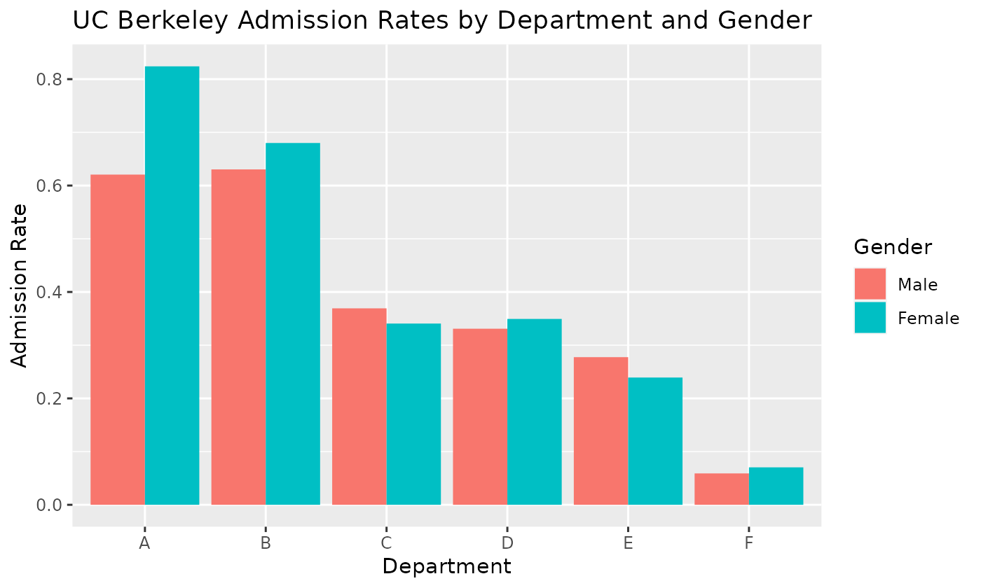
Figure 2. UC Berkeley admission rates by department and gender.
(d) [4 pts] The overall rate is a weighted average of department rates, weighted by where each group applied. Two things differ across groups:
- Departments differ in selectivity. Overall admission is about 63–64% in A and B, 25–35% in C–E, and 6% in F.
- Men and women applied to different departments. 51% of male applicants applied to the easy departments A and B, versus 7% of female applicants. 72% of female applicants applied to the selective C, E, and F, versus 33% of male applicants.
So men’s overall rate is weighted toward high-admit departments and women’s toward low-admit ones, producing 44.5% vs. 30.4% even though within-department rates are similar or favor women. With both genders given the same department mix, the standardized rates are 38.7% (men) and 43.0% (women), and the gap disappears.
(e) [4 pts] Not justified. A change in the estimate after adjustment shows only that the variable is associated with both gender and admission. A confounder, a mediator, and a collider can each change an estimate, and the data alone cannot say which one Department is (adjustment does not reveal causal role).
Department is unlikely to be a confounder. A confounder is a common cause of exposure and outcome (Gender ← Dept → Admit). An applicant’s gender is not caused by the department they choose. A more plausible DAG is Gender → Dept → Admit, with a possible direct arrow Gender → Admit (bias in admissions). Then Dept is a mediator: adjusting for it estimates the direct effect, not the total effect. If unmeasured factors U (e.g., preparation, interests) also affect Dept and Admit, Dept is additionally a collider (Gender → Dept ← U → Admit), and conditioning on it opens a bias path.
To justify treating Dept as a confounder we would need to assume: (i) Dept precedes gender and causes it (Dept → Gender), which is implausible; (ii) Dept → Admit; and (iii) no other open backdoor paths (no unmeasured confounding), plus positivity and consistency. These come from subject-matter knowledge and study design, not from the data.

