Data Dictionary and Exploratory Data Analysis
2023 NVSS Natality Extract: Maternal Smoking and Preterm Birth
Faruk Muritala
STAT 7900 - Causal Analysis, Kennesaw State University
1. Purpose and Scope
This document supports the project proposal by describing the analytic file itself: what each variable contains, how much of it is missing and why, and how the candidate covariates relate to one another and to treatment and outcome. It is a companion reference, not a substitute for the proposal's identification argument; the adjustment-set reasoning is developed there.
All figures below are computed directly from the actual 2023 extract (3,476,180 rows) rather than estimated or assumed. The accompanying R script (eda_data_dictionary.R) reproduces every number in this document and is intended to be run directly against the data file.
2. Data Source and Collection
The extract is drawn from the 2023 U.S. National Vital Statistics System (NVSS) natality public-use file, a near-census administrative record of live births compiled by the National Center for Health Statistics (NCHS) from state-filed birth certificates. Because it is administrative rather than survey data, several features of how it was collected shape how it should be read.
Self-reported fields. Maternal smoking status is reported by the mother (or transcribed from the prenatal record) at the time of birth registration, not independently verified. The vital-statistics literature documents under-reporting of smoking during pregnancy, which would be expected to bias any estimated effect toward the null rather than away from it.
Two distinct kinds of missing data. Most fields in this file use explicit NCHS sentinel codes (typically 9, 99, or 99.9) to mean "not stated," rather than leaving the field blank. These are recoded to true NA before any analysis; left un-recoded, a sentinel like bmi = 99.9 would silently distort the variable's mean and correlations. A smaller number of fields, most notably marital status (dmar), are genuinely blank in the raw file for a structural reason: not every state reports marital status on the birth certificate. That is true missingness rather than a respondent's unknown answer, and it is why dmar is excluded from the analysis entirely rather than imputed.
Restriction to singleton births. The extract is pre-restricted to singleton live births (plurality = 1 throughout), since multiple gestation is itself a strong, non-confounding cause of preterm delivery that would otherwise distort the exposure-outcome comparison.
Coverage. Coding definitions below follow the published NCHS Natality Public-Use File User Guide's standard category scheme, which is stable across recent data years; category text should be cross-checked against the exact 2023 User Guide before being quoted precisely in a submitted manuscript.
3. Data Dictionary
Every variable in the raw extract, its role in the analysis, its coding, and its real, computed missingness rate (after sentinel-code recoding where applicable):
Variable | Label | Role | Coding | % missing
dob_yy | Birth year | Context | 2023 (single value) | 0.000%
mager | Mother's age (single years) | Confounder | 12-50 years | 0.000%
mrace6 | Mother's bridged race (6-category recode) | Confounder | 1=NH White, 2=NH Black, 3=NH AIAN, 4=NH Asian, 5=NH NHOPI, 6=Hispanic | 0.000%
dmar | Marital status | Not used (true missing, not sentinel) | 1=Married, 2=Unmarried | 11.158%
meduc | Mother's education (2003 revision recode) | Confounder | 1=8th grade or less ... 8=Doctorate/Professional, 9=Unknown | 1.693%
precare5 | Month prenatal care began (5-category recode) | Confounder | 1=1st trimester, 2=2nd, 3=3rd, 4=No care, 5=Unknown | 1.786%
wic | WIC participation during pregnancy | Confounder | Y/N/U | 0.981%
priorlive | Prior births now living | Used to derive parity | 0-30 (count), 99=Not stated | 0.108%
priordead | Prior births now dead | Used to derive parity | 0-30 (count), 99=Not stated | 0.214%
priorterm | Prior pregnancy terminations | Used to derive parity | 0-30 (count), 99=Not stated | 0.258%
rf_ppterm | Risk factor: previous preterm birth | Confounder | Y/N/U | 0.126%
rf_pdiab | Risk factor: pre-pregnancy diabetes | Confounder | Y/N/U | 0.126%
rf_phype | Risk factor: pre-pregnancy hypertension | Confounder | Y/N/U | 0.126%
rf_gdiab | Risk factor: gestational diabetes | Excluded (gestational, possible mediator) | Y/N/U | 0.126%
rf_ghype | Risk factor: gestational hypertension | Excluded (gestational, possible mediator) | Y/N/U | 0.126%
bmi | Pre-pregnancy BMI | Confounder | 13.0-99.8 kg/m^2, 99.9=Not stated | 2.165%
cig_0 | Cigarettes/day before pregnancy | Not used directly (see cig_rec) | 0-98 count, 99=Unknown | 0.014%
cig_rec | Cigarette smoker recode (any smoking during pregnancy) | TREATMENT (T) | Y = smoked at any point, N = did not | 0.000%
dplural | Plurality | Restriction variable (pre-restricted to singletons) | 1 in this extract | 0.000%
sex | Infant sex | Not used | M/F | 0.000%
oegest_comb | Obstetric estimate of gestation, combined | Used to derive OUTCOME (Y) | 17-47 completed weeks | 0.000%
dbwt | Birth weight | Not used | 227-9998 grams, 9999=Not stated | 0.014%
pay_rec | Payment source for delivery | Considered and excluded; see proposal Section 7 | 1=Medicaid, 2=Private, 3=Self-pay, 4=Other, 9=Unknown | 0.692%
restatus | Residence status relative to state of occurrence | Not used | 1=Resident, 2=Intrastate nonresident, 3=Interstate nonresident, 4=Foreign resident | 0.000%

Three additional variables are derived rather than read directly from the file: nulliparous (1 if priorlive, priordead, and priorterm are all zero; 0.350% missing, inheriting missingness from its three source fields), preterm (the outcome Y, 1 if oegest_comb < 37 weeks; 0.000% missing), and smoker (the treatment T, taken directly from cig_rec; 0.000% missing).
4. Missingness
After recoding NCHS sentinel codes to true NA, missingness is low across the file: every candidate covariate is missing in under 2.2% of records, and most are missing in under 1%. The two most-missing covariates are prenatal-care timing (precare5, 1.786%) and education (meduc, 1.693%); nine of the ten covariates in the adjustment set are missing in under 1% of records.
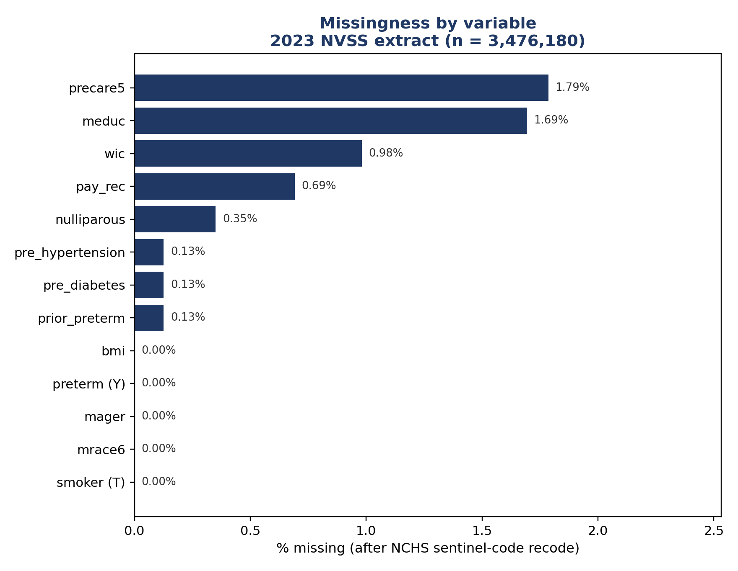
Figure A. Missingness by variable, 2023 NVSS extract (n = 3,476,180). Marital status (dmar) is shown separately in the data dictionary above; it is not part of the adjustment set.
Complete-case impact. Restricting to complete cases on treatment, outcome, and the ten adjustment-set covariates drops the analytic file from 3,476,180 to 3,297,356 rows, a loss of 178,824 records (5.144%). This is modest relative to the size of the file, and the planned analysis proceeds on a complete-case basis; if missingness on any covariate later proves related to both smoking and preterm birth, that would be a source of residual bias worth flagging explicitly in the final report, consistent with Section 7 of the proposal.
5. Correlation Structure
Pairwise Pearson correlations were computed across treatment (smoker), outcome (preterm), and every candidate covariate, using pairwise-complete observations. This is a descriptive, exploratory step: it does not itself determine which variables belong in the adjustment set (that argument, based on the causal diagram, is made in the proposal), but it grounds that argument in the data and surfaces relationships worth knowing before modeling begins.
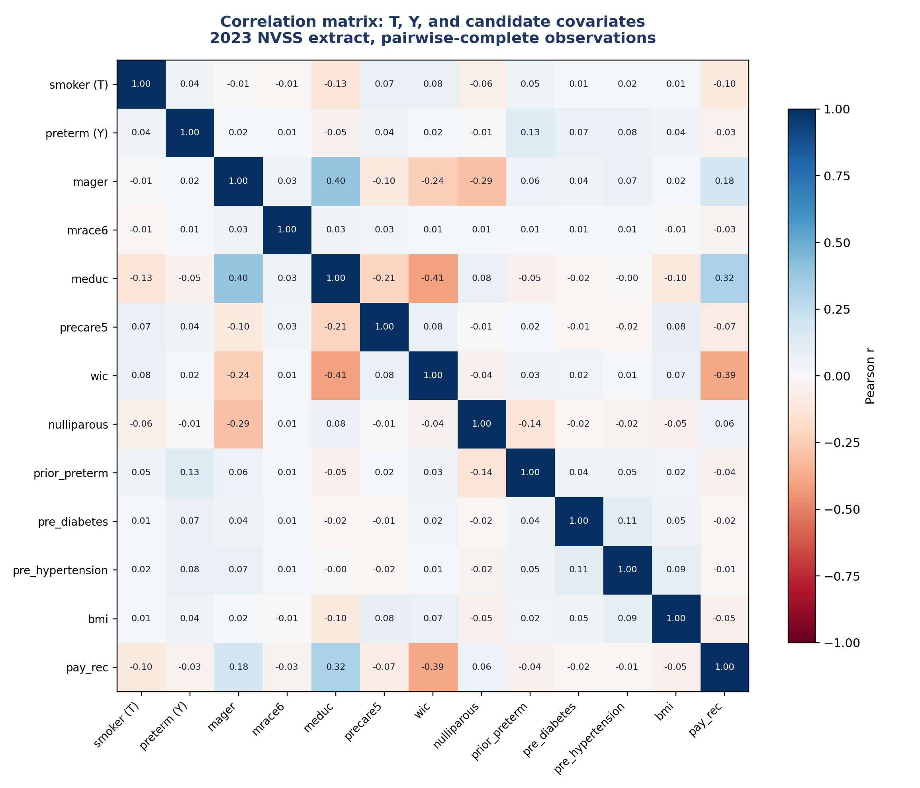
Figure B. Correlation matrix across treatment, outcome, and eleven candidate covariates (includes payer type, considered and excluded from the adjustment set; see proposal Section 7). 2023 NVSS extract, pairwise-complete observations.
Key relationships
Strongest correlates of smoking status. Education (meduc) shows the strongest association with smoking among all candidate covariates (r = -0.128, coded so that higher educational attainment associates with lower smoking prevalence), followed by payer type (pay_rec, r = -0.100) and WIC participation (wic, r = 0.078). This is the empirical basis for the strength claim made about education in the proposal's node-by-node defense.
Correlates of preterm birth. Prior preterm birth (r = 0.130) and the two pre-pregnancy risk-factor variables, hypertension (r = 0.076) and diabetes (r = 0.072), show the strongest associations with the outcome, consistent with their established clinical role as risk factors for early delivery.
Structure among the confounders themselves. Several covariates are substantially correlated with one another, most notably education and WIC participation (r = -0.411), maternal age and education (r = 0.398), and payer type and WIC participation (r = -0.387). These relationships are the empirical counterpart to the assumed ordering shown in Figure 2b of the proposal, and they illustrate why payer type and education move together: both sit on the same underlying socioeconomic gradient, which is the basis for treating their shared correlation with smoking as confounded by that gradient rather than as two independent causal edges.
Magnitudes generally. No pairwise correlation among the covariates exceeds 0.41 in absolute value, and most are well under 0.20, so multicollinearity is not expected to be a substantial concern for the planned logistic propensity-score model.
6. Full Correlation Matrix
Values are Pearson correlation coefficients, pairwise-complete observations, rounded to three decimal places.
 | T | Y | mager | mrace6 | meduc | precare5 | wic | nullip. | p.preterm | p.diab | p.hype | bmi | pay_rec
smoker (T) | 1.000 | 0.037 | -0.006 | -0.014 | -0.128 | 0.071 | 0.078 | -0.059 | 0.047 | 0.009 | 0.022 | 0.013 | -0.100
preterm (Y) | 0.037 | 1.000 | 0.020 | 0.014 | -0.046 | 0.037 | 0.016 | -0.006 | 0.130 | 0.072 | 0.076 | 0.044 | -0.034
mager | -0.006 | 0.020 | 1.000 | 0.033 | 0.398 | -0.095 | -0.240 | -0.292 | 0.057 | 0.043 | 0.066 | 0.022 | 0.184
mrace6 | -0.014 | 0.014 | 0.033 | 1.000 | 0.035 | 0.027 | 0.014 | 0.011 | 0.010 | 0.013 | 0.011 | -0.007 | -0.026
meduc | -0.128 | -0.046 | 0.398 | 0.035 | 1.000 | -0.214 | -0.411 | 0.075 | -0.047 | -0.019 | -0.003 | -0.099 | 0.325
precare5 | 0.071 | 0.037 | -0.095 | 0.027 | -0.214 | 1.000 | 0.076 | -0.007 | 0.018 | -0.009 | -0.017 | 0.083 | -0.073
wic | 0.078 | 0.016 | -0.240 | 0.014 | -0.411 | 0.076 | 1.000 | -0.040 | 0.032 | 0.025 | 0.013 | 0.074 | -0.387
nulliparous | -0.059 | -0.006 | -0.292 | 0.011 | 0.075 | -0.007 | -0.040 | 1.000 | -0.140 | -0.018 | -0.024 | -0.053 | 0.059
prior_preterm | 0.047 | 0.130 | 0.057 | 0.010 | -0.047 | 0.018 | 0.032 | -0.140 | 1.000 | 0.036 | 0.053 | 0.025 | -0.043
pre_diabetes | 0.009 | 0.072 | 0.043 | 0.013 | -0.019 | -0.009 | 0.025 | -0.018 | 0.036 | 1.000 | 0.108 | 0.048 | -0.017
pre_hypertension | 0.022 | 0.076 | 0.066 | 0.011 | -0.003 | -0.017 | 0.013 | -0.024 | 0.053 | 0.108 | 1.000 | 0.090 | -0.014
bmi | 0.013 | 0.044 | 0.022 | -0.007 | -0.099 | 0.083 | 0.074 | -0.053 | 0.025 | 0.048 | 0.090 | 1.000 | -0.052
pay_rec | -0.100 | -0.034 | 0.184 | -0.026 | 0.325 | -0.073 | -0.387 | 0.059 | -0.043 | -0.017 | -0.014 | -0.052 | 1.000

7. Data-Collection Caveats
Binary exposure coding. The smoking indicator used here is binary (any cigarette use in pregnancy versus none); it does not capture smoking intensity (cigarettes per day) or the trimester in which smoking occurred, both of which the dose-response literature shows matter for the size of the effect.
Self-report. As noted in Section 2, smoking status is self-reported at intake, and under-reporting is documented in the vital-statistics literature. This would be expected to attenuate rather than inflate any estimated association.
Structural versus item-level missingness. Marital status (dmar) is missing for a structural reason (some states do not report it) rather than because individual respondents declined to answer, which is why it is excluded from the analysis rather than imputed alongside the sentinel-coded fields.
Coding-scheme verification. The category definitions in Section 3 follow the standard NCHS scheme; the exact 2023 NVSS User Guide should be consulted before quoting precise category wording in the final manuscript, since minor definitional changes across data years are possible.

