Project Proposal
Causal Effect of Maternal Smoking During Pregnancy on Preterm Birth: A Propensity-Score and Doubly Robust (AIPW) Approach
Faruk Muritala
STAT 7900 – Causal Analysis, Kennesaw State University
Instructor: Dr. Dhrubajyoti Ghosh | Deliverable: Project Proposal (due October 12, 2026)
1. Project Topic
This project is an observational causal analysis that will estimate the causal effect of a modifiable prenatal exposure, maternal smoking during pregnancy, on a major adverse birth outcome, preterm birth, using real-world administrative data and propensity-score adjustment methods.
The project is motivated by a poster presented at the Joint Statistical Meetings by researchers at Utah Valley University (Heiny & Islam), which applied propensity-score matching to a similar maternal-smoking and preterm-birth question on a comparatively small, individually matched sample. Matching at that scale is well suited to a small cohort, but it does not scale efficiently to a near-census administrative file: exact or nearest-neighbor matching requires a pairwise search over the full control pool for every treated unit, and at a cohort size of several million births, extensive ties in the propensity-score distribution make that search computationally impractical. This proposal extends the general approach of the cited poster to the full 2023 U.S. national birth cohort rather than a matched subsample, and for that reason relies on weighting-based propensity-score methods, specifically inverse-probability-of-treatment weighting and propensity-score-quintile stratification, together with a doubly robust estimator (AIPW), rather than individual-level matching, as the primary strategy for confounding control. This choice, its justification, and its practical implications are detailed further in Section 7.
2. Causal Question and Objective
Following the five ingredients of a well-posed causal question (Lecture 3: population, treatment, comparator, outcome, time), the causal question for this project is specified as follows:
Population: Women with a singleton live birth in the United States in 2023
Treatment (T): Maternal smoking at any point during pregnancy (self-reported on the birth certificate)
Comparator: No maternal smoking during pregnancy
Outcome (Y): Preterm birth: delivery before 37 completed weeks of gestation (binary)
Time: Single pregnancy episode ending in a 2023 birth (cross-sectional; no longitudinal follow-up beyond delivery)

Using course notation, let Y(1) and Y(0) denote each mother's potential preterm-birth outcome under smoking and non-smoking, respectively. The estimand of interest is the average treatment effect (ATE):
ATE = E[Y(1) − Y(0)] = E[Y(1)] − E[Y(0)]
interpreted as the change in preterm-birth risk if the study population had smoked during pregnancy versus if the same population had not. Objective: obtain a defensible estimate of this effect (reported as an odds ratio and, secondarily, a risk difference) under a pre-specified set of identifying assumptions, using a propensity-score-based adjustment strategy justified by an explicit causal diagram.
3. Dataset
The analysis will use the 2023 U.S. National Vital Statistics System (NVSS) natality public-use file, published by the National Center for Health Statistics (NCHS) and distributed by NBER (data.nber.org/nvss/natality/csv/2023/natality2023us.zip). The file is a near-census record of essentially every live birth registered in the United States in 2023 (approximately 3.6 million birth-certificate records), including maternal demographic and socioeconomic fields, prenatal-care and medical-history indicators, self-reported smoking status, and gestational age at delivery.
The data are public and de-identified at the individual level (no names, addresses, or other direct identifiers), so no IRB review is required. Records will be restricted to singleton births with non-missing gestational age, smoking status, and the planned covariate set (Section 7); the exact resulting analytic sample size will depend on field completeness and will be reported once the restriction is applied.
4. Treatment (Exposure)
Maternal smoking during pregnancy, coded as a binary indicator (T = 1 if the mother reported smoking at any point during pregnancy on the birth certificate; T = 0 otherwise). This is the standard binary coding used in the source literature; it does not capture dose (cigarettes per day) or trimester timing, a limitation noted in Section 7.
5. Outcome
Preterm birth, coded as a binary indicator (Y = 1 if the recorded obstetric estimate of gestational age at delivery is below 37 completed weeks; Y = 0 otherwise). Preterm birth is one of the leading drivers of infant morbidity and mortality in the United States, and it is the outcome used in the study this project extends, which supports comparability of findings.
6. Target Population
Mothers of singleton live births in the United States in 2023 with complete data on gestational age, smoking status, and the covariates listed in Section 7. Multiple births (twins, triplets, etc.) will be excluded, since plurality is itself a strong, non-confounding cause of preterm delivery that would otherwise distort the exposure–outcome comparison. The estimated effect will therefore generalize to the singleton-birth population, not to all U.S. births.
7. Proposed Approach
Smoking status is not randomly assigned: maternal age, race/ethnicity, education, prior obstetric history, and pre-existing medical conditions plausibly predict both smoking and preterm birth. Any unadjusted comparison of preterm-birth rates between smokers and non-smokers therefore mixes the causal effect of smoking with confounding by these shared causes. The planned analysis addresses this with a propensity-score (PS) approach, carried out in the following stages (Figure 1):
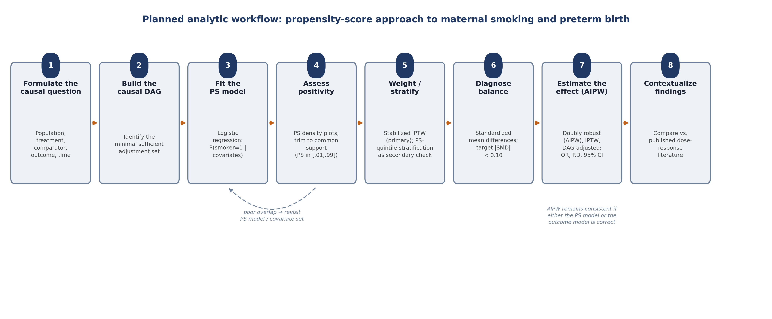
Figure 1. Planned analytic workflow. Each stage will be disclosed in the eventual write-up exactly as executed, including the rationale noted under Stage 7 for reporting AIPW as the primary result.
Stage 1-2: Causal diagram and adjustment set. A directed acyclic graph (DAG) will be drawn to represent the assumed causal structure linking maternal smoking, preterm birth, and their shared causes, and to identify a minimal sufficient adjustment set: the smallest set of pre-treatment variables that blocks every backdoor path between T and Y without conditioning on a mediator or a collider. Every edge into T is defended individually, on the substantive question of whether that variable can plausibly cause smoking, rather than assumed from a variable's relevance to Y alone. On this standard, the adjustment set includes ten pre-treatment covariates: maternal age, race/ethnicity, education, prenatal-care onset timing, WIC participation, parity, prior preterm birth, pre-pregnancy diabetes, pre-pregnancy hypertension, and pre-pregnancy BMI. A draft of this diagram is attached as Figure 2a and is also provided as a separate, editable PowerPoint file (native, draggable shapes) so that the adjustment set can be revised jointly with feedback on this proposal.
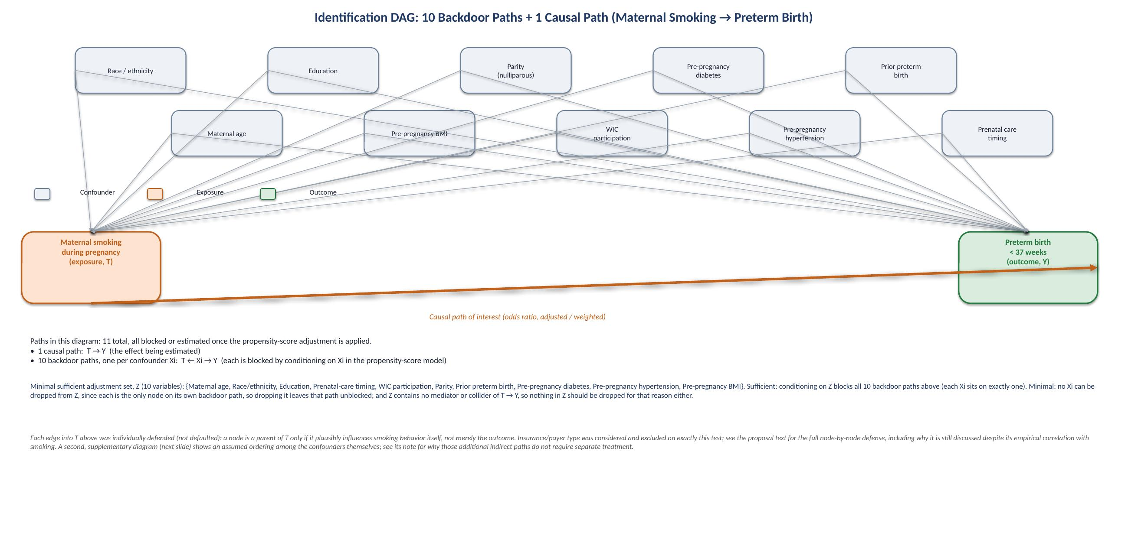
Figure 2a. Identification DAG. Every path relevant to identification is drawn explicitly: one causal path (T → Y, bold orange) and ten backdoor paths, one per confounder (T ← Xi → Y, thin gray). The full path list and the minimal-adjustment-set argument are given in the text below.
All eleven paths, listed. The identification DAG above contains exactly eleven directed paths between T and Y:
(1) the causal path T → Y: this is the effect being estimated, not blocked;
(2-11) ten backdoor paths, one per confounder Xi: T ← Xi → Y, for Xi ∈ {maternal age, race/ethnicity, education, prenatal-care timing, WIC participation, parity, prior preterm birth, pre-pregnancy diabetes, pre-pregnancy hypertension, pre-pregnancy BMI}.
Minimal sufficient adjustment set. Let Z be the set of all ten confounders listed above. Z is sufficient: conditioning on Z blocks all ten backdoor paths, since each one passes through exactly one member of Z. Z is minimal: no variable can be removed from it, since each confounder is the only node on its own backdoor path, so dropping it would leave that specific path unblocked (open); Z also contains no mediator or collider of T → Y that would need to be excluded. This is the formal justification for the propensity-score model's covariate list in Stage 3.
Node-by-node defense of every edge into T. The standard applied to every candidate covariate is whether it plausibly causes smoking specifically, not merely whether it is associated with preterm birth. For each variable, the question is whether it can plausibly cause smoking: if not, no causal edge into T is drawn; if so, the edge is retained. Each candidate variable was evaluated individually against smoking, not just against preterm birth:
Education → T: kept. Lower educational attainment plausibly increases smoking via socioeconomic pathways (health literacy, income, workplace and social norms) that precede and are largely independent of the pregnancy itself. This is also the strongest empirical correlate of smoking status among all candidate covariates in the 2023 extract (r = −0.128, coded so that higher educational attainment associates with lower smoking prevalence).
Maternal age, race/ethnicity, WIC participation, parity, prior preterm birth, pre-pregnancy diabetes, pre-pregnancy hypertension, pre-pregnancy BMI, prenatal-care timing → T: kept. Each plausibly precedes and shapes smoking behavior or reflects a shared upstream cause with it (for example, WIC participation and parity both proxy socioeconomic circumstances that influence smoking uptake and cessation); none is a consequence of the smoking decision itself.
Insurance/payer type → T: excluded. Insurance or payer type is not a plausible direct cause of smoking: it does not causally precede or determine whether a mother smokes. This exclusion is a genuine judgment call worth stating plainly. pay_rec is, in fact, correlated with smoking status in the 2023 extract (r = −0.100, comparable in magnitude to several retained covariates), but the more defensible reading is that this correlation reflects confounding by socioeconomic status rather than a direct causal relationship: the same underlying socioeconomic gradient that drives the education-to-smoking pathway also appears to sort mothers into insurance categories. Because education is already included in the adjustment set, this shared socioeconomic pathway is still addressed. Adding insurance itself would risk conditioning on a variable whose relationship to T runs through a common cause rather than a direct edge, without a corresponding identification benefit, and at some cost to the positivity assumption, since including additional weakly justified covariates increases the risk that some covariate strata contain few or no treated or untreated units.
A note on the confounders' own structure. The ten confounders are not assumed to be causally unrelated to one another. For example, maternal age plausibly influences parity, and education plausibly influences WIC participation. Figure 2b, attached separately, sketches one plausible ordering among them for illustration. This ordering does not change the argument above: because every confounder is a direct parent of both T and Y (Figure 2a), conditioning on each one individually blocks every path that runs through it, including any longer path that happens to pass through other confounders first, a standard consequence of d-separation (conditioning on a non-collider blocks every path through that node). No separate accounting of paths through the confounders' internal structure is required.
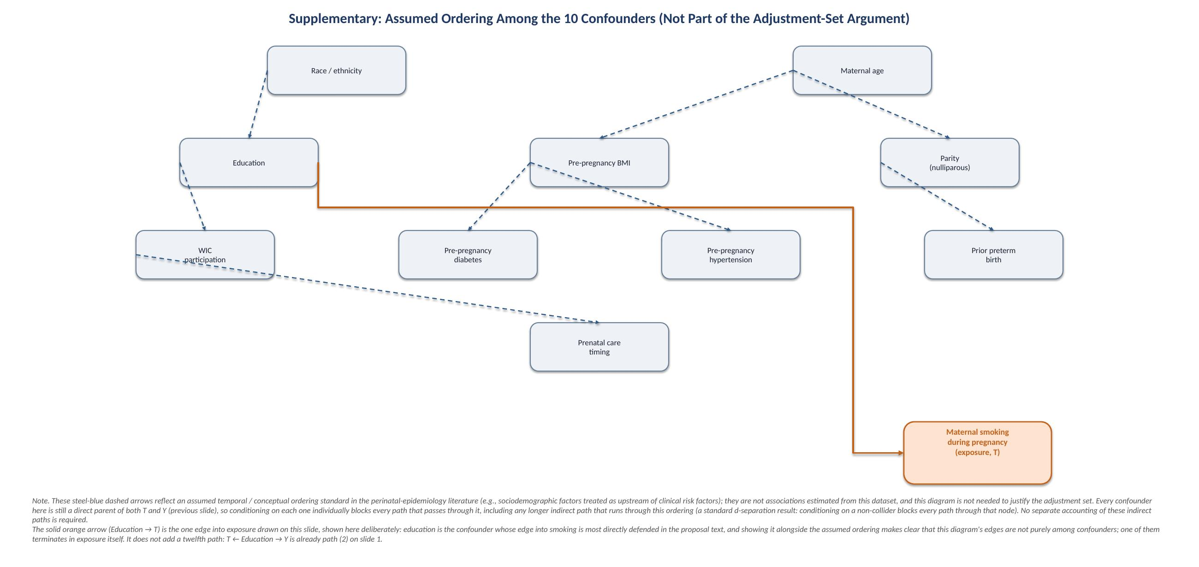
Figure 2b (supplementary, not required for identification). One plausible ordering among the ten confounders, shown separately from Figure 2a to keep each diagram readable. Steel-blue dashed arrows are an assumed temporal/conceptual ordering, not an estimated association. The solid orange arrow (Education → T) is included deliberately, to keep the edge into exposure visible alongside the confounders' own structure. It is not a new, twelfth path: it corresponds to path (2) from Figure 2a. An editable PowerPoint with both diagrams is attached separately.
Stage 3-4: Propensity-score model and positivity. A logistic-regression model for P(T = 1 | covariates) will be fit on the adjustment set. Because the analytic file is expected to contain several million rows, computational feasibility will be assessed up front; if fitting on the full cohort is not tractable, the model will be fit on a stratified subsample and used to score the full cohort, with the exact procedure disclosed. Positivity (adequate overlap in propensity scores between smokers and non-smokers) will be assessed visually with propensity-score density plots, and the analytic sample will be trimmed to a common-support region before any effect is estimated.
Stage 5: Weighting and stratification, in place of individual matching. As explained in Section 1, individual-level 1:1 propensity-score matching does not scale to a cohort of this size, so the primary confounding-control strategy uses weighting-based methods instead. Stabilized inverse-probability-of-treatment weighting (IPTW) is the primary estimator, with propensity-score-quintile stratification (Mantel-Haenszel pooling across strata) reported as a secondary check. Both assign each unit a closed-form function of its own propensity score, so neither requires the pairwise search over the control pool that makes matching impractical at this scale.
Stage 6: Balance diagnostics. Covariate balance after weighting will be assessed using standardized mean differences (SMD) for every covariate in the adjustment set, with a target of |SMD| < 0.10 as evidence that weighting has removed the measured confounding that motivated it.
Stage 7: Effect estimation via a doubly robust estimator (AIPW). A weighting-based estimator such as IPTW is consistent only if the propensity-score model is correctly specified, a condition that cannot be guaranteed in practice. The estimation plan therefore also includes augmented inverse-probability weighting (AIPW), a doubly robust estimator that combines the propensity-score model with an outcome regression so that the treatment-effect estimate remains consistent if either model, not necessarily both, is correctly specified. AIPW is reported as the primary doubly robust result, with the crude comparison, DAG-adjusted regression, IPTW, and PS-quintile stratification reported alongside it to show a transparent progression from an unadjusted comparison to a fully specified doubly robust estimate. All estimators are reported as an odds ratio (primary) and a risk difference (secondary), each with a robust (sandwich) variance estimator and a 95% confidence interval.
Stage 8: Context. The resulting estimate will be compared against the published dose-response literature on maternal smoking and preterm birth to assess whether it falls within a plausible, previously-documented range.
Identification assumptions. The causal interpretation of the ATE rests on four standard assumptions, each of which will be stated explicitly and, where testable, checked in the eventual analysis: (1) conditional exchangeability: no unmeasured confounding once the DAG-identified adjustment set is controlled for; (2) positivity: every covariate stratum has a nonzero probability of both smoking and non-smoking, checked via the overlap diagnostic in Stage 4; (3) consistency: the smoking status recorded on the birth certificate corresponds to a well-defined exposure; and (4) SUTVA: one mother's smoking status does not affect another mother's outcome. Self-reported exposure and the binary (any/none) coding of smoking are acknowledged in advance as sources of possible residual bias, to be discussed candidly in the final report.
Reproducibility. The full pipeline will be implemented independently in both R and SAS, and all code will be maintained in a public GitHub repository (github.com/fmurital/Causal-Inference-) rather than reproduced inline in the paper, so that every reported number can be traced to and re-run from its exact source.

