Contents

The image of the application 1

Variance formula: 3

The logic of outliers detection: 3

Trend detection 4

Logging 4

## The image of the application

This is a WPF application which is created with net framework 4.7, and the class libraries with .net standard 2.

It’s a simple application that contains 4 steps leading to processing an input file and analyze its json records. There is a small sample input file with the project that you can test the process with it, but this application has been tested with a file containing 700,000 records and passed the test.

1.First Step: WelCome and Introduction

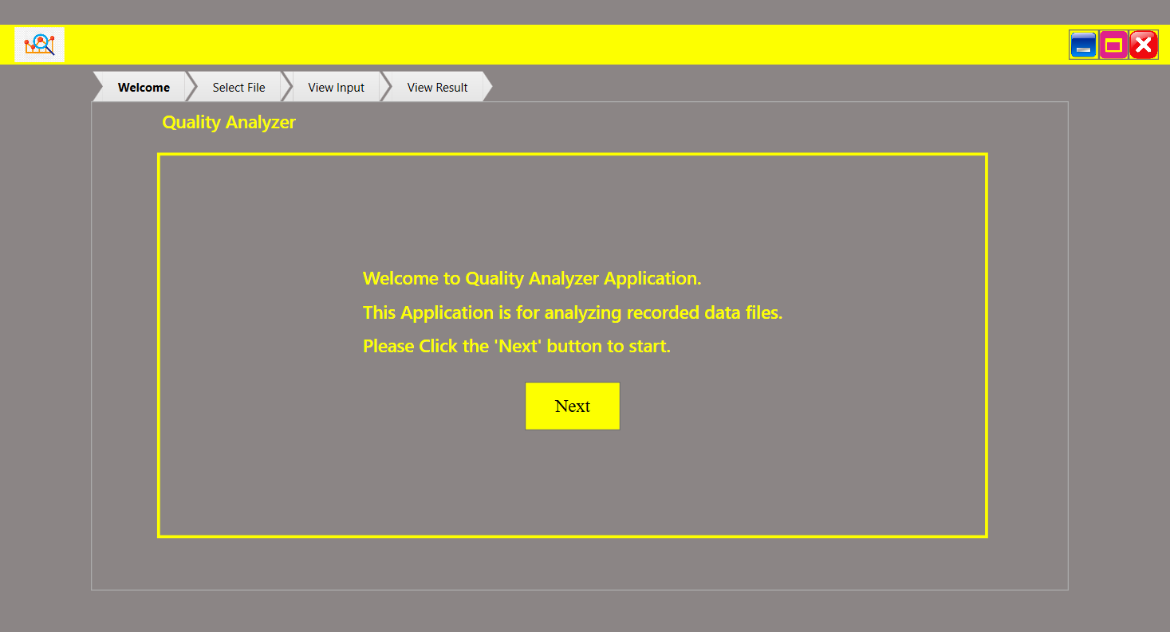

2.Second Step: Choose Your file, Customer can click on the box to open a ‘Open file dialog’ to choose his file or simply drag and drop his file to the box

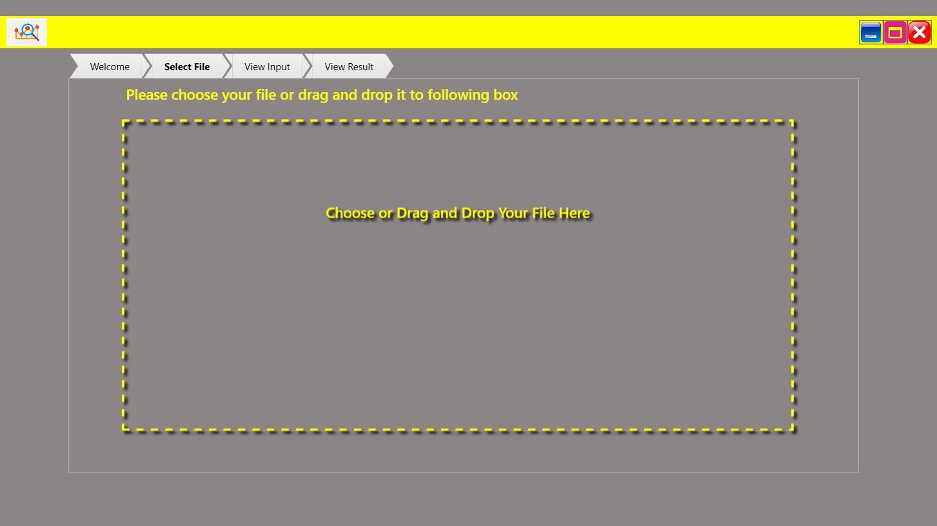

2.Third Step: View input Data, Customer can View the input data and use the pagination to move between records. If the customer clicks on Analyze Quality button he would navigate to the last page that is the result page.

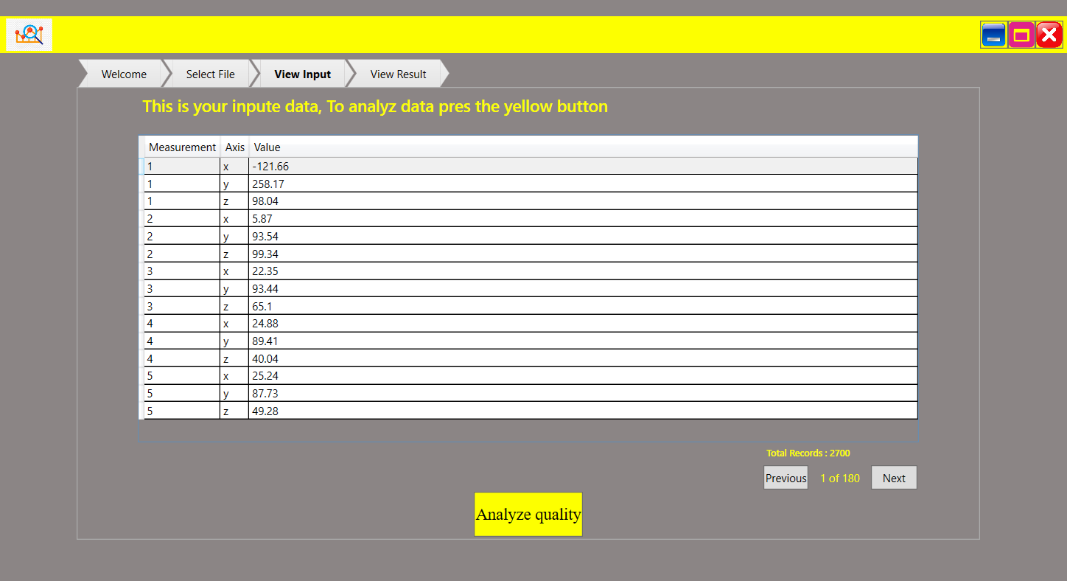

2.Forth Step: View result Data, Customer can View the result data and use the pagination to move between records.

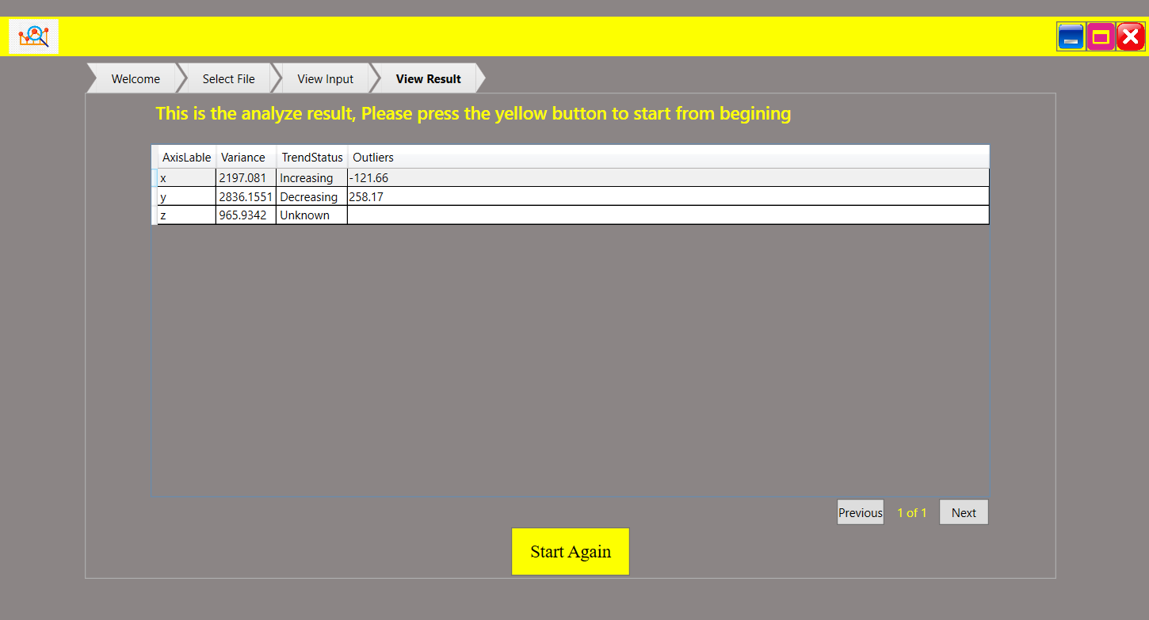

-----------------------------------------------------------------------------------------------------------------------------

## Variance formula:

I have used this formula to calculate variance:

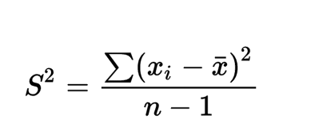

---------------------------------------------------------------------------------------------------------------------------

## The logic of outliers detection:

A standard way of checking for outliers is to use quartiles and the interquartile range for defining thresholds. Take the median to divide your data in two halves, then use the medians of the upper and lower halves to divide your data into four parts. The resulting 3 numbers are your quartiles.

Sample input : [15, 17, 19, 16, 14, 58]

In sample case you get

Q1 = 15

Q2 = 16.5

Q3 = 19

The interquartile range is IQR = Q3 − Q1 = 4.

Common thresholds to detect outliers would be

Tlo= Q1 − 1.5 ⋅IQR = 9

 And

 Thi= Q3 + 1.5 ⋅ IQR = 25

Any values less than Tlo or greater than Thi are classified as outliers.

So the value 58 would clearly be detected as an outlier.

-------------------------------------------------------------------------------------------------------------------------------

## Trend detection

For the trend detection, I have just checked if the range of values is increasing or decreasing.

-------------------------------------------------------------------------------------------------------------------------------

## Logging

I have used Nlog package for logging messages. If any exceptions throws the log of the exception will be found in : D:/Logs/${shortdate}/${date:format=HH}.txt or {basedir}/Logs/${shortdate}/${date:format=HH}.txt addresses

Thanks for your attention

Fatemeh