# Code challenge easynvest

***(work in progress)***

# Description

This is the complete document of the challenge proposed by Easynvest. Disclosure of company name and publishing of the results were explicitly authorized by their recruiting team.

Easynvest is a fintech company, more specifically a digital broker-dealer which helps thousands of clients to invest their money easily and quickly. They are known for their online platform and strong digital presence.

The complete description of the challenge may be found in the file challenge_description/challenge_description.pdf (in Portuguese).

# Introduction

## The data set

The data set received was in the form of an Excel spreadsheet with two tabs. The first tab contained 4973 entries (N=4973), one unique ID and 10 characteristics (11 columns total).  
The second tab has entries which are not described elsewhere. The lack of a formal description casts unecessary uncertainty into the data at hand. Lack of proper definition is a discouraged practice in data creation (e.g.: absence of research method and methodology). Data definition must not be open for interpretation.

A remarkable fact of this data set is that it does not contain any null values. Such high quality data sets are rare to find and may indicate that its source is very thoughtful of its data management.

A final remark is that the characteristics' names (column names) should not be considered self explanatory. A codebook is often use to describe published data.  
To illustrate the critique above consider the variable 'VALOR_01' (value_01; there are 4 of these variables). To what value does it refer to? Is it the amount already invested in the investment platform? Is it the income enumerated by different sources of income? Is it profit? If it is income, is it yearly or monthly?  
Another illustration is the 'GEO_REFERENCIA' (georeference) variable. It has values ranging from 10 to 999 but it is not explained elsewhere. Usual geolocation information are comprised of x and y coordinates or other better known formats. Also, it cannot refer to Brazilian municipalities because there exists ~5500 of them.  
Consequently this variable has been neglected in the present analysis.

As one can see, this seemingly unimportant differences may yield different interpretations later on the data analysis and render some conclusions useless or even worse: wrong.

# Approach

As stated in the challenge description my work should:

1. **Group users finding well defined groups with common characteristics.**
   * In order to do that I have clustered the data set using the *K-Means* clustering algorithm.
2. **Justify the chosen clustering algorithm.**
   * This algorithm is one of the most *commonly used* algorithm in Data Sciences. As such one can easily find support, implementations, discussions and suggestions on various references. Such vast amount of information is not something to be neglected.  
     The algorithm also *allows the specification of the number of clusters* to be found. This is seen as drawback according to some sources. Yet I think that it can be overcome with successively running the algorithm with a different cluster number. Specifying the number of clusters also impedes the algorithm to come up with a number of clusters which may be uninterpretable (too few, e. g. 2 or too many 10+).  
     The algorithm tends to yield *clusters with similar size*. This may be a desired characteristic in a business setting for example, where investment of resources (time and capital) may be applied to a cluster of clients. In such cases one does not want to invest those in a cluster just to find out that it aggregates to just a few individuals of their clientele.
3. **Present metrics of perfomance for the chosen algorithm.**
   * In this case the *silhouette analysis* was performed to assess the effectivenss of the clustering algorithm.  
     Also the *intra-group and inter-group standard deviation* and means were taken in consideration to interpret the results of this clustering algorithm.
4. **Discuss the metrics of performance to assess the clusters.**
   * See discussion of the clustering for a detailed assessment of the clustering algorithm.
5. **Explain the results.**
   * See the results and summary sections for a precise answer to this question.

# Results

## Preprocessing

### Variable scaling

The received data needed preprocessing before applying te clustering method. That is because the K-Means clustering method is sensitive to variable scaling (more precisely to variance). Without scaling, variables tend to have a variances of different orders of magnitude (standard deviation for the data set before preprocessing):

|  |  |
| --- | --- |
| variable | std |
| valor_01 | 6098.823 |
| valor_02 | 89180.835 |
| valor_03 | 37645.943 |
| valor_04 | 23246.037 |
| age | 10.792 |
| estado_civil_solteiro | 0.500 |
| estado_civil_casado | 0.486 |
| estado_civil_outro | 0.297 |
| genero_m | 0.416 |
| genero_f | 0.416 |
| perfil_a | 0.458 |
| perfil_b | 0.416 |
| perfil_c | 0.216 |
| perfil_d | 0.161 |

Standard deviation for the data set after preprocessing (abbreviated):

|  |  |
| --- | --- |
| variable | std |
| valor_01 | 1.0 |
| valor_02 | 1.0 |
| (...) | 1.0 |
| perfil_c | 1.0 |
| perfil_d | 1.0 |

That means that without scaling the four variables of 'valor' would dominate the clustering sensitivity, rendering the presence of the other variables useless.

### Nominal variables processing

Some presented variables are categorical and do not meaningfully present any interpretation from a numerical standpoint. For example, height may be compared so that a person who is 170 cm high is higher than someone who is 165 cm.  
There is no parallel to variables which represent 'non rankable' variables such as gender and ethnicity. Assigning a value of 1 for male, 0 for female and 2 for non identified gender does not mean that in this scenario that male > female.

In order to overcome this problem categorical variables with N categories are transformed to new binary characteristics (then scaled as commented above). To illustrate suppose that we begin only with col1 and col_a, col_b and col_c are generated from them:

|  |  |  |  |
| --- | --- | --- | --- |
| col1 | col_a | col_b | col_c |
| a | 1 | 0 | 0 |
| b | 0 | 1 | 0 |
| c | 0 | 0 | 1 |
| a | 1 | 0 | 0 |

This allow them to be included in the K-Means clustering algorithm.

## Clustering

### Choice of the number of clusters

**I have chosen the numbers of clusters to be six.** See the discussion below for details.

*Before diving in the details of my choice, one cannot overstress the importance of the choice of the number of clusters. This is arguably the most tricky decision in this challenge as it deals with a great mix of technical as well as non-technical details.*

#### Silhouette analysis (technical analysis)

Silhouette analysis is a technique used to compare how well your data is sorted into clusters. It can be calculated to all data points and then averaged to provide a summary statistic. It ranges from -1 to 1:

* Values near to -1: the data point was incorrectly clustered and should belong to a different cluster
* Values near to zero: the point lies between two clusters and lack a sharp 'belonging attribute' (it could thus belong to both clusters)
* Values near to one: the data point was correctly classified and lies near to other data points in the same cluster. Its cluster is adequately away from other clusters

From a pure technical standpoint choosing the number of clusters such that the average value for silhouette is maximum is the best option. On the other hand, working with such a large number of clusters may hinder the interpretability of the results as clusters probably would not have a sharp distinction between them (consider that our data set has 10 dimensions originally). Probably the communication of such results for a multidiscipliniary team of mixed background would be noisy as well.

#### Real world analysis (non-technical analysis)

I have chosen the number of cluster to be 6 for a couple of different reasons. First of all, analyzing the average value for silhouette we can see that the average value for silhouette reaches a maximum at around 18 clusters.  
Thus we naively could choose the number of clusters to be 18.

However in the context of the **interpretability and communications** of the results one would limit the number of clusters to a maximum of ~10.

Back to the average silhouettes, we can see that it is an increasing function between 2 and 6 clusters, almost doubling its value in this interval. This means that the samples are on average better defined in their own cluster and far away from other clusters. Another fact that indicates that 6 is a good number for clusters is that in this case just a few data points show a silhouette smaller than zero. In other words, just a few data points are incorrectly labeled in their cluster (those data points are unfrequent and are concentrated on cluster 2) (see below). Using the same argumentation the cluster that is best defined is cluster 1 because of the high incidence of data points at near 0.75 silhouette value.

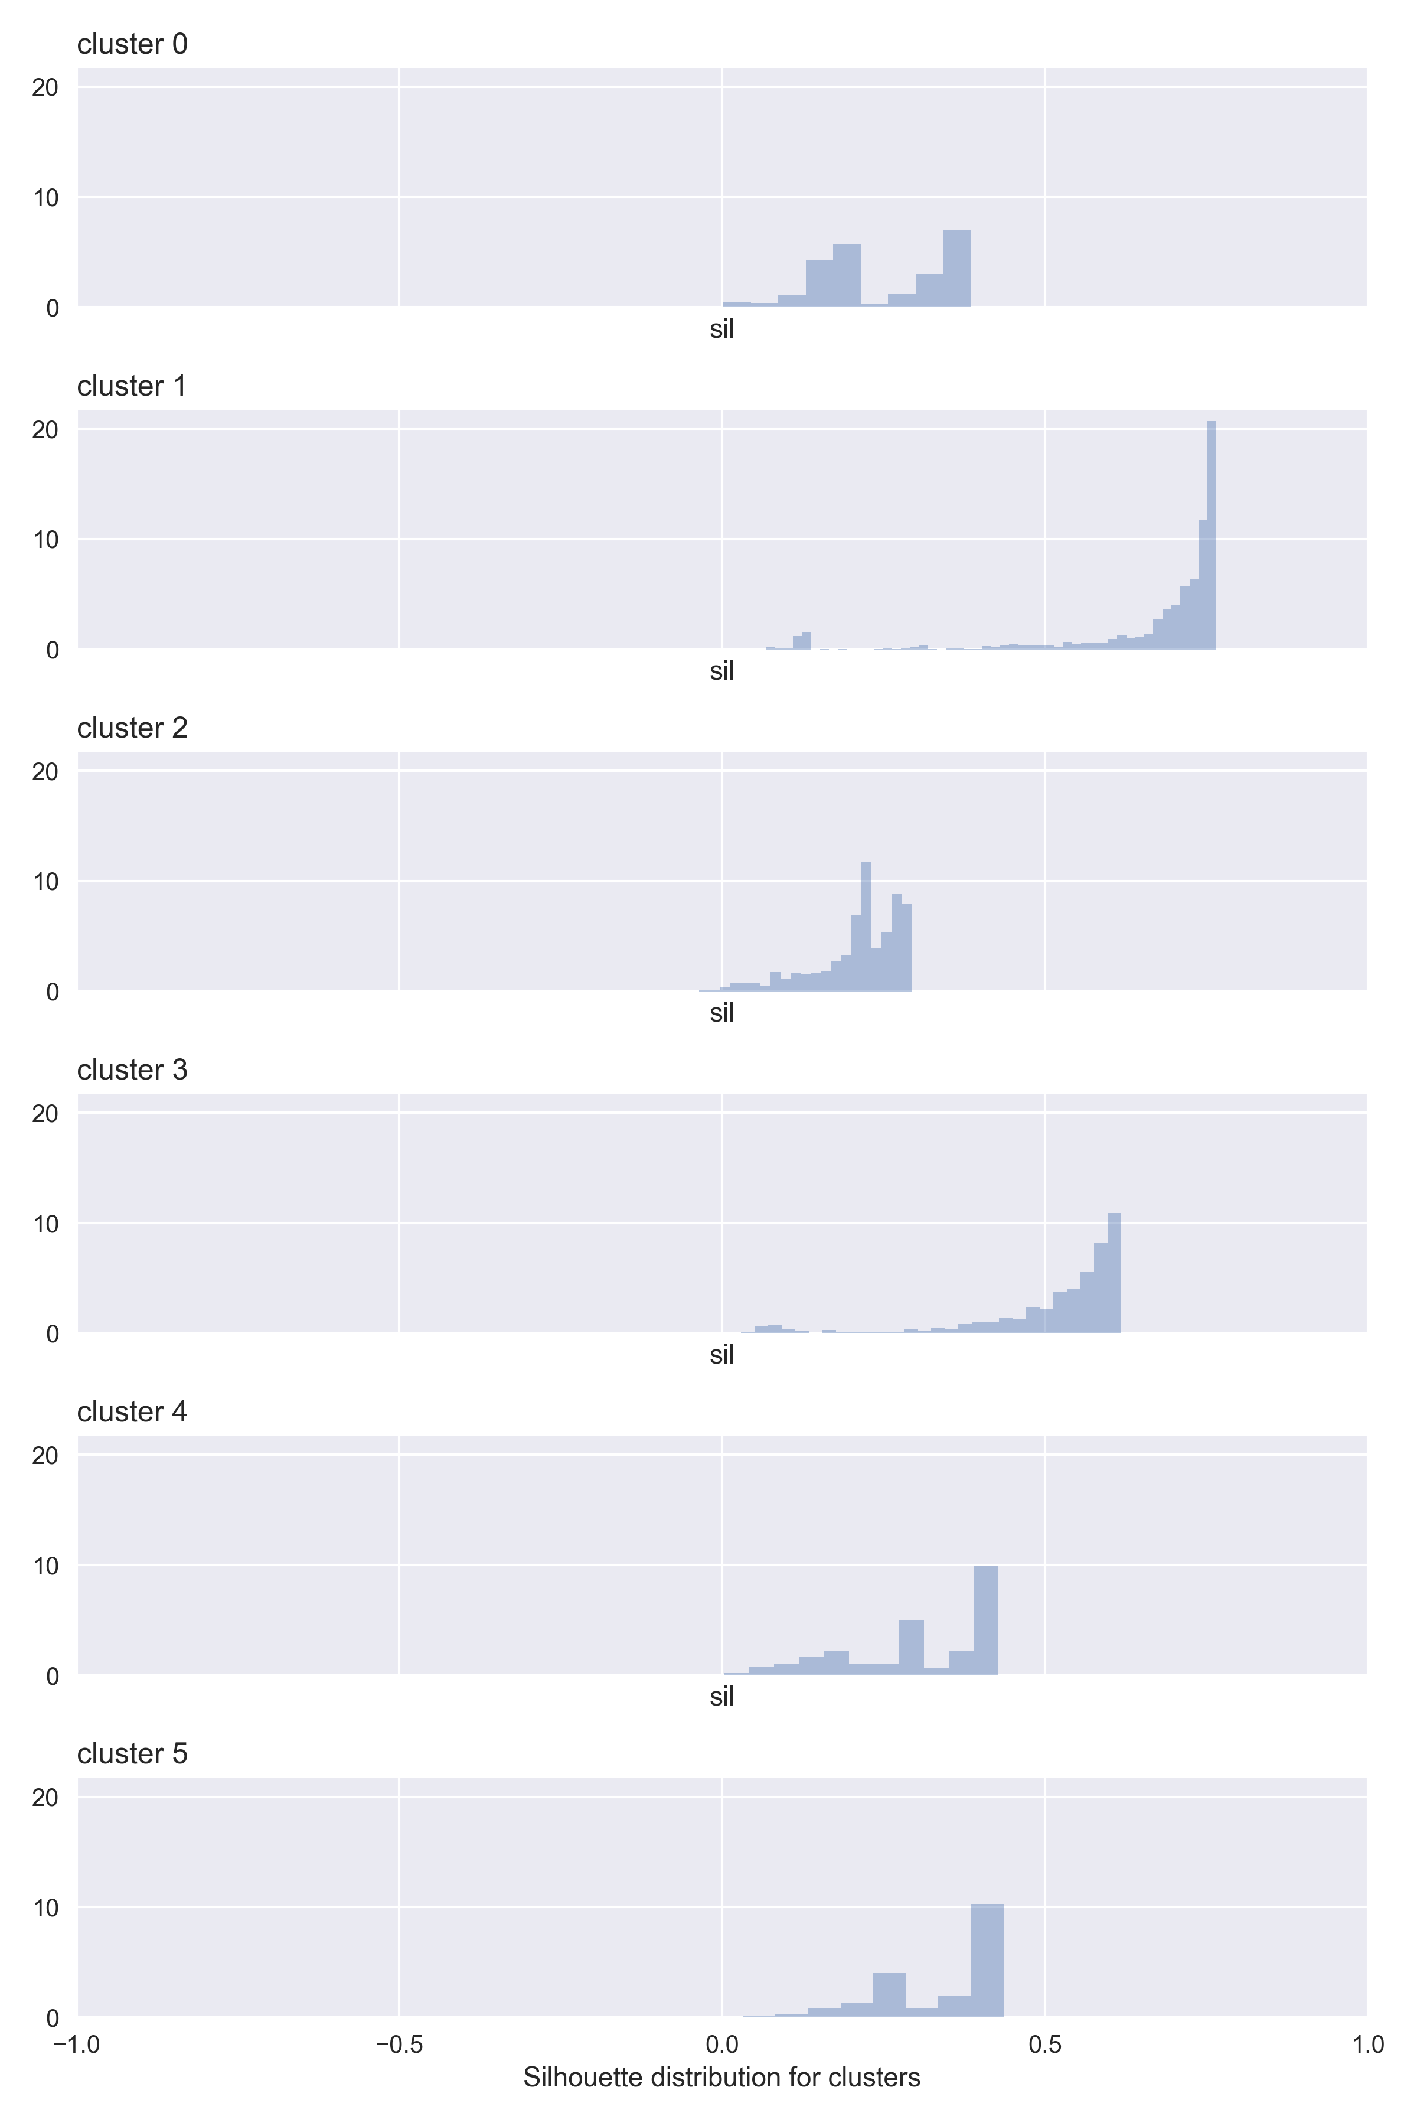

See images for silhouette for all images.

## Cluster interpretation

For cluster interpretation two resources are available:

1. Tables output to stdout during program execution.
2. Plots.

Please notice that all tables, plots and results are exhastively detailed below. They are repeated here for convenience.

From a general standpoint clusters should have low intra-cluster variance and high inter-cluster variance for each variable.

### Cluster 0

*Distinctive features:*

1. Has all individuals with 'other' marital status (that is, it is neither married nor single).

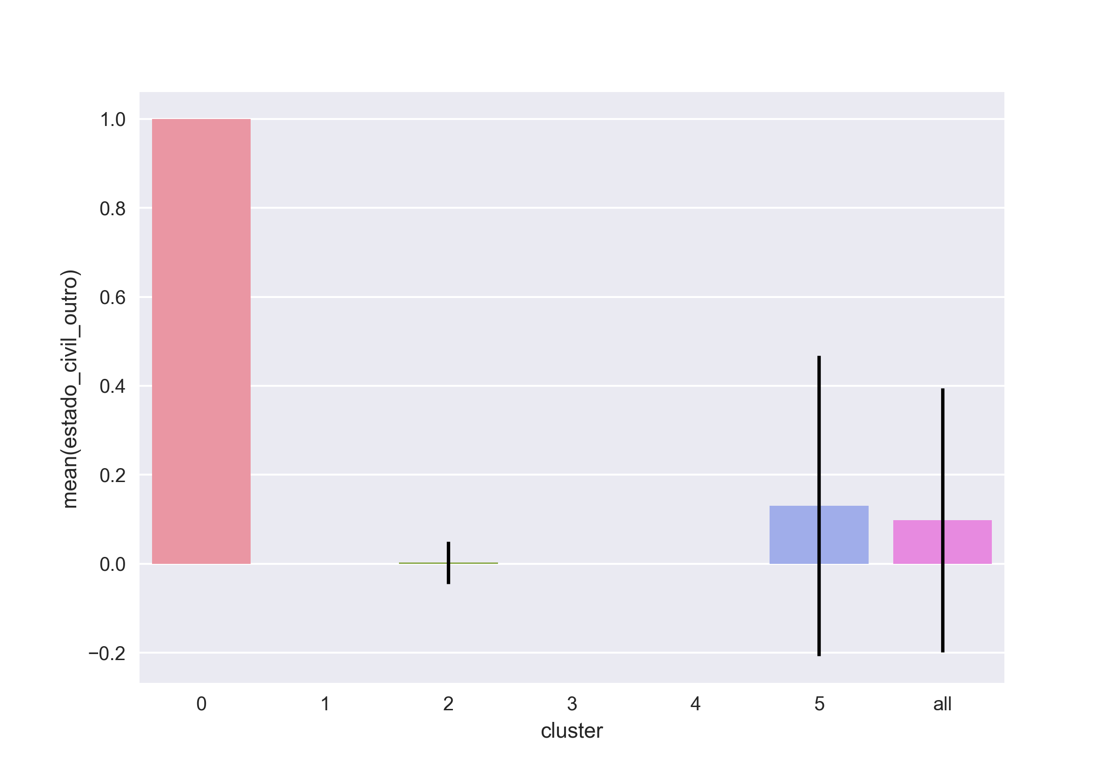

1. Has the highest age mean of all groups even though there is a high dispersion both intra and inter cluster for this variable.

### Cluster 1

*Distinctive features:*

1. Has the most concentration of single persons ('solteiro').

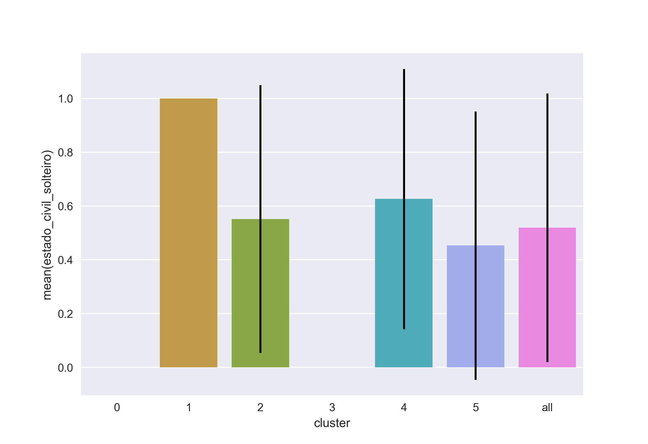

1. It is solely composed of male individuals (absence of 'genenro_f'). This also happens to cluster 2 and cluster 3.
2. Has the most concentration of profile D ('perfil_d'). Also contains a lot of profile A individuals.
3. Has the most concentration young people.
4. Has the highest average value of silhouette (see above).
5. It is the cluster which aggregates most individuals (~1400).

### Cluster 2

*Distinctive features:*

1. Has the highest averages for 'valor_02', 'valor_03' and 'valor_04'. In respect to these 3 variables all the other groups have lower averages.

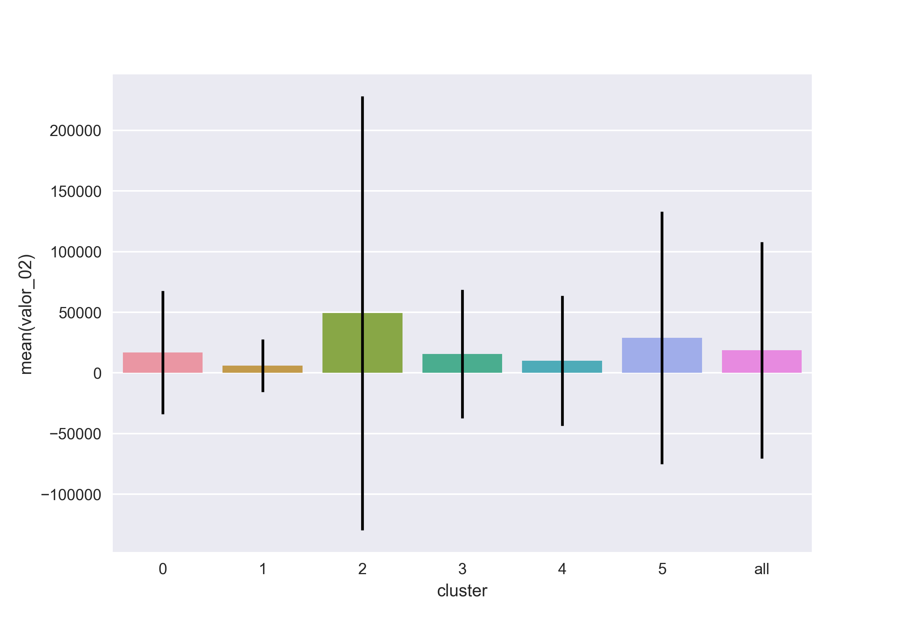

1. Includes almost solely profile B people.
2. Contains almost solely males.

### Cluster 3

*Distinctive features:*

1. It is the group with the highest proportion of married individuals ('estado_civil_casado'). And it is solely comprised of married individuals.

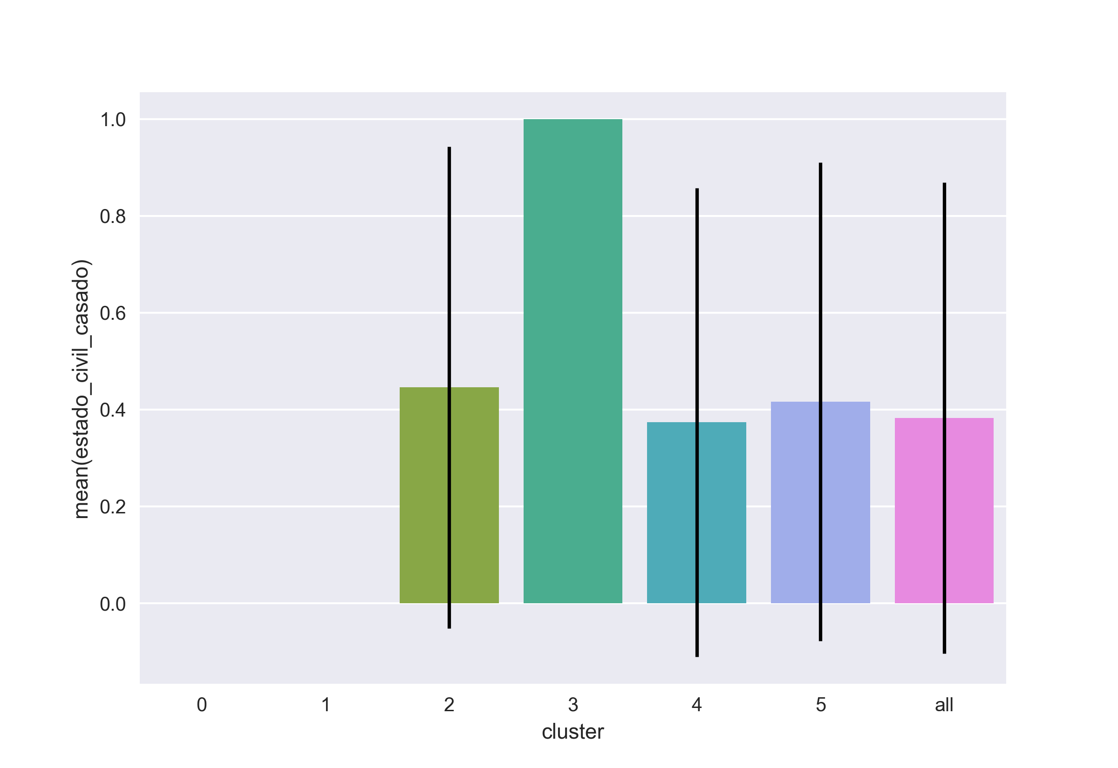

1. The cluster is entirely comprised of male individuals.
2. The cluster contains only individuals from profile A and profile D.

### Cluster 4

*Distinctive features:*

1. Comprised solely of female subjects:

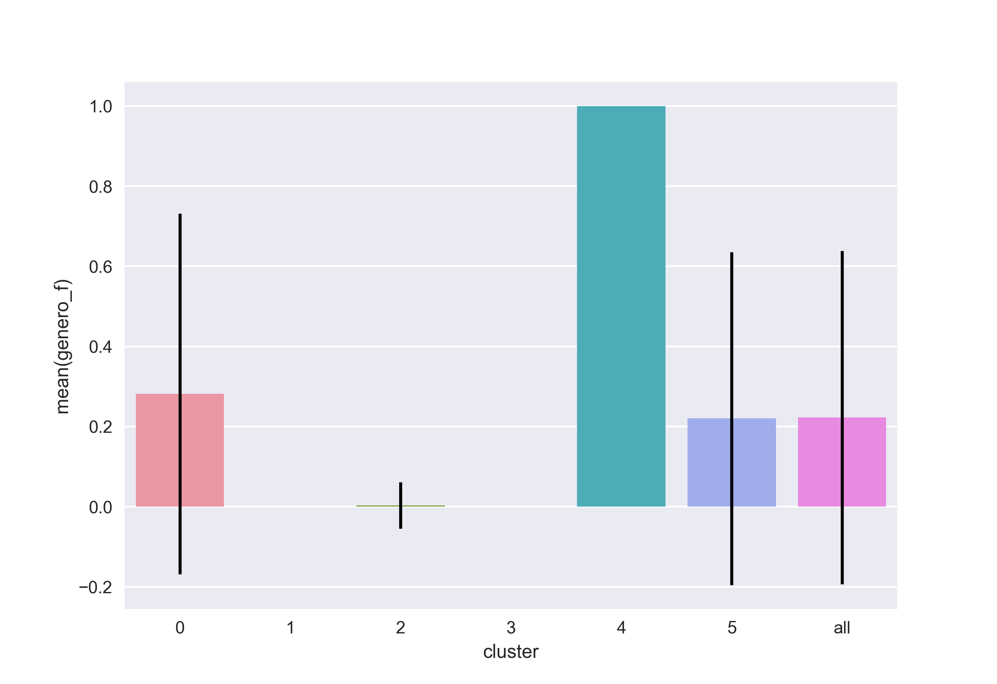

1. Contains a fair distribution of different profiles ('perfil'), marital status, and values ('valor')

### Cluster 5

*Distinctive features:*

1. Comprised solely of profile C and it contains this group entirely:

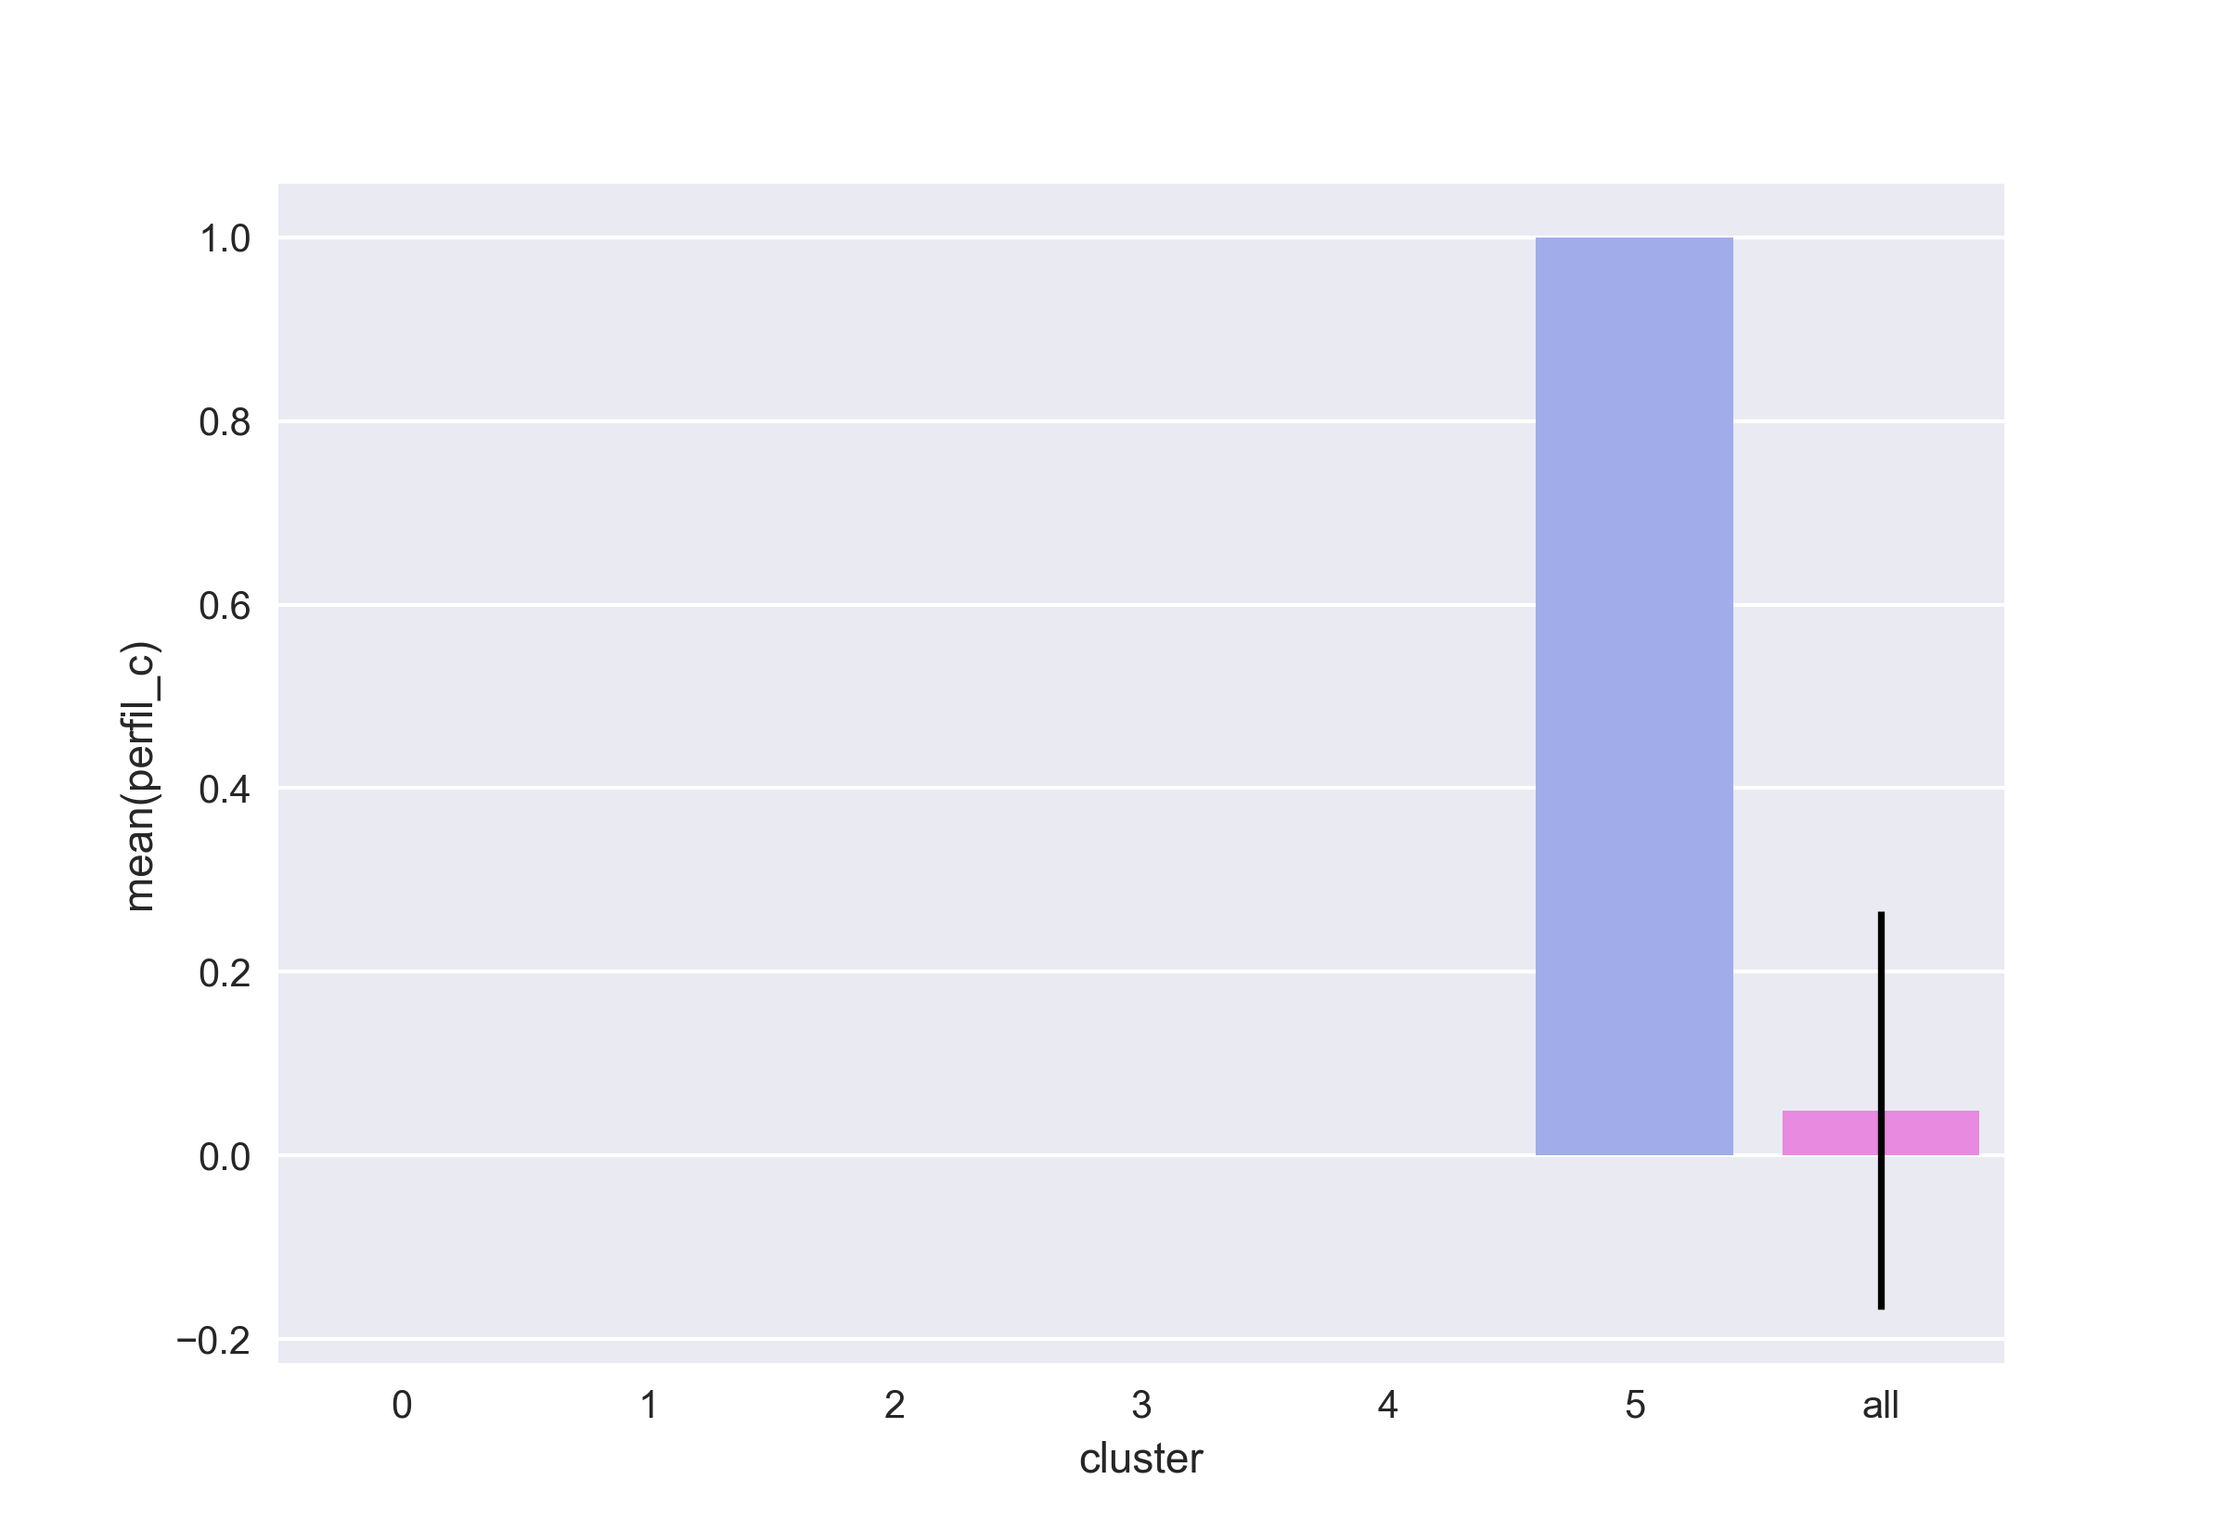

(the absence of the errorbar indicates that there in only one value for this variable in for this cluster).

1. It is the smallest of all clusters: 245 individuals.

# Summary

The clusterization was conducted properly and yielded significant results. This is evidenced by:

* A satisfactory value of silhouette indicated good clustering (0.433)
* A reasonable amount of clusters, facilitating the communication and interpretation of the results (one of the strenghts of the algorithm)
* Some very sharp separations, some of which are coupled and yield easily interpretable results:
  + Cluster 0:
    - it contains all individuals with 'other' marital status
    - has the highest age mean
    - (notice that the two variables are correlated)
  + Cluster 1:
    - all individuals are single males
    - lowest age mean of all clusters
    - it is the largest cluster
  + Cluster 2:
    - concentrates individuals with high value variables ('valor') from 2 to 4
  + Cluster 3:
    - group entirely comprised of male individuals
    - group entirely comprised of married individuals
  + Cluster 4:
    - group entirely composed of female subjects
  + Cluster 5:
    - it contains all individuals with profile C ('perfil_c')

# Additional information & Reproducibility

## Reproducibility

Reproducibility is going to be assessed in this task. In order to comply with it the software versions needed to replicate the experiement are specified below.

Also non deterministic part of the algorithms are fixed using a defined random seed at code/control.py and invoked properly during code execution.

Finally the code is hosted on github to allow any team to replicate and judge the results themselves.

## Tools

* Vim
* vim --version  
  VIM - Vi IMproved 8.0 (2016 Sep 12, compiled Apr 4 2017 13:41:19)  
  Included patches: 1-542  
  Modified by <cygwin@cygwin.com>  
  Compiled by <cygwin@cygwin.com>  
  Huge version without GUI.
* python
* python3 --version  
  Python 3.6.1
* python modules:
* data-utilities==1.2.6  
  matplotlib==2.0.0  
  numpy==1.12.1  
  pandas==0.19.2  
  scikit-learn==0.18.1  
  scipy==0.19.0  
  seaborn==0.7.1
* pandoc
* pandoc --version  
  pandoc.exe 1.19.2.1  
  Compiled with pandoc-types 1.17.0.4, texmath 0.9, skylighting 0.1.1.4  
  Default user data directory: C:\Users\e061568\AppData\Roaming\pandoc  
  Copyright (C) 2006-2016 John MacFarlane  
  Web: http://pandoc.org  
  This is free software; see the source for copying conditions.  
  There is no warranty, not even for merchantability or fitness  
  for a particular purpose.

# Other remarks

Here are comments which would not fit elsewhere in the discussion of the document. Despite there are discussions on some of these topics I thought they would not fit well in the flow of the assignment.

* As suggested in the introduction, a more precise definition of the data set could improve the conclusions that could be drawn from it. When presenting a data set for someone who is not acquainted with how it was generated extreme care should be taken in order to communicate the variables, their origin and their precise meaning carefully.
* K-Means clusterization algorithm:
  + Randomization of the initial cluster points may yield very different clusters for the given data. This is considered a weakness. To ovecome this the algorithm may use the *k-means++* initial seeding which improve the initial assignment of the algorithm.
* Approximate running time for the main.py is 7 minutes on commodity hardware:
* time python3 main.py  
   7:06.02
* It is dominated by the plotting of different k-means silhouettes. The rest of the code runs in less than one minute (full running time is kept for reproducibility).

# Next steps

* XXX TODO: close and comment all open 'XXX TODO'.
* XXX TODO: coding conventions and style will also be assessed.
  + Comment that it is PEP8 compliant
    - Comment on python-mode and contributions
  + Comment on docstrings style
    - Comment on sphinx documentation

# All output from python code

## All the images

### Silhouette

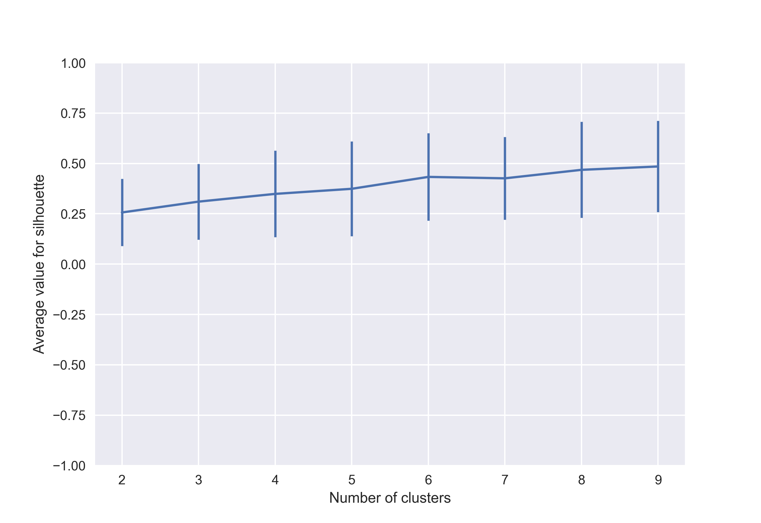

file silhouette.png

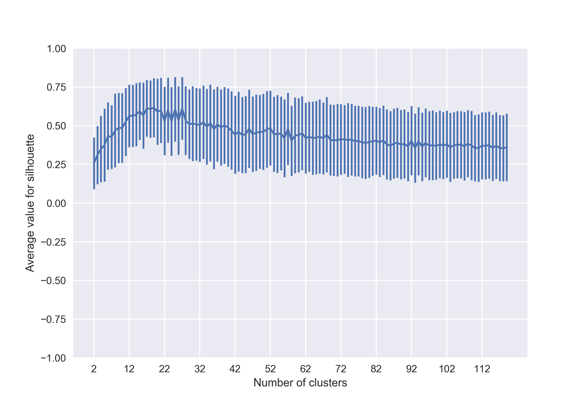

file silhouette_120.png

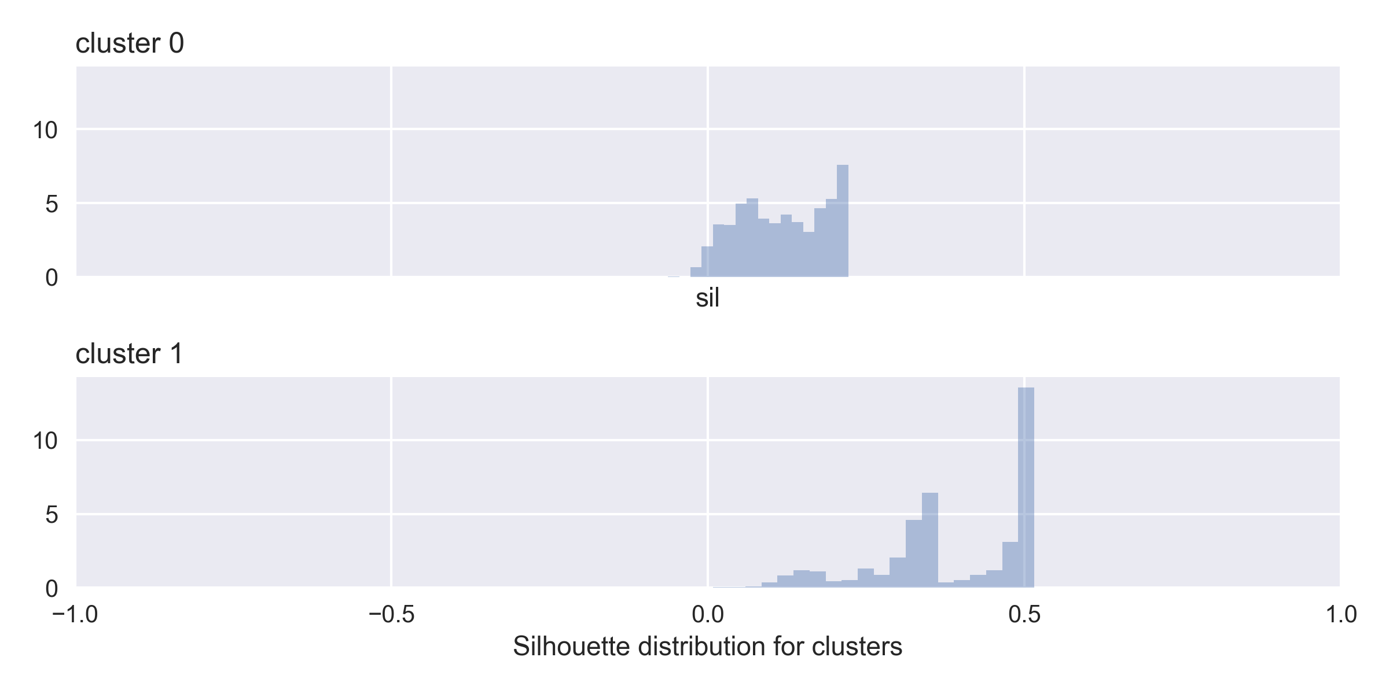

file silhouette_distribution_for_n=2_clusters.png

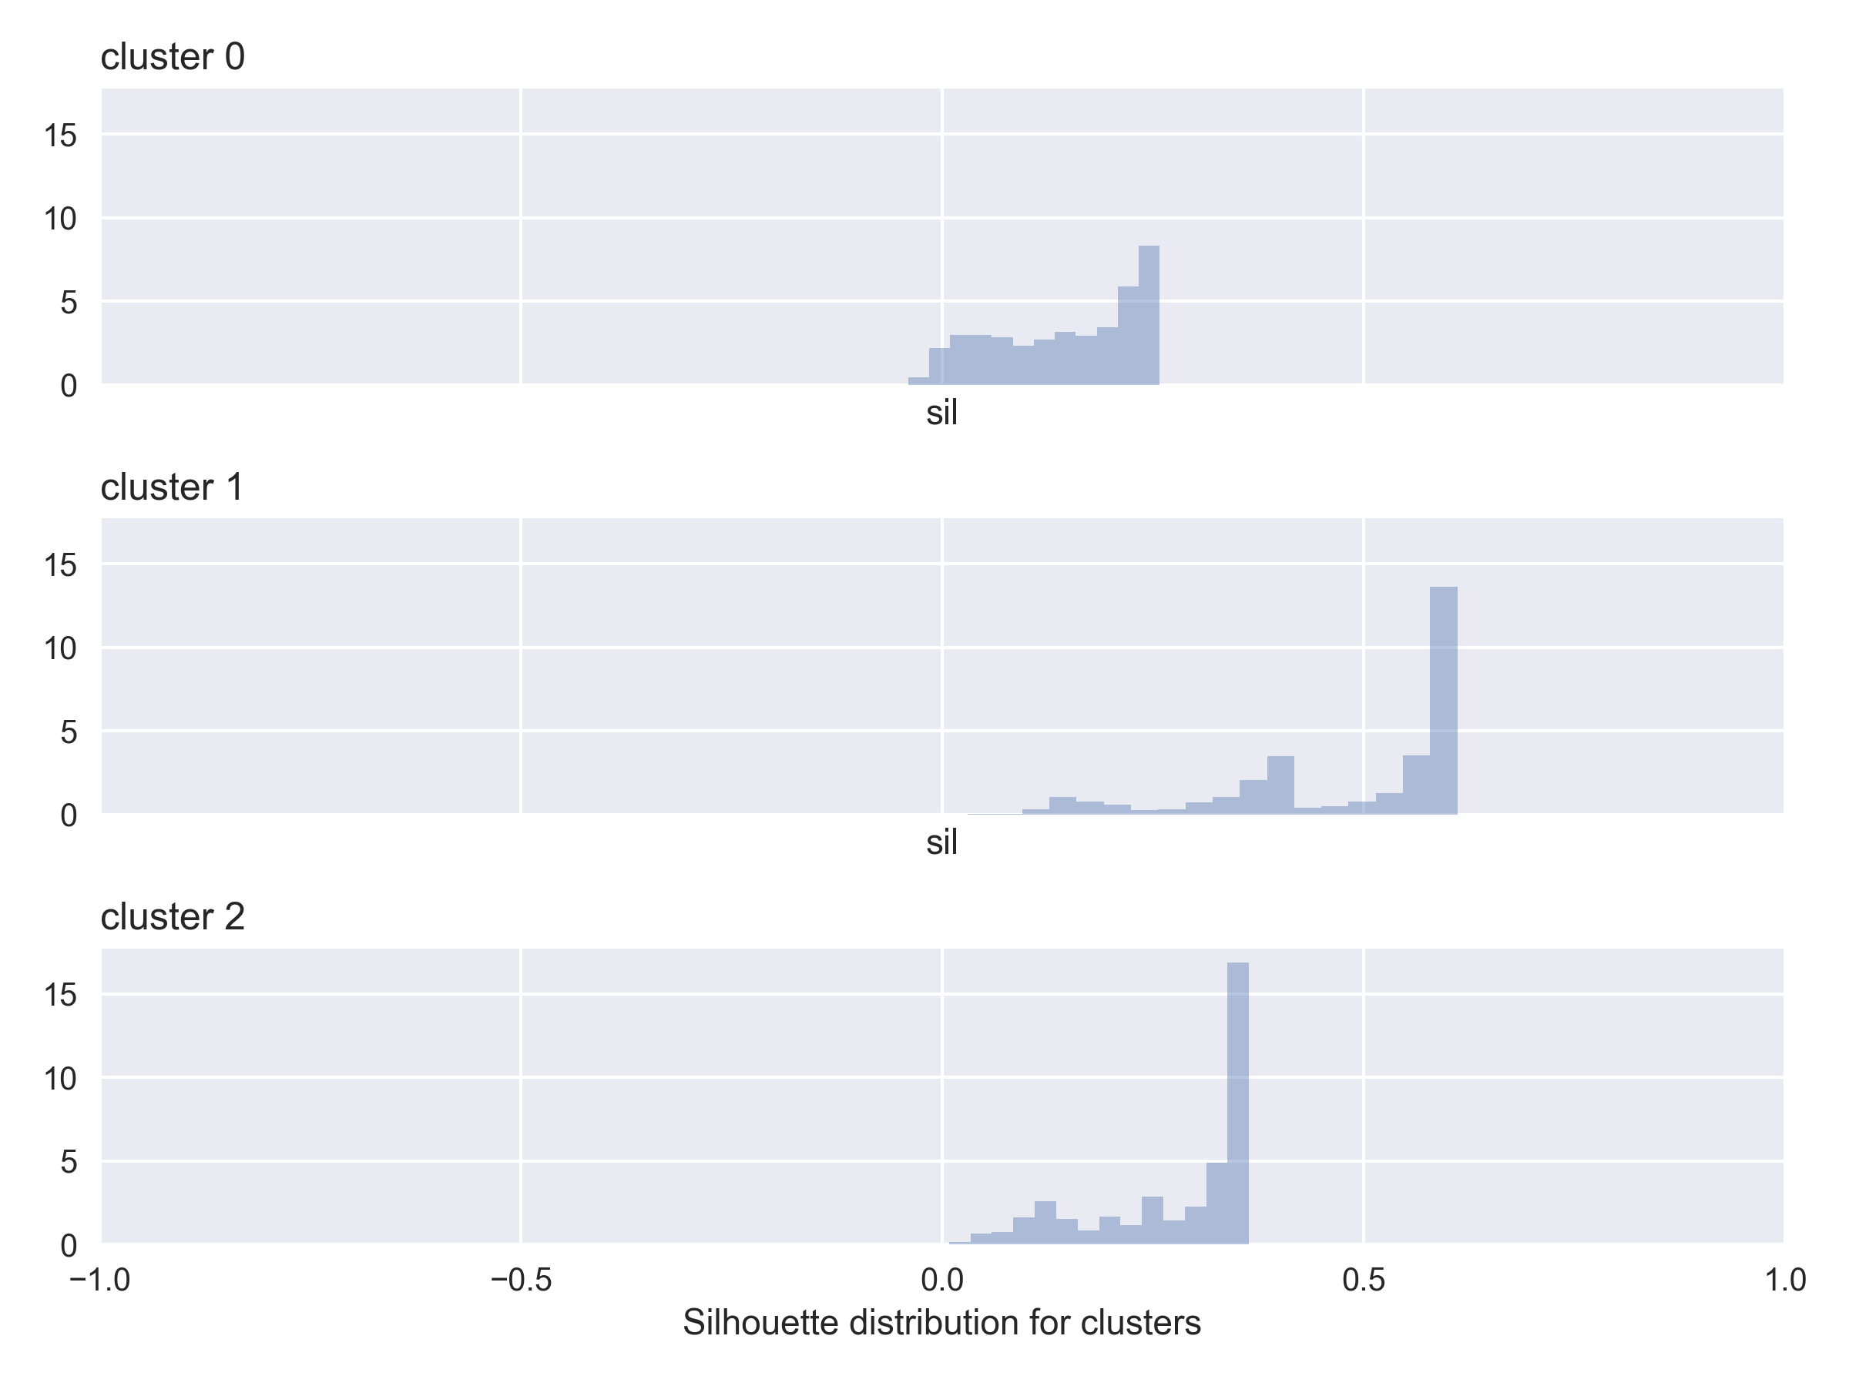

file silhouette_distribution_for_n=3_clusters.png

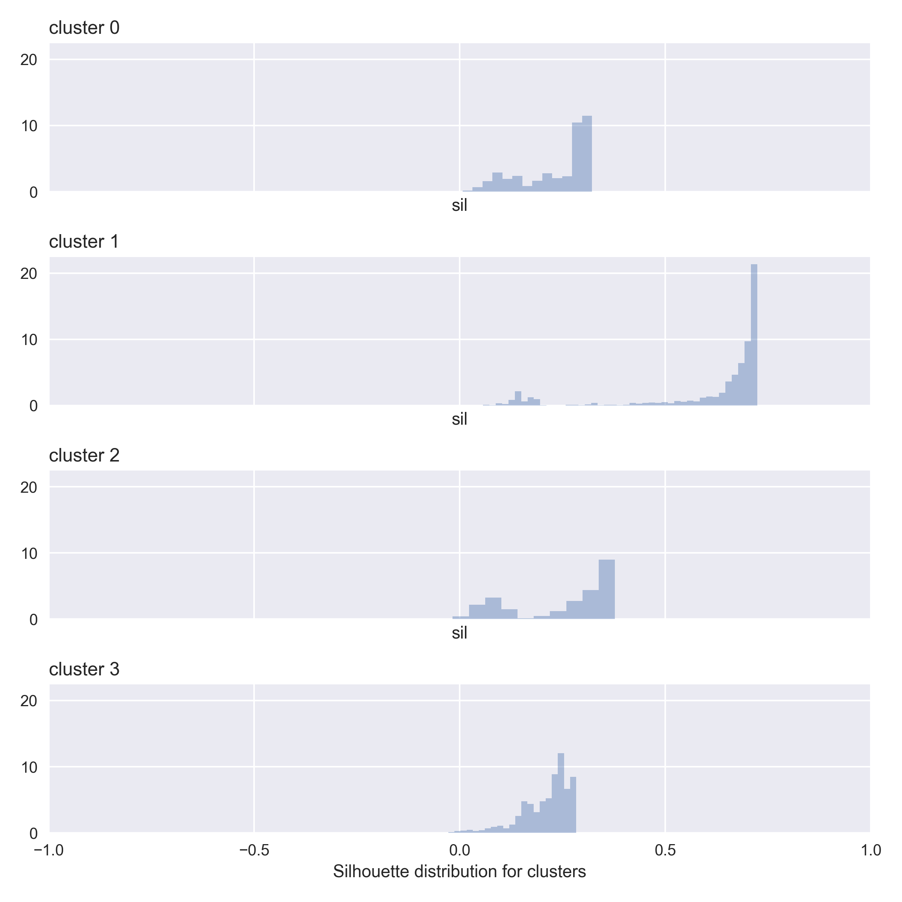

file silhouette_distribution_for_n=4_clusters.png

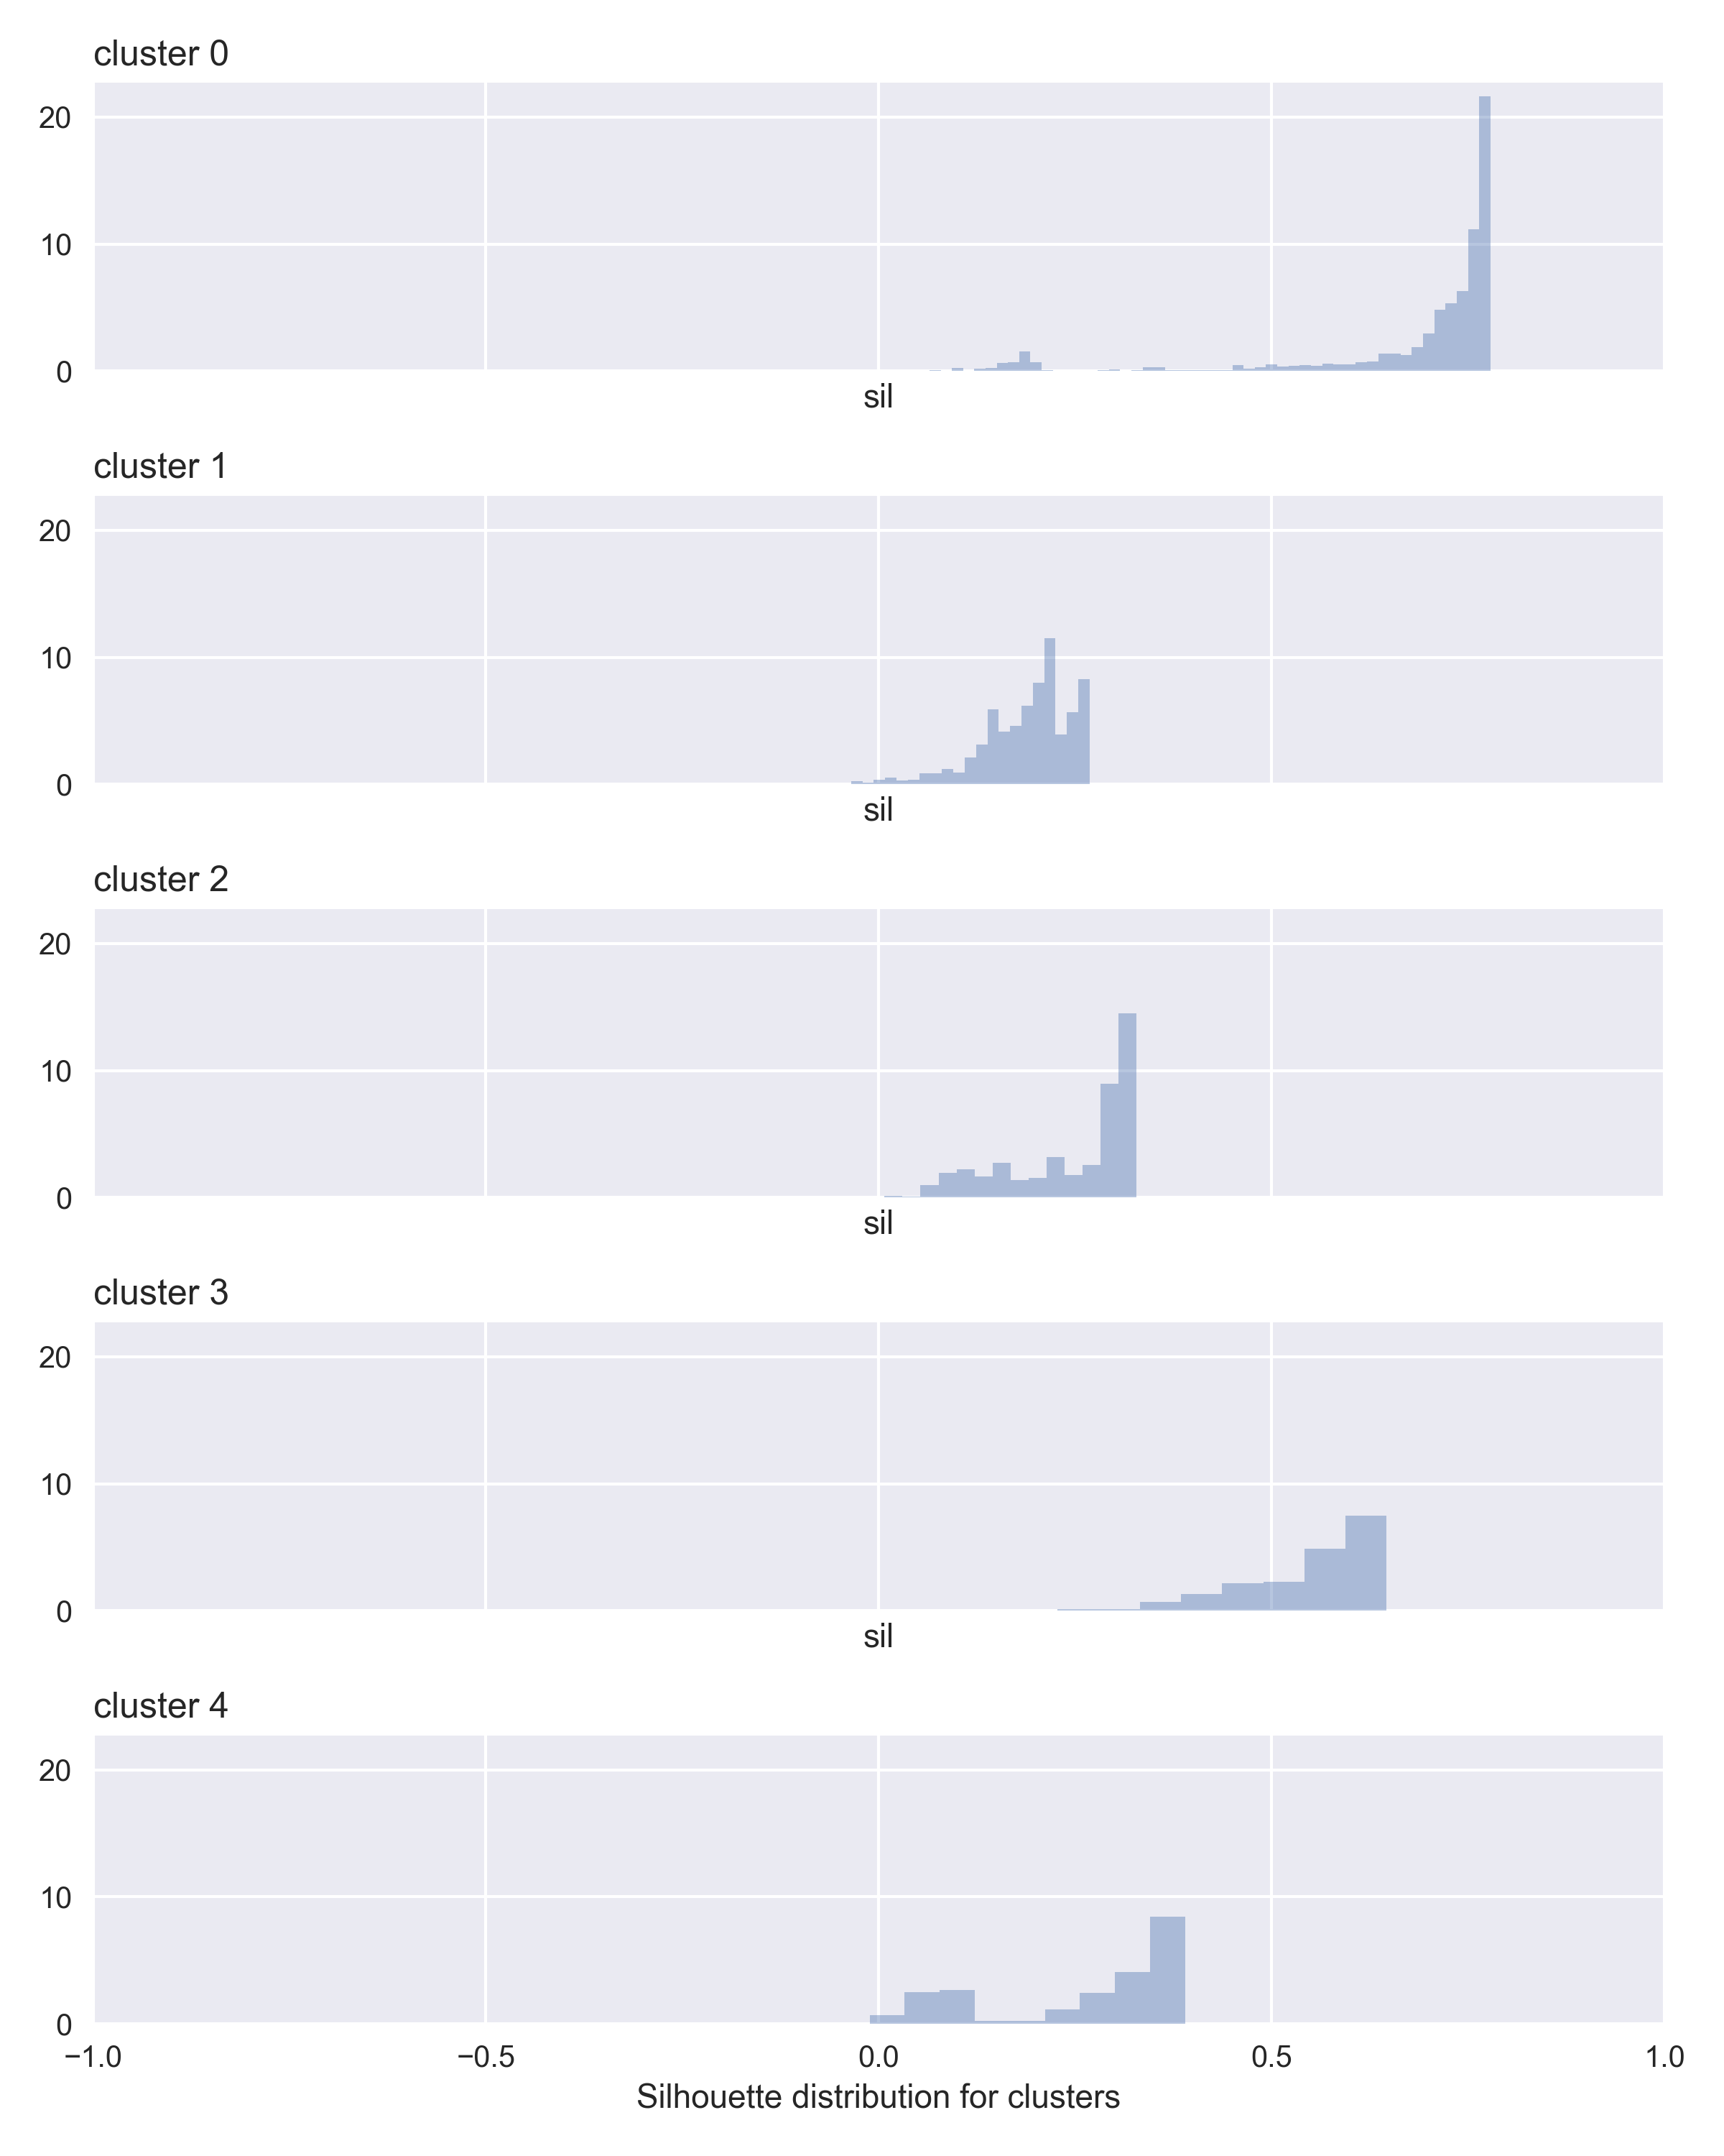

file silhouette_distribution_for_n=5_clusters.png



file silhouette_distribution_for_n=6_clusters.png

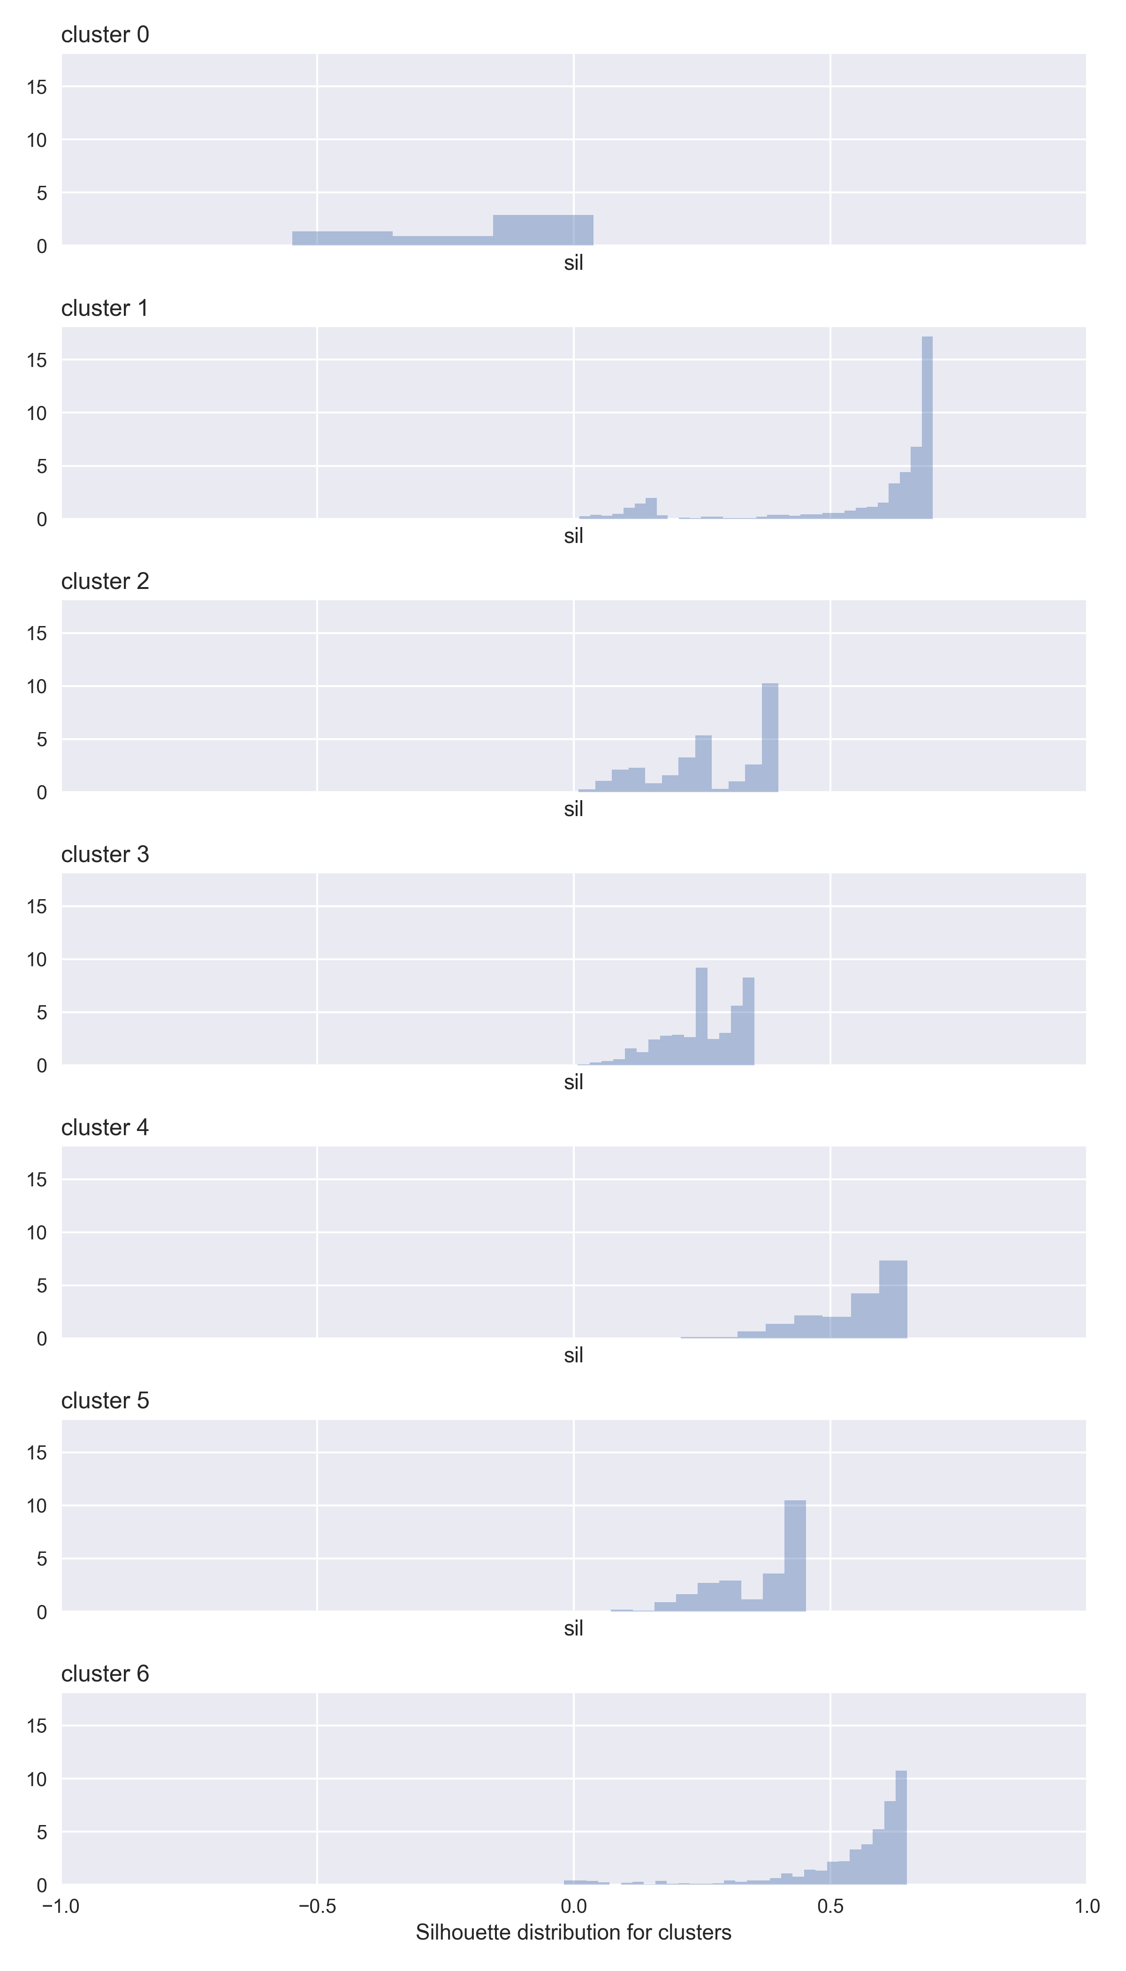

file silhouette_distribution_for_n=7_clusters.png

### Clusters

Notice that the error bars represented here are +- 1 standard deviation.

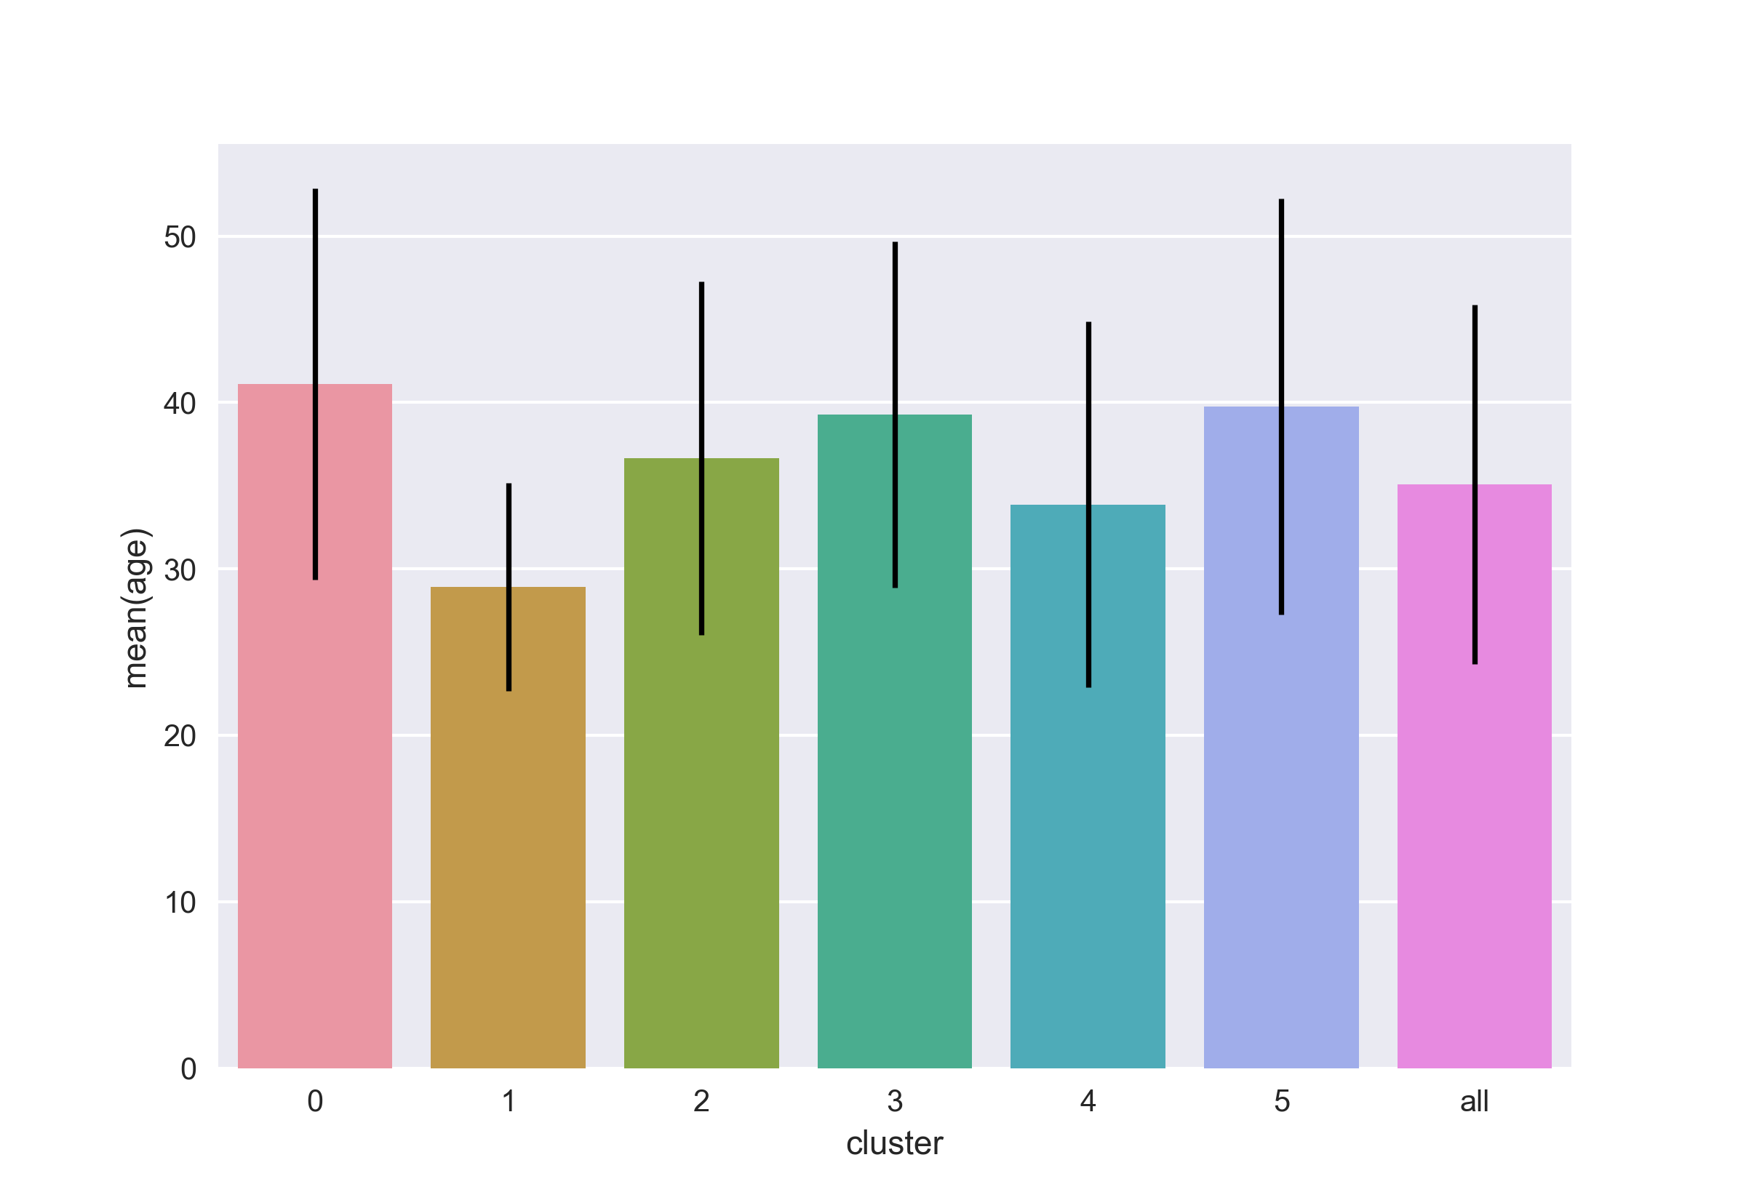

file cluster_analysis_cluster_mean_of_variables_age.png

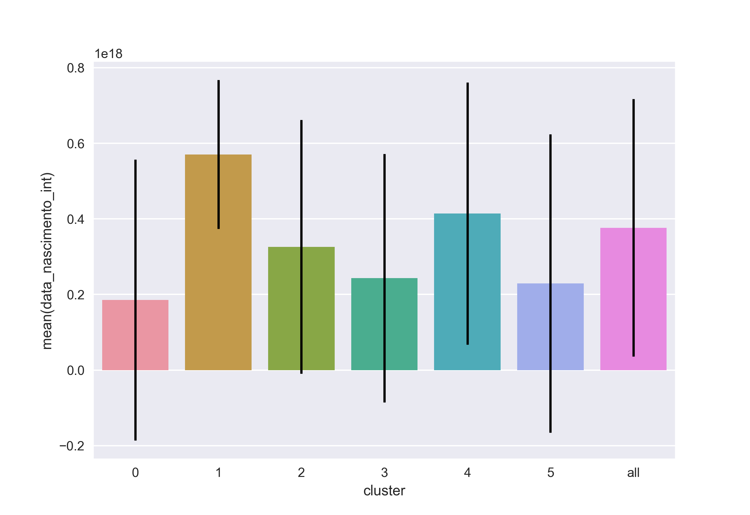

file cluster_analysis_cluster_mean_of_variables_data_nascimento_int.png



file cluster_analysis_cluster_mean_of_variables_estado_civil_casado.png



file cluster_analysis_cluster_mean_of_variables_estado_civil_outro.png



file cluster_analysis_cluster_mean_of_variables_estado_civil_solteiro.png



file cluster_analysis_cluster_mean_of_variables_genero_f.png

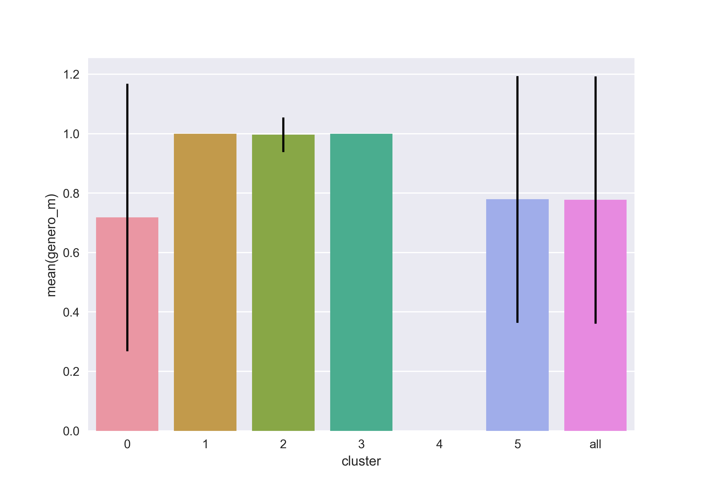

file cluster_analysis_cluster_mean_of_variables_genero_m.png

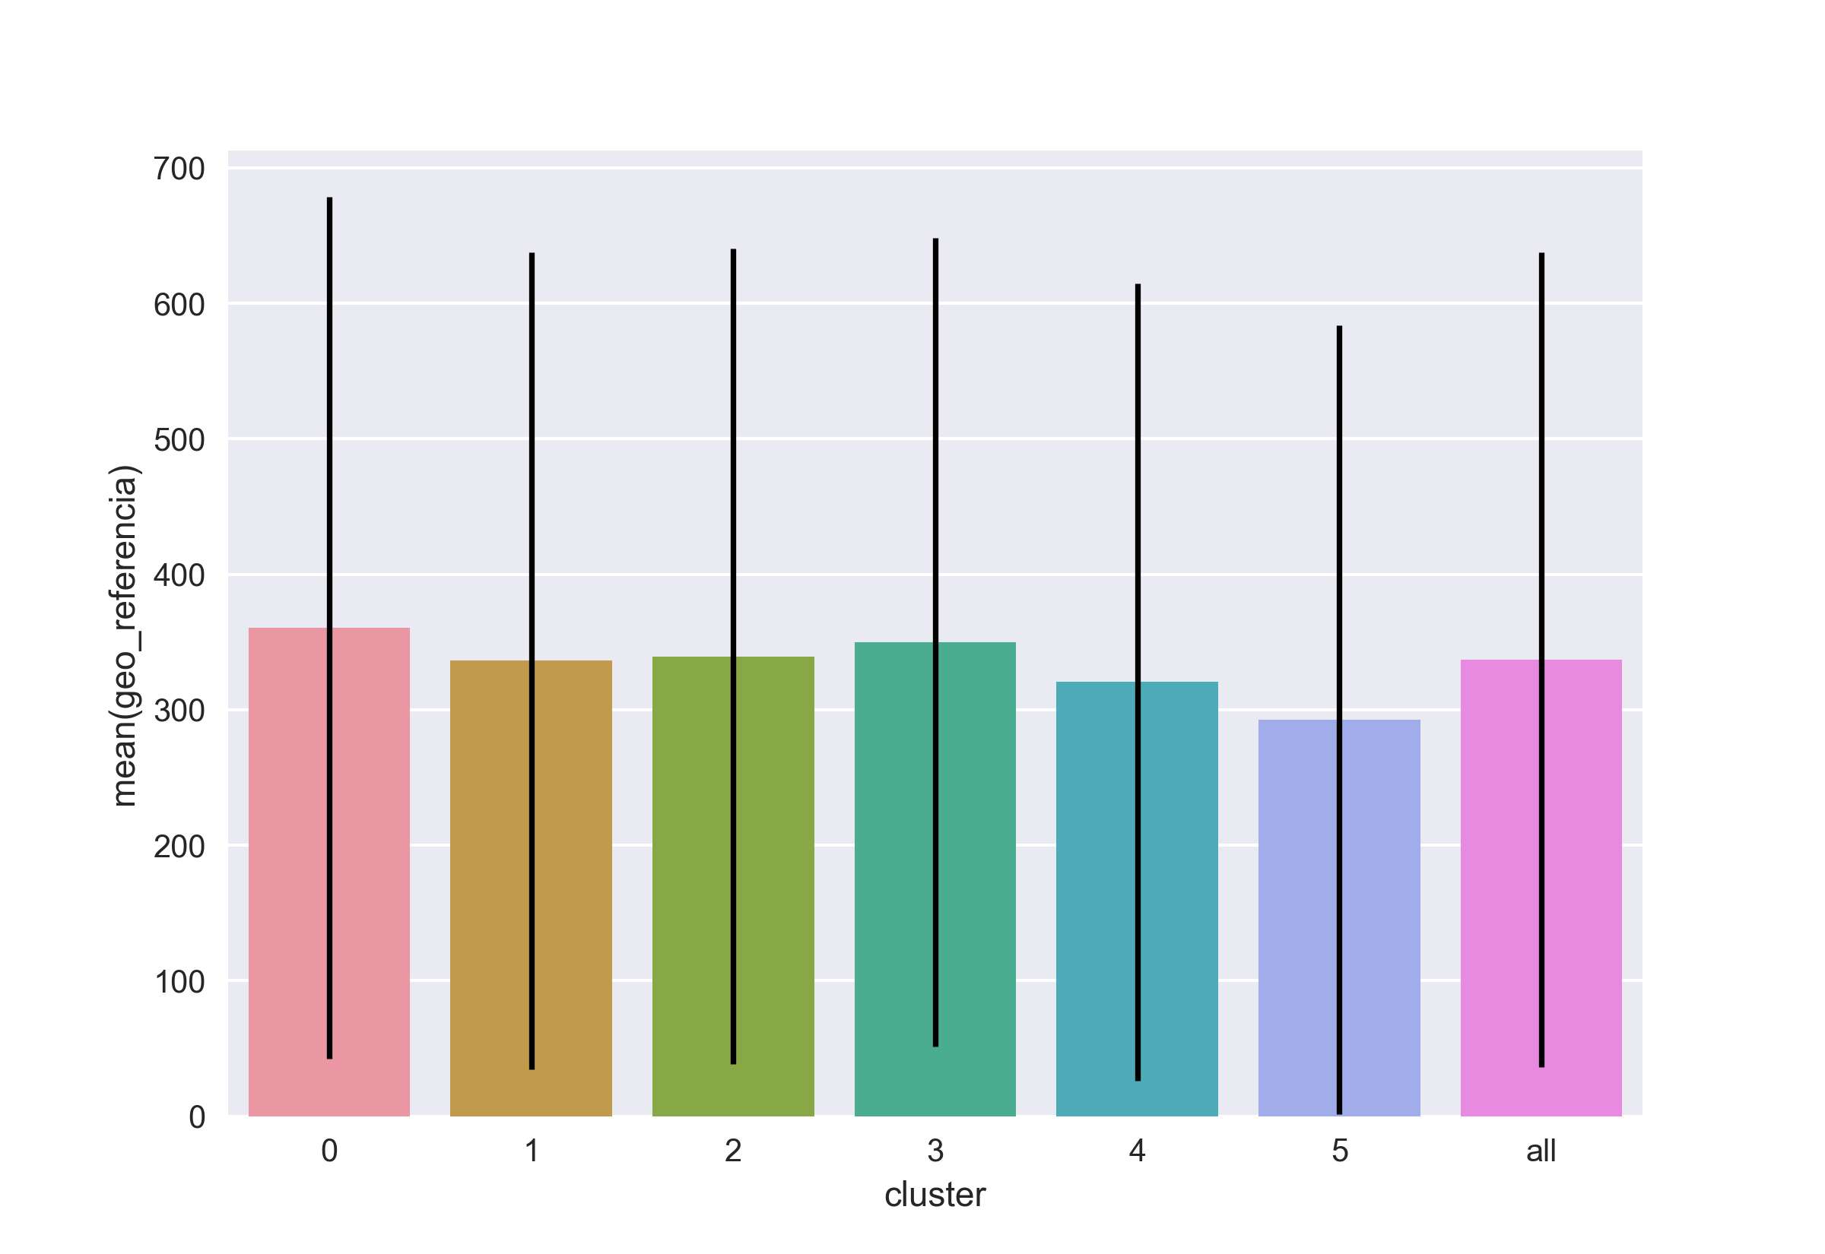

file cluster_analysis_cluster_mean_of_variables_geo_referencia.png

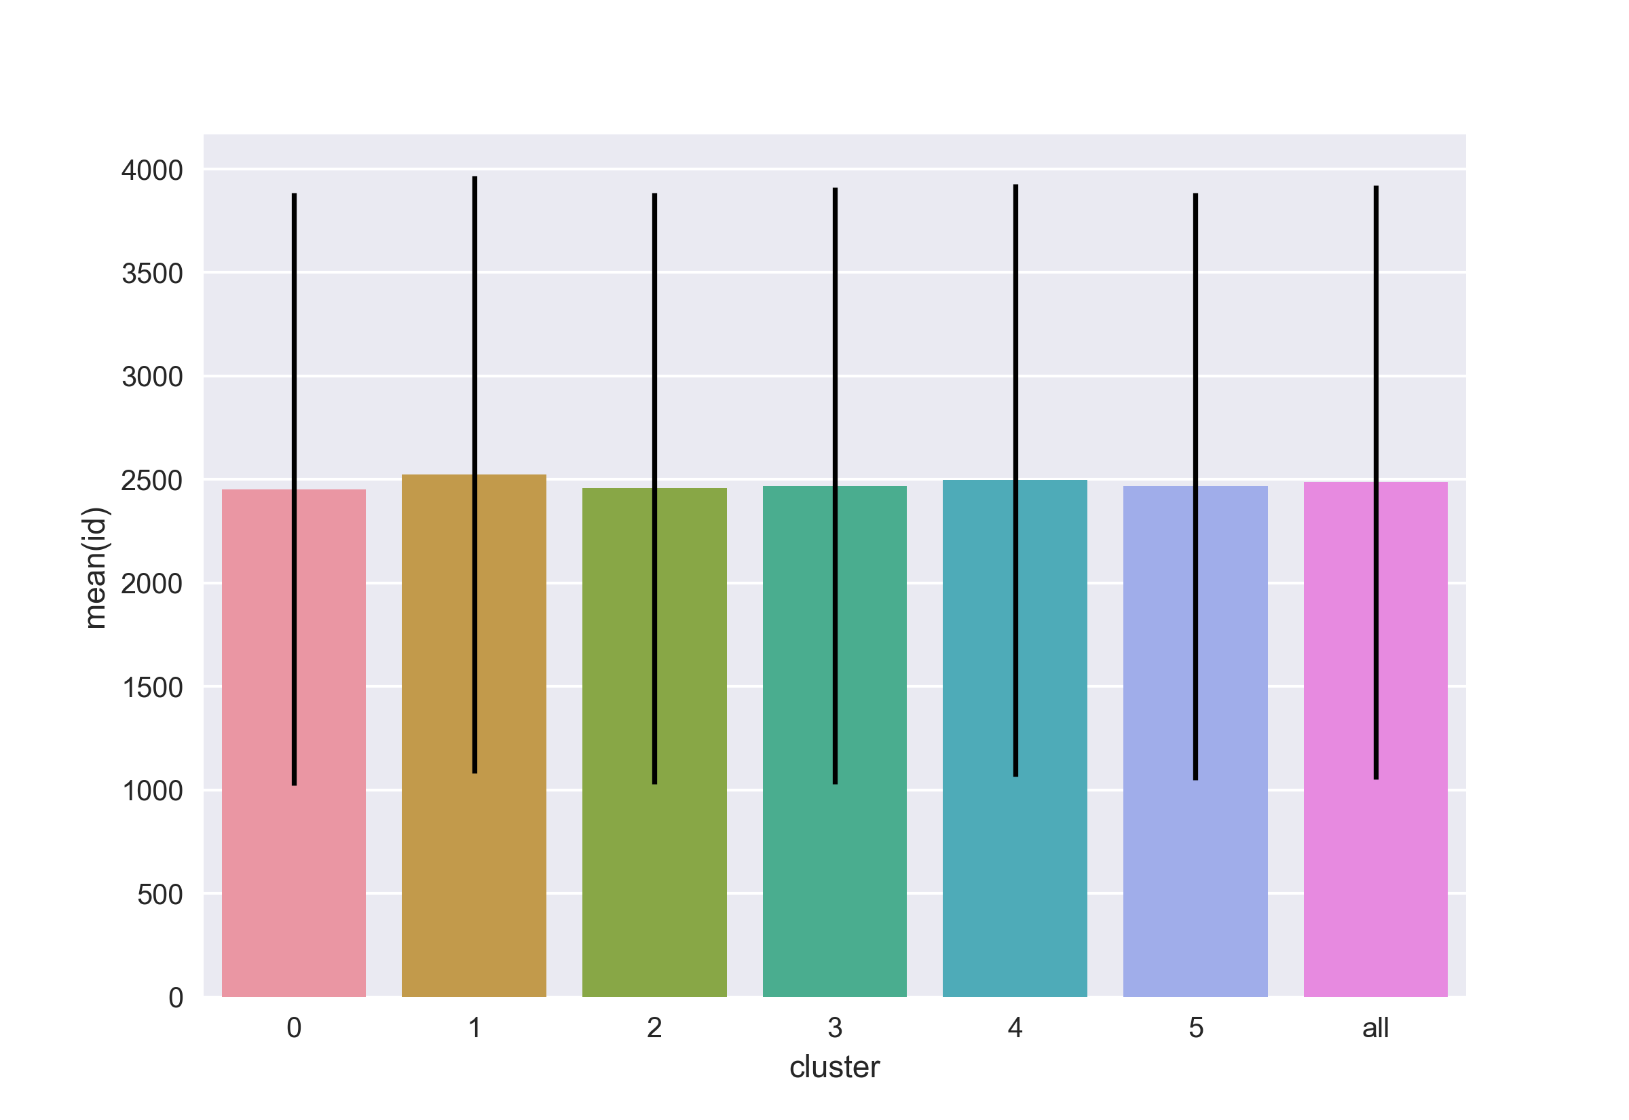

file cluster_analysis_cluster_mean_of_variables_id.png

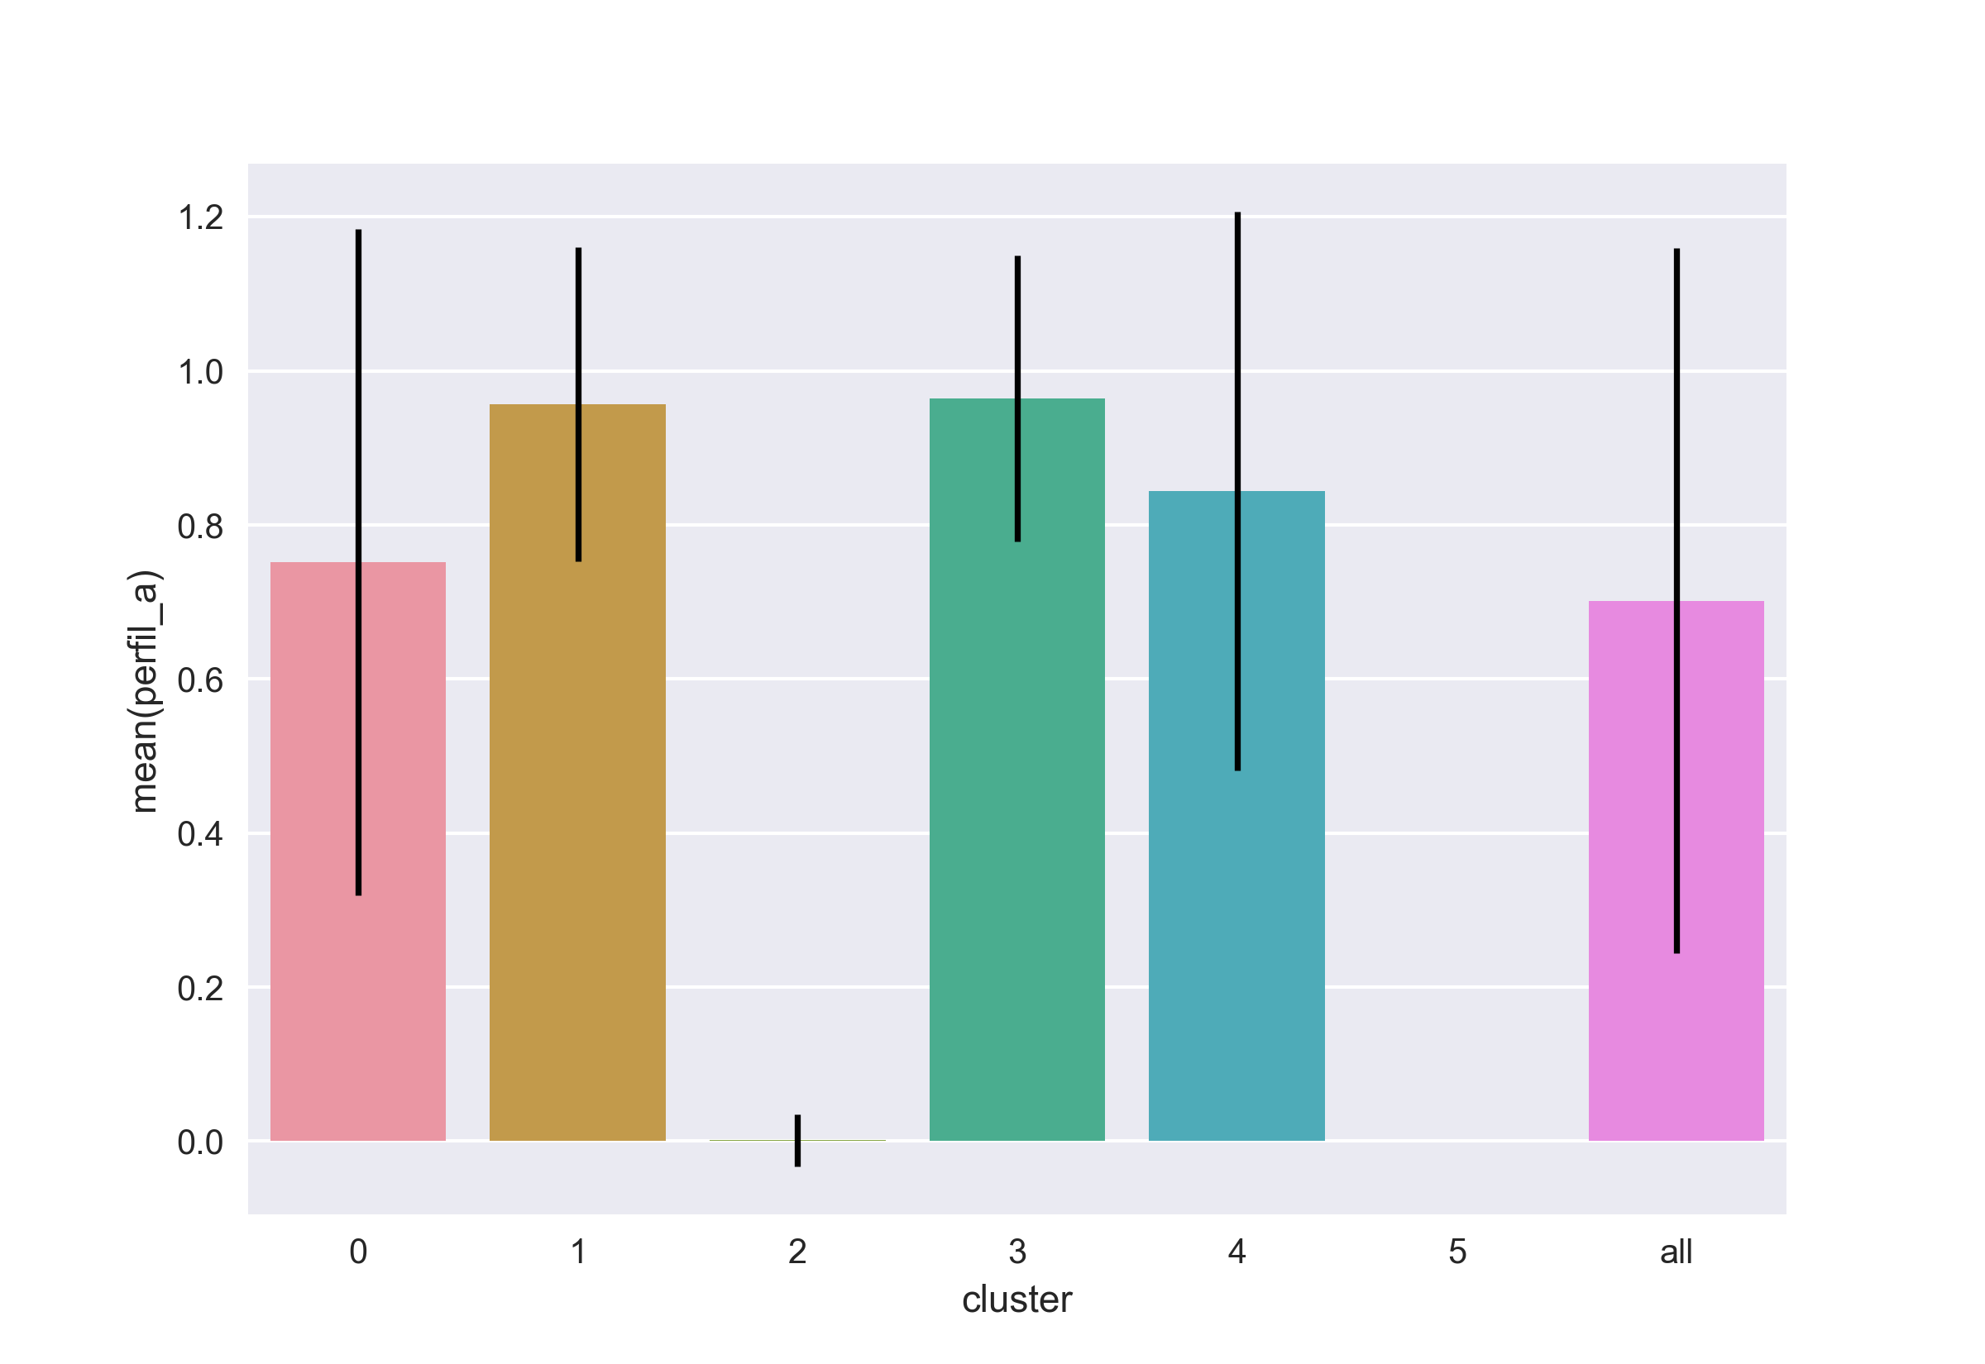

file cluster_analysis_cluster_mean_of_variables_perfil_a.png

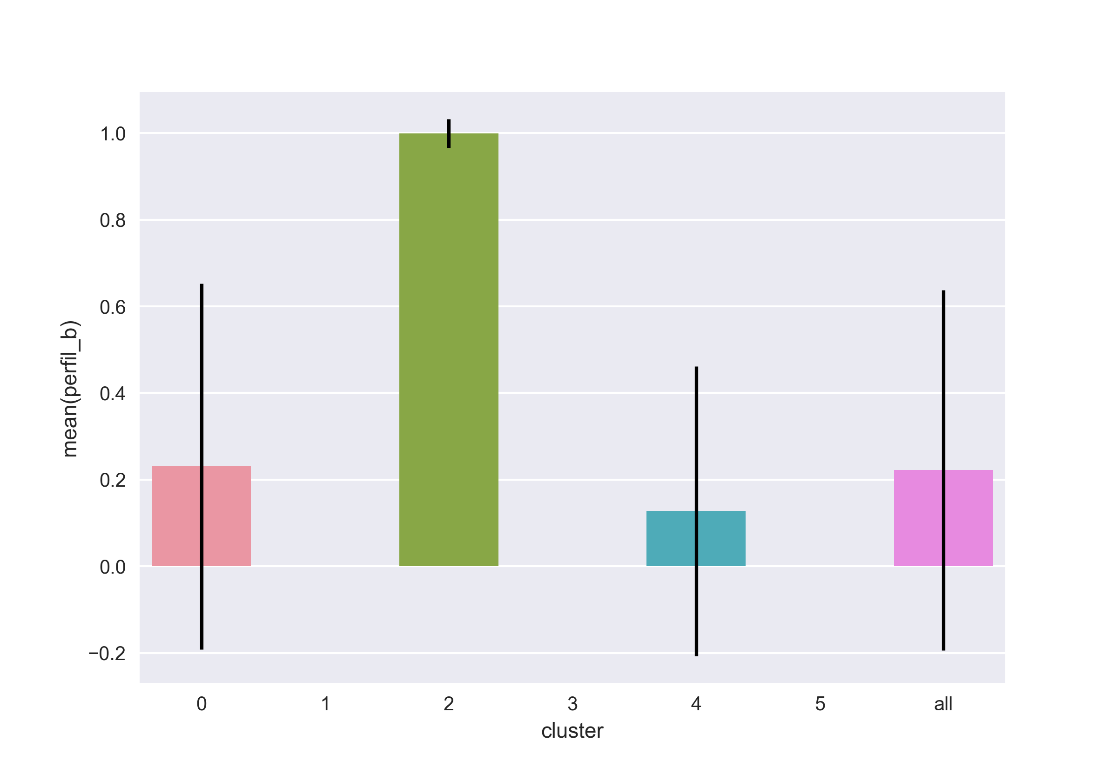

file cluster_analysis_cluster_mean_of_variables_perfil_b.png



file cluster_analysis_cluster_mean_of_variables_perfil_c.png

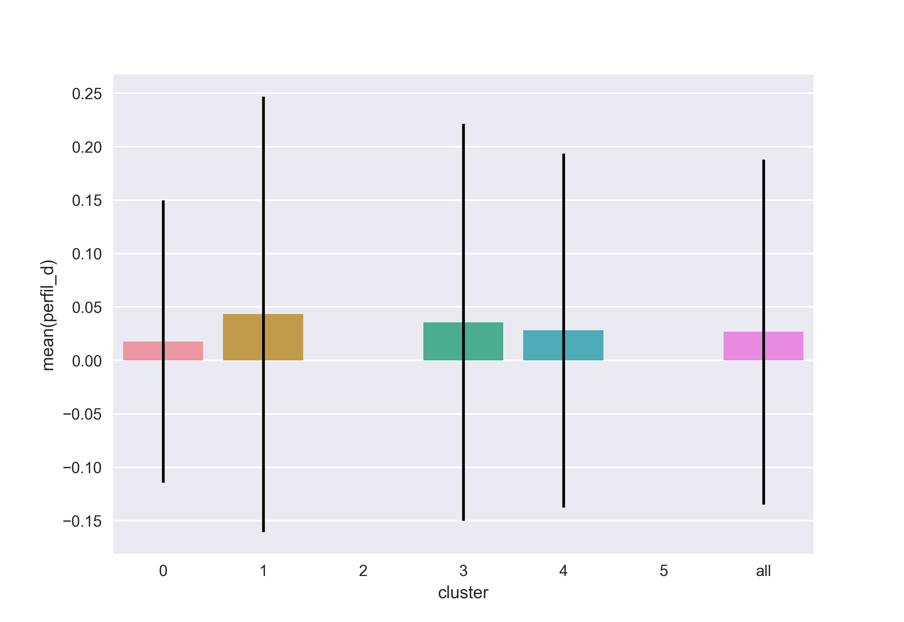

file cluster_analysis_cluster_mean_of_variables_perfil_d.png

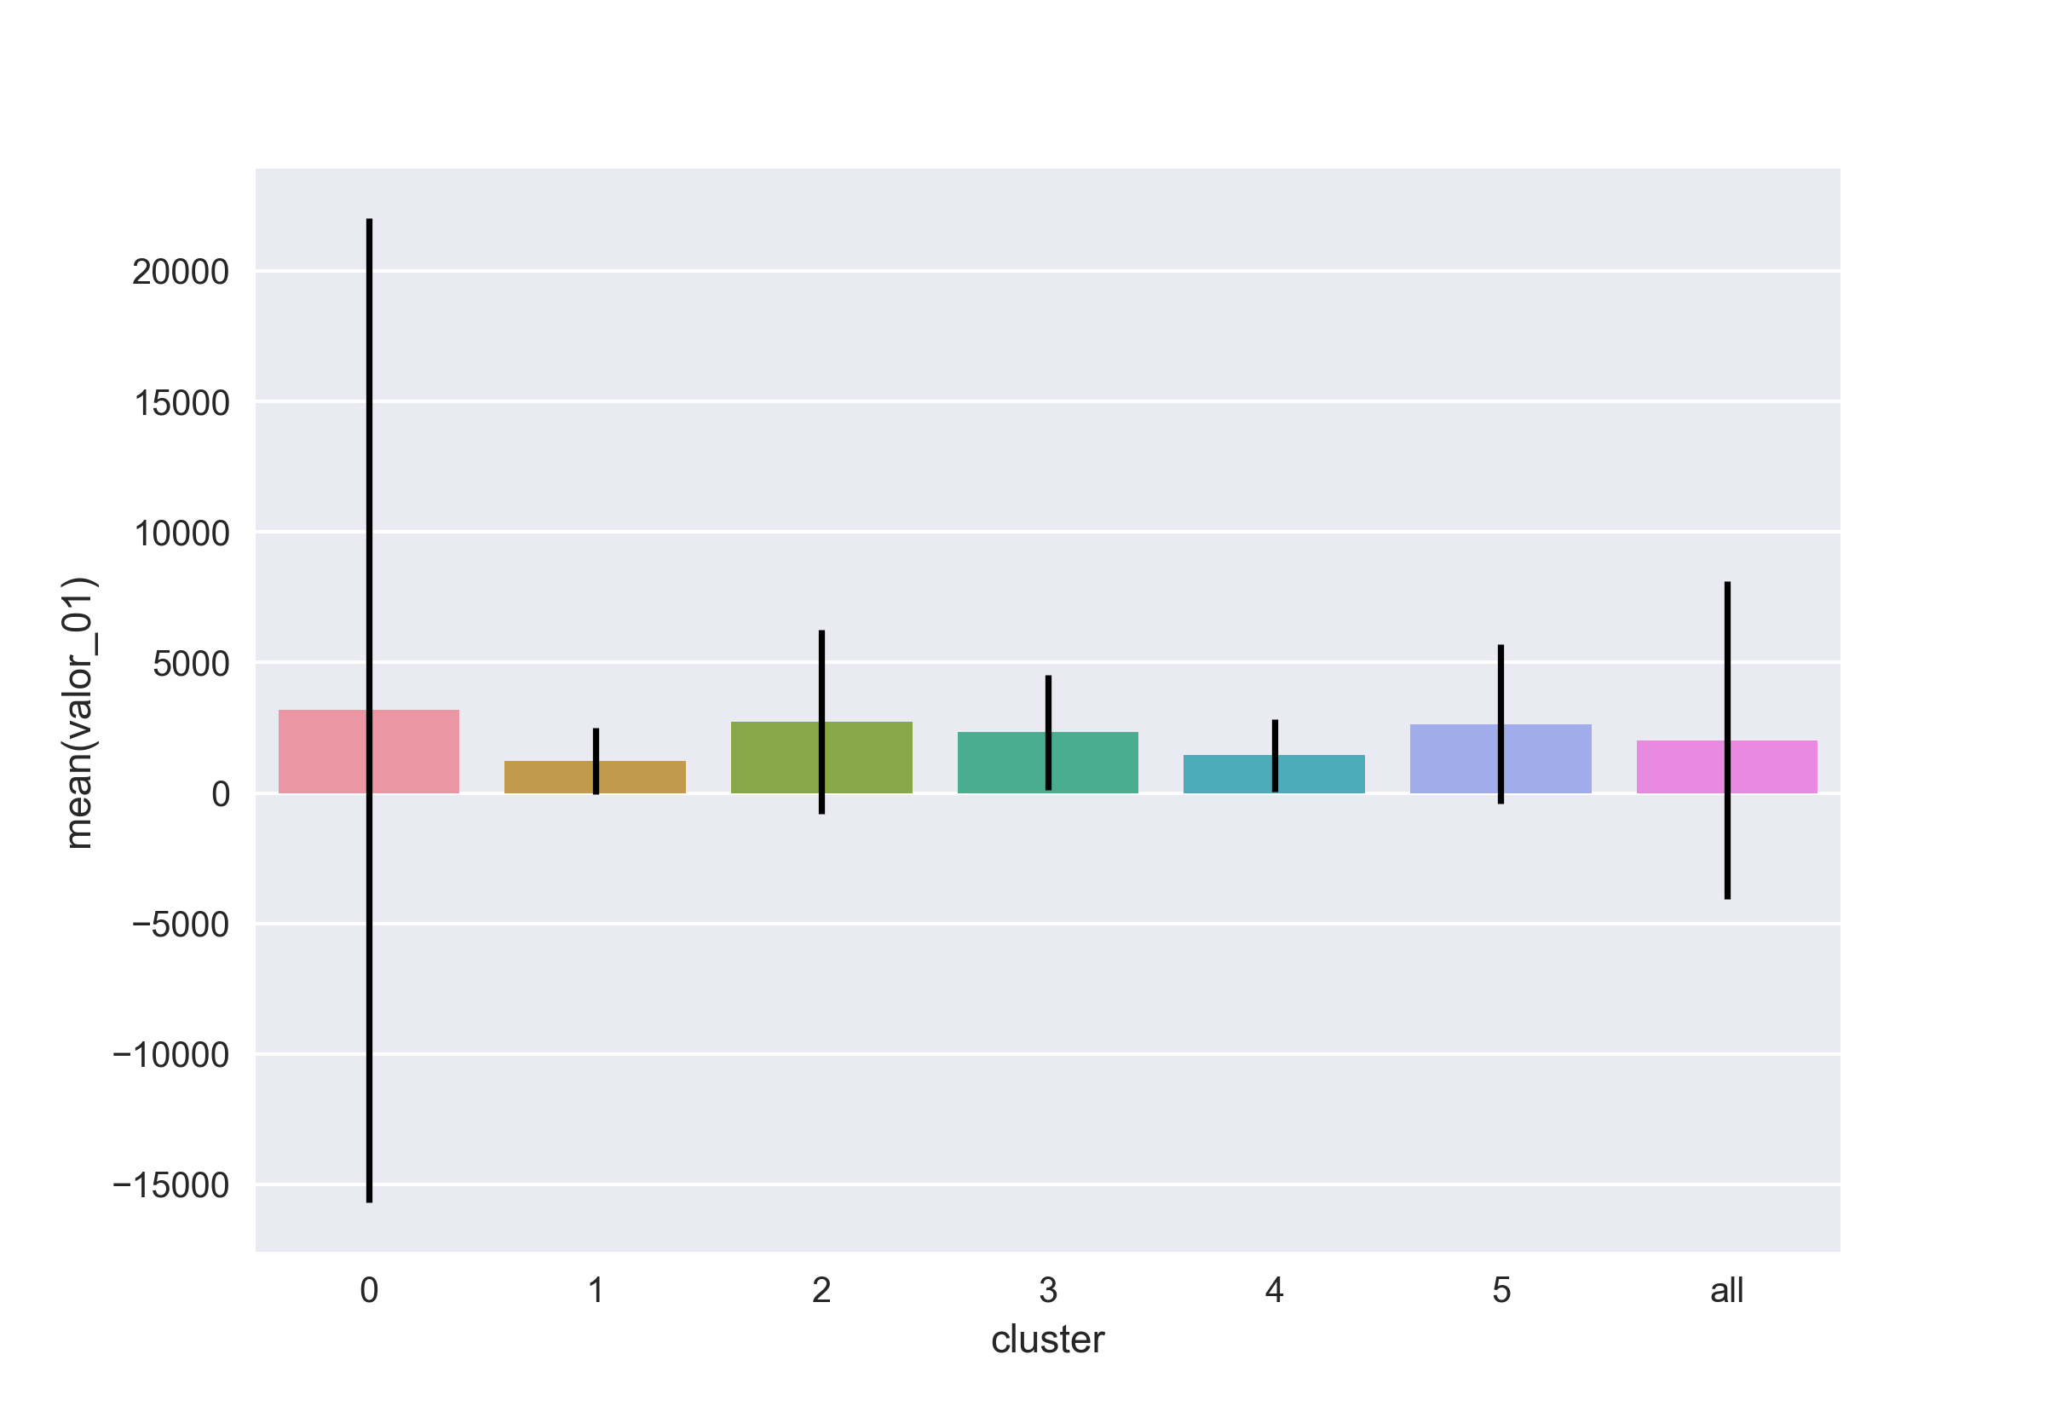

file cluster_analysis_cluster_mean_of_variables_valor_01.png



file cluster_analysis_cluster_mean_of_variables_valor_02.png

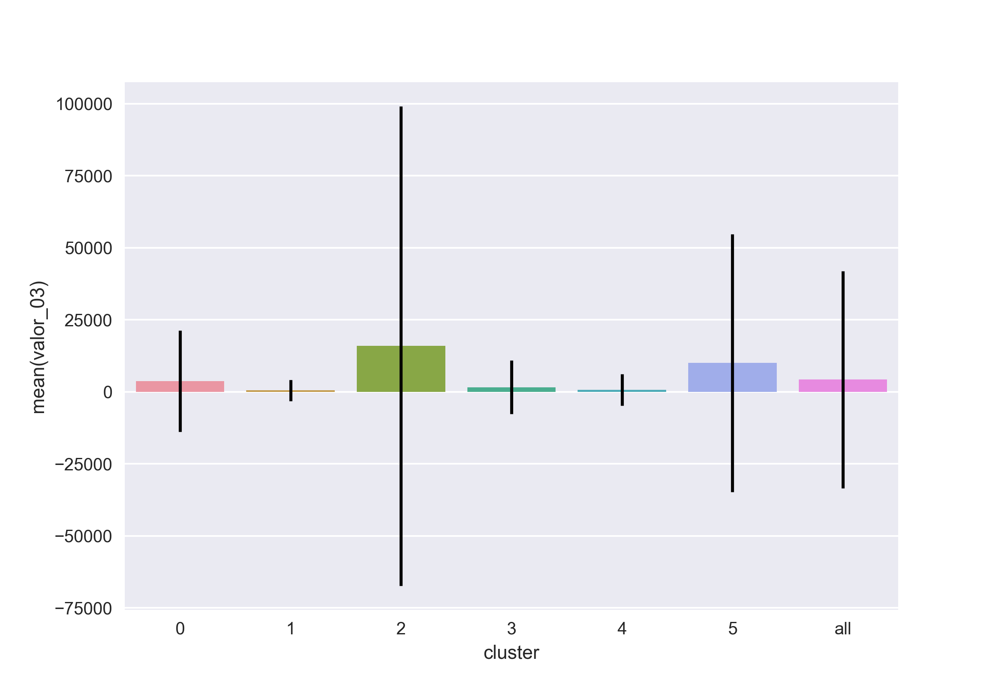

file cluster_analysis_cluster_mean_of_variables_valor_03.png

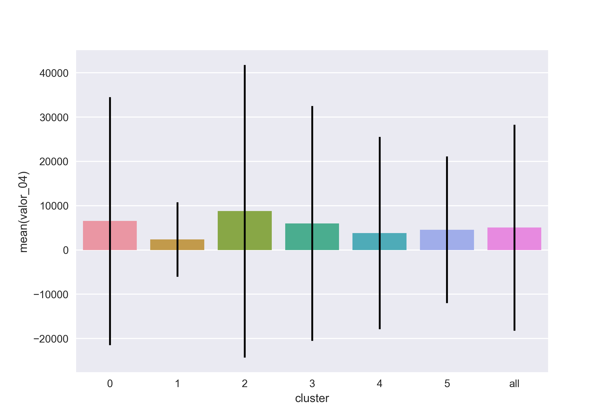

file cluster_analysis_cluster_mean_of_variables_valor_04.png

## Code output (stdout)

----------------------------------------------------------------------  
The effect of preprocessing on standard deviation ------------------  
----------------------------------------------------------------------  
 before:  
valor_01 6098.823  
valor_02 89180.835  
valor_03 37645.943  
valor_04 23246.037  
age 10.792  
estado_civil_solteiro 0.500  
estado_civil_casado 0.486  
estado_civil_outro 0.297  
genero_m 0.416  
genero_f 0.416  
perfil_a 0.458  
perfil_b 0.416  
perfil_c 0.216  
perfil_d 0.161  
dtype: float64  
 after:  
valor_01 1.0  
valor_02 1.0  
valor_03 1.0  
valor_04 1.0  
age 1.0  
estado_civil_solteiro 1.0  
estado_civil_casado 1.0  
estado_civil_outro 1.0  
genero_m 1.0  
genero_f 1.0  
perfil_a 1.0  
perfil_b 1.0  
perfil_c 1.0  
perfil_d 1.0  
dtype: float64  
  
----------------------------------------------------------------------  
Features for different number of clusters --------------------------  
----------------------------------------------------------------------  
Silhouette average for 2 clusters 0.256  
Number of individuals per cluster for 2 clusters ---------------------  
(2392,)  
(2580,)  
Silhouette average for 3 clusters 0.310  
Number of individuals per cluster for 3 clusters ---------------------  
(1887,)  
(1979,)  
(1106,)  
Silhouette average for 4 clusters 0.349  
Number of individuals per cluster for 4 clusters ---------------------  
(1103,)  
(1492,)  
(1405,)  
(972,)  
Silhouette average for 5 clusters 0.374  
Number of individuals per cluster for 5 clusters ---------------------  
(1431,)  
(972,)  
(1072,)  
(133,)  
(1364,)  
Silhouette average for 6 clusters 0.433  
Number of individuals per cluster for 6 clusters ---------------------  
(451,)  
(1407,)  
(884,)  
(1062,)  
(923,)  
(245,)  
Silhouette average for 7 clusters 0.426  
Number of individuals per cluster for 7 clusters ---------------------  
(23,)  
(1547,)  
(1017,)  
(952,)  
(133,)  
(244,)  
(1056,)  
Silhouette average for 8 clusters 0.468  
Silhouette average for 9 clusters 0.485  
  
----------------------------------------------------------------------  
Cluster standard deviation of variables ----------------------------  
----------------------------------------------------------------------  
 id geo_referencia valor_01 valor_02 valor_03 \  
cluster   
0 1432.085 318.310 18855.499 50776.256 17566.300   
1 1444.033 301.413 1273.152 21754.206 3742.253   
2 1429.445 300.858 3528.072 178904.471 83183.573   
3 1440.205 298.530 2208.455 53021.604 9307.479   
4 1431.331 294.305 1391.051 53714.303 5459.086   
5 1417.395 291.092 3051.785 104054.907 44757.829   
all 1435.437 300.712 6098.823 89180.835 37645.943   
  
 valor_04 data_nascimento_int age estado_civil_solteiro \  
cluster   
0 27998.787 3.714e+17 11.769 0.000   
1 8408.652 1.972e+17 6.248 0.000   
2 33028.168 3.354e+17 10.628 0.498   
3 26499.920 3.286e+17 10.414 0.000   
4 21677.157 3.467e+17 10.985 0.484   
5 16546.183 3.947e+17 12.508 0.499   
all 23246.037 3.406e+17 10.792 0.500   
  
 estado_civil_casado estado_civil_outro genero_m genero_f \  
cluster   
0 0.000 0.000 0.450 0.450   
1 0.000 0.000 0.000 0.000   
2 0.497 0.048 0.058 0.058   
3 0.000 0.000 0.000 0.000   
4 0.484 0.000 0.000 0.000   
5 0.494 0.338 0.415 0.415   
all 0.486 0.297 0.416 0.416   
  
 perfil_a perfil_b perfil_c perfil_d   
cluster   
0 0.433 0.422 0.000 0.132   
1 0.204 0.000 0.000 0.204   
2 0.034 0.034 0.000 0.000   
3 0.186 0.000 0.000 0.186   
4 0.363 0.334 0.000 0.166   
5 0.000 0.000 0.000 0.000   
all 0.458 0.416 0.216 0.161   
  
----------------------------------------------------------------------  
Cluster mean of variables ------------------------------------------  
----------------------------------------------------------------------  
 id geo_referencia valor_01 valor_02 valor_03 valor_04 \  
cluster   
0 2452.268 360.517 3176.098 16914.336 3676.908 6541.581   
1 2524.927 336.119 1241.121 5949.802 472.001 2373.197   
2 2457.329 339.374 2737.195 49328.855 15918.938 8769.796   
3 2469.815 349.920 2329.157 15720.792 1585.815 5992.588   
4 2497.011 320.521 1448.414 10067.777 631.819 3835.935   
5 2466.812 292.376 2645.085 28873.244 10001.609 4562.969   
all 2486.500 336.808 2022.698 18638.059 4246.265 5041.123   
  
 data_nascimento_int age estado_civil_solteiro \  
cluster   
0 1.856e+17 41.120 0.000   
1 5.707e+17 28.918 1.000   
2 3.262e+17 36.665 0.552   
3 2.436e+17 39.281 0.000   
4 4.143e+17 33.871 0.626   
5 2.291e+17 39.741 0.453   
all 3.766e+17 35.068 0.520   
  
 estado_civil_casado estado_civil_outro genero_m genero_f \  
cluster   
0 0.000 1.000 0.718 0.282   
1 0.000 0.000 1.000 0.000   
2 0.446 0.002 0.997 0.003   
3 1.000 0.000 1.000 0.000   
4 0.374 0.000 0.000 1.000   
5 0.416 0.131 0.780 0.220   
all 0.383 0.098 0.777 0.223   
  
 perfil_a perfil_b perfil_c perfil_d   
cluster   
0 0.752 0.231 0.000 0.018   
1 0.957 0.000 0.000 0.043   
2 0.001 0.999 0.000 0.000   
3 0.964 0.000 0.000 0.036   
4 0.844 0.128 0.000 0.028   
5 0.000 0.000 1.000 0.000   
all 0.702 0.222 0.049 0.027   
  
----------------------------------------------------------------------  
Normalized cluster standard deviation of variables -----------------  
----------------------------------------------------------------------  
 id geo_referencia valor_01 valor_02 valor_03 valor_04 \  
cluster   
0 0.992 1.000 1.000 0.284 0.211 0.848   
1 1.000 0.947 0.068 0.122 0.045 0.255   
2 0.990 0.945 0.187 1.000 1.000 1.000   
3 0.997 0.938 0.117 0.296 0.112 0.802   
4 0.991 0.925 0.074 0.300 0.066 0.656   
5 0.982 0.914 0.162 0.582 0.538 0.501   
all 0.994 0.945 0.323 0.498 0.453 0.704   
  
 data_nascimento_int age estado_civil_solteiro \  
cluster   
0 0.941 0.941 0.000   
1 0.499 0.499 0.000   
2 0.850 0.850 0.996   
3 0.833 0.833 0.000   
4 0.878 0.878 0.969   
5 1.000 1.000 0.998   
all 0.863 0.863 1.000   
  
 estado_civil_casado estado_civil_outro genero_m genero_f \  
cluster   
0 0.000 0.000 1.000 1.000   
1 0.000 0.000 0.000 0.000   
2 1.000 0.141 0.129 0.129   
3 0.000 0.000 0.000 0.000   
4 0.973 0.000 0.000 0.000   
5 0.993 1.000 0.922 0.922   
all 0.977 0.879 0.924 0.924   
  
 perfil_a perfil_b perfil_c perfil_d   
cluster   
0 0.945 1.000 0.0 0.649   
1 0.445 0.000 0.0 1.000   
2 0.074 0.080 0.0 0.000   
3 0.406 0.000 0.0 0.912   
4 0.794 0.792 0.0 0.813   
5 0.000 0.000 0.0 0.000   
all 1.000 0.986 1.0 0.792   
  
----------------------------------------------------------------------  
Normalized cluster mean --------------------------------------------  
----------------------------------------------------------------------  
 id geo_referencia valor_01 valor_02 valor_03 valor_04 \  
cluster   
0 0.971 1.000 1.000 0.343 0.231 0.746   
1 1.000 0.932 0.391 0.121 0.030 0.271   
2 0.973 0.941 0.862 1.000 1.000 1.000   
3 0.978 0.971 0.733 0.319 0.100 0.683   
4 0.989 0.889 0.456 0.204 0.040 0.437   
5 0.977 0.811 0.833 0.585 0.628 0.520   
  
 data_nascimento_int age estado_civil_solteiro \  
cluster   
0 0.325 1.000 0.000   
1 1.000 0.703 1.000   
2 0.572 0.892 0.552   
3 0.427 0.955 0.000   
4 0.726 0.824 0.626   
5 0.401 0.966 0.453   
  
 estado_civil_casado estado_civil_outro genero_m genero_f \  
cluster   
0 0.000 1.000 0.718 0.282   
1 0.000 0.000 1.000 0.000   
2 0.446 0.002 0.997 0.003   
3 1.000 0.000 1.000 0.000   
4 0.374 0.000 0.000 1.000   
5 0.416 0.131 0.780 0.220   
  
 perfil_a perfil_b perfil_c perfil_d   
cluster   
0 0.780 0.231 0.0 0.409   
1 0.992 0.000 0.0 1.000   
2 0.001 1.000 0.0 0.000   
3 1.000 0.000 0.0 0.825   
4 0.875 0.128 0.0 0.650   
5 0.000 0.000 1.0 0.000   
  
----------------------------------------------------------------------  
Cluster sum of variables -------------------------------------------  
----------------------------------------------------------------------  
 id geo_referencia valor_01 valor_02 valor_03 \  
cluster   
0 1.106e+06 162593.0 1.432e+06 7.628e+06 1.658e+06   
1 3.553e+06 472919.0 1.746e+06 8.371e+06 6.641e+05   
2 2.172e+06 300007.0 2.420e+06 4.361e+07 1.407e+07   
3 2.623e+06 371615.0 2.474e+06 1.670e+07 1.684e+06   
4 2.305e+06 295841.0 1.337e+06 9.293e+06 5.832e+05   
5 6.044e+05 71632.0 6.480e+05 7.074e+06 2.450e+06   
  
 valor_04 data_nascimento_int age estado_civil_solteiro \  
cluster   
0 2.950e+06 8.370e+19 18544.975 0.0   
1 3.339e+06 8.029e+20 40687.039 1407.0   
2 7.752e+06 2.883e+20 32411.595 488.0   
3 6.364e+06 2.587e+20 41715.986 0.0   
4 3.541e+06 3.824e+20 31263.225 578.0   
5 1.118e+06 5.613e+19 9736.619 111.0   
  
 estado_civil_casado estado_civil_outro genero_m genero_f \  
cluster   
0 0.0 451.0 324.0 127.0   
1 0.0 0.0 1407.0 0.0   
2 394.0 2.0 881.0 3.0   
3 1062.0 0.0 1062.0 0.0   
4 345.0 0.0 0.0 923.0   
5 102.0 32.0 191.0 54.0   
  
 perfil_a perfil_b perfil_c perfil_d   
cluster   
0 339.0 104.0 0.0 8.0   
1 1346.0 0.0 0.0 61.0   
2 1.0 883.0 0.0 0.0   
3 1024.0 0.0 0.0 38.0   
4 779.0 118.0 0.0 26.0   
5 0.0 0.0 245.0 0.0

# Bibliography

## K-Means algorithm

1. <https://en.wikipedia.org/wiki/K-means_clustering>
2. <http://scikit-learn.org/stable/modules/generated/sklearn.cluster.KMeans.html#sklearn.cluster.KMeans>

## Silhouette analysis

1. <http://scikit-learn.org/stable/modules/clustering.html#silhouette-coefficient>
2. <http://www.sciencedirect.com/science/article/pii/0377042787901257>

## Preprocessing

1. <http://scikit-learn.org/stable/modules/preprocessing.html>
2. <https://stats.stackexchange.com/questions/21222/are-mean-normalization-and-feature-scaling-needed-for-k-means-clustering>