NIST CSF Compliance Assessment

uowd

Assessment Date: April 10, 2026
Generated: April 10, 2026 at 09:30 AM
Report ID: report_48

Metric | Value
Overall Compliance | 1.8%
Total Gaps Identified | 15
Overall Risk Score | 10.0/10
Critical Findings | 1

Table of Contents
1. Executive Summary
2. Organization Information
3. Compliance Gaps Analysis
4. Risk Assessment
5. Recommendations
6. Questionnaire Evidence

Executive Summary
This NIST Cybersecurity Framework (CSF) compliance assessment was conducted for uowd, a medium organization in the Academic sector.
The assessment identified 15 compliance gaps across 2 NIST CSF functions. The overall compliance score is 1.8%, with an overall risk score of 10.0/10.
Key findings include 1 critical issues that require immediate attention, and 2 high-priority recommendations for remediation.
The assessment covered the following NIST CSF functions: Govern, Protect.
AI Confidence Score: 0.81
Control | Risk | Confidence
PR-1 | Critical | 0.90
PR-AC-10 | High | 0.90
AT-2 | High | 0.90
SC-2 | High | 0.90
SC-11 | High | 0.90

Organization Information
Field | Information
Organization Name | uowd
Industry Sector | Academic
Organization Size | medium
Contact Person
Contact Email
Assessment Date | April 10, 2026

Compliance Gaps Analysis

Protect Function

RC.RP-01: Recovery Planning - Recovery Procedures for Critical Systems
Review Status: Verified
Risk Level: High

Category:
Recover - Planning and Testing

Description:
No documented recovery procedures for critical systems, prioritization of recovery activities based on business impact is not implemented, integrity verification of backups before restoration is not conducted, and recovery procedures are not tested through exercises or drills.

Reasoning:
The organization lacks formal recovery procedures, which is crucial for ensuring the continuity of operations in case of a security incident. The absence of these procedures can lead to significant downtime and data loss.

PR.AA-02: Identity and Access Management - Multi-Factor Authentication (MFA)
Review Status: Verified
Risk Level: High

Category:
Identity and Access Management - User Authentication

Description:
Multi-factor authentication is not implemented, even though it is recommended by NIST. Administrative access to backend systems is restricted but not documented.

Reasoning:
The organization does not enforce multi-factor authentication, which significantly weakens the security of user accounts and backend systems. This gap can lead to unauthorized access and data breaches.

RC.RP-03: Recovery Planning - Verification of Backup Integrity
Review Status: Verified
Risk Level: High

Category:
Recover - Planning and Testing

Description:
The integrity of backups is not verified before restoration, which can lead to data corruption or loss.

Reasoning:
Without verifying backup integrity, the organization cannot ensure that restored data is accurate and reliable. This gap increases the risk of data loss during recovery processes.

PR.DS-01: Data Security - Data Encryption at Rest (DR.AE)
Review Status: Verified
Risk Level: High

Category:
Data Security - Data Protection

Description:
User data is stored without encryption, increasing the risk of exposure in case of a security breach.

Reasoning:
The lack of encryption at rest exposes sensitive information to unauthorized access. Without proper encryption, even if backups are verified, data can still be compromised during recovery processes.

RC.RP-05: Recovery Planning - Recovery Time Objective (RTO) and Recovery Point Objective (RPO)
Review Status: Verified
Risk Level: High

Category:
Recover - Planning and Testing

Description:
No recovery time objective (RTO) or recovery point objective (RPO) is established, which is crucial for planning effective disaster recovery strategies.

Reasoning:
Without RTO and RPO, the organization cannot determine how quickly it can recover from a security incident and what level of data loss is acceptable. This gap increases the risk of prolonged downtime and data loss during recovery processes.

PR-1: Develop, implement, and maintain policies and procedures to ensure the confidentiality, integrity, and availability of organizational information.
Review Status: Verified
Risk Level: Critical

Category:
PR-1 - PR-1

Description:
• Lack of documented policies and procedures

Reasoning:
The policy explicitly states a lack of documented policies and procedures, which is a critical gap in ensuring the security and compliance of EuroGoTrip.

PR-AC-10: Implement a comprehensive set of security controls to protect organizational operations and assets.
Review Status: Verified
Risk Level: High

Category:
PR-AC-10 - PR-AC-10

Description:
Some security controls are implemented,

Reasoning:
The policy acknowledges that some security controls are missing or partially implemented, which increases the risk of unauthorized access or data breaches.

PR-2: Implement policies and procedures to ensure that monitoring and analysis are conducted to identify security incidents and to implement corrective actions.
Review Status: Verified
Risk Level: High

Category:
PR-2 - PR-2

Description:
• Limited monitoring and resilience planning

Reasoning:
The policy mentions limited monitoring and resilience planning, which is a high-risk gap in identifying and responding to security incidents.

PR-4: Implement policies and procedures to ensure that the organization's information is protected from unauthorized access, use, disclosure, modification, or destruction.
Review Status: Verified
Risk Level: Medium

Category:
PR-4 - PR-4

Description:
EuroGoTrip partially aligns with the NIST Cybersecurity Framework Protect function but

Reasoning:
The policy states that EuroGoTrip partially aligns with the NIST Cybersecurity Framework Protect function but does not fully comply with its requirements, which is a moderate-risk gap in protecting organizational information.

Govern Function

AT-2: Provide cybersecurity awareness training to all personnel with access to organizational systems and data.
Review Status: Verified
Risk Level: High

Category:
AT-2 - AT-2

Description:
There are no documented training materials, no phishing simulations, and no scheduled

Reasoning:
The policy does not provide formal cybersecurity awareness training, which is a critical control for ensuring employees understand their role in protecting user data.

SC-2: Implement software updates and patches in a timely manner for all software on the system.
Review Status: Verified
Risk Level: High

Category:
SC-2 - SC-2

Description:
Third-party libraries are used extensively, but there is no process to ensure they are up to date

Reasoning:
The policy does not have a process to ensure third-party libraries are up-to-date or free from known vulnerabilities, which is required by SC-2.

SC-11: Implement a process to ensure that critical systems and data are backed up and can be restored in the event of a disaster or system failure.
Review Status: Verified
Risk Level: High

Category:
SC-11 - SC-11

Description:
Redundancy is limited, and failover procedures are

Reasoning:
The policy mentions limited redundancy and incomplete failover procedures, which is required by SC-11. The policy does not mention a formal disaster recovery plan, which is required by SC-11.

AU-6: Implement a password policy that requires strong and unique passwords for all users.
Review Status: Verified
Risk Level: Medium

Category:
AU-6 - AU-6

Description:
are not required to meet strict complexity rules, and users are allowed to reuse old passwords.

Reasoning:
The policy allows users to reuse old passwords, which increases the risk of unauthorized access or data breaches. The policy mentions logging, but it's not being used for security monitoring as required by AU-6.

SC-8: Encrypt all sensitive information in transit.
Review Status: Verified
Risk Level: Medium

Category:
SC-8 - SC-8

Description:
Data transmitted between users and the application is generally protected using HTTPS.

Reasoning:
The policy only mentions encryption for data transmitted between users and the application, but not for internal system communications or backups. The policy does not mention encryption for backups, which is a critical control for ensuring data integrity.

AC-10: Conduct regular access reviews to ensure that users have the necessary permissions and access rights.
Review Status: Verified
Risk Level: Medium

Category:
AC-10 - AC-10

Description:
Access reviews are not conducted regularly.

Reasoning:
The policy does not mention conducting regular access reviews, which increases the risk of unauthorized access or data breaches.

Risk Assessment
Risk Title | Risk Level | Likelihood | Impact | Status
No Multi-Factor Authentication Implemented | High | High - Without MFA, attackers can easily bypass login credentials through phishing or stolen credentials. | Critical - Unauthorized access to backend systems can lead to data breaches and financial losses. | Not Started
No Verification of Backup Integrity | High | Medium - Without verification, attackers may exploit vulnerabilities in the backup process to compromise restored data. | High - Data loss during recovery processes can result in significant downtime and financial losses. | Not Started
Data Stored Without Encryption at Rest | High | Medium - Attackers can easily access sensitive information if backups are compromised or stolen. | High - Unauthorized access to sensitive data can lead to financial losses and reputational damage. | Not Started

No Multi-Factor Authentication Implemented
Risk Level:
High
Description:
The organization does not enforce multi-factor authentication, which significantly weakens the security of user accounts and backend systems.
Business Impact:
Increased risk of unauthorized access, potential for data breaches, and financial loss

No Verification of Backup Integrity
Risk Level:
High
Description:
The integrity of backups is not verified before restoration, which can lead to data corruption or loss.
Business Impact:
Increased risk of data corruption, potential for prolonged downtime, and financial loss

Data Stored Without Encryption at Rest
Risk Level:
High
Description:
User data is stored without encryption, increasing the risk of exposure in case of a security breach.
Business Impact:
Increased risk of unauthorized access, potential for data breaches, and financial loss

Risk Heat Map Analysis
Heat Map Summary:
Heat map analysis covering 1 items.
1 items exceed organizational risk appetite.
Organization Risk Appetite: Not specified

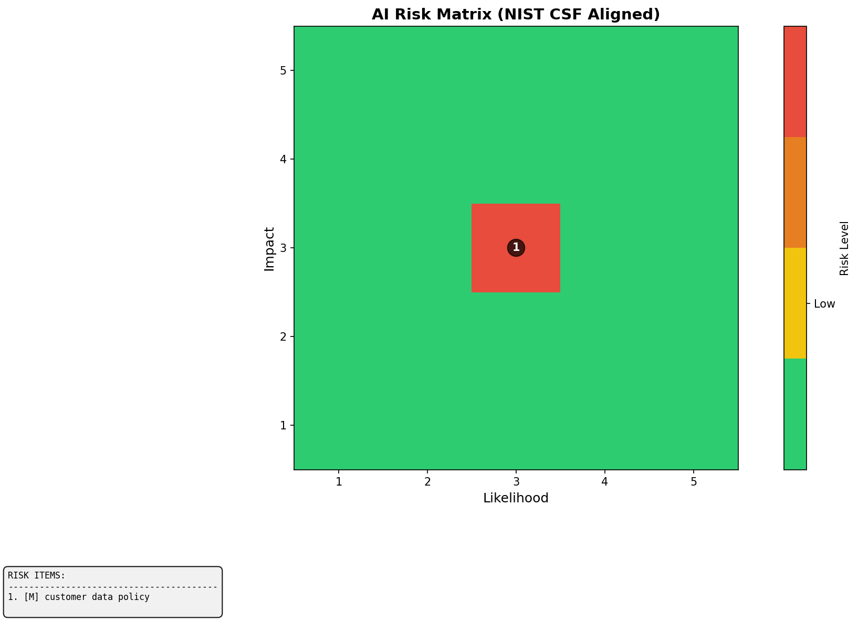
Figure 1: Risk Heat Map (Likelihood vs Impact)

Item Name | Likelihood | Impact | Risk Level | Above Appetite
customer data policy | 3 | 3 | Medium | Yes

Recommendations

High Priority Recommendations

Implement Multi-Factor Authentication (MFA)
Priority:
High
Estimated Effort:
4-6 weeks for initial implementation
Description:
Enforce multi-factor authentication to enhance the security of user accounts and backend systems.
Implementation Steps:
- • Step 1: Select and implement a multi-factor authentication solution (e.g., SMS codes, biometrics)
- • Step 2: Train users on how to use MFA
- • Step 3: Monitor user adoption and effectiveness of the new system

Establish Recovery Time Objective (RTO) and Recovery Point Objective (RPO)
Priority:
High
Estimated Effort:
4-6 weeks for initial implementation
Description:
Define RTO and RPO for critical systems to ensure effective disaster recovery planning.
Implementation Steps:
- • Step 1: Conduct a thorough risk assessment to identify critical systems and their recovery needs
- • Step 2: Establish RTOs and RPOs based on the organization's business continuity plan
- • Step 3: Communicate RTOs and RPOs to all relevant stakeholders

