NIST CSF Compliance Assessment

uowd

Assessment Date: April 10, 2026
Generated: April 10, 2026 at 07:27 PM
Report ID: report_49

Metric | Value
Overall Compliance | 1.4%
Total Gaps Identified | 14
Overall Risk Score | 10.0/10
Critical Findings | 6

Table of Contents
1. Executive Summary
2. Organization Information
3. Compliance Gaps Analysis
4. Risk Assessment
5. Recommendations
6. Questionnaire Evidence

Executive Summary
This NIST Cybersecurity Framework (CSF) compliance assessment was conducted for uowd, a medium organization in the Academic sector.
The assessment identified 14 compliance gaps across 3 NIST CSF functions. The overall compliance score is 1.4%, with an overall risk score of 10.0/10.
Key findings include 6 critical issues that require immediate attention, and 3 high-priority recommendations for remediation.
The assessment covered the following NIST CSF functions: Protect, Govern, Recover.
AI Confidence Score: 0.85
Control | Risk | Confidence
RC.RP-01 | Critical | 0.90
RC.RP-02 | Critical | 0.90
RC.RP-03 | Critical | 0.90
RC.RP-05 | Critical | 0.90
RC.CO-03 | Critical | 0.90

Organization Information
Field | Information
Organization Name | uowd
Industry Sector | Academic
Organization Size | medium
Contact Person
Contact Email
Assessment Date | April 10, 2026

Compliance Gaps Analysis

Recover Function

RC.RP-01: Recovery Planning - Recovery Procedures Documentation
Review Status: Verified
Risk Level: Critical

Category:
Recovery Planning - Procedures Documentation

Description:
No documented recovery procedures for critical systems.

Reasoning:
Questionnaire response indicates organization does not have formal recovery procedures documented.

RC.RP-02: Recovery Planning - Recovery Activity Prioritization
Review Status: Verified
Risk Level: Critical

Category:
Recovery Planning - Activity Prioritization

Description:
No recovery activities prioritized based on business impact.

Reasoning:
Questionnaire response indicates organization does not have a formal process for prioritizing recovery activities by business impact.

RC.RP-03: Recovery Planning - Backup Integrity Verification
Review Status: Verified
Risk Level: Critical

Category:
Recovery Planning - Backup Integrity

Description:
No verification of backup integrity before restoration.

Reasoning:
Questionnaire response indicates organization does not verify the integrity of backups and recovery assets before restoration.

RC.RP-05: Recovery Planning - Recovery Procedure Testing
Review Status: Verified
Risk Level: Critical

Category:
Recovery Planning - Procedure Testing

Description:
No recovery procedures tested through exercises or drills.

Reasoning:
Questionnaire response indicates organization does not test its recovery procedures through exercises or drills.

RC.CO-03: Recovery Communication - Recovery Status Reporting to Stakeholders
Review Status: Verified
Risk Level: Critical

Category:
Recovery Communication - Status Reporting

Description:
No communication of recovery status and progress to stakeholders.

Reasoning:
Questionnaire response indicates organization does not communicate recovery status and progress to stakeholders.

Protect Function

PR-1: Develop, implement, and maintain policies and procedures to ensure the confidentiality, integrity, and availability of organizational information.
Review Status: Verified
Risk Level: Critical

Category:
PR-1 - PR-1

Description:
• Lack of documented policies and procedures

Reasoning:
The policy explicitly states a lack of documented policies and procedures, which is a critical gap in ensuring the security and compliance of EuroGoTrip.

PR-AC-10: Implement a comprehensive set of security controls to protect organizational operations and assets.
Review Status: Verified
Risk Level: High

Category:
PR-AC-10 - PR-AC-10

Description:
Some security controls are implemented,

Reasoning:
The policy acknowledges that some security controls are missing or partially implemented, which increases the risk of unauthorized access or data breaches.

PR-2: Implement policies and procedures to ensure that monitoring and analysis are conducted to identify security incidents and to implement corrective actions.
Review Status: Verified
Risk Level: High

Category:
PR-2 - PR-2

Description:
• Limited monitoring and resilience planning

Reasoning:
The policy mentions limited monitoring and resilience planning, which is a high-risk gap in identifying and responding to security incidents.

PR-4: Implement policies and procedures to ensure that the organization's information is protected from unauthorized access, use, disclosure, modification, or destruction.
Review Status: Verified
Risk Level: Medium

Category:
PR-4 - PR-4

Description:
EuroGoTrip partially aligns with the NIST Cybersecurity Framework Protect function but

Reasoning:
The policy states that EuroGoTrip partially aligns with the NIST Cybersecurity Framework Protect function but does not fully comply with its requirements, which is a moderate-risk gap in protecting organizational information.

Govern Function

SC-2: Implement software updates and patches in a timely manner for all software on the network.
Review Status: Verified
Risk Level: High

Category:
SC-2 - SC-2

Description:
Third-party libraries are used extensively, but there is no process to ensure they are up to date

Reasoning:
The policy does not have a process to ensure third-party libraries are up-to-date or free from known vulnerabilities, which is required by SC-2.

SC-6: Implement a disaster recovery plan to ensure that the system can be restored in case of a disaster or major failure.
Review Status: Verified
Risk Level: High

Category:
SC-6 - SC-6

Description:
There is no formal disaster recovery plan.

Reasoning:
The policy does not mention implementing a disaster recovery plan, which is required by SC-6.

SC-3: Implement redundant systems and ensure that failover procedures are in place to minimize the impact of system failures.
Review Status: Verified
Risk Level: High

Category:
SC-3 - SC-3

Description:
Redundancy is limited, and failover procedures are

Reasoning:
The policy mentions that redundancy is limited, which may not meet the requirements of SC-3.

AU-6: Implement a password policy that requires strong and unique passwords for all users.
Review Status: Verified
Risk Level: Medium

Category:
AU-6 - AU-6

Description:
are not required to meet strict complexity rules, and users are allowed to reuse old passwords.

Reasoning:
The policy allows users to reuse old passwords, which increases the risk of unauthorized access or data breaches. The policy mentions that logging is primarily used for troubleshooting, which may not meet the requirements of AU-6.

AC-10: Conduct regular access reviews to ensure that users have the necessary permissions and access rights.
Review Status: Verified
Risk Level: Medium

Category:
AC-10 - AC-10

Description:
Access reviews are not conducted regularly.

Reasoning:
The policy does not mention conducting regular access reviews, which increases the risk of unauthorized access or data breaches.

Risk Assessment
Risk Title | Risk Level | Likelihood | Impact | Status
Lack of Formal Recovery Procedures and Testing Plan | Critical | High - Without a formal process, risks accumulate over time. | Critical - Unmanaged risks can lead to significant financial and reputational losses due to data loss or system downtime. | Not Started

Lack of Formal Recovery Procedures and Testing Plan
Risk Level:
Critical
Description:
Organization lacks formal recovery procedures and testing plan, leading to potential vulnerabilities in disaster response.
Business Impact:
Increased vulnerability to cyber threats, regulatory non-compliance, potential financial/reputational loss

Risk Heat Map Analysis
Heat Map Summary:
Heat map analysis covering 1 items.
1 items exceed organizational risk appetite.
Organization Risk Appetite: Not specified

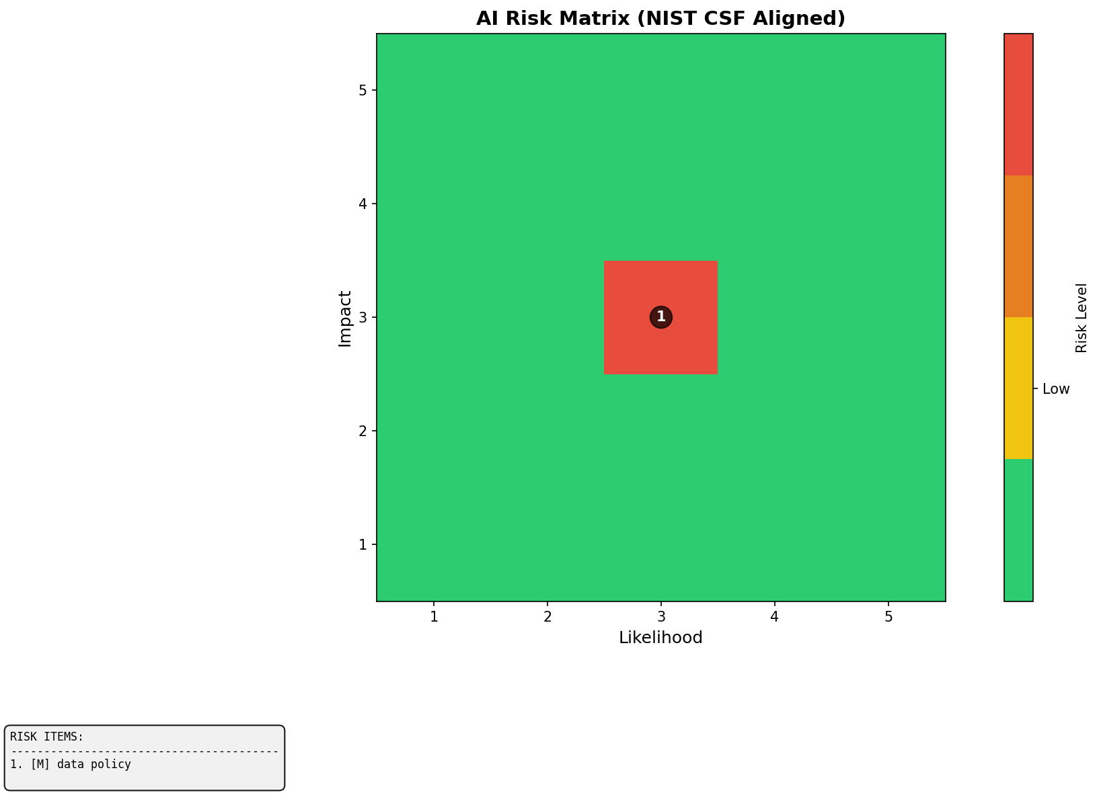
Figure 1: Risk Heat Map (Likelihood vs Impact)

Item Name | Likelihood | Impact | Risk Level | Above Appetite
data policy | 3 | 3 | Medium | Yes

Recommendations

High Priority Recommendations

Develop and Document Recovery Procedures
Priority:
High
Estimated Effort:
6-8 weeks
Description:
Create formal recovery procedures for critical systems, including prioritization of activities based on business impact.
Implementation Steps:
- • Step 1: Conduct a thorough review of all critical systems and identify key recovery procedures.
- • Step 2: Develop detailed recovery procedures, including prioritization based on business impact.
- • Step 3: Document the developed procedures in an organized manner accessible to relevant personnel.
- • Step 4: Train relevant personnel on the new procedures.

Implement Recovery Procedure Testing Plan
Priority:
High
Estimated Effort:
12-16 weeks
Description:
Develop and implement a plan to test recovery procedures through exercises or drills.
Implementation Steps:
- • Step 1: Identify key recovery procedures and develop a testing plan.
- • Step 2: Schedule and conduct the first set of exercises or drills based on the developed plan.
- • Step 3: Review results, identify areas for improvement, and update the testing plan accordingly.
- • Step 4: Conduct regular follow-up tests to ensure ongoing effectiveness.

Establish Recovery Status Reporting Mechanism
Priority:
High
Estimated Effort:
6-8 weeks
Description:
Develop a mechanism for reporting recovery status to stakeholders.
Implementation Steps:
- • Step 1: Identify key stakeholders and determine their reporting needs.
- • Step 2: Develop a standardized format for recovery status reports.
- • Step 3: Train relevant personnel on the standardized report format.
- • Step 4: Implement a process for regular reporting of recovery status to identified stakeholders.

