Lab 01 : Hello Arduino

#define R 3

#define G 5

void setup() {

Serial.begin(9600);

pinMode(R,OUTPUT);

pinMode(G,OUTPUT); }

void loop() {

// put your main code here, to run repeatedly:

digitalWrite(R,HIGH);

delay(1000);

digitalWrite(R,LOW);

delay(1000);

digitalWrite(G,HIGH);

delay(1000);

digitalWrite(G,LOW);

delay(1000);

}

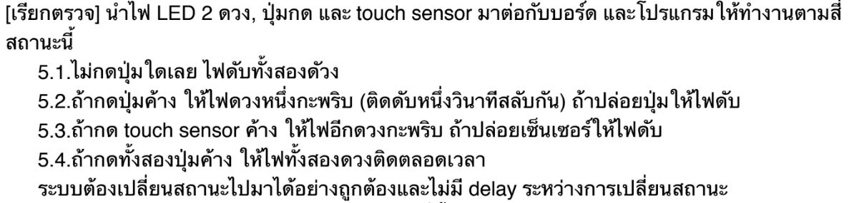

#define BOTTON 7 #define TOUCH 4 #define R 3

#define G 5 int ledState = 0; unsigned long timePrev;

void setup() {

Serial.begin(9600); pinMode(R,OUTPUT);

pinMode(G,OUTPUT); pinMode(BOTTON,INPUT);

pinMode(TOUCH,INPUT);

}

void loop() {

unsigned long timeNow, timeElapsed;

timeNow = millis();

timeElapsed = timeNow-timePrev;

int buttonValue = digitalRead(BOTTON);

int touchValue = digitalRead(TOUCH);

if (buttonValue == LOW && touchValue == LOW){

digitalWrite(R,LOW);

digitalWrite(G,LOW);

}

if(buttonValue == HIGH && touchValue == HIGH) {

digitalWrite(R,HIGH);

digitalWrite(G,HIGH);

}

if (buttonValue != touchValue){

if (buttonValue == HIGH){

digitalWrite(G,LOW);

if (timeElapsed > 1000) {

timePrev = timeNow;

ledState = 1 - ledState; //toggle state

digitalWrite(R, ledState); //turn LED on after 1 sec

}

}

if (touchValue == HIGH) {

digitalWrite(R,LOW);

if (timeElapsed > 1000) {

timePrev = timeNow;

ledState = 1 - ledState; //toggle state

digitalWrite(G, ledState); //turn LED on after 1 sec

}



#define BOTTON 7 #define R 3

int previous = LOW; long time = 0;

long debounce = 200; int state = HIGH;

void setup() {

Serial.begin(9600); pinMode(R,OUTPUT); pinMode(BOTTON,INPUT);

}

void loop() {

// put your main code here, to run repeatedly:

int buttonValue = digitalRead(BOTTON);

if(buttonValue == HIGH && previous == LOW && millis() - time > debounce) {

state = !state;

time = millis();

}

digitalWrite(R, state);

previous = buttonValue;

}

Lab 02 : Digital and Analog I/O



#define BUTTON 0 #define LED 2

int brightness = 0; int count = 0;

void setup() {

Serial.begin(9600); pinMode(LED, OUTPUT);

pinMode(BUTTON, INPUT);

}

void loop() {

if (digitalRead(BUTTON)== HIGH) {

count++ ;

brightness+=62; }

if ((count > 0) && (count <= 4)) {

analogWrite(LED, brightness); }

if (count > 4) {

brightness = 0 ;

count = 0;

analogWrite(LED, brightness); }

}



const int SW_pin = 0;

const int X_pin = A0; // analog pin connected to X output

const int Y_pin = A1; // analog pin connected to Y output

void setup() {

pinMode(SW_pin, INPUT); digitalWrite(SW_pin, HIGH);

Serial.begin(9600);

}

void loop() {

Serial.print("X-axis: ");

Serial.print(analogRead(X_pin));

Serial.print(" | ");

Serial.print("Y-axis: ");

Serial.print(analogRead(Y_pin));

Serial.println(" | ");

delay(200);

}



#define led 5 #define pot A1

void setup() {

// put your setup code here, to run once:

Serial.begin(9600); pinMode(led,OUTPUT);

}

void loop() {

int readPod = analogRead(pot) /10;

digitalWrite(led,HIGH);

delay(readPod);

digitalWrite(led,LOW);

delay(readPod);

digitalWrite(led,HIGH);

delay(readPod);

digitalWrite(led,LOW);

delay(readPod);

}

Lab 03 : Library

#include <ChainableLED.h> #include <DHT.h>

#define DHTPIN 5 #define DHTTYPE DHT22

#define NUM_LEDS 7

ChainableLED leds(7, 8, NUM_LEDS);

DHT dht(DHTPIN, DHTTYPE);

float check = 0 ; int blue = 255; int red = 139;

void setup() {

Serial.begin(9600);

dht.begin();

leds.init(); }

void loop() {

float t = dht.readTemperature();

Serial.println(t); Serial.println(check); Serial.println("---------");

delay(500);

// int rate = map(t,0,100,0,255);

if (check > t) {

red -=35;

blue +=35 ;

Serial.println("------check > t---"); }

if (t > check) {

red +=35;

blue -= 35;

Serial.println("------t > check---"); }

if (blue > 255) { blue = 255; }

if (blue < 0) { blue = 0; }

if (red > 255) { red = 255;}

if (red < 0) { red = 0; }

leds.setColorRGB(0,red,0,blue);

check = t ;

Serial.println(red); Serial.println(blue); Serial.println("----*******--");

delay(500);

}



#include <Arduino.h>

#include <DHT.h>

#include <TM1637Display.h>

#define DHTPIN 5

#define CLK 3

#define DIO 4

#define DHTTYPE DHT22

DHT dht(DHTPIN, DHTTYPE);

const uint8_t DEGREES [ ] = {

SEG_A | SEG_B | SEG_G | SEG_F, // superscript o

SEG_A | SEG_F | SEG_E | SEG_D, // C

};

const uint8_t Huma [ ] = {

SEG_F | SEG_E | SEG_G | SEG_C | SEG_B // H,

};

TM1637Display display(CLK, DIO);

void setup() {

Serial.begin(9600);

display.setBrightness(0x0a);

}

void loop() {

// put your main code here, to run repeatedly:

uint8_t data[] = { 0xff, 0xff, 0xff, 0xff };

readHumidity();

int h = dht.

int t = dht.readTemperature();

bool lz = false ;

display.showNumberDec(t, lz,2,0);

display.setSegments(DEGREES,2,2);

delay(1000);

display.showNumberDec(h, lz,2,0);

data[2] = display.encodeDigit(2);

display.setSegments(data[2],1,2);

display.setSegments(Huma,1,3);

delay(1000);

Lab 04: Sound



#include <Ultrasonic.h>

#define red 2 #define green 3

#define blue 4 Ultrasonic ultrasonic(6);

void setup() {

Serial.begin(9600);

pinMode(red,OUTPUT);

pinMode(green,OUTPUT);

pinMode(blue,OUTPUT);

}

void loop() {

ultrasonic.MeasureInCentimeters();

int x = ultrasonic.RangeInCentimeters;

delay(100);Serial.println(x);

if (x<=10){

digitalWrite(red,HIGH);

digitalWrite(green,LOW);

digitalWrite(blue,LOW);

}

if (x>10 && x<=20){

digitalWrite(red,HIGH);

digitalWrite(green,HIGH);

digitalWrite(blue,LOW);

} if (x>20 ){

digitalWrite(red,HIGH);

digitalWrite(green,HIGH);

digitalWrite(blue,HIGH);

}

}

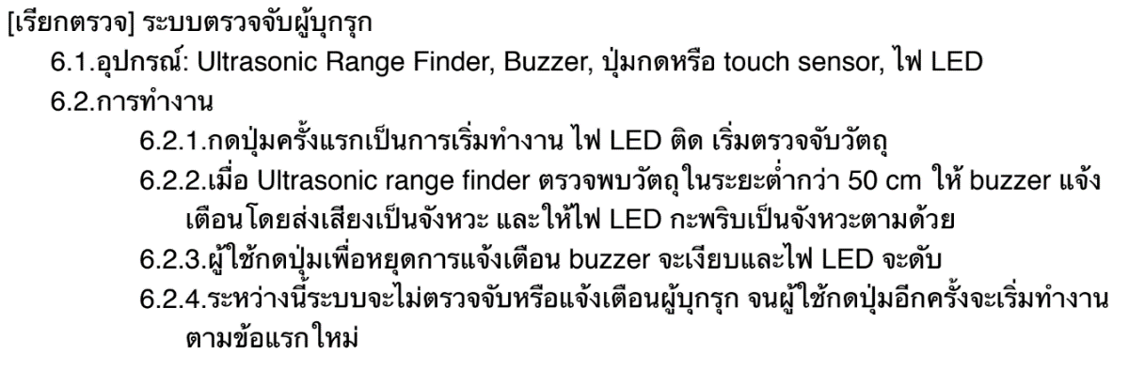

#include <Ultrasonic.h> #define buzzer 3

#define r 2 #define button 7

Ultrasonic ultrasonic(6);

int start = 0; int dis = 0 ;

int times = -1 ; int checkPoint = 0 ;

void setup() {

Serial.begin(9600);

pinMode(r,OUTPUT);

pinMode(button,INPUT);

}

void loop() {

delay(100);

if (digitalRead(button) == 1) {

times += 1 ;

}

if (times %2 == 0) {

ultrasonic.MeasureInCentimeters();

dis = ultrasonic.RangeInCentimeters;

Serial.println(dis);

delay(100);

if (dis < 50) {

analogWrite(buzzer,1);

digitalWrite(r,HIGH);

delay(100);

analogWrite(buzzer,0);

digitalWrite(r,LOW);

delay(100);

checkPoint++ ;

}

}

if (checkPoint != 0) {

analogWrite(buzzer,1);

digitalWrite(r,HIGH);

delay(100);

analogWrite(buzzer,0);

digitalWrite(r,LOW);

delay(100);

}

if (times %2 != 0) {

start = 0 ;

checkPoint = 0 ;

digitalWrite(r,LOW);

analogWrite(buzzer,0);

}

Serial.println(start);

Serial.println("---------");

Serial.println(times);

}

Lab 06:Serial

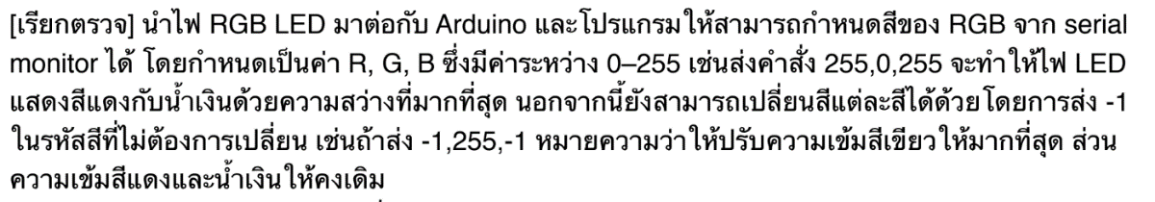

char buffer[18];

int red, green, blue; int RedPin = 6; int GreenPin = 5;

int BluePin = 3; int i = 0 ; String ledInput[3] ;

void setup() {

Serial.begin(9600); //Serial.flush();

pinMode(RedPin, OUTPUT);

pinMode(GreenPin, OUTPUT);

pinMode(BluePin, OUTPUT);

}

void loop() {

if (Serial.available() > 0) {

int index=0;

delay(100); // let the buffer fill up

int numChar = Serial.available();

if (numChar>15) {

numChar=15;

}

while (numChar--) {

buffer[index++] = Serial.read();

}

splitString(buffer);

int R = ledInput[0].toInt();

int G = ledInput[1].toInt();

int B = ledInput[2].toInt();

analogWrite(RedPin,R);

analogWrite(GreenPin,G);

analogWrite(BluePin,B);

i=0;

}

}

void splitString(char* data) {

Serial.print("Data entered: ");

Serial.println(data);

char* parameter;

parameter = strtok (data, " ,");

while (parameter != NULL) {

// Serial.println(parameter);

if (parameter == "-1") { i++; }

else {

ledInput[i]=parameter;

i++;

}

parameter = strtok (NULL, " ,");

}

// Clear the text and serial buffers

for (int x=0; x<16; x++) {

buffer[x]='\0';

}

Serial.flush();

i = 0 ;

}

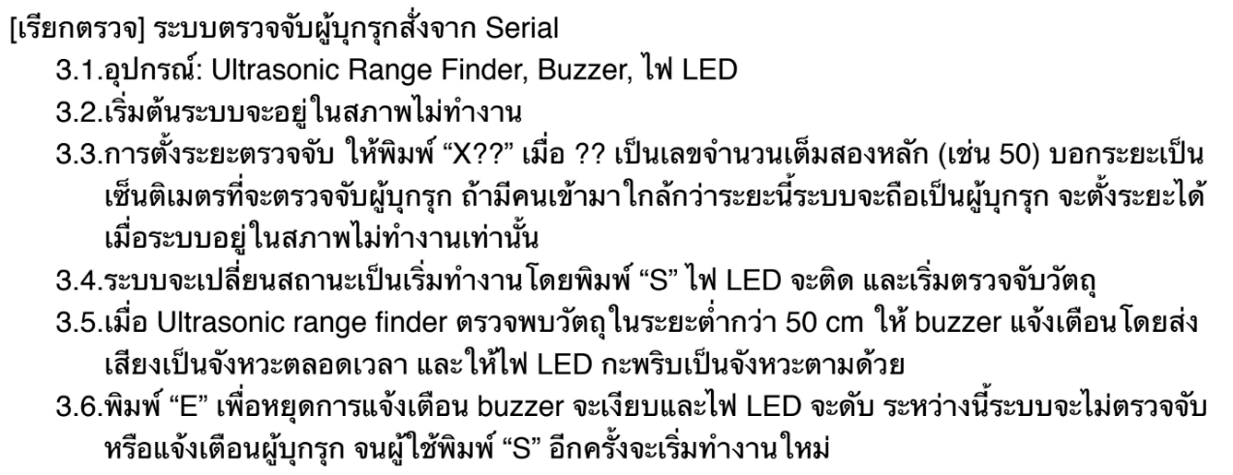

#include <Ultrasonic.h>

#define buzzer 3

#define r 2

Ultrasonic ultrasonic(6);

int num = 1000 ;

int dis ;

int checkPoint = 0 ;

int start = 0;

int times = -1 ;

void setup() {

// put your setup code here, to run once:

Serial.begin(9600);

}

void loop() {

char inputText;

if (Serial.available() > 0) { // is a character available?

inputText = Serial.read(); // get the character

if ((inputText == 's') || (inputText == 'S') || (inputText == 'e') || (inputText == 'E')) {

times += 1 ;

Serial.println(times);

}

if (inputText >= 'X') {

num = Serial.parseInt();

Serial.println(num);

Serial.println(times);

}

}

if (times %2 == 0) {

ultrasonic.MeasureInCentimeters();

dis = ultrasonic.RangeInCentimeters;

Serial.println(dis);

delay(100);

if (dis < num) {

analogWrite(buzzer,1);

digitalWrite(r,HIGH);

delay(100);

analogWrite(buzzer,0);

digitalWrite(r,LOW);

delay(100);

checkPoint++ ;

}

}

if (checkPoint != 0) {

analogWrite(buzzer,1);

digitalWrite(r,HIGH);

delay(100);

analogWrite(buzzer,0);

digitalWrite(r,LOW);

delay(100);

}

if (times %2 != 0) {

start = 0 ;

checkPoint = 0 ;

digitalWrite(r,LOW);

analogWrite(buzzer,0);

}

}

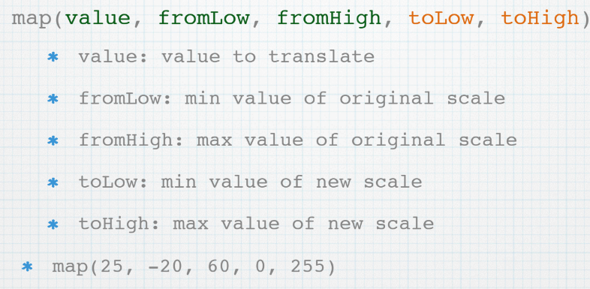

NOTE

analogWrite() ----> works on pin 3, 5, 6, 9, 10, and 11 (0-255)

