Table Of Contents

Table Of Contents 1
Introduction 3
Working of the System – Game Logic 3
Working of the whole system 5
Inputs to the System 5
The Game Logic 5
Output 5
Appendix A – The Keypad 6
Design and Logic 6
Inputs 6
Outputs 6
Appendix B – Microcontroller Code Logic 8
Appendix C – The Display Unit 11
LED Matrix arrangement 11
Display control and addressing 11
Voltage Requirements 11
Use of the bus transceiver 12
Appendix D – Decoder Logic 13
Decoding Function 13
Truth Table of Latch Selection 13
Features 14
Appendix E – Microcontroller PIN assignments 15
Port Assignment 15
Appendix F – ICs used in the project 16
The 74245 3-state Octal Bus Transceiver 16
74373 3-state Octal D-Type Latches 18
The AT90S8515 Micro Controller Unit 20
The 74138 3x8 line decoder 24
Pin Diagram 25
Truth Table 25
Logic Diagram 26
The 7404 Inverter 27
Pin Diagram/Logic Diagram 27
Truth Table 27
Block Diagram 28

Introduction

This system implements a small and popular computer game named ‘Snake’. It consists of a Microcontroller Unit, which provides the main logic that drives the whole system, and a display unit that is connected to the Microcontroller Unit through an address decoding logic. The inputs to the Microcontroller Unit through a custom designed keypad.

The game logic, written in C, is dumped on to the Flash Memory built in to the Microcontroller Unit. The display system is an elaborate digital circuit that makes use of the memory decoding principles to address the individual display elements on the LED screen. It consists of a decoder, latches and bus transceivers. The Microcontroller Unit drives the decoder by selecting the appropriate latch and supplies data to that latch through another port on a common bus. The latches then drive the bus transceivers that activate the appropriate row on the LED display.

The configuration and working of the major components used and the working of the system as a whole is explained in detail in the following lines.

Working of the System – Game Logic

1. Microcontroller initiates the Display Unit (refer to Appendix C) and clears all the LEDs. This is done by iterating through each of the latch ICs enable pins through the decoder logic and setting 0x00 on the bus. Each latch controls one column of 8 LEDs.

2. The system now waits for the input key from the control pad (refer to Appendix A). While a key is not detected, it moves the snake to the next position as set by the rules of the game. If a key is detected, it is checked if the key was allowed and action is done accordingly. The keypad design issues are explained in Appendix A.

3. The microcontroller selects the active column through the decoder. A binary pattern (000-111) is supplied to the decoder and the decoder enables the appropriate ENABLE pin of the latch which is to receive the data from the bus.

4. An 8-bit bus is installed on the board which connects to all the latches and the data on the bus is set directly by the microcontroller. Refer to Appendix E to see how this is done.

5. The latch whose enable pin is high fetches the new data from the bud and updates itself accordingly. The new latched data is forwarded to the bud driver connected to the latch which drives the LED column selected.

Working of the whole system

Inputs to the System
The input system consists of a custom designed keypad consisting of four keys corresponding to the four directions of movement. The keys are coupled to the Microcontroller Unit through inverters that act as active pull-ups to keep the inactivated pins of the Microcontroller Unit at high logic level. This scheme is used to prevent all the input pins to be grounded when one of the switches is activated (which connects it to the ground). These inputs are coupled to the Port C of the Microcontroller Unit.

The Game Logic
The game logic is dumped on to the 8KB Flash Memory built in to the Microcontroller Unit. It has been written in C programming language to keep it portable to other platforms. The result is that the same code can be ported to other Microcontroller platforms without any modifications. The C code has been compiled for the specific Microcontroller Unit in use using a modified version of the popular GCC compiler.

The program takes the key inputs from port C and decides the next step on the basis of the current state and the current inputs. The program then updates the state of the display system by first applying an address of the appropriate row to the decoder connected to the port D and then putting the data, which is the current state of the currently selected row of the display elements, on a common bus connected to the port B.

Output
The display unit consists of a 3x8 line decoder which is connected to the port D of the Microcontroller Unit. The decoder selects one of the eight latch-transceiver pairs depending on its selection inputs that it receives from the Microcontroller Unit. This pulls one of the decoder output pins to the low voltage level which is then fed through the inverters to the enable input of the corresponding latch. The latch whose enable input is high is selected or activated and it loads the new data on the bus. The new data is fed to the bus transceivers that provide the high current required to operate the LEDs. The latch IC is in fact a set of eight latches each corresponding to a single LED on the display.

Appendix A – The Keypad

Design and Logic

Four keys keypad has been manually constructed using the inverter gate and push-buttons. The circuit diagram is as follows:

Pin Diagram | Logic Diagram
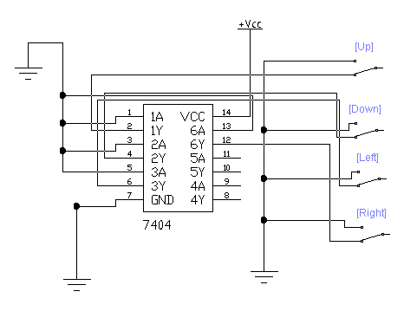 | 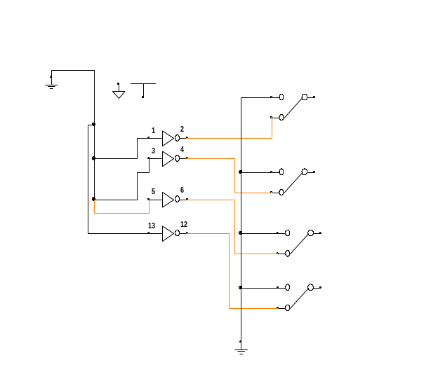

Inputs 4 push-buttons, which moves the state of the button from released state to pressed state.

Outputs
Key | Pressed | Released
UP | LOW | HIGH
DOWN | LOW | HIGH
LEFT | LOW | HIGH
RIGHT | LOW | HIGH

The keypad output is sent to the microcontroller for detection of the key that was pressed and appropriate action is taken after that.

Appendix B – Microcontroller Code Logic

The game has the following globally declared control variables:

The game considers the matrix display as an 8-byte char array called ledsDisplay. Each byte stores the status (ON or OFF) of a row of the display matrix.

The position of each bit of snake is stored in a circular array of a structure called snake, which makes use of bit field operator to store the column and row position of each bit in the matrix display.

There are two variables for controlling the head and tail of the circular array called head and tail (actually storing the information of head and tail index of snake in the array).

A variable is also taken for storing the information of snake size called snakeLength.

The game has some further controlling variables as:

refresh

To store the delay time between successive snake movement.

MINSNAKELEN

The minimum snake size that will be assign when the game starts.

curDir

Holds the information in which user directed the snake (by default it is UP).

headX and headY

These variables store the column and row position of the head of snake as the current position.

randX and randY

They contain the current position of star (the bit that snake has to be eat).

Found

Work as a flag. Tell whether snake head has reached the star position or not.

MAXSNAKELEN

When the snake reaches this length the game automatically switches to the next difficulty level.
The game code has following processing steps:

Step#01

The game checks the status of key (as by default it is UP). To move snake head according to key status the current position of head is updated for further processing if the next position of head strike the boundary of the display the game terminates (it is indicated by the blinking matrix display after that game restarts).

Step#02

A function snakeStrike (takes next headX and headY position as arguments) checks whether the snake has hit itself. If so then restart the game.

Step#03

A function matchStar (takes next headX and headY position and current randX and randY as arguments and returns ‘1’ for success if found else return ‘0’) determines whether the snake’s head has reached the star or not. If so then return 1 else return 0.

Step#04

Function posStar (takes randX, randY and found as arguments) check if found = 1 or if the game is started and randX and randY has NULL assignment, it assigns a new position to randX and randY.

Step#5

Function addSnake (take next headX and headY position as arguments) adds a new node to the snake and increments its size and saves the new snake position in the new node.

Step#6

Function eatSnake (takes MINSNAKELEN, headX , headY and found as arguments) removes the tail position if snake size is greater than MAXSNAKELEN and found = 0 and decrements the snake size. Otherwise, it retains the previous snake position and does not decrement the snake.

Step#7

Function checkMaxSnakeLen (take pointers to refresh, headX, heady, randX, randY and curDir as arguments) checks if snake size is greater than MAXSNAKELEN then it reinitializes all the variables and speeds up (by decreasing the delay i.e., by decrementing the refresh variable) and restarts the game.

Step#8

Function drawSnake (takes no arguments) sends the position of the bits to the latch selected through port B. It sends 1-byte at a time (i.e. the position of a row of matrix display) and updates the new locations.

Step#9

A delay function (takes refresh as arguments) creates a pause between successive snake movements on the display.

Step#10

Take input from user for the next snake movement.

The program continues till the power is turned OFF. The program reinitializes if the snake hits the walls or it hits itself.

Appendix C – The Display Unit

LED Matrix arrangement

The display unit consists of a square matrix of dimension 8x8. Each LED has its positive terminal (anode) connected to one of the pins on the output bus of the bus transceiver. The negative terminals (cathode) of all the LEDs are connected to a common ground through a 1 kOhm resistor.

O | O | O | O | O | O | O | O
O | O | O | O | O | O | O | O
O | O | O | O | O | O | O | O
O | O | O | O | O | O | O | O
O | O | O | O | O | O | O | O
O | O | O | O | O | O | O | O
O | O | O | O | O | O | O | O
O | O | O | O | O | O | O | O
O | O | O | O | O | O | O | O

Display control and addressing

The LEDs on the matrix are controlled through the Address Decoding Logic Unit (Appendix D). There is one latch IC per column of the LED display and each LED in that column is controlled by one of the 8 latches in the IC. This latch stores the current state of the LED and it is connected to the LED through a bus transceiver (which provides the LED driving current). When the latch gets its value from the data bus it changes its state and it is reflected at the output of the bus transceiver. The corresponding LED switches ON or OFF depending on the value of the bus transceiver pin to which this LED is connected.

Voltage Requirements

The large number of LEDs require approximately 9 Volts of DC supply to operate. It can operate at lower voltages if the current supplied is increased. The current requirements are between 500 mA to 1 A.

Use of the bus transceiver

The bus transceivers that couple the LEDs to their corresponding latches provide the driving current for the LEDs. The latch IC is itself cannot source or sink enough current to drive all the LEDs in a column.
The bus transceiver, consisting of Schmitt Triggers, provides a high current of more than 20 mA at each pin.

Appendix D – Decoder Logic

Decoding Function

The 3x8 line decoder provides the main decoding logic to address the eight latches of the display system. It takes a 3-bit code from the least significant 3 bits of the port D of the microcontroller unit and in turn pulls one of its 8 output lines to logic high. These outputs are connected to the enable pins of the eight latches that store the state of the LEDs.
The outputs of the decoder are active low, that is, it pulls the selected line down to the low voltage level. The enable pins of the latches are active high. To compensate this behavior, 2 inverter ICs have been used that pull the invert the output of the decoder before sending it to the latches. The latch, whose enable pin is high, goes into the LOAD mode and fetches the new data on the bus.

Truth Table of Latch Selection

Input | Latch Selected
000 | L₀
001 | L₁
010 | L₂
011 | L₃
100 | L₄
101 | L₅
110 | L₆
111 | L₇

Features
The decoding section, along with the latches, forms the basis for a complete 8-bit memory system. The inputs to the decoder form the address to which the new data is to be written and the common bus acts as the data bus. The latches, act as the storage cells, fetching data from the common bus and storing it. The same bus can be used for reading process if a 1x2 de-multiplexer is used with a read/write signal as the selection signal. The display system itself is an optical memory system that stores the data on a matrix of light emitting diodes.

Appendix E – Microcontroller PIN assignments

Port Assignment

The microcontroller unit has four ports numbered A, B, C, and D. Each port is 8 bits in length. Port A (Pins 32 – 39) is left unused. Port B (Bus) is used to broadcast the data to all the latches. The least significant 3 bits of Port D (Decoder) are used to send the latch selection code to the decoder. The least significant 4 bits of Port C (Control) are used to take input from the keypad. Each key on the keypad is connected to one pin on Port C. The inputs from the keypad are active low, that is, the key whose corresponding bit is low is taken as being pressed.
The oscillator is an 8 MHz Piezoelectric crystal oscillator. It is connected to pins 18 and 19 of the microcontroller and is coupled to the ground through a 30 pF capacitor.
Microcontroller Unit
Decoder
Data Bus
Keypad

Data Bus

Appendix F – ICs used in the project

The 74245 3-state Octal Bus Transceiver

The SN54/74LS245 is an Octal Bus Transmitter/Receiver designed for 8-line asynchronous 2-way data communication between data buses. Direction Input (DR) controls transmission of Data from bus A to bus B or bus B to bus A depending upon its logic level. The Enable input (E) can be used to isolate the buses. It is a 20 - pin IC whose configuration is as follows:

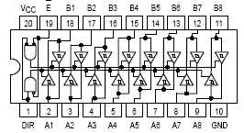

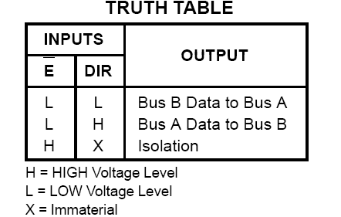

pins | function
Pin 20 (Vcc) | This is used to power the IC.
Pin 10 ( GND ) | This is used for providing the common IC Ground.
Pin 1 ( DIR ) | This is used to control the direction of flow of data. If this pin is high the data flows from the A Bus to the B Bus.
Pin 19 ( Enable ) | This is an active low input and it is used to enable or disable the flow of data.  If this pin is high the data pins of the IC that are being used as output go to the high impedance or Z-state.
Pins 2-9 ( A1 - A8 ) | These pins form the A Bus. They are numbered from A1 to A8.  They can be input or output depending on the direction pin.  If the direction pin is high they act as input pins.
Pins 18 – 11 ( B1 - B8 ) | These pins form the B Bus. They are numbered form B1 to B8.  They act as output pins when the direction pin is high and input  when the direction pin is low.

74373 3-state Octal D-Type Latches

These 8-bit registers feature totem-pole 3-STATE outputs designed specifically for driving highly-capacitive or relatively low-impedance loads. The high-impedance state and increased high-logic level drive provide these registers with the capability of being connected directly to and driving the bus lines in a bus-organized system without need for interface or pull-up components. They are particularly attractive
for implementing buffer registers, I/O ports, bidirectional bus drivers, and working registers. A buffered output control input can be used to place the eight outputs in either a normal logic state (high or low logic levels) or a high-impedance state. In the high-impedance state the
outputs neither load nor drive the bus lines significantly. The output control does not affect the internal operation of the latches or flip-flops. That is, the old data can be retained or new data can be entered even while the outputs are off.

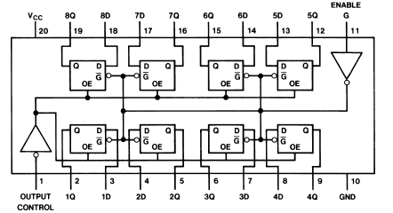

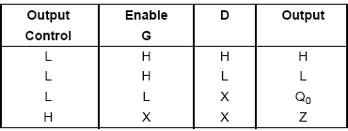

Pins | Function
Pin 20 ( Vcc ) | This pin provides the power to the IC.
Pin 10 ( GND ) | This pin provides the common IC Ground.
Pin 1 (Output Control ) | This active low pin controls the state of the output pins of the latches. If this pin is high it pulls the output pins of the latches up to the Z-state or high impedance state.
Pin 11 (Enable) | The enable which is active high. It is used to load the data into the latches. When the enable input is high, the D-latches store the data on their input pins. If this pin is low, the latches retain the data on their output.
Pins 3, 4, 7, 8, 13, 14, 17, 18 ( Input ) | These pins form the input pins to the D-latches, each for a different latch.
Pins 2, 5, 6, 9, 12, 15, 16, 19 ( Output ) | These pins form the output pins of the D-latches, each for a different latch.

The AT90S8515 Micro Controller Unit

The AT90S8515 is a low-power CMOS 8-bit microcontroller based on the AVR RISC architecture. By executing2 powerful instructions in single clock cycle, the AT90S8515 achieves throughputs approaching 1 MIPS / MHz, allowing the system designer to optimize power consumption versus processing speed.

The AVR core combines a rich instruction set with 32 general-purpose working registers. All the 32 registers are directly connected to the Arithmetic Logic Unit (ALU),
allowing 2 independent registers to be accessed in one single instruction executed in one clock cycle. The resulting architecture is more code efficient while achieving throughputs up to ten times faster than the conventional CISC microcontrollers.

The AT90S8515 provides the following features: 8K bytes of In-System Programmable

Flash, 512 bytes EEPROM, 512 bytes SRAM, 32 general-purpose I/O lines, 32 general-purpose working registers, flexible timer/counters with compare modes, internal and external interrupts, a programmable serial UART, programmable Watchdog Timer with internal oscillator, an SPI serial port and two software-selectable power-saving modes. The Idle Mode stops the CPU while allowing the SRAM, timer/counters, SPI port and interrupt system to continue functioning. The Power-down mode saves the register contents but freezes the oscillator, disabling all other chip functions until the next external interrupt or hardware reset.

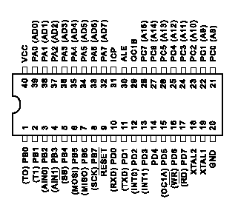

Pins | Function
VCC | Supply Voltage.
GND | Ground.
Port A (PA7..PA0) | Port A is an 8-bit bi-directional I/O port. Port pins can provide internal pull up resistors (selected for each bit). The Port A output buffers can sink 20 mA and can drive LED displays directly. When pins PA0 to PA7 are used as inputs and are extremely pulled low, they will source current if the internal pull-up resistors are activated. The Port A pins are tri-stated when a reset condition becomes active, even if the clock is not active.  Port A serves as multiplexed address/data input/output when using external RAM.
Port B (PB7..PB0) | Port B is an 8-bit bi-directional I/O port. Port pins can provide internal pull up resistors (selected for each bit). The Port B output buffers can sink 20 mA and can drive LED displays directly. When pins PB0 to PB7 are used as inputs and are extremely pulled low, they will source current if the internal pull-up resistors are activated. The Port B pins are tri-stated when a reset condition becomes active, even if the clock is not active.
Port C (PC7..PC0) | Port C is an 8-bit bi-directional I/O port. Port pins can provide internal pull up resistors (selected for each bit). The Port C output buffers can sink 20 mA and can drive LED displays directly. When pins PC0 to PC7 are used as inputs and are extremely pulled low, they will source current if the internal pull-up resistors are activated. The Port C pins are tri-stated when C reset condition becomes active, even if the clock is not active.  Port C also serves as an external output when using external SRAM.
Port D (PD7..PD0) | Port D is an 8-bit bi-directional I/O port. Port pins can provide internal pull up resistors (selected for each bit). The Port D output buffers can sink 20 mA and can drive LED displays directly. When pins PD0 to PD7 are used as inputs and are extremely pulled low, they will source current if the internal pull-up resistors are activated. The Port D pins are tri-stated when D reset condition becomes active, even if the clock is not active.
RESET | Reset input. A low level on this pin for more than 50 ns will generate a reset, even if the clock is not running. Shorter pulses are not guaranteed to generate a reset.
XTAL1 | Input to the inverting oscillator amplifier and input to the internal clock operating circuit.
XTAL2 | Output from the inverting oscillator amplifier.
ICP | ICP is the input pin for the Timer/Counter 1 Input Capture Function.
OC1B | OC1B is the output pin for the Timer/Counter 1 Output CompareB function.
ALE | ALE is the Address Latch Enable used when the External Memory is enabled. The ALE strobe is used is used to latch the low order address (8 bits) into an address latch during the first access cycle, and the AD0-7 pins are used for data during the second access cycle.

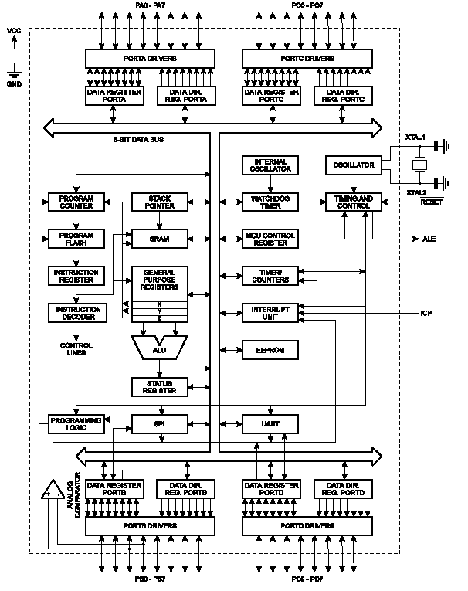

The 74138 3x8 line decoder

The DM74LS138 decodes one-of-eight lines, based upon the conditions at the three binary select inputs and the three enable inputs. Two active-low and one active-high enable inputs reduce the need for external gates or inverters when expanding. A 24-line decoder can be implemented with no external inverters, and a 32-line decoder requires only one inverter. An enable input can be used as a data input for demultiplexing applications.

Pins | Function
Pin 16 (Vcc) | This pin is used to power up the IC.
Pin 8 (GND) | This pin is used to provide the common IC Ground.
Pin 7,9-15 (Output) | These active low pin are used as output pins. Only one of them is low at a time depending on the selection and enable inputs.
Pins 1,2,3 (Selection Inputs) | These active high input lines are used to select one out of eight output lines.
Pins 4,5,6 (Enable inputs) | These 3 strobe pins, 2 of them active low are used to enable or disable the IC. When they are low the IC is disabled and all the outputs are HIGH.

Pin Diagram
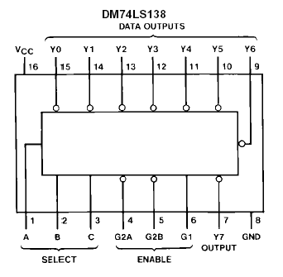

Truth Table
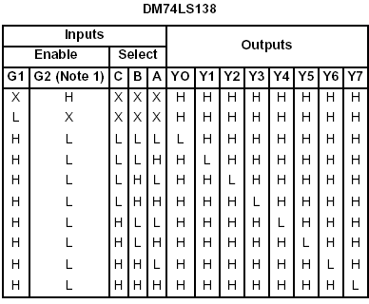

Logic Diagram
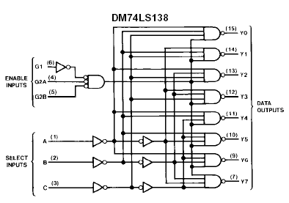

The 7404 Inverter

This device contains six independent gates each of which
performs the logic INVERT function.

Pin Diagram/Logic Diagram

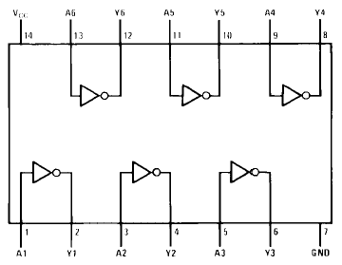

Truth Table

Input | Output
L | H
H | L

Block Diagram
Microcontroller Unit
Data Bus
LED Address
Keypad
Decoder
Inverter
Transceiver
Latch
Transceiver
Latch
Transceiver
Latch
Data Bus
LED Matrix
To Latches

