MAE 6220

Homework 3

Due XXXXXXXXXXXXXXX

1. Examine the consistency of the following parabolic equation, using a central differencing scheme for discretization in space and a first order forward differencing scheme for discretization in time.

$\frac{∂u}{∂t}-\frac{∂^{2}u}{∂x^{2}}=0$ (Eq. 1)

1. Examine the stability of Eq.1 for the grid shown in Fig.1 using a central differencing scheme for discretization in space. The boundary conditions are $u\left(t,0\right)=a$ and $u\left(t, L\right)=b$.

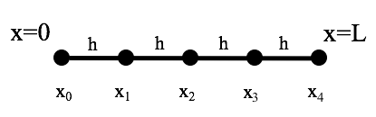

Fig. 1