MAE 6220

Homework 4

Due XXXXXXXXXXXXXXX

Lid-driven cavity is a two-dimensional steady benchmark problem. Figure 1.a shows the appropriate domain dimensions and flow properties. The flow is characterized by a large central vortex and two smaller vortices which occupy the bottom corners (figure 1.b).

Create a uniform 64x64 grid in FLUENT. Enable **double precision** and run in **serial mode**. When setting boundary conditions, note that the top wall (lid) is a moving wall. Therefore, switch from stationary wall to moving wall and prescribe the appropriate velocity magnitude and direction. For this exercise, you only need to monitor the residuals for continuity so turn off everything else. Set the convergence criteria for continuity to 10e-5.

Part 1.

Run the simulation using the following pressure-velocity coupling schemes while **keeping all other settings the same**: SIMPLE, SIMPLEC, PISO and COUPLED. As a result, you will run the calculation four separate times. For each calculation, make a note of the number of iterations it takes to achieve convergence. Export the Residual vs. Iterations plot using

File > Save Picture

and include them in your report. Which scheme converges in fewer iterations and why?

Part 2.

The setup for this part is exactly the same as part 1 just that here you will run each of the calculations for **50 iterations only**. At the end of each calculation go to

Report > System > Time Usage.

FLUENT outputs time statistics to the terminal. Make a note of the total calculation time listed under ID (do not confuse this with the total time for model timers). Which scheme is faster per iteration and why?

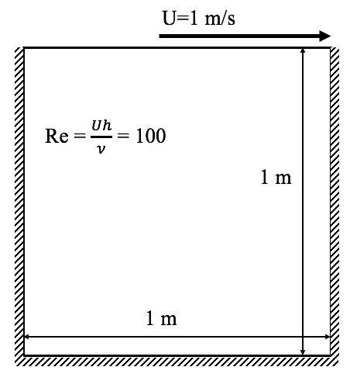 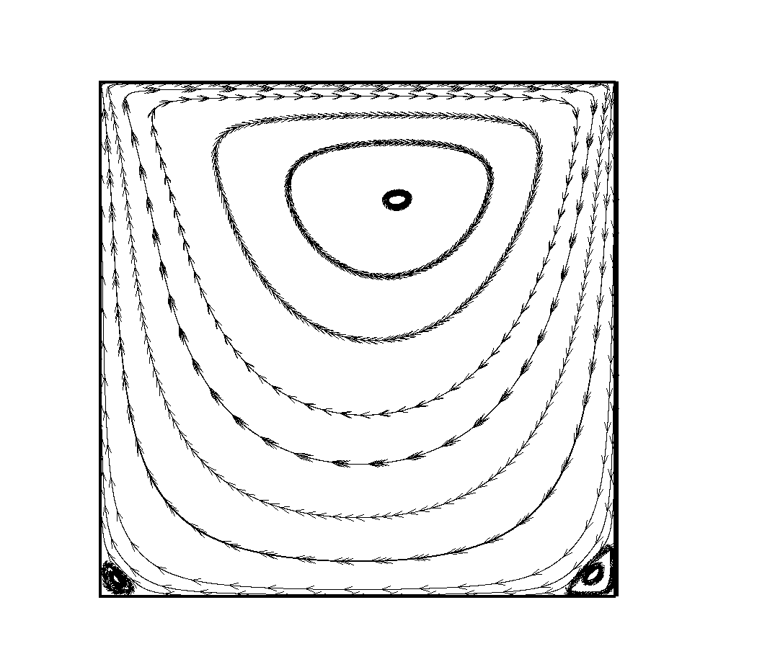

(a) (b)

Figure 1. Lid-driven cavity. (a) Domain dimensions and flow properties (b) Flow streamlines