**MAE 6220 Homework 1 Due: XX/XX**

1-In this problem, our goal is to simulate steady laminar flow between two infinitely long flat plates. Since the plates are infinitely long, the flow regime can be considered two dimensional. A schematic drawing of the flow is presented in figure 1.

The appropriate coordinate system, dimensions and flow properties are also given. This flow regime is one of the few examples for which an analytical solution to Navier-Stokes equations exists. The analytical solution can be found in any introductory fluid mechanics text book.

Simulate this flow regime for three different grid resolutions and compare the following flow properties to the analytical solution for each case. Please note that this is not an axisymmetric flow.

**(a) fully developed streamwise velocity profile (b) wall shear stress (c) development lengt**h

Include visualizations of the mesh and number of computational points in your report.

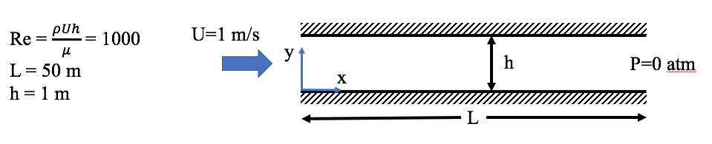

Figure 1. Steady laminar flow between two infinitely long flat plates

2-The purpose of this problem is to 1) simulate a time-dependent (unsteady) flow; 2) prescribe custom initial conditions for velocity components and pressure, 3) access features of FLUENT that are not directly accessible through the graphic user interface (GUI) and 4) compare discretization schemes in terms of accuracy.

Taylor-Green vortex is an exact solution of the Navier-Stokes equations that, for $ν=1 m^{2}/s$, is given by

$$u=-e^{-2t}\cos{x\sin{y}}$$

$$v=e^{-2t}\sin{x}\cos{y}$$

$$p=-\frac{e^{-4t}}{4}\left(\cos{2x}+\cos{2y}\right).$$

Equation 1. Solution to the Taylor-Green vortex problem at $ν=1 m^{2}/s$.

The flow field for $0≤x≤2π$ and $0≤y≤2π$ at $t=0$ is shown in figure 2.

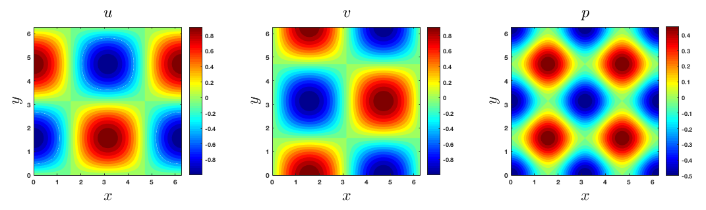

Figure 2. Velocity and pressure fields for the Taylor-Green vortex. Left: u velocity; middle: v velocity; right: pressure.

Given that the solution is time-dependent, you must choose transient formulation in FLUENT. The boundary conditions are periodic all around. Periodic boundaries are used when the flow in a sense repeats itself in space. Consider the example in Figure 3 which is a 2D representation of a typical heat exchanger. The rows of rods repeat their pattern in $y$ direction and so we only simulate a portion of the physical space (designated as domain in figure 3). The flow that leaves the domain from the top side enters it from the bottom. You can learn more about implementing periodic BCs in this video: <https://youtu.be/EXg8N4upZeQ>.

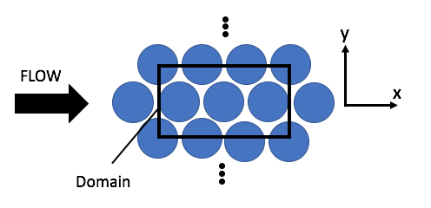

Figure 3. Periodic boundary conditions

Periodic boundary condition in FLUENT is not accessible through the GUI. To do so within the meshing module, name the boundaries **top, bottom, left and right** accordingly. In FLUENT, click on ‘Boundary Conditions’. All boundaries are listed under ‘Zone’. Click through them. You will notice that each boundary has a unique ID (figure 4).

Click on the command terminal shown in figure 4 and press enter. A menu of different FLUENT settings appears. Access the ‘define/’ menu by simply typing ‘define’ and pressing enter. Press enter again to see the submenu. From here go to:

boundary-conditions/ > modify-zones/

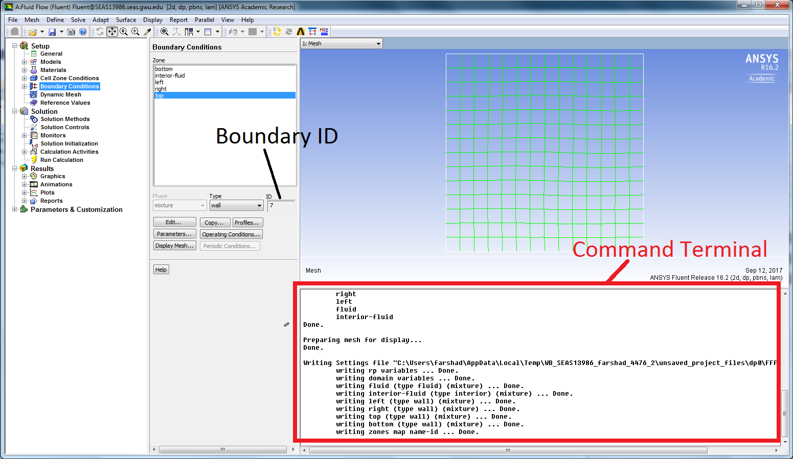

Figure 4. Boundary ID and Command terminal

And press enter (useful note: you can move up one submenu at a time by typing in ‘q’). Type in ‘make-periodic’. FLUENT will ask for the ID of the periodic zone. Type in the ID for the **left** boundary and press enter. For ‘Shadow Zone’, enter the ID of the right boundary. FLUENT will ask if this is a rotational boundary. Type in ‘no’ or ‘n’. Type in ‘yes’ for the two remaining questions. FLEUNT then removes the **right** boundary and if you click on **left**, you will see that it is designated as periodic. Repeat the same steps for top and bottom boundaries.

For this problem, we will use the velocity and pressure in equation 1 at $t=0$ for initial conditions. To do so, from the top menu in fluent go to

Define > Custom Field Functions

Custom field functions calculator opens. You can use the calculator buttons to insert your desired function in the textbox. Enter the relation for $u$ at $t=0$. In order to insert variables $x$ and $y$, click on the Field Functions dropdown menu and select Mesh. From the second dropdown menu directly below, select X-Coordinate and then click Select. Variable $x$ is inserted into the textbox. Once you are done inserting the mathematical relation, name your function $ux$ using the New Function Name textbox and click Define. Do the same for v-velocity and pressure and name them $uy$ and $pi$ respectively.

In Solution Initialization, choose Standard Initialization. You will notice that the Patch button is inactive. Initialize the flow using any value for pressure and the two velocity components. The Patch button is then activated. Click on Patch. Once the patch window is open, check Use Field Functions. In the Variable menu click on Pressure. Select $pi$ from the Field Function menu and choose the interior zone from Zones to Patch. Click on the Patch button (figure 5). Repeat the same process for the each of the velocity components. Check the initial flow field in the graphics module. It should look like figure 2.

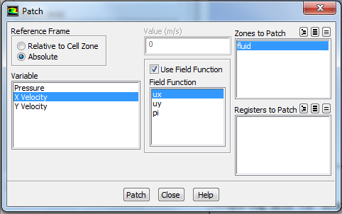

Figure 5. Patching the initial flow field

In ‘Solution Methods’, use the following settings.

Pressure-Velocity Coupling: SIMPLE

Gradient: Least Squares Cell Based

Pressure: Second Order

You will run the calculation using 3 grids (16x16, 32x32 and 64x64 cells), each with both first order and second order upwind schemes for momentum spatial discretization. Therefore, you will do a total of 6 simulations. We are interested in the results at $t=2s.$ Write the velocity and pressure results into an ASCII file for each simulation and calculate the average L2 norm of pressure (you can use MATLAB, Excel or any other software capable of reading CSV files).

$$L2-norm=\sqrt{Σ{\left(p_{numerical}-p_{analytical}\right)}^{2}}$$

You will have a total of six data points. Plot the L2 norms against grid size for both first order and second order upwind schemes and explain the trends you see. You can use the following settings for ‘Run Calculation’.

Time Stepping Method: Fixed

Time Step Size: 0.01 s

Number of Time Steps: 200

Max Iterations/Time Step: 50