**MAE 6220 Project 2 Due: XX/XX**

In this project, we are investigating steady laminar flow over a smooth 2-D cylinder. The domain size and other relevant flow properties are given in figure 1. Prepare a report that includes the following:

1. Contours of velocity components ( $u$ and $v$) and pressure
2. Streamline plots
3. Drag coefficient $C_{D}=\frac{D}{\frac{1}{2}ρU^{2}A}$ and comparison to experimental values (figure 2)
4. Separation angle
5. Mesh statistics and features. Explain why you chose that particular grid and why you think it is suitable for this problem.

Perform a grid independence study. This involves solving the numerical problem, starting with a coarse mesh. You will then redo the calculation using a finer mesh. You continue to refine the mesh until flow features (e.g. drag coefficient) do not change with respect to mesh size.

In order to calculate drag, you can add a drag monitor in the ‘Monitors’ section of FLUENT. Prescribe the appropriate reference values, convergence criteria and boundary conditions. Note that the upper and lower horizontal boundaries are slip-walls meaning that shear at the wall is zero and this has to be taken into account when prescribing boundary conditions.

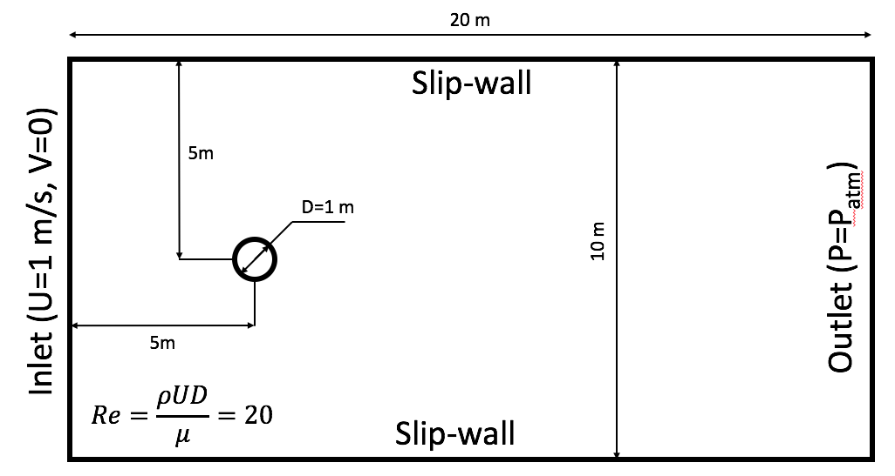

Figure 1. Flow past a cylinder

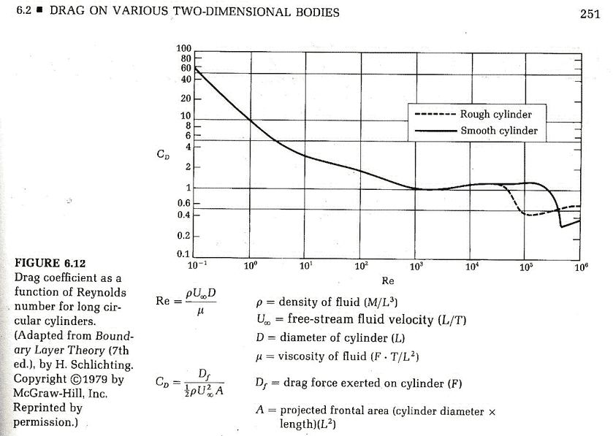

Figure 2. Drag coefficient vs. Reynolds number